Cumulative catchments: A novel approach for catchment-based flood susceptibility identification

Abdullah AKBAS¹, Aydoğan AVCIOĞLU², Hasan OZDEMIR¹, Tolga GORUM³, and Paul Bates^{4,5}

¹Bursa Uludağ University, Faculty of Art and Science, Geography Department, Physical Geography Division, BURSA/TÜRKİYE
²BRGM, 3 avenue Claude Guillemin, Orl´eans 45060, France
³Eurasia Institute of Earth Sciences, Istanbul Technical University, Istanbul, TÜRKİYE
⁴University of Bristol, School of Geographical Sciences, Bristol, BS8 1SS, United Kingdom
⁵Fathom, Bristol, 7-18 Berkeley, BS8 1HB, United Kingdom

*Corresponding Author: Geography Department, Physical Geography Division, Bursa Uludağ University, Bursa, Türkiye, 16000 (abdullahakbas@uludag.edu.tr)

ORCID for AKBAS: https://orcid.org/0000-0003-2024-0565
ORCID for AVCIOĞLU: https://orcid.org/0000-0001-7814-0554
ORCID for GORUM: https://orcid.org/0000-0001-9407-7946
ORCID for OZDEMIR: https://orcid.org/0000-0001-8885-9298
ORCID for BATES: https://orcid.org/0000-0001-9192-9963

Funding Information: This study was funded by the TUBITAK-Scientific and Technological Research Council of Türkiye with the 3501 Career Development Program (CAREER) (Project No: 121Y578).

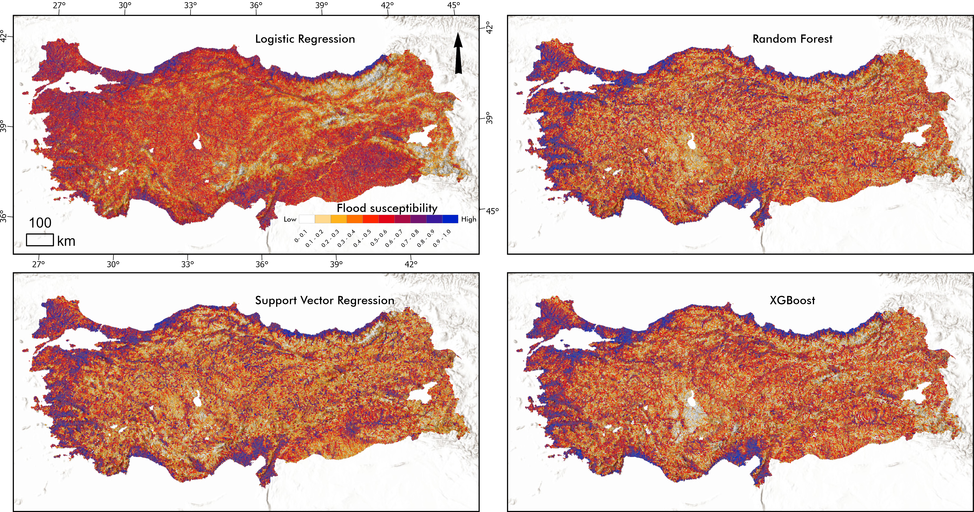
Figure S1. Flood susceptibility maps resulted from logistic regression, random forest, support vector regression and XGBoost.

Table S1: Comparison of model results.
Model | Accuracy | Macro F1-score | ROC-AUC | Precision (Class 0 / 1) | Recall (Class 0 / 1) | F1-score (Class 0 / 1)
XGBoost | 0.72 | 0.72 | 0.8005 | 0.73 / 0.72 | 0.73 / 0.72 | 0.73 / 0.72
Random Forest | 0.72 | 0.72 | 0.8013 | 0.72 / 0.73 | 0.74 / 0.70 | 0.73 / 0.71
SVM (RBF) | 0.71 | 0.71 | 0.7770 | 0.70 / 0.71 | 0.72 / 0.69 | 0.71 / 0.70
Logistic Reg. | 0.68 | 0.68 | 0.7440 | 0.69 / 0.67 | 0.67 / 0.70 | 0.68 / 0.68

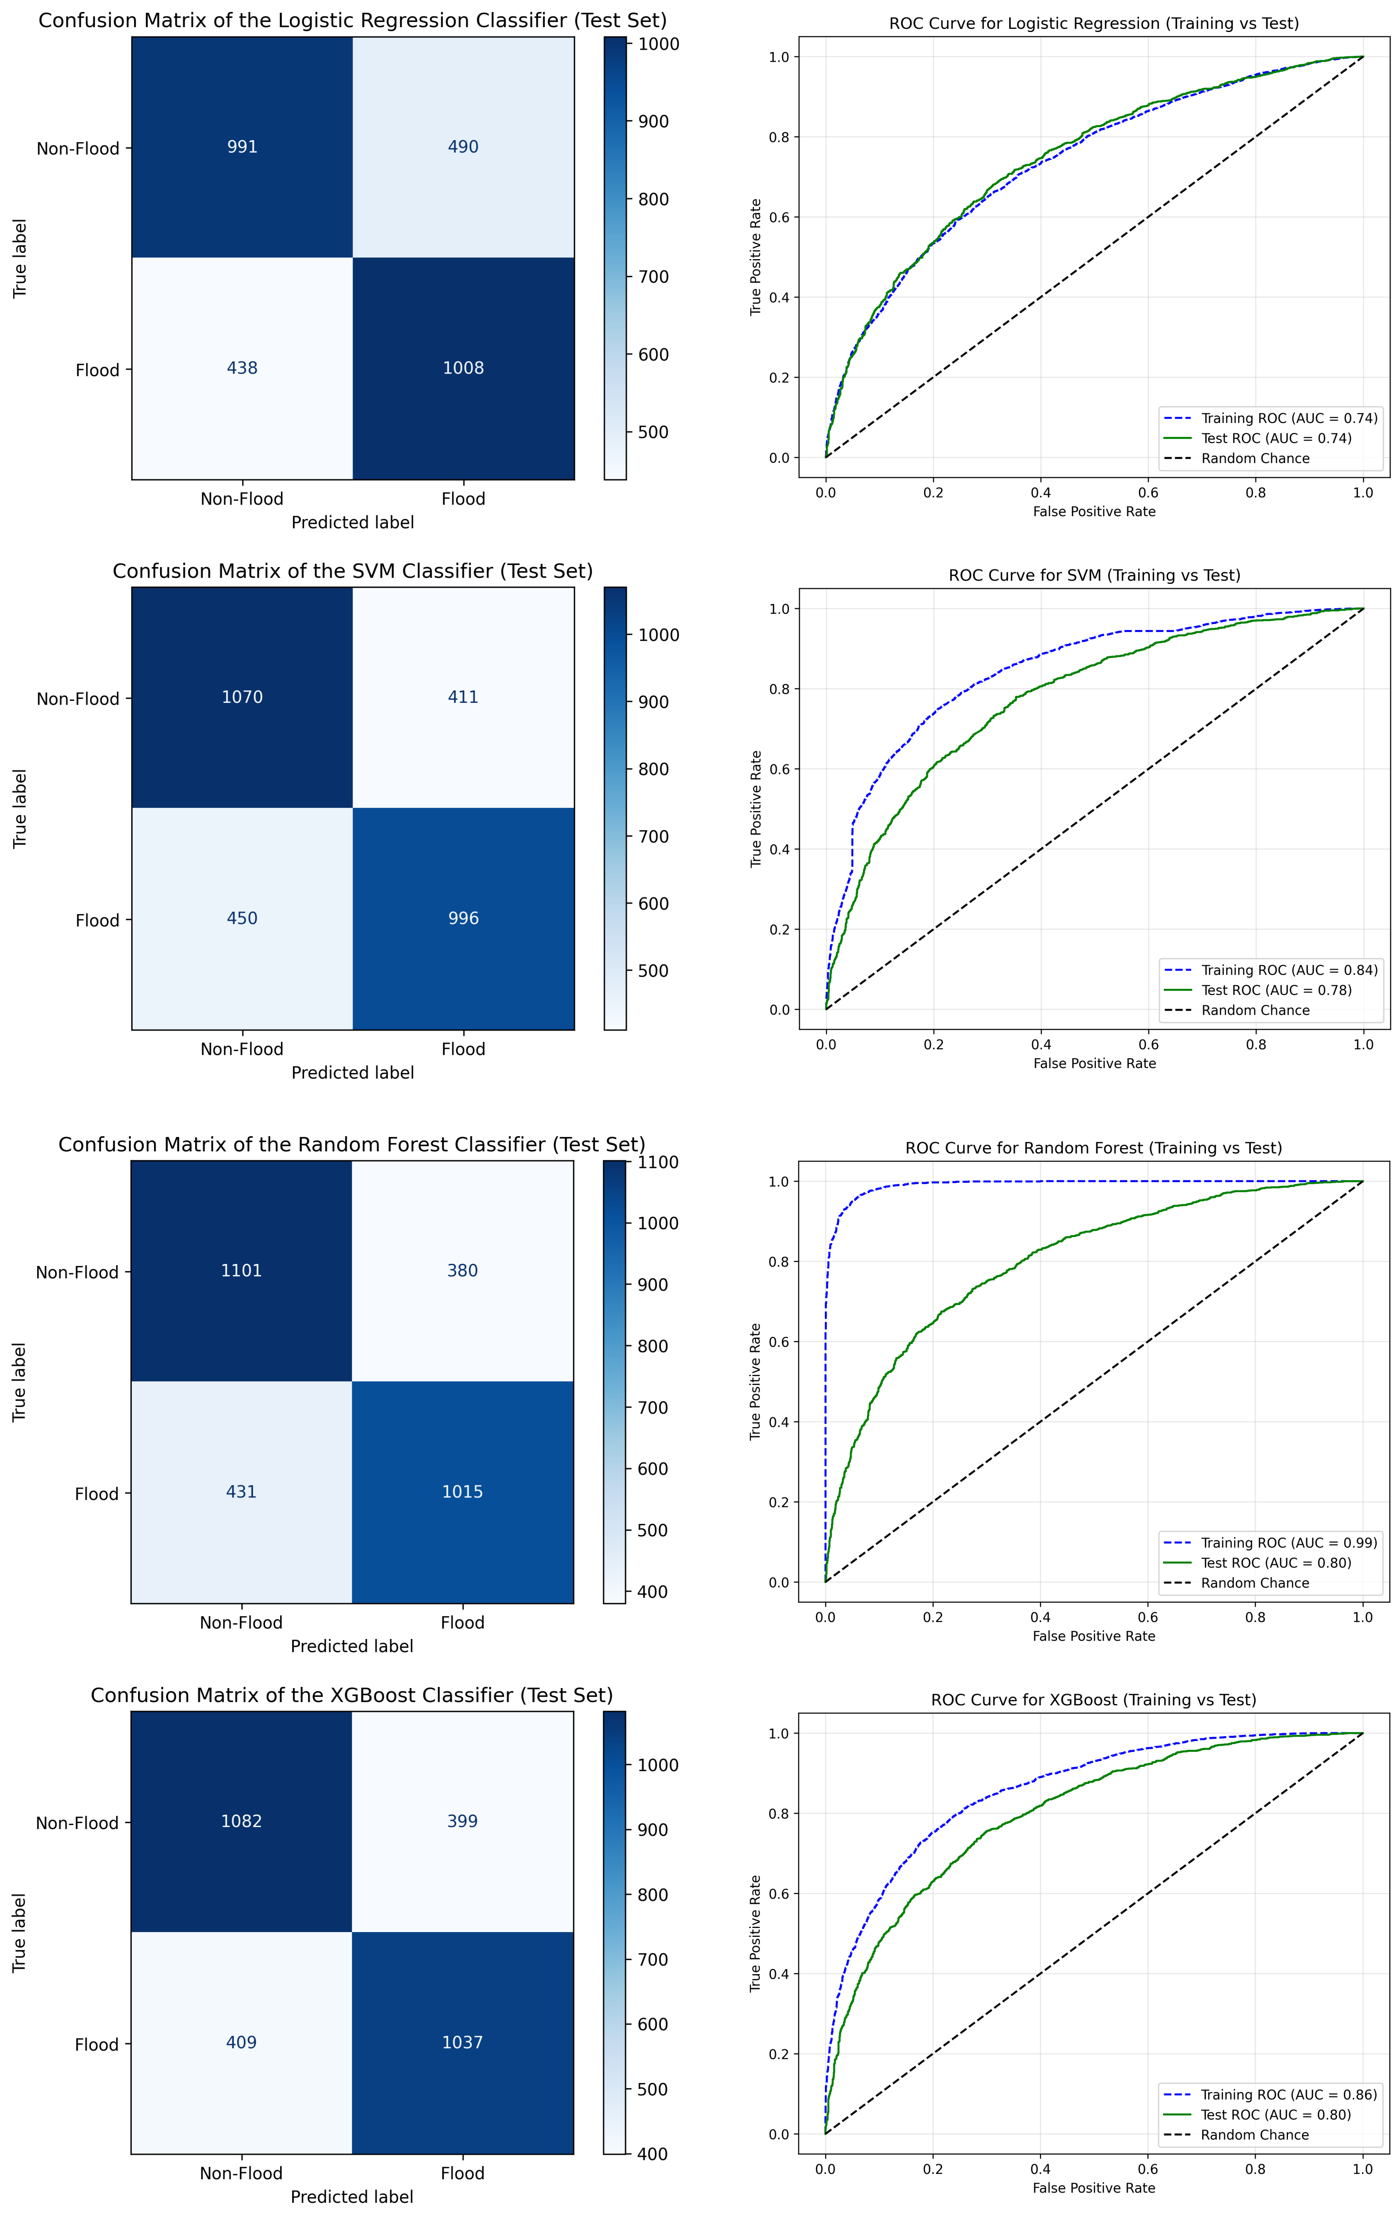
Figure S2. Confusion matrix and ROC curve for each ML model. Each confusion matrix shows actual (rows) and predicted (columns) sample percentages. The cells represent true negatives, false positives, false negatives, and true positives, respectively.

