APPENDICES
Appendix I
Permission to Use Three-Component Model (TCM) Employee Commitment Survey
Mulugeta Abera mulugetaabera88@gmail.com
To:meyer@uwo.ca,nallen@uwo.ca
Jan 16 at 8:21 AM

Dear Sirs (Allen and Meyer),
I am Mulugeta Abera Wondafrash, a PhD student in Educational Leadership and Policy Studies at Haramaya University, Ethiopia (Africa). I am preparing a Ph.D. Dissertation on a topic "The Relationship between Instructional Leadership Practices and Teachers Job Performance at Haramaya University. While searching on line on Google, I found your Three Component Model (TCM) Employee Commitment Survey which has been predominantly used by many researchers and I came to believe that you are the authority in the field of organizational commitment. I got interested in the instrument for my dissertation. Hence, would you please allow me to adapt it (only wordings) for academic dissertation to secondary school context? I am looking forward to hearing from you.Thank you in advance for your understanding.

Mulugeta Abera Wondafrash

Haramaya University, Ethiopia

Teacher Commitment Scale
John Meyer <meyer@uwo.ca>

 | 1:13 ከሰዓት (ከ1 ሰዓት በፊት)
  John Peter Meyer
To:'Mulugeta Abera Wondafrash

Hello,
Thank you for your interest in using the Three-Component Model (TCM) Employee Commitment Survey in your research. You can get information about the measure, a Users’ Guide, and the measure itself at: http://employeecommitment.com/
For academic / research purposes, please choose the Academic Package. (There is no charge for this package.)
I wish you well with your research!
Best regards,
John Meyer

Appendix II

Seeking Permission to Use PIMRS

የገቢ መልዕክት ሳጥን
በየገቢ መልዕክት ሳጥን አመልካች መለያ ያሉ ሁለንም መልዕክቶች ፈልግ
የገቢ መልዕክት ሳጥን አመልካች መለያን ከዚህ ንግግር አስወግድ

 | 24 ኦክቶ 2024 10:25 ከሰዓት (ከ14 ሰዓቶች በፊት)
  Mulugeta Abera <mulugetaabera88@gmail.com>
ለHallinger

Dear Dr. Philip Hallinger
I am Mulugeta Abera Wondafrash, a PhD student in Educational Leadership and Policy Studies at Haramaya University, Ethiopia (Africa). I am preparing a Ph.D. Dissertation on a topic "The relationship between instructional leadership styles, teacher’s job satisfaction and commitment" at Haramaya University. While searching on line on Google, I found your instructional management rating scale PIMRS which has been predominantly used by many researchers and I came to believe that you are the authority in the field of leadership and management. I got interested in the instrument for my dissertation. Hence, would you please allow me to adapt it (only wordings) for academic dissertation to secondary school context? I am looking forward to hearing from you. Thank you in advance for your understanding.

Mulugeta Abera Wondafrash

Haramaya University, Ethiopia


 | 2:37 ጥዋት (ከ10 ሰዓቶች በፊት)
  Philip Hallinger
ለእኔ

Dear Mulugeta Abera

I have waived the usual fee for your use of the PIMRS. You now have my permission to use the copyrighted PIMRS instrument. Note however, that all conditions of use still apply to you (i.e., supplying me with your final soft copy of the study and raw data file). You now are able to access various PIMRS resources on my website at https://philiphallinger.com/tool/survey/pimrs/a/researcherLogin-2.html
For full and up-to-date information on the PIMRS and its use as a research and evaluation tool, please see my latest book, Assessing Principal Instructional Leadership with the PIMRS. The book contains useful information for researchers on the scale including its development, use, validity and reliability. Please keep in mind the conditions of your purchase including sending me: 1) a copy of the translated PIMRS (if applicable), 2) a copy of your RAW DATASET, and 3) a pdf copy of your completed study.
Please also note that the user is requested to include ALL questions including demographic questions (i.e., gender, years of experience, years of teaching experience, school level) in the PIMRS unless otherwise waived by the publisher.
If you need any assistance, please contact me directly

Appendix III: Consent Letter to Sample Secondary Schools

Dear All Under mentioned Secondary Schools,
I am Mulugeta Abera, a PhD Student in Educational Leadership and Policy Studies (ELPS) at Haramaya University. I am now at Dissertation Phase and my topic is entitled "Relationship between instructional leadership styles of principals, teachers’ job satisfaction and commitment in East Hararghe zone secondary schools". When I was randomly selecting 24 sample secondary schools from the East Hararghe zone secondary schools, your secondary school was selected through Simple Random Sampling.
Therefore, I would like to request you to show your consent on the participation of your secondary school and provide me with permission to conduct my dissertation research with utmost ethical principles of research. I would also like to assure you that whatever pieces of information and data I collect from humans, materials, and documents in your secondary school for my dissertation research till the end will be kept confidential and only used for academic purposes with maximum care. Thank you in advance for your cooperation.
With Best Regards,

Appendix IV: Consent Letter for Respondents

Dear Respondents,

I am Mulugeta Abera, a PhD Student in Educational Leadership and Policy Studies (ELPS) at Haramaya University. I am now at Dissertation Phase and my topic is entitled "Relationship between instructional leadership Styles of Principals, Teachers’ Job Satisfaction and Commitment in East Hararghe Zone Secondary Schools". When I was randomly selecting respondents from your secondary school, your name was selected through Simple Random Sampling to participate in this study as a respondent.

Therefore, I would like to request you to show your consent on your participation in this study and provide me with genuine information and data that are critical for the success of this research. I would also like to assure you that whatever pieces of information and data you provide will be kept confidential and only used for academic purposes with maximum care. Participation in this research is voluntary and you can withdraw from participation and/or withhold any data you provided any time. Thank you in advance for your cooperation.

With Best Regards,

Appendix V: Questionnaire for School Principals
HARAMAYA UNIVERSITY
COLLEGE OF EDUCATION AND BEHAVIORAL SCIENCES
A Questionnaire to be filled in by School Principals

Dear Respondents,
The purpose of this questionnaire is to collect data for the research entitled “Relationship between Instructional Leadership Styles of Principals, Teachers Job Satisfaction and Commitment in Secondary Schools of East Hararghe Zone” which is conducted for PhD Dissertation in the field of Educational Leadership and Policy Studies at Haramaya University. The successful accomplishment of this study greatly depends upon your honest and genuine responses to each item. Hence, the researcher kindly requests you to give your genuine responses. The data you provide will be used only for this research purpose and will be kept confidential. It may take you twenty-five minutes to complete all the four parts of this questionnaire. Participation is voluntary. Please, do not write your name. After completing filling or for any question, please give me a page on 0913608348 and I will call you back on spot.
Thank you in advance for your willingness and kind cooperation!!
Mulugeta Abera, PhD Candidate, 0913608348
General Directions
Part I: Demographic Data
The first part of the questionnaire contains demographic information (Age, Sex, Marital Status, Service Year, Level of Education, and Specialization); thus, the researcher kindly requests you to give the necessary responses for each item by putting “√” mark or by writing the correct response in the space provided.
- School: __________________________________________________
- Age: ____________________
- Sex: Male Female
- Marital Status: Married Single Divorced Widowed
- Service Year in this School ______________________
- Level of Education: Certificate Diploma Degree Masters PhD Other
- Specialization: ___________________________
- Leadership Position: Principals Vice Principal
- Year of Service in the Current Position_______________________________

Continues…
Part II: Perceptions of School Leaders on their Instructional leadership Style

The following statements are about how you led your school. Please indicate the extent to which you agree or disagree with the statements by putting “√” mark under the appropriate numbers. Please kindly answer all the statements. Use the following Likert-Type Scales:

1= Strongly Disagree 2= Disagree 3= Undecided 4= Agree 5= Strongly Agree

S.N. | Related to the Instructional Leadership Style, I, as a leader, | 1 | 2 | 3 | 4 | 5
 | Theme 1: Define a School Mission
 | Develop a Focused Set of Annual School-Wide Goals
 | Frames the School's Goals in Terms of Staff Responsibilities
 | Uses Needs Assessment to Secure Staff Input on Goal Development
 | Use Data on Student Performance When Developing the Schools’ Academic Goals
 | Develops Goals that Are Easily Understood by Teachers in the Schools
Theme 2: Communicate the School Goals
 | Communicate the school’s mission effectively to members of the school community
 | Discuss school’s academic goals with teachers at meetings
 | Refer to the school’s academic goals when making curricular decisions with teachers
 | Ensures school’s academic goals are reflected in posters or bulletin boards in schools
 | Refers to school’s mission with students in assemblies or discussions
Theme 3: Supervise & Evaluate the Instruction
 | Ensures that classroom priorities of teachers are consistent with the schools goals
 | Reviews student work products when evaluating classroom instructions
 | Conducts informal observations in classrooms on a regular basis
 | Points out specific strengths in teacher's instructional practices in conferences or written evaluations.
 | Points out specific weaknesses in teacher instructional practices in conferences or written evaluations
Theme 4: Coordinate the Curriculum
 | Makes clear the responsibility among principal, vice principal, or teacher-leaders for coordinating the curriculum across grade levels
 | Draw upon the results of school-wide testing when making curricular decisions.
 | Monitor the classroom curriculum to see that it covers the school’s curricular objectives
 | Assess the overlap between school’s curricular objectives and school’s achievement tests
 | Participate actively in the review of curricular materials
Theme 5: Monitor Student Progress
 | Meets with teachers to discuss student progress
 | Discusses academic performance results with teachers to identify curricular strengths and weaknesses
 | Use tests and other performance measure to assess progress toward school goals.
 | Informs teachers of school performance results in a memo or newsletter
 | Inform students of school’s academic progress
Theme 6: Protect Instructional Time
 | Limit interruptions of instructional time by public address announcements
 | Ensure that students are not called to the office during instructional time
 | Ensures that tardy and truant students suffer specific consequences for missing instructional time
 | Encourage teachers to use instructional time for teaching and practicing new skills and concepts
 | Limit intrusion of extra- and co-curricular activities on instructional time
Theme 7: Maintain High Visibility
 | Take time to talk informally with students and teachers during recess and breaks
 | Visits classrooms occasionally to discuss school issues with teachers
 | attends in extra- and co-curricular activities
 | Covers classes while waiting for teachers to arrive
 | Tutors students or provide direct instruction to classes
Theme 8: Provide Incentives for Teachers
 | Reinforces superior performance by teachers in staff meetings, newsletters, and memos
 | Compliment teachers privately for their efforts or performance
 | Acknowledges teachers' exceptional performance in writing memos for their personnel files
 | Reward special efforts by teachers with opportunities for professional recognition
 | Creates professional growth opportunities for teachers as reward for their special contributions
Theme 9: Promote Professional Development
 | Ensure that in service activities attended by staff are consistent with the school's goals.
 | Actively supports the use of skills acquired during in service training
 | Obtains participation of the whole staff in important in service activities
 | Leads teacher in service activities related to instruction
 | Provides time for teachers to share ideas or information from different training program
Theme 10: Provide Incentives for Learning
 | Recognizes students who do superior work with formal rewards such as an honor roll or mention in the principal's newsletter
 | Use assemblies to honor students for academic accomplishments or for good behavior
 | Recognize superior student achievement by meeting with the students in the office
 | Contact parents to communicate improved or exemplary student performance or contributions.
 | Support teachers actively in their recognition of student contributions and accomplishments in class
Ended

Appendix VI: Questionnaire for Teachers
HARAMAYA UNIVERSITY
COLLEGE OF EDUCATION AND BEHAVIORAL SCIENCES
A Questionnaire to be filled in by Teachers
Dear Respondents,
The purpose of this questionnaire is to collect information for the research entitled “Relationship between Instructional Leadership Style of Principals, Teachers Job Satisfaction and Commitment in East Hararghe Zone Secondary Schools” which is conducted for PhD Dissertation in the field of Educational Leadership and Policy Studies at Haramaya University. The successful accomplishment of this study greatly depends upon your honest and genuine responses to each item. Hence, the researcher kindly requests you to give your genuine responses. The data you provide will be used only for this research purpose and will be kept confidential. It may take you twenty-five minutes to complete all the four parts of this questionnaire. Participation is voluntary. Please, do not write your name. After completing filling or for any question, please give me a page on 0913608348 and I will call you back on spot.
Thank you in advance for your willingness and kind cooperation!!
Mulugeta Abera, PhD Candidate, 0913608348
General Directions
Part I: Demographic Data

The first part of the questionnaire contains demographic information (Department, Age, Sex, Marital Status, Service Year, Level of Education, and Specialization); thus, the researcher kindly requests you to give the necessary responses for each item by putting “√” mark or by writing the correct response in the space provided. The responses you provide to these demographic characteristics will be used only to compare and contrast the results for this research.

- Depaertment__________________________________________________
- Age: __________________
- Sex: Male Female
- Marital Status: Married Single Divorced Widowed
- Service Year in this School __________________
- Level of Education: Certificate Diploma Degree Masters PhD Other
- Field of Specialization: ___________________________

Continues…
Part II: Perceptions of Teachers on their School Leaders Leadership Style

The following statements are about how you led your school. Please indicate the extent to which you agree or disagree with the statements by putting “√” mark under the appropriate numbers. Please kindly answer all the statements. Use the following Likert-Type Scales:
1= Strongly Disagree 2= Disagree 3= Undecided 4= Agree 5= Strongly Agree

S.N |  | Related to the Instructional Leadership Style, My Principal… |  | 1 | 2 | 3 | 4 | 5
 |  | Theme 1: Define a School Mission
 |  | Develop a Focused Set of Annual School-Wide Goals |  | 1 | 2 | 3 | 4 | 5
 |  | Frames The School's Goals in Terms of Staff Responsibilities |  | 1 | 2 | 3 | 4 | 5
 |  | Uses Needs Assessment to Secure Staff Input on Goal Development |  | 1 | 2 | 3 | 4 | 5
 |  | Use Data on Student Performance When Developing the Schools’ Academic Goals |  | 1 | 2 | 3 | 4 | 5
 |  | Develops Goals that Are Easily Understood by Teachers in the Schools |  | 1 | 2 | 3 | 4 | 5
Theme 2: Communicate the School Goals
 | Communicate the school’s mission effectively to members of the school community |  |  | 1 | 2 | 3 | 4 | 5
 | Discuss school’s academic goals with teachers at meetings |  |  | 1 | 2 | 3 | 4 | 5
 | Refer to the school’s academic goals when making curricular decisions with teachers |  |  | 1 | 2 | 3 | 4 | 5
 | Ensures school’s academic goals are reflected in posters or bulletin boards in schools |  |  | 1 | 2 | 3 | 4 | 5
 | Refers to school’s mission with students in assemblies or discussions |  |  | 1 | 2 | 3 | 4 | 5
Theme 3: Supervise & Evaluate the Instruction My Principal…
 | Ensures that classroom priorities of teachers are consistent with the schools goals |  |  | 1 | 2 | 3 | 4 | 5
 | Reviews student work products when evaluating classroom instructions |  |  | 1 | 2 | 3 | 4 | 5
 | Conducts informal observations in classrooms on a regular basis |  |  | 1 | 2 | 3 | 4 | 5
 | Points out specific strengths in teacher's instructional practices in conferences or written evaluations. |  |  | 1 | 2 | 3 | 4 | 5
 | Points out specific weaknesses in teacher instructional practices in conferences or written evaluations |  |  | 1 | 2 | 3 | 4 | 5
Theme 4: Coordinate the Curriculum
 | Makes clear the responsibility among principal, vice principal, or teacher-leaders for coordinating the curriculum across grade levels |  |  | 1 | 2 | 3 | 4 | 5
 | Draw upon the results of school-wide testing when making curricular decisions. |  |  | 1 | 2 | 3 | 4 | 5
 | Monitor the classroom curriculum to see that it covers the school’s curricular objectives |  |  | 1 | 2 | 3 | 4 | 5
 | Assess the overlap between school’s curricular objectives and school’s achievement tests |  |  | 1 | 2 | 3 | 4 | 5
 | Participate actively in the review of curricular materials |  |  | 1 | 2 | 3 | 4 | 5
Theme 5: Monitor Student Progress
 | Meets with teachers to discuss student progress |  |  | 1 | 2 | 3 | 4 | 5
 | Discusses academic performance results with teachers to identify curricular strengths and weaknesses |  |  | 1 | 2 | 3 | 4 | 5
 | Use tests and other performance measure to assess progress toward school goals. |  |  | 1 | 2 | 3 | 4 | 5
 | Informs teachers of school performance results in a memo or newsletter |  |  | 1 | 2 | 3 | 4 | 5
 | inform students of school’s academic progress |  |  | 1 | 2 | 3 | 4 | 5
Theme 6: Protect Instructional Time
 | Limit interruptions of instructional time by public address announcements |  |  | 1 | 2 | 3 | 4 | 5
 | Ensure that students are not called to the office during instructional time |  |  | 1 | 2 | 3 | 4 | 5
 | Ensures that tardy and truant students suffer specific consequences for missing instructional time |  |  | 1 | 2 | 3 | 4 | 5
 | Encourage teachers to use instructional time for teaching and practicing new skills and concepts |  |  | 1 | 2 | 3 | 4 | 5
 | limit intrusion of extra- and co-curricular activities on instructional time |  |  | 1 | 2 | 3 | 4 | 5
Theme 7: Maintain High Visiblity
 | Take time to talk informally with students and teachers during recess and breaks |  |  | 1 | 2 | 3 | 4 | 5
 | Visits classrooms occasionally to discuss school issues with teachers |  |  | 1 | 2 | 3 | 4 | 5
 | Attends in extra- and co-curricular activities |  |  | 1 | 2 | 3 | 4 | 5
 | Covers classes while waiting for teachers to arrive |  |  | 1 | 2 | 3 | 4 | 5
 | Tutors students or provide direct instruction to classes |  |  | 1 | 2 | 3 | 4 | 5
Theme 8: Provide Incentives for Teachers My Principal…
 | Reinforces superior performance by teachers in staff meetings, newsletters, and memos |  |  | 1 | 2 | 3 | 4 | 5
 | Compliment teachers privately for their efforts or performance |  |  | 1 | 2 | 3 | 4 | 5
 | Acknowledges teachers' exceptional performance in writing memos for their personnel files |  |  | 1 | 2 | 3 | 4 | 5
 | Reward special efforts by teachers with opportunities for professional recognition |  |  | 1 | 2 | 3 | 4 | 5
 | Creates professional growth opportunities for teachers as reward for their special contributions |  |  | 1 | 2 | 3 | 4 | 5
Theme 9: Promote Professional Development
 |  |  | Ensure that in service activities attended by staff are consistent with the school's goals. | 1 | 2 | 3 | 4 | 5
 |  |  | Actively supports the use of skills acquired during in service training | 1 | 2 | 3 | 4 | 5
 |  |  | Obtains participation of the whole staff in important in service activities | 1 | 2 | 3 | 4 | 5
 |  |  | leads teacher in service activities related to instruction | 1 | 2 | 3 | 4 | 5
 |  |  | Provides time for teachers to share ideas or information from different training program | 1 | 2 | 3 | 4 | 5
Theme 10: Provide Incentives for Learning
 |  |  | Recognizes students who do superior work with formal rewards such as an honor roll or mention in the principal's newsletter | 1 | 2 | 3 | 4 | 5
 |  |  | Use assemblies to honor students for academic accomplishments or for good behavior | 1 | 2 | 3 | 4 | 5
 |  |  | recognize superior student achievement by meeting with the students in the office | 1 | 2 | 3 | 4 | 5
 |  |  | Contact parents to communicate improved or exemplary student performance or contributions. | 1 | 2 | 3 | 4 | 5
 |  |  | Support teachers actively in their recognition of student contributions and accomplishments in class | 1 | 2 | 3 | 4 | 5
Continues…

Part IV: Opinions of Teachers about Their Commitment to School
The following eighteen (18) statements are about your opinions on your commitment to school where you are work now which might be in relation to the style of instructional leadership. Please indicate the extent of your agreement or disagreement with each statement by putting “√” or “X” mark under a number from 1 to 5. Please do not put your name on this questionnaire. Use the following scales:

1= Strongly Disagree 2= Disagree 3= Undecided 4= Agree 5= Strongly Agree
S.N. |  |  | Your Perceptions towards Commitment to School | 1 | 2 | 3 | 4 | 5
Theme 1: Affective Commitment to School Items
 | I would be very happy to work in this school for the rest of my career |  |  | 1 | 2 | 3 | 4 | 5
 | I feel this school’s problems are my own |  |  | 1 | 2 | 3 | 4 | 5
 | I feel like part of the family at this school |  |  | 1 | 2 | 3 | 4 | 5
 | I feel emotionally attached to this school |  |  | 1 | 2 | 3 | 4 | 5
 | This school has a great deal of personal meaning for me |  |  | 1 | 2 | 3 | 4 | 5
 | I feel a strong sense of belonging to this school |  |  | 1 | 2 | 3 | 4 | 5
Theme 2: Continuance Commitment to School Items
 |  | It would be very hard for me to leave my school right now, even if I wanted to |  | 1 | 2 | 3 | 4 | 5
 |  | Too much of my life would be disrupted if I decided I wanted to leave my school now |  | 1 | 2 | 3 | 4 | 5
 |  | I feel that I have too few options to consider leaving this school |  | 1 | 2 | 3 | 4 | 5
 |  | One of the few serious consequences of leaving this school would be the scarcity of available alternatives |  | 1 | 2 | 3 | 4 | 5
 |  | Right now, staying with this school is a matter of necessity as  much as desire |  | 1 | 2 | 3 | 4 | 5
 |  | One of the major reasons I continue to work for this school is that leaving would require considerable personal sacrifice; another school may not match the overall benefits I have here |  | 1 | 2 | 3 | 4 | 5
Theme 3: Normative Commitment to School Items
 |  | I do not feel an obligation to remain with my current employer |  | 1 | 2 | 3 | 4 | 5
 |  | Even if it were to my advantage, I do not feel it would be right to leave my school now |  | 1 | 2 | 3 | 4 | 5
 |  | I would feel guilty if I left my school now |  | 1 | 2 | 3 | 4 | 5
 |  | This school deserves my loyalty |  | 1 | 2 | 3 | 4 | 5
 |  | I would not leave my school right now because I have a sense of obligation to the people in it. |  | 1 | 2 | 3 | 4 | 5
 |  | I owe a great deal to my school. |  | 1 | 2 | 3 | 4 | 5
Ended

Appendix VII: INTERNAL RELIABILITY TEST RESULT
Reliability result of defining school mission
Reliability Statistics
Cronbach's Alpha | No of Items
.994 | 10

Reliability result of Managing Instructional Program
Reliability Statistics
Cronbach's Alpha | No of Items
.988 | 15

Reliability result of developing positive school learning climate
Reliability Statistics
Cronbach's Alpha | No of Items
.993 | 25
Reliability result of intrinsic job satisfaction
Reliability Statistics
Cronbach's Alpha | No of Items
.989 | 12

Reliability result of extrinsic job satisfaction
Reliability Statistics
Cronbach's Alpha | No of Items
.990 | 8

Reliability result of affective commitment
Reliability Statistics
Cronbach's Alpha | No of Items
.973 | 6

Reliability result of continuance commitment
Reliability Statistics
Cronbach's Alpha | No of Items
.988 | 6

Reliability result of normative commitment
Reliability Statistics
Cronbach's Alpha | No of Items
.980 | 6
Appendix VIII: Test of Normality to Determine
Sample Characteristics

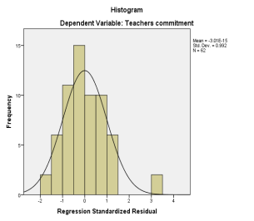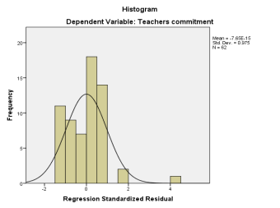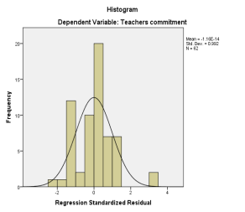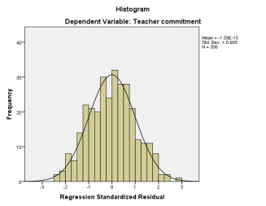

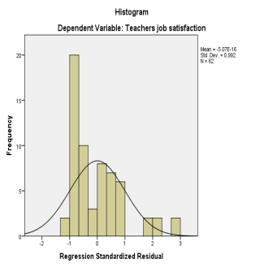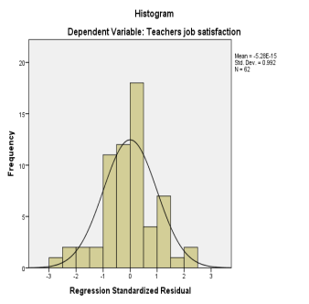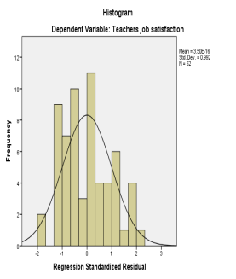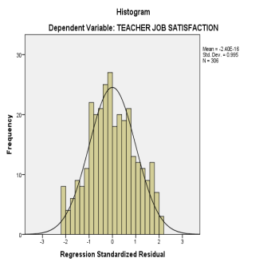
Figure 2 Histogram for job satisfaction and commitment
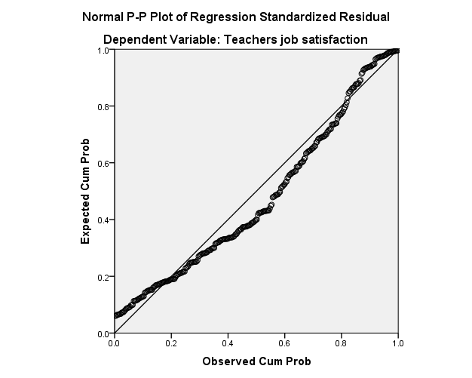
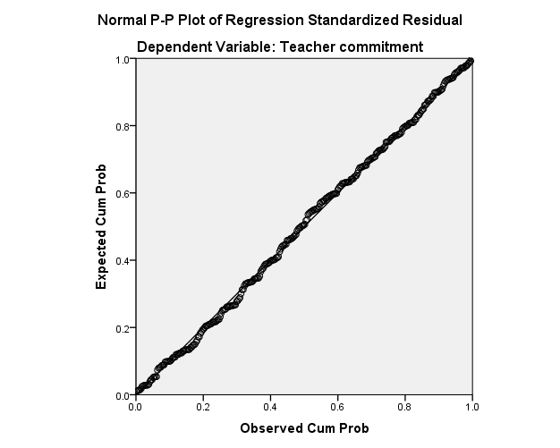
Figure 3, Normal P-P plot for regression
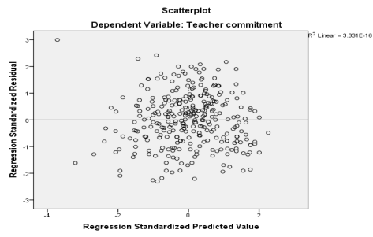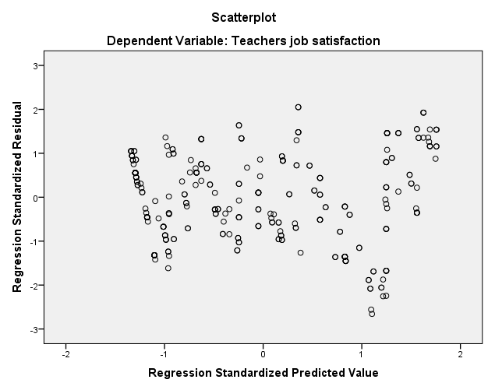
Figure 4 Scatter plot for homoscedasticity
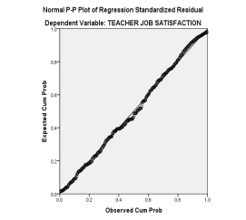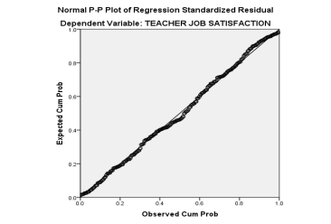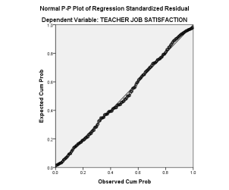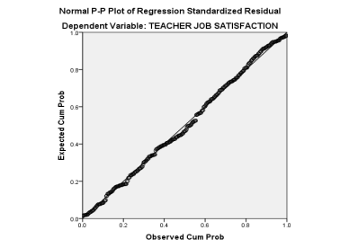

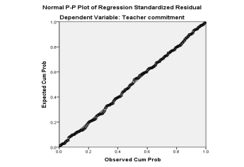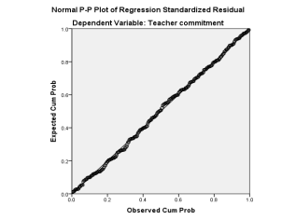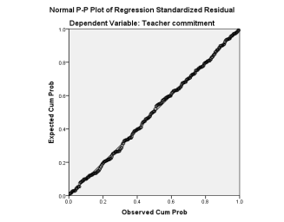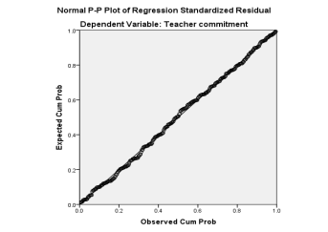
Figure 5 Normal P-P Plot for satisfaction and commitment
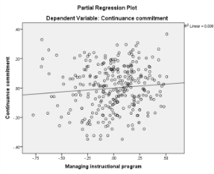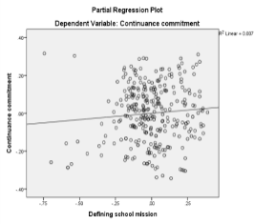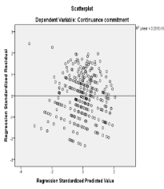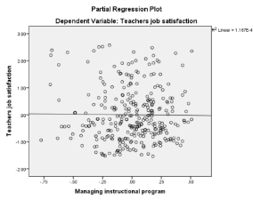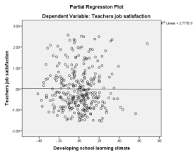
Figure 6 Scatter plot for outliers

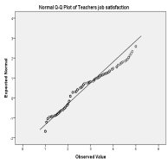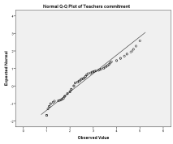
Figure 7 Normal Q-Q Plot for job satisfaction and commitment

Appendix VIII Sample Size and Sampling Techniques
Table 1: Sample size and sampling techniques based on (Yamane et al., 1967)
S.N. | Schools | Teachers |  |  | School Principals
S.N. | Schools | Popn | Sample | % | Pop | Sam | %
1 | Burka | 54 | 27 | 50 | 2 | 2 | 100
2 | Kumbi | 24 | 12 | 50 | 2 | 2 | 100
3 | Meyu | 35 | 18 | 50 | 2 | 2 | 100
4 | Midega | 24 | 12 | 50 | 1 | 1 | 100
5 | Kobo | 65 | 24 | 37 | 4 | 4 | 100
6 | Karamile | 66 | 24 | 37 | 4 | 4 | 100
7 | Kersa | 57 | 21 | 37 | 3 | 3 | 100
8 | Felana | 28 | 10 | 37 | 2 | 2 | 100
9 | Muti | 28 | 10 | 37 | 2 | 2 | 100
10 | Kurfa | 79 | 29 | 37 | 4 | 4 | 100
11 | Harow | 23 | 8 | 37 | 2 | 2 | 100
12 | Boko | 36 | 13 | 37 | 2 | 2 | 100
13 | Furda | 26 | 10 | 37 | 3 | 3 | 100
14 | Koromi | 23 | 8 | 37 | 2 | 2 | 100
15 | Lafto | 24 | 9 | 37 | 2 | 2 | 100
16 | Bisidimo | 36 | 13 | 37 | 2 | 2 | 100
17 | Jarso | 33 | 12 | 37 | 3 | 3 | 100
18 | Babile | 36 | 13 | 37 | 3 | 3 | 100
19 | Sekere | 22 | 8 | 37 | 2 | 2 | 100
20 | Weter | 35 | 13 | 37 | 3 | 3 | 100
21 | Ugas | 22 | 8 | 37 | 2 | 2 | 100
22 | Bedeno | 30 | 11 | 37 | 3 | 3 | 100
23 | Beroda | 38 | 14 | 37 | 3 | 3 | 100
24 | Deder | 85 | 31 | 37 | 4 | 4 | 100
 | Total | 929 | 358 | 44% | 62 | 62 | 100
 |  | Simple random sampling |  |  | Purposive sampling
Source: East Hararghe Zone Education Office (2025)

Appendix IX Linearity Test Results
Table 10: Linearity Test Results (n = 306, p< 0.01)
Correlations
 | IJS | EJS | AC | CC | NC | DSM | MIP | DPSLC
IJS | 1
IJS | 306
EJS | .802** | 1
EJS | .000
EJS | 306 | 306
AC | .801** | .808** | 1
AC | .000 | .000
AC | 306 | 306 | 306
CC | .508** | .563** | .601** | 1
CC | .000 | .000 | .000
CC | 306 | 306 | 306 | 306
NC | .807** | .801** | .791** | .509** | 1
NC | .000 | .000 | .000 | .000
NC | 306 | 306 | 306 | 306 | 306
DSM | .803** | .604** | .606** | .608** | .688** | 1
DSM | .000 | .000 | .000 | .000 | .000
DSM | 306 | 306 | 306 | 306 | 306 | 306
MIP | .648** | .808** | .801** | .677** | .800** | .711** | 1
MIP | .000 | .000 | .000 | .000 | .000 | .000
MIP | 306 | 306 | 306 | 306 | 306 | 306 | 306
DPSLC | .660** | .698** | .807** | .501** | .800** | .803** | .800** | 1
DPSLC | .000 | .000 | .000 | .000 | .000 | .000 | .000
DPSLC | 306 | 306 | 306 | 306 | 306 | 306 | 306 | 306
**. Correlation is significant at the 0.01 level (2-tailed).

