Supplementary Figures
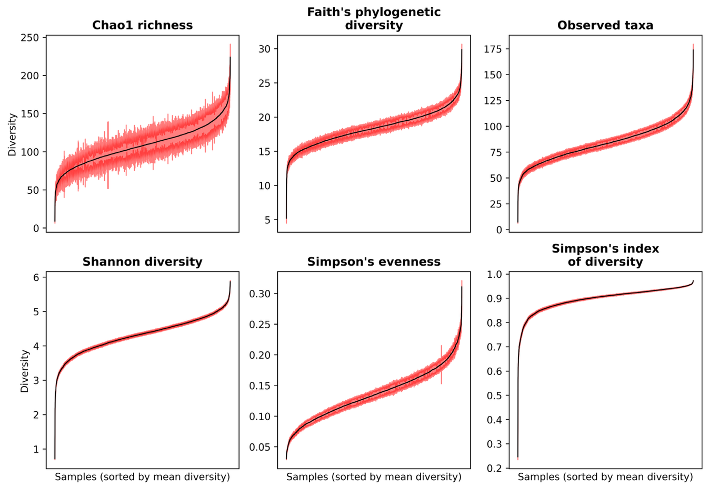
Figure S1. Effect of repeated rarefaction on alpha diversity calculations. All samples were rarefied to 2000 sequences n=100 times. Each plot here shows the mean while the shaded area shows the standard deviation for each sample. All other figures show only the mean for each sample.

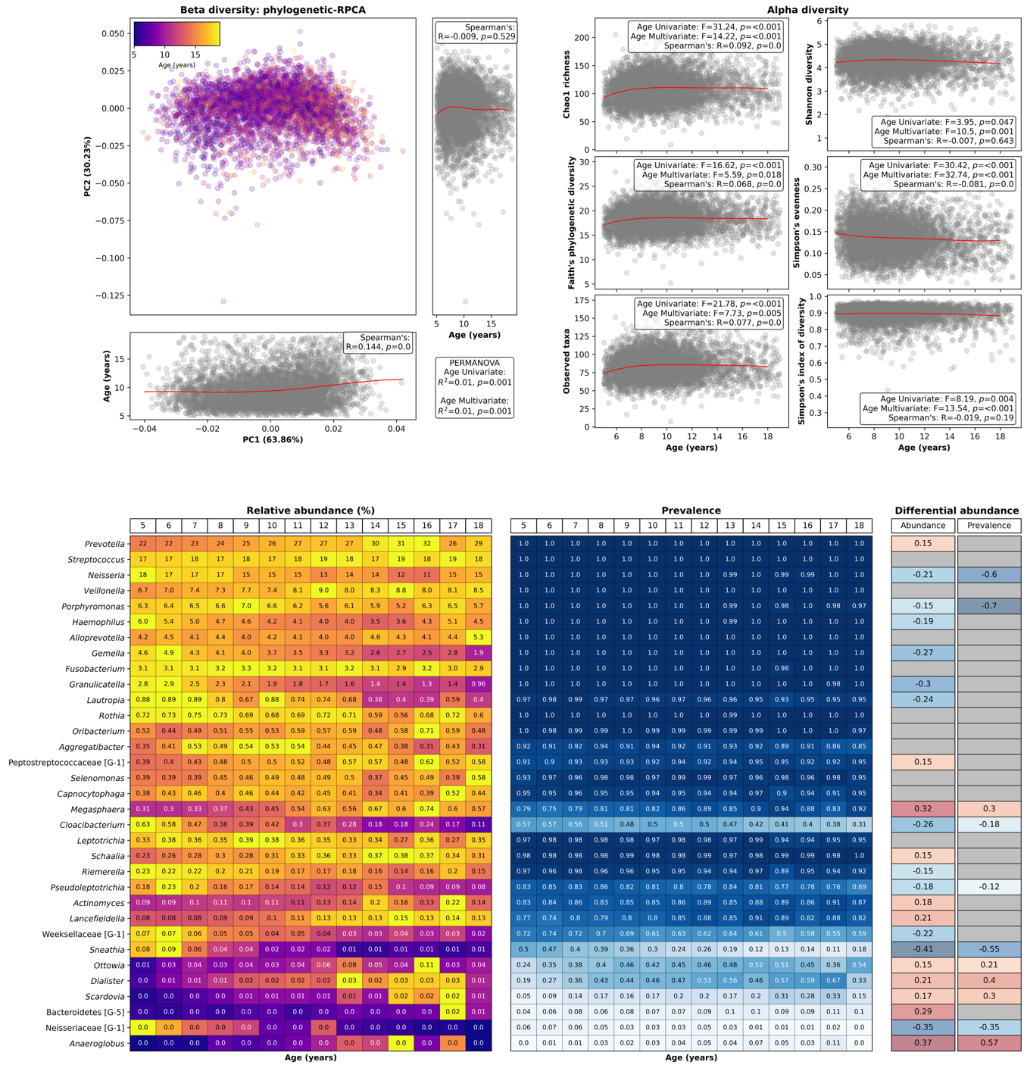
Figure S2. Association between age and the salivary microbiome in children and adolescents. (Top left) Phylogenetic-Robust Principal Component Analysis (RPCA) representing beta diversity between all participants, with each participant coloured by age, with the plots on the bottom and right showing each of the Principal Components (PCs) with age. Red lines showed the least squares regression lines for all samples. (Top right) six different alpha diversity metrics (y-axis) plotted against age (x-axis), with the red line again showing the least squares regression lines for all samples. Statistics values shown on the top left and top right are for uni- and multivariate PERMANOVA and ANOVA tests, respectively, along with Spearman’s correlations between each metric and age. (Bottom) Relative abundance (%), prevalence and differential abundance for genera that were either within the 20 most abundant genera overall (by mean abundance) or that were significantly differentially abundant with age (MaAsLin3 q ≤ 0.1). The left plot shows relative abundance with the cells being coloured by the proportion of the maximum abundance within each genus, with values being the mean within each age group (yellow being the most abundant and dark blue being the least abundant). The middle plot shows prevalence within each age group, with dark blue indicating high prevalence and white indicating low prevalence. The right plot shows coefficients for each genus with abundance or prevalence, with red colours indicating a positive association (i.e., higher with increasing age) and blue colours indicating a negative association (i.e., lower with increasing age). Coefficients are only shown for genera that were significantly differentially abundant (q ≤ 0.1).

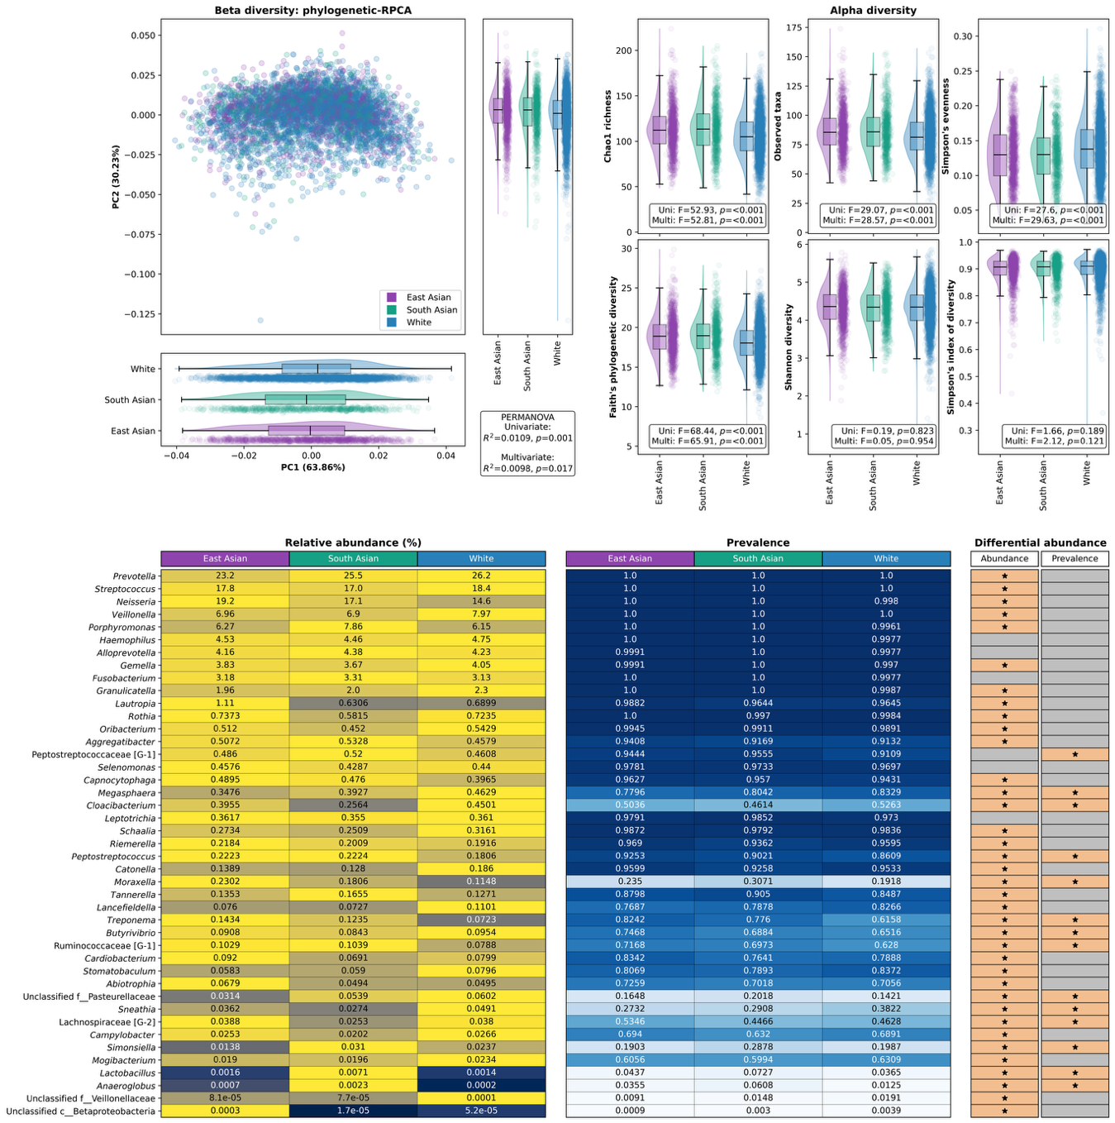
Figure S3. Association between ethnicity and the salivary microbiome in children and adolescents. (Top left) Phylogenetic-Robust Principal Component Analysis (RPCA) representing beta diversity between all participants, with each participant coloured by ethnicity, with the plots on the bottom and right showing each of the Principal Components (PCs) with ethnicity. (Top right) six different alpha diversity metrics (y-axis) plotted against ethnicity (x-axis). Box plots represent the interquartile range (IQR) and the line represents the median while whiskers represent the 1.5 x the IQR added to the third quartile or subtracted from the first quartile. Shaded areas indicate violin plots and each point represents a participant. Statistics values shown on the top left and top right are for uni- and multivariate PERMANOVA and ANOVA tests, respectively. (Bottom) Relative abundance (%), prevalence and differential abundance for genera that were either within the 20 most abundant genera overall (by mean abundance) or that were significantly differentially abundant with ethnicity (MaAsLin3 q ≤ 0.1). The left plot shows relative abundance with the cells being coloured by the proportion of the maximum abundance within each genus, with values being the mean within each ethnicity group (yellow being the most abundant and dark blue being the least abundant). The middle plot shows prevalence within each ethnicity group, with dark blue indicating high prevalence and white indicating low prevalence. The right plot shows whether each genus was significantly associated with abundance or prevalence. No reference group was used for differential abundance tests and there are therefore no coefficients associated with ethnicity. Cells are coloured and have a star for genera that were significantly differentially abundant (q ≤ 0.1).

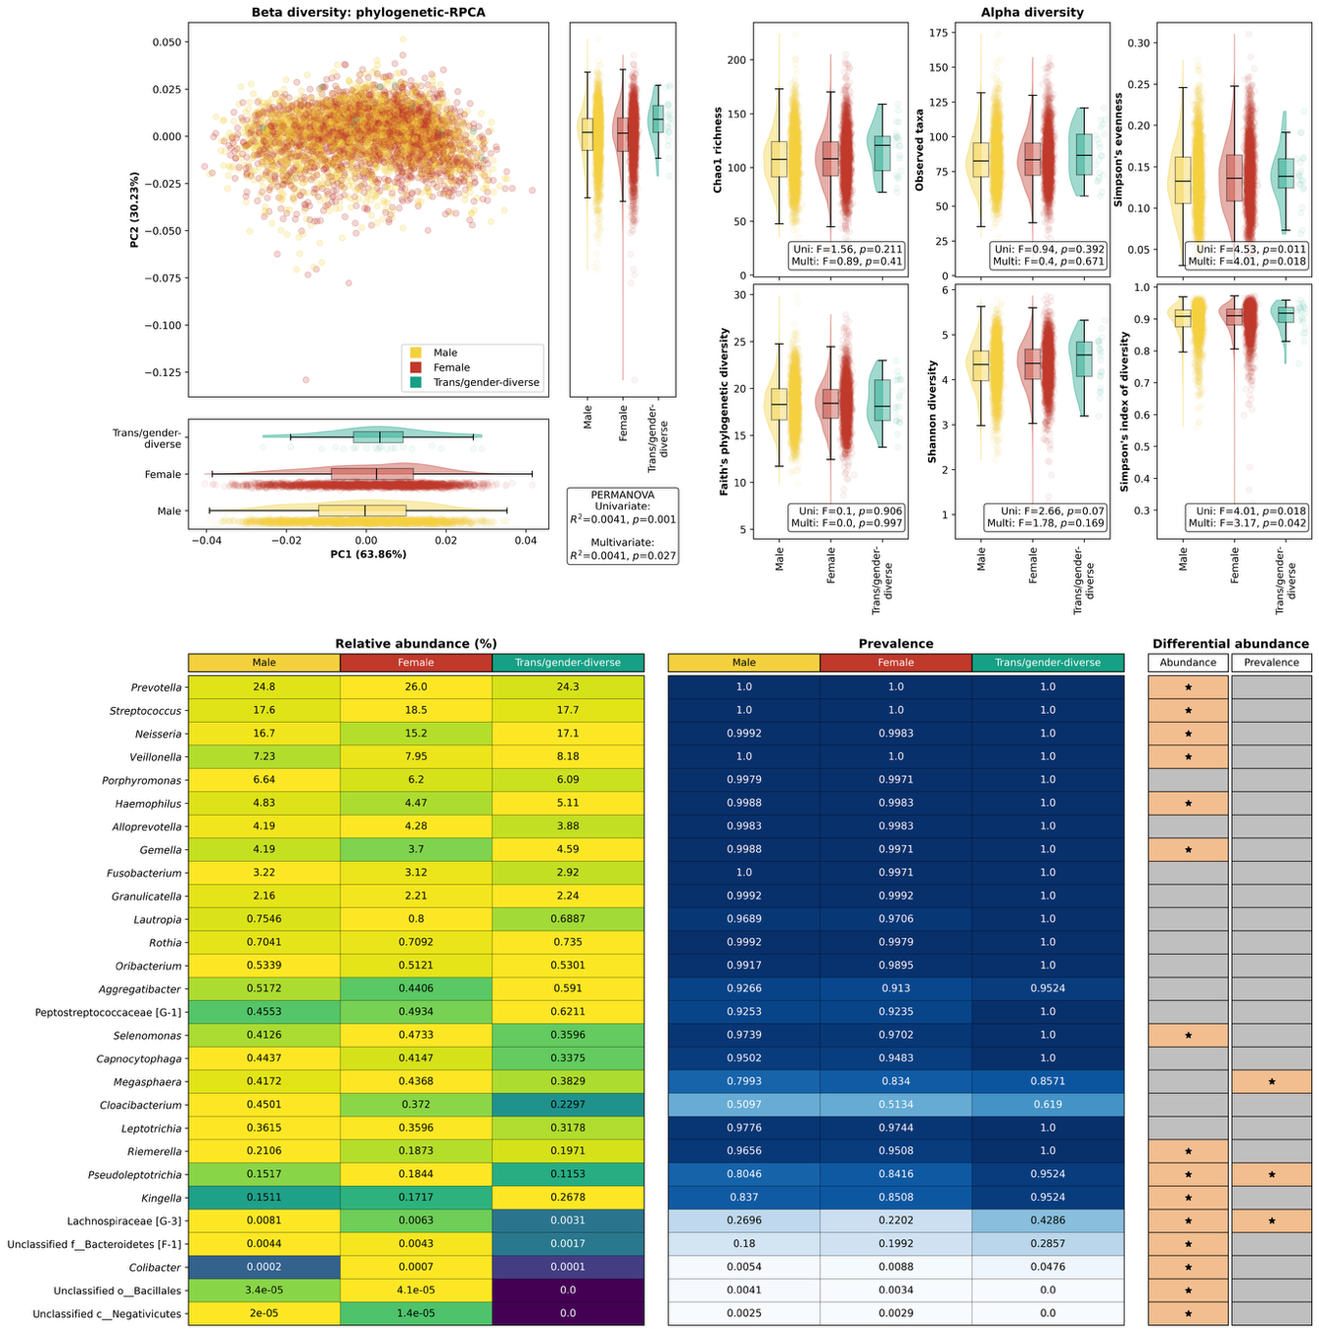
Figure S4. Association between gender and the salivary microbiome in children and adolescents. (Top left) Phylogenetic-Robust Principal Component Analysis (RPCA) representing beta diversity between all participants, with each participant coloured by gender, with the plots on the bottom and right showing each of the Principal Components (PCs) with gender. (Top right) six different alpha diversity metrics (y-axis) plotted against gender (x-axis). Box plots represent the interquartile range (IQR) and the line represents the median while whiskers represent the 1.5 x the IQR added to the third quartile or subtracted from the first quartile. Shaded areas indicate violin plots and each point represents a participant. Statistics values shown on the top left and top right are for uni- and multivariate PERMANOVA and ANOVA tests, respectively. (Bottom) Relative abundance (%), prevalence and differential abundance for genera that were either within the 20 most abundant genera overall (by mean abundance) or that were significantly differentially abundant with gender (MaAsLin3 q ≤ 0.1). The left plot shows relative abundance with the cells being coloured by the proportion of the maximum abundance within each genus, with values being the mean within each gender group (yellow being the most abundant and dark blue being the least abundant). The middle plot shows prevalence within each gender group, with dark blue indicating high prevalence and white indicating low prevalence. The right plot shows whether each genus was significant associated with abundance or prevalence. No reference group was used for differential abundance tests and there are therefore no coefficients associated with ethnicity. Cells are coloured and have a star for genera that were significantly differentially abundant (q ≤ 0.1).

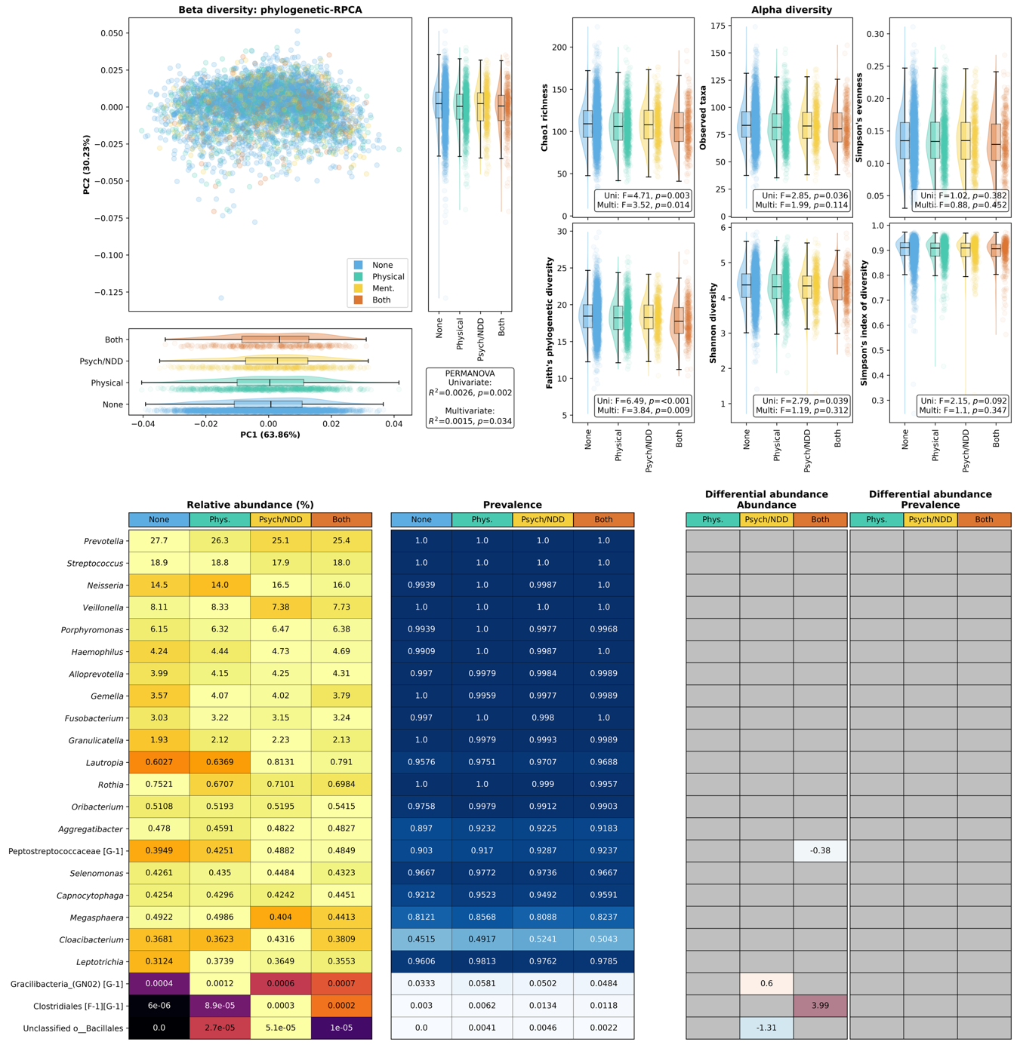
Figure S5. Association between diagnosed health conditions and the salivary microbiome in children and adolescents. (Top left) Phylogenetic-Robust Principal Component Analysis (RPCA) representing beta diversity between all participants, with each participant coloured by physical health condition or psychiatric/neurodevelopmental disorder (Psych/NDD), with the plots on the bottom and right showing each of the Principal Components (PCs) with the diagnosed health conditions. (Top right) six different alpha diversity metrics (y-axis) plotted against diagnosed health conditions (x-axis). Box plots represent the interquartile range (IQR) and the line represents the median while whiskers represent the 1.5 x the IQR added to the third quartile or subtracted from the first quartile. Shaded areas indicate violin plots and each point represents a participant. Statistics values shown on the top left and top right are for uni- and multivariate PERMANOVA and ANOVA tests, respectively. (Bottom) Relative abundance (%), prevalence and differential abundance for genera that were either within the 20 most abundant genera overall (by mean abundance) or that were significantly differentially abundant between those with no diagnosed condition and those with a physical health condition, a psychiatric/neurodevelopmental disorder, or both physical health conditions and psychiatric/neurodevelopmental disorders (MaAsLin3 q ≤ 0.1). The left plot shows relative abundance with the cells being coloured by the proportion of the maximum abundance within each genus, with values being the mean within each health condition group (yellow being the most abundant and black being the least abundant). The middle plot shows prevalence within each health condition group, with dark blue indicating high prevalence and white indicating low prevalence. The right plot shows coefficients for each genus with abundance or prevalence, with red colours indicating a positive association (i.e., higher in those with no condition) and blue colours indicating a negative association (i.e., lower in those with no condition). No diagnosed condition was the reference group for all differential abundance tests. Coefficients are only shown for genera that were significantly differentially abundant (q ≤ 0.1).

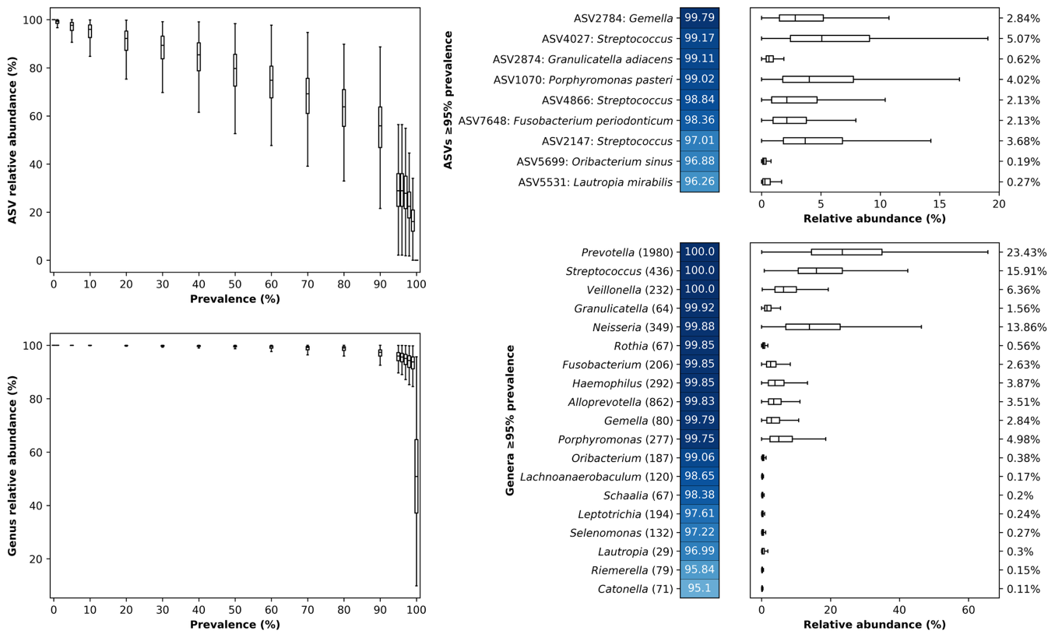
Figure S6. Prevalence of ASVs and genera within children and adolescents. (Left) Relative abundance remaining (y-axis) within samples when ASVs (top) or genera (bottom) below different prevalence thresholds (x-axis) are removed. (Right) Prevalence and relative abundance of all ASVs (top) or genera (bottom) that are present in ≥95% participants. Box plots represent the interquartile range (IQR) and the line represents the median while whiskers represent the 1.5 x the IQR added to the third quartile or subtracted from the first quartile. Values on the right are the median relative abundance for each ASV/genus. Numbers in brackets next to genus names indicate the number of ASVs within each genus.

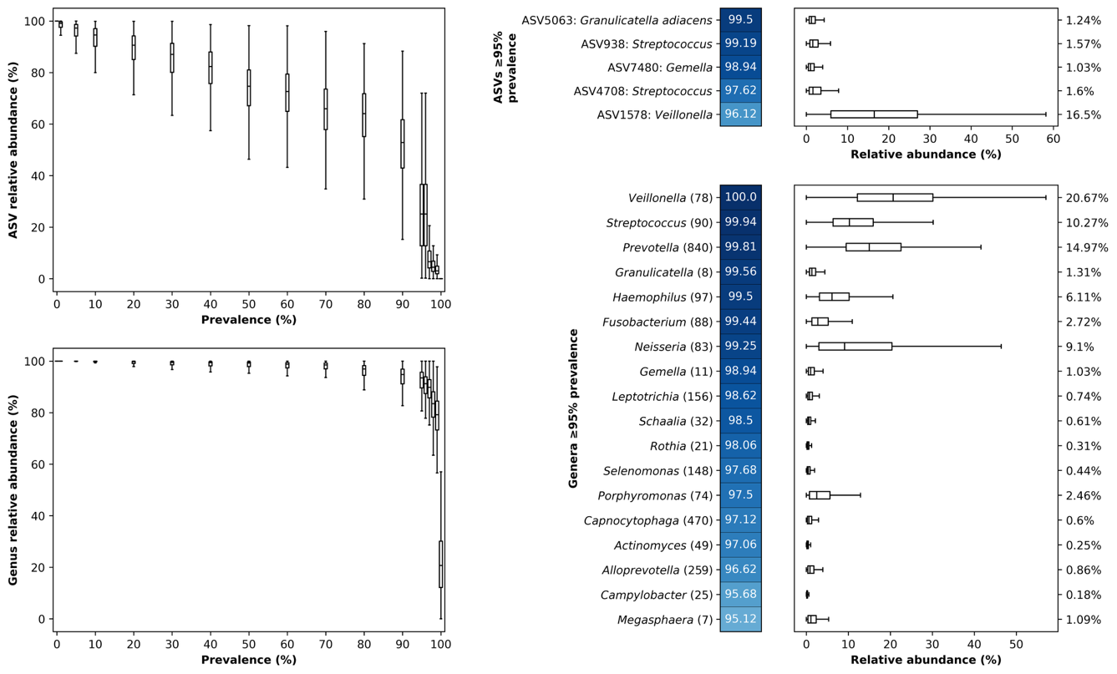
Figure S7. Prevalence of ASVs and genera within adults from the Atlantic PATH cohort. (Left) Relative abundance remaining (y-axis) within samples when ASVs (top) or genera (bottom) below different prevalence thresholds (x-axis) are removed. (Right) Prevalence and relative abundance of all ASVs (top) or genera (bottom) that are present in ≥95% participants. Box plots represent the interquartile range (IQR) and the line represents the median while whiskers represent the 1.5 x the IQR added to the third quartile or subtracted from the first quartile. Values on the right are the median relative abundance for each ASV/genus. Note that ASV numbers here are not the same as in Fig. S6. Numbers in brackets next to genus names indicate the number of ASVs within each genus.

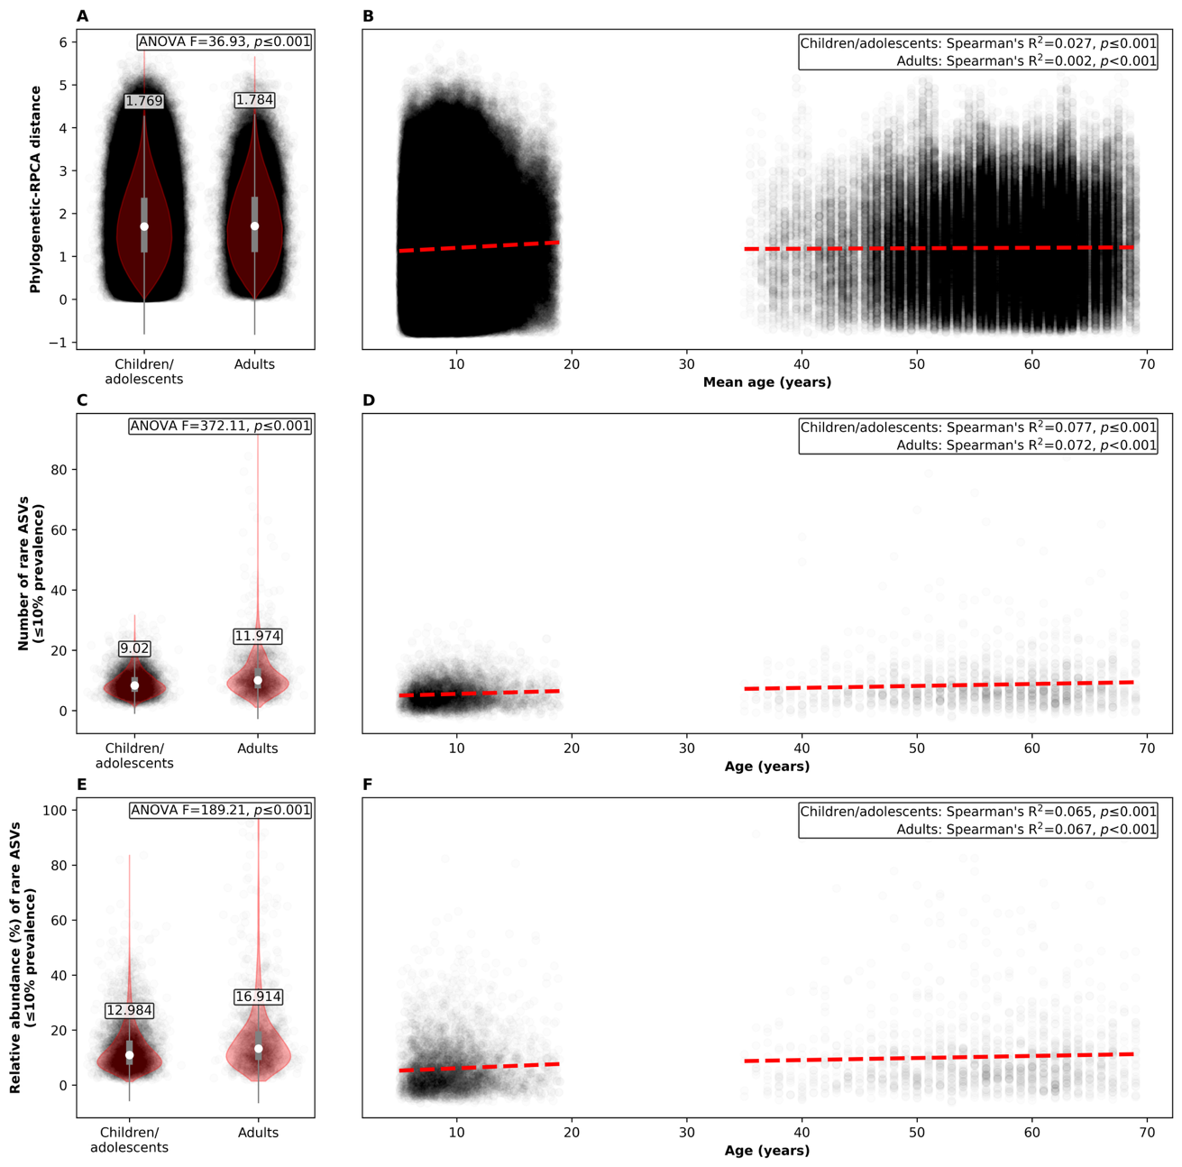
Figure S8. Children have more consistent oral microbiomes than adults. (A) and (B) show phylogenetic-RPCA distances between all pairs of participants that are ≤1 year apart in age, (C) and (D) show the number of rare ASVs (≤10% prevalence) in all participants, and (E) and (F) show the total relative abundance of rare ASVs (≤10% prevalence) in all participants. (A), (C) and (E) show participants grouped to children/adolescents (Spit for Science cohort) and adults (Atlantic PATH cohort), with violin plots showing the distribution of data, grey lines indicating the interquartile range, and white points and text showing the mean for each group. (B), (D) and (F) show distances, number of ASVs, or relative abundance of ASVs on a continuous scale, with the x-axis representing the mean age (B) or age (D and F) in years. In (A) and (B) points represent a pair or participants while in all other subplots each point represents a participant.

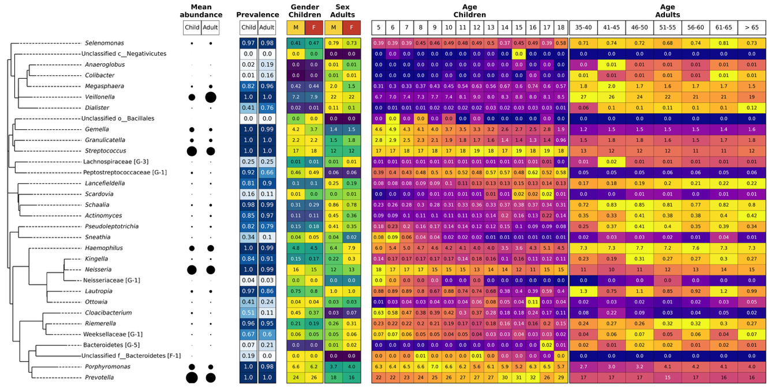
Figure S9. Abundance and prevalence within children and adolescents compared with adults for all genera that are significantly differentially abundant with age or gender in children. From left to right, subplots show a phylogenetic tree, genus name, mean relative abundance within children/adolescents and adults, prevalence within children/adolescents and adults, and heatmaps showing mean relative abundance within children/adolescents and adults grouped by gender/sex (male [M], female [F]; Atlantic PATH did not collect information on gender from the adults at baseline), and age rounded down to a whole number for children/adolescents, or within five-year groupings for adults. Circles in the mean abundance column are scaled to represent the mean abundance of that genus, with larger circles representing higher relative abundance. For the prevalence heatmap, lighter colours indicate lower prevalence while darker colours indicate higher prevalence. For the relative abundance heatmaps, lighter colours represent higher values while darker colours represent lower values; colours are scaled within age/gender groups for each genus. For both prevalence and relative abundance, all values are shown within cells.

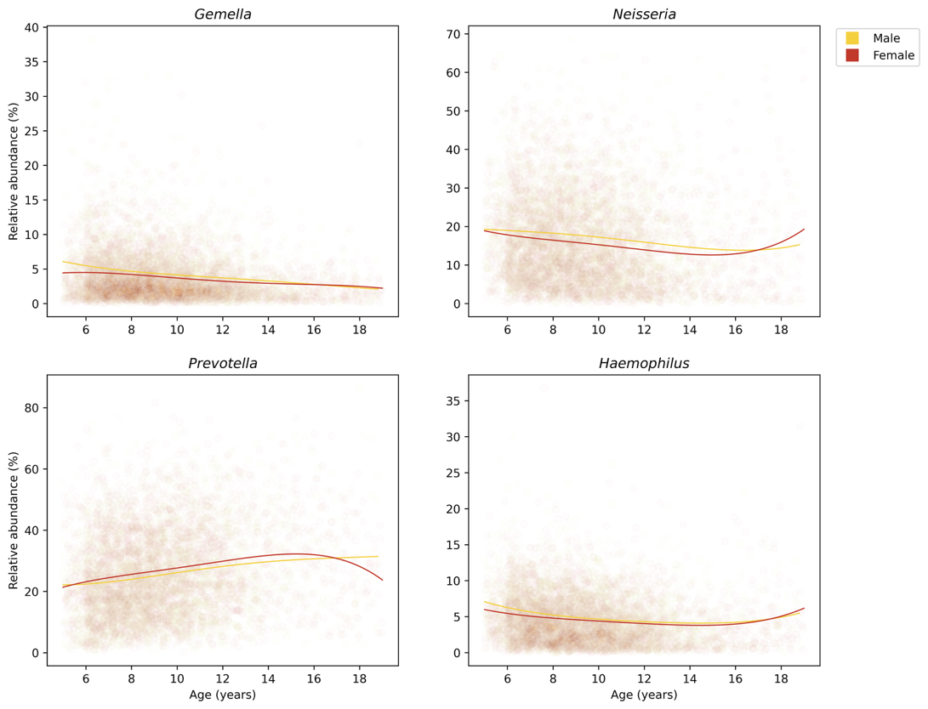
Figure S10. Association between age and gender for four abundant genera that were significantly differentially abundant with both age and gender. Plots show the relative abundance of each genus (y-axis) plotted against age (x-axis) with individual points showing participants and lines showing the least squares regression for males (yellow) or females (red).

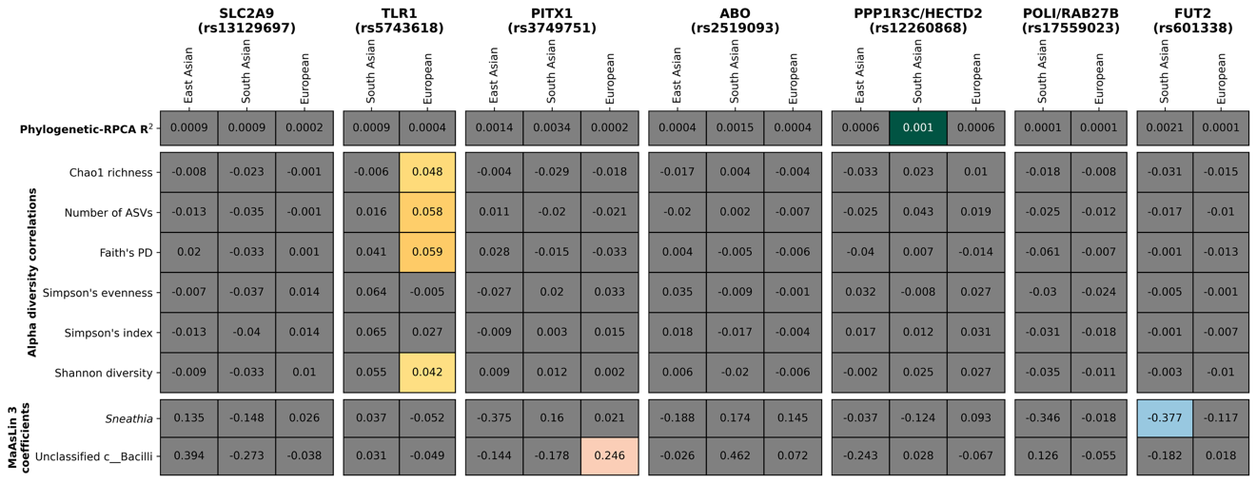
Figure S11. Associations between alternate alleles at seven human genome loci and beta diversity, alpha diversity, or the abundance of genera. Association with: phylogenetic-RPCA distances (beta diversity) showing R² values in cells (top); alpha diversity metrics, showing Spearman’s correlation values in cells (middle); and the abundance of genera, showing MaAsLin 3 coefficients in cells (bottom). Significant associations (PERMANOVA/ANOVA p ≤ 0.05 or MaAsLin 3 q ≤ 0.1) are indicated with coloured cells. Values for all statistical tests are shown in Table S7.

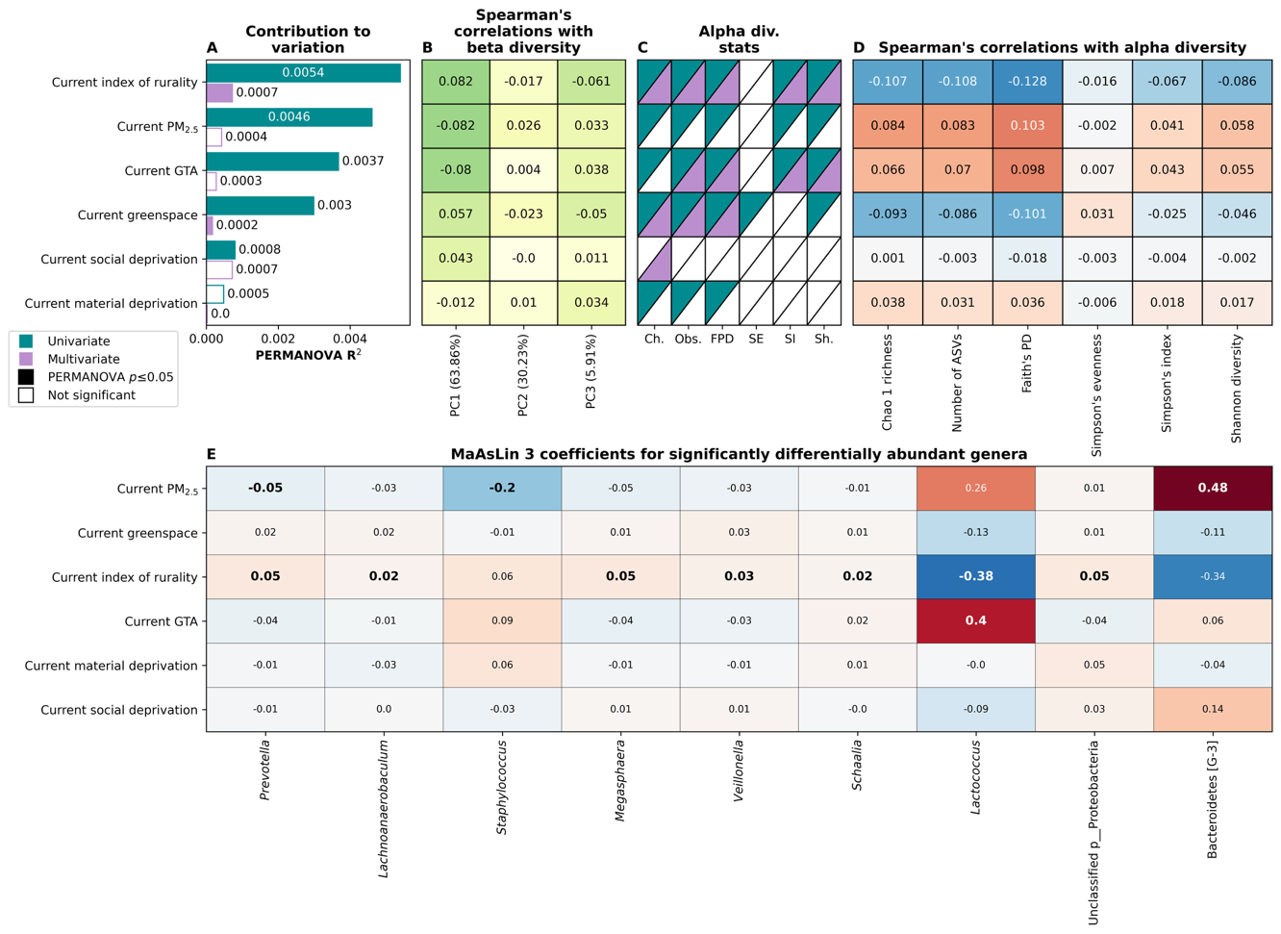
Figure S12. Association between current marginalisation, environmental characteristics and the oral microbiome in children and adolescents (n=4,178). Contribution to beta diversity variation (A) and Spearman’s correlation with beta diversity (B) represented by phylogenetic RPCA diversity on PC1, PC2 and PC3. For each PC, the variation represented by it is shown in the labels. Alpha diversity statistical test results (C) and Spearman’s correlation with alpha diversity metrics (D). Coefficients obtained for significant (q ≤ 0.1) associations between genus abundance and the shown metrics obtained using MaAsLin 3 (E). Marginalisation and environmental variables for the participants’ current postal code are used and are sorted by PERMANOVA multivariate R² effect size in (A)-(D). In (A) and (C), univariate and multivariate statistical test results are shown in blue or purple, respectively, and filled bars/boxes represent significant p-values. Multivariate tests included age, gender, ethnicity and diagnosed health condition as well as all variables shown here; see Methods section for full details on how statistical tests were carried out. In (B) higher absolute correlations (darker green) represent higher associations with each PC, while in (D) and (E), higher (darker red) or lower (darker blue) values represent positive or negative associations, respectively. In (E) significant (q ≤ 0.1) coefficients are shown with bold text.

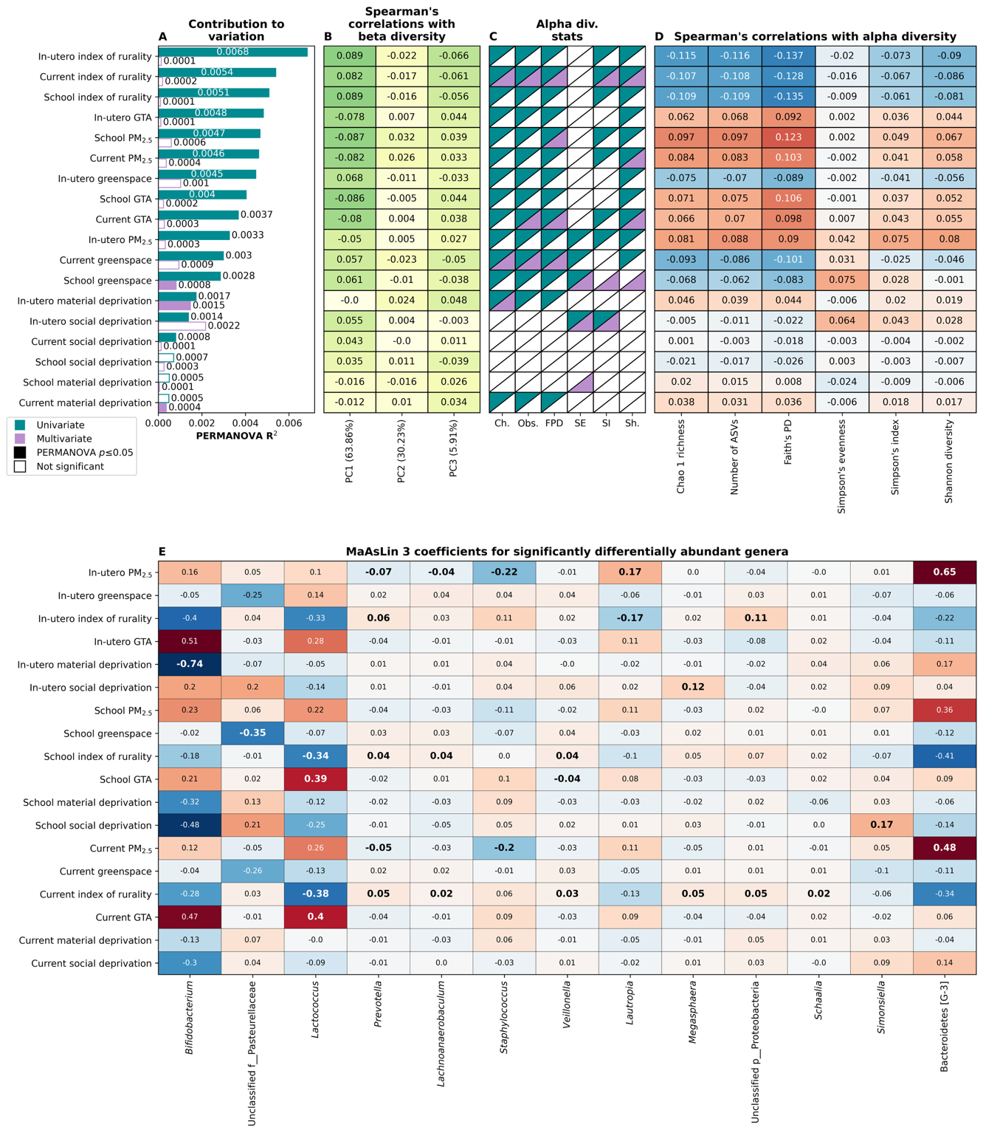
Figure S13. Association between marginalisation, environmental characteristics and the oral microbiome in children and adolescents for their current, school, and in-utero postal codes (n=2,571). Contribution to beta diversity variation (A) and Spearman’s correlation with beta diversity (B) represented by phylogenetic RPCA diversity on PC1, PC2 and PC3. For each PC, the variation represented by it is shown in the labels. Alpha diversity statistical test results (C) and Spearman’s correlation with alpha diversity metrics (D). Coefficients obtained for significant (q ≤ 0.1) associations between genus abundance and the shown metrics obtained using MaAsLin 3 (E). Marginalisation and environmental variables for the participants’ current, school, and in-utero postal codes are used and are sorted by PERMANOVA multivariate R² effect size in (A)-(D). In (A) and (C), univariate and multivariate statistical test results are shown in blue or purple, respectively, and filled bars/boxes represent significant p-values. Multivariate tests included age, gender, ethnicity and diagnosed health condition as well as all variables shown here; see Methods section for full details on how statistical tests were carried out. In (B) higher absolute correlations (darker green) represent higher associations with each PC, while in (D) and (E), higher (darker red) or lower (darker blue) values represent positive or negative associations, respectively. In (E) significant (q ≤ 0.1) coefficients are shown with bold text.

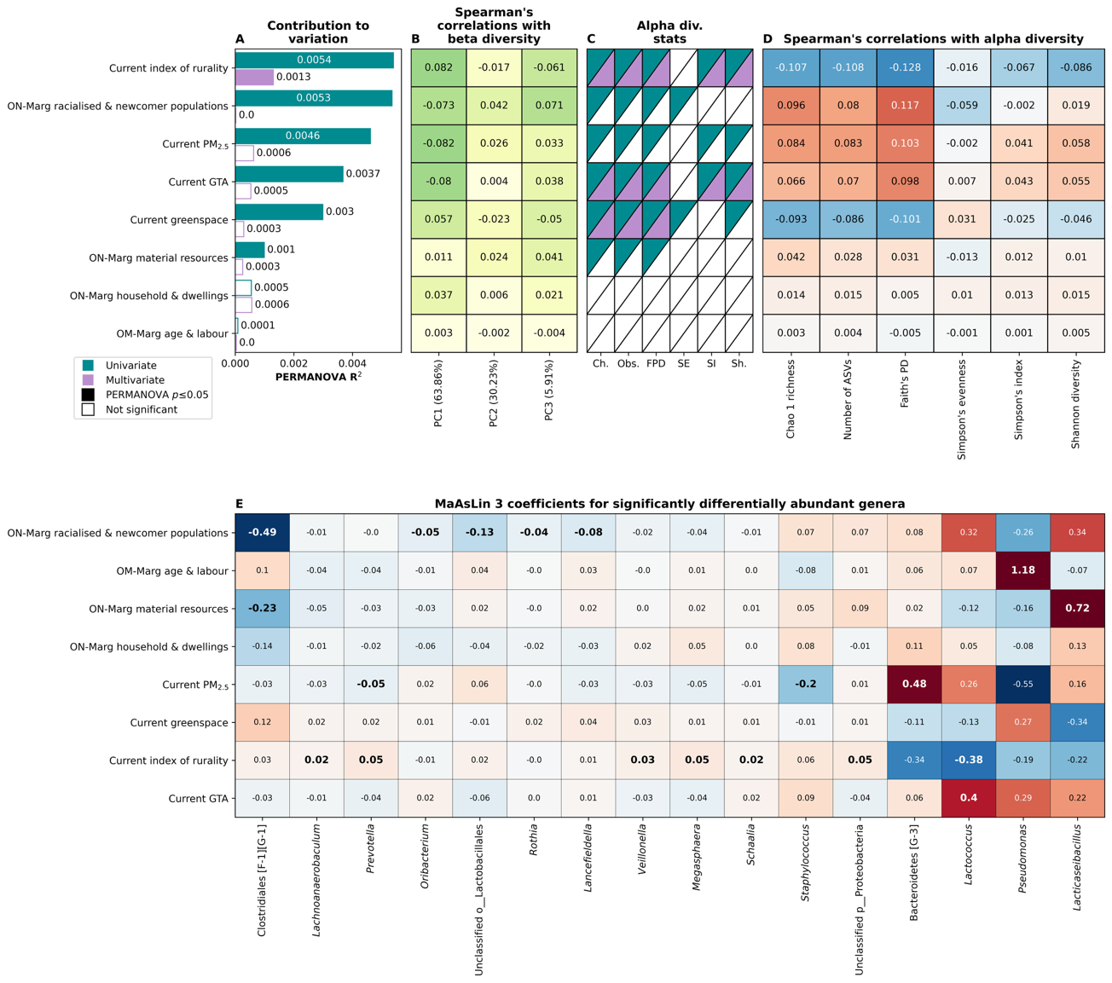
Figure S14. Association between ON-Marg marginalisation indices, environmental characteristics and the oral microbiome in children and adolescents for their current postal codes (n=3,776). Contribution to beta diversity variation (A) and Spearman’s correlation with beta diversity (B) represented by phylogenetic RPCA diversity on PC1, PC2 and PC3. For each PC, the variation represented by it is shown in the labels. Alpha diversity statistical test results (C) and Spearman’s correlation with alpha diversity metrics (D). Coefficients obtained for significant (q ≤ 0.1) associations between genus abundance and the shown metrics obtained using MaAsLin 3 (E). ON-Marg marginalisation indices and environmental variables for the participants’ postal codes are used and are sorted by PERMANOVA multivariate R² effect size in (A)-(D). In (A) and (C), univariate and multivariate statistical test results are shown in blue or purple, respectively, and filled bars/boxes represent significant p-values. Multivariate tests included age, gender, ethnicity and diagnosed health condition as well as all variables shown here; see Methods section for full details on how statistical tests were carried out. In (B) higher absolute correlations (darker green) represent higher associations with each PC, while in (D) and (E), higher (darker red) or lower (darker blue) values represent positive or negative associations, respectively. In (E) significant (q ≤ 0.1) coefficients are shown with bold text.

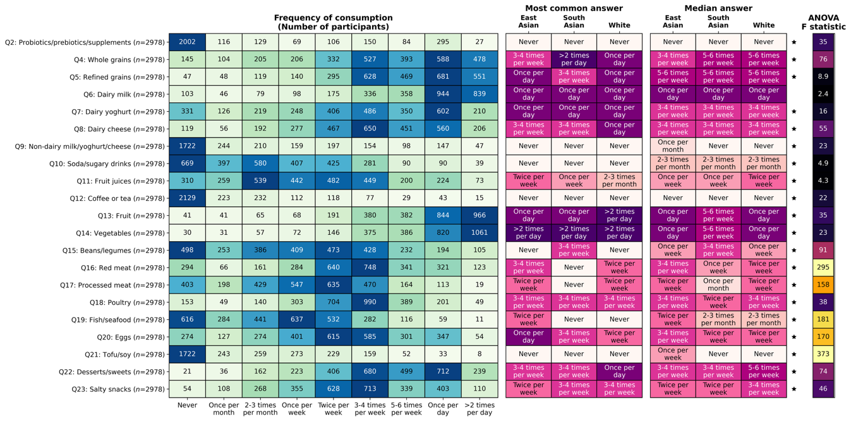
Figure S15. Frequency of consumption of different food items and the most common/median answer given by participants of different ethnicities. (Left) Summary of the frequency with which all food items are consumed by participants, with the numbers in cells indicating the number of participants that gave this answer. (Right) Most common or median answer given by participants of different ethnicities. Significant (p ≤ 0.05) ANOVA test results are denoted with a star and ANOVA test statistics are shown on the far right. All ANOVA tests included age, gender, ethnicity, and diagnosed health condition as well as family ID.

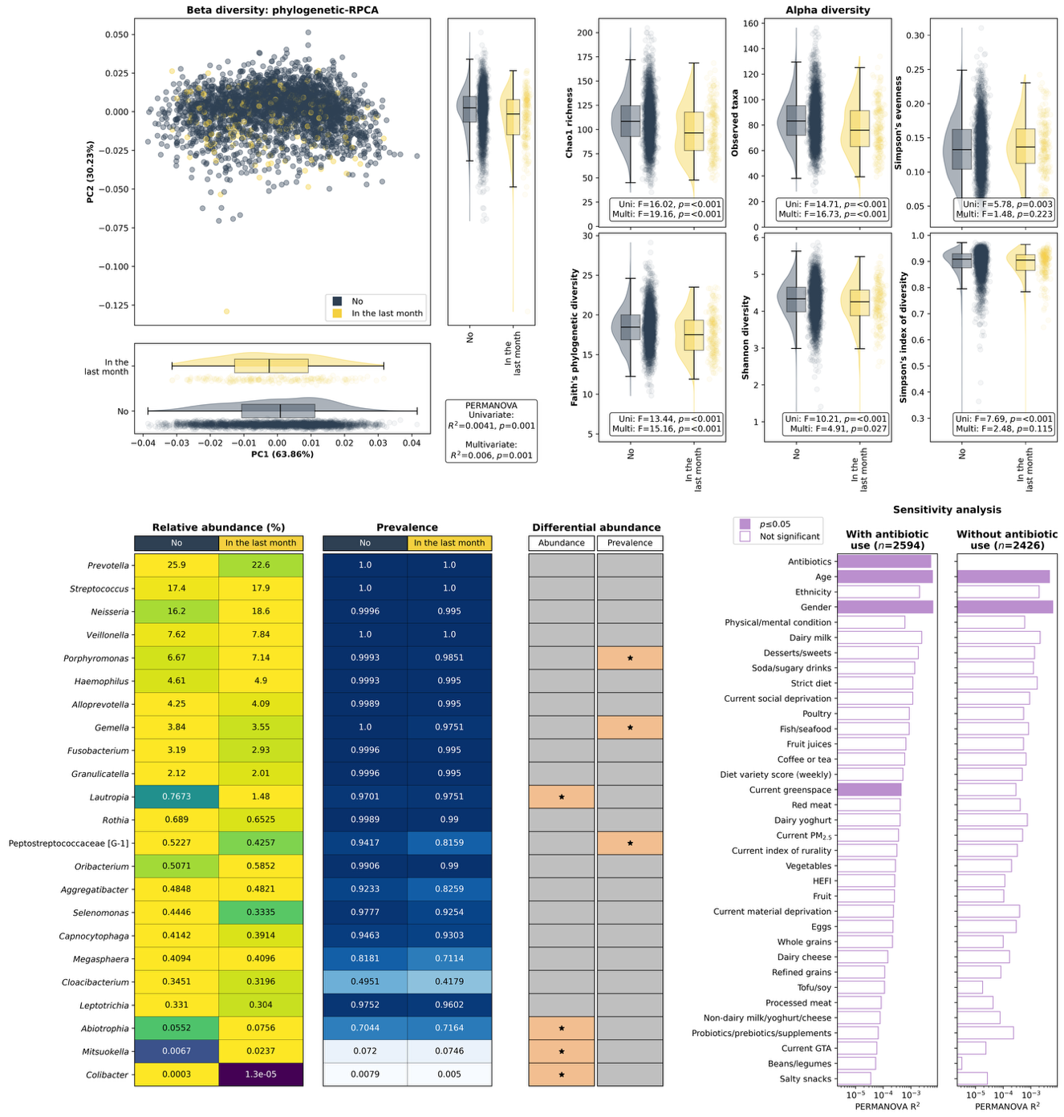
Figure S16. Association between antibiotic use and the salivary microbiome in children and adolescents. (Top left) Phylogenetic-Robust Principal Component Analysis (RPCA) representing beta diversity between all participants, with each participant coloured by whether they have taken antibiotics within the last month or not, with the plots on the bottom and right showing each of the Principal Components (PCs) with antibiotic use. (Top right) six different alpha diversity metrics (y-axis) plotted against antibiotic use (x-axis). Box plots represent the interquartile range (IQR) and the line represents the median while whiskers represent the 1.5 x the IQR added to the third quartile or subtracted from the first quartile. Shaded areas indicate violin plots and each point represents a participant. Statistics values shown on the top left and top right are for uni- and multivariate PERMANOVA and ANOVA tests, respectively. (Bottom left) Relative abundance (%), prevalence and differential abundance for genera that were either within the 20 most abundant genera overall (by mean abundance) or that were significantly differentially abundant with antibiotic use (MaAsLin3 q ≤ 0.1). The left plot shows relative abundance with the cells being coloured by the proportion of the maximum abundance within each genus, with values being the mean within each antibiotic use group (yellow being the most abundant and dark blue being the least abundant). The middle plot shows prevalence within each antibiotic use group, with dark blue indicating high prevalence and white indicating low prevalence. The right plot shows whether each genus was significant associated with abundance or prevalence. Cells are coloured and have a star for genera that were significantly differentially abundant (q ≤ 0.1). (Bottom right) Sensitivity analysis showing PERMANOVA R² values and significance for all participants that have information for all metadata variables with (n=2598) or without (n=2429) those that have taken antibiotics within the last month. Filled bars indicate significant p-values (p ≤ 0.05) and all R² values shown are for multivariate analyses including all variables. Note that the x-axis here is on a log scale.

