Supplementary Appendix
Procoagulant platelets in antiphospholipid syndrome

Jan Zlamal, Günalp Uzun, Andreas Witzemann, Carolin Schnaidt, Nadja Risio, Sebastian Hörber, Irene Gonzalez-Menendez, Karina Althaus, Anika Cappenberg, Oliver Borst, Helene Häberle, Peter Rosenberger, Stephan Singer, Markus W. Löffler, Leticia Qunitanilla-Martinez, Johannes Oldenburg, Heiko Rühl and Tamam Bakchoul

Table of Content
Methods 2
Laboratory testing of antiphospholipid antibodies 2
Serum-/IgG-induced procoagulant platelet (PCP) formation 2
PF4 antibody serology and PF4-Induced platelet activation assay 3
Immunoglobulin G isolation 4
Thrombin generation assay 5
Animal model of antibody-mediated platelet disorders 6
Histological examination 7
In vitro model of immunothrombosis 7
Preparation of washed platelets 8
Platelet neurophil aggregates 8
Neutrophil extracellular trap (NET) formation 9
Quantification of myeloperoxidase-DNA complexes 10
Molecular mechanisms of APS-induced procoagulant platelet formation 10
Platelet intracellular calcium assay 11
Platelet-associated IgG assay 11
F(ab′)₂ preparation from IVIG 12
Platelet IgG binding competition assay 12
Statistics 13
Results 14
Table S1. Characteristics of APS patients with and without recurrent thrombotic events 14
Table S2.Characteristics of APS patients with and without serum-induced PCP formation 15
Supplementary Figure 1. 16
Supplementary Figure 2. 17
Supplementary Figure 3. 19
Supplementary Figure 4. 20
Supplementary Figure 5. 21
Supplementary Figure 6. 22
Supplementary Figure 7. 23
Supplementary Figure 8. 24
References 25

Methods

Laboratory testing of antiphospholipid antibodies
Serological testing for immunoglobulin G (IgG) and immunoglobulin M anti-cardiolipin and anti-beta-2-glycoprotein I (β2GPI) antibodies, respectively, as well as functional lupus anticoagulant testing, was performed in the central laboratory at the University Hospital Tübingen as well as in the diagnostic laboratory at the Institute of Experimental Hematology and Transfusion Medicine in Bonn. Both laboratories are accredited by the German national accreditation body (Deutsche Akkreditierungsstelle GmbH; DAkkS). Serological assays followed the current International Society on Thrombosis and Haemostasis (ISTH) Scientific and Standardization Committee (SSC) recommendations for antiphospholipid antibody testing¹, and lupus anticoagulant (LA) testing was performed according to the updated ISTH SSC guidance for LA detection.² Serum samples used for experimental analyses were aliquoted, frozen at -80 °C, and centrally stored at Tübingen. Prior to the described experimental procedures, sera were thawed and heat-inactivated at 56°C for 30 minutes (min), followed by centrifugation at 5000g. Supernatants were used for all experimental procedures.

Serum-/IgG-induced procoagulant platelet (PCP) formation
A flow cytometry (FC)-based protocol was used to investigate the impact of antiphospholipid syndrome (APS) antibodies on platelets. Briefly, fresh whole blood from healthy donors was drawn into sodium-citrate containing tubes by cubital venipuncture (S-Monovette® Citrate 9NC; SARSTEDT, Nümbrecht, Germany) and allowed to rest for 30 min at RT. Following centrifugation (120g, 20 min, RT, w/o brake), platelet-rich-plasma (PRP) was gently separated and 37.5 µL (11.25 x 10⁶ platelets) of PRP were incubated with 5 µL heat-inactivated serum from APS patients, non-APS patients or healthy controls and incubated for 1 hour under rotation at RT. Afterwards, 5 µL of the platelet suspension were transferred into a final volume of 100 µL Hanks´ balanced salt solution (HBSS) with Ca²⁺/Mg²⁺ ions (Carl Roth, Karlsruhe, Germany). The cell suspension was then incubated with anti-CD62p-APC (BD Biosciences, Milpitas, USA) and Annexin-V-FITC (Immunotools, Friesoythe, Germany) for 15 min at RT in the dark. Afterwards, platelets were resuspended with HBSS to a final volume of 500 μL and immediately assessed via FC (Navios, Beckman-Coulter, Brea, USA). Platelets were gated based on their characteristic forward and side scatter properties. Procoagulant platelets were defined as CD62p and Annexin-V double positive events. Platelets that were treated with thrombin receptor activating peptide-6 (TRAP-6, 10µM; Sigma-Aldrich, St. Louis, USA) and Convulxin (0.1 μg/mL, Enzo Life Sciences, Lörrach, Germany) served as a positive control.

PF4 antibody serology and PF4-Induced platelet activation assay
Patient sera were tested for anti-PF4 antibodies using an in-house PF4 enzyme-linked immunosorbent assay (PF4-EIA). In brief, PF4 (25 μg/mL, Chromatec, Greifswald, Germany) was incubated in carbonate coating buffer at 4°C, overnight in a 96 well microtitre plate (Nunc MaxiSorp™, Langenselbold, Germany). Then, plates were washed three times with PBS/Tween buffer (0.05 % Tween 20 in PBS) before blocking with 3% bovine serum albumin (BSA) for 2h, or overnight. Plates were again washed three times and incubated with patient sera (1 h, diluted 1:50 in PBS/Tween buffer). After further washing three times, plates were incubated (RT, 1 h) with 1:1000 diluted peroxidase-conjugated anti-human IgG (Jackson ImmunoResearch Laboratories Inc, USA). After five times washing, plates were incubated ( 6 min, dark) with substrate tetramethylbenzidine (TMB one, Kementec, Denmark). The reaction was stopped with H₂SO₄, and the absorbance was measured at 450 nm with a Tecan microplate reader and analyzed using Magellan software (Tecan GmbH, Crailsheim, Germany).
For the PF4-Induced Platelet Activation Assay (PIPA), washed platelets from four healthy donors were pre-incubated with PF4 for 10 min at RT (50 μg/mL; ChromaTec GmbH, Greifswald, Germany). Then, 20 μL of patient serum and 75 μL of washed platelets (300 × 10³ platelets/μL) were added to microtiter wells. Spherical stir bars were added to the microtiter well and stirred at 500 revolutions per minute (rpm). Wells were examined for loss of turbidity in five-minute intervals. A serum was deemed reactive (positive) if a shift from turbidity to transparency occurred within 30 min in at least two platelet suspensions. Sera of vaccine-induced thrombotic thrombocytopenia (VITT) patients served as positive controls. The observation period was 45 min. All patient sera were heat-inactivated at 56 °C for 30 min before testing.

Immunoglobulin G isolation
IgG fractions from APS patients or controls were isolated using a commercially available IgG-purification-kit (Melon Gel IgG Spin Purification Kit; Thermo Fisher Scientific, Waltham, USA) according to manufacturer’s instructions. IgG concentrations were measured using a spectrophotometer at an excitation wavelength of 280 nm (NanoDrop One; Thermo Fisher Scientific, Waltham, USA).

Thrombin generation assay
The ability of APS sera to induce thrombin generation (TG) on the platelet surface was tested via Calibrated Automated Thrombogram (CAT system; Stago, Maastricht, Netherlands) according to the manufacturer’s instructions. Briefly, venous blood was withdrawn from healthy individuals into citrate-anticoagulant tubes (S-Monovette® Citrate 9NC; SARSTEDT, Nümbrecht, Germany) and allowed to rest for 20 min at RT. PRP was prepared by centrifugation (20 min, 120g, RT, w/o brake) and adjusted with autologous platelet-poor plasma (PPP; 10 min, 2000g, RT) to a platelet count of 150 x 10⁹/L. Afterwards, PRP was treated with APS patient or control serum (60 min, RT, radial rotation). Samples were centrifuged (10 min, 700g, w/o brake) and the remaining platelet pellet gently resuspended in autologous PPP. 80 μL of the cell suspension were transferred into round-bottom 96 well-microtitre plates (Fluoroskan Ascent; ThermoLabsystems, Helsinki, Finland) and supplemented with 20 μL of PRP-reagent containing recombinant tissue factor (Thrombinoscope BV, Maastricht, The Netherlands). 20 μL of fluorogenic substrate and calcium (FluCa-Kit reagent; Thrombinoscope BV, Maastricht, The Netherlands) were dispensed automatically by the device into each well. Fluorescence was acquired for 60 min with a 390-nm excitation/460-nm emission filter set, and parameters were automatically calculated by dedicated software (Thrombinoscope BV, Maastricht, The Netherlands).

Animal model of antibody-mediated platelet disorders
The impact of APS antibodies on human platelets was assessed using a novel humanized mouse model based on the NOD.Cg-Prkdc^{scid} Il2rg^{tm1Wjl}/SzJ (NSG) strain (Stock No. 005557; purchased from The Jackson Laboratory Bar Harbor, USA via Charles River Laboratories). 8-16 week-old sex- and age-matched animals were used for this study. Murine platelets were depleted via intraperitoneal injection of anti-mouse GPIbα (clone R300; EMFRET Analytics, Eibelstadt Germany). Next, resting human platelets (0.4 x 10⁹ in 150 µL), prepared as previously described, were administered via lateral tail vein injection.³ After sampling blood to determine baseline values for circulating human platelets, IgG from sera of APS patients or healthy controls were injected. Periodical blood sampling was performed at 30, 120 and 240 min following IgG injection to analyse human platelet survival. After collection, samples were diluted in PBS and stained with anti-human CD41-PE-Cy5 (Beckman Coulter) and anti-mouse CD41-FITC (BD Biosciences) for 15 min at RT. A counting bead-based FC protocol was used to determine circulating human platelet counts and survival (Fluorospheres; Beckman Coulter). In indicated experiments, 1g/kg/bodyweight IVIG (Privigen; CSL Behring, Marburg, Germany) was administered i.v. 30 min post APS IgG injection. Following euthanasia, liver and lungs were harvested en-bloc and rinsed with PBS prior to fixation in 4% PBS-buffered formalin (Carl Roth, Karlsruhe, Germany). All animal experiments were approved by the University of Tübingen Animal Care and Ethics Committee (M21/21G).

Histological examination
Paraffin-embedded specimens were cut in 3-5 µm-thick sections. Staining for haematoxylin and eosin (H&E) was performed. Immunohistochemistry was performed on an automated immunostainer (Ventana Medical Systems, Oro Valley, USA), adapted from the manufacturer’s protocols for open procedures with minor modifications. All slides were stained with anti-fibrin(-ogen) antibody, recognizing fibrinogen and fibrin cleavage products (A0080, polyclonal; Agilent, Santa Clara, USA). Appropriate positive and negative controls were used. All samples were scanned with a Ventana DP200 imager (Roche, Basel, Switzerland) and processed with the Image Viewer MFC application. Final image preparation was performed with Adobe Photoshop. The histologic samples were analyzed by an experienced pathologist (L. Quintanilla-Martinez).

In vitro model of immunothrombosis
To investigate the effect of APS IgG on the coagulation cascade and subsequent thrombus formation, an ex vivo model (BioFlux 200, Fluxion Biosciences, Alameda, USA) was used as previously described.^{4,5} Different microfluidic-based experimental settings were designed to: i) asses the impact of APS antibodies on whole blood , ii) dissect the specific role of PCP on thrombus formation, and iii) analyse the inhibitory effects of several agents of interest. Blood samples were perfused through the collagen-coated microfluidic system at a shear rate of 500s⁻¹ (20 dyne) for 15 min. After perfusion, immunofluorescence and bright field images were taken (Axio observer 7; Carl Zeiss, Oberkochen, Germany) and analysed using Fiji image processing software.⁶

Preparation of washed platelets
Washed platelets were prepared from venous blood samples as previously described. Briefly, whole blood from healthy donors who showed an adequate platelet response upon platelet Fc-gamma-RIIA (FcγRIIA) crosslinking with anti-CD9 IgG (clone ALB6; Beckman-Coulter) (time to platelet aggregation <20 minutes) was drawn into acidic-citrate-dextrose (ACD) containing vacutainers (BD Biosciences) by cubital venipuncture and allowed to rest for 45 min at 37°C. After centrifugation (120g, 20 min, RT, w/o brake), PRP was gently separated and supplemented with 2.5 U/mL apyrase (Sigma-Aldrich) and 333 µL/mL pre-warmed ACD (Sigma-Aldrich, St. Louis, USA). After an additional centrifugation step (650g, 7 min, RT, w/o brake), the platelet pellet was resuspended in 5 mL wash-solution and allowed to rest for 15 min at 37°C (modified bicarbonate-based Tyrode buffer: pH adjusted to 6.3, 0.35% bovine serum albumin (BSA), 0.1% glucose (Braun, Melsungen, Germany), 2.5 U/mL apyrase, 1 U/µL hirudin (Pentapharm, Basel, Switzerland). Following a final centrifugation step (650g, 7 min, RT, w/o brake), washed platelets were resuspended and adjusted to 300 x 10⁹ platelets/L in resuspension-buffer (modified bicarbonate-based Tyrode buffer: pH adjusted to 7.2-7.4, 0.35% bovine serum albumin (BSA), 0.1% glucose, 1 mM MgCl₂, 2 mM CaCl₂).

Platelet neurophil aggregates
Neutrophils were isolated from healthy whole blood, using a negative selection kit (MACSxpress®; Miltenyi Biotec, Bergisch Gladbach, Germany) according to the manufacturers’ instructions. Unstimulated neutrophils (5 x 10⁶/mL) were coincubated with APS- or control serum-treated platelets for 15 min at RT in HBSS with Ca²⁺. Afterwards the cell suspension was stained with anti-CD41-BV421 (clone HIP8; BD Biosciences, Milpitas, USA), anti-CD45-PE-Cy5 (clone 2D1; Biozol, Eching, Germany), anti-CD16-PE (clone REA423; Miltenyi Biotec, Bergisch Gladbach, Germany), anti-CD62P-APC (clone AK4; BD Biosciences, Milpitas, USA), Annexin-V-FITC (Immunotools, Frisoythe, Germany) or isotype control for 15 min at RT and HBSS with Ca²⁺ was added to a final volume of 500 µL. Platelet-neutrophil interactions were immediately assessed by FC (DxFlex, Beckman Coulter, Brea, USA).

Neutrophil extracellular trap (NET) formation
The impact of APS serum-induced PCPs on NET formation was examined using a static cell adhesion assay. Briefly, washed platelets that had been incubated with APS or control serum (1 h, RT, radial rotation) were coincubated with neutrophils (5 × 10⁶ cells/mL) under restored calcium conditions (1.25 mM; 1 hour, 37°C). Afterwards the platelet-neutrophil suspension was spread on fibrinogen-coated coverslips (1 hour, 37°C, 100 µg/mL, Merck-Milipore, Darmstadt, Germany). After incubation, supernatants were gently removed. Adherent cells were stained with 3 µg/mL of Hoechst 33342 (Thermo Fisher Scientifc, Waltham, USA), FITC-labelled anti-human myeloperoxidase (clone REA491; Miltenyi Biotec, Bergisch Gladbach, Germany) and APC-labelled anti-CD41, clone HIP8 (Biolegend, San Diego, USA), gently washed with PBS and fixed with 1% paraformaldehyde for 15 min at RT (Morphisto, Offenbach am Main, Germany). Following washing with PBS, samples were covered with mounting medium (Ibidi, Martinsried, Germany), which was followed by immunofluorescence microscopy analysis. Images were taken from 3-5 randomly chosen microscopic fields at x40 magnification (Axio observer 7; Carl Zeiss, Oberkochen, Germany). Images were processed identically using adjusted threshold settings and exclusion of image artefacts by using Fiji image processing software.

Quantification of myeloperoxidase-DNA complexes
An in-house ELISA was used for semi-quantitative assessment of myeloperoxidase-DNA complexes in cell supernatants. Briefly, high-binding 96 well plates (Nunc MaxiSorp; Thermo Fisher Scientific) were coated with 1 µg/mL anti-myeloperoxidase antibody (0400-0002; Bio-Rad, Hercules, USA). After washing and blocking, cell supernatants were collected at 1500g, 10 min, 4°C, with brake, then added to the coated plates. After washing, anti-DNA-POD antibody (Cell Death Detection ELISAplus kit; Roche, Mannheim, Germany) was added at 1:100 dilution, and plates were incubated with tetramethylbenzidine substrate (TMB one; Kementec, Taastrup, Denmark) prior to analysis at 450 nm wavelength (Tecan GmbH, Crailsheim, Germany).

Molecular mechanisms of APS-induced procoagulant platelet formation
To investigate the impact of FcγRIIA inhibition, platelets were pretreated with the monoclonal FcγRIIA blocking antibody IV.3 (Stemcell Technologies, Vancouver, Canada) or a monoclonal isotype-matched control (final concentration 20 µg/mL; Thermo Fisher Scientific, Waltham, USA) for 30 min at RT prior to APS patient serum treatment. The impact of platelet phosphatidylserine exposure following the incubation with control or APS patient serum was investigated by treating platelets with specific phosphatidylserine-binding protein lactadherin, final concentration 10 µg/mL (Prolytix, Essex Junction, USA).
For the investigation of platelet spleen tyrosine kinase (SYK) signaling, platelets were pretreated with the non-selective SYK inhibitor R406 (active metabolite of fostamatinib, 5 µM), the selective SYK inhibitor lanraplenib (5 µM), (both Selleck Chemicals, Houston, USA), or DMSO vehicle for 30 min at RT prior to APS patient serum incubation (1 hour, RT, radial rotation).
The relevance of platelet bruton’s tyrosine kinase (BTK) was explored by pretreating platelets with 0.5 µM ibrutinib (Selleck Chemicals, Houston, USA) for 30 min at RT.
To investigate potential inhibitory effects of intravenous immunoglobulin (IVIG) on APS antibody-mediated platelet effects, platelets were coincubated with high dose IVIG, final concentration 20 mg/mL (Privigen, CSL Behring, Marburg, Germany).

Platelet intracellular calcium assay
To analyse intracellular calcium mobilisation, washed platelets were incubated with 2 µM of the calcium selective ion indicator Fluo-3 AM (Thermo Fisher Scientific, Waltham, USA) for 1 hour at RT prior to incubation with patient serum and subsequent FC analysis.
For the chelation of extracellular calcium, ethylene glycol-bis(β-aminoethyl ether)-N,N,N′,N′-tetraacetic acid (EGTA,1 mM) was incubated with platelets for 5 min at 37°C (Sigma-Aldrich, St. Louis, USA). For the depletion of calcium in platelets inner compartment, platelets were pretreated with 20 µM 1,2-Bis(2-aminophenoxy)ethane- tetraacetic acid tetrakis(acetoxymethyl ester) (BAPTA-AM) for 15 min at 37°C (Selleck Chemicals, Houston, USA). After serum incubation, platelets -having undergone intracellular calcium chelation with BAPTA-AM were resuspended in a final volume of 500 µL HBSS with Ca²⁺. EGTA-treated platelets were resuspended in HBSS without Ca²⁺ to maintain extracellular calcium depletion. Samples were immediately assessed by FC (Navios, Beckman-Coulter). Procoagulant platelets were determined as CD62p and Lactadherin-FITC double positive events (Prolytix, Essex Junction, USA ).

Platelet-associated IgG assay
Binding of serum IgG to platelets was analyzed using an FC-based assay. Briefly, PRP from healthy individuals was adjusted to 300 x 10⁹/L with autologous platelet-poor plasma and incubated with control or APS patient serum for 30 min at RT. Afterwards, samples were washed twice (650g, RT, w/o brake) with PBS and incubated with AF647-labelled goat anti-human IgG secondary antibody (Thermo Fisher Scientific, Waltham, USA) for 30 min at RT. Following two additional washing steps, platelets were brought to a final volume of 500µL with PBS and analyzed by FC. Platelets that were incubated with anti-HPA1aa WHO antibody (NIBSC, Hertfordshire, United Kingdom) served as positive control.
For visualization of antibody binding to platelets, the microscopy-based platelet-adhesion immunofluorescence test (PAIFT) was utilized as previously described.⁷
To analyze the dynamic changes in antibody-binding to platelets, patient sera or IgGs were labelled with the Zenon Human IgG labelling kit, AF647 conjugate (Thermo Fisher Scientific, Waltham, USA).

F(ab′)₂ preparation from IVIG
IVIG was diluted in a 0.1 M sodium citrate buffer (pH 3.5) and the solution was supplemented with pepsin (Carl Roth, Karlsruhe, Germany) at 2% w/w per amount of IVIG. Digestion of IgG to F(ab′)2 fragments was carried out for 20 h at 37°C. Afterwards, F(ab′)2 fragments were dialyzed against sterile PBS in Pur-A-Lyzer Maxi Dialyisis tubes (Merck-Millipore, Darmstadt, Germany) with a molecular weight cut off (MWCO) of 50 kDa to remove cleavage products. Samples were concentrated via spin column centrifugation using Amicon Ultra centrifugal filter tubes with a MWCO of 50 kDa (Merck-Millipore, Darmstadt, Germany). Purity of F(ab′)2 fragments was verified by sodium dodecyl sulfate–polyacrylamide gel electrophoresis and Coomassie blue staining.

Platelet IgG binding competition assay
To investigate the interaction of high-dose IVIG with human platelet FcγRIIA, the competitive replacement of the IV.3 antibody from FcγRIIA by IVIG, or corresponding IVIG F(ab´)₂ was evaluated in a FC-based assay. Briefly, 50 × 10³ platelets were incubated with indicated concentrations of IVIG or equimolar amounts of IVIG F(ab´)₂ (30 min, RT, radial rotation), which was followed by the addition of 1 μg/mL FITC-conjugated IV.3 antibody (Stemcell Technologies, Vancouver, Canada) for another 30 min, at RT. Afterwards, samples were brought to a final volume of 500 µL with PBS and immediately analyzed by FC.

Statistics
Statistical analyses were performed using GraphPad Prism version 10.1.0 (GraphPad Software, La Jolla, CA, USA) or IBM SPSS Statistics version 31 (IBM Corp., Armonk, NY, USA). Continuous variables are presented as mean ± SEM when comparing group means and as mean ± SD, when illustrating distributions of individual data points. Clinical variables are summarized as mean ± SD or median (range), as appropriate. Normality was assessed using the Kolmogorov–Smirnov test. For normally distributed data, group comparisons were performed using the unpaired Student’s t-test; for non-normally distributed data, the Mann-Whitney U test was applied. Categorical variables were compared using Fisher’s exact test. Unless otherwise specified, statistical tests were two-sided with P < 0.05 considered statistically significant. For the analysis of PCP formation in patients with 0-1 thrombotic event vs. 2 or more thrombotic events, a one-sided test was used based on a prespecified one directional hypothesis.

Results

Table S1. Characteristics of APS patients with and without recurrent thrombotic events
Characteristic | ≤1 Thrombotic event  (n=42) | ≥2 Thrombotic events  (n=40) | P value
Mean age (range) — yr | 50 (14-79) | 54 (20-84) | 0.33
Female sex — no. (%) | 23 (55%) | 24 (60%) | 0.63
Mean platelet count (range) — ×10⁹/L | 217 (70-356) | 225 (15-429) | 0.66
Median D-dimer* (range) — µg/dL | 0.20 (0.19-3.10) | 0.33 (0.19-80.0) | 0.16
Median procoagulant platelet induction (range) — % | 6.4(2.0-32.2) | 13.2(2.8-68.3) | 0.03
APS serological profile — no. (%)
Lupus anticoagulant | 26 (62) | 22 (55) | 0.53
IgG anticardiolipin | 33 (79) | 27 (68) | 0.26
IgM anticardiolipin | 26 (62) | 43 (58) | 0.69
IgG anti-β₂-glycoprotein I | 37 (88) | 30 (75) | 0.13
IgM anti-β₂-glycoprotein I | 24 (57) | 24 (60) | 0.79
Antithrombotic therapy — no. (%)
Aspirin | 7 (17) | 10 (25) | 0.35
Clopidogrel | 1 (2.4) | 2 (5) | 0.53
Vitamin K antagonist† | 18 (44) | 16 (40) | 0.72
Heparin | 1 (2.4) | 5 (12.5) | 0.08
Direct oral anticoagulant† | 13 (31) | 13 (33) | 0.94
*Data missing in 4 patients, †Data missing in 1 patient

Table S2.Characteristics of APS patients with and without serum-induced PCP formation
Characteristic | PCP negative (n=44) | PCP-positive (n=38) | P value
Mean age (range) — yr | 48 (14-77) | 56 (22-84) | 0.04
Female sex — no. (%) | 26 (59%) | 21 (55%) | 0.73
Mean platelet count (range) — ×10⁹/L | 216 (84-328) | 226 (15-429) | 0.56
Median D-dimer* (range) — µg/dL | 0.19 (0.19-1.49) | 0.35 (0.19-80) | 0.01
APS serological profile — no. (%)
Lupus anticoagulant | 28 (64) | 20 (53) | 0.31
IgG anticardiolipin | 34 (77) | 26 (68) | 0.37
IgM anticardiolipin | 26 (59) | 23 (60) | 0.89
IgG anti-β₂-glycoprotein I | 36 (82) | 31 (82) | 0.98
IgM anti-β₂-glycoprotein I | 24 (55) | 24 (63) | 0.43
Previous thrombotic events — no. (%)
Arterial only | 9 (21) | 11 (29) | 0.75
Venous only | 26 (60) | 18 (47) | 0.75
Both arterial and venous | 8 (18) | 8 (21) | 0.75
Recurrent thrombosis — no. (%) | 18 (41) | 22 (58) | 0.13
Pregnancy morbidity — no. (%) | 4 (15) | 2 (9) | 0.55
Antithrombotic therapy — no. (%)
Aspirin | 7 (17) | 10 (25) | 0.35
Clopidogrel | 1 (2.4) | 2 (5) | 0.53
Vitamin K antagonist† | 18 (44) | 16 (40) | 0.72
Heparin | 1 (2.4) | 5 (12.5) | 0.08
Direct oral anticoagulant† | 13 (31) | 13 (33) | 0.94
*Data missing in 4 patients, †Data missing in 1 patient
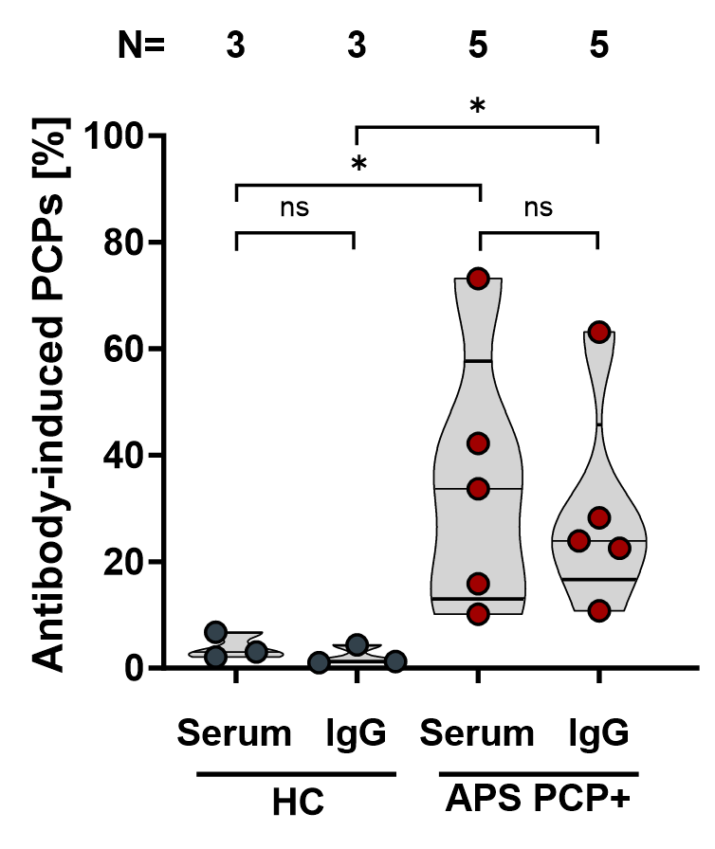
Supplementary Figure 1. Procoagulant platelet (PCP) formation induced by healthy control (HC), or APS serum, or the corresponding IgG- fractions. Healthy control platelets were incubated with serum or IgG and tested for expression of the PCP markers CD62p and phosphatidylserine in flow cytometry. Data are presented as mean percentage of CD62p/PS positive platelets ± SEM. P values were calculated using the Mann-Whitney U, or paired t-test. ns, not significant; *p<0.05.
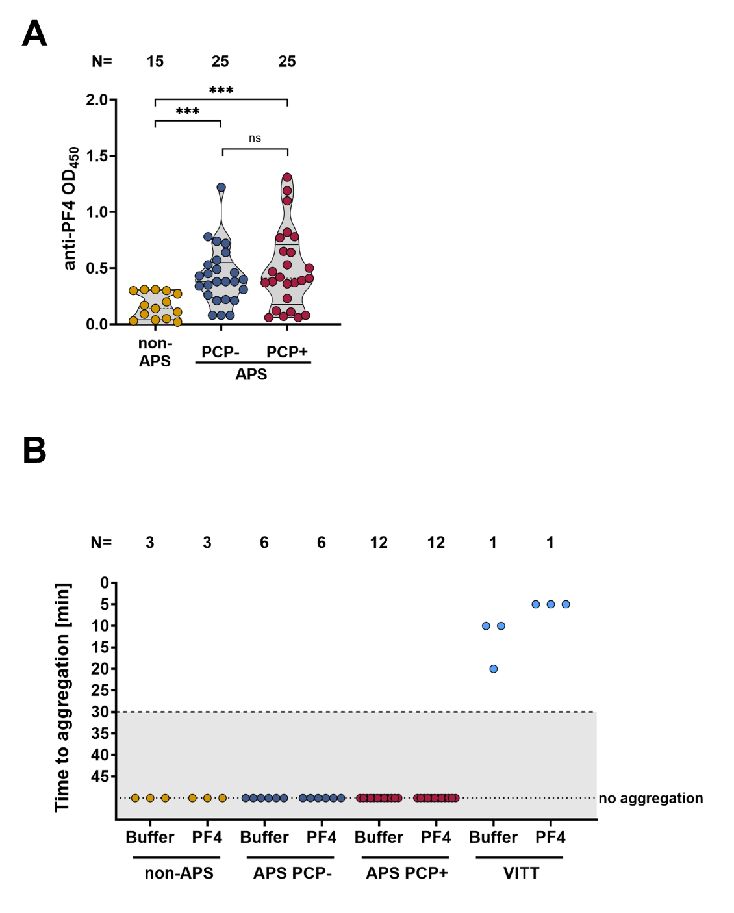

Supplementary Figure 2. Patient sera were tested for anti-PF4 antibodies using an in-house PF4 enzyme-linked immunosorbent assay (PF4-EIA). [A] Anti-PF4 optical density (OD) values of non-APS, APS PCP-, or APS PCP+ patients are shown. [B] PF4-induced Platelet Activation Assay (PIPA): Washed platelets of four healthy donors were incubated with sera in the presence or absence of exogenous PF4 [10 µg/mL]. Time to loss of turbitidy was recorded for up to 45 min. A serum was deemed as reactive if at least two of four test cells lost turbidity within 30 minutes. Sera from patients with vaccine-induced thrombotic thrombocytopenia (VITT) served as positive controls.

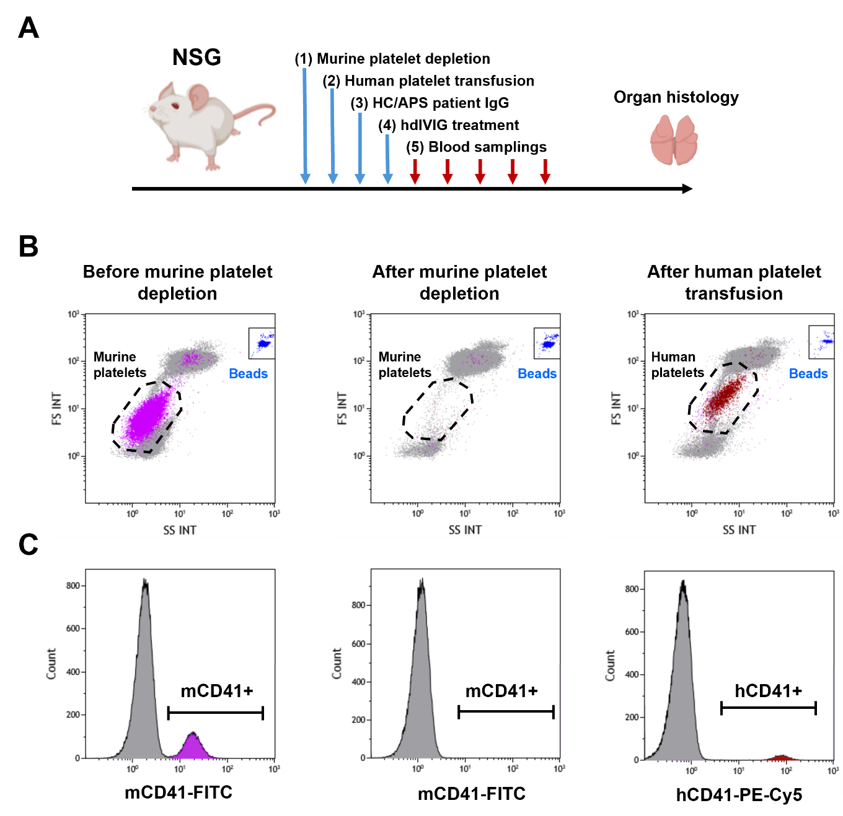
Supplementary Figure 3. [A] Schematic diagram for the experimental procedure to investigate survival of human platelets after injection of antibodies in the mouse model of antibody-mediated platelet disorders.⁵ Representative flow cytometry forward vs. side-scatter dot plots [B], or histograms [C] of murine platelets before (left panel), and after depletion of endogenous platelets (middle panel) with anti-mGPIbα antibody (clone R300). Human platelets were identified as events of characteristic size and granularity expressing human CD41 (hCD41) after transfusion of human platelets into endogenous platelet-depleted mice (right panel).

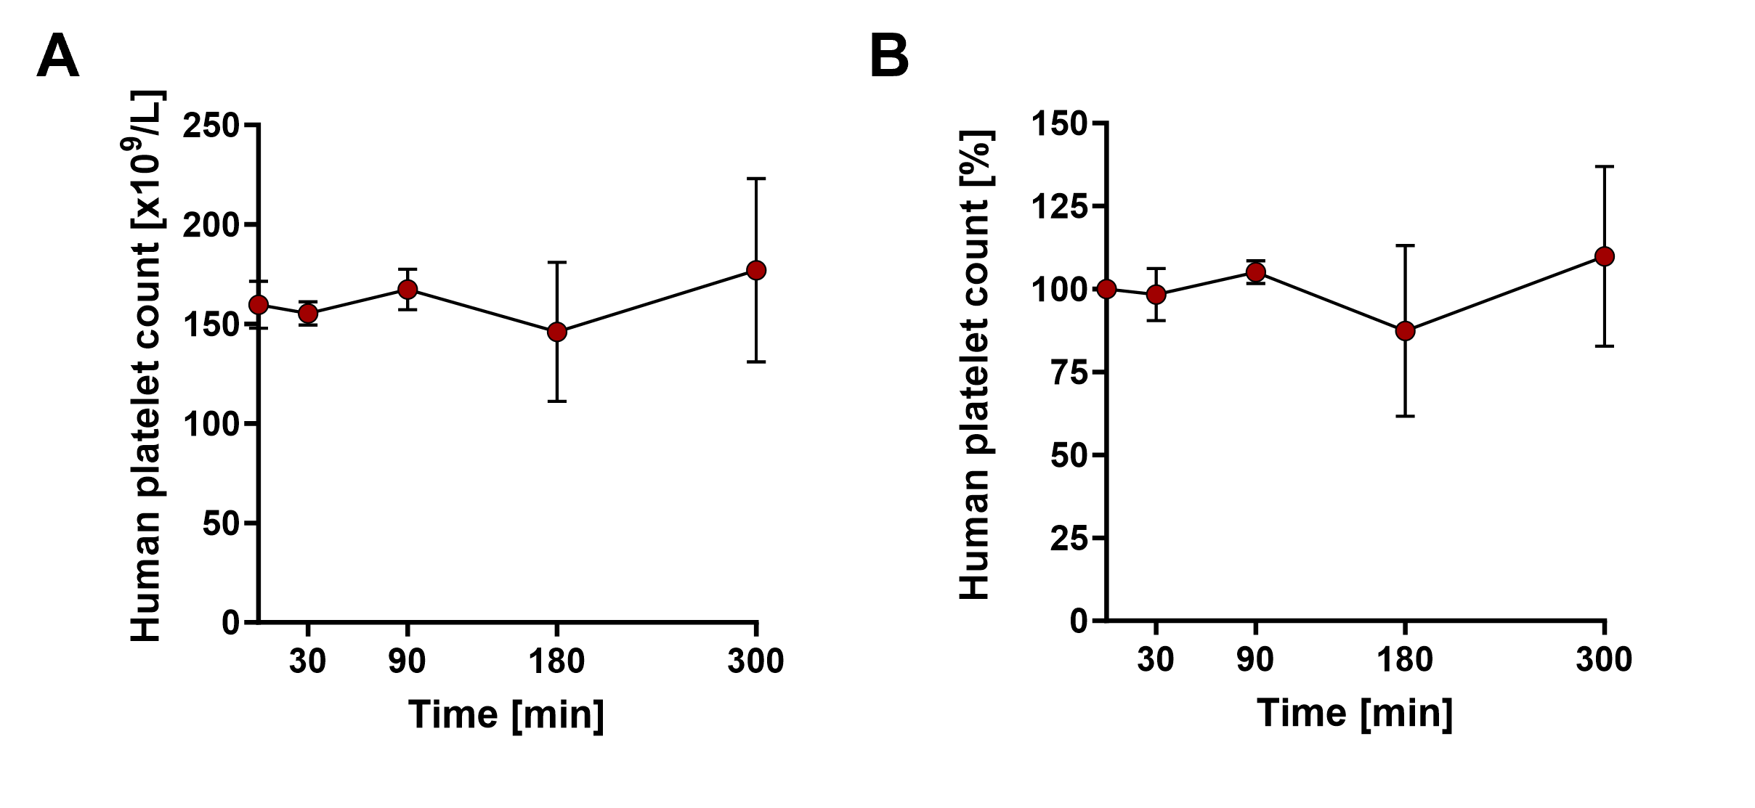
Supplementary Figure 4. Survival of transfused human platelets in anti-mGPIbα (R300) endogenous platelet-depleted NSG mice. [A] Human platelet count was assessed relative to the first sample, or [B], in absolute numbers of circulating human (hCD41 pos.) platelets. Mean ± SEM of N=3 mice are shown.

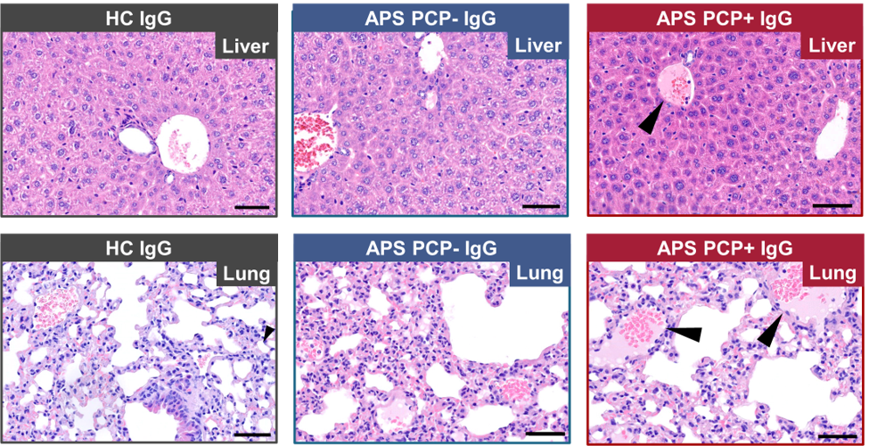
Supplementary Figure 5. Impact of APS patient antibodies on thrombus formation in vivo. Hematoxylin-eosin-stained thick sections from the liver and lungs of human platelet-transfused NSG mice that were sacrificed 24 h after injection with healthy control (HC), PCP-negative, or PCP-positive APS patient IgG. 2-3 mice were tested per group. Representative images are shown, scale bar: 50 µm.

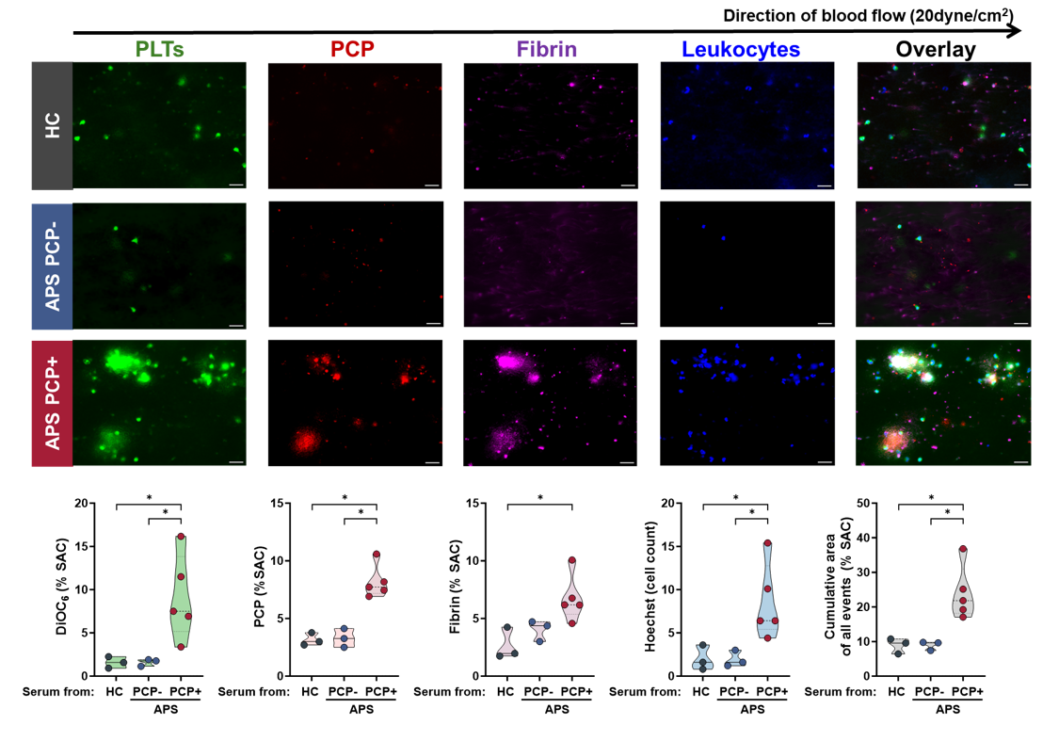
Supplementary Figure 6. Whole blood samples from healthy individuals were incubated with serum form healthy controls, PCP- negative or PCP-positive APS patient serum prior to perfusion through collagen-coated microfluidic channels at a shear rate of 500s-1 (20 dyne/cm²) for 15 minutes. After perfusion, images were acquired at x40 magnification. Scale bar: 20 μm. Lower panel: violin plots showing the percentage of total surface area coverage (% SAC) by DiOC₆, phosphatidylserine (PS), Fibrin, count of Hoechst-positive-labeled cells and cumulative total % SAC with DiOC₆, phosphatidylserine (PS), or Fibrin labeled thrombus captured in the microfluidic channel. Each dot represents healthy control or patient serum tested in 2-3 independent experiments. Data are presented as mean percentage ± SEM. P values were calculated using the Mann-Whitney U, or paired t-test, ns: non-significant. *P<0.05.
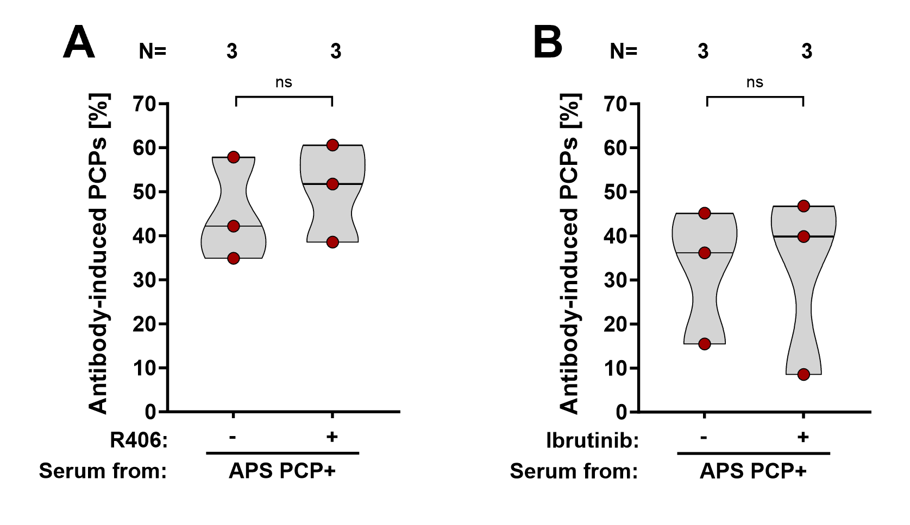
Supplementary Figure 7. Impact of platelet tyrosine kinase inhibition on APS antibody-induced procoagulant platelet formation. Platelets were incubated with APS patient serum in the presence of vehicle or [A] SYK inhibitor R406 (5 μM), or [B] bruton´s tyrosine kinase inhibitor ibrutinib (0.5 µM) and tested for procoagulant platelet (PCP) formation by flow cytometry. Both inhibitors were used at a concentration that inhibited agonist-induced platelet activation (data not shown). Data are presented as mean percentage of PCP ± SEM. P values were calculated using the paired t-test. ns: non-significant. **P<0.01.

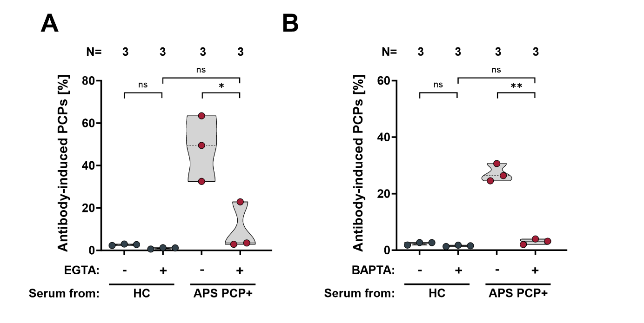

Supplementary Figure 8. Panel [A], APS serum-induced procoagulant platelet (PCP) formation in the presence of extracellular calcium (vehicle), or chelation of extracellular calcium with the calcium chelator EGTA (1 mM). [B] APS serum-induced PCP formation without chelation (vehicle), or under chelation of intracellular calcium with BAPTA-AM (20 µM). PCP formation was assessed by labelling of platelets with anti-CD62p-APC and the calcium-independent phosphatidylserine-binding protein lactadherin-FITC. Data are presented as mean percentage of PCP ± SEM. P values were calculated using the Mann-Whitney U, or paired t-test. ns: non-significant. *P<0.05, **P<0.01.

References
1. Devreese KMJ, Bertolaccini ML, Branch DW, et al. An update on laboratory detection and interpretation of antiphospholipid antibodies for diagnosis of antiphospholipid syndrome: guidance from the ISTH-SSC Subcommittee on Lupus Anticoagulant/Antiphospholipid Antibodies. J Thromb Haemost. 2025;23(2):731-744.
2. Devreese KMJ, de Groot PG, de Laat B, et al. Guidance from the Scientific and Standardization Committee for lupus anticoagulant/antiphospholipid antibodies of the International Society on Thrombosis and Haemostasis: Update of the guidelines for lupus anticoagulant detection and interpretation. J Thromb Haemost. 2020;18(11):2828-2839.
3. Paul DS, Bergmeier W. Novel Mouse Model for Studying Hemostatic Function of Human Platelets. Arterioscler Thromb Vasc Biol. 2020;40(8):1891-1904.
4. Zlamal J, Singh A, Weich K, et al. Platelet phosphatidylserine is the critical mediator of thrombosis in heparin-induced thrombocytopenia. Haematologica. 2023;108(10):2690-2702.
5. Zlamal J, Ripoll VM, Lee CSM, et al. Platelet spleen tyrosine kinase is a key regulator of anti-PF4 antibody-induced immunothrombosis. Blood Adv. 2025;9(8):1772-1785.
6. Schindelin J, Arganda-Carreras I, Frise E, et al. Fiji: an open-source platform for biological-image analysis. Nat Methods. 2012;9(7):676-682.
7. Schneider W, Schnaidt M. The platelet adhesion immunofluorescence test: a modification of the platelet suspension immunofluorescence test. Blut. 1981;43(6):389-392.

