Supporting Information for

Defect-Tailored Titanate Nanowire Filters for Highly Efficient Electrooxidation in Water Treatment

Zezhen Hao and Wensi Chen*

Zachry Department of Civil & Environmental Engineering, Texas A&M University,
College Station, Texas 77843, USA
*Corresponding Author, Email: wensi.chen@tamu.edu

Summary

Number of Pages: 28 (S1-S28)

Supplementary Texts: 1-7

Supplementary Figures: 1-20

Supplementary Table: 1

Table of Contents
Supplementary Methods
Chemicals and Materials.
Supplementary Text 1. Normalized pollutant removal rate calculation.
Supplementary Text 2. Energy consumption calculation.
Supplementary Text 3. Optimization for pristine TiO₂ nanowire synthesis.
Supplementary Text 4. Synthesis of TiO_{x} nanowire by H₂ reduction.
Supplementary Text 5. Hydraulic retention time calculation.
Supplementary Text 6. EO treatment for recalcitrant organic micropollutants.
Supplementary Text 7. Flow-through EO mechanism investigation.
Supplementary Figures
Supplementary Figure 1. SEM images of the pristine TiO₂ nanowires synthesis for EG optimization.
Supplementary Figure 2. SEM images of the pristine TiO₂ nanowires synthesis for NaOH optimization.
Supplementary Figure 3. Comparison of TiO_{x} nanowires made of different reduction methods.
Supplementary Figure 4. Effects of NaBH₄ amount on nanowire reduction efficiency.
Supplementary Figure 5. Sheet resistance change of the NaBH₄-reduced TiO_{x} nanowires.
Supplementary Figure 6. XRD patterns of different TiO_{x} nanowires.
Supplementary Figure 7. XPS spectra of Ti 2p peak of different TiO_{x} nanowires.
Supplementary Figure 8. XPS spectra of Pd 3d peak of different TiO_{x} nanowires.
Supplementary Figure 9. Morphology and sheet resistance of nanowire filters made by different filter substrates.
Supplementary Figure 10. SEM images of Pd-doped nanowire filters with different nanowire loading densities.
Supplementary Figure 11. Electric double-layer capacitance measurement of different nanowire filters.
Supplementary Figure 12. Flow-through EO treatment using the Pd-doped TiO_{x} nanowire filter.
Supplementary Figure 13. Removal efficiency of different recalcitrant organic pollutants.
Supplementary Figure 14. BA removal efficiency at different initial concentrations.
Supplementary Figure 15. BA removal efficiency with TBA radical scavenger under flow mode.
Supplementary Figure 16. BA removal efficiency with TBA radical scavenger under batch mode.
Supplementary Figure 17. Oxalate removal efficiency with TBA radical scavenger under flow mode.
Supplementary Figure 18. BA removal efficiency in different electrolytes.
Supplementary Figure 19. Optical images of Pd-doped TiO_{x} nanowires after long-term EO operation.
Supplementary Figure 20. Cell setup for electrochemical characterization of the nanowire filter.
Supplementary Table
Supplementary Table 1. Composition of the simulated groundwater.

Supplementary Methods
Chemicals and Materials. Titanium dioxide nanoparticles (TiO₂, average size of 21 nm, ≥99.5%), sodium borohydride (NaBH₄, 99%), sodium perchlorate (NaClO₄, ≥98.0%), benzoic acid (C₇H₆O₂, ≥99.5%), palladium chloride (PdCl₂, 99%), ethanol (C₂H₆O, ≥99.5%), and sodium oxalate (Na₂C₂O₄, ≥99.5%) were purchased from Sigma-Aldrich (St. Louis, MO, USA). Hydrochloric acid (HCl, 36.5-38.0%), sulfuric acid (H₂SO₄, 95.0-98.0%), calcium chloride (CaCl₂, ≥99.0%), magnesium sulfate (MgSO₄, ≥99.5%), sodium sulfate (Na₂SO₄, ≥99.0%), sodium bicarbonate (NaHCO₃, ≥99.7%), tert-butyl alcohol (TBA, C₄H₁₀O, ≥99%), ethylene glycol (EG, C₂H₆O₂, ≥99.0%), and sodium hydroxide (NaOH, ≥97%) were purchased from VWR International (Radnor, PA, USA). All chemicals were used as received without further purification. Nafion solution, graphite felt, and platinized Ti mesh were purchased from Fuel Cell Store (Bryan, TX, USA). Graphite felt (diameter of 3.5 cm) was treated with H₂SO₄ (95.0-98.0%) overnight to improve hydrophilicity before usage. Stainless steel mesh (Grade 304, 20 mesh woven, wire diameter of 0.38 mm) was purchased from Thermo Scientific Chemicals (Waltham, MA, USA). Deionized (DI) water with a resistivity of >18.2 MΩ•cm at room temperature was obtained from GenPure ultrapure water system (Tewksbury, MA, USA).

Supplementary Text 1. Normalized pollutant removal rate calculation. The pollutant removal rate normalized to nanowire loading was calculated by the following equation:
Removal Rate (per mg nanowire) = (C_{in}–C_{out})×J/Γ_{NW} (Eq. 1)
where C_{in} is the influent pollutant concentration, and C_{out} is the effluent pollutant concentration, J is the water flux, and Γ_{NW} is the loading density of nanowires. In different influent BA concentration tests, J was fixed at 11 L m⁻² h⁻¹, and Γ_{NW} was fixed at 1 mg cm⁻².
For 10 μM influent BA concentration, C_{out} = 0 μM, so the normalized removal rate is $\frac{\left({ 10 μM}^{ }-{ 0 μM}^{ }\right) ×{ 11 L m}^{-2}h^{-1}}{1 mg cm^{-2} }$= 0.010 µM mg⁻¹ h⁻¹.
For 25 μM influent BA concentration, C_{out} = 0.8 μM, so the normalized removal rate is $\frac{\left({ 25 μM}^{ }-{ 0.8 μM}^{ }\right) ×{ 11 L m}^{-2}h^{-1}}{1 mg cm^{-2}}$= 0.027 µM mg⁻¹ h⁻¹.
For 50 μM influent BA concentration, C_{out} = 4.1 μM, so the normalized removal rate is $\frac{\left({ 50 μM}^{ }-{ 4.1 μM}^{ }\right)×{11 L m}^{-2}h^{-1}}{1 mg cm^{-2} }$= 0.050 µM mg⁻¹ h⁻¹.
For 100 μM influent BA concentration, C_{out} = 10.7 μM, the normalized removal rate is $\frac{\left({ 100 μM}^{ }-{ 10.7 μM}^{ }\right)×{11 L m}^{-2}h^{-1}}{1 mg cm^{-2} }$= 0.098 µM mg⁻¹ h⁻¹.

Supplementary Text 2. Energy consumption calculation. The electrical energy consumption normalized to per log-removal of micropollutant can be calculated using the following equation:
Energy Consumption (per log removal) = (E_{Cell}×i×S)/[r×log(C_{in}–C_{out})] (Eq. 2)
where E_{Cell} is the cell voltage, i is current density, S is electrode surface area, r is the flow rate, C_{in} is the influent pollutant concentration, and C_{out} is the effluent pollutant concentration. For long-term tests in this study, electrode surface area was 5.72 cm², flow rate was 0.05 mL min⁻¹, and C_{in} was 25 μM BA.
At 1.4 mA cm⁻² current density, average E_{Cell} during initial 40 hours is 3.4 V, average C_{out} is 1.6 μM, so the energy consumption is $\frac{3.4 V×{1.4 mA cm}^{-2}×{5.72 cm}^{2}}{0.05 mL \min^{-1}×log({\frac{25 μM}{1.6 μM})}}=7.6 kWh m^{-3}$.
At 1.0 mA cm⁻² current density, average E_{Cell} during initial 75 hours is 2.9 V, average C_{out} is 4.1 μM, so the energy consumption is $\frac{2.9 V×{1.0 mA cm}^{-2}×{5.72 cm}^{2}}{0.05 mL \min^{-1}×log({\frac{25 μM}{4.1 μM})}}=7.0 kWh m^{-3}$.
At 0.5 mA cm⁻² current density, average E_{Cell} during initial 120 hours is 2.9 V, average C_{out} is 9.2 μM, so the energy consumption is $\frac{2.9 V×{0.5 mA cm}^{-2}×{5.72 cm}^{2}}{0.05 mL \min^{-1}×log({\frac{25 μM}{9.2 μM})}}=6.4 kWh m^{-3}$.
For the simulated real water test, average E_{Cell} during initial 95 hours is 2.9 V, average C_{out} is 11.6 μM, so the energy consumption is $\frac{2.9 V×{0.5 mA cm}^{-2}×{5.72 cm}^{2}}{0.05 mL \min^{-1}×log({\frac{25 μM}{ 11.6 μM})}}=8.2 kWh m^{-3}$.

Supplementary Text 3. Optimization for pristine TiO₂ nanowire synthesis. Pristine TiO₂ nanowires were synthesized via a hydrothermal method in EG solution at alkaline conditions. The concentrations of EG and NaOH were optimized to achieve desired nanowires with high aspect ratio. To test the effect of EG concentration, 400 mg of TiO₂ nanoparticles were dispersed in 30 mL of 5 M NaOH solution containing 30-70 vol% EG in a 50 mL polypropiolactone-lined autoclave. The autoclave was heated at 200 °C for 24 hours in a gravity convection oven. After cooling to room temperature, the reaction mixture was neutralized using 1 M HCl and repeatedly rinsed with deionized water and ethanol. The products were collected by centrifugation and dried overnight at 60 °C in a vacuum oven to obtain the final synthesized materials. To investigate the effects of NaOH concentration, EG was fixed at 50 vol% and NaOH concentration varied from 5-9 M while all subsequent steps followed the previous protocol.

Supplementary Text 4. Synthesis of TiO_{x} nanowire by H₂ reduction. TiO_{x} nanowires reduced by H₂ were synthesized as a control to compare reduction efficiencies by different methods. In brief, the pristine TiO₂ nanowires were directly annealed and reduced at 600 °C for 6 hours under 95% Ar/5% H₂ using the tube furnace. The heating rate was 5 °C min⁻¹ with a gas flow rate of 0.3 L min⁻¹.

Supplementary Text 5. Hydraulic retention time calculation. The hydraulic retention time (HRT) that electrolyte stays within the reaction chamber was calculated by dividing the reactor volume (V) by the influent flow rate (r):
HRT = V/r (Eq. 3)
in which the reactor volume (V) is 1.72 cm³ (area of 5.72 cm² and 0.3 cm in height). When the flow rate is 1 mL min⁻¹ (i.e., water flux of 105 L m⁻² h⁻¹), the corresponding HRT is 1.7 min.

Supplementary Text 6. EO treatment for recalcitrant organic micropollutants. Representative micropollutants other than BA including 4-chlorophenol, 1,4-dioxane, and bisphenol A were each prepared at 25 μM in 100 mM NaClO₄. During flow-through EO treatment, applied current density was set at 4 mA cm⁻² and water flux was fixed at 11 L m⁻² h⁻¹ for all cases. The effluents were collected to evaluate the removal efficiencies. The micropollutant concentrations were tested by HPLC equipped with a diode array detector. The mobile phase flow rate was set at 1 mL min⁻¹ for 4-chlorophenol and 1,4-dioxane, and 0.5 mL min⁻¹ for bisphenol A, respectively. For 4-chlorophenol detection, the mobile phase was 50% acetonitrile and 50% phosphoric acid (0.01%), and the retention time was 3.34 min at 224 nm wavelength. For 1,4-dioxane detection, the mobile phase was 10% acetonitrile and 90% phosphoric acid (0.01%), and the retention time was 2.56 min at 195 nm wavelength. For bisphenol A detection, the mobile phase was 70% methanol and 30% phosphoric acid (0.01%), and the retention time was 6.41 min at 230 nm wavelength.

Supplementary Text 7. Flow-through EO mechanism investigation. For radical quenching experiments, TBA was added as the •OH scavenger. At 25 μM of initial BA, 50 mM of TBA was added. At 1 mM of initial BA, 1 M of TBA was added. Control experiments without TBA addition were conducted under same conditions for comparison. The supporting electrolyte was 100 mM NaClO₄ in all cases. The treated samples were collected and analyzed by HPLC to determine the BA removal efficiency. The sodium oxalate (Na₂C₂O₄) was selected as the probe for the direct oxidation pathway validation. Feed solution containing 1 mM Na₂C₂O₄, with or without 1 M TBA addition, was prepared in 100 mM NaClO₄. The oxalate concentrations before and after treatment were detected by ion chromatography (IC, Thermo Fisher, Waltman. MA, USA). Oxalate was separated by Dionex IonPac AS18 column with eluent of 10 mM KOH at a flow rate of 1 mL min⁻¹. The retention time for oxalate was 55.3 min.
Supplementary Figures
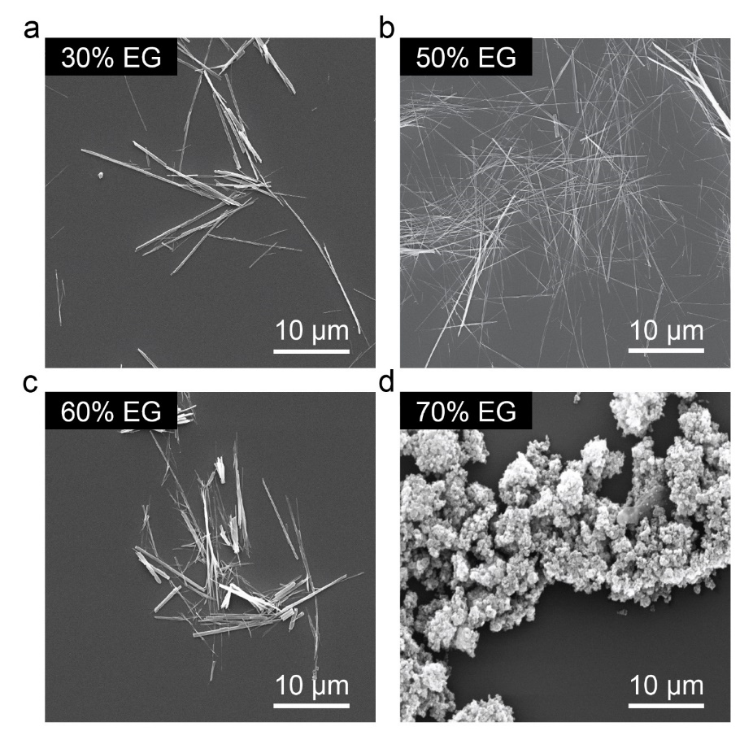
Supplementary Figure 1. SEM images of the pristine TiO₂ nanowires synthesized under different EG concentrations. The NaOH concentration was fixed at 5 M while EG concentration was adjusted from 30-70 vol%. The hydrothermal reaction was conducted at 200 °C for 24 hours. (a) 30 vol% EG, (b) 50 vol% EG, (c) 60 vol% EG, and (d) 70 vol% EG. At 30 vol% EG, the resulting nanowire product had a diameter of 150-200 nm. As the EG concentration increased to 50 vol%, the lateral growth of the nanowires was limited by the increased capping agent amount, which led to ultrathin nanowires with diameters of 50-100 nm and an average length of 22 µm. However, when the EG concentration reached 60 vol%, we noticed the average length of the resulting nanowires was less than 15 µm due to the excess capping agent. If further increasing the EG concentration to 70 vol%, the product was only aggregated nanoparticles. Based on these results, we chose 50 vol% as the optimal EG concentration.
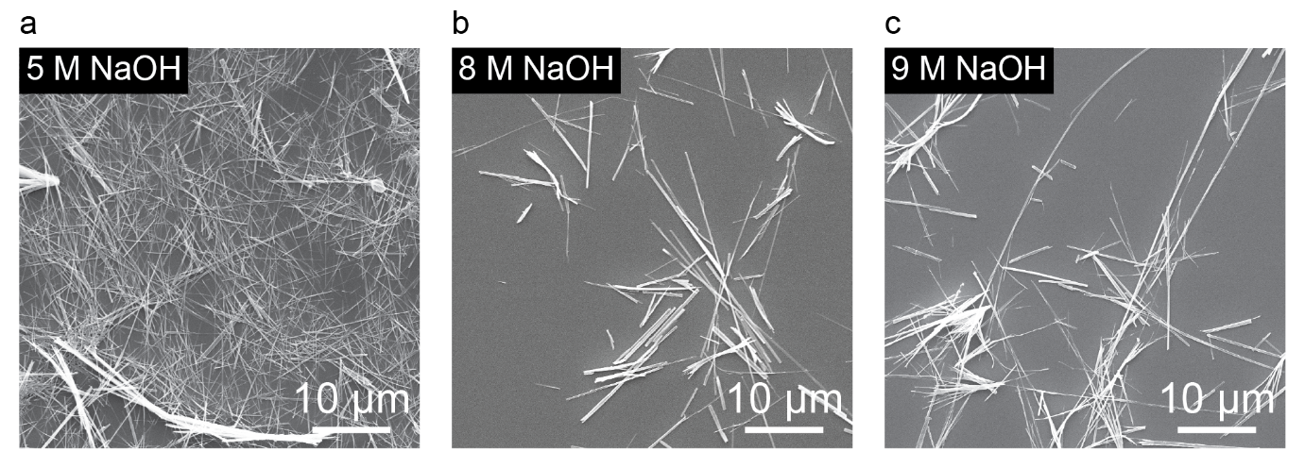
Supplementary Figure 2. SEM images of the pristine TiO₂ nanowires synthesized under different NaOH concentrations. The EG concentration was fixed at 50 vol% while NaOH concentration was adjusted from 5-9 M. The hydrothermal reaction was conducted in a polypropiolactone-lined autoclave at 200 °C for 24 hours. (a) 5 M NaOH, (b) 8 M NaOH, and (c) 9 M NaOH. From the results, we found that 5 M NaOH showed the most uniform TiO₂ nanowire morphology, while increasing the NaOH concentration to 8 M generated a small fraction of longer nanowires (>30 µm) but increased the average diameter to ~150 nm. Once the NaOH concentration was increased to 9 M, a similar morphology was observed with some ultra-long nanowires (>50 µm) forming, and the length distribution of nanowires became broader and less uniform. Based on these results, we chose 5 M NaOH as the optimal EG concentration.
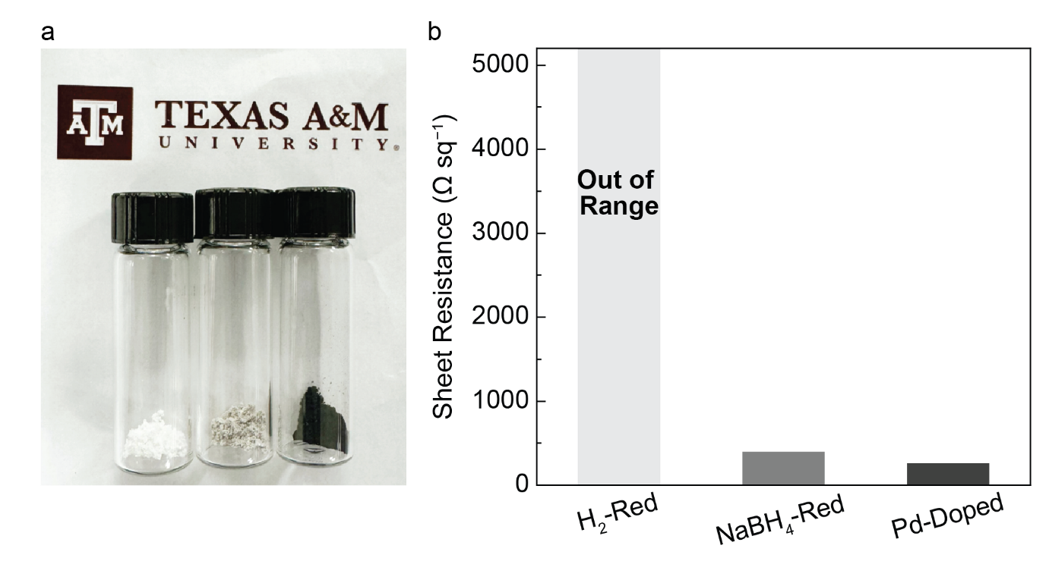
Supplementary Figure 3. Comparison of TiO_{x} nanowires made of different reduction methods. (a) Optical image of pristine TiO₂ nanowires (left, white powder), TiO_{x} nanowires reduced by 5% H₂ under 600 °C for 6 hours (middle, light gray powder), and TiO_{x} nanowires reduced by NaBH₄ under 450 °C for 6 hours (right, black powder). (b) The sheet resistance of different TiO_{x} nanowire products. The reduced nanowires were loaded onto a non-conductive 0.22 μm PES filter at a loading density of 5 mg cm⁻². The sheet resistance of the nanowire layer was then measured by a four-point surface resistivity meter. The H₂-reduced TiO_{x} nanowire layer showed a sheet resistance of more than 20000 Ω sq⁻¹, while the NaBH₄-reduced nanowire layer with or without Pd doping showed 400 Ω sq⁻¹ and 260 Ω sq⁻¹, respectively. The NaBH₄-assisted method showed a higher reduction efficiency, and Pd doping could further reduce sheet resistance.

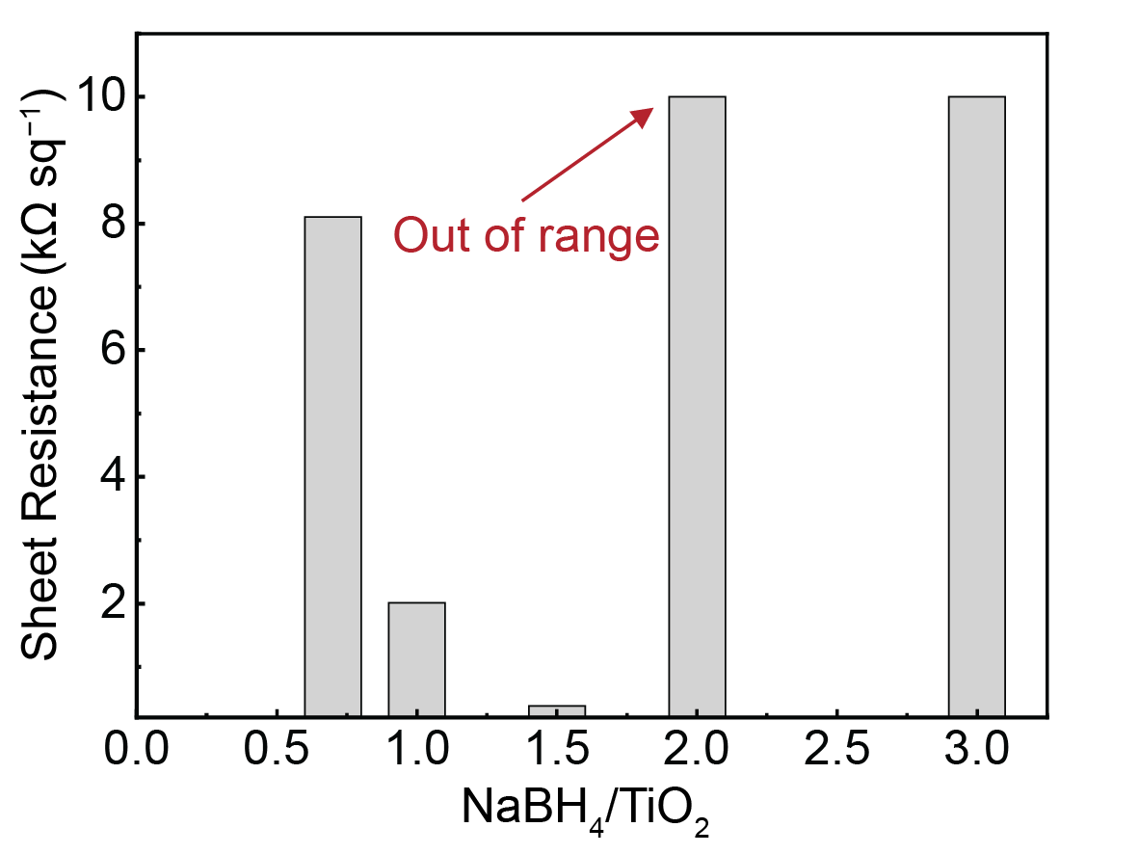
Supplementary Figure 4. Effects of NaBH₄ amount on nanowire reduction efficiency. TiO_{x} nanowires reduced by different amounts of NaBH₄ (NaBH₄/TiO₂ weight ratio from 0.7-3.0) was synthesized to compare the reduction efficiency and identify the optimal reduction process. The reduced nanowires were loaded onto a non-conductive 0.22 μm PES filter at a loading density of 5 mg cm⁻². The sheet resistance of the nanowire layer was then measured by a four-point surface resistivity meter. The results indicated that at relatively low NaBH₄/TiO₂ ratios, increasing NaBH₄ amount could greatly enhance the reduction efficiency. When the NaBH₄/TiO₂ ratio increased from 0.7 to 1.5, the sheet resistance of the nanowire layer significantly decreased from ~8000 Ω sq⁻¹ to ~400 Ω sq⁻¹. However, once the NaBH₄/TiO₂ ratio exceeded 2.0, the sheet resistance of the nanowire layer was out of the detection limit (>20000 Ω sq⁻¹). This is because the excess NaBH₄ reductant remained unreacted after the annealing process and would cause spontaneous combustion in aqueous solutions during the subsequent rising steps and reoxidation of TiO_{x} nanowires. Therefore, we chose NaBH₄/TiO₂ ratio at 1.5 as the optimal reduction condition.
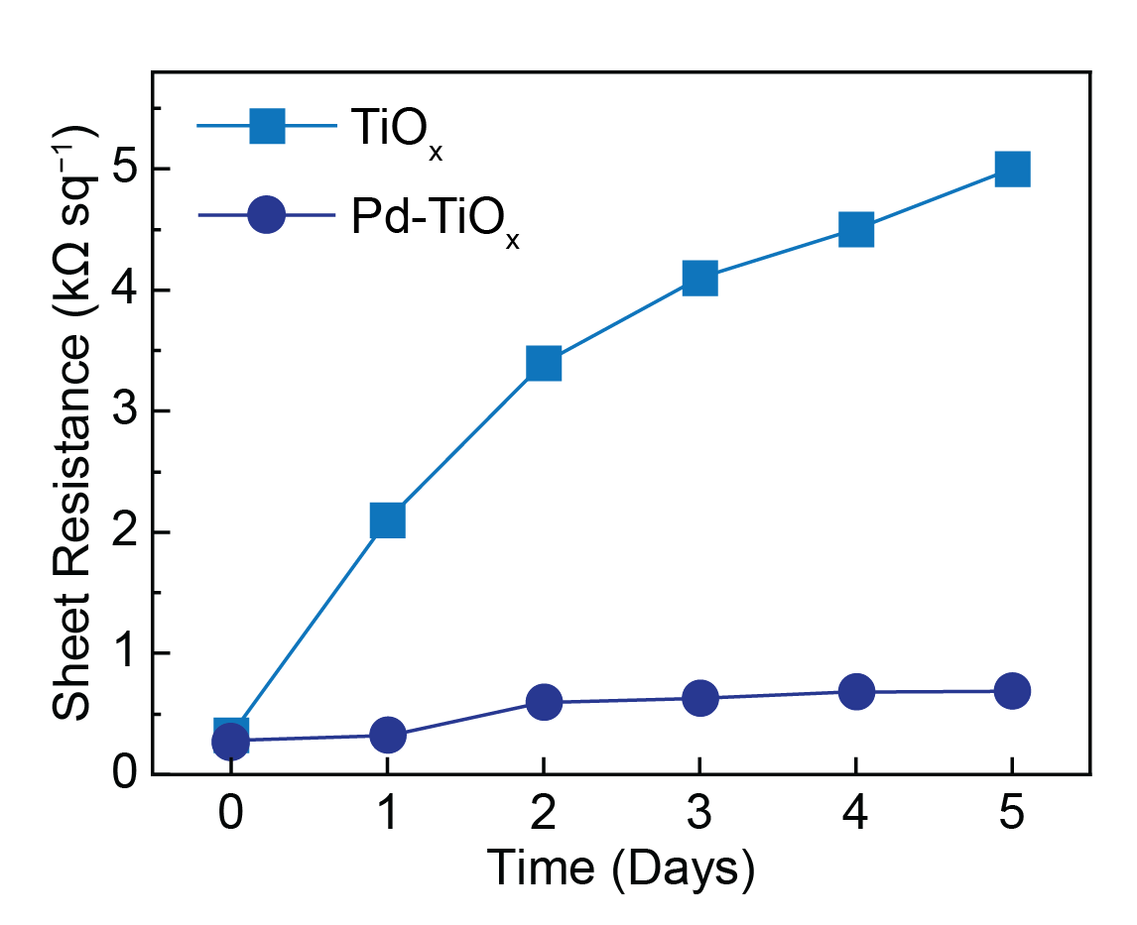
Supplementary Figure 5. Sheet resistance change of the NaBH₄-reduced TiO_{x} nanowires with or without Pd doping. The reduced nanowires were loaded onto a non-conductive 0.22 μm PES filter at a loading density of 5 mg cm⁻². The sheet resistance of the nanowire layer was measured daily for 5 days under ambient storage.
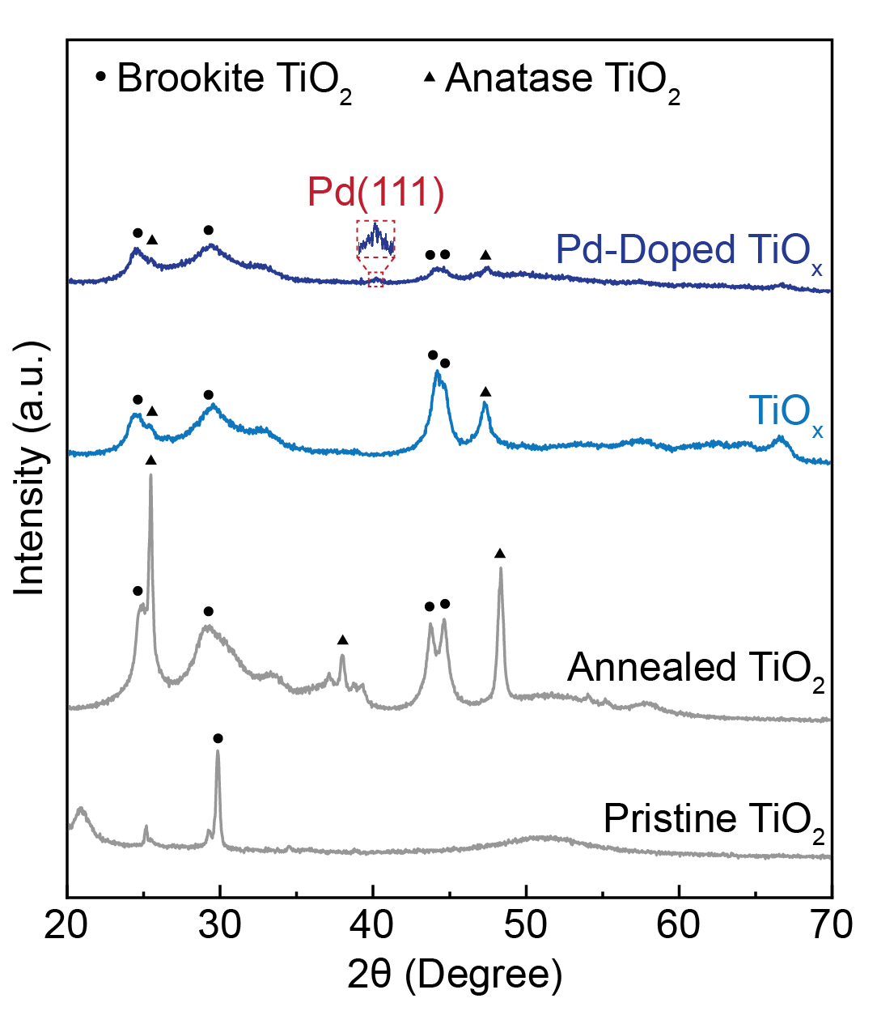
Supplementary Figure 6. XRD patterns of pristine TiO₂ nanowires, annealed TiO₂ nanowires, undoped TiO_{x} nanowires, and Pd-doped TiO_{x} nanowires. XRD was conducted over a 2θ of 20-70 degrees at a scan rate of 1 degree per minute. Pristine TiO₂ showed a brookite phase peak. Annealed TiO₂ nanowire under Ar atmosphere showed the peaks for anatase TiO₂ (JCPDS No. 21-1272) at 2θ of 25.2, 37.8, and 47.9 degrees, which is corresponding to anatase (101), (004), and (200) lattice planes, respectively. In addition, the annealed TiO₂ nanowire showed a characteristic doublet peak at 43.2 and 44.7 degrees refer to brookite TiO₂ (JCPDS No. 29-1360) (211) and (213) lattice plane, which had been commonly detected in TiO₂ nanowires synthesized by hydrothermal methods.¹ After NaBH₄ reduction, anatase peaks were reduced significantly while doublet brookite peaks remained in the TiO_{x} nanowire structure. While for Pd-doped TiO_{x} nanowire, the XRD results showed almost negligible peaks for either anatase or brookite lattice, which indicated that Pd doping further enhanced reduction efficiency and caused deformation of TiO₂ lattice. In the meantime, Pd-doped nanowires showed a weak peak for Pd(111) at 40.1 degrees that validated the successful incorporation of Pd dopant.
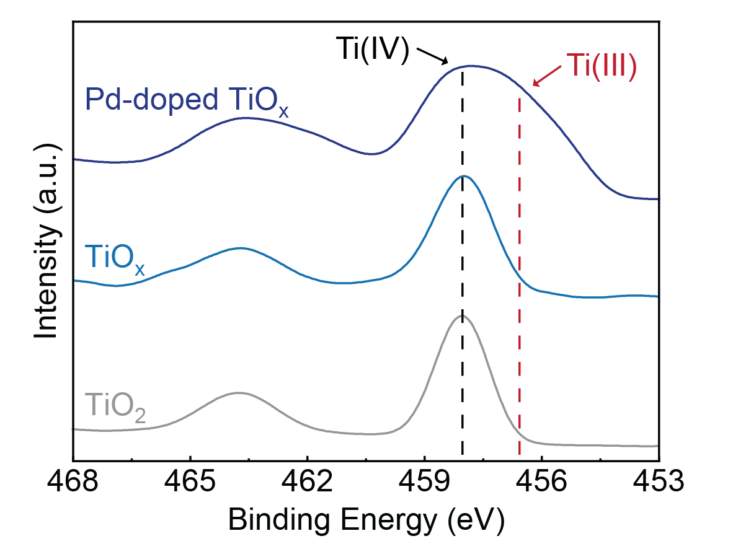
Supplementary Figure 7. XPS spectra of Ti 2p peak of pristine TiO₂ nanowires, TiO_{x} nanowires, and Pd-doped TiO_{x} nanowires. The Ti(Ⅳ) 2p_{3/2} peak has a binding energy of 458.3 eV, and the Ti(Ⅲ) 2p_{3/2} peak has a binding energy of 456.8 eV.² Undoped TiO_{x} nanowires showed an insignificant change of the Ti oxidation state compared with pristine TiO₂ nanowires likely because of the rapid reoxidation of surface Ti(Ⅲ) under ambient conditions. Pd-doped TiO_{x} nanowires showed an obviously larger fraction of Ti(Ⅲ) compared with the undoped ones because of the stabilized Ti(Ⅲ) sites after Pd doping.
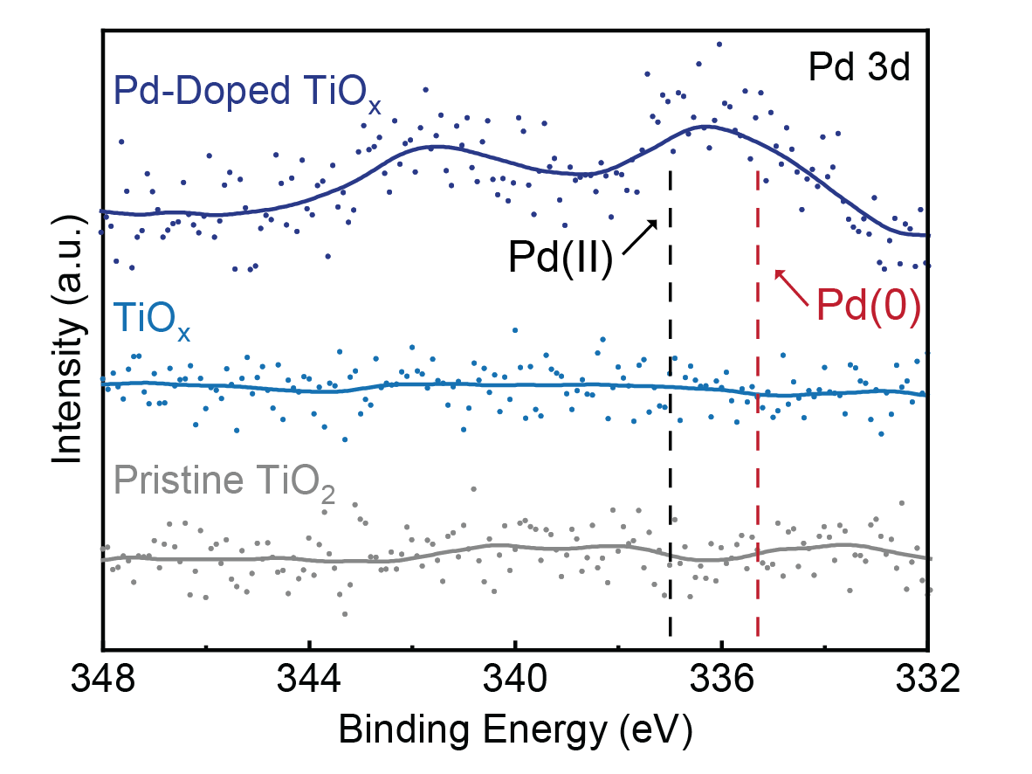
Supplementary Figure 8. XPS spectra of Pd 3d peak of pristine TiO₂ nanowires, TiO_{x} nanowires, and Pd-doped TiO_{x} nanowires. The Pd 3d_{5/2} peak was observed on the binding energy of 336.1 eV, which is between Pd(0) peak at 335.3 eV and Pd(II) peak at 337.0 eV.³ This intermediate oxidation state indicated the existence of both Pd(0) and Pd(II) in the doped nanowires.
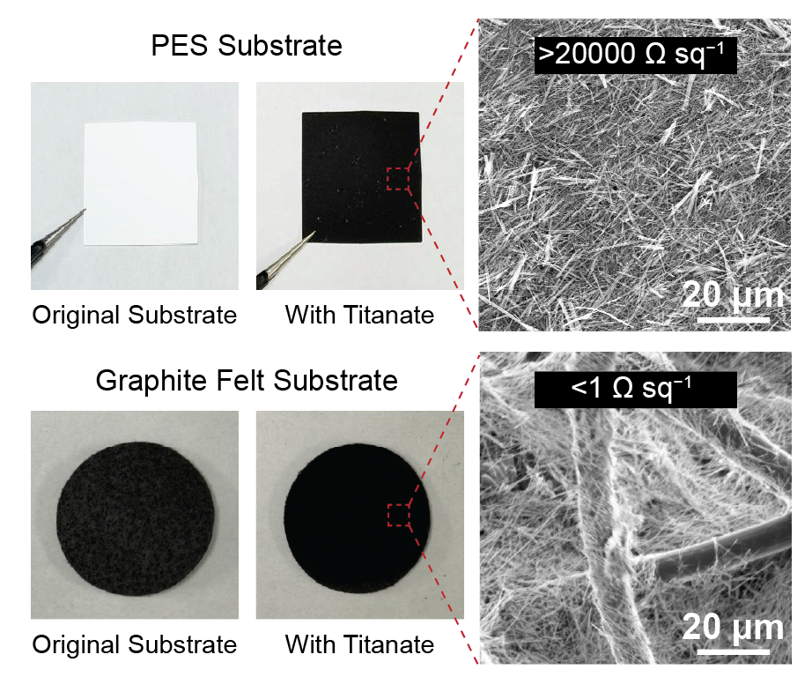
Supplementary Figure 9. Optical and SEM images of titanate nanowire filters made by different filter substrates. The PES nanowire filter was prepared by ultrasonically dispersing Pd-doped TiO_{x} nanowires in ethanol, followed by vacuum filtration of the suspension onto a PES filter (average pore size of 0.22 μm; thickness of ~200 μm) and subsequent drying. The graphite felt filter was fabricated by drop casting method. The nanowire loading density was fixed at 1 mg cm⁻². Both filters showed successful formation of interconnected nanowire layers, while the graphite felt based nanowire filter showed significantly lower sheet resistance and thus superior electrical conductivity.
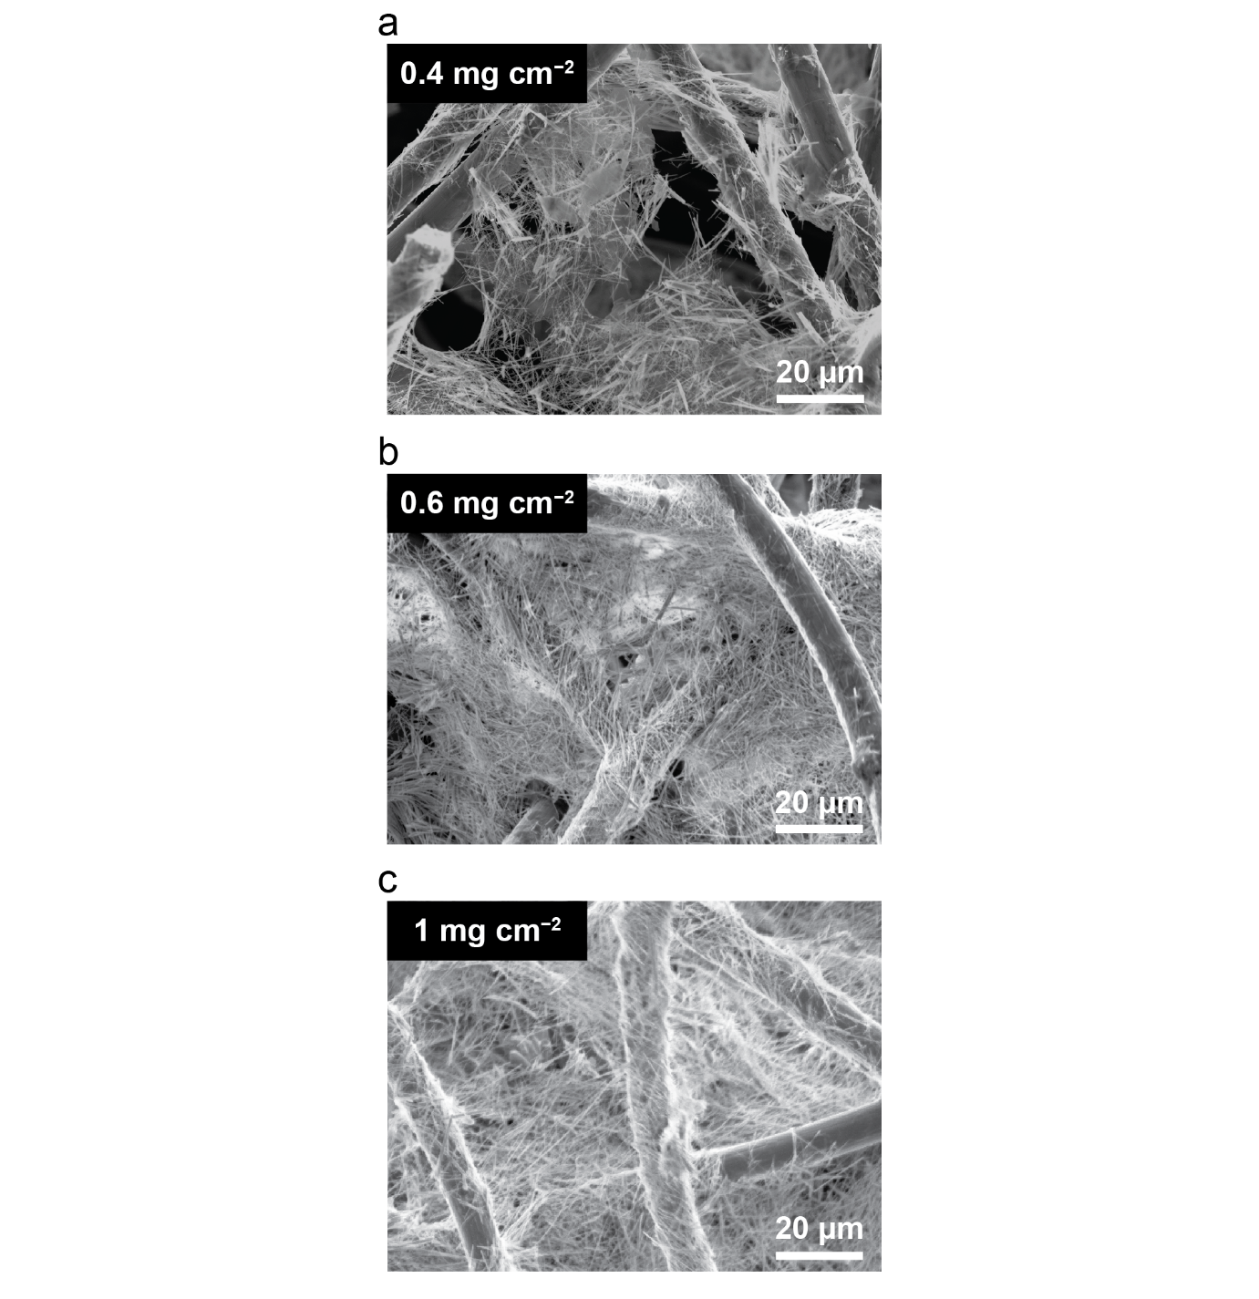Supplementary Figure 10. SEM images of Pd-doped TiO_{x} nanowire filters with different nanowire loading densities. (a) 0.4 mg cm⁻², (b) 0.6 mg cm⁻², and (c) 1 mg cm⁻². At 0.4 mg cm⁻² loading, incomplete nanowire coverage led to some large pores (>20 μm). As the loading density increased to 0.6 mg cm⁻², a continuous nanowire layer was observed with nanoscale channels (<200 nm). Once the loading density reached 1.0 mg cm⁻², the denser nanowire layer constructed a smaller channel size (~100 nm).

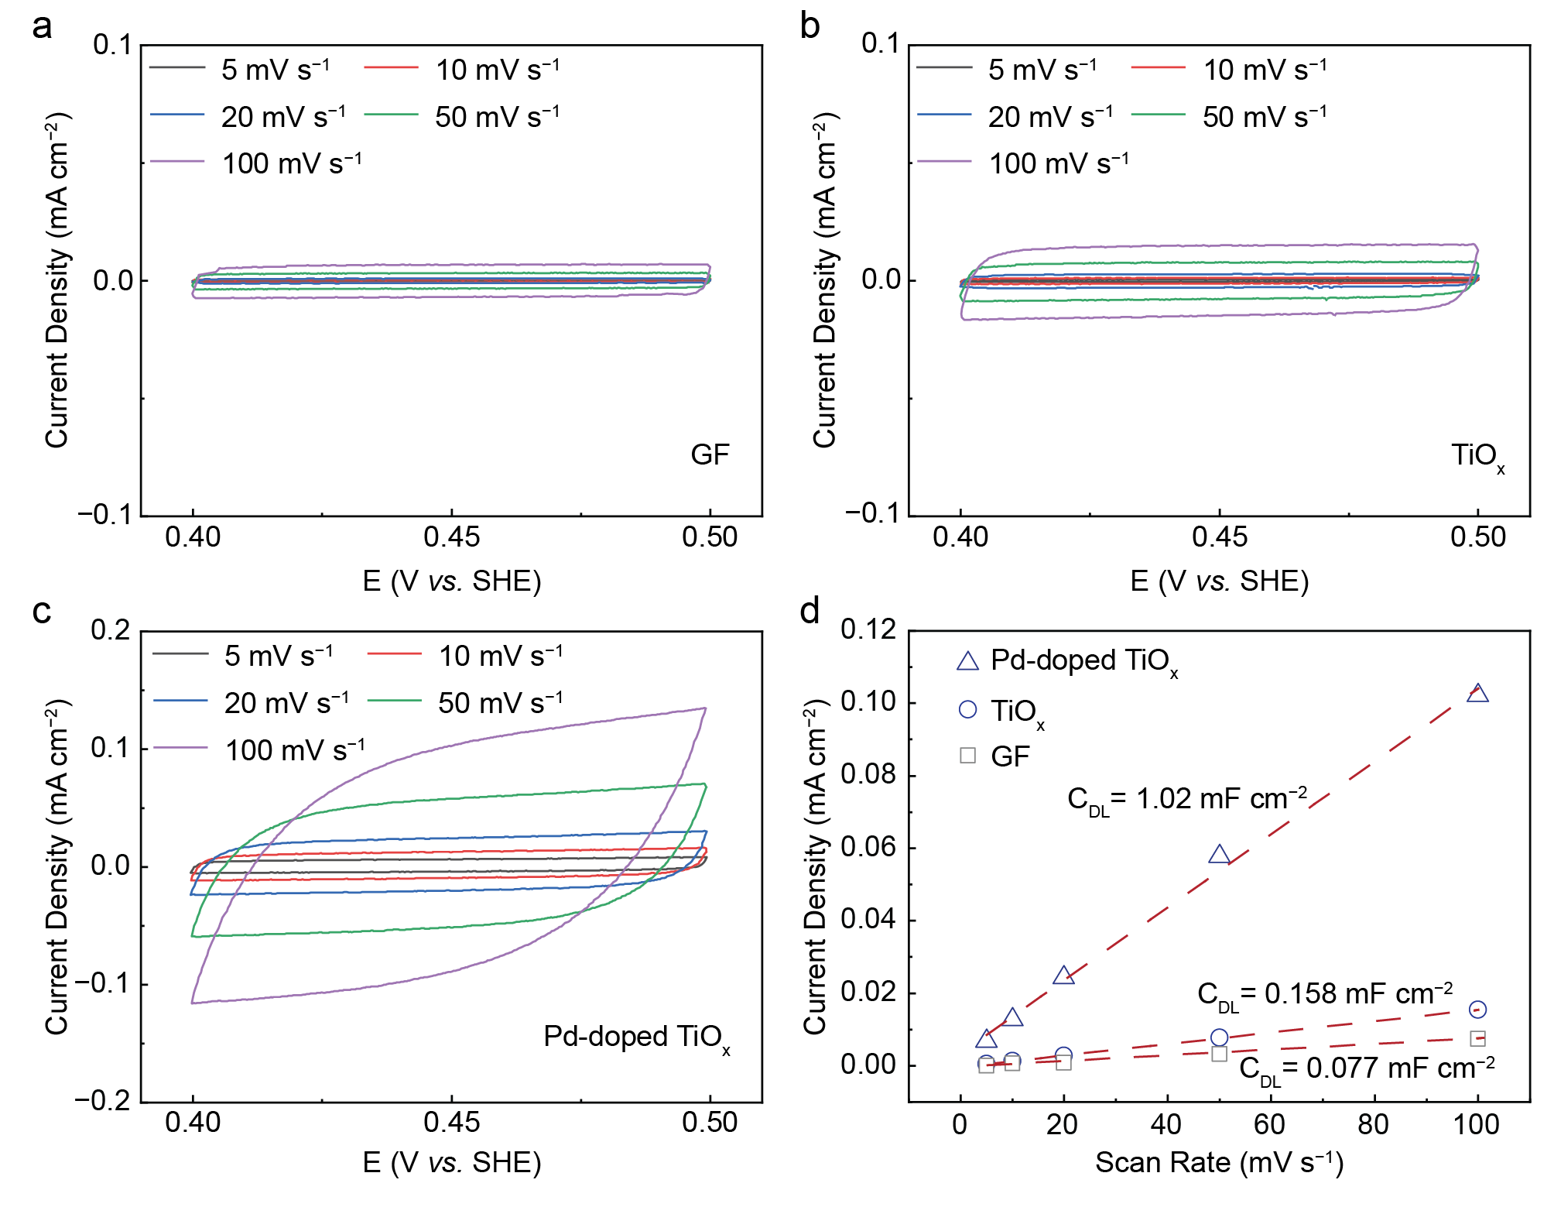
Supplementary Figure 11. Electric double-layer capacitance measurement of nanowire filters. The CV scanning of (a) graphite felt substrate, (b) undoped TiO_{x} nanowire filter, and (c) Pd-doped TiO_{x} nanowire filter was conducted in a non-faradic potential range of 0.4-0.5 V vs. SHE in 100 mM NaClO₄. (d) Double layer capacitance (C_{DL}) of different filters. C_{DL} was calculated by the following equation:
C_{DL} = j/v (Eq. 4)
in which capacitive currents (j) was chosen at 0.45 V and scan rates (v) varied from 5-100 mV s⁻¹. The calculated C_{DL} of graphite felt, undoped nanowire filter and Pd-doped nanowire filter were 0.077, 0.158 and 1.02 mF cm⁻², respectively. The electrochemically active surface area (ECSA) of different filters was determined by C_{DL}, electrode surface area (S), and specific double layer capacitance (C_{s}):
ECSA = C_{DL}×S/C_{s} (Eq. 5)
We assume all three filters are composed of similar materials and morphology (same C_{s} and S), the ECSA of the filter was proportional to its C_{DL}.
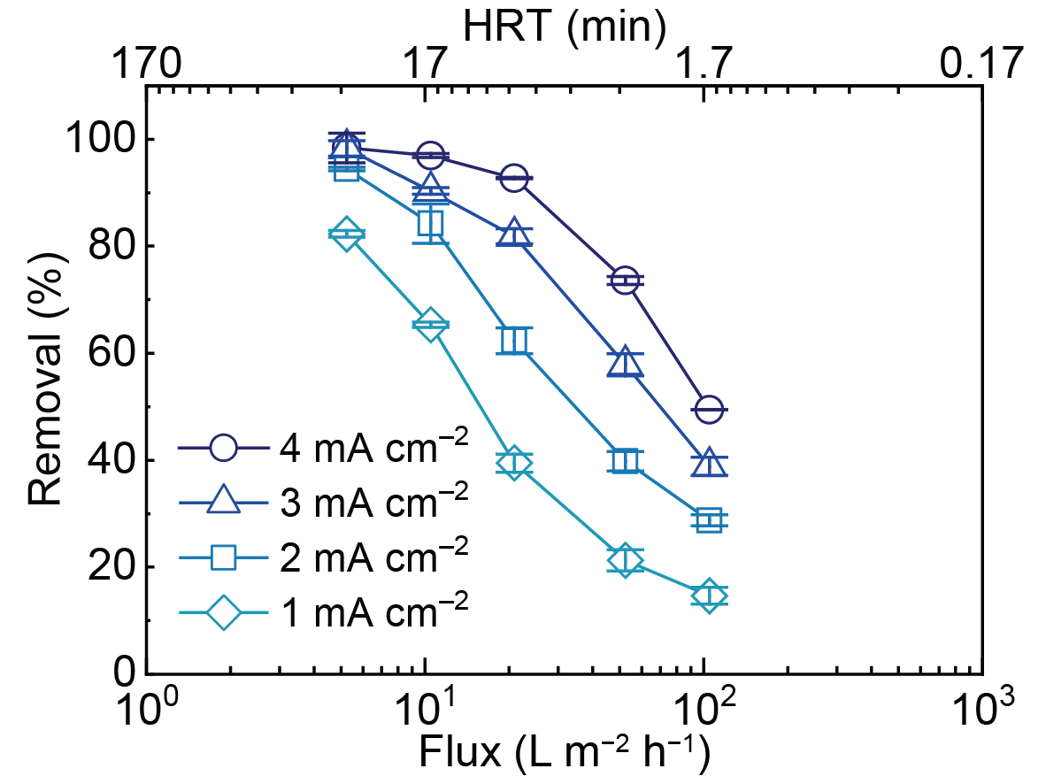
Supplementary Figure 12. Electrified flow-through treatment using the Pd-doped TiO_{x} nanowire filter. The feed solution was 25 μM BA in 100 mM NaClO₄ electrolyte. The electrolysis experiments were conducted at water fluxes from 5-105 L m⁻² h⁻¹ (HRT from 27-1.7 min) under current densities ranging from 1-4 mA cm⁻².

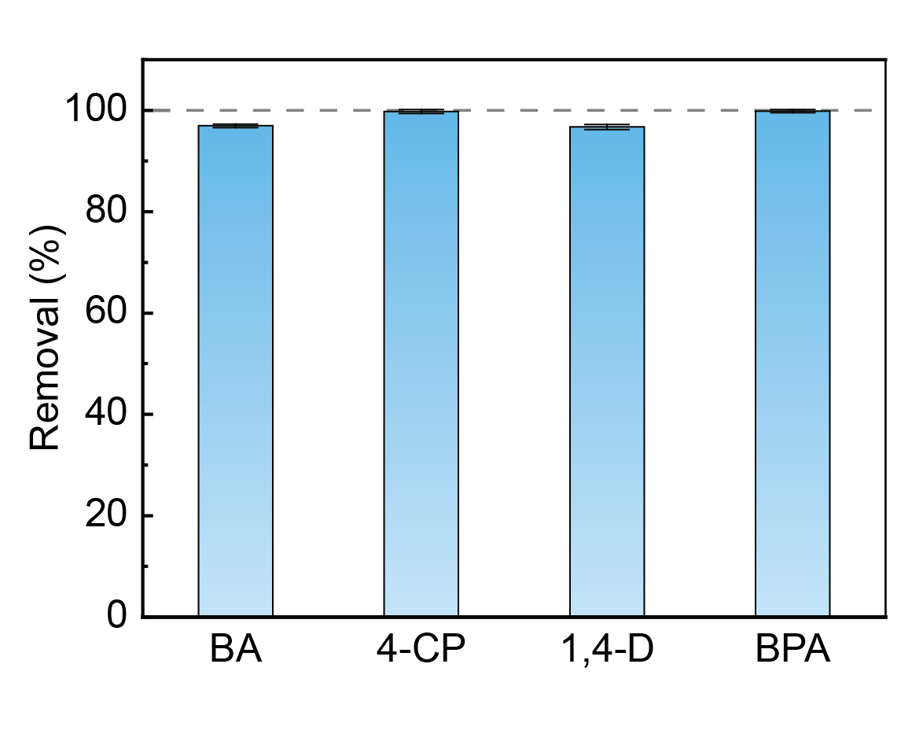
Supplementary Figure 13. Removal efficiency of different recalcitrant organic pollutants. The tested pollutants included benzoic acid (BA), 4-chlorophenol (4-CP), 1,4-dioxane (1,4-D), and bisphenol-A (BPA). The feed solution was 25 μM of individual pollutant in 100 mM NaClO₄ electrolyte. Applied current density was 4 mA cm⁻² and water flux was 11 L m⁻² h⁻¹.

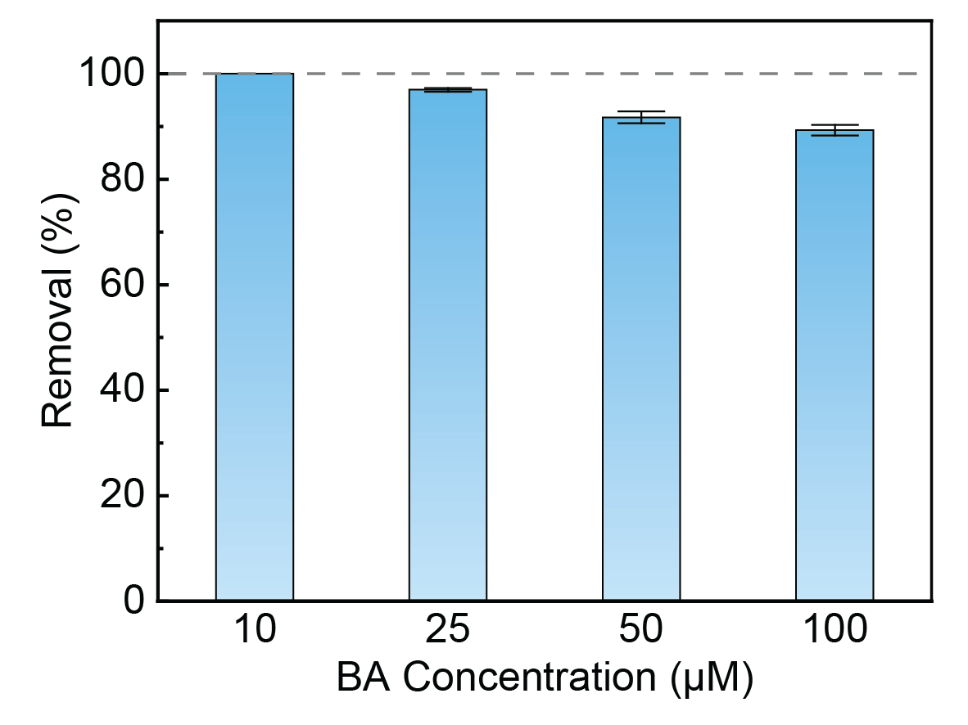
Supplementary Figure 14. BA removal efficiency at different initial concentrations. The feed solution was 10-100 μM BA in 100 mM NaClO₄ electrolyte. Applied current density was 4 mA cm⁻² and water flux was 11 L m⁻² h⁻¹. When the initial concentration was 10 μM, the BA concentration in the treated water was lower than the detection limit.
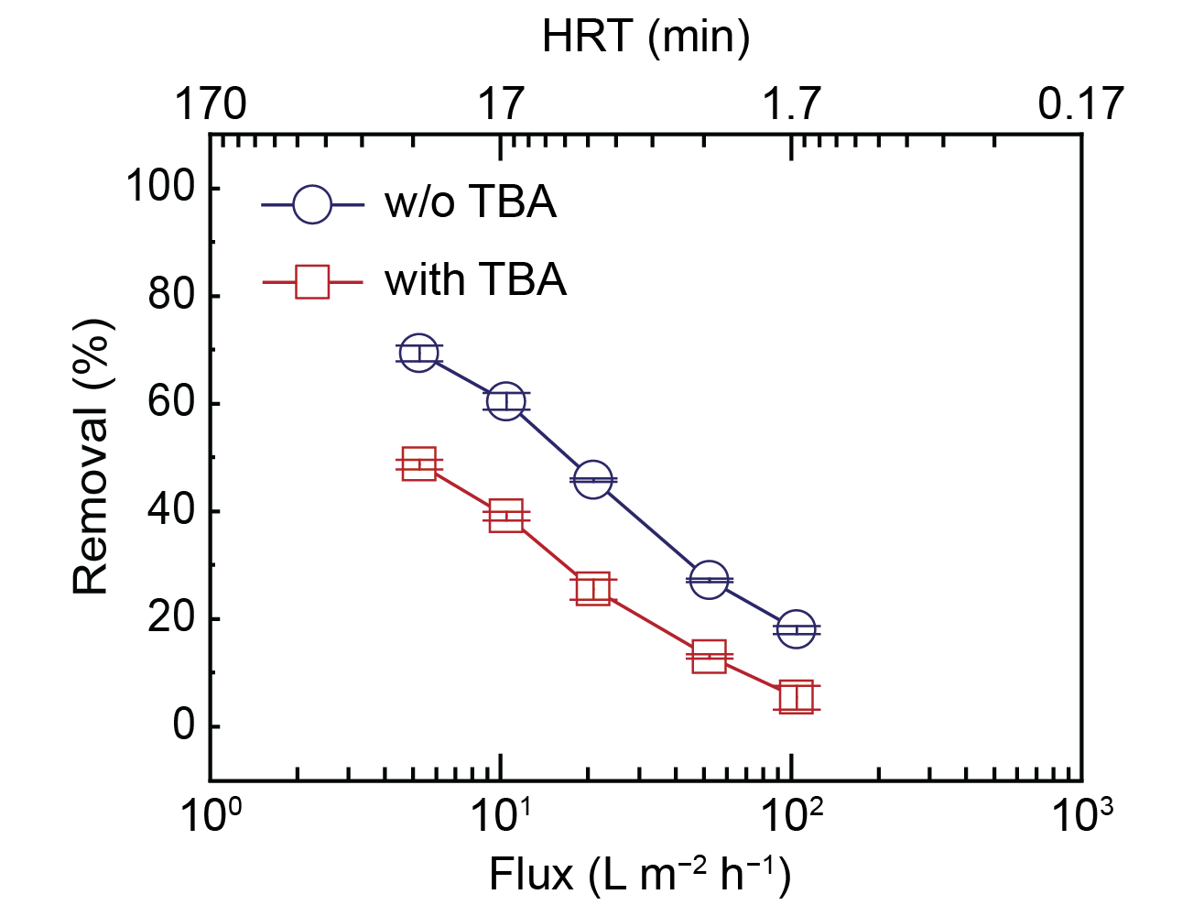
Supplementary Figure 15. BA removal efficiency with 1 M TBA as a radical scavenger. The feed solution was 1 mM BA in 100 mM NaClO₄ electrolyte. Applied current density was 4 mA cm⁻², and water flux varied from 5-105 L m⁻² h⁻¹ (HRT from 27-1.7 min).

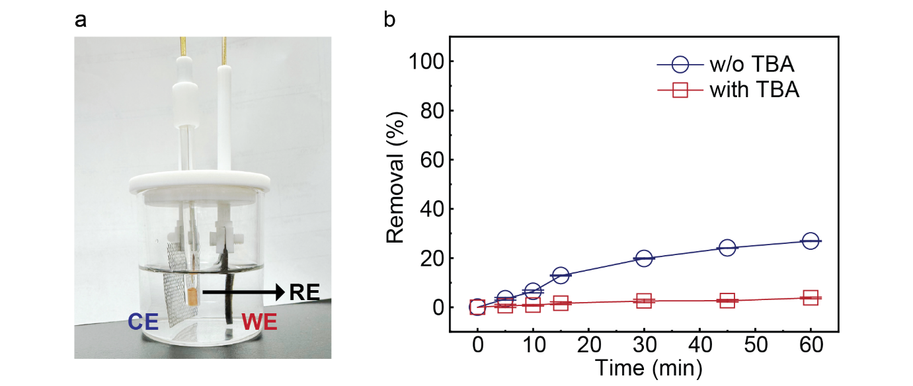
Supplementary Figure 16. BA removal efficiency with 1 M TBA as a radical scavenger in a batch reactor. (a) Batch reactor setup. The working electrode was a Pd-doped TiO_{x} nanowire filter, and the counter electrode was a platinized Ti mesh. The Ag/AgCl/KCl (saturated) was applied as the reference electrode. The surface area of both working and counter electrodes was 5.7 cm². (b) BA removal efficiency with 1 M TBA as a radical scavenger. The electrolyte was 50 mL of 100 mM NaClO₄ with an initial BA concentration of 1 mM. The experiment was conducted under a constant current density of 4 mA cm⁻². The results indicated that ~25% BA removal was achieved after 60 min treatment in the absence of TBA, whereas adding TBA reduced the removal efficiency to less than 5%.
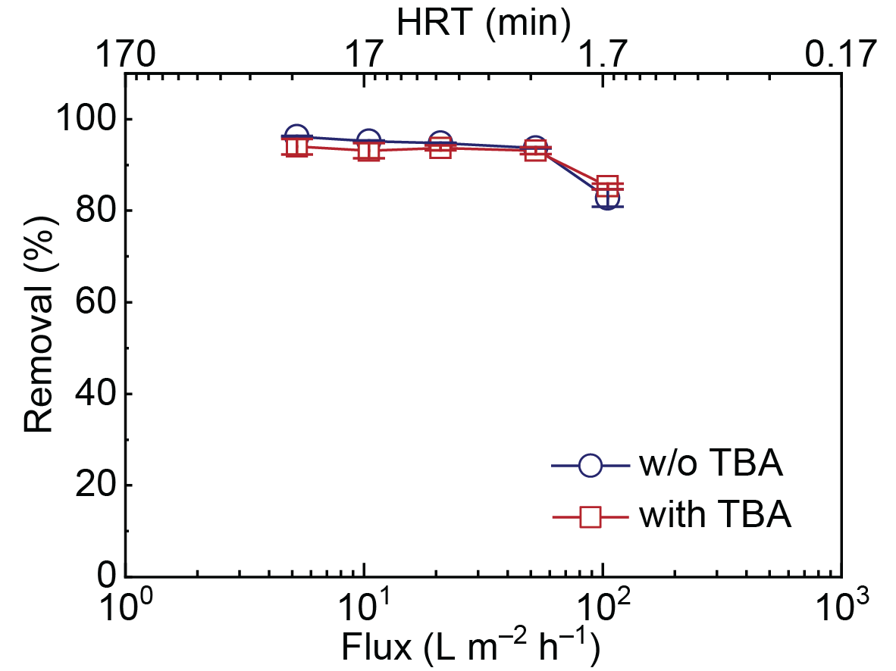
Supplementary Figure 17. Oxalate removal efficiency with 1 M TBA as a radical scavenger. The feed solution of 1 mM Na₂C₂O₄ was in 100 mM NaClO₄ electrolyte. Applied current density was 4 mA cm⁻², and water flux varied from 5-105 L m⁻² h⁻¹ (HRT from 27-1.7 min).
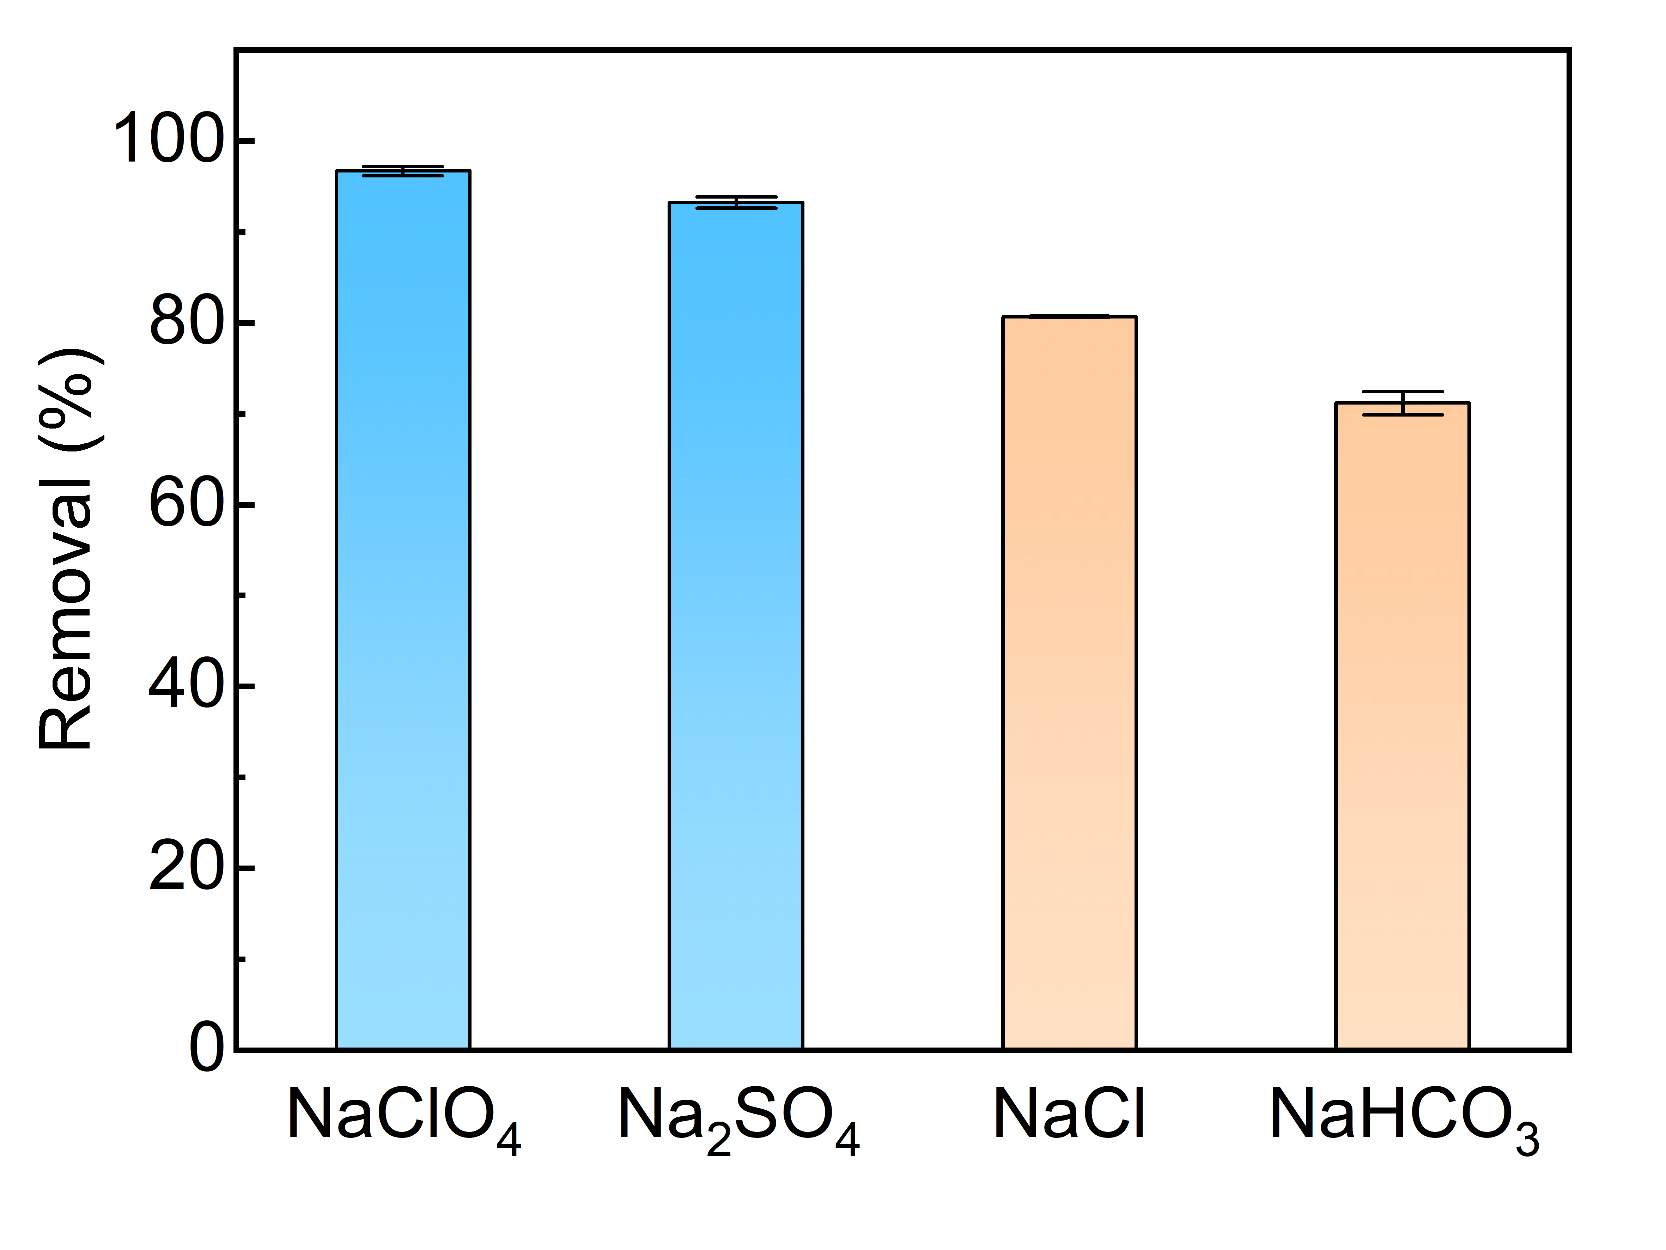
Supplementary Figure 18. BA removal efficiency in different electrolytes. The feed solution was 25 μM BA in 100 mM of NaClO₄, Na₂SO₄, NaCl, and NaHCO₃ electrolyte, respectively. Applied current density was 4 mA cm⁻², and water flux was 11 L m⁻² h⁻¹. Both NaClO₄ and Na₂SO₄ achieved high BA removal efficiencies (>93%), whereas NaCl and NaHCO₃ resulted in reduced efficiencies of 81% and 72%, respectively. The performance drop in NaCl electrolyte can be attributed to the lower oxidation overpotential of Cl⁻ (2Cl⁻ → Cl₂(g) + 2e⁻, E°= 1.36 V vs. SHE), which enables Cl⁻ oxidation to compete with EO at the anode. The performance drop in NaHCO₃ electrolyte is likely due to the adsorption of HCO₃⁻ on active sites, blocking the electron transfer to the pollutants.
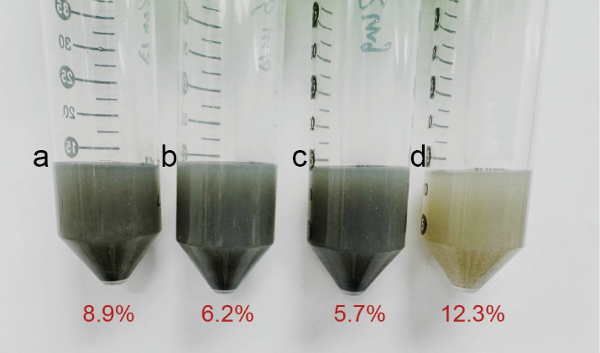
Supplementary Figure 19. Optical images and corresponding XPS lattice oxygen ratio of Pd doped TiO_{x} nanowires after long-term EO operation. The experiments were conducted under (a) 1.4 mA cm⁻², (b) 1.0 mA cm⁻², and (c) 0.5 mA cm⁻² in 100 mM NaClO₄ electrolyte, and (d) 0.5 mA cm⁻² in simulated groundwater matrix. After treatment, each filter was immersed in 12 mL of ethanol and sonicated for 30 min to ensure all the nanowires were detached from the substrate. The nanowires recovered from (d) showed a much lighter color and higher lattice oxygen ratio than those recovered from (a-c), which indicated the severe nanowire deactivation due to the groundwater matrix effect.

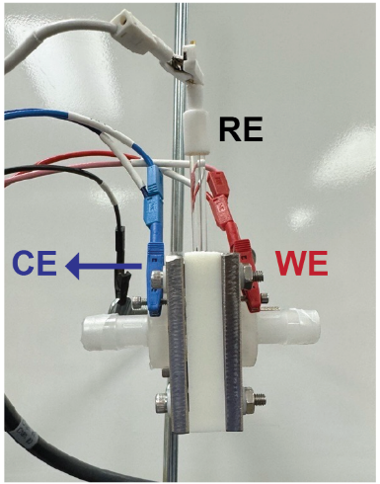
Supplementary Figure 20. Cell setup for electrochemical characterization of the nanowire filter. The working electrode was the nanowire filter, and the counter electrode was a platinized Ti mesh. The surface area of both electrodes was 5.7 cm². The Ag/AgCl/KCl (saturated) was applied as the reference electrode in the middle of a polytetrafluoroethylene spacer (thickness: 1.2 cm). The reactor cell was initially mounted vertically, and the feed solution was pumped through the chamber to ensure full wetting of both the working and counter electrodes to mimic the flow-through status. Afterward, the inlet and outlet were capped, the reactor was positioned horizontally, and electrochemical characterization was performed.

Supplementary Table
Supplementary Table 1. Composition of the simulated groundwater⁴
Ions | Concentration (mM) | Molecular Weight | Concentration (mg L⁻¹)
HCO₃⁻ | 15 | 61.02 | 915.3
Cl⁻ | 9 | 35.45 | 319.05
SO₄²⁻ | 1 | 96.06 | 96.06
Na⁺ | 20 | 22.99 | 459.8
Ca²⁺ | 2 | 40.09 | 80.18
Mg²⁺ | 1 | 24.31 | 24.31

Supplementary References
1. Al-Hajji, L. et al. Comparison of TiO2 nanowires and TiO2 nanoparticles for p hotodegradation of resorcinol as endocrine model. Journal of Nanoparticle Research 22, 40 (2020).
2. Korduban, O., Kryshchuk, T., Kandyba, V. & Trachevskii, V. XPS studies of the surface of TiO 2: Ag nanopowders. Chemistry, Physics and Technology of Surface 11, 547-555 (2020).
3. Peuckert, M. XPS study on surface and bulk palladium oxide, its thermal stability, and a comparison with other noble metal oxides. The Journal of Physical Chemistry 89, 2481-2486 (1985).
4. Zhou, X., Stetzenbach, K. J., Johannesson, K. H. & Farnham, I. M. Major ion geochemistry of groundwaters from southern Nevada and eastern California, USA. Chinese Journal of Geochemistry 19, 1 (2000).

