Supplementary Information

Bactericidal activity of novel calcium-based core-shell particles and its mechanism of action

Mehdi Mohammadi^{a,b}, Noora Naif Darwish^{b}, Gopal Ramamourthyª, Ian A Lewisª *, Maen Husein^{b}*

ªAlberta Centre for Advanced Diagnostics (ACAD), Department of Biological Sciences, University of Calgary, AB, Canada
^{b}Department of Chemical and Petroleum Engineering, University of Calgary, AB, Canada

E. coli 25922GFP
E. coli 25922GFP is a genetically modified version of the reference strain E. coli ATCC 25922, widely used in antimicrobial testing and biofilm studies. It expresses green fluorescent protein (GFP), allowing real-time visualization of bacterial behavior without altering its core characteristics. GFP, derived from Aequorea victoria, emits bright green fluorescence when exposed to blue light and is highly stable, with a half-life of about 26 hours at 37°C. This strain maintains growth similar to its parent and is ideal for tracking bacterial viability, adhesion, and biofilm formation in various research settings (Andersen et al., 1998).

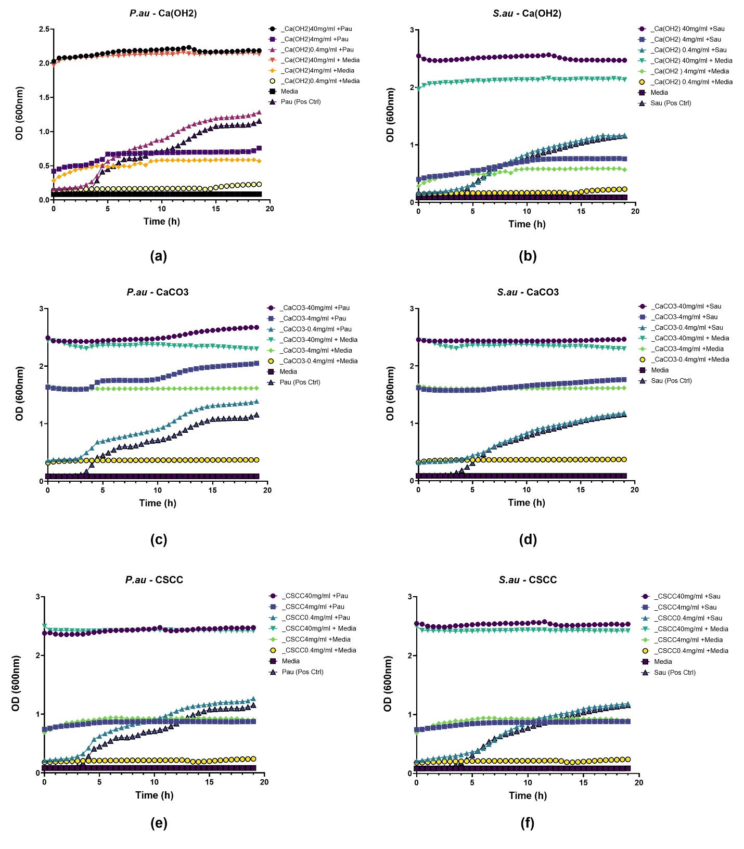 Figure S2, Optical density measurement result

Figure S3, protocol of Broth dilution method and spot plating

Zeta Potential measurements
Table S1: Zeta potential measurements for particles and E. coli bacteria
Sample | Zeta Potential (mV) | pH
${Ca(OH)}_{2}$ – 0.1 wt% | 24.9 | 12.29
${CaCO}_{3}$ – 0.1 wt% | 0.99 | 8.74
CSCC – 0.1 wt% | 31.7 | 11.87
E. coli – 5.5 OD | -18.0 | 6.69
E. coli – 0.75 OD | -17.0 | 6.84
E. coli – 0.075 OD | -15.8 | 6.89
E. coli – 0.0075 OD | -16.1 | -
MH medium | -15.1 | 6.62

