Supporting information for
Treatment of polluted urban surface waters by sponge based aerobic biofilm reactor: Purification performances and resilience

Shangwei He ^{a,b}, Na Songª, Zongbao Yao ª, Helong Jiang ^{a*}

- State Key Laboratory of Lake Science and Environment, Nanjing Institute of Geography and Limnology, Chinese Academy of Sciences, Nanjing 210008, China
- University of Chinese Academy of Sciences, Beijing 100049, China

Corresponding author: Nanjing Institute of Geography and Limnology, Chinese Academy of Sciences, 73 East Beijing Road, Nanjing 210008, China.
E-mail address: hljiang@niglas.ac.cn

There are 4 pages in this SI, containing 3 figures.

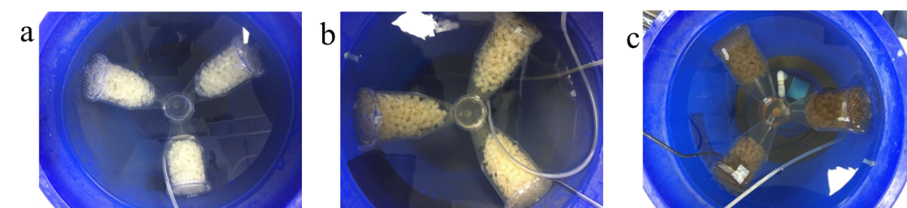
Fig. S1 Appearances of the biofilms attached on polyurethane sponges in SABR at different times. (a) 0 day; (b) 20th days; (c) 100th days (Only filling ratio by 80% were present.)

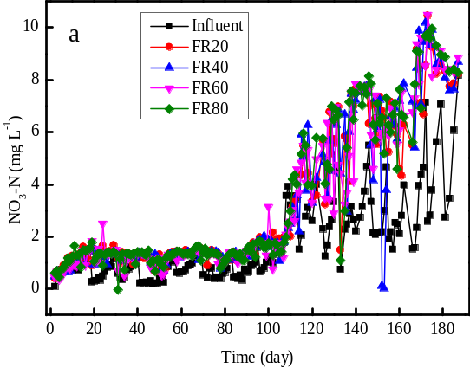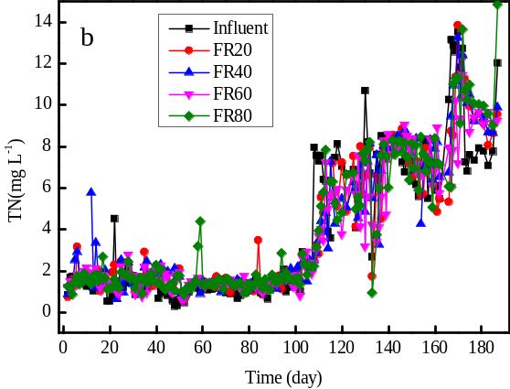
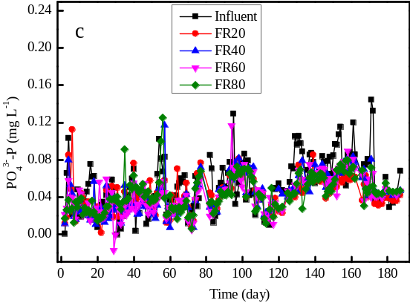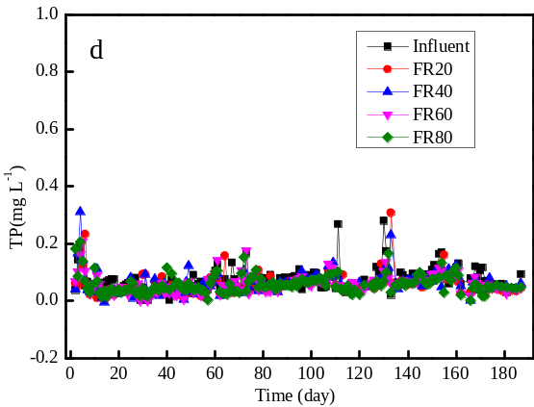
Fig. S2 Water qualities in continuous experiments by SABRs (Filling ratios by 20%, 40%, 60%, 80% were referred to as FR20, FR40, FR60, and FR80, respectively).

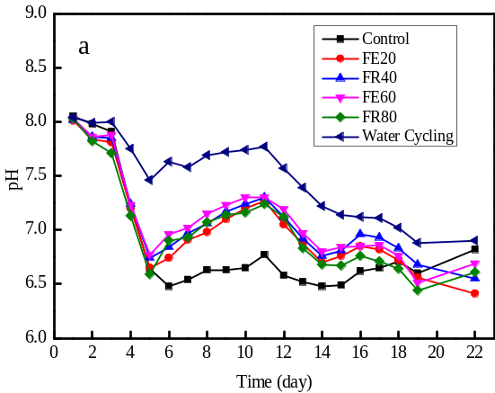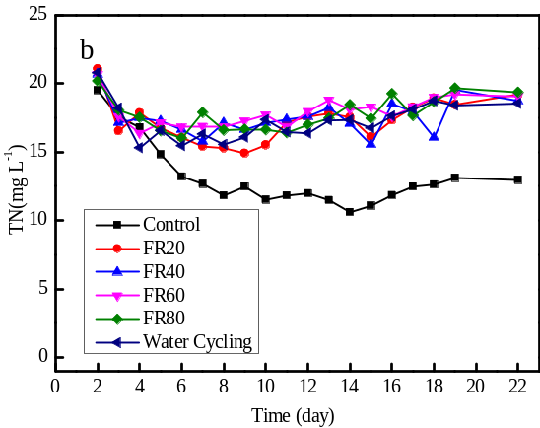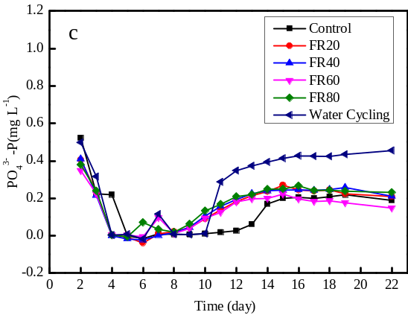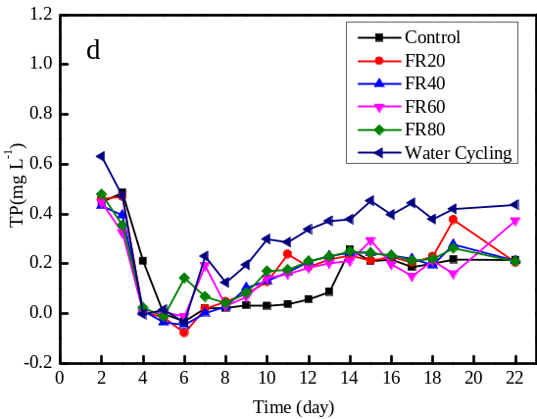
Fig. S3 Purification performances of SABRs in stageⅤ(TOC were 59.56±3.09 mg L⁻¹ at the beginning of the experiment. Filling ratios by 20%, 40%, 60%, 80% were referred to as FR20, FR40, FR60 and FR80, respectively).

