The global potential of aquavoltaics for power generation and offsetting the carbon footprint of freshwater aquaculture

Supplementary Notes 1
Supplementary Note 1: Scenarios for future greenhouse gas (GHG) emissions from freshwater aquaculture 2
Supplementary Figures 3
Supplementary Figure 1 3
Supplementary Figure 2 3
Supplementary Figure 3 4
Supplementary Figure 4 4
Supplementary Figure 5 5
Supplementary Figure 6 5
Supplementary Figure 7 6
Supplementary Figure 8 6
Supplementary Figure 9 7
Supplementary Tables 7
Supplementary Table 1 7
Supplementary Table 2 7
Supplementary Table 3 9
Supplementary References 11

Supplementary Notes
Supplementary Note 1: Scenarios for future greenhouse gas (GHG) emissions from freshwater aquaculture
In this study, we estimated GHG emissions from freshwater aquaculture in various countries in 2050 under three socioeconomic scenarios, based on Shen et al.¹. These scenarios are derived from the Food and Agriculture Organization of the United Nations (FAO) projections for the future of food and agriculture systems. The scenarios covered include ²:

Business as usual (BAU). The scenario is mostly characterized by a continuation of past trends and policy directions. This scenario is designed to help understand what the world would look like should outstanding challenges for food and agricultural systems remain unaddressed. Under the BAU scenario, the global economy grows at moderate rates, with significant disparities across regions. Moreover, significant inequalities persist within societies in terms of income, earning opportunities and access to basic goods and services. Consumers in high-income countries maintain their preferences for resource-intensive food, including animal products. In low-and middle-income countries, the relatively limited income expansion does not favour a transition towards healthier diets, despite some convergence towards the caloric consumption levels of high-income countries. Limited investments are undertaken to increase the sustainability of food and agricultural systems, as well as of other sectors of the economy, such as the energy sector. GHG emissions therefore keep rising, and climate change is only partially mitigated.

Towards Sustainability (TSS). The scenario is designed to help understand which proactive changes are needed to build more sustainable food and agricultural systems. Under this scenario, the global economy grows at moderate rates, as under the BAU scenario. However, income, earning opportunities and access to basic goods and services are more equitably distributed across countries and layers of societies thanks to proactive policies that are implemented as soon as possible, with improved governance and stronger national and international institutions. Diets in high-income countries shift towards a higher intake of fruits and vegetables and a lower intake of animal products due to a rising consumer awareness regarding sustainability issues, while income growth in low- and middle-income countries favors more balanced diets than in BAU. Not only do consumers adopt more sustainable diets; they also take action to reduce waste. Significant investments are undertaken to increase the environmental sustainability of food and agricultural systems, as well as of other sectors of the economy. This leads to an increased efficiency in the use of natural resources and reductions in post-harvest losses. GHG emissions are progressively reduced to help realize stronger climate change mitigation than under the BAU scenario.

Stratified Societies (SSS). The scenario describes a future of exacerbated inequalities in terms of income, earning opportunities and access to essential goods and services across countries and layers of societies. Under this bleaker scenario, the global economy grows at faster rates than under the other two scenarios. However, selected regions – and particularly sub-Saharan Africa (SSA) – do not benefit significantly from this faster growth. Income, earning opportunities and access to goods and services are increasingly skewed to the advantage of elites, leaving large pockets of marginalized people. Consumption preferences tilt towards more animal products everywhere, while food waste increases, particularly in high-income countries. Limited or no investments are made to increase the sustainability of food and agricultural systems or of other sectors of the economy, particularly in low-income countries. As a consequence, the depletion and inefficient use of natural resources increases, as does food loss at all levels of the food value chain. GHG emissions also rise, leading to exacerbated climate change with severe impacts on human activities and the environment.

Supplementary Figures
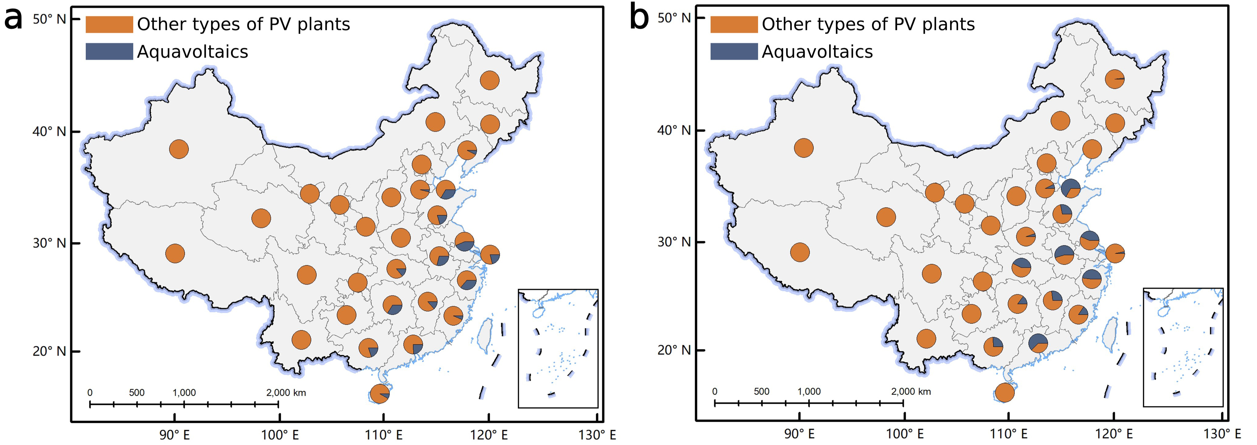
Supplementary Figure 1: a, Proportion of aquavoltaics area to total area of PV plant across Chinese provinces as of 2022. b, Proportion of newly added aquavoltaics area to newly added area of PV plant in 2022. Spatial distribution data of PV plants in China are derived from Chen et al. ³.

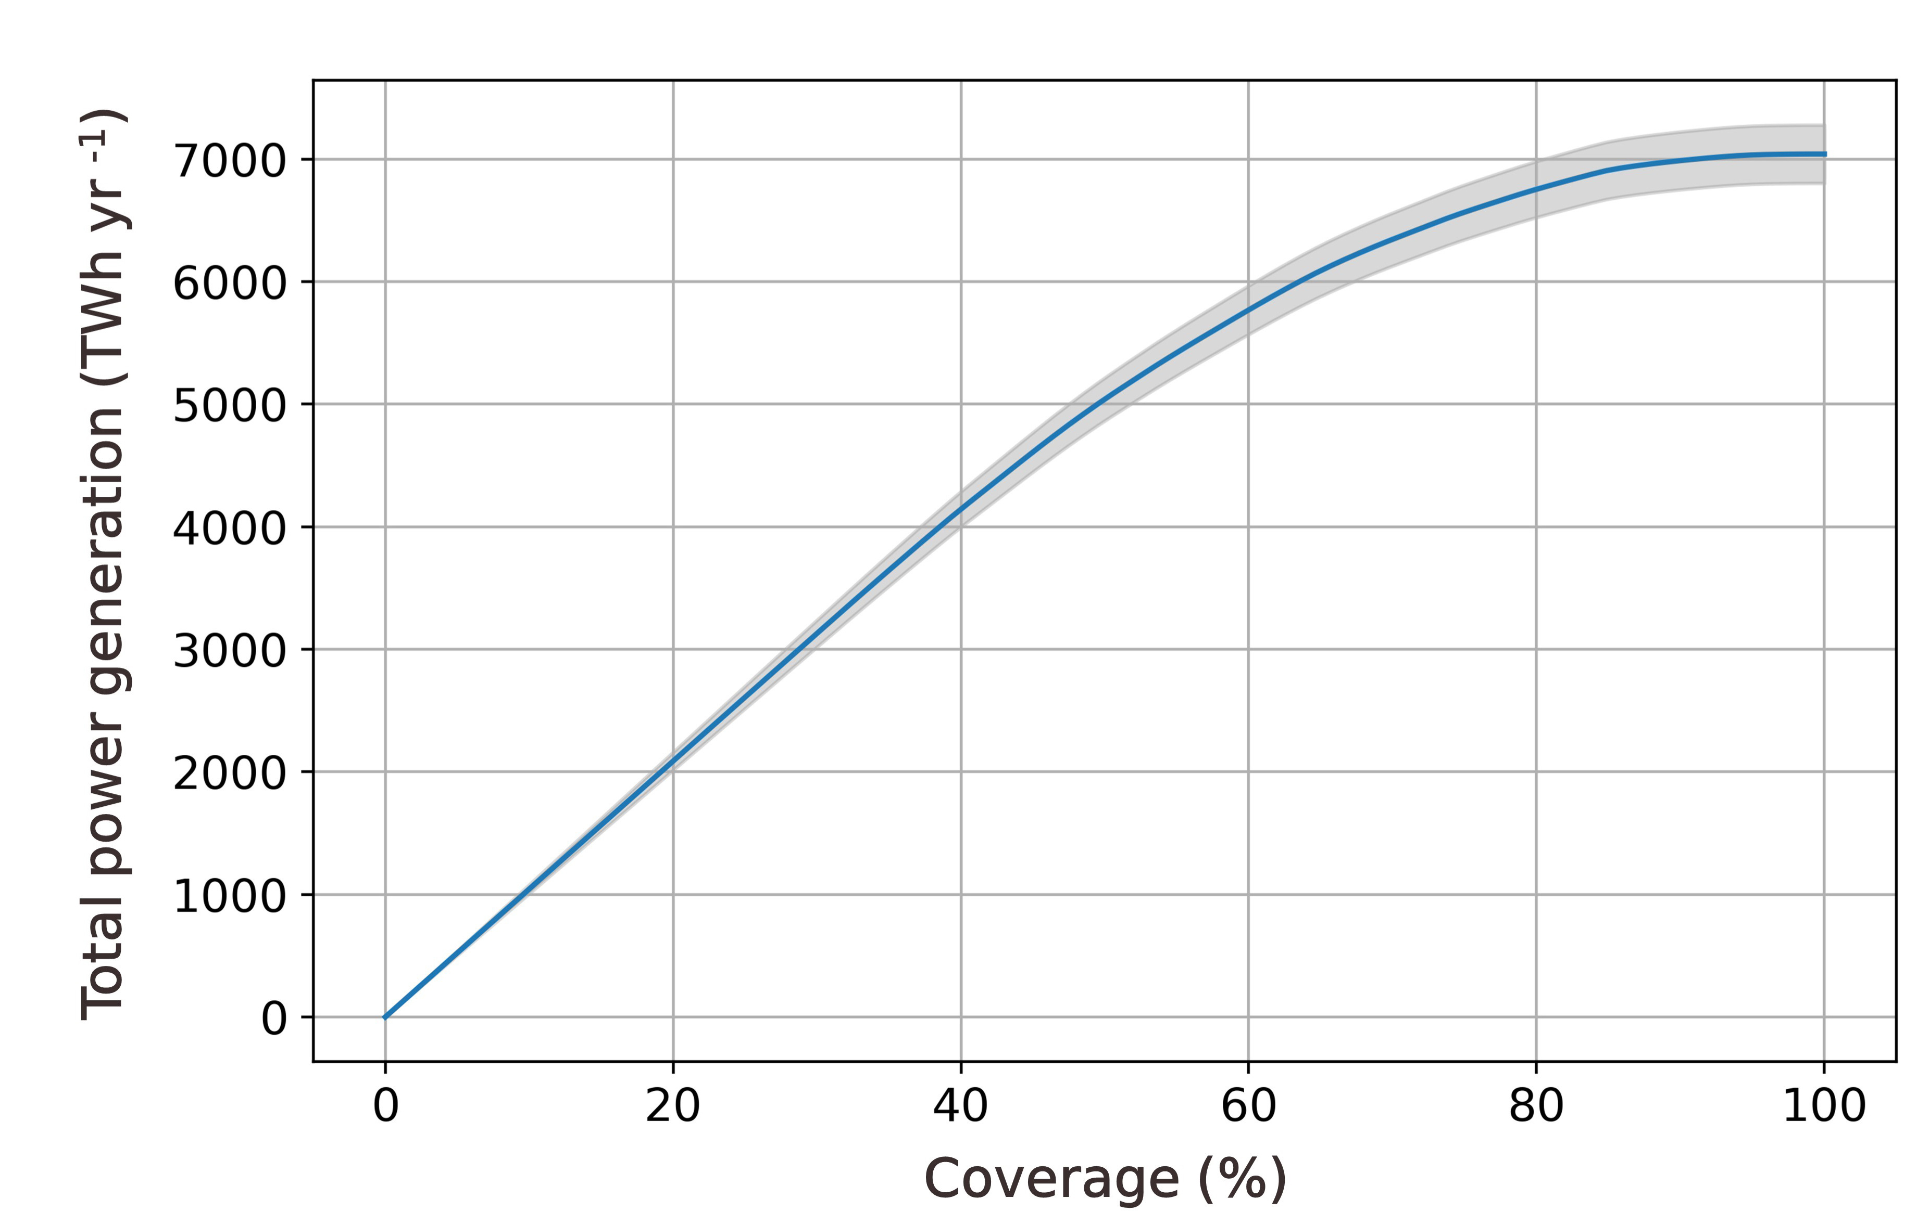
Supplementary Figure 2: Global electricity generation potential for aquavoltaics across varying coverage rates. Grey shading indicates standard deviation.
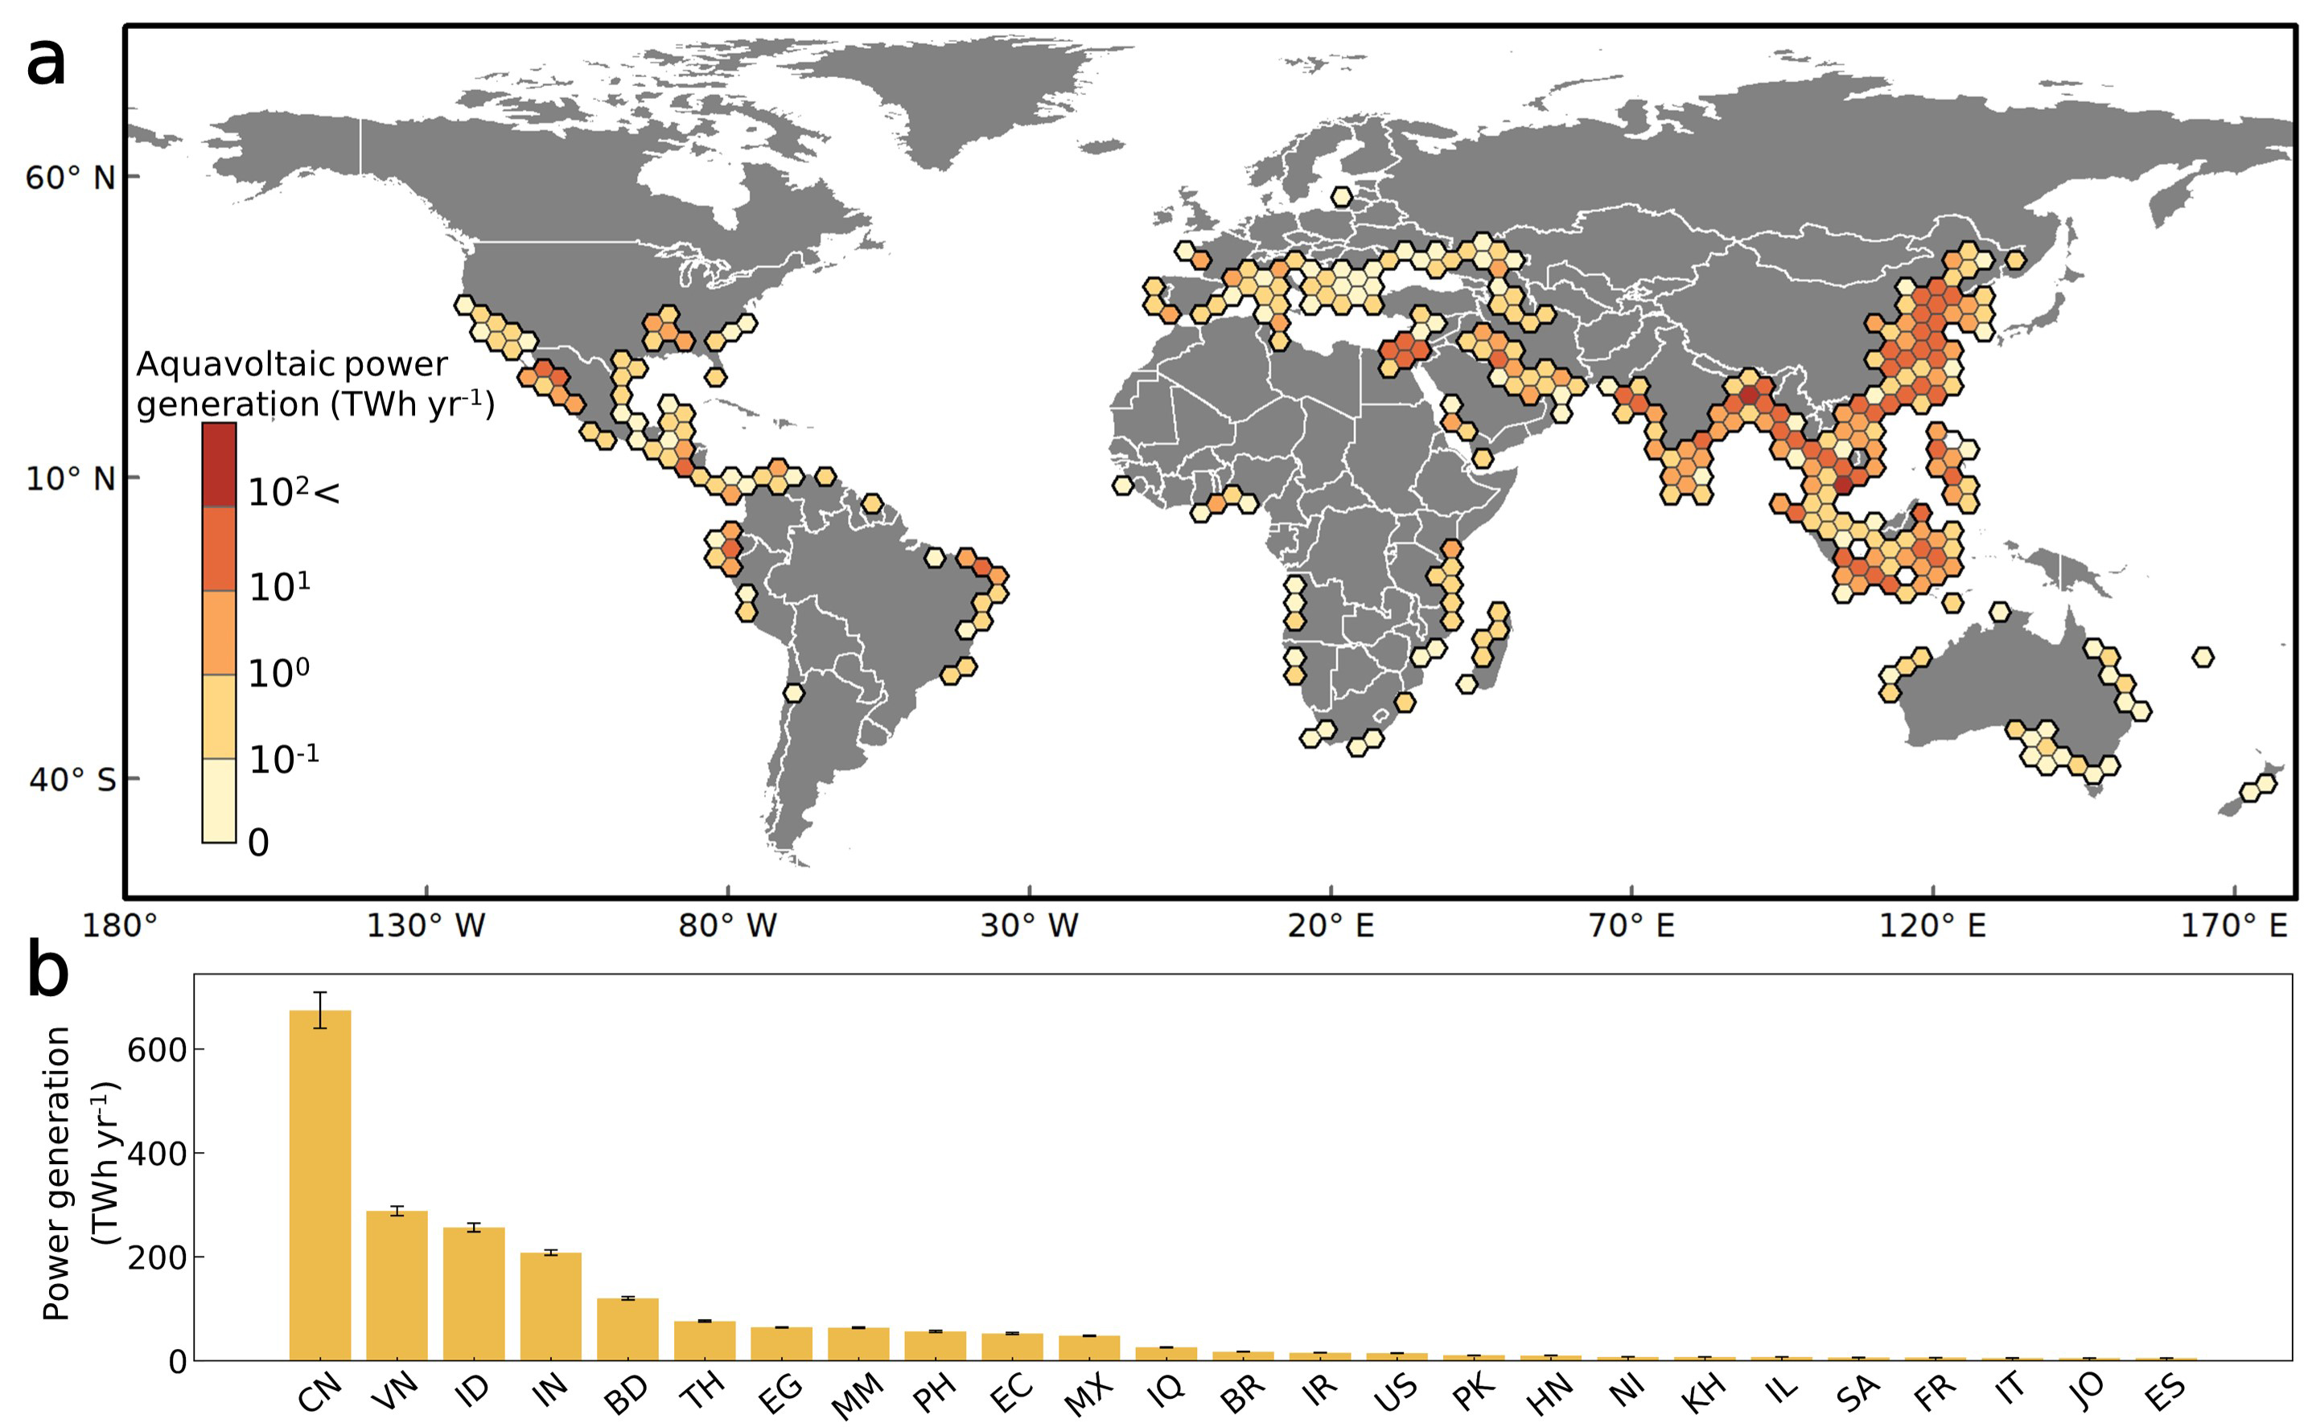
Supplementary Figure 3: Global electricity generation potential for aquavoltaics at a coverage of 20%. a, Mean annual electricity generation potential for aquavoltaics from 2001 to 2023 across a 3-degree hexagonal grid. b, Top 25 countries ranked by aquavoltaic power generation potential. Error bars indicate the standard deviation.

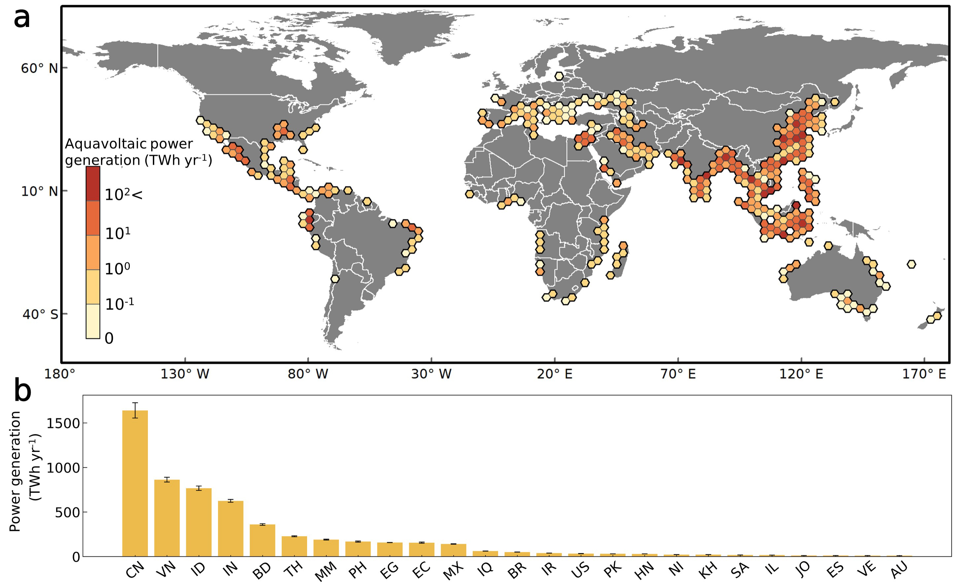
Supplementary Figure 4: Global electricity generation potential for aquavoltaics at a coverage of 60%. a, Mean annual electricity generation potential for aquavoltaics from 2001 to 2023 across a 3-degree hexagonal grid. b, Top 25 countries ranked by aquavoltaic power generation potential. Error bars indicate the standard deviation.

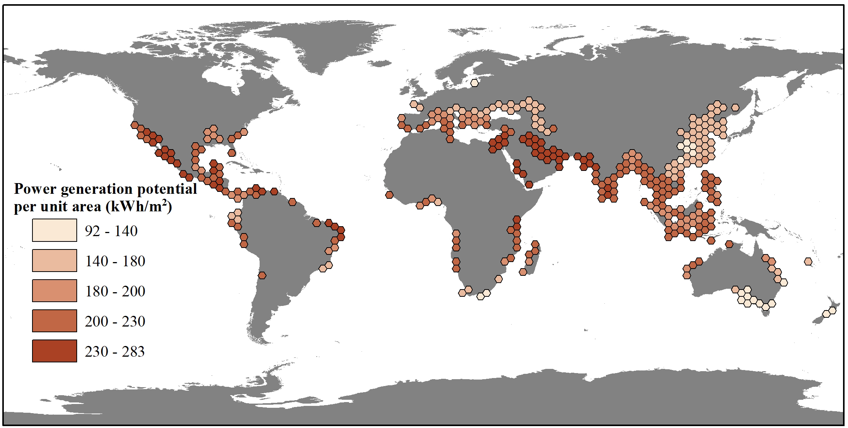
Supplementary Figure 5: Spatial distribution of mean annual electricity generation potential per unit area for aquavoltaics from 2001 to 2020 across a 3-degree hexagonal grid.

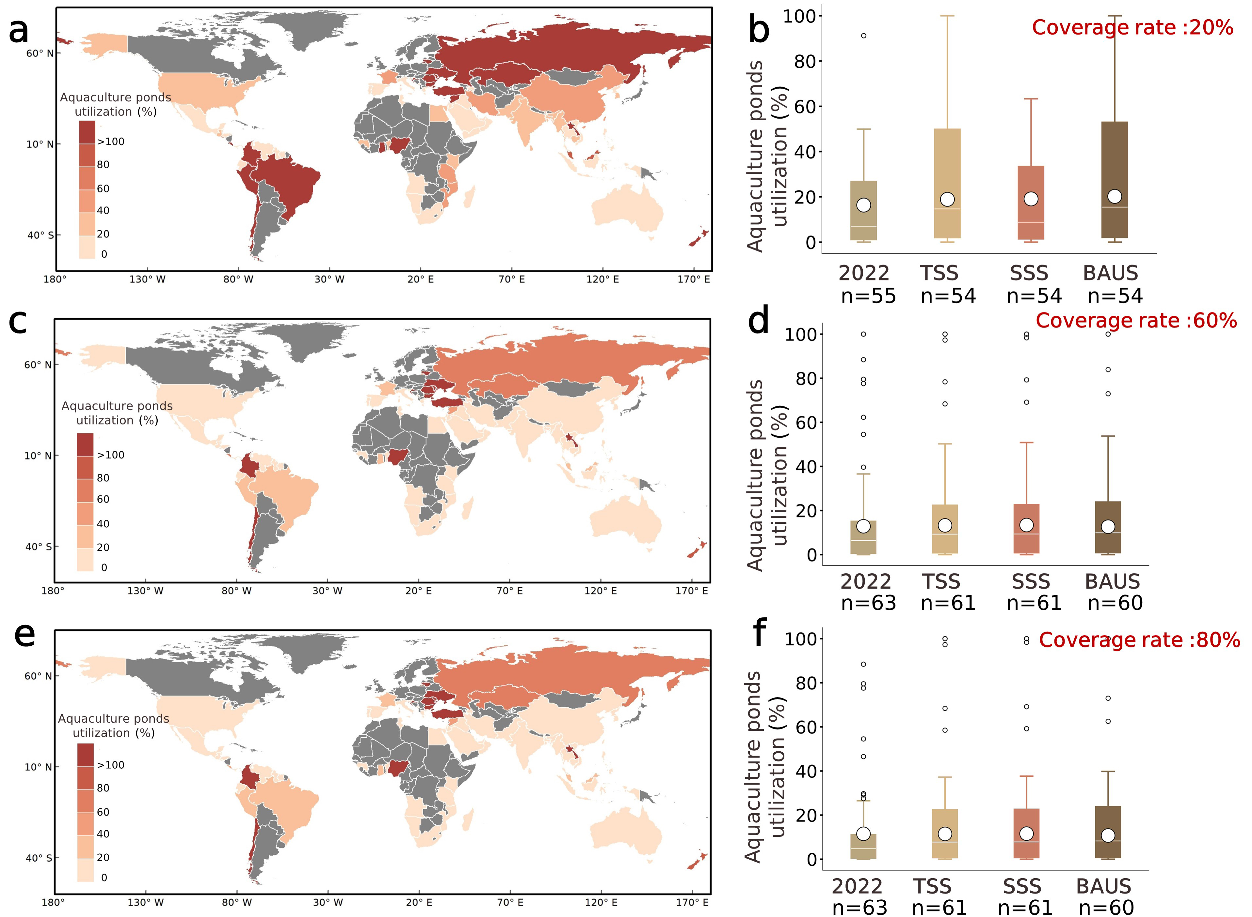
Supplementary Figure 6: National freshwater aquaculture emission offsetting through aquavoltaics deployment under different coverage scenarios. a, c, e, Required aquaculture pond utilization for aquavoltaics deployment to fully offset 2022 GHG emissions under 20%, 60%, and 80% panel coverage assumptions, respectively. b, d, f, Comparison of required pond utilization for aquavoltaics deployment under 20%, 60%, and 80% panel coverage assumptions to offset GHG emissions in 2022 and 2050 across three socioeconomic scenarios (SSS, TSS, and BAUS). The white line within the boxplots indicates the mean, while the white dot represents the median of the boxplots. n indicates the number of countries where the required utilization does not exceed 100%.

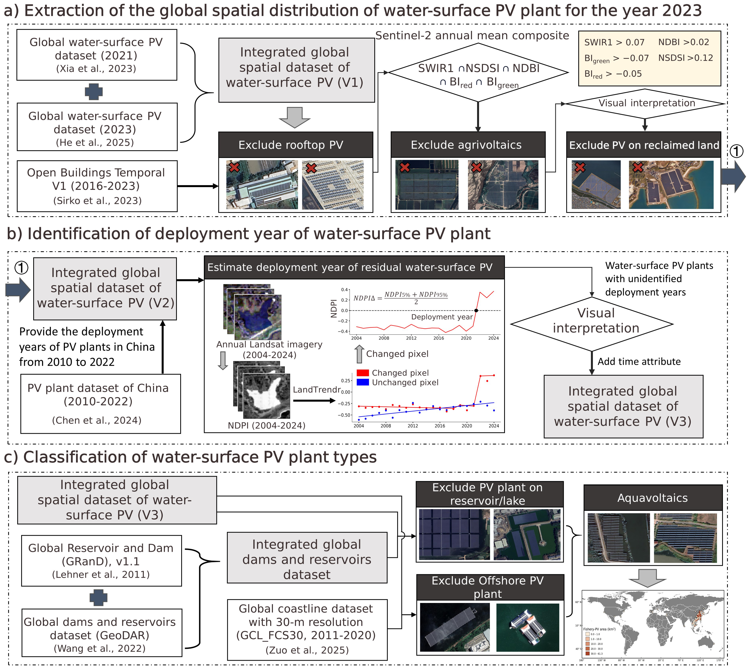
Supplementary Figure 7: Framework for mapping the global spatiotemporal distribution of aquavoltaics in this study.
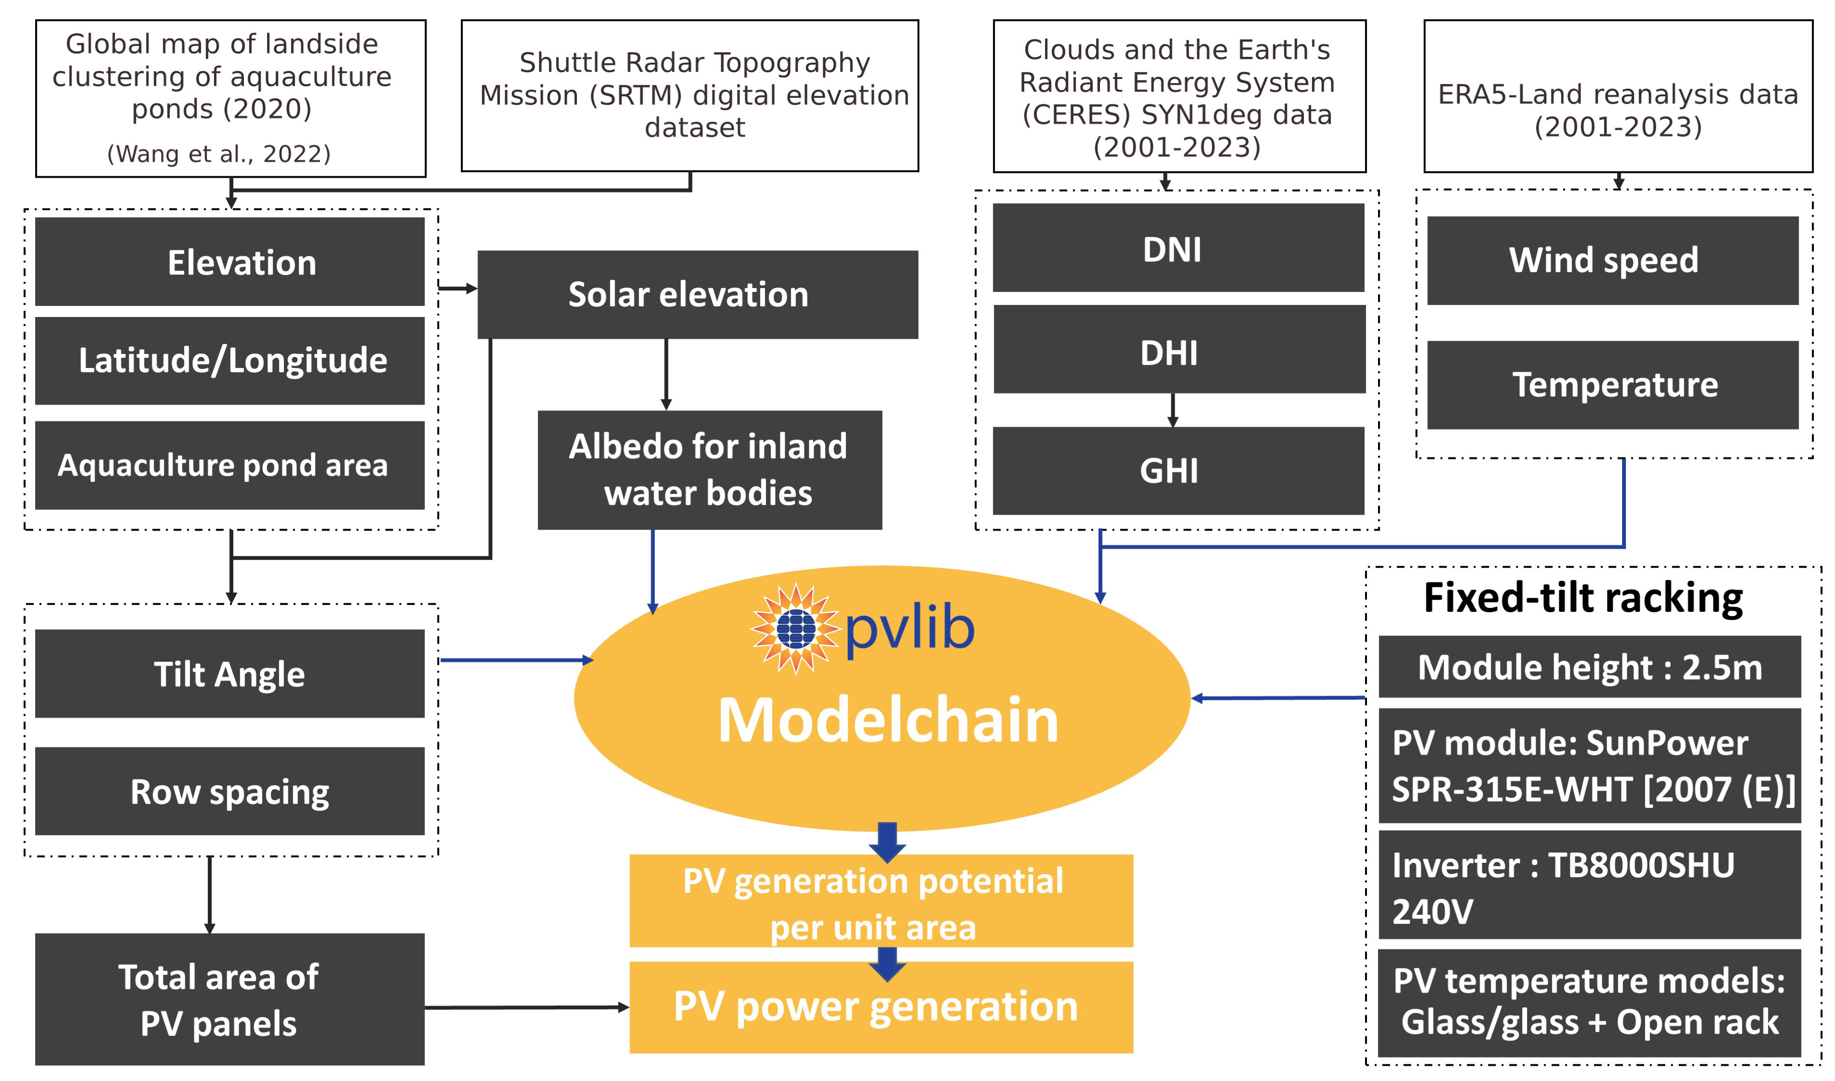
Supplementary Figure 8: Workflow for estimating the power generation potential of aquavoltaics using pvlib-python in this study.
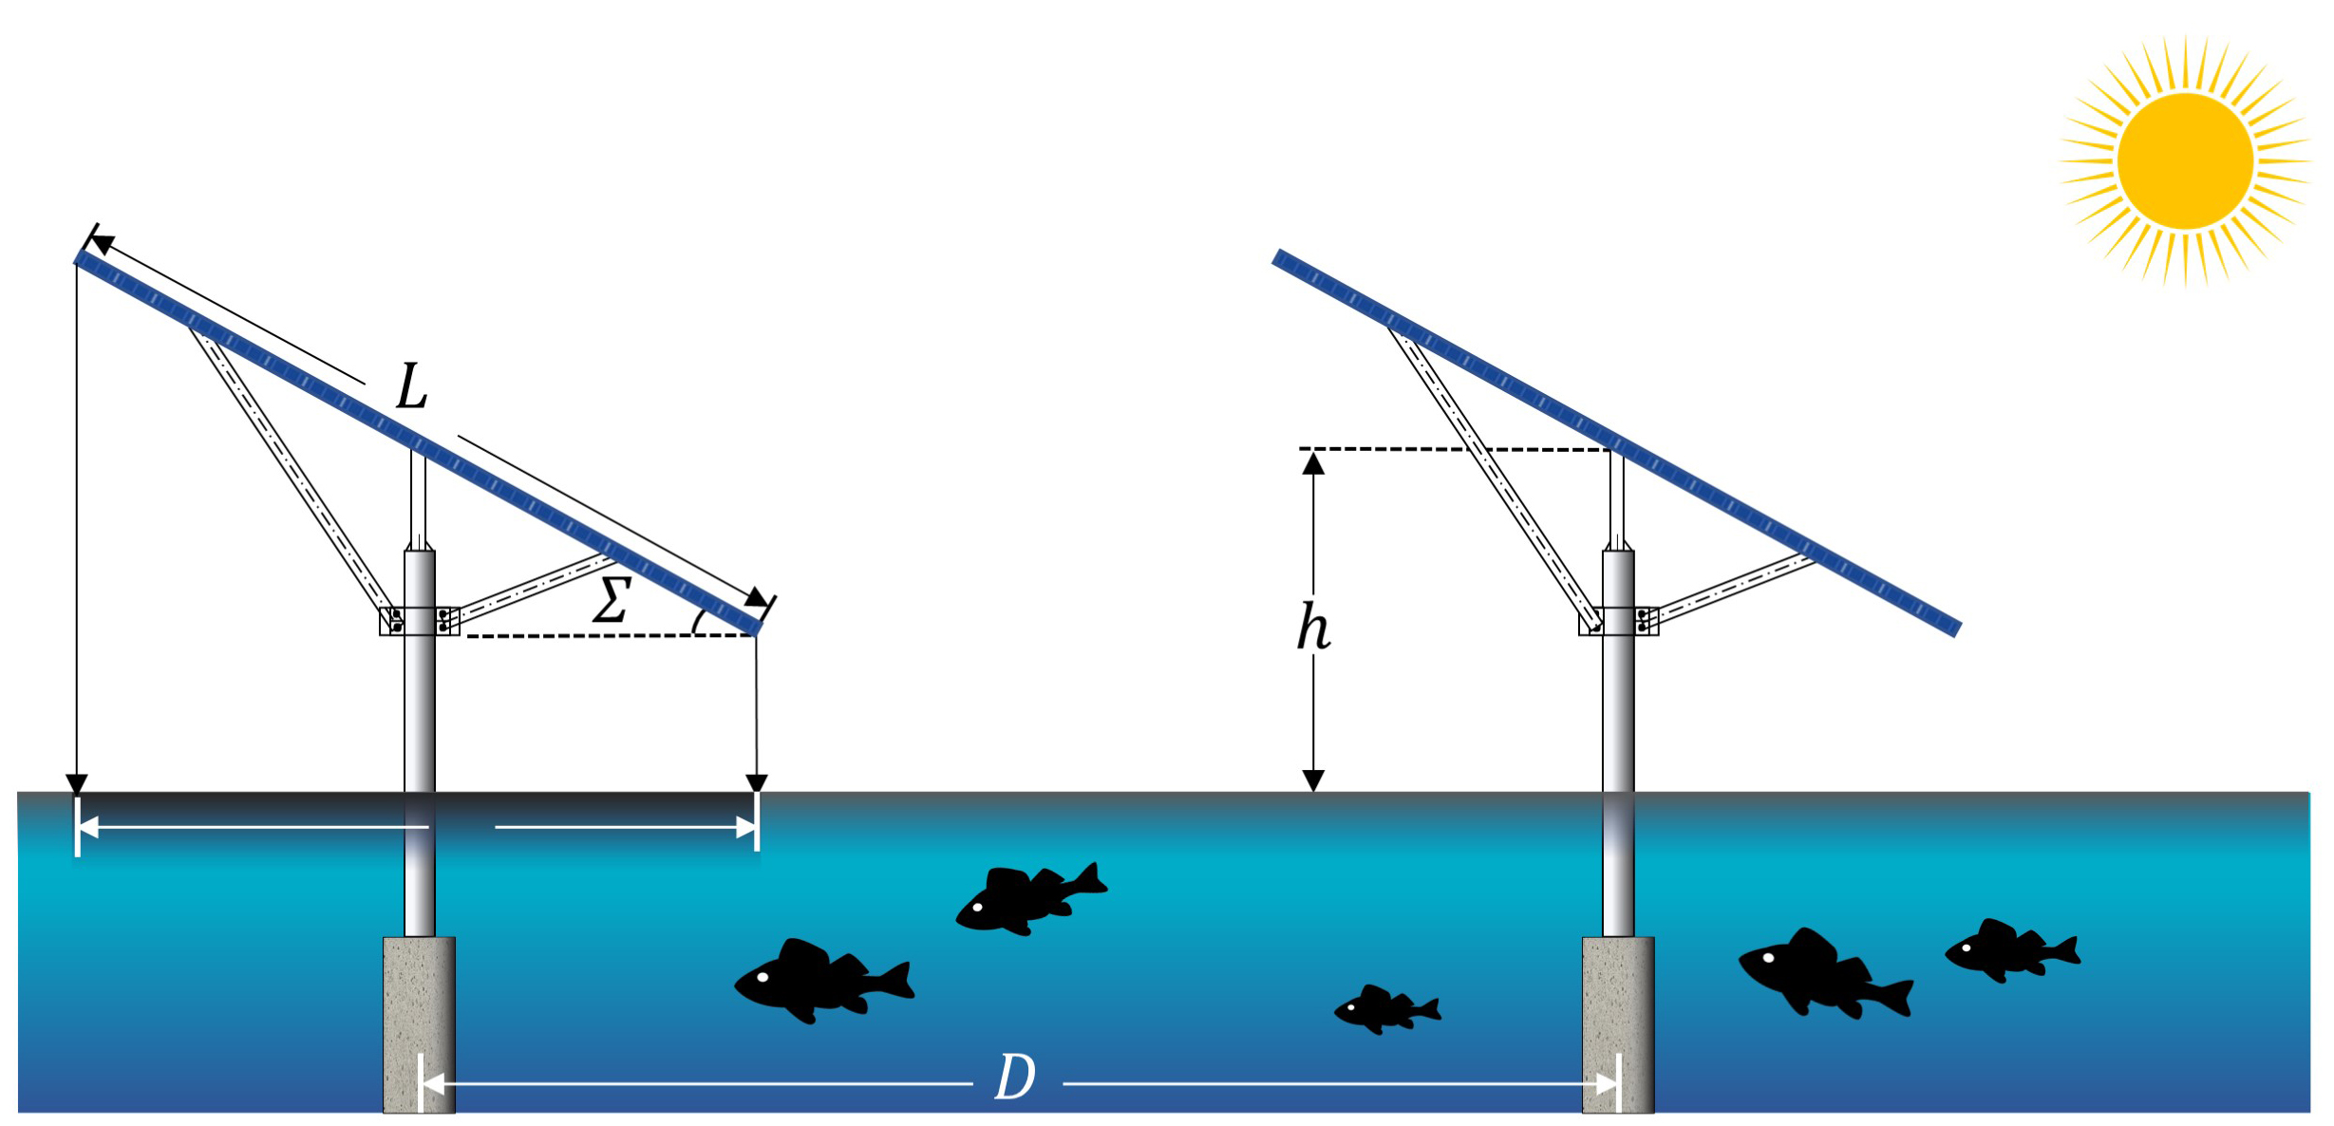
Supplementary Figure 9: Common Aquavoltaics design and installation parameters used for estimating power generation potential in this study.

Supplementary Tables
Supplementary Table 1: Deployment area of aquavoltaics and other WSPV types across countries.
Country | Area (ha) |  | Country | Area (ha)
Country | Aquavoltaics | Other WSPV types | Country | Aquavoltaics | Other WSPV types
China | 41261.63 | 12703.44 | Germany | 0.00 | 10.85
Vietnam | 380.52 | 1067.51 | Spain | 5.95 | 3.65
South Korea | 294.50 | 464.10 | Belgium | 0.00 | 8.76
Japan | 0.00 | 524.38 | Cambodia | 1.18 | 5.85
Thailand | 189.72 | 266.82 | Portugal | 0.00 | 5.50
Israel | 133.78 | 152.55 | Ghana | 0.00 | 3.92
Netherlands | 0.00 | 206.29 | Luxembourg | 0.00 | 3.73
India | 22.87 | 179.84 | Myanmar | 2.50 | 0.00
Malaysia | 12.56 | 118.98 | Albania | 0.00 | 1.90
Singapore | 0.00 | 67.28 | New Zealand | 0.00 | 1.47
United States | 15.23 | 19.66 | Brazil | 0.00 | 1.23
France | 0.00 | 31.89 | Italy | 0.42 | 0.70
Syria | 1.91 | 19.06 | Australia | 0.05 | 0.00
Laos | 10.06 | 2.31 | World | 42332.89 | 15883.83
United Kingdom | 0.00 | 12.171

Supplementary Table 2: Area of land clustered aquaculture ponds (LCAP), electricity generation potential, and electricity generation potential per unit area by country.
Country | Area of LCAP (km²) | Generation potential (GWh/yr) | Generation potential per unit area  (kWh m⁻² yr⁻¹)
China | 21715.893 | 1321368.46 ± 68266.68 | 155.19 ± 8.00
Vietnam | 7062.895 | 575645.98 ± 17976.89* | 203.76 ± 6.36
Indonesia | 6276.251 | 511437.93 ± 16538.89* | 203.72 ± 6.59
India | 4747.493 | 416727.50 ± 10224.43 | 219.45 ± 5.38
Bangladesh | 3058.122 | 239968.00 ± 5993.06* | 196.17 ± 4.90
Thailand | 1769.000 | 151839.31 ± 3649.14 | 214.58 ± 5.16
Egypt | 1276.725 | 127919.49 ± 1353.46 | 250.48 ± 2.65
Myanmar | 1522.177 | 126882.66 ± 3009.75* | 208.39 ± 4.94
Philippines | 1337.234 | 112198.19 ± 4052.39* | 209.76 ± 7.58
Ecuador | 1518.794 | 104317.77 ± 4185.82* | 171.71 ± 6.89
Mexico | 942.125 | 95552.58 ± 1732.03 | 253.56 ± 4.60
Iraq | 506.407 | 50880.87 ± 887.72 | 251.19 ± 4.38
Brazil | 356.197 | 34108.63 ± 600.84 | 239.39 ± 4.22
Iran | 310.456 | 30106.07 ± 600.14 | 242.92 ± 4.85
United States | 361.419 | 28194.14 ± 972.30 | 195.03 ± 6.73
Pakistan | 204.215 | 20346.02 ± 307.56 | 249.08 ± 3.77
Honduras | 206.788 | 20083.98 ± 475.61* | 242.81 ± 5.75
Nicaragua | 144.453 | 14380.60 ± 326.38* | 248.88 ± 5.65
Cambodia | 165.583 | 14236.44 ± 316.25* | 214.94 ± 4.77
Israel | 141.414 | 14081.90 ± 180.91 | 248.95 ± 3.20
Saudi Arabia | 105.924 | 11511.74 ± 128.90 | 271.70 ± 3.04
Jordan | 96.891 | 9672.49 ± 124.01 | 249.57 ± 3.20
Spain | 109.378 | 9624.96 ± 192.41 | 219.99 ± 4.40
France | 155.238 | 9402.63 ± 221.95 | 179.52 ± 4.26
Italy | 140.226 | 7943.98 ± 262.39 | 176.43 ± 5.97
Venezuela | 81.510 | 7181.52 ± 167.45 | 220.26 ± 5.14
Australia | 110.486 | 7166.28 ± 236.09 | 162.15 ± 5.34
North Korea | 99.072 | 6457.06 ± 315.23 | 163.10 ± 7.96
Panama | 77.997 | 5781.45 ± 157.11 | 185.31 ± 5.04
Russia | 101.214 | 4632.77 ± 161.68 | 159.17 ± 5.59
Emirates | 40.492 | 4287.24 ± 59.75 | 264.70 ± 3.69
Kenya | 39.531 | 3955.33 ± 64.84 | 250.14 ± 4.10
Malaysia | 47.044 | 3835.17 ± 97.69 | 203.81 ± 5.19
Ghana | 45.703 | 3795.37 ± 53.91 | 207.61 ± 2.95
Peru | 39.748 | 3243.09 ± 98.40 | 203.98 ± 6.19
Tunisia | 34.407 | 3108.35 ± 44.67 | 225.85 ± 3.25
South Korea | 44.892 | 2950.64 ± 155.99 | 164.32 ± 8.69
Portugal | 35.586 | 2893.43 ± 77.26 | 206.22 ± 5.53
Sri Lanka | 29.673 | 2859.59 ± 36.09 | 240.92 ± 3.04
Colombia | 28.712 | 2643.22 ± 81.74 | 230.15 ± 7.12
Madagascar | 22.472 | 1884.01 ± 43.98 | 209.59 ± 4.89
Tanzania | 20.760 | 1841.14 ± 40.36 | 221.72 ± 4.86
Turkey | 20.135 | 1719.63 ± 27.93 | 213.52 ± 3.47
Namibia | 17.760 | 1475.95 ± 21.82 | 207.77 ± 3.07
Azerbaijan | 21.023 | 1456.90 ± 39.49 | 173.33 ± 4.70
Guatemala | 14.650 | 1386.06 ± 28.75 | 236.53 ± 4.91
Costa Rica | 15.742 | 1326.72 ± 38.02 | 210.70 ± 6.04
Greece | 11.765 | 916.00 ± 23.23 | 196.03 ± 4.98
Mozambique | 11.411 | 863.99 ± 31.72 | 189.29 ± 6.95
El Salvador | 8.954 | 854.66 ± 21.15 | 238.62 ± 5.90
Angola | 9.650 | 801.74 ± 18.65 | 207.71 ± 4.83
Yemen | 6.879 | 733.31 ± 19.21 | 266.50 ± 6.98
Albania | 11.165 | 672.02 ± 19.40 | 196.05 ± 5.66
Belize | 6.598 | 556.76 ± 15.85 | 210.96 ± 6.01
South Africa | 6.730 | 377.22 ± 19.57 | 140.12 ± 7.27
Benin | 4.671 | 359.10 ± 5.98 | 192.19 ± 3.20
Oman | 3.265 | 349.37 ± 3.70 | 267.49 ± 2.83
Montenegro | 4.390 | 234.53 ± 7.91 | 187.74 ± 6.34
Slovenia | 5.193 | 222.75 ± 9.78 | 162.16 ± 7.12
Suriname | 2.401 | 198.53 ± 3.93 | 206.68 ± 4.09
Romania | 3.526 | 160.76 ± 6.28 | 159.34 ± 6.16
Kazakhstan | 2.551 | 147.83 ± 4.50 | 164.66 ± 5.02
New Zealand | 4.496 | 143.37 ± 3.79 | 92.29 ± 2.44
Guinea | 1.177 | 103.79 ± 1.27 | 220.38 ± 2.70
Guyana | 1.132 | 101.99 ± 2.14 | 225.32 ± 4.72
Qatar | 1.044 | 98.26 ± 1.90 | 235.36 ± 4.54
Ukraine | 2.028 | 69.50 ± 2.31 | 156.68 ± 5.22
Lithuania | 4.633 | 67.75 ± 2.90 | 115.89 ± 4.97
Croatia | 1.218 | 53.41 ± 2.54 | 161.46 ± 7.67
Moldova | 1.249 | 51.10 ± 1.71 | 157.43 ± 5.28
Syria | 0.422 | 37.51 ± 0.50 | 226.24 ± 3.02
Bulgaria | 0.199 | 10.08 ± 0.47 | 159.10 ± 7.43
Nigeria | 0.046 | 3.16 ± 0.06 | 170.43 ± 3.44
Laos | 0.002 | 0.20 ± 0.00 | 212.75 ± 3.91
Chile | 0.001 | 0.11 ± 0.00 | 206.43 ± 5.42
* indicates that the country's electricity generation potential for aquavoltaics exceeds its current electricity demand.

Supplementary Table 3: Freshwater aquaculture production and carbon emissions in 2022, projected GHG emissions under different scenarios in 2050, and required aquaculture pond utilization for aquavoltaics deployment to offset 2022 GHG emissions by country.
Country | Production (thousand tonnes of liveweight) | GHG emissions (thousand tonnes of CO₂e) | Future projections of GHG emissions (thousand tonnes of CO₂e) |  |  | Aquaculture ponds  utilization (%)
Country | Production (thousand tonnes of liveweight) | GHG emissions (thousand tonnes of CO₂e) | TSS | SSS | BAUS | Aquaculture ponds  utilization (%)
China | 32886.95 | 245524.40 | 306616.06 | 309967.06 | 327280.53 | 23.03
India | 9025.60 | 70485.02 | 88383.16 | 89349.10 | 94339.77 | 18.92
Indonesia | 3656.35 | 28148.25 | 35295.89 | 35681.64 | 37674.67 | 6.84
Vietnam | 3220.86 | 25479.53 | 31949.50 | 32298.67 | 34102.74 | 8.18
Bangladesh | 2484.53 | 19047.45 | 23884.14 | 24145.17 | 25493.82 | 15.23
Myanmar | 1138.56 | 8704.96 | 10915.40 | 11034.69 | 11651.04 | 11.07
Egypt | 1405.26 | 7600.96 | 9531.06 | 9635.22 | 10173.41 | 11.16
Brazil | 615.69 | 4530.06 | 5680.37 | 5742.45 | 6063.20 | 55.02
Iran | 412.47 | 3615.74 | 4533.88 | 4583.43 | 4839.44 | 21.11
Thailand | 466.95 | 3370.56 | 4226.44 | 4272.63 | 4511.28 | 5.12
Cambodia | 314.31 | 2488.43 | 3120.31 | 3154.41 | 3330.60 | 19.93
Nigeria | 259.02 | 2062.34 | 2586.03 | 2614.29 | 2760.31 | >100.00
United States | 251.30 | 1911.11 | 2396.39 | 2422.58 | 2557.90 | 17.28
Philippines | 262.02 | 1901.19 | 2383.96 | 2410.01 | 2544.63 | 2.53
Russia | 195.04 | 1647.95 | 2066.41 | 2089.00 | 2205.68 | 79.50
Colombia | 197.02 | 1587.91 | 1991.12 | 2012.89 | 2125.32 | >100.00
Turkey | 146.06 | 1453.70 | 1822.84 | 1842.76 | 1945.69 | >100.00
Pakistan | 165.33 | 1277.14 | 1601.44 | 1618.94 | 1709.37 | 12.04
Laos | 145.00 | 1083.22 | 1358.28 | 1373.12 | 1449.82 | >100.00
Ghana | 132.65 | 967.35 | 1212.98 | 1226.24 | 1294.73 | 60.55
Malaysia | 116.37 | 893.09 | 1119.87 | 1132.11 | 1195.35 | 44.28
Peru | 69.23 | 671.61 | 842.16 | 851.36 | 898.91 | 53.00
Mexico | 54.71 | 388.19 | 486.76 | 492.08 | 519.56 | 0.84
France | 37.14 | 364.86 | 457.50 | 462.50 | 488.34 | 29.11
Italy | 33.36 | 331.12 | 415.20 | 419.74 | 443.18 | 8.16
Sri Lanka | 43.14 | 313.99 | 393.72 | 398.02 | 420.25 | 16.77
South Korea | 39.81 | 277.89 | 348.45 | 352.26 | 371.94 | 19.79
Honduras | 37.90 | 265.60 | 333.04 | 336.68 | 355.48 | 2.34
Tanzania | 29.11 | 205.51 | 257.70 | 260.52 | 275.07 | 22.91
Saudi Arabia | 28.68 | 203.15 | 254.73 | 257.51 | 271.90 | 3.42
Kenya | 27.83 | 202.67 | 254.13 | 256.91 | 271.26 | 11.00
Spain | 19.88 | 186.39 | 233.72 | 236.28 | 249.47 | 5.70
Iraq | 23.00 | 177.48 | 222.55 | 224.98 | 237.55 | 0.35
Guatemala | 17.23 | 121.02 | 151.74 | 153.40 | 161.97 | 12.67
North Korea | 15.01 | 118.86 | 149.05 | 150.68 | 159.09 | 2.98
Ukraine | 14.63 | 114.67 | 143.79 | 145.36 | 153.48 | >100.00
Ecuador | 13.67 | 106.89 | 134.04 | 135.50 | 143.07 | 0.19
Costa Rica | 14.59 | 103.95 | 130.35 | 131.78 | 139.14 | 94.75
Moldova | 12.91 | 99.77 | 125.11 | 126.48 | 133.54 | >100.00
Romania | 11.21 | 94.02 | 117.90 | 119.18 | 125.84 | >100.00
El Salvador | 12.00 | 84.10 | 105.46 | 106.61 | 112.56 | 21.94
Kazakhstan | 9.44 | 80.05 | 100.38 | 101.47 | 107.14 | 77.58
Bulgaria | 8.06 | 70.93 | 88.93 | 89.91 | 94.93 | >100.00
Israel | 10.41 | 62.68 | 78.59 | 79.45 | 83.89 | 1.29
Lithuania | 4.86 | 38.81 | 48.66 | 49.20 | 51.94 | >100.00
Mozambique | 5.52 | 38.68 | 48.50 | 49.03 | 51.77 | 20.94
Venezuela | 4.57 | 36.91 | 46.28 | 46.78 | 49.40 | 0.78
Croatia | 4.19 | 33.54 | 42.05 | 42.51 | 44.89 | >100.00
Benin | 4.40 | 32.63 | 40.92 | 41.37 | 43.68 | 13.32
New Zealand | 2.48 | 24.68 | 30.95 | 31.29 | 33.03 | 88.41
Greece | 2.35 | 23.23 | 29.13 | 29.45 | 31.10 | 5.55
Jordan | 2.58 | 19.04 | 23.88 | 24.14 | 25.49 | 0.42
Angola | 2.34 | 16.39 | 20.56 | 20.78 | 21.94 | 1.64
Madagascar | 2.10 | 15.10 | 18.94 | 19.14 | 20.21 | 1.00
South Africa | 1.52 | 14.04 | 17.60 | 17.79 | 18.79 | 3.48
Syria | 1.76 | 13.29 | 16.67 | 16.85 | 17.79 | 54.52
Slovenia | 1.02 | 9.71 | 16.44 | 16.62 | 17.54 | 8.83
Australia | 1.13 | 9.51 | 12.18 | 12.31 | 13.00 | 0.15
Chile | 0.95 | 9.49 | 11.92 | 12.05 | 12.72 | >100.00
Guinea | 1.18 | 8.94 | 11.92 | 12.05 | 12.72 | 13.40
Portugal | 0.87 | 8.65 | 11.90 | 12.03 | 12.70 | 0.82
Montenegro | 0.72 | 7.18 | 11.22 | 11.34 | 11.97 | 4.14
Tunisia | 0.96 | 5.62 | 10.84 | 10.96 | 11.57 | 0.41
Azerbaijan | 0.47 | 3.85 | 9.00 | 9.10 | 9.61 | 0.54
Oman | 0.29 | 2.03 | 7.05 | 7.13 | 7.53 | 1.31
Panama | 0.23 | 1.65 | 4.83 | 4.89 | 5.16 | 0.07
Emirates | 0.12 | 1.12 | 2.54 | 2.57 | 2.71 | 0.05
Belize | 0.07 | 0.49 | 2.06 | 2.09 | 2.20 | 0.27
Namibia | 0.04 | 0.29 | 1.41 | 1.42 | 1.50 | 0.07
Qatar | 0.04 | 0.26 | 0.62 | 0.62 | 0.66 | 0.57
Suriname | 0.03 | 0.24 | 0.36 | 0.36 | 0.38 | 0.14
Nicaragua | 0.03 | 0.18 | 0.32 | 0.33 | 0.35 | 0.002
Guyana | 0.01 | 0.10 | 0.30 | 0.31 | 0.32 | 0.13
Yemen | 0.01 | 0.07 | 0.23 | 0.23 | 0.24 | 0.01

Supplementary References
- Shen, L. et al. Marine aquaculture can deliver 40% lower carbon footprints than freshwater aquaculture based on feed, energy and biogeochemical cycles. Nature Food 5, 615-624 (2024).
- FAO. The future of food and agriculture: alternative pathways to 2050. Food and Agriculture Organization of the United Nations Rome 60 (2018).
- Chen, Y., Zhou, J., Ge, Y. & Dong, J. Uncovering the rapid expansion of photovoltaic power plants in China from 2010 to 2022 using satellite data and deep learning. Remote Sensing of Environment 305, 114100 (2024).

