SUPPLEMENTARY MATERIAL

Mycotoxins occurrence in dry herbs used for tea preparation: method validation, analysis of bulk samples and dietary risk assessment

Camila Suguiura Evangelista¹, Denise Carvalho Mello¹, Eloisa Dutra Caldas¹, Patrícia Diniz Andrade^{1,2}
¹Laboratory of Toxicology, Faculty of Health Sciences, University of Brasília, Brasilia, DF 70910-900, Brazil
²Faculty of Agronomy and Veterinary Medicine, University of Brasília, DF 70910-900, Brazil

Table S1. Number of samples collected in the Federal District between 2018 and 2021.
Sample (scientific name) | Plant part | Manufacture's recommendation (g) | N | Positive samples | Mycotoxin | Level  (µg/kg)
Angelica (Angelica officinalis L.) | Leaf | 2 - 20 | 2 | 1 | FB₂ | 10.1
 |  |  |  |  | OTA | Traces
 |  |  |  |  | ZEN | Traces
Arnica (Arnica montana) | Bark and leaf | 3 | 1 | < LOD
Arnica-do-mato (Solidago microglossa) | Leaf | 3 | 1 | < LOD
Artichoke (Cynara scolymus) | Leaf | 3 - 10 | 5 | 1 | FB₂ | 2.9
Assa-peixe (Vernonia polysphaera) | Leaf | 3 | 1 | < LOD
Barbatimão (Stryphnodedron barbatiman) | Bark | 3 | 1 | < LOD
Black mulberry (Morus nigra) | Leaf | 3 - 10 | 2 | 1 | ZEN | 52.0
 |  |  |  |  | α-ZEL | Traces
Bladder wrack (Fucus vesiculosus) | Leaf | 9 - 12 | 3 | 1 | AFB₂ | Traces
Boldo (Boldus boldus) | Leaf | 3 - 10 | 1 | < LOD
Boldo (Peumus boldus) | Leaf | 3 - 10 | 6 | < LOD
Canela de velho (Miconia albicans) | Leaf | NR | 2 | 1 | ZEN | Traces
Carqueja (Baccharis trimera) | Leaf | 10 | 1 | < LOD
Cáscara sagrada (Rhamnus purshiana) | Bark | 3 | 2 | < LOD
Cat’s claw. (Uncaria tomentosa) | Bark | 3 | 6 | 2 | AFB₁ | 9.8
 |  |  |  |  | AFB₂ | Traces
 |  |  |  |  | FB₂ | Traces
 |  |  |  |  | OTA | Traces – 10.0
Chamomile (Matricaria chamomilla) | Flower | 3 - 10 | 1 | < LOD
Chamomile (Matricaria recutita) | Flower | 3 - 10 | 1 | 1 | ZEN | 6.6
Chamomile (Matricaria chamomilla) | Flower and aerial part | 3 - 10 | 1 | < LOD
Chamomile (Matricaria recutita) | Flower, leaf and stem | 3 - 10 | 1 | < LOD
Chamomille (Matricaria recutita) | Leaf | 3 - 10 | 2 | 1 | ZEN | Traces
Chapéu de couro (Echinodorus macrophyllus) | Leaf | 3 | 3 | < LOD
Chlorella (Chlorella pyrenoidosa) | Algae | NR | 2 | < LOD
Comfrey (Symphytum officinale) | Leaf | 9 | 1 | 1 | ZEN | 8.3
Espinheira santa (Maytenus ilicifolia) | Leaf | 10 | 5 | 1 | AFB₁ | 7.8
Ginkgo (Ginkgo biloba) | Leaf | 3 | 2 | 1 | FB₂ | 4.7
 |  |  |  |  | ZEN | 6.5
Gotu kola (Hydrocotyle asiatica) | Leaf | 3 | 2 | 1 | FB₂ | Traces
 |  |  |  |  | OTA | 11.6
 |  |  |  |  | ZEN | 9.2
Green tea (Camelia sinensis) | Leaf | 3 - 18 | 3 | 2 | AFG₂ | 3.2
 |  |  |  |  | ZEN | Traces
Green tea (Camelia sinensis) | Leaf andstalk | 3 - 18 | 1 | 1 | AFB₂ | 47.1
Guarana (Paullinia cupana) | Seed | 3 | 3 | 3 | FB₂ | Traces – 2.2
 |  |  |  |  | OTA | Traces
Hibiscus (Hibiscus sabdariffa) | Flower | 10 | 1 | 1 | FB₂ | Traces
Hibiscus (Rosa sinensis) | Flower | 10 | 1 | < LOD
Horse chestnut (Aesculus hippocastanum) | Seed | 3 | 1 | 1 | AFB₁ | 28.6
 |  |  |  |  | FB₂ | Traces
 |  |  |  |  | OTA | Traces
 |  |  |  |  | ZEN | Traces
Horsetail (Equisetum arvense L) | Aerial part | 3 - 10 | 2 | 2 | ZEN | 366.3-1955
 |  |  |  |  | α-ZEL | 40.0
Horsetail (Equisetum hyemale) | Leaf | 3 - 10 | 2 | 1 | ZEN | 867.2
 |  |  |  |  | α-ZEL | 7.0
Hoseradish tree (Moringa oleifera) | Leaf | 0.1 | 1 | 1 | AFG₁ | 62.4
Muira puama (Ptychopetalum olacoides) | Bark | 3 | 2 | 1 | AFG₁ | 7.7
Mulungu (Erythrina velutina) | Bark | 10 | 2 | 2 | ZEN | 13.6-49.0
Myrcia (Myrcia multiflora) | Leaf | 9 - 12 | 1 | < LOD
Passion fruit (Passiflora alata) | Leaf | 3 | 1 | 1 | ZEN | 14.5
Passion fruit (Passiflora incarnata) | Leaf and stem | 3 | 1 | 1 | ZEN | 14.5
Peruvian maca (Lepidium meyenii) | Root | NR | 1 | < LOD
Senna (Cassia acutifolia) | Leaf | 3 - 10 | 3 | < LOD
Senna (Cassia acutifolia) | Leaf and bark | 3 - 10 | 1 | 1 | AFB₂ | 465.2
Senna (Senna alexandrina) | Leaf | 3 - 10 | 3 | < LOD
Senna (Cassia angustifolia) | Leaf | 3 - 10 | 3 | < LOD
Spirulina (Spirulina plantesis) | Algae | NR | 2 | < LOD
Tribulus (Tribulus terrestris) | Fruit dry extract | NR | 1 | 1 | FB₂ | Traces
 |  |  |  |  | OTA | 2.7
Traces: ≥ LOD <LOQ
Table S2. Extraction conditions tested based on modified QuEChERS procedures.
Test | Water, mL/  time, min | ACN, mL (% formic acid) | Dispersion salt |  | Clean-up volume (mL)ª | Clean-up
1 | 6.5/30 | 7.5 (1) | 3.75g MgSO₄+ NaOAc (4:1) | 3 |  | 0.6g MgSO₄+PSA (3:1)
2 | 15/15 | 15 (10) | 5g MgSO₄+ NaCl (4:1) | 3 |  | 0,6g MgSO₄+C18 (3:1)
3 | 15/15 | 15 (10) | 5g MgSO₄+ NaCl (4:1) | 3 |  | 0.6g MgSO₄+PSA+C18 (6:1:1)
4 | 15/30 | 15 (10) | 5g MgSO₄+ NaCl (4:1) | 9 |  | 1.26g MgSO₄+PSA+CGB (3:1)
ªAliquot of the extract used for clean-up.

Table S3. Optimized ESI-MS/MS parameters, chromatographic retention times, ion ratios, and internal standards (IS) used for the multi-mycotoxin LC–MS/MS analysis of dry herbs.
Analyte | DP (V) | Transition (m/z) | CE (V) | CXP (V) | RT (min) | Ion ratio (RSD; %)
15-AcDON | 106 | 339.1 → 261.1 | 15 | 14 | 6.6 | 0.6 (8.5)
15-AcDON | 106 | 339.1 → 137.1 | 15 | 16 | 6.6 | 0.6 (8.5)
3-AcDON | 96 | 339.0 → 231.1 | 15 | 12 | 6.3 | 0.5 (14.7)
3-AcDON | 96 | 339.0 → 203.0 | 21 | 12 | 6.3 | 0.5 (14.7)
U-AFB₁ (IS) | 126 | 330.1→ 301.0 | 33 | 26 | 11.0 | 0.9 (2.0)
U-AFB₁ (IS) | 126 | 330.1 → 255.0 | 51 | 28 | 11.0 | 0.9 (2.0)
AFB₁ | 121 | 313.0 → 241.0 | 49 | 26 | 11.1 | 1.2 (4.0)
AFB₁ | 121 | 313.0 → 285.0 | 31 | 14 | 11.1 | 1.2 (4.0)
AFB₂ | 136 | 315.0 → 259.0 | 39 | 22 | 10.6 | 0.5 (7.1)
AFB₂ | 136 | 315.0 → 243.0 | 51 | 26 | 10.6 | 0.5 (7.1)
U-AFG₁ (IS) | 16 | 346.1 → 257.1 | 37 | 30 | 10.2 | 0.7 (2.9)
U-AFG₁ (IS) | 16 | 346.1 → 212.0 | 55 | 24 | 10.2 | 0.7 (2.9)
AFG₁ | 101 | 329.0 → 200.0 | 53 | 22 | 10.2 | 1.5 (5.2)
AFG₁ | 101 | 329.0 → 243.0 | 37 | 28 | 10.2 | 1.5 (5.2)
AFG₂ | 136 | 331.0 → 245.0 | 41 | 12 | 9.8 | 1.0 (15.2)
AFG₂ | 136 | 331.0 → 189.0 | 55 | 20 | 9.8 | 1.0 (15.2)
CTV | 71 | 403.1 → 297.1 | 21 | 16 | 16.5 | 1.0 (11.6)
CTV | 71 | 403.1 → 139.0 | 33 | 10 | 16.5 | 1.0 (11.6)
d1-DON (IS) | 41 | 298.1 → 249.1 | 15 | 14 | 3.0 | 0.4 (5.1)
d1-DON (IS) | 41 | 298.1 → 203.1 | 21 | 24 | 3.0 | 0.4 (5.1)
DON | 76 | 297.1 → 249.0 | 16 | 11 | 3.0 | 0.8 (12.2)
DON | 76 | 297.1 → 203.2 | 21 | 10 | 3.0 | 0.8 (12.2)
D3G | -45 | 503.1 → 427.1 | -26 | -23 | 3.2 | 0.4 (15.2)
D3G | -45 | 503.1 → 247.0 | -28 | -19 | 3.2 | 0.4 (15.2)
U-FB₁ (IS) | 36 | 756.5 → 356.2 | 55 | 20 | 15.5 | 0.9 (4.0)
U-FB₁ (IS) | 36 | 756.5 → 374.2 | 51 | 18 | 15.5 | 0.9 (4.0)
FB₁ | 151 | 723.2 → 352.2 | 49 | 18 | 15.45 | 0.6 (7.7)
FB₁ | 151 | 723.2 → 547.2 | 39 | 26 | 15.45 | 0.6 (7.7)
FB₂ | 141 | 706.3 → 336.3 | 49 | 18 | 18.2 | 0.5 (8.4)
FB₂ | 141 | 706.3 → 318.2 | 51 | 14 | 18.2 | 0.5 (8.4)
FB₃ | 161 | 706.3 → 336.2 | 51 | 16 | 16.9 | 0.5 (1.8)
FB₃ | 161 | 706.3 → 318.3 | 51 | 16 | 16.9 | 0.5 (1.8)
U-OTA (IS) | 51 | 424.1 → 249.9 | 33 | 28 | 16.1 | 0.5 (3.5)
U-OTA (IS) | 51 | 424.1 → 232.0 | 49 | 26 | 16.1 | 0.5 (3.5)
OTA | 91 | 404.0 → 239.0 | 33 | 12 | 16.1 | 0.3 (4.8)
OTA | 91 | 404.0 → 102.0 | 85 | 12 | 16.1 | 0.3 (4.8)
U-ZEN (IS) | -80 | 335.1 → 185.0 | -34 | -9 | 15.7 | 4.1 (19.5)
U-ZEN (IS) | -80 | 335.1 → 139.9 | -40 | -11 | 15.7 | 4.1 (19.5)
ZEN | -130 | 317.0 → 175.2 | -32 | -15 | 15.7 | 0.8 (5.2)
ZEN | -130 | 317.0 → 130.8 | -36 | -17 | 15.7 | 0.8 (5.2)
α-ZEL | -130 | 319.0 → 160.0 | -40 | -17 | 15.4 | 0.8 (9.8)
α-ZEL | -130 | 319.0 → 130.0 | -44 | -15 | 15.4 | 0.8 (9.8)
DP = declustering potential; CE = collision energy; CXP = collision cell exit potential; RT = retention time of the analyte in the chromatographic run; Ion ratio = qualifier/quantifier obtained through the validation experiments; RSD = relative standards deviation; IS = internal standard.

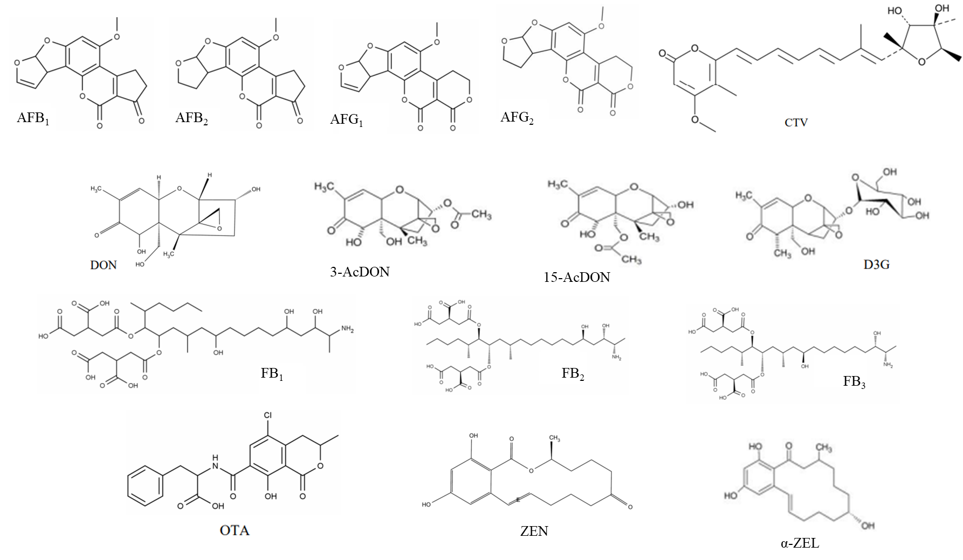
Figure S1 – Chemical structures of mycotoxins analyzed in the present study
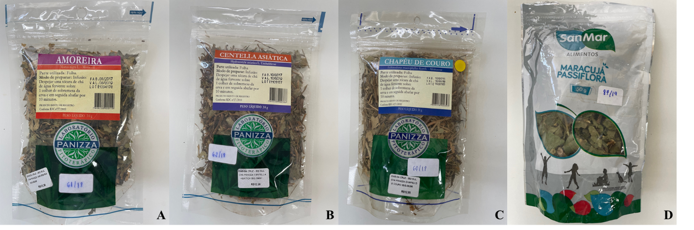
Figure S2 – Examples of dry herbs bulk samples purchased from retail stores and compounding pharmacies in the Federal District, Brazil. A) Black mulberry (Morus nigra) B) Gotu kola (Hydrocotyle asiatica) C) Chapéu de couro (Echinodorus macrophyllus) D) Passion fruit (Passiflora alata).

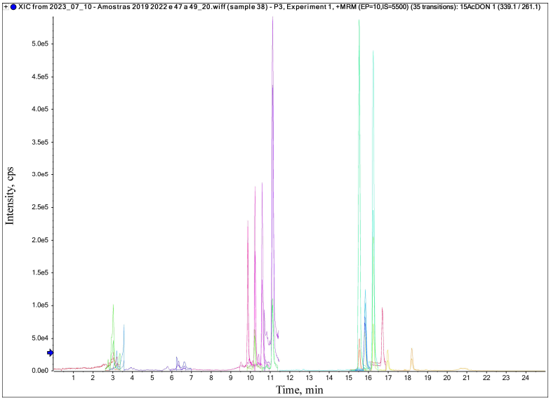
Figure S3 - QTRAP 6500+ UHPLC/MS/MS ion chromatogram obtained from the selected reaction monitoring mode of a matrix-matched calibration sample fortified at an intermediate level (12 to 537 µg/kg).

