Appendices
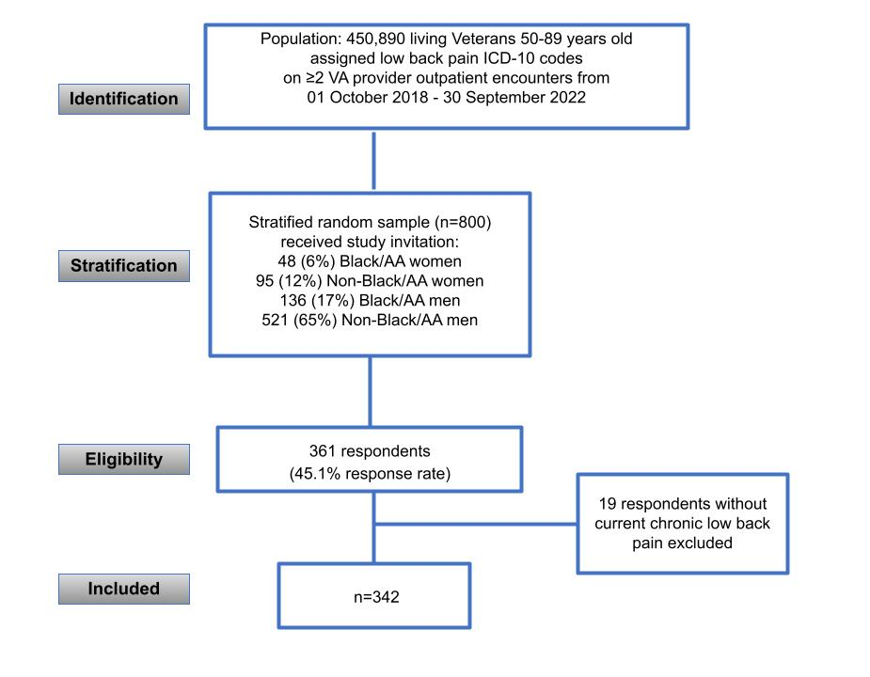
Appendix 1: STROBE Study Flow Diagram.

Appendix 2: Missingness of variables before imputation

Variable | Missing, n(%*)
Fibromyalgia Severity Score | 25 (7.3%)
Age in years | 41 (12%)
Total number of comorbidities | 40 (11.7%)
BMI | 35 (10.2%)
Pain Intensity (PROMIS SF-3a) T-score | 6 (1.8%)
Gender | 28 (8.2%)
Race | 50 (14.6%)
Ethnicity | 105 (30.7%)
Prior back surgery | 2 (0.6%)
Employment status | 31 (9.1%)
Education | 29 (8.5%)
Prescription opioid use in last year (any) | 19 (5.6%)
VR-12 MCS & PCS** | 7 (2.0%)
*Total dataset n=342.
**VR-12 data handled via tool developer recommendations using a single imputation to produce a complete case if at least one non-missing item.

Appendix 3: Results of multiple linear regression using complete cases only (no imputation)
Outcome: Physical Function (VR-12 PCS)
Model 1a (unadjusted); R² =0.19, n=313
Variable | β (95% CI) | SE | p
(intercept) | 38.7 (36.50, 40.82) | 1.10 | <0.001**
Fibromyalgia Severity Score | -0.73 (-0.90, -0.56) | 0.09 | <0.001**
Model 2b (adjusted), R² =0.46, n = 180
Variable | β (95% CI) | SE | p
(intercept) | 82.7 (65.13, 100.24) | 8.89 | <0.001**
Fibromyalgia Severity Score | -0.35 (-0.62, -0.08) | 0.14 | 0.0111*
Age in years | -0.09 (-0.28, 0.10) | 0.10 | 0.3604
Women (vs men) | -2.07 (-5.17, 1.04) | 1.57 | 0.1901
Race: Black/African-American | -0.20 (-3.43, 3.04) | 1.64 | 0.9047
Ethnicity: Hispanic/Latino | -1.12 (-6.24, 4.01) | 2.59 | 0.6678
BMI | -0.23 (-0.45, -0.01) | 0.11 | 0.041*
Employment Status
Other | reference | - | -
Retired | -4.38 (-9.83, 1.08) | 2.76 | 0.1151
Employed full or part time | -0.47 (-6.18, 5.24) | 2.89 | 0.8699
Disabled | -3.83 (-9.62, 1.97) | 2.93 | 0.194
Number of comorbidities | -1.60 (-2.63, -0.56) | 0.52 | 0.0026*
Pain Intensity | -0.42 (-0.60, -0.24) | 0.09 | <0.001**
Education
HS diploma/GED or less | -1.46 (-4.94, 2.01) | 1.76 | 0.4079
Some college, Vocational/skilled trade, or Associates degree | 0.18 (-2.53, 2.88) | 1.37 | 0.8963
Bachelors, masters, or professional degree | reference | - | -
Prior back surgery | -1.87 (-5.13, 1.39) | 1.65 | 0.2592
Prescribed opioid use in last year (any) | -0.245 (-3.02, 2.54) | 1.41 | 0.8623
Outcome: Psychological Function (VR-12 MCS)

Model 3b (unadjusted); R² =0.19; n = 313
Variable | β (95% CI) | SE | p
(intercept) | 56.27 (53.36, 59.18) | 1.48 | <0.001**
Fibromyalgia Severity Score | -0.996 (-1.22, -0.77) | 0.12 | <0.001**
Model 4b (adjusted); R² = 0.34; n = 180
Variable | β (95% CI) | SE | p
(intercept) | 54.35 (28.80, 79.89) | 12.9 | <0.001**
Fibromyalgia Severity Score | -0.53 (-0.92, -0.14) | 0.20 | 0.0079*
Age in years | 0.12 (-0.16, 0.40) | 0.14 | 0.3939
Women (vs men) | -1.24 (-5.76, 3.28) | 2.29 | 0.589
Race: Black/African-American | 0.39 (-4.32, 5.09) | 2.38 | 0.8719
Ethnicity: Hispanic/Latino | -4.01 (-11.51, 3.40) | 3.78 | 0.2842
BMI | 0.24 (-0.08, 0.56) | 0.16 | 0.1369
Employment Status
Other | Reference | - | -
Retired | 5.79 (-2.15, 13.73) | 4.02 | 0.1518
Employed full or part time | 12.84 (4.53, 21.15) | 4.21 | 0.0027*
Disabled | 2.56 (-5.88, 10.99) | 4.27 | 0.5503
Number of comorbidities | -0.26 (-1.77, 1.24) | 0.76 | 0.7286
Pain Intensity | -0.36 (-0.62, -0.10) | 0.13 | 0.0065*
Education
No high school diploma or HS diploma/GED | -0.67 (-5.73, 4.39) | 2.56 | 0.7935
Some college, Vocational/skilled trade, or Associates degree | -3.27 (-7.20, 0.67) | 2.00 | 0.1033
Bachelors, masters, or professional degree | Reference | - | -
Prior back surgery | 1.69 (-3.05, 6.43) | 2.40 | 0.483
Prescription opioid use in last year (any) | -0.22 (-4.27, 3.83) | 2.05 | 0.9146
*p-value <0.05
**p-value <0.001

