Supplementary data:

Model name | A (mm) | a | p0 | alpha | b
S | 8.25 | 3.47 | 4.33 | 0.6 | 0.15
M | 9.25 | 4.00 | 5.00 | 0.6 | 0.15
L | 10.25 | 4.53 | 5.67 | 0.6 | 0.15
RC | 9.25 | 4.00 | 5.00 | 1.2 | 0.15
FC | 9.25 | 4.00 | 5.00 | 0.6 | 0.23
FNR | 9.25 | 4.00 | 5.00 | 0.6 | 0.15

Table 1: Numerical parameters used to define the cochlear models: A (mm) corresponds to the distance from the round window to the lateral wall along the cochlear axis. The parameters a, b, p₀, and α are internal descriptors of the parametric cochlear model: a and b characterize the evolution of the curvature, whereas p₀ and α define the longitudinal components of the cochlear centerline. Values are reported for six different models: Small (S), Medium (M), Large (L), “roller coaster” (RC), “fast-curled” (FC), and “facial-nerve recess” (FNR).
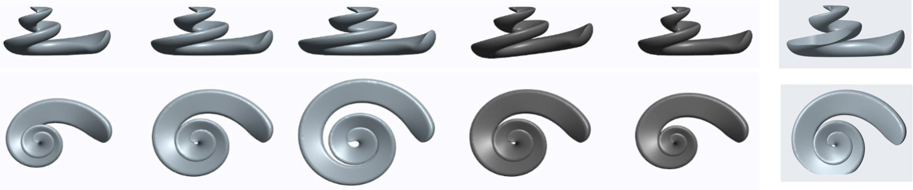
A
B
alpha

SI: Parameters used to define the cochlear models:
All the parameters have been previously described in these publications:
B. Escudé, C. James, O. Deguine, N. Cochard, E. Eter, B. Fraysse, The size of the cochlea and predictions of insertion depth angles for cochlear implant electrodes, Audiol Neurootol 11 Suppl 1 (2006) 27–33. https://doi.org/10.1159/000095611
R. Hussain, A. Frater, R. Calixto, C. Karoui, J. Margeta, Z. Wang, M. Hoen, H. Delingette, F. Patou, C. Raffaelli, C. Vandersteen, N. Guevara, Anatomical Variations of the Human Cochlea Using an Image Analysis Tool, J Clin Med 12 (2023) 509. https://doi.org/10.3390/jcm12020509.

