Supplementary Figure 1: Experiment 2, best estimates for participants with repeated measurements.

a b
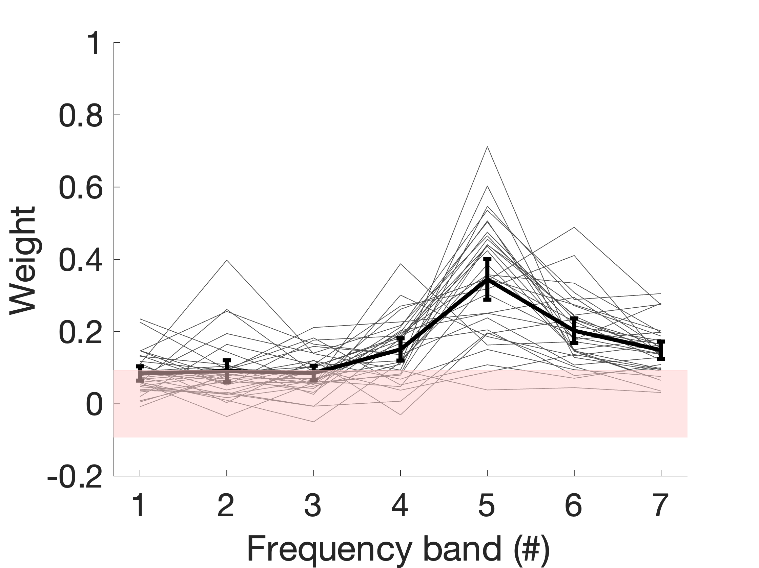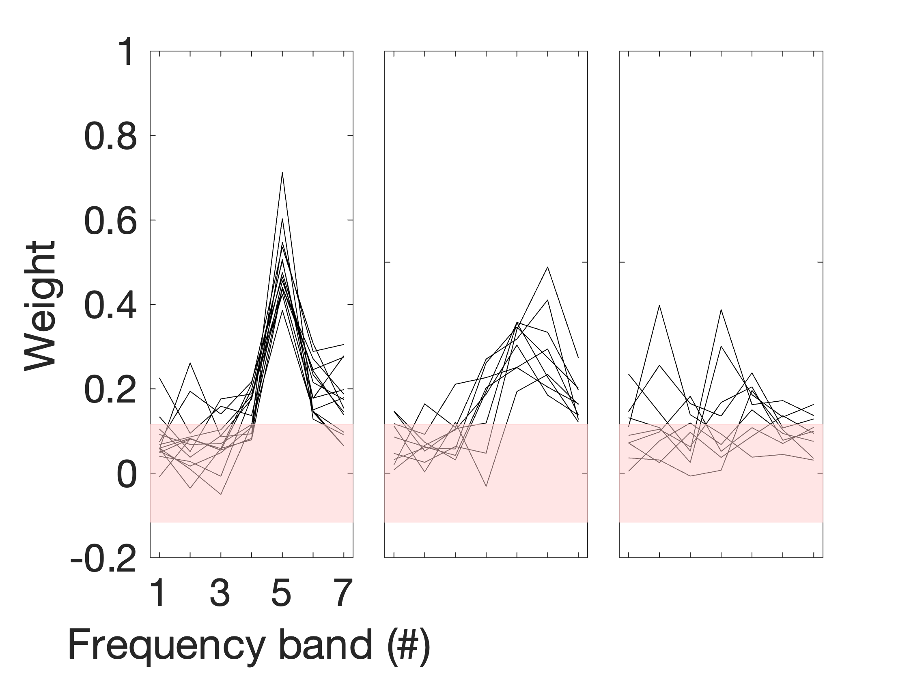

a. The best estimates (averages across sessions) of the profiles of individual participants who performed the experiment 3 or 4 times are shown as thin lines. The thick line represents the average profile across participants. The shaded area around 0 indicates the 95% confidence interval for a null weight. Error bars represent 95% confidence intervals about the mean. b. A k-means cluster analysis was performed, as for Experiment 1, arbitrarily choosing 3 clusters for display purposes. These clusters resembled those displayed in Fig. 2b: a first cluster exhibits a sharp peak centred on the 5th frequency band (N=14); a second cluster displays a shallower peak in the same region or higher (N=9); and a third cluster has a peak away from the 5th frequency band (N=9).

Supplementary Figure 2: Experiments 4 and 5, test/retest individual data

a. Pitch
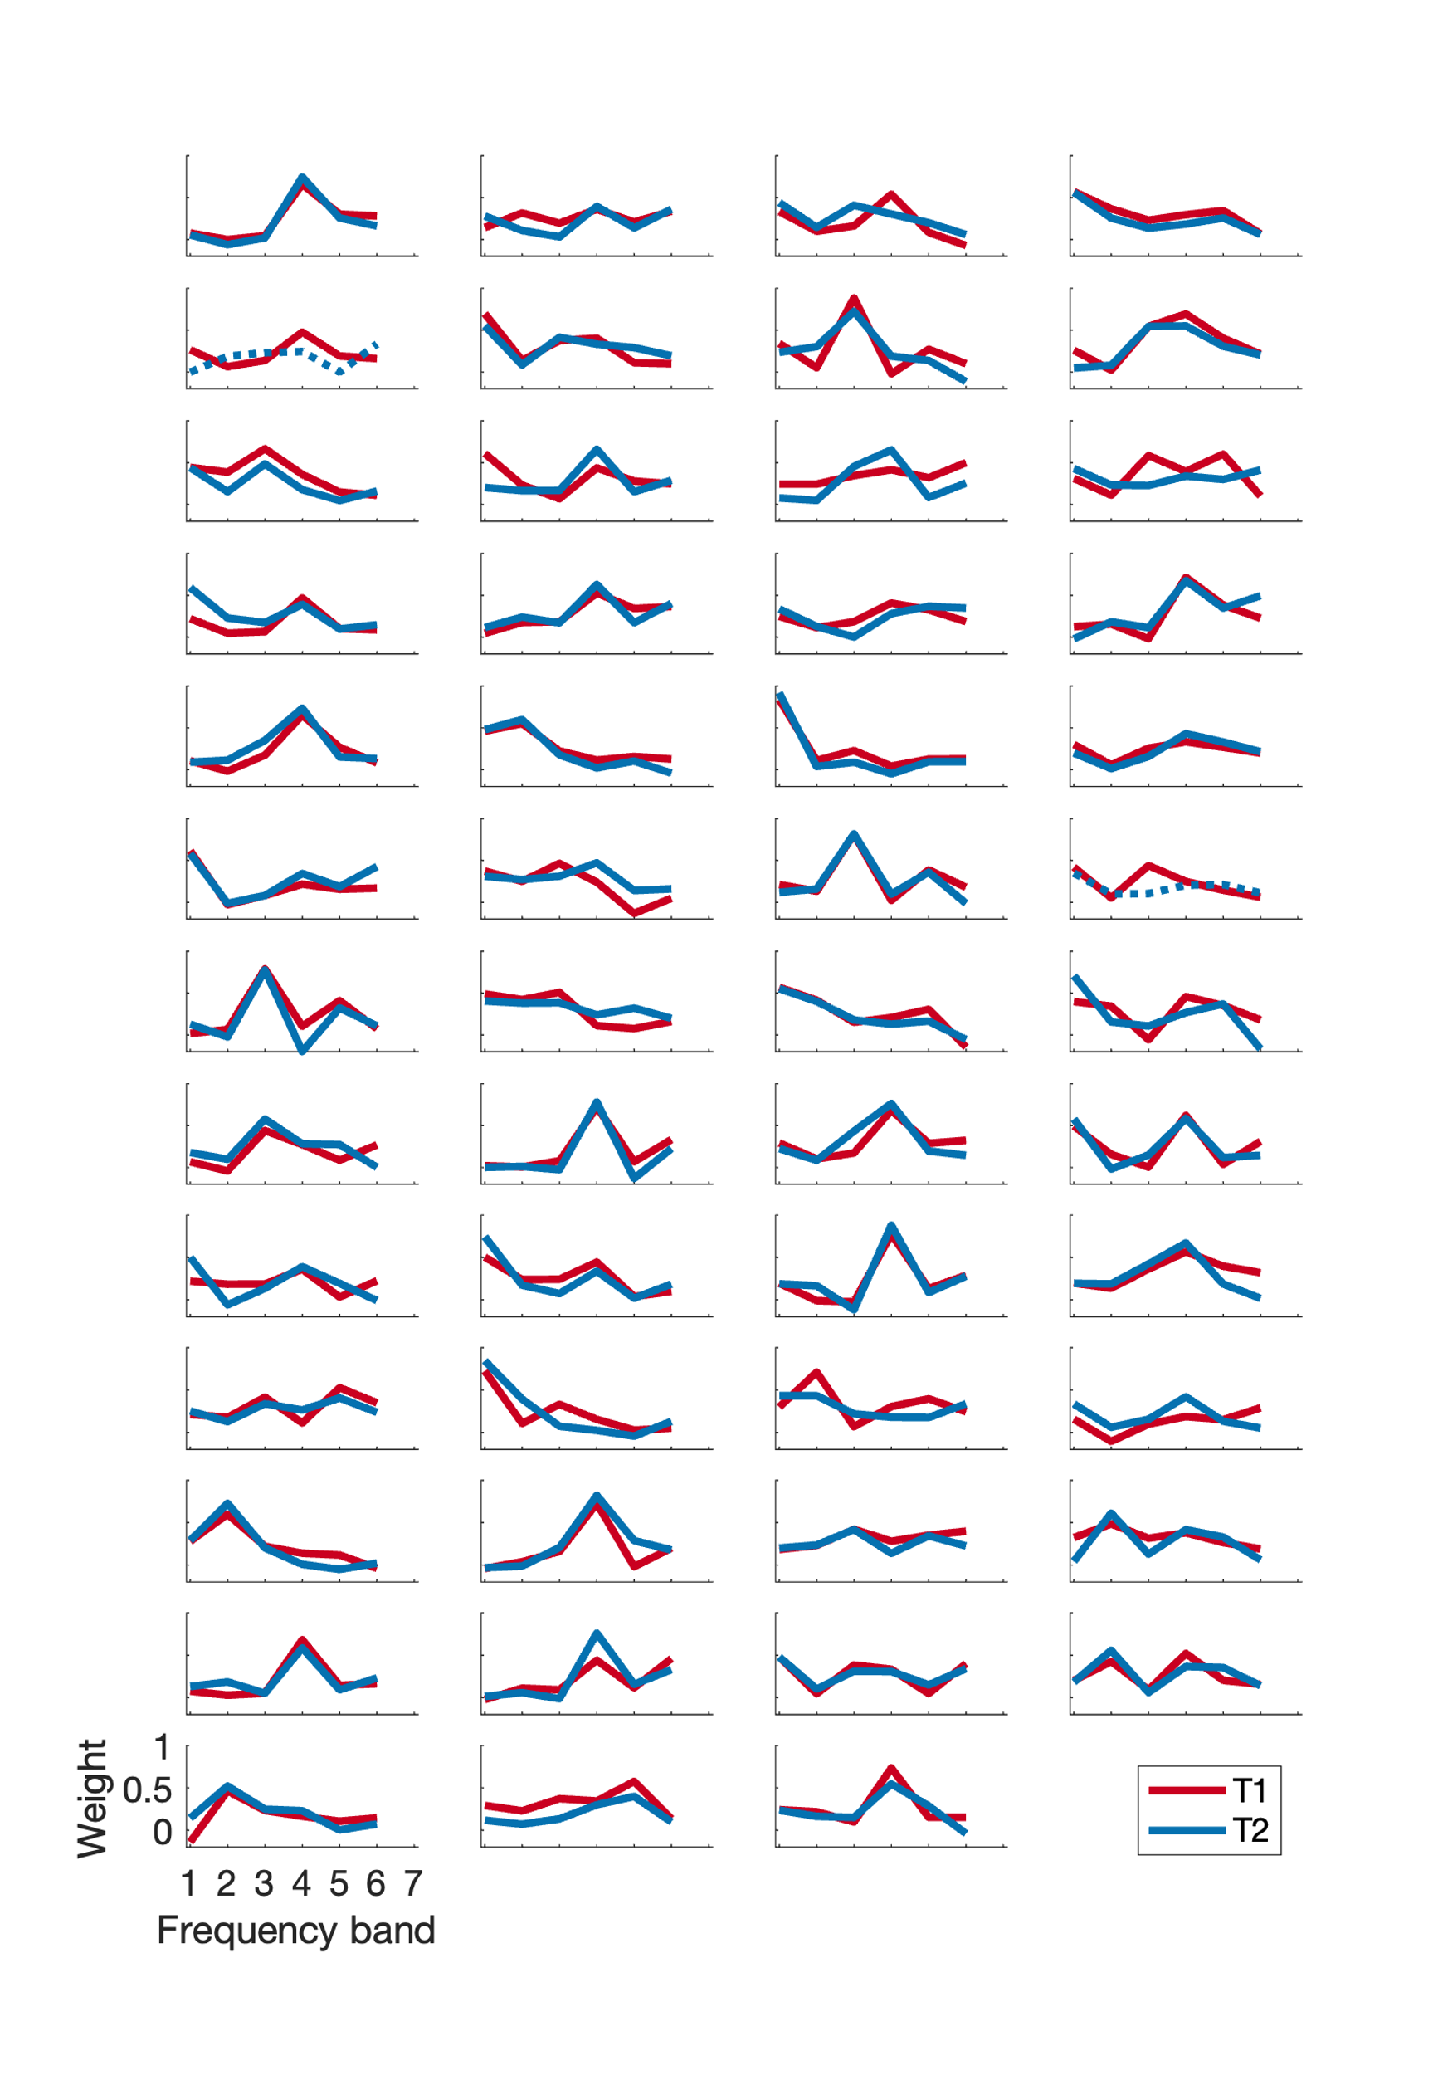
b. Loudness
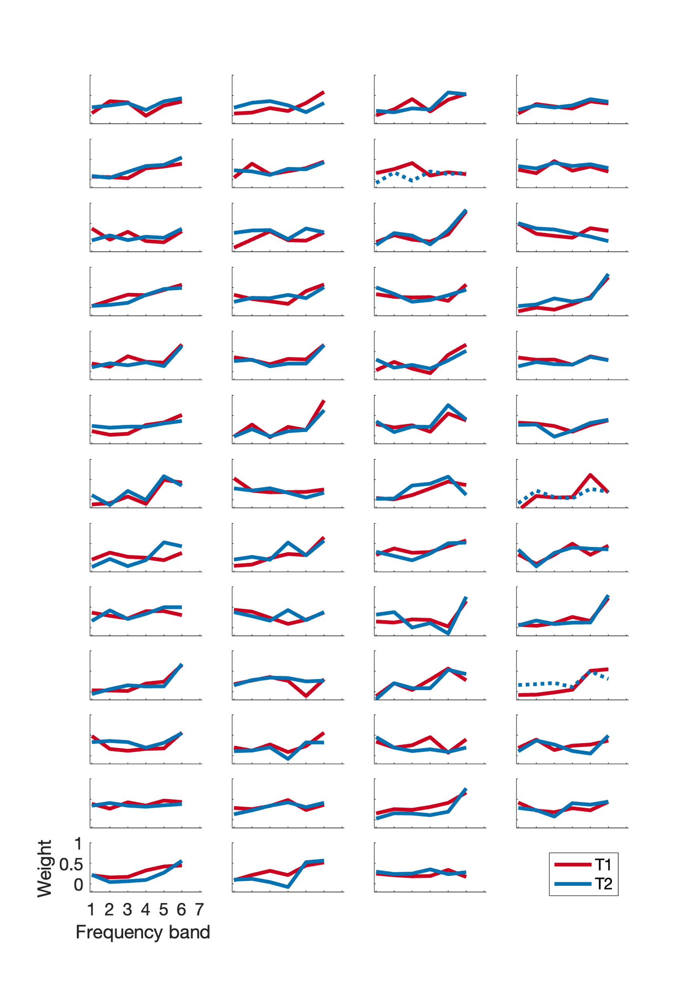

c. Lateralization
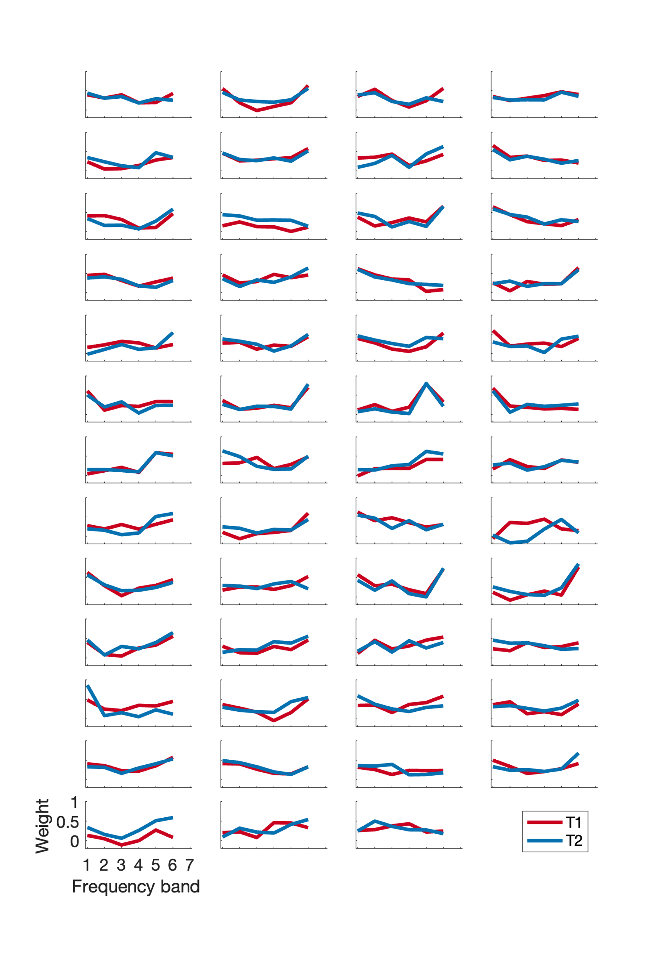
a., b, c. Individual profiles at for the test at Experiment 4 (T1, red lines) and retest at Experiment 5 (T2, after 1 to 3 weeks, blue lines) for the three tasks. Dotted lines represent sessions for which the 80% criterion on coherent trials was not achieved.
Supplementary Figure 3: Correlations with Hearing Health Questionnaire

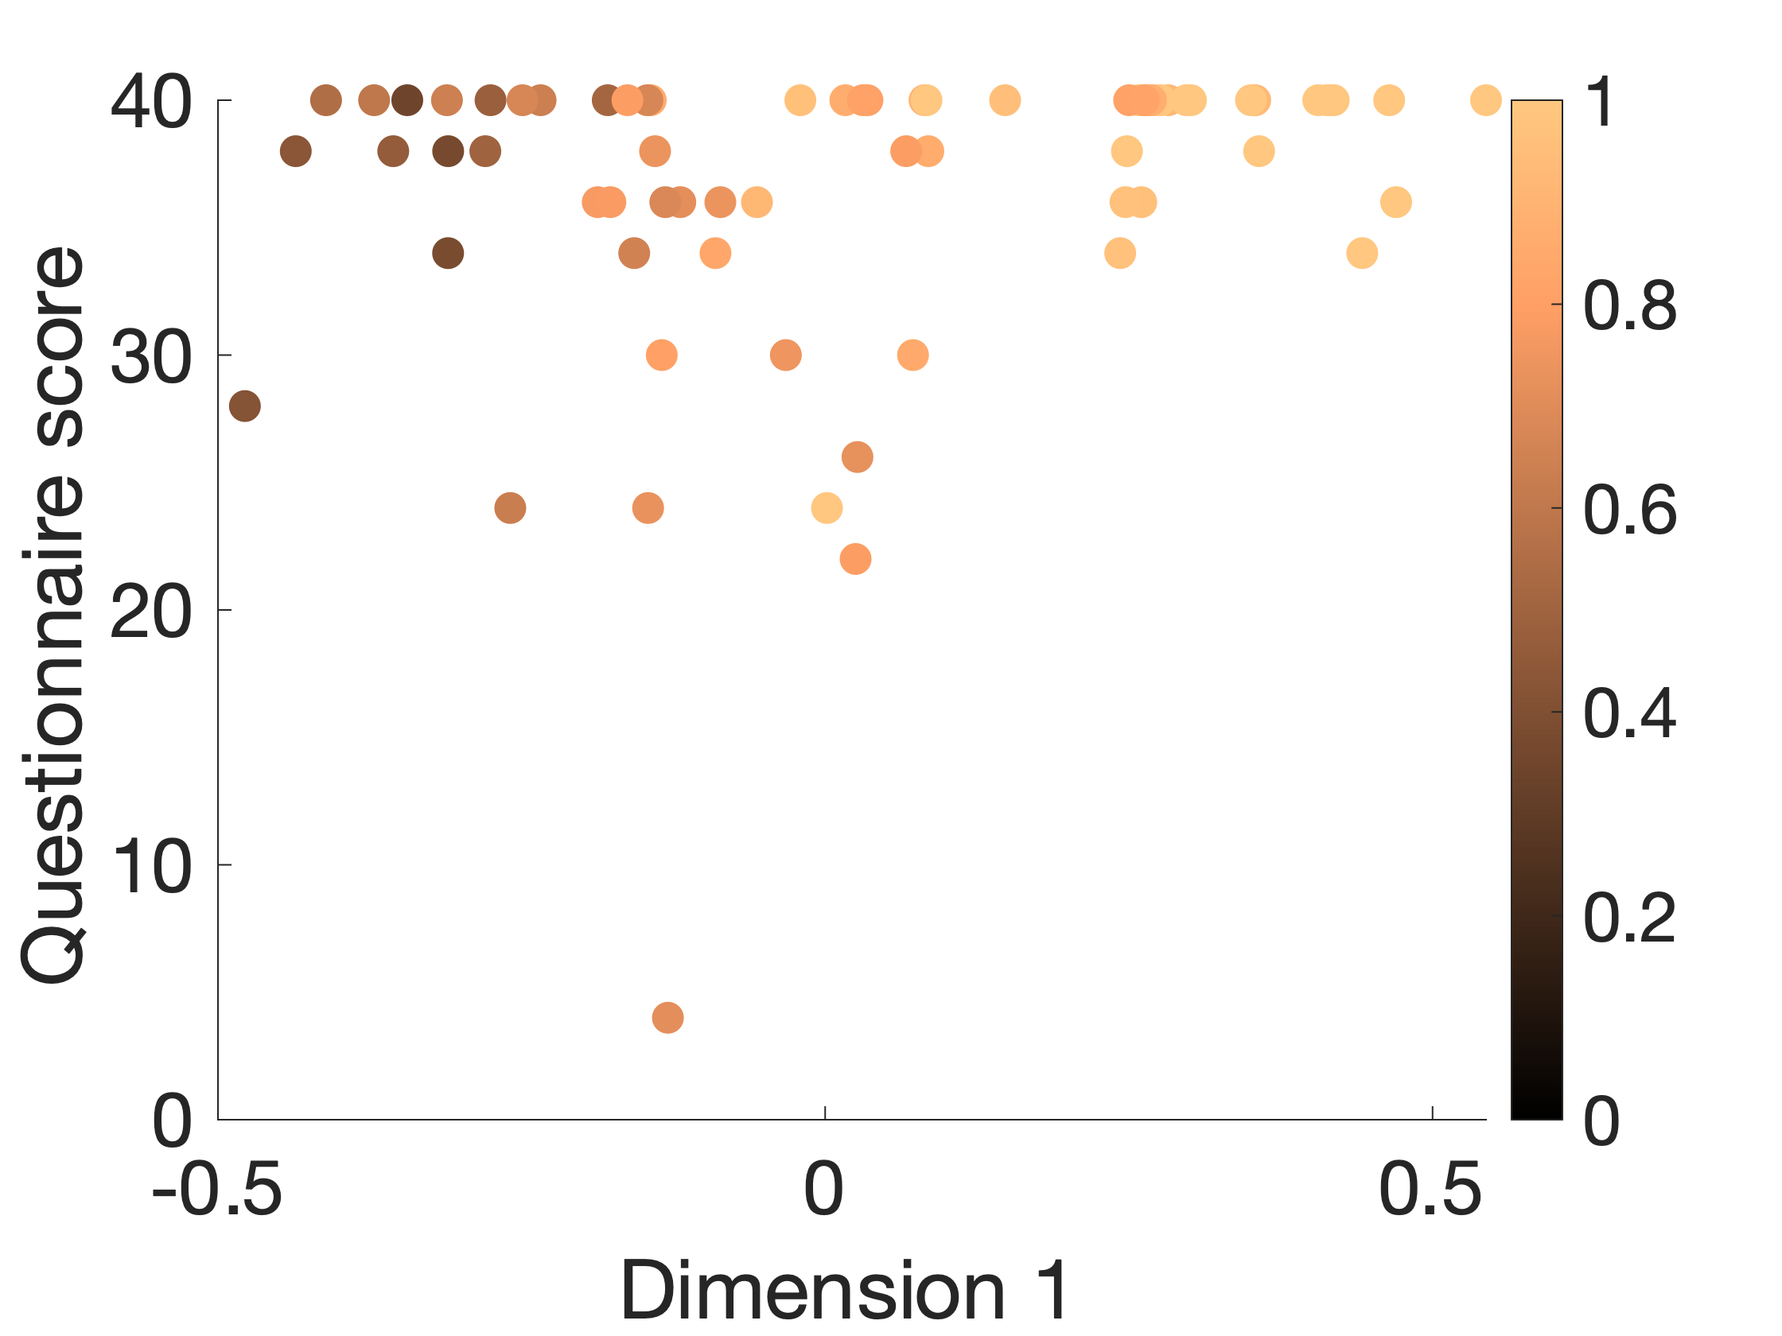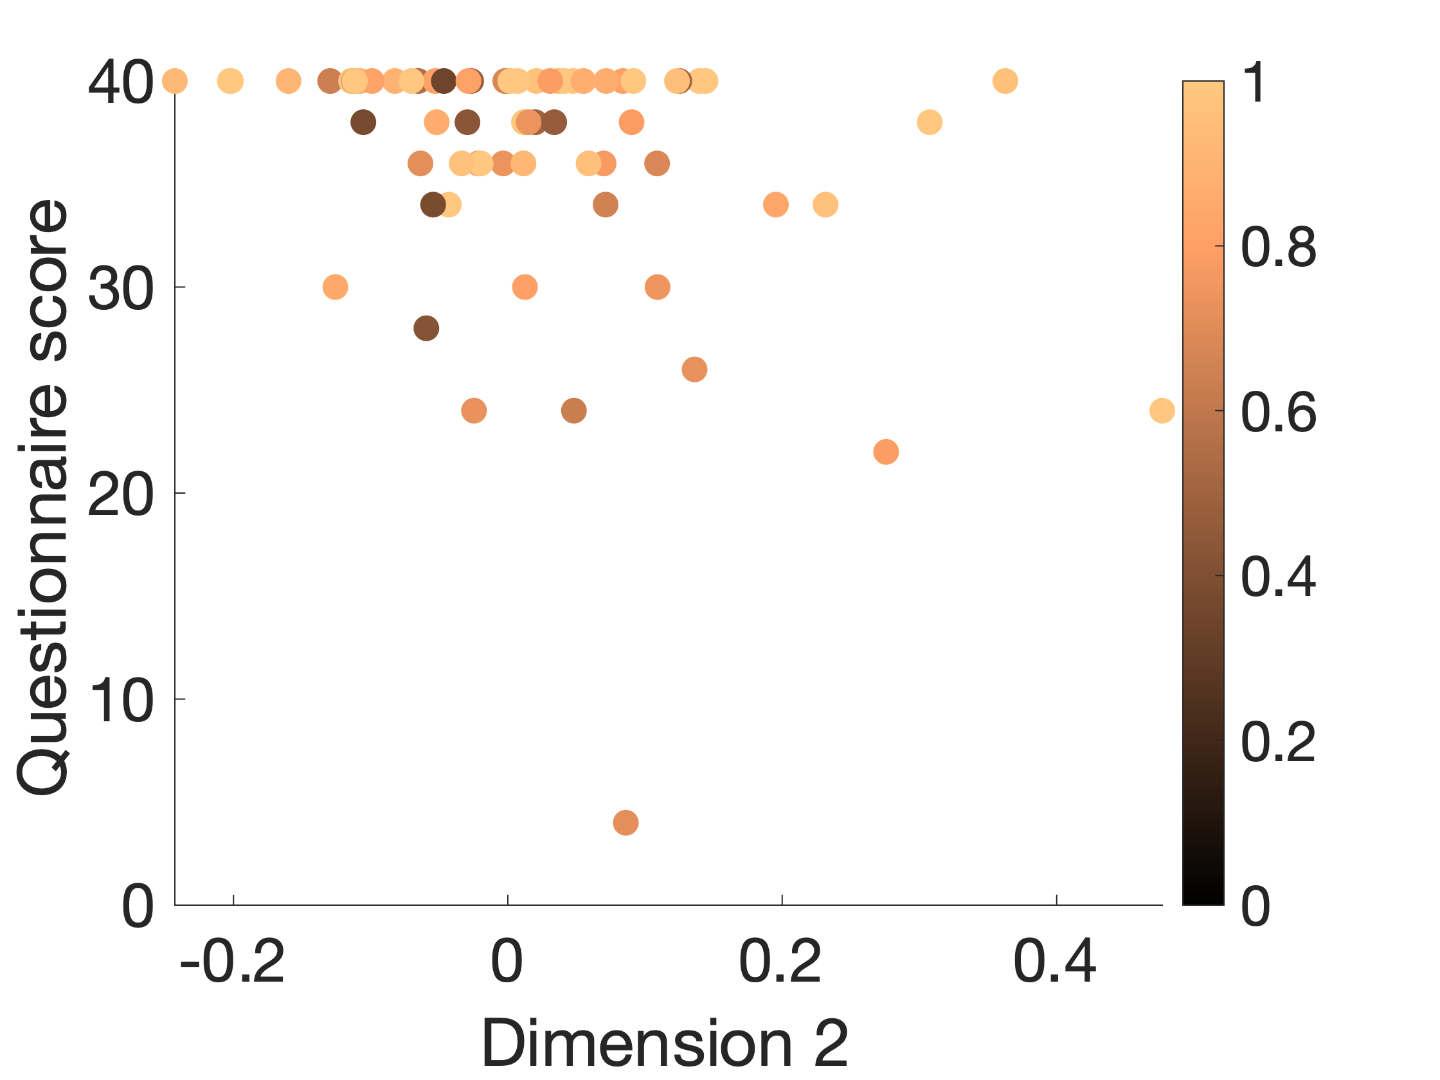

In Experiment 1, in addition to the inclusion criterion requiring no self-reported hearing deficit, hearing health was self-assessed using the revised version of the Hearing Handicap Inventory for Adults (Cassarly et al., 2019). This questionnaire included 10 items, such as “Does a hearing problem cause you difficulty when attending a party?”, which should be sensitive to hearing deficits even when they do not translate into clinically abnormal audiograms. Results were heavily skewed towards maximal performance, with 53% of respondents (N=70) giving the highest rating (40 out of 40) indicating no self-assessed hearing problems whatsoever, as expected from the inclusion criterion. There was some spread in the data, however, the interquartile range being 36 - 40. Even though more than half of respondents were at ceiling, we explored whether there was a correlation between the questionnaire score and other variables, using Spearman-rank correlations. A small but significant correlation was observed with performance on the coherent trials: ρ(69) = 0.26, p = 0.03. A correlation with the position on the first PCA dimension was also observed: ρ(69) = 0.27, p = 0.02, as well as a correlation with the position on the second PCA dimension ρ(69) = -0.28, p = 0.02. No correlation with age was observed: ρ(69) = 0.07, p = 0.57.

Cassarly, C., Matthews, L. J., Simpson, A. N., & Dubno, J. R. (2019). The Revised Hearing Handicap Inventory and Screening Tool Based on Psychometric Reevaluation of the Hearing Handicap Inventories for the Elderly and Adults. Ear & Hearing, 41(1), 95–105. https://doi.org/10.1097/aud.0000000000000746

