SUPPLEMENTARY MATERIAL
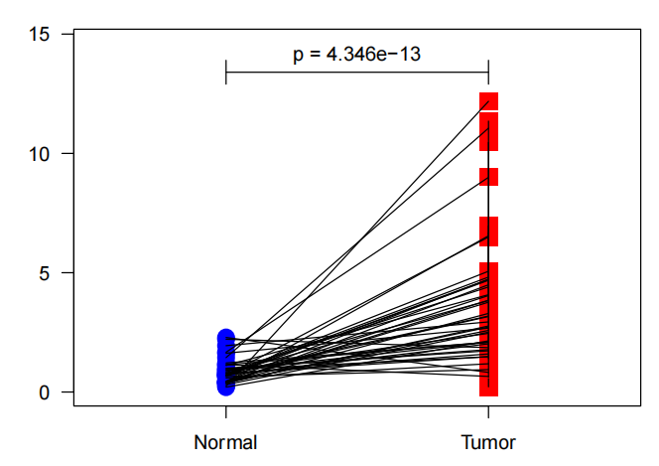
Supplementary. 1 Differential expression of HSF4 between paired subgroups

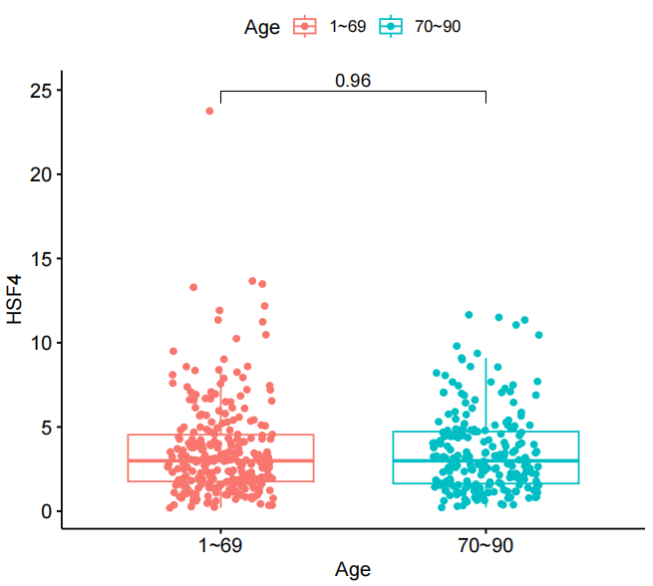
Supplementary. 2 Differences in HSF4 expression between age subgroups

Supplementary. 3 Logistic regression relationships between HSF4 expression and clinical information
Clinical Characteristics | Total | Odds ratio in HSF4 expression | P-Value
Stage (Ⅰ VS IV) | 158 | 1.138889 (0.6825523-1.91271) | 0.01098282
Age (<70 VS≥70) | 488 | 1 (0.6996522-1.429282) | 1
T (T1 VS T4) | 65 | 0.9934641 (0.3190016-3.242363) | 0.2911443
M (M0 VS M1) | 434 | 1.876293 (1.113143-3.216303) | 0.01961575
N (N0 VS N3) | 373 | 1.386736 (0.8984372-2.14528) | 0.001119075

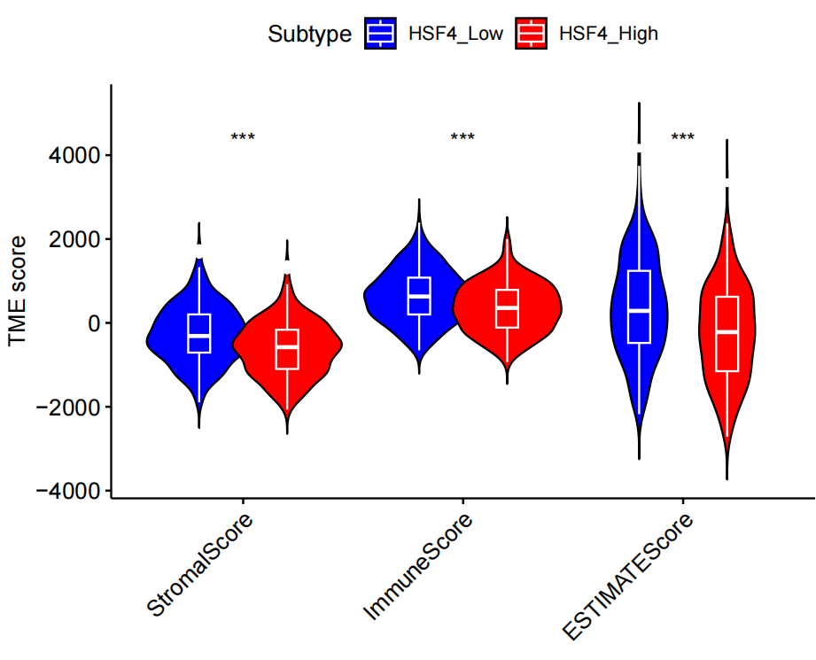
Supplementary. 4 Differences in TME scores between groups with high and low HSF4 expression

