Supplementary Materials
Results
GLM Random Effect Group Analysis Results
Healthy Control Subjects
At the group level, the neural activations for the positive emotions contrast were mainly located in bilateral middle and inferior occipital cortices, bilateral fusiform gyri, bilateral inferior frontal cortices (pars triangularis, and opercularis), bilateral middle temporal cortices, bilateral thalamus, left precentral cortex. The negative emotions contrast showed wider neural activation also comprising the right inferior temporal cortex.

People with Multiple Sclerosis
No suprathreshold (p_{FWE}<0.05) neural activity was observed for pwMS considering the acquisition performed on the whole sample preceding the EMDR treatment.

Threshold-weighted Overlap Maps Results
Healthy Control Subjects
The ${OM}_{th-w}$ at the 1st resulted in 0.74 peak consistency for positive emotions contrast. The resulting consistency peak value for the 2nd was 0.64.
Figure S1 shows the comparison between GLM group statistics and ${OM}_{th-w}$ compared to the GLM standard group results for the 1st scan of negative emotion contrast.
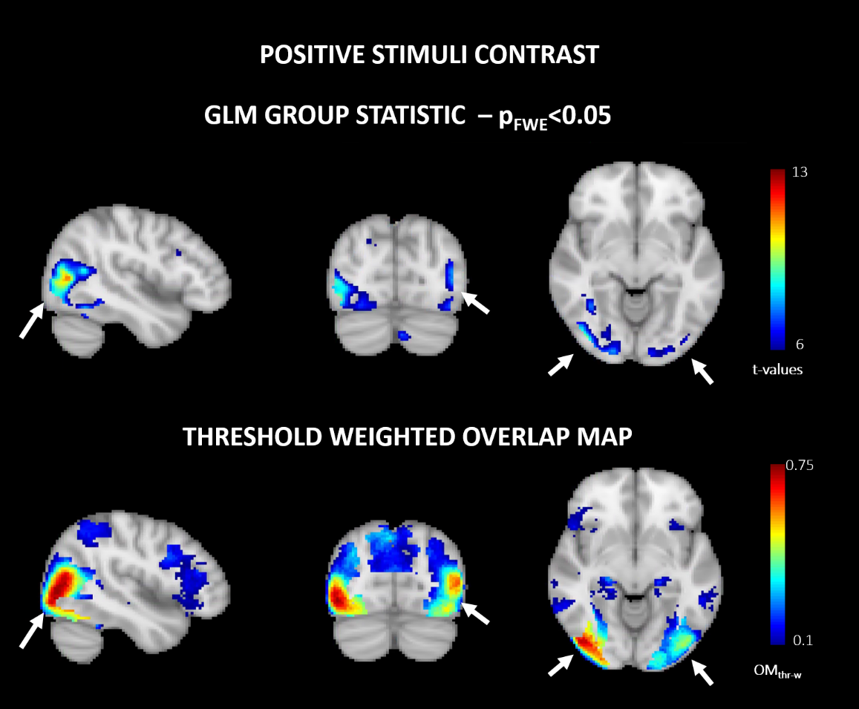
Figure S1. Mean group effects spatial maps (top-panel) derived from GLM standard statistic (p_{FWE}<0.05) and consistency maps (bottom-panel) threshold weighted overlap maps (${OM}_{th-w}$) derived according to (Seghier & Price, 2016) for the positive stimuli contrast of the healthy control group. The maps are color-coded according to the t-values and consistency values for the GLM derived maps and ${OM}_{th-w}$, respectively. Main differences between the two maps are pointed by white arrows.

Table S1 reports the delta values measuring the difference between the 1st and 2nd in peak and average consistency for each ROI for positive and negative stimuli respectively.
Table S1. Peak and Average Consistency values obtained from the ${OM}_{th-w}$of the positive stimuli in HC group are reported. The delta values computed as differences between 1st and 2nd scan are also reported for peak and average consistency. Delta values highlighted in bold refers to differences equal or above the 75° percentile.
ROIs Labels | ROIs Number | Peak Consistency 1st Scan | Peak Consistency 2nd Scan | Delta Peak Consistency (1st Scan – 2nd Scan) | Average Consistency 1st Scan | Average Consistency 2nd Scan | Delta Average Consistency (1st Scan – 2nd Scan)
Frontal_Inf_Oper_L | 1 | 0.29 | 0.25 | 0.04 | 0.10 | 0.07 | 0.03
Frontal_Inf_Orb_L | 2 | 0.15 | 0.23 | -0.08 | 0.06 | 0.11 | -0.04
Frontal_Inf_Tri_L | 3 | 0.25 | 0.25 | 0.00 | 0.11 | 0.10 | 0.01
Frontal_Sup_Medial_L | 4 | 0.23 | 0.27 | -0.03 | 0.10 | 0.11 | 0.00
Insula_L | 5 | 0.19 | 0.21 | -0.03 | 0.07 | 0.05 | 0.02
Parietal_Inf_L | 6 | 0.29 | 0.24 | 0.06 | 0.13 | 0.08 | 0.04
Precuneus_L | 7 | 0.30 | 0.25 | 0.05 | 0.12 | 0.11 | 0.01
Fusiform_L | 8 | 0.62 | 0.45 | 0.17 | 0.21 | 0.14 | 0.07
Hippocampus_L | 9 | 0.22 | 0.16 | 0.06 | 0.08 | 0.07 | 0.01
ParaHippocampal_L | 10 | 0.16 | 0.11 | 0.05 | 0.05 | 0.04 | 0.01
Temporal_Mid_L | 11 | 0.63 | 0.47 | 0.16 | 0.12 | 0.12 | 0.00
Cuneus_L | 12 | 0.37 | 0.23 | 0.14 | 0.18 | 0.11 | 0.07
Occipital_Inf_L | 13 | 0.58 | 0.46 | 0.12 | 0.32 | 0.26 | 0.07
Occipital_Mid_L | 14 | 0.65 | 0.54 | 0.11 | 0.24 | 0.20 | 0.04
Amygdala_L | 15 | 0.20 | 0.14 | 0.06 | 0.09 | 0.07 | 0.02
Thal_L | 16 | 0.22 | 0.18 | 0.05 | 0.10 | 0.06 | 0.04
Frontal_Inf_Oper_R | 17 | 0.25 | 0.21 | 0.04 | 0.10 | 0.08 | 0.03
Frontal_Inf_Orb_R | 18 | 0.19 | 0.16 | 0.03 | 0.06 | 0.06 | 0.00
Frontal_Inf_Tri_R | 19 | 0.27 | 0.23 | 0.03 | 0.10 | 0.08 | 0.02
Frontal_Sup_Medial_R | 20 | 0.22 | 0.23 | -0.01 | 0.07 | 0.09 | -0.01
Insula_R | 21 | 0.17 | 0.11 | 0.06 | 0.06 | 0.04 | 0.02
Parietal_Inf_R | 22 | 0.27 | 0.18 | 0.10 | 0.14 | 0.08 | 0.06
Precuneus_R | 23 | 0.33 | 0.25 | 0.08 | 0.16 | 0.12 | 0.04
Fusiform_R | 24 | 0.69 | 0.55 | 0.14 | 0.26 | 0.19 | 0.07
Hippocampus_R | 25 | 0.29 | 0.15 | 0.14 | 0.10 | 0.08 | 0.02
ParaHippocampal_R | 26 | 0.27 | 0.19 | 0.08 | 0.06 | 0.05 | 0.01
Temporal_Mid_R | 27 | 0.73 | 0.64 | 0.09 | 0.18 | 0.17 | 0.00
Cuneus_R | 28 | 0.50 | 0.33 | 0.17 | 0.24 | 0.14 | 0.10
Occipital_Inf_R | 29 | 0.73 | 0.58 | 0.15 | 0.47 | 0.39 | 0.08
Occipital_Mid_R | 30 | 0.74 | 0.58 | 0.16 | 0.26 | 0.21 | 0.06
Amygdala_R | 31 | 0.18 | 0.13 | 0.05 | 0.09 | 0.07 | 0.02
Thal_R | 32 | 0.31 | 0.17 | 0.14 | 0.09 | 0.06 | 0.03

Figure S2 represents the bar charts of ROIs showing differences above the 75° percentile considering peak and mean values derived from the ${OM}_{th-w}$ of the positive emotion contrast in the 1st and in the 2nd scans in the control group.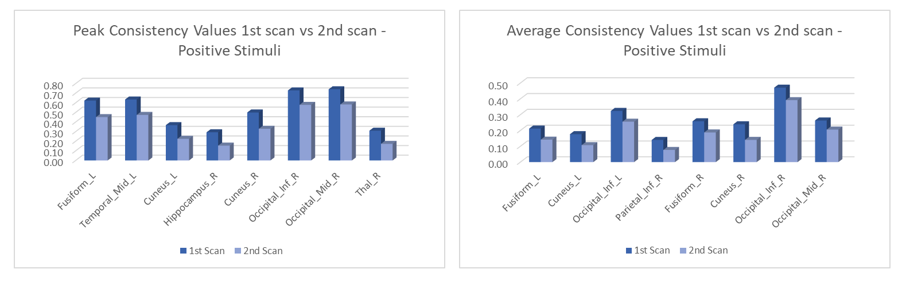
Figure S2. The bar charts represent the consistency peak (left panel) and average (right panel) values extracted from the ${OM}_{th-w}$ map of positive stimuli for each ROIs of the 1st and 2nd scans of the healthy control group. Legend: L = Left; R = Right; Mid = Middle; Inf = Inferior; Thal = Thalamus.

People with Multiple Sclerosis
The ${OM}_{th-w}$ pre-rehabilitation resulted in 0.59 peak consistency for positive emotion contrast. The resulting consistency peak value post-rehabilitation was 0.78.
Figure S3 shows the comparison between GLM group statistics and ${OM}_{th-w}$ compared to the GLM standard group results for the pre-rehabilitation scan of positive stimuli contrast.
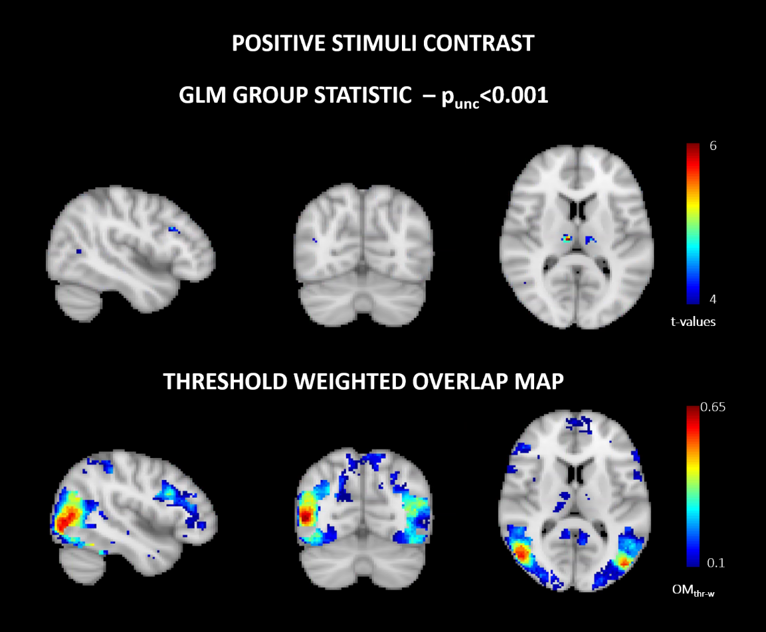
Figure S3. Comparison between mean group effects spatial maps (top-panel) derived from GLM standard statistic (p_{FWE}<0.05) and consistency maps (bottom-panel) threshold weighted overlap maps (${OM}_{th-w}$) derived according to (Seghier & Price, 2016) for the positive stimuli contrast of the multiple sclerosis cohort. The maps are color-coded according to the t-values and consistency values for the GLM derived maps and ${OM}_{th-w}$ respectively.
Table S2. Peak and Average Consistency values obtained from the ${OM}_{th-w}$ of the positive stimuli in MS group are reported. The delta values computed as differences between pre and post scan are also reported for peak and average consistency. Delta values highlighted in bold refers to differences equal or above the 75° percentile.
ROIs Labels | ROIs Number | Peak Consistency Scan pre | Peak Consistency Scan post | Delta Peak Consistency (Scan pre – Scan post) | Average Consistency Scan pre | Average Consistency Scan post | Delta Average Consistency (Scan pre – Scan post)
Frontal_Inf_Oper_L | 1 | 0.38 | 0.28 | 0.10 | 0.11 | 0.09 | 0.01
Frontal_Inf_Orb_L | 2 | 0.13 | 0.22 | -0.09 | 0.05 | 0.07 | -0.02
Frontal_Inf_Tri_L | 3 | 0.31 | 0.28 | 0.03 | 0.09 | 0.11 | -0.02
Frontal_Sup_Medial_L | 4 | 0.16 | 0.27 | -0.10 | 0.06 | 0.10 | -0.04
Insula_L | 5 | 0.11 | 0.18 | -0.07 | 0.04 | 0.07 | -0.02
Parietal_Inf_L | 6 | 0.20 | 0.25 | -0.05 | 0.08 | 0.09 | -0.01
Precuneus_L | 7 | 0.21 | 0.32 | -0.11 | 0.06 | 0.14 | -0.08
Fusiform_L | 8 | 0.37 | 0.52 | -0.15 | 0.11 | 0.21 | -0.10
Hippocampus_L | 9 | 0.07 | 0.22 | -0.14 | 0.04 | 0.09 | -0.05
ParaHippocampal_L | 10 | 0.09 | 0.25 | -0.16 | 0.04 | 0.07 | -0.02
Temporal_Mid_L | 11 | 0.42 | 0.59 | -0.17 | 0.10 | 0.14 | -0.05
Cuneus_L | 12 | 0.14 | 0.23 | -0.09 | 0.05 | 0.11 | -0.06
Occipital_Inf_L | 13 | 0.37 | 0.54 | -0.17 | 0.16 | 0.34 | -0.18
Occipital_Mid_L | 14 | 0.56 | 0.63 | -0.07 | 0.15 | 0.28 | -0.13
Amygdala_L | 15 | 0.14 | 0.21 | -0.07 | 0.06 | 0.09 | -0.03
Thal_L | 16 | 0.14 | 0.16 | -0.02 | 0.05 | 0.06 | -0.02
Frontal_Inf_Oper_R | 17 | 0.32 | 0.30 | 0.01 | 0.13 | 0.12 | 0.01
Frontal_Inf_Orb_R | 18 | 0.21 | 0.23 | -0.02 | 0.06 | 0.08 | -0.01
Frontal_Inf_Tri_R | 19 | 0.28 | 0.39 | -0.11 | 0.10 | 0.12 | -0.02
Frontal_Sup_Medial_R | 20 | 0.20 | 0.23 | -0.03 | 0.06 | 0.08 | -0.02
Insula_R | 21 | 0.14 | 0.23 | -0.09 | 0.05 | 0.08 | -0.03
Parietal_Inf_R | 22 | 0.25 | 0.41 | -0.17 | 0.09 | 0.09 | 0.00
Precuneus_R | 23 | 0.27 | 0.38 | -0.11 | 0.07 | 0.11 | -0.04
Fusiform_R | 24 | 0.58 | 0.59 | -0.02 | 0.16 | 0.23 | -0.08
Hippocampus_R | 25 | 0.11 | 0.29 | -0.18 | 0.04 | 0.11 | -0.06
ParaHippocampal_R | 26 | 0.16 | 0.32 | -0.16 | 0.05 | 0.07 | -0.02
Temporal_Mid_R | 27 | 0.59 | 0.78 | -0.19 | 0.17 | 0.21 | -0.04
Cuneus_R | 28 | 0.33 | 0.45 | -0.12 | 0.09 | 0.23 | -0.14
Occipital_Inf_R | 29 | 0.50 | 0.74 | -0.24 | 0.19 | 0.38 | -0.19
Occipital_Mid_R | 30 | 0.55 | 0.72 | -0.18 | 0.19 | 0.30 | -0.11
Amygdala_R | 31 | 0.11 | 0.25 | -0.14 | 0.06 | 0.12 | -0.06
Thal_R | 32 | 0.11 | 0.23 | -0.12 | 0.04 | 0.06 | -0.01

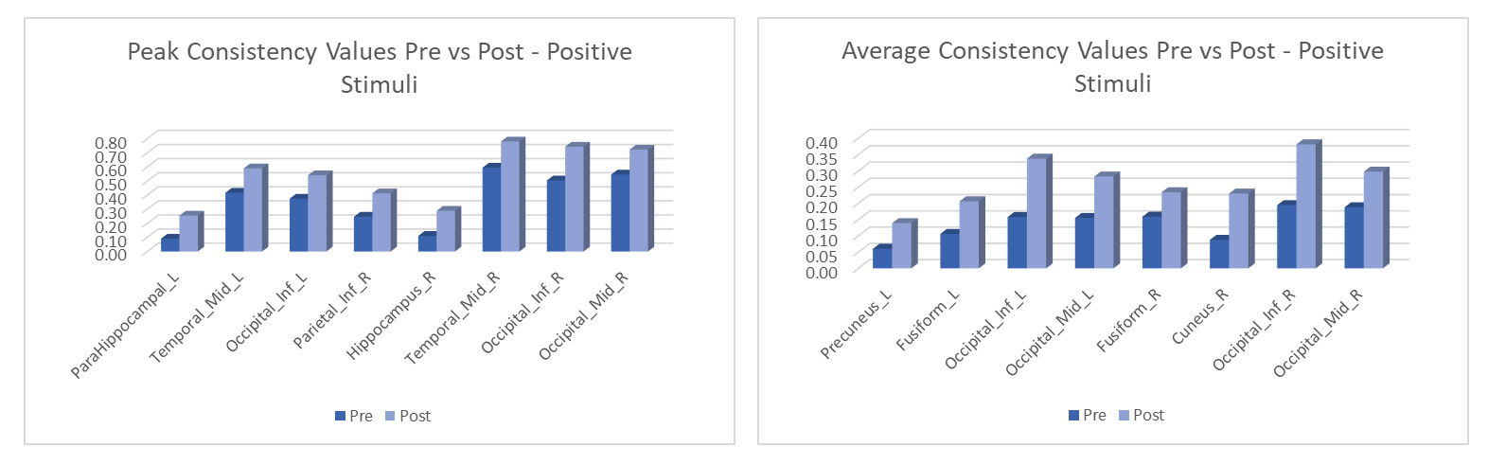
Figure S4. The bar charts represent the consistency peak (left panel) and average (right panel) values extracted from the ${OM}_{th-w}$ map of positive stimuli for each ROIs of the pre and post-rehabilitation scans of the pwMS. Legend: L = Left; R = Right; Mid = Middle; Inf = Inferior; Thal = Thalamus.
The comparison of the ${OM}_{th-w}$, namely the spatial maps measuring consistency independently from the statistical thresholds pre- and post-rehabilitation for the MS group is reported in Figure S5.
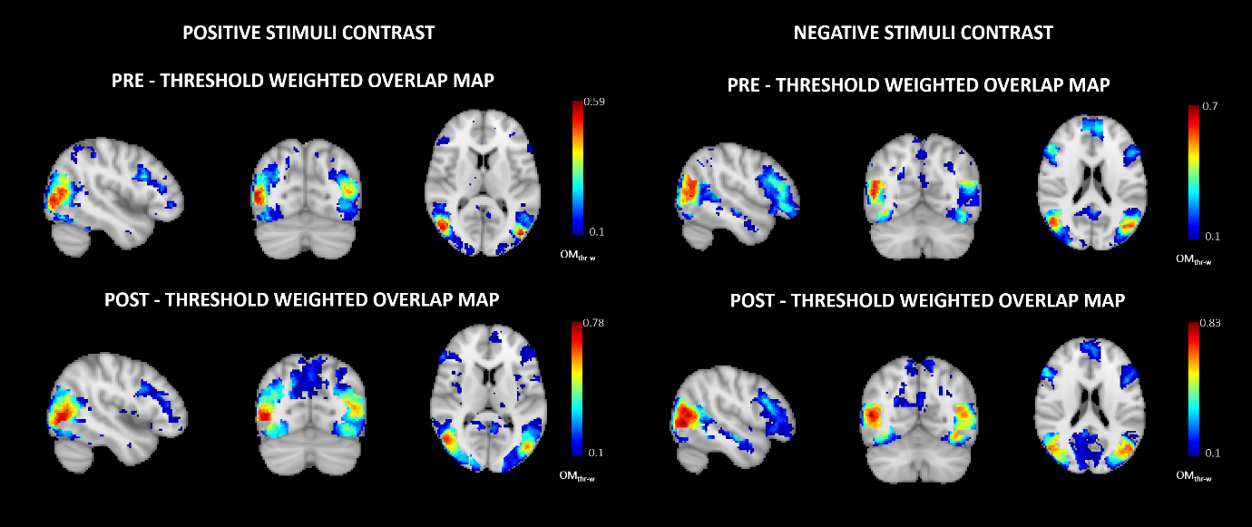
Figure S5. Comparison between pre (top-panel) and post (bottom-panel) rehabilitation ${OM}_{th-w}$ consistency maps derived for positive (left) and negative (right) stimuli contrasts in the pwMS group.

Table S3. Statistical comparison of peak and average delta values between scans extracted across ROIs from ${OM}_{th-w}$ derived from positive emotions contrast within the HC and MS groups.
Stimuli Valence | Measure between scans (${OM}_{th-w}$) | p-value | mean difference
HC | Peak delta values (1st vs 2nd HC) | <0.001 | 0.074
HC | Average delta values (1st vs 2nd HC) | <0.001 | 0.028
pwMS
pwMS | Peak delta values (Pre vs Post pwMS) | <0.001 | -0.099
pwMS | Average delta values (Pre vs Post pwMS) | <0.001 | -0.052

