Supplementary file 3:

Snack Preference Questionnaire Survey(Version 2）
Instructions:

Target: Snack A vs. Snack B

Scenario: Before eating a snack

Dear Student,

Hello! This questionnaire aims to understand preferences in snack choices. We expect you to select which snack you would prefer from the following choice sets and indicate whether you would actually eat this snack in real life by ticking the corresponding box.

If you happen to like both snacks, please select the one you prefer more and check "Yes" for the option "Considering your daily diet, would you eat this snack in real life?"

If you do not like either snack, please select the one that is relatively more acceptable to you and check "No" for the option "Considering your daily diet, would you eat this snack in real life?"

The snacks in this questionnaire are hypothetical and may not exist in reality. Please answer based on your true thoughts. There are no right or wrong answers; your choices represent your personal perspective.

This questionnaire consists of 8 choice sets. Please answer them one by one.

Each choice set is independent.

Please base your selection primarily on the text description; images are for reference only.

Choice Set 1/8
Snack Attributes | Snack A |  | Snack B
Taste | Savory Flavor | 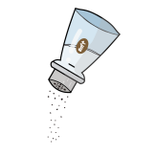 | Original Flavor | 
Nutrient  Claims | None | 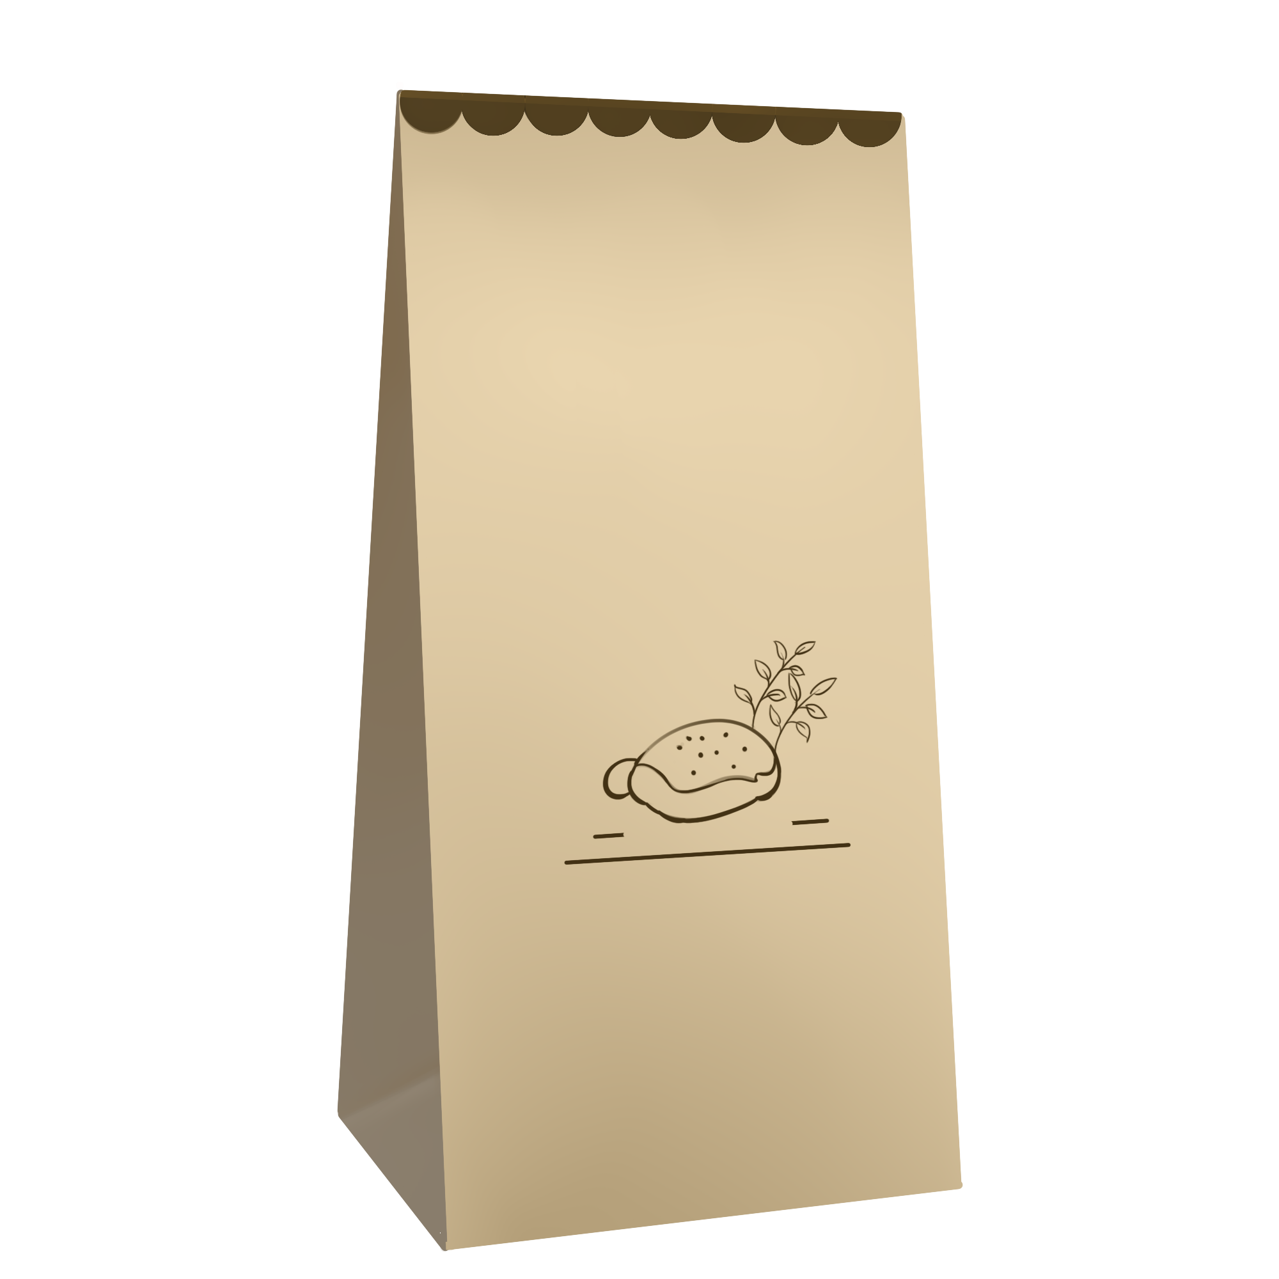 | Rich Minerals / Vitamins | 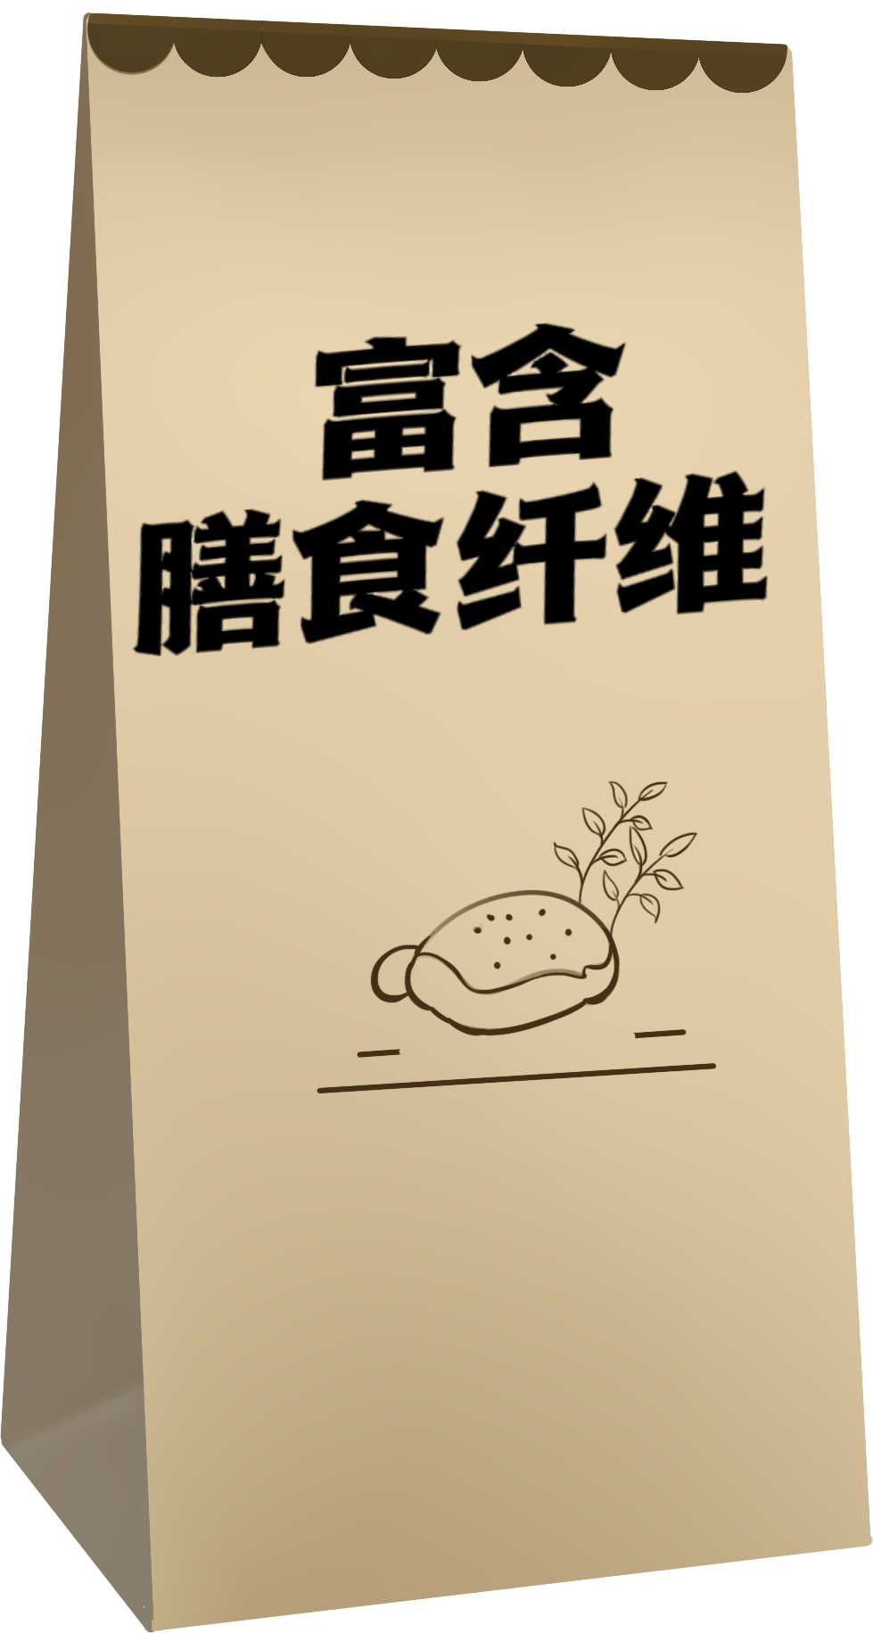
Purchase Location | Near School | 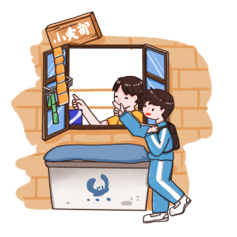 | Convenience Store | 
Price | ≥10 ¥CNY |  | 5~9 ¥CNY
Package Size | Large | 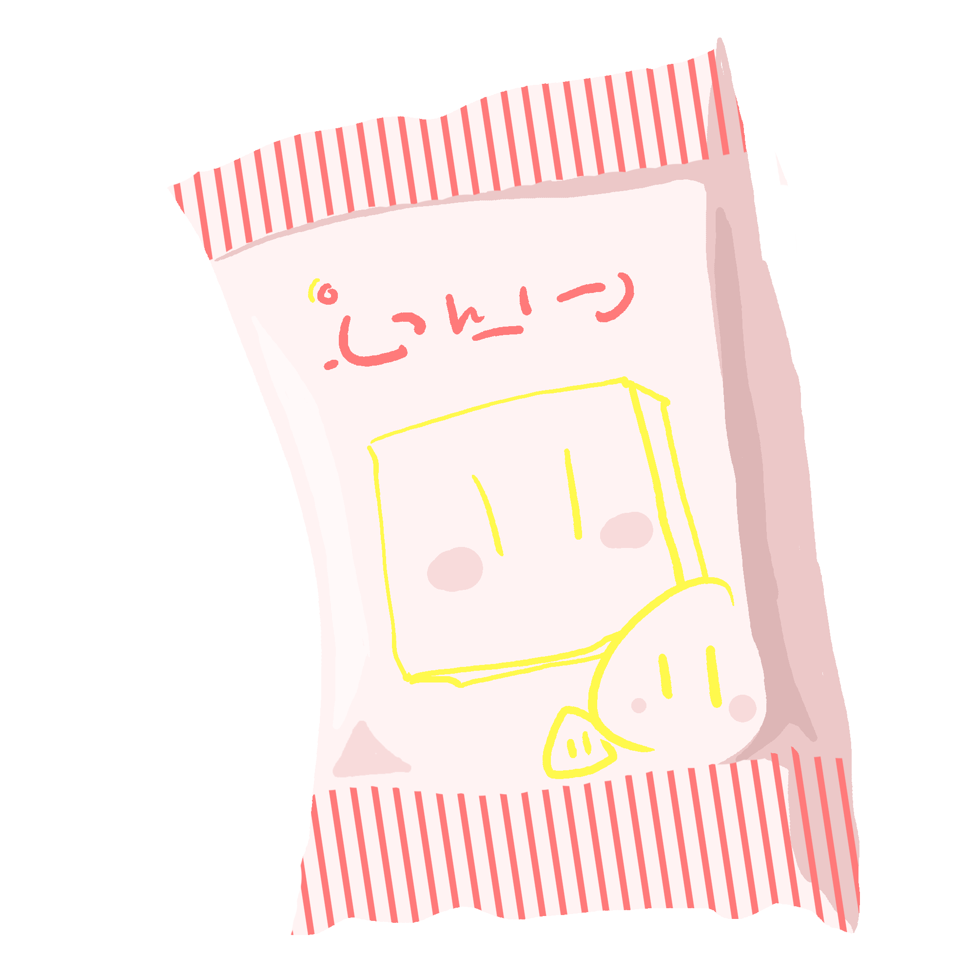 | Medium
Social Influence | Peer Recommendations |  | Advertising/ Influencer Recommendations | 
Which option would you be more willing to choose | Snack A |  | Snack B
Considering your daily diet, would you consume this snack in real life?
Yes No

Choice Set 2/8
Snack Attributes | Snack A |  | Snack B
Taste | Savory Flavor |  | Spicy Flavor | 
Nutrient Claims | Rich Minerals/ Vitamins |  | None
Purchase Location | Near School |  | Online | 
Price | <5 ¥CNY |  | 5~9 ¥CNY
Package Size | Medium |  | Large
Social Influence | Family Consumption Habits | 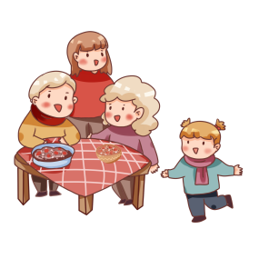 | Peer Recommendations
Which option would you be more willing to choose | Snack A |  | Snack B
Considering your daily diet, would you consume this snack in real life?
Yes No

Choice Set 3/8
Snack Attributes | Snack A |  | Snack B
Taste | Savory Flavor |  | Original Flavor
Nutrient Claims | Rich  Minerals/ Vitamins | 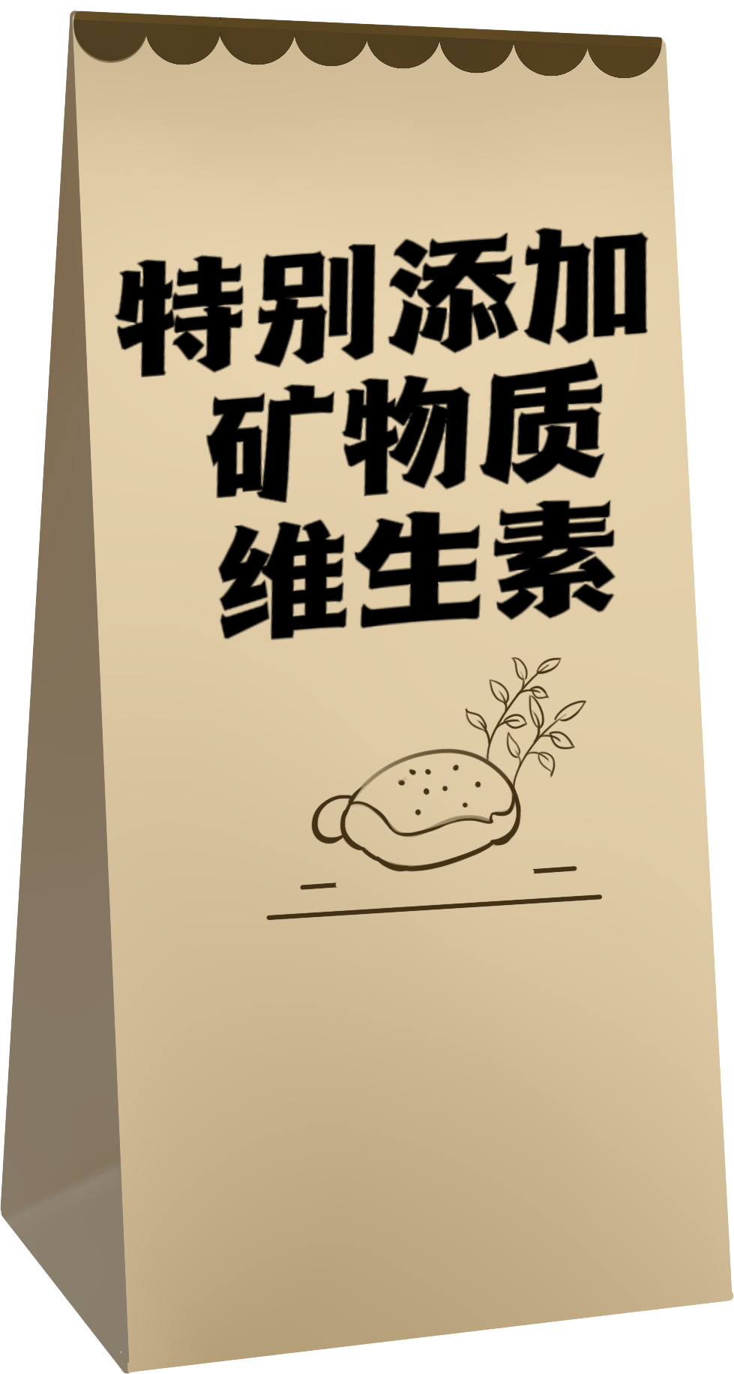 | Low Fat | 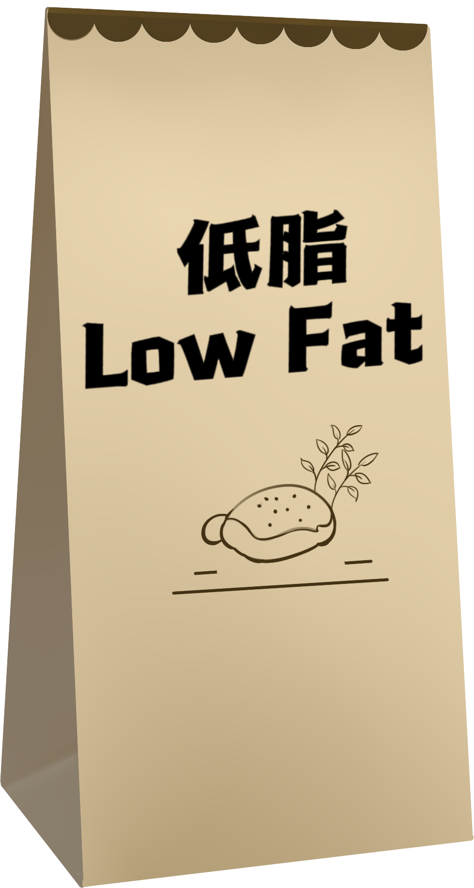
Purchase Location | Supermarket/  Hypermarket |  | Online
Price | 5~9 ¥CNY |  | <5 ¥CNY
Package Size | Large |  | Small
Social Influence | Advertising/ Influencer Recommendations |  | Peer Recommendations
Which option would you be more willing to choose | Snack A |  | Snack B
Considering your daily diet, would you consume this snack in real life?
Yes No
Choice Set 4/8
Snack Attributes | Snack A |  | Snack B
Taste | Spicy Flavor |  | Sweet Flavor | 
Nutrient Claims | Low Fat |  | Rich Minerals/ Vitamins
Purchase Location | Near School |  | Convenience Store
Price | <5 ¥CNY |  | ≥10 ¥CNY
Package Size | Small |  | Medium
Social Influence | Advertising/ Influencer Recommendations |  | Family Consumption Habits
Which option would you be more willing to choose | Snack A |  | Snack B
Considering your daily diet, would you consume this snack in real life?
Yes No

Choice Set 5/8
Snack Attributes | SnackA |  | SnackB
Taste | Sweet Flavor |  | Spicy Flavor
Nutrient Claims | Low Fat |  | Rich  Minerals/ Vitamins
Purchase Location | Online |  | Convenience Store
Price | ≥10 ¥CNY |  | 5~9 ¥CNY
Package Size | Medium |  | Small
Social Influence | Advertising/ Influencer Recommendations |  | Peer Recommendations
Which option would you be more willing to choose | Snack A |  | Snack B
Considering your daily diet, would you consume this snack in real life?
Yes No

Choice Set 6/8
Snack Attributes | Snack A |  | Snack B
Taste | Savory Flavor |  | Spicy Flavor
Nutrient Claims | Rich  Minerals/ Vitamins |  | None
Purchase Location | Online |  | Convenience Store
Price | 5~9 ¥CNY |  | <5 ¥CNY
Package Size | Small |  | Large
Social Influence | Peer Recommendations |  | Family Consumption Habits
Which option would you be more willing to choose | Snack A |  | Snack B
Considering your daily diet, would you consume this snack in real life?
Yes No
Choice Set 7/8
Snack Attributes | Snack A |  | Snack B
Taste | Sweet Flavor |  | Savory Flavor
Nutrient Claims | Rich Minerals / Vitamins |  | Low Fat
Purchase Location | Online |  | Convenience Store
Price | <5 ¥CNY |  | ≥10 ¥CNY
Package Size | Large |  | Medium
Social Influence | Advertising/ Influencer Recommendations |  | Peer Recommendations
Which option would you be more willing to choose | Snack A |  | Snack B
Considering your daily diet, would you consume this snack in real life?
Yes No

Choice Set 8/8
Snack Attributes | Snack A |  | Snack B
Taste | Savory Flavor |  | Sweet Flavor
Nutrient Claims | None |  | Low Fat
Purchase Location | Online |  | Supermarket/  Hypermarket
Price | ≥10 ¥CNY |  | 5~9 ¥CNY
Package Size | Small |  | Medium
Social Influence | Family Consumption Habits |  | Peer Recommendations
Which option would you be more willing to choose | Snack A |  | Snack B
Considering your daily diet, would you consume this snack in real life?
Yes No

