Supplementary file 2:

Snack Preference Questionnaire Survey(Version 1）
Instructions:

Target: Snack A vs. Snack B

Scenario: Before eating a snack

Dear Student,

Hello! This questionnaire aims to understand preferences in snack choices. We expect you to select which snack you would prefer from the following choice sets and indicate whether you would actually eat this snack in real life by ticking the corresponding box.

If you happen to like both snacks, please select the one you prefer more and check "Yes" for the option "Considering your daily diet, would you eat this snack in real life?"

If you do not like either snack, please select the one that is relatively more acceptable to you and check "No" for the option "Considering your daily diet, would you eat this snack in real life?"

The snacks in this questionnaire are hypothetical and may not exist in reality. Please answer based on your true thoughts. There are no right or wrong answers; your choices represent your personal perspective.

This questionnaire consists of 8 choice sets. Please answer them one by one.

Each choice set is independent.

Please base your selection primarily on the text description; images are for reference only.

Choice Set 1/8
Snack Attributes | Snack A |  | Snack B
Taste | Savory  Flavor | 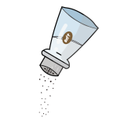 | Spicy  Flavor | 
Nutrient Claims | Low Fat | 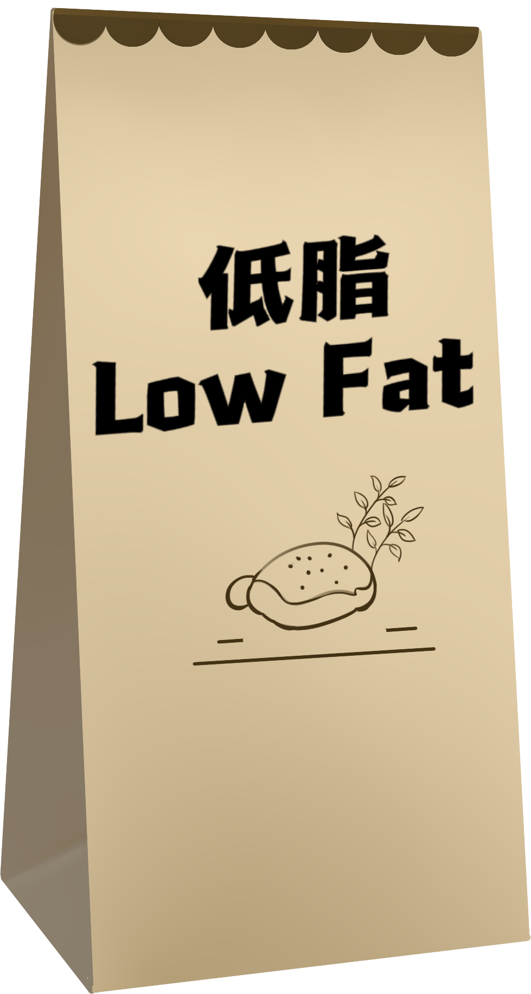 | Rich Minerals/  Vitamins | 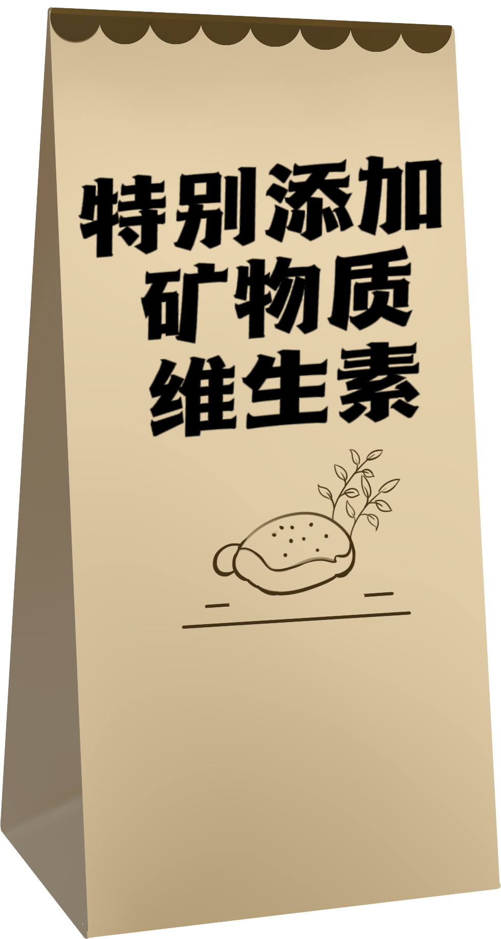
Purchase Location | Convenience  Store |  | Supermarket/  Hypermarket | 
Price | 5~9 ¥CNY |  | ≥10 ¥CNY
Package Size | Large | 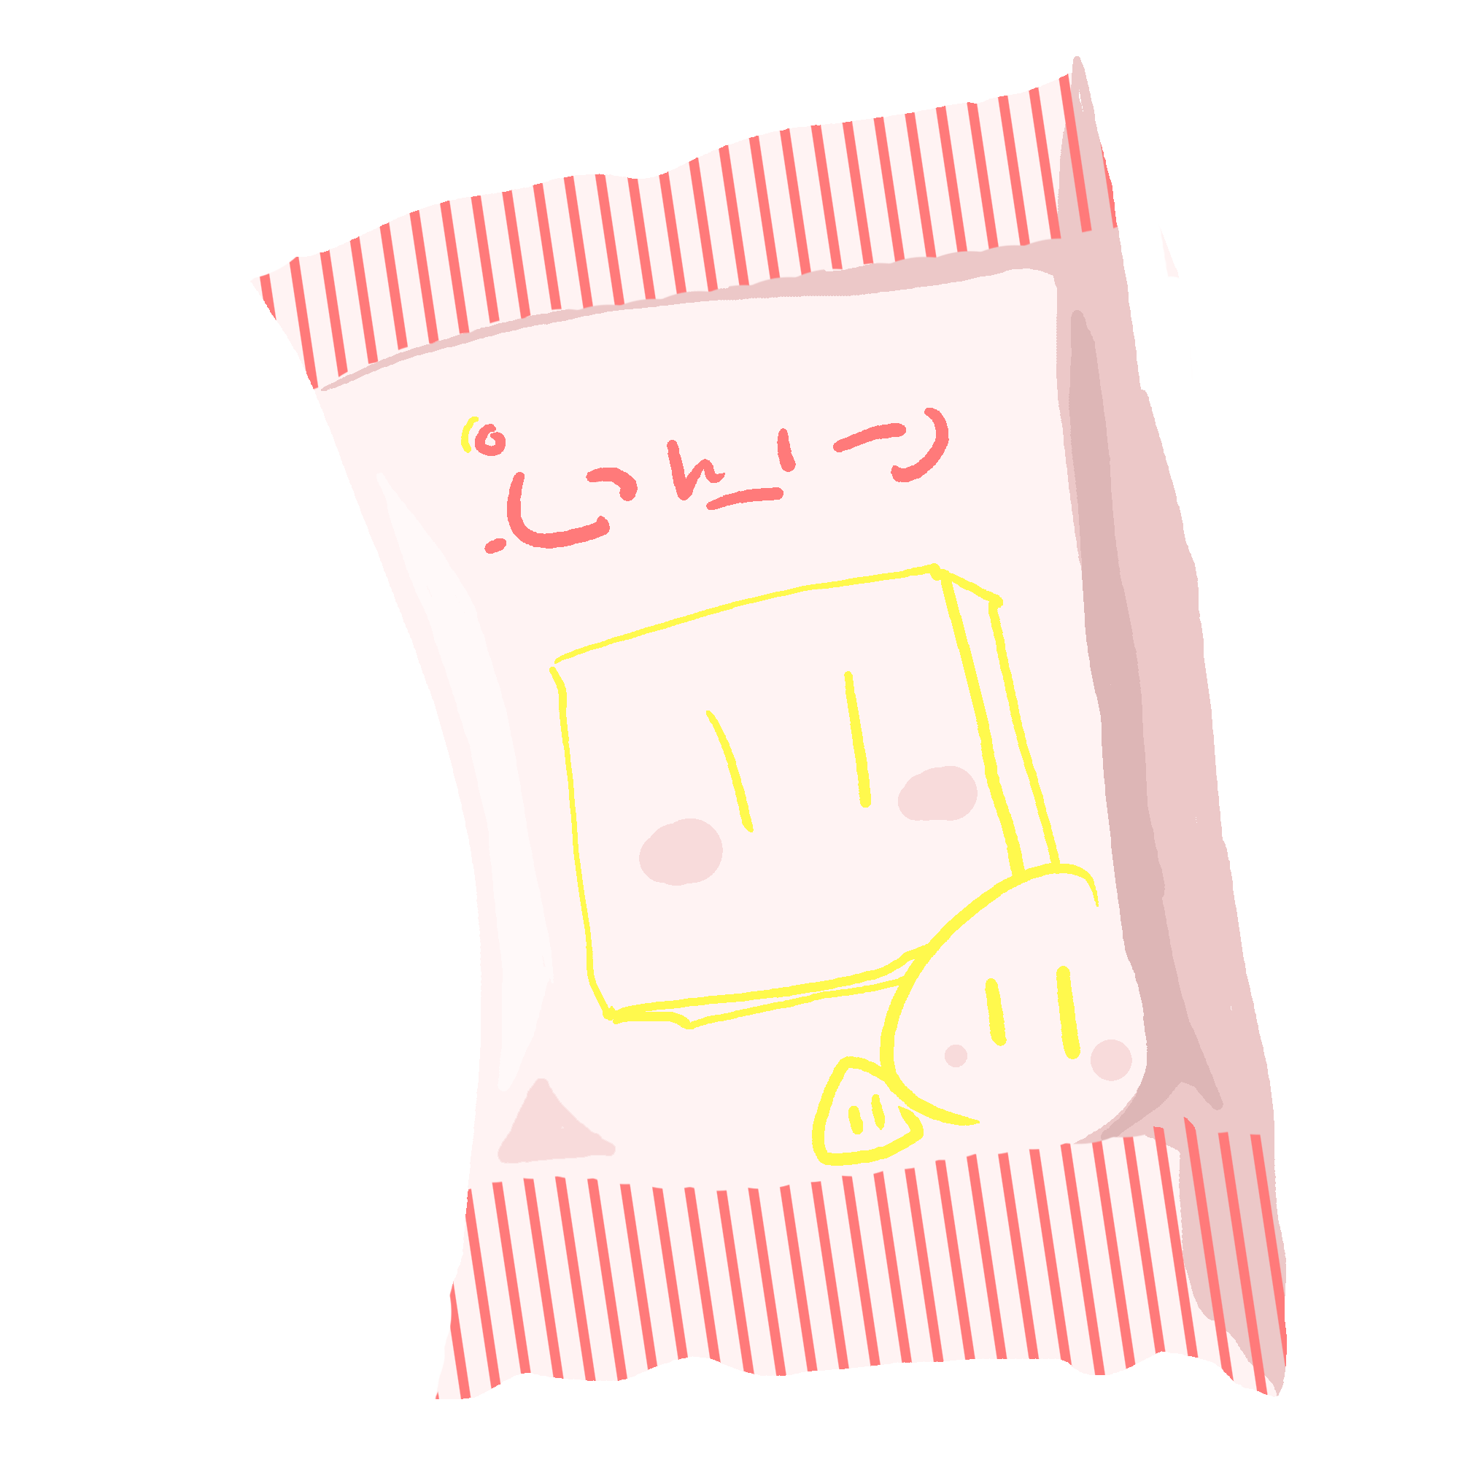 | Medium
Social Influence | Advertising/  Influencer Recommendations |  | Peer Recommendations | 
Which option would you be more willing to choose | Snack A |  | Snack B
Considering your daily diet, would you consume this snack in real life?
Yes No
Choice Set 2/8
Snack Attributes | Snack A |  | Snack B
Taste | Sweet Flavor |  | Original Flavor | 
Nutrient Claims | None | 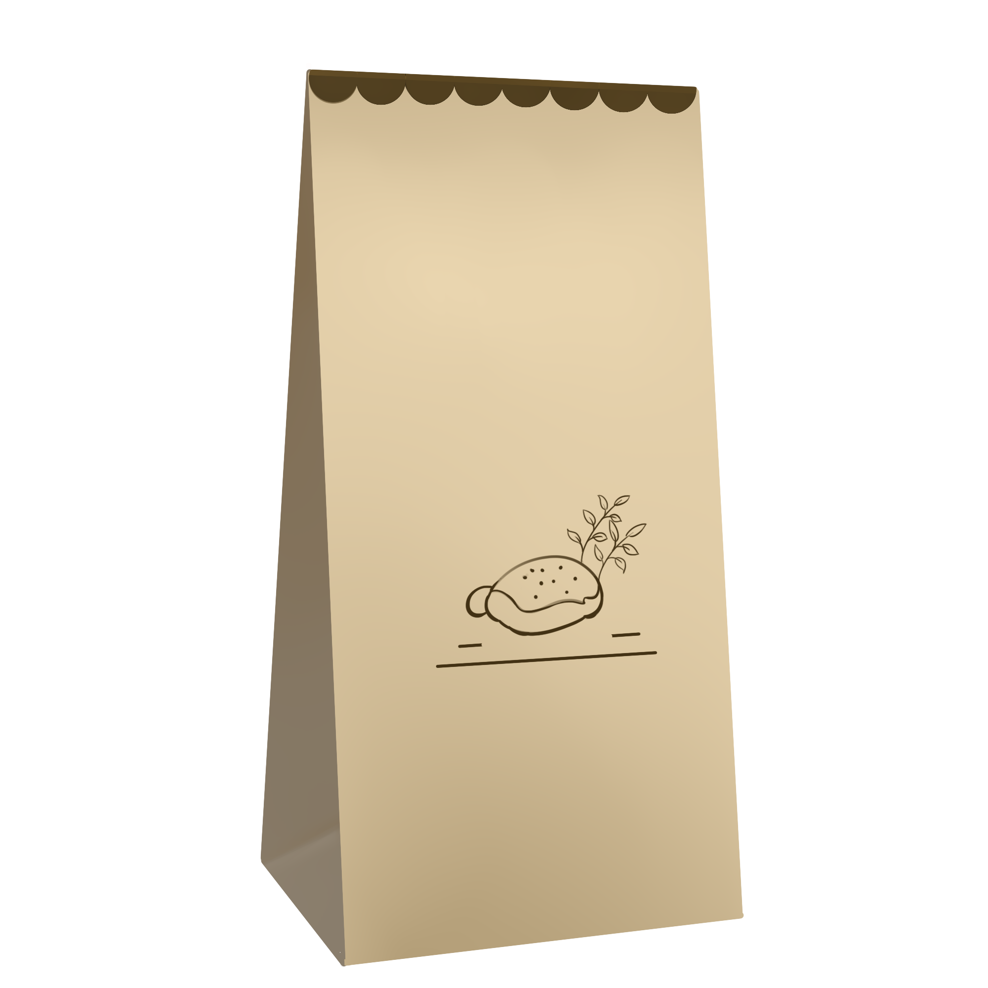 | Rich Minerals / Vitamins
Purchase Location | Near School | 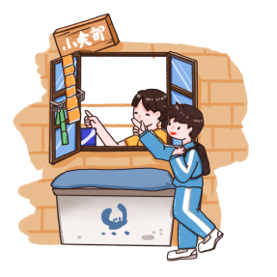 | Convenience  Store
Price | 5~9 ¥CNY |  | ≥10 ¥CNY
Package Size | Small |  | Large
Social Influence | Family Consumption Habits | 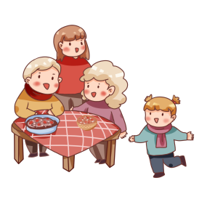 | Advertising/ Influencer Recommendations
Which option would you be more willing to choose | Snack A |  | Snack B
Considering your daily diet, would you consume this snack in real life?
Yes No

Choice Set 3/8
Snack Attributes | SnackA |  | SnackB
Taste | Spicy  Flavor |  | Original Flavor
Nutrient Claims | Low Fat |  | None
Purchase Location | Supermarket/ Hypermarket |  | Near School
Price | ≥10 ¥CNY |  | <5 ¥CNY
Package Size | Small |  | Medium
Social Influence | Family Consumption Habits |  | Peer Recommendations
Which option would you be more willing to choose | Snack A |  | Snack B
Considering your daily diet, would you consume this snack in real life?
Yes No

Choice Set 4/8
Snack Attributes | Snack A |  | Snack B
Taste | Original Flavor |  | Spicy  Flavor
Nutrient Claims | Rich Minerals / Vitamins |  | High Dietary Fiber | 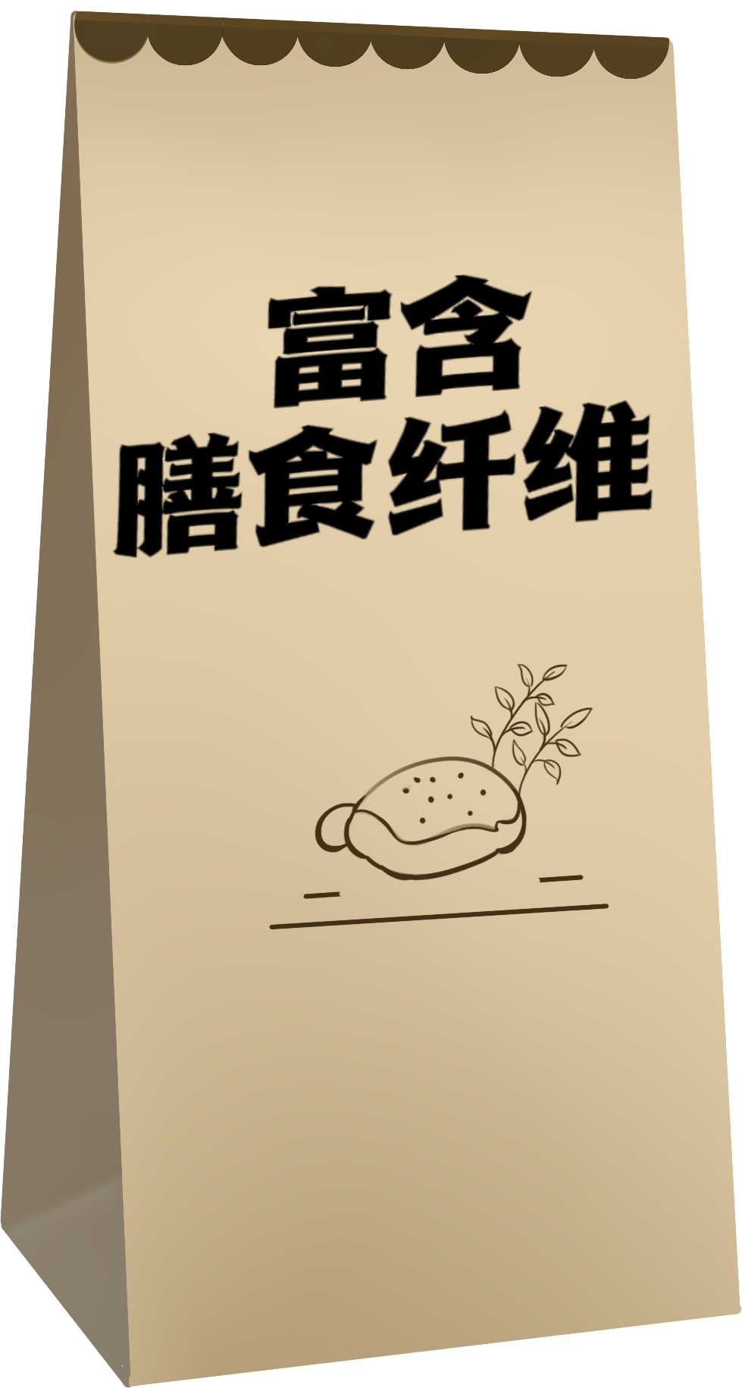
Purchase Location | Supermarket/ Hypermarket |  | Near School
Price | <5 ¥CNY |  | ≥10 ¥CNY
Package Size | Small |  | Medium
Social Influence | Family Consumption Habits |  | Advertising/ Influencer Recommendations
Which option would you be more willing to choose | SnackA |  | SnackB
Considering your daily diet, would you consume this snack in real life?
Yes No

Choice Set 5/8
Snack Attributes | Snack A |  | Snack B
Taste | Sweet Flavor |  | Spicy  Flavor
Nutrient Claims | High Dietary Fiber |  | Rich Minerals / Vitamins
Purchase Location | Supermarket/ Hypermarket |  | Online | 
Price | ≥10 ¥CNY |  | 5~9 ¥CNY
Package Size | Small |  | Medium
Social Influence | Peer Recommendations |  | Family Consumption Habits
Which option would you be more willing to choose | SnackA |  | SnackB
Considering your daily diet, would you consume this snack in real life?
Yes No

Choice Set 6/8
Snack Attributes | Snack A |  | Snack B
Taste | Savory  Flavor |  | Sweet  Flavor
Nutrient Claims | None |  | Rich Minerals / Vitamins
Purchase Location | Supermarket/ Hypermarket |  | Near School
Price | <5 ¥CNY |  | ≥10 ¥CNY
Package Size | Medium |  | Large
Social Influence | Advertising/ Influencer Recommendations |  | Family Consumption Habits
Which option would you be more willing to choose | Snack A |  | Snack B
Considering your daily diet, would you consume this snack in real life?
Yes No

Choice Set 7/8
Snack Attributes | Snack A |  | Snack B
Taste | Sweet Flavor |  | Original Flavor
Nutrient Claims | Rich Minerals / Vitamins |  | High Dietary Fiber
Purchase Location | Convenience  Store |  | Supermarket/ Hypermarket
Price | <5 ¥CNY |  | 5~9 ¥CNY
Package Size | Small |  | Large
Social Influence | Advertising/ Influencer Recommendations |  | Family Consumption Habits
Which option would you be more willing to choose | Snack A |  | Snack B
Considering your daily diet, would you consume this snack in real life?
Yes No

Choice Set 8/8
Snack Attributes | Snack A |  | Snack B
Taste | Original Flavor |  | Savory  Flavor
Nutrient Claims | None |  | High Dietary Fiber
Purchase Location | Near School |  | Online
Price | ≥10 ¥CNY |  | <5 ¥CNY
Package Size | Small |  | Large
Social Influence | Advertising/ Influencer Recommendations |  | Peer Recommendations
Which option would you be more willing to choose | Snack A |  | Snack B
Considering your daily diet, would you consume this snack in real life?
Yes No

