Supplementary information

Safeguarding Food Security is the Key to Unlocking the Land-Use Trilemma and Enabling Climate–Biodiversity Policy Synergies
Xiaotian Maª, Petr Havlík^{b}, Chao Yue^{c}, David Leclère^{b}, Stefan Frank^{b}, Zhenzhong Zeng^{d}, Hancheng Dai^{*a,e,f}

ª College of Environmental Sciences and Engineering, Peking University, Beijing, 100871, China
^{b} International Institute for Applied Systems Analysis (IIASA), Laxenburg, Austria
^{c} College of Natural Resources and Environment, Northwest A&F University, Yangling 712100, China
^{d} School of Environmental Science and Engineering, Southern University of Science and Technology, Shenzhen, 518055, China
^{e} Institute of Carbon Neutrality, Peking University, Beijing, 100871, China
^{f} Institute for Global Health and Development, Peking University, Beijing, 100871, China
* Correspondence: dai.hancheng@pku.edu.cn

Supplementary Methods
- Modelling Framework
- Food and Regions in GLOBIOM Model
- Biodiversity Priority Data
- Regional Afforestation from G4M Model
- Regional Bioenergy Supply and Demand
- Negative Emission Potential from Biomass
- Regional Income Levels
- Emulator-based global sensitivity analysis

Modelling Framework
GLOBIOM (Global Biosphere Management Model) ^{1,2} is a global bottom-up recursive dynamic partial equilibrium economic model of agriculture (including livestock), forestry, and bioenergy (Supplementary Fig. 1). The model computes a market equilibrium in 10-year time steps from 2000 to 2060 (2100) by maximizing welfare (the sum of consumer and producer surplus) subject to technological, resource, and political constraints. It has a detailed representation of the main land-use sectors at a 0.5° × 0.5° grid cell resolution and allows for an accurate assessment of biophysical and socioeconomic impacts. The model uses high spatial and commodity resolution as well as the physical rather than monetary representation of variables compared with the general equilibrium models. Agricultural commodities include 18 major crops (barley, dry beans, cassava, chickpeas, corn, cotton, groundnut, millet, potatoes, rapeseed, rice, soybeans, sorghum, sugarcane, sunflower, sweet potatoes, wheat, and oil palm) and seven livestock products (meat and milk of cattle and buffalos, meat and milk of sheep and goats, pig meat, poultry meat, and eggs). The 18 crops represent more than 70% of the total world harvested area and 85% of the vegetal calorie supply.
The demand for agricultural commodities within each region is endogenously calculated based on population, gross domestic product and equilibrium prices. The crop supply was calculated using the biophysical Environmental Policy Integrated Climate (EPIC) model ³. Each crop can be produced under four technologies: subsistence, low-input rainfed, high-input rainfed and high-input irrigated. GLOBIOM uses Enke–Samuelson–Takayama–Judge spatial equilibrium approach to simulate trade, assuming homogeneous goods. Trade occurs across 37 economic regions according to marginal production prices and transportation costs in each region. Bilateral trade flows were endogenously computed through the minimization of total trading costs.
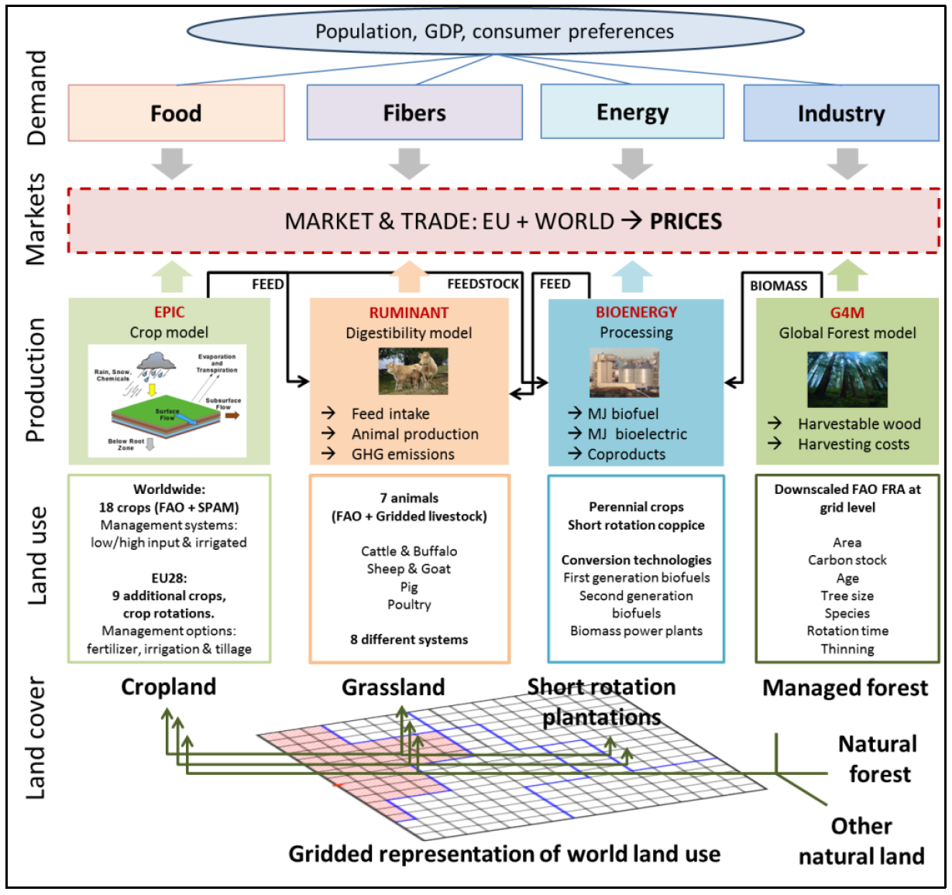
Supplementary Fig. 1. Overview of the GLOBIOM model. The Figure is taken from https://iiasa.github.io/GLOBIOM/introduction.html
GLOBIOM represents the competition between different land-use-based activities. It includes six land cover types: cropland, grassland, short rotation plantations, managed forests, unmanaged forests, and other natural vegetation lands. Depending on the relative profitability of primary product, by-product, and final product production activities, the model can switch from one land cover type to another. Spatially explicit land conversions over the simulation period are endogenously determined within the available land resources and considering conversion costs. Land conversion possibilities are further restricted through biophysical land suitability and production potentials, as well as through a matrix of potential land cover transitions. The allocation of acreage by the crops (food crops and energy crops for bioenergy) and management system is determined by potential yields, production costs, and expansion constraints (e.g., land and water). GLOBIOM covers major GHG emissions from agricultural production, forestry and other land use, including CO2 emissions from above- and below-ground biomass changes related to land-use change, N2O from the application of synthetic fertilizer and manure to soils, N2O from manure dropped on pastures, CH4 from rice cultivation, N2O and CH4 from manure management and CH4 from enteric fermentation.
Data on agricultural regional market variables, including demand and production, are for the base year and harmonized with FAOSTAT ⁴. The spatially explicit land-use allocation is initialized for 2000 with GLC2000 ⁵, which attributes to each 1x1 km resolution pixel a certain land cover by using remote-sensing techniques. In GLOBIOM, grassland is where ruminant grazing is occurring. This explains why the grassland area differs from grassland statistics. The remaining grassland is included in other natural lands because it has more ecological function than agricultural use. The spatially explicit productivity of crops, grasslands, forests, and short-rotation tree plantations is estimated together with related environmental parameters (GHG budgets, nutrient and water balance) at the level of the simulation units. For crops, yields under different management systems are calculated with the biophysical EPIC model. The spatially explicit fertilizer use for crops comes from EPIC rescaled by FAOSTAT country values. For forest parameters, GLOBIOM relies on the outputs of a dynamic forest management model, the Global Forest Model (G4M) ⁶. Grassland productivity is obtained by combining results from the EPIC and the CENTURY biogeochemistry model ^{2,7}. Livestock production systems are parameterized with the global database developed by Herrero et al ⁸. Parameters of livestock production are calculated based on a digestion and metabolism model (RUMINANT) ⁸. Parameters of the short-rotation plantations for bioenergy were estimated based on net primary productivity (NPP) maps ⁹ and calculated by Havlík et al. (2011) ¹. A detailed overview of data sources on model data sources for the environmental indicators was described in previous studies ^{10,11}.

Food and Regions in the GLOBIOM Model
In GLOBIOM, agricultural production is represented for 18 crops (barley, dry beans, cassava, chick peas, corn, cotton, groundnut, millet, oil palm, potatoes, rapeseed, rice, soybeans, sorghum, sugar cane, sunflower, sweet potatoes and wheat) and seven types of livestock (bovine meat and milk, small ruminant meat and milk, pig meat, poultry meat, and eggs) (Supplementary Table 1). Economic market balances in GLOBIOM are solved at the level of 37 economic regions (Supplementary Table 2).
Supplementary Table 1. Food in GLOBIOM.
Number | Abbreviation | Interpretation
1 | BVMEAT | Bovines meat
2 | SGMEAT | Sheep and goats meat
3 | PGMEAT | Pig meat
4 | PTMEAT | Poultry meat
5 | ALMILK | MILK
6 | PTEGGS | EGGS
1 | Barl | Barley
2 | Cass | Cassava
3 | Corn | Corn
4 | Cott | Cotton
5 | Gnut | Groundnuts
6 | Mill | Millet
7 | Pota | Potatos
8 | Rice | Rice
9 | Soya | Soybeans
10 | Srgh | Sorghum
11 | SugC | SugarCane
12 | Sunf | Sunflower
13 | SwPo | Sweet Potatoes
14 | Whea | Wheat
15 | BeaD | Dry Beans
16 | ChkP | Chick Pea
17 | Rape | Rape seed
18 | OPAL | Oil Palm

Supplementary Table 2. list of GLOBIOM regions
 | Model regions | Countries
Europe (EUR) | EU Baltic | Estonia, Latvia, Lithuania
Europe (EUR) | EU Central East | Bulgaria, Czech Republic, Hungary, Poland, Romania, Slovakia, Slovenia
Europe (EUR) | EU Mid West | Austria, Belgium, Germany, France, Luxembourg, Netherlands
Europe (EUR) | EU North | Denmark, Finland, Ireland, Sweden, United Kingdom
Europe (EUR) | EU South | Cyprus, Greece, Italy, Malta, Portugal, Spain
Europe (EUR) | RCEU | Albania, Bosnia and Herzegovina, Croatia, Macedonia, Serbia-Montenegro
Europe (EUR) | ROWE | Gibraltar, Iceland, Norway, Switzerland
Former USSR  (CIS) | Russia | Russian Federation
Former USSR  (CIS) | Ukraine | Ukraine
Former USSR  (CIS) | Former USSR | Armenia, Azerbaijan, Belarus, Georgia, Kazakhstan, Kyrgyzstan, Moldova, Tajikistan, Turkmenistan, Uzbekistan
Oceania (OCE) | Australia | Australia
Oceania (OCE) | New Zealand | New Zealand
Oceania (OCE) | Pacific Islands | Fiji Islands, Kiribati, Papua New Guinea, Samoa, Solomon Islands, Tonga, Vanuatu
Oceania (OCE) | Canada | Canada
North America (NAM) | United States of America | United States of America
Latin America (LAM) | Argentina | Argentina
Latin America (LAM) | Brazil | Brazil
Latin America (LAM) | Mexico | Mexico
Latin America (LAM) | RCAM | Bahamas, Barbados, Belize, Bermuda, Costa Rica, Cuba, Dominica, Dominican Republic,  El Salvador, Grenada, Guatemala, Haiti, Honduras, Jamaica, Nicaragua, Netherland  Antilles, Panama, St Lucia, St Vincent, Trinidad and Tobago
Latin America (LAM) | RSAM | Bolivia, Chile, Colombia, Ecuador, Guyana, Paraguay, Peru, Suriname, Uruguay, Venezuela
Eastern Asia (EAS) | China | China
Eastern Asia (EAS) | Japan | Japan
Eastern Asia (EAS) | South Korea | South Korea
Southeast Asia (SEA) | Indonesia | Indonesia
Southeast Asia (SEA) | Malaysia | Malaysia
Southeast Asia (SEA) | RSEA OPA | Brunei Daressalaam, Singapore, Myanmar, Philippines, Thailand
Southeast Asia (SEA) | RSEA PAC | Cambodia, Korea DPR, Laos, Mongolia, Viet Nam
South Asia (SAS) | India | India
South Asia (SAS) | RSAS | Afghanistan, Bangladesh, Bhutan, Maldives, Nepal, Pakistan, Sri Lanka
Middle-East North Africa (MNA) | Middle East | Bahrain, Iran, Iraq, Israel, Jordan, Kuwait, Lebanon, Oman, Qatar, Saudi Arabia, Syria, United Arab Emirates, Yemen
Middle-East North Africa (MNA) | Northern Africa | Algeria, Egypt, Libya, Morocco, Tunisia, West Sahara
Middle-East North Africa (MNA) | Turkey | Turkey
Sub-Saharan Africa (SSA) | Congo Basin | Cameroon, Central African Republic, Congo Republic, Democratic Republic of Congo,Equatorial Guinea, Gabon
Sub-Saharan Africa (SSA) | Eastern Africa | Burundi, Ethiopia, Kenya, Rwanda, Tanzania, Uganda
Sub-Saharan Africa (SSA) | South Africa | South Africa
Sub-Saharan Africa (SSA) | Southern Africa (Rest of) | Angola, Botswana, Comoros, Lesotho, Madagascar, Malawi, Mauritius, Mozambique, Namibia, Swaziland, Zambia, Zimbabwe
Sub-Saharan Africa (SSA) | West and Central Africa | Benin, Burkina Faso, Cape Verde, Chad, Cote d’Ivoire, Djibouti, Eritrea, Gambia, Ghana, Guinea, Guinea Bissau, Liberia, Mali, Mauritania, Niger, Nigeria, Senegal, Sierra Leone, Somalia, Sudan, Togo

Biodiversity Priority Data
Jung et al. ¹² provide the spatial guidance necessary to identify land areas with the most significant potential for synergies between biodiversity conservation and nature’s contributions to people. If priority were given to biodiversity only, managing 30% of optimally located land area for conservation may be sufficient to meet conservation targets for 81.3% of the terrestrial plant and vertebrate species considered. We just use the priority data across 50-km² grids only for biodiversity (Supplementary Fig. 2), which can be matched with the grids of the GLOBIOM model.
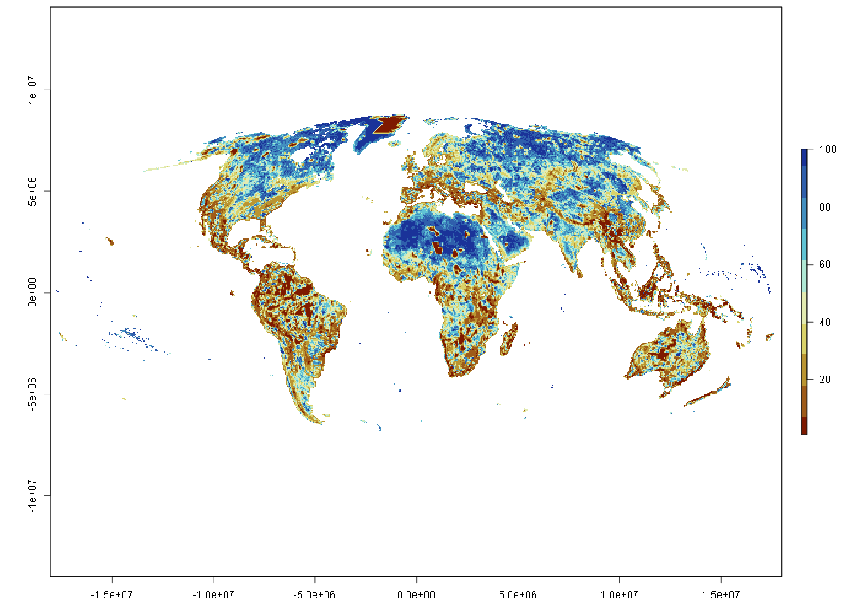
Supplementary Fig. 2. Priority data across 50-km² grids for species target. The figure is taken from https://zenodo.org/records/5006332.

Regional Afforestation from the G4M Model
The IIASA Global Forest Model (G4M, https://iiasa.ac.at/models-tools-data/g4m) estimates the productivity of five forest types (evergreen needleleaf, evergreen broadleaf, deciduous needleleaf, deciduous broadleaf and woody savannas) in four ecoregions (Tropical, Subtropical, Temperate and Boreal) based on dynamic site characteristics (monthly Temperature, Precipitation, Radiation, CO2), semi dynamic (Water holding capacity, sold depth, Nitrogen, Phosphorus, Salinity, pH-Value) and static (air pressure). Combining productivity with a management regime (e.g. keep current stock, maximize harvests, maximize stock, no harvests) which could be turned on or off to change the current species to better adapted to the potentially changed site characteristics, it is possible to show the development of increment (carbon sequestration), stock (stored carbon) and harvests (potential substitutes for nonrenewable products and in those also stored carbon).
It can compare the income derived from forests with the income that could be derived from an alternative use of the same land, for example, to grow grain for food or biofuel. To do this, G4M estimates the amount of net income currently being derived from forests by calculating the amount and value of wood produced minus the harvesting costs (i.e., logging and timber extraction). It also assesses the potential income represented by carbon storage in forests (sequestration). Taking these values into account, G4M demonstrates whether it would be more profitable to grow crops or bio-fuels at the location, or whether forestry is the economically best option for the land. This allows us to identify regions with high deforestation pressure and regions which could be afforested. By estimating the time needed to make these land use changes, it is also possible to show forest cover development over time. G4M thus provides an economically sound basis for decision making, either independently or in conjunction with other models.
GLOBIOM is linked with the G4M model ^{13,14} for the detailed representation of forest management and carbon flows. This study did not directly run the coupled GLOBIOM-G4M model for scenario simulation, but uses two scenario data sets of the G4M model (Supplementary Table 3), the SSP2 benchmark scenario and the SSP2-RCP2.6 scenario (data used in L scenario). The specific afforestation and deforestation data by countries are shown in the table below. The data were merged into 37 regions in the GLOBIOM model according to Supplementary Table 2.
Supplementary Table 3. Future trends in afforestation of 192 countries
Country |  | SSP2 scenario |  |  | RCP2.6 scenario
 | 2020 | 2030 | 2040 | 2050 | 2030 | 2040 | 2050
World | 165629 | 208226 | 259463 | 308976 | 254462 | 342631 | 428043
Afghanistan | 0.98 | 9.23 | 25.13 | 46.67 | 9.26 | 25.17 | 46.70
Albania | 40.07 | 64.28 | 87.22 | 94.09 | 64.28 | 90.34 | 117.62
Algeria | 0.00 | 0.00 | 0.00 | 0.00 | 0.00 | 0.00 | 12.72
Andorra | 0.00 | 0.00 | 0.00 | 0.00 | 0.00 | 0.00 | 0.00
Angola | 4.25 | 0.00 | 0.00 | 0.00 | 312.11 | 650.66 | 1105.72
Antigua_and_Barbuda | 0.00 | 0.00 | 0.00 | 0.00 | 0.00 | 0.00 | 0.00
Argentina | 11456.96 | 12014.74 | 12392.75 | 12590.76 | 15140.84 | 17694.77 | 19181.04
Armenia | 7.70 | 12.00 | 16.52 | 21.19 | 12.00 | 16.52 | 21.19
Australia | 69.77 | 71.94 | 71.94 | 71.94 | 71.94 | 301.27 | 1120.90
Austria | 920.44 | 836.63 | 968.78 | 1264.65 | 1030.98 | 1263.93 | 1968.84
Azerbaijan | 76.22 | 125.33 | 174.60 | 224.88 | 125.33 | 174.60 | 224.88
Bahamas | 0.00 | 0.00 | 0.00 | 0.00 | 0.00 | 0.00 | 0.00
Bahrain | 0.00 | 0.00 | 0.00 | 0.00 | 0.00 | 0.00 | 0.00
Bangladesh | 0.00 | 0.00 | 0.00 | 0.00 | 0.00 | 0.00 | 0.00
Barbados | 0.00 | 0.00 | 0.00 | 0.00 | 0.00 | 0.00 | 0.00
Belarus | 745.18 | 1135.25 | 1525.19 | 1915.52 | 1135.25 | 1525.19 | 1916.93
Belgium | 20.81 | 31.71 | 42.94 | 59.25 | 31.71 | 44.69 | 75.21
Belize | 0.00 | 0.00 | 0.00 | 0.00 | 0.00 | 0.00 | 2.93
Benin | 0.00 | 0.00 | 0.00 | 0.00 | 0.00 | 0.00 | 0.00
Bhutan | 152.38 | 206.29 | 242.62 | 254.82 | 210.27 | 254.96 | 271.46
Bolivia | 0.00 | 0.00 | 0.00 | 0.00 | 571.01 | 2006.92 | 4148.95
Bosnia_and_Herzegovina | 147.92 | 226.91 | 286.88 | 318.12 | 229.43 | 308.66 | 381.20
Botswana | 0.00 | 0.00 | 0.00 | 0.00 | 0.00 | 0.00 | 0.00
Brazil | 15059.49 | 11675.38 | 16125.71 | 22045.86 | 31869.30 | 48086.80 | 63601.82
Brunei_Darussalam | 2.65 | 2.69 | 8.09 | 13.56 | 10.28 | 17.96 | 25.31
Bulgaria | 549.93 | 554.16 | 573.81 | 636.25 | 554.23 | 565.94 | 606.22
Burkina_Faso | 833.48 | 1786.67 | 2943.98 | 3509.16 | 1994.24 | 3521.18 | 4649.40
Burundi | 7.35 | 19.30 | 19.30 | 19.30 | 21.42 | 47.74 | 87.03
Cambodia | 0.00 | 0.00 | 0.00 | 0.00 | 0.00 | 0.00 | 88.92
Cameroon | 474.02 | 357.17 | 477.67 | 555.15 | 1398.88 | 2167.45 | 2909.24
Canada | 5980.65 | 8732.78 | 11239.71 | 13569.58 | 8701.10 | 11214.73 | 13540.11
Central_African_Republic | 977.84 | 1670.86 | 2520.22 | 3425.57 | 1664.78 | 2474.14 | 3284.83
Chad | 0.00 | 0.00 | 0.00 | 0.00 | 0.00 | 0.00 | 0.00
Chile | 1025.66 | 1390.15 | 1698.37 | 1925.78 | 1478.22 | 1849.63 | 2156.20
China | 55395.75 | 65641.66 | 69986.58 | 72346.78 | 65709.03 | 70093.24 | 72385.66
Colombia | 6761.34 | 6723.40 | 7554.63 | 8871.38 | 11944.75 | 17014.44 | 21703.89
Comoros | 0.00 | 0.00 | 0.00 | 0.00 | 0.00 | 0.00 | 0.00
Congo | 53.44 | 88.02 | 129.05 | 170.91 | 90.76 | 134.87 | 180.68
Costa_Rica | 364.02 | 397.35 | 423.34 | 423.34 | 421.69 | 450.17 | 450.18
Cote_d_Ivoire | 1754.71 | 2875.90 | 3967.41 | 4682.32 | 2988.19 | 4289.97 | 5244.27
Croatia | 183.46 | 273.23 | 344.49 | 406.25 | 279.67 | 368.44 | 448.85
Cuba | 893.03 | 1159.70 | 1242.41 | 1269.89 | 1284.78 | 1422.72 | 1479.22
Cyprus | 0.00 | 0.00 | 0.00 | 0.00 | 0.00 | 0.00 | 0.00
Czech_Republic | 45.02 | 68.33 | 93.36 | 117.59 | 68.33 | 92.77 | 118.34
Democratic_Peoples_Republic_of_Korea | 0.00 | 0.00 | 0.00 | 0.00 | 0.00 | 0.00 | 0.00
Democratic_Republic_of_the_Congo | 0.00 | 0.00 | 0.00 | 0.00 | 0.00 | 0.00 | 0.00
Denmark | 133.53 | 197.07 | 258.81 | 315.65 | 197.07 | 259.06 | 317.43
Djibouti | 0.00 | 0.00 | 0.00 | 0.00 | 0.00 | 0.00 | 0.00
Dominica | 0.00 | 0.00 | 0.00 | 0.00 | 0.00 | 0.00 | 0.00
Dominican_Republic | 22.66 | 35.73 | 54.37 | 80.77 | 36.91 | 77.13 | 132.18
Ecuador | 116.67 | 0.00 | 0.00 | 0.00 | 1972.51 | 3441.54 | 4752.72
Egypt | 0.00 | 0.00 | 0.00 | 0.00 | 0.00 | 0.00 | 0.00
El_Salvador | 0.00 | 0.00 | 0.00 | 0.00 | 0.00 | 0.00 | 0.00
Equatorial_Guinea | 0.00 | 0.00 | 0.00 | 0.00 | 0.00 | 0.00 | 0.00
Eritrea | 18.65 | 33.06 | 84.08 | 195.34 | 33.06 | 84.08 | 195.34
Estonia | 41.48 | 75.28 | 118.65 | 162.38 | 84.19 | 127.55 | 171.28
Ethiopia | 1170.31 | 2439.56 | 4063.92 | 5173.53 | 3851.41 | 7981.48 | 12887.97
Faeroe_Islands | 0.00 | 0.00 | 0.00 | 0.00 | 0.00 | 0.00 | 0.00
Falkland_Islands | 0.00 | 0.00 | 0.00 | 0.00 | 0.00 | 0.00 | 0.00
Fiji | 0.00 | 0.00 | 0.00 | 0.00 | 0.00 | 0.00 | 0.00
Finland | 0.04 | 0.05 | 0.07 | 0.10 | 0.07 | 0.12 | 0.20
France | 1360.75 | 1952.55 | 2533.41 | 3080.80 | 2042.14 | 2682.75 | 3288.35
French_Guiana | 0.00 | 0.00 | 0.00 | 0.00 | 0.00 | 0.00 | 0.00
Gabon | 4898.82 | 7520.49 | 10249.74 | 12397.27 | 5597.86 | 5698.26 | 5698.26
Gambia | 0.00 | 0.00 | 0.00 | 0.00 | 0.00 | 0.00 | 0.00
Georgia | 270.18 | 439.47 | 620.72 | 799.85 | 439.47 | 620.72 | 800.36
Germany | 91.59 | 97.22 | 150.35 | 250.99 | 130.03 | 210.88 | 383.62
Ghana | 908.06 | 1749.59 | 2526.67 | 3097.14 | 2408.54 | 4032.14 | 5400.56
Greece | 138.19 | 129.96 | 130.28 | 130.28 | 138.19 | 144.40 | 146.30
Greenland | 0.00 | 0.00 | 0.00 | 0.00 | 0.00 | 0.00 | 0.00
Grenada | 0.00 | 0.00 | 0.00 | 0.00 | 0.00 | 0.00 | 0.00
Guadeloupe | 0.00 | 0.00 | 0.00 | 0.00 | 0.00 | 0.00 | 0.00
Guatemala | 150.43 | 187.86 | 250.70 | 290.14 | 353.42 | 568.10 | 768.73
Guinea | 269.50 | 494.88 | 756.59 | 1011.09 | 495.32 | 807.68 | 1194.95
Guinea_Bissau | 0.00 | 0.00 | 0.00 | 0.00 | 0.00 | 0.00 | 0.00
Guyana | 198.89 | 202.99 | 246.62 | 275.15 | 261.52 | 321.33 | 377.79
Haiti | 0.00 | 0.00 | 0.00 | 0.00 | 0.00 | 36.72 | 185.02
Honduras | 0.00 | 0.00 | 0.00 | 0.00 | 0.00 | 0.00 | 0.00
Hungary | 227.97 | 296.57 | 350.75 | 396.30 | 296.97 | 348.22 | 408.68
Iceland | 0.00 | 0.00 | 0.00 | 0.00 | 0.00 | 0.00 | 0.00
India | 8109.73 | 10990.51 | 12440.76 | 12950.17 | 11408.62 | 13293.60 | 14289.60
Indonesia | 0.00 | 0.00 | 0.00 | 0.00 | 0.00 | 0.00 | 14.06
Iran_Islamic_Republic_of | 34.64 | 48.60 | 73.97 | 105.90 | 73.73 | 130.75 | 194.52
Iraq | 17.52 | 28.34 | 52.50 | 77.18 | 38.59 | 62.76 | 87.43
Ireland | 198.62 | 257.51 | 311.95 | 403.24 | 258.29 | 303.63 | 356.56
Israel | 0.00 | 0.00 | 0.00 | 0.00 | 1.93 | 5.86 | 9.84
Italy | 1368.56 | 1605.17 | 1757.42 | 1812.89 | 1637.81 | 1809.01 | 1882.43
Jamaica | 0.00 | 0.00 | 0.00 | 0.00 | 0.00 | 0.00 | 0.00
Japan | 417.31 | 696.22 | 998.72 | 1304.64 | 750.36 | 1108.59 | 1500.09
Jordan | 0.00 | 0.00 | 0.00 | 0.00 | 0.00 | 0.00 | 0.00
Kazakhstan | 426.30 | 1046.44 | 1711.24 | 2114.14 | 1202.97 | 1818.92 | 2159.30
Kenya | 708.95 | 886.05 | 1175.48 | 1329.66 | 1419.39 | 2209.20 | 3115.29
Kuwait | 0.00 | 0.00 | 0.00 | 0.00 | 0.00 | 0.00 | 0.00
Kyrgyzstan | 72.14 | 115.73 | 163.26 | 192.07 | 115.73 | 163.26 | 192.07
Lao_Peoples_Democratic_Republic | 1108.89 | 1184.13 | 2800.54 | 4676.95 | 4682.90 | 7621.83 | 9284.09
Latvia | 240.64 | 339.28 | 414.20 | 469.34 | 336.62 | 411.55 | 468.53
Lebanon | 0.00 | 0.00 | 0.00 | 0.00 | 0.00 | 0.00 | 0.00
Lesotho | 16.71 | 29.93 | 46.58 | 65.49 | 29.93 | 46.58 | 65.49
Liberia | 26.71 | 93.51 | 183.59 | 291.33 | 102.82 | 283.26 | 582.82
Libyan_Arab_Jamahiriya | 0.00 | 0.00 | 0.00 | 0.00 | 0.00 | 0.00 | 0.00
Liechtenstein | 0.00 | 0.00 | 0.00 | 0.00 | 0.00 | 0.00 | 0.00
Lithuania | 284.11 | 430.77 | 575.73 | 719.66 | 430.82 | 576.54 | 720.52
Luxembourg | 9.34 | 14.02 | 14.02 | 14.02 | 14.02 | 16.06 | 16.06
Madagascar | 419.21 | 928.11 | 1830.82 | 2995.95 | 947.61 | 1838.74 | 3110.71
Malawi | 411.32 | 768.62 | 1195.77 | 1451.93 | 766.16 | 1226.79 | 1508.83
Malaysia | 346.49 | 728.04 | 1765.32 | 3653.13 | 1974.69 | 4218.85 | 5876.49
Mali | 0.02 | 0.00 | 0.00 | 0.00 | 0.07 | 0.15 | 0.27
Malta | 0.00 | 0.00 | 0.00 | 0.00 | 0.00 | 0.00 | 0.00
Martinique | 0.00 | 0.00 | 0.00 | 0.00 | 0.00 | 0.00 | 0.00
Mauritania | 0.00 | 0.00 | 0.00 | 0.00 | 0.00 | 0.00 | 0.00
Mauritius | 0.00 | 0.00 | 0.00 | 0.00 | 0.00 | 0.00 | 0.00
Mexico | 439.16 | 330.18 | 484.83 | 640.10 | 869.05 | 6304.94 | 11942.38
Monaco | 0.00 | 0.00 | 0.00 | 0.00 | 0.00 | 0.00 | 0.00
Mongolia | 0.00 | 0.00 | 0.00 | 0.00 | 0.00 | 0.00 | 0.00
Morocco | 205.38 | 292.02 | 365.48 | 397.53 | 292.08 | 366.36 | 399.50
Mozambique | 611.63 | 1292.21 | 2316.59 | 3558.67 | 1421.45 | 2593.07 | 4058.63
Myanmar | 1963.13 | 3138.77 | 5834.41 | 9566.14 | 3803.17 | 6653.21 | 11262.56
Namibia | 0.00 | 0.00 | 0.00 | 0.00 | 0.00 | 0.00 | 0.00
Nepal | 0.00 | 0.00 | 0.00 | 0.00 | 0.00 | 0.00 | 0.00
Netherlands | 50.11 | 36.99 | 68.61 | 139.46 | 64.23 | 127.64 | 221.65
New_Caledonia | 0.00 | 0.00 | 0.00 | 0.00 | 0.00 | 0.00 | 0.00
New_Zealand | 81.18 | 132.03 | 183.61 | 235.27 | 134.03 | 186.96 | 239.96
Nicaragua | 0.00 | 0.00 | 0.00 | 0.00 | 3.10 | 151.12 | 394.38
Nigeria | 0.00 | 0.00 | 0.00 | 0.00 | 0.00 | 0.00 | 0.00
Northern_Mariana_Islands | 0.00 | 0.00 | 0.00 | 0.00 | 0.00 | 0.00 | 0.00
Norway | 487.45 | 775.26 | 940.14 | 1084.40 | 777.48 | 953.95 | 1101.42
Oman | 0.00 | 0.00 | 0.00 | 0.00 | 0.00 | 0.00 | 0.00
Pakistan | 0.02 | 0.02 | 0.03 | 0.04 | 0.03 | 0.04 | 0.05
Palestinian_Territories | 0.00 | 0.00 | 0.00 | 0.00 | 0.00 | 0.00 | 0.00
Panama | 68.97 | 75.39 | 108.26 | 146.42 | 122.22 | 176.47 | 231.36
Papua_New_Guinea | 3.30 | 0.30 | 0.82 | 1.80 | 40.64 | 80.44 | 121.29
Paraguay | 469.03 | 591.19 | 770.82 | 999.77 | 1082.21 | 1748.59 | 2439.83
Peru | 3397.67 | 2840.09 | 3374.76 | 4408.45 | 4694.98 | 5281.94 | 5696.88
Philippines | 1249.02 | 1728.53 | 2050.35 | 2217.59 | 1750.87 | 2084.98 | 2291.31
Poland | 592.84 | 770.16 | 883.82 | 971.88 | 768.90 | 875.38 | 1072.50
Portugal | 191.07 | 266.01 | 339.46 | 408.73 | 272.67 | 354.11 | 431.68
Puerto_Rico | 0.00 | 0.00 | 0.00 | 0.00 | 0.00 | 0.00 | 0.00
Qatar | 0.00 | 0.00 | 0.00 | 0.00 | 0.00 | 0.00 | 0.00
Republic_of_Korea | 0.00 | 596.33 | 740.85 | 751.23 | 437.51 | 499.70 | 681.86
Republic_of_Moldova | 142.19 | 226.97 | 316.67 | 408.87 | 226.97 | 316.67 | 408.87
Republic_of_Serbia | 825.48 | 920.45 | 975.23 | 1011.42 | 1030.79 | 1104.26 | 1157.35
Reunion | 0.00 | 0.00 | 0.00 | 0.00 | 0.00 | 0.00 | 0.00
Romania | 435.83 | 670.45 | 905.27 | 1120.66 | 670.78 | 904.88 | 1125.94
Russian_Federation | 4385.15 | 7393.16 | 10455.76 | 13445.80 | 7374.02 | 10319.56 | 13190.49
Rwanda | 128.88 | 119.26 | 127.35 | 127.35 | 137.75 | 148.96 | 162.12
Saint_Kitts_and_Nevis | 0.00 | 0.00 | 0.00 | 0.00 | 0.00 | 0.00 | 0.00
Saint_Lucia | 0.00 | 0.00 | 0.00 | 0.00 | 0.00 | 0.00 | 0.00
Saint_Vincent_and_the_Grenadines | 0.00 | 0.00 | 0.00 | 0.00 | 0.00 | 0.00 | 0.00
San_Marino | 0.00 | 0.00 | 0.00 | 0.00 | 0.00 | 0.00 | 0.00
Sao_Tome_and_Principe | 0.00 | 0.00 | 0.00 | 0.00 | 0.00 | 0.00 | 0.00
Saudi_Arabia | 0.00 | 0.00 | 0.00 | 0.00 | 0.00 | 0.00 | 0.00
Senegal | 345.36 | 570.89 | 839.30 | 1119.58 | 579.69 | 855.38 | 1170.00
Sierra_Leone | 162.06 | 306.47 | 705.32 | 873.16 | 798.44 | 1625.83 | 1983.57
Singapore | 0.74 | 0.74 | 1.47 | 2.94 | 0.74 | 1.47 | 2.94
Slovakia | 38.42 | 57.63 | 77.30 | 97.70 | 57.60 | 77.07 | 97.24
Slovenia | 63.74 | 95.97 | 127.47 | 157.51 | 95.97 | 126.24 | 155.17
Solomon_Islands | 0.00 | 0.00 | 0.00 | 0.00 | 0.00 | 0.00 | 0.00
Somalia | 0.00 | 0.00 | 0.00 | 0.00 | 0.00 | 0.00 | 0.00
South_Africa | 83.40 | 129.80 | 180.85 | 233.48 | 131.08 | 180.72 | 231.39
Spain | 173.81 | 161.47 | 164.83 | 166.23 | 181.59 | 193.98 | 204.06
Sri_Lanka | 0.00 | 0.00 | 0.00 | 0.00 | 0.00 | 0.00 | 0.00
Sudan | 1171.89 | 2004.47 | 3002.40 | 4186.64 | 2026.35 | 3129.65 | 4471.73
Suriname | 114.72 | 97.54 | 115.25 | 132.00 | 143.23 | 170.04 | 189.95
Svalbard_and_Jan_Mayen | 0.00 | 0.00 | 0.00 | 0.00 | 0.00 | 0.00 | 0.00
Swaziland | 0.01 | 0.00 | 0.12 | 0.41 | 0.01 | 0.14 | 0.42
Sweden | 1226.55 | 1326.59 | 1378.83 | 1422.13 | 1326.97 | 1377.83 | 1423.59
Switzerland | 97.90 | 148.70 | 199.79 | 251.24 | 148.70 | 199.79 | 251.24
Syrian_Arab_Republic | 124.38 | 194.83 | 266.28 | 315.49 | 194.83 | 271.87 | 337.42
Tajikistan | 0.00 | 0.00 | 0.00 | 0.00 | 1.05 | 3.44 | 6.03
Thailand | 1.06 | 5.30 | 90.32 | 208.68 | 9.23 | 80.36 | 209.39
The_former_Yugoslav_Republic_of_Macedonia | 84.80 | 129.93 | 159.76 | 165.90 | 133.72 | 181.63 | 222.34
Togo | 56.07 | 107.41 | 160.31 | 220.51 | 129.20 | 211.57 | 285.95
Trinidad_and_Tobago | 0.00 | 0.00 | 0.00 | 0.00 | 0.00 | 0.00 | 0.00
Tunisia | 173.24 | 173.20 | 173.20 | 173.20 | 173.24 | 173.24 | 173.24
Turkey | 2838.22 | 4006.64 | 4970.87 | 5637.83 | 4064.20 | 5187.57 | 6163.00
Turkmenistan | 0.00 | 0.00 | 0.00 | 0.00 | 0.00 | 0.00 | 0.00
Turks_and_Caicos_Islands | 0.00 | 0.00 | 0.00 | 0.00 | 0.00 | 0.00 | 0.00
Uganda | 298.11 | 383.64 | 426.40 | 446.41 | 918.25 | 1641.69 | 2388.68
Ukraine | 442.69 | 695.12 | 958.36 | 1227.76 | 695.12 | 958.36 | 1227.76
United_Arab_Emirates | 0.00 | 0.00 | 0.00 | 0.00 | 0.00 | 0.00 | 0.00
United_Kingdom | 255.98 | 368.35 | 507.84 | 626.16 | 370.96 | 504.48 | 636.88
United_Republic_of_Tanzania | 516.82 | 1853.23 | 4634.05 | 8421.40 | 1941.22 | 4965.94 | 9724.11
United_States_of_America | 8132.53 | 11998.49 | 15901.18 | 19423.39 | 12068.52 | 16026.55 | 19613.22
Uruguay | 91.08 | 88.44 | 88.44 | 88.44 | 91.36 | 92.34 | 93.93
Uzbekistan | 0.01 | 0.00 | 0.00 | 0.00 | 0.03 | 0.06 | 0.08
Vanuatu | 0.00 | 0.00 | 0.00 | 0.00 | 0.00 | 0.00 | 0.00
Venezuela | 0.00 | 0.00 | 0.00 | 0.00 | 0.00 | 0.00 | 36.40
Viet_Nam | 4854.77 | 6914.73 | 7977.22 | 8579.38 | 7142.89 | 8422.80 | 9106.48
Western_Sahara | 0.00 | 0.00 | 0.00 | 0.00 | 0.00 | 0.00 | 0.00
Yemen | 0.00 | 0.00 | 0.00 | 0.00 | 0.00 | 0.00 | 0.00
Zambia | 314.50 | 16.88 | 22.73 | 22.73 | 1107.24 | 1980.70 | 2904.37
Zimbabwe | 0.00 | 0.00 | 0.00 | 0.00 | 0.00 | 0.00 | 0.00

Regional Bioenergy Supply and Demand
The GLOBIOM model simulates both food-based liquid biofuels and woody lignocellulosic bioenergy. Liquid biofuels are pivotal for decarbonizing the transport sector, while woody lignocellulosic bioenergy is key for the decarbonization of other sectors, especially for the power and heat sector. The GLOBIOM model uses an exogenous demand trajectory for liquid biofuels from the POLES (Prospective Outlook on Long-Term Energy Systems) model ¹⁵.
Energy plantations and forestry residues are two feedstock sources of woody lignocellulosic bioenergy in the GLOBIOM model. Energy plantations are short-rotation plantations (SRP) covering short-rotation (i.e., 2 to 5 years) coppice and longer rotation (~10 years) forestry for the production of energy wood, for example, poplar, willow, or eucalyptus. Forestry residues are the by-products (for example, branches, stumps, bark, sawdust, and saw chips) produced during the final product production processes, which can be used for energy production. In this study, the biomass energy demand data are sourced from the IPCC AR6 database. The average results of the C2 (1.5℃-overshoot) scenario for each scenario are selected and listed in Supplementary Table 4.
Land suitability criteria determine the land suitable for energy plantations based on aridity, temperature, elevation, population, and land-cover data and the yields of energy plantations are based on net primary productivity (NPP) maps ⁹ and the model’s calculations as described in Havlík et al. (2011) ¹. Energy plantations can expand to include land-cover types such as cropland, grassland, and other natural vegetation lands. Energy plantation area expansion is determined based on the land-use change constraints and the relative profitability of alternative land-use options. Land-use change constraints define which land areas can be changed to plantations and how much of these areas can be changed within each period and region (so-called inertia conditions). Land-use inertia conditions limit the maximum feasible plantation expansion to 5% of available areas for each period. For example, plantation area expansion to cropland and grassland depends on the economic trade-off between food and wood production. Hence, the competition between alternative uses of land is modeled explicitly. When carrying out simulations over several periods, changes made in one period, are consistently transferred into the next, introducing recursive dynamics into the model. More details are provided in Havlík et al. (2011) ¹, Lauri et al (2014) ¹⁶ and Li et al. (2020) ¹⁷. Considering China has a water shortage, we assume no irrigation for energy crops.
GLOBIOM has a detailed simulation for the forest sector and its supply chains ¹⁸ based on the Global Forest Model (G4M) ^{6,13}, which is a spatially explicit process-based model. The model defines five primary forest products (sawn wood, plywood, fiberboard, chemical pulp, mechanical pulp, other industrial roundwood, fuelwood, and energy wood) and five by-products (sawdust, woodchips, bark, black liquor, and recycled wood). Detailed information on the forest sector is supplied in Lauri et al. ^{16,18}. Biomass for bioenergy can be sourced from the forest industry by-products. However, their availability and the share that can be used for bioenergy are limited, considering the environment and sustainability. We assume that forestry residues that are available for bioenergy differ under the key scenario and other scenarios.
Supplementary Table 4. Regional bioenergy use for B scenario.
Regions | Year | Lower bound | Key scenario | Upper bound
WesternEurope | 2020 | 2.01 | 4.04 | 5.55
SubSaharanAfrica | 2020 | 10.29 | 12.03 | 15.53
SouthAsia | 2020 | 7.91 | 8.59 | 10.92
PlannedAsiaChina | 2020 | 5.28 | 5.45 | 6.66
PacificOECD | 2020 | 0.23 | 0.56 | 0.69
OtherPacificAsia | 2020 | 2.56 | 5.66 | 7.86
NorthAmerica | 2020 | 4.07 | 7.12 | 5.39
MidEastNorthAfrica | 2020 | 0.15 | 0.43 | 0.83
LatinAmericaCarib | 2020 | 2.85 | 4.43 | 4.86
FormerSovietUnion | 2020 | 0.46 | 0.99 | 1.03
CentralEastEurope | 2020 | 0.59 | 1.18 | 1.61
WesternEurope | 2030 | 3.38 | 5.77 | 7.06
SubSaharanAfrica | 2030 | 13.14 | 14.11 | 17.77
SouthAsia | 2030 | 6.8 | 9.42 | 13.91
PlannedAsiaChina | 2030 | 7.35 | 9.13 | 9.49
PacificOECD | 2030 | 0.83 | 1.18 | 1.58
OtherPacificAsia | 2030 | 5.62 | 6.58 | 7.05
NorthAmerica | 2030 | 6.87 | 8.18 | 9.94
MidEastNorthAfrica | 2030 | 0.23 | 0.73 | 1.19
LatinAmericaCarib | 2030 | 6.01 | 9.24 | 10.06
FormerSovietUnion | 2030 | 1.45 | 1.87 | 2.28
CentralEastEurope | 2030 | 0.99 | 1.68 | 2.05
WesternEurope | 2040 | 3.94 | 6.98 | 9.28
SubSaharanAfrica | 2040 | 11.19 | 13.91 | 17.08
SouthAsia | 2040 | 5.56 | 9.45 | 13.26
PlannedAsiaChina | 2040 | 7.1 | 11.06 | 11.73
PacificOECD | 2040 | 1.32 | 1.92 | 2.72
OtherPacificAsia | 2040 | 5.82 | 7.44 | 6.43
NorthAmerica | 2040 | 7.33 | 10.56 | 12.67
MidEastNorthAfrica | 2040 | 0.25 | 1.46 | 1.79
LatinAmericaCarib | 2040 | 6.54 | 11.09 | 14.53
FormerSovietUnion | 2040 | 2.4 | 4.22 | 4.08
CentralEastEurope | 2040 | 1.15 | 2.03 | 2.7
WesternEurope | 2050 | 5.78 | 9.09 | 10.76
SubSaharanAfrica | 2050 | 9.36 | 16.56 | 24.46
SouthAsia | 2050 | 6.24 | 9.76 | 12.92
PlannedAsiaChina | 2050 | 12.62 | 16.78 | 19.48
PacificOECD | 2050 | 2.31 | 3.48 | 4.41
OtherPacificAsia | 2050 | 7.78 | 10.63 | 10.24
NorthAmerica | 2050 | 12.26 | 16.96 | 21.74
MidEastNorthAfrica | 2050 | 0.36 | 2.87 | 3.39
LatinAmericaCarib | 2050 | 10.27 | 20.89 | 30.83
FormerSovietUnion | 2050 | 3.5 | 8.19 | 8.86
CentralEastEurope | 2050 | 1.68 | 2.65 | 3.13

Calculation of the Negative Emission Potential from Biomass
To determine the negative emission potential that can be obtained via BECCS, we assumed that bioenergy is used to produce electricity in biomass-fired power plants equipped with carbon capture and storage (CCS). The amount of negative emission potential $Q_{{CO}_{2}}$ is calculated as:
$$Q_{{CO}_{2}}= Q_{Bio} ∗CC∗EC∗3.67$$
whereis the biomass consumption quantity; CC is the carbon content in biomass, for which we use 47.1% ¹⁹; EC is the efficiency of CO2 capture of CCS, for which we use 90% ²⁰; 3.67 is the conversion factor of C to CO2 ¹⁹; and the heat content of biomass is 19 GJ/t biomass ²¹.

Regional Income Levels and Calculation of Food Subsidy
We classify regional income levels based on the definition of the World Bank ²². However, Gross Domestic Product (GDP) was used for approximation instead of gross national income (GNI). The GDP, population, per capita GDP and income level classification of 37 regions in 2020 in the model are shown in Supplementary Table 5.
Supplementary Table 5. Regional Income Levels.
Regions | GDP(billion $) | POP(million) | GDP per Capita | Income level
ArgentinaReg | 378.80 | 43.57 | 8.69 | Upper middle
AustraliaReg | 1175.39 | 25.99 | 45.23 | High
BrazilReg | 1582.95 | 210.74 | 7.51 | Upper middle
CanadaReg | 1534.32 | 37.76 | 40.63 | High
ChinaReg | 8575.38 | 1428.79 | 6.00 | Upper middle
CongoBasin | 98.50 | 122.42 | 0.80 | low
EU_Baltic | 80.93 | 6.64 | 12.19 | High
EU_CentralEast | 1210.51 | 98.98 | 12.23 | High
EU_MidWest | 7723.93 | 186.34 | 41.45 | High
EU_North | 4186.21 | 92.86 | 45.08 | High
EU_South | 3755.11 | 134.49 | 27.92 | High
Former_USSR | 381.64 | 96.50 | 3.95 | Lower Middle
IndiaReg | 2318.52 | 1388.09 | 1.67 | Lower Middle
IndonesiaReg | 710.63 | 261.70 | 2.72 | Lower Middle
JapanReg | 5078.59 | 124.81 | 40.69 | High
MalaysiaReg | 274.48 | 32.95 | 8.33 | Upper middle
MexicoReg | 1289.29 | 126.18 | 10.22 | Upper middle
MiddleEast | 2312.75 | 263.09 | 8.79 | Upper middle
NewZealandReg | 151.84 | 4.85 | 31.30 | High
NorthernAf | 640.69 | 188.81 | 3.39 | Lower Middle
Pacific_Islands | 18.66 | 10.90 | 1.71 | Lower Middle
RCAM | 305.46 | 87.19 | 3.50 | Lower Middle
RCEU | 74.53 | 18.85 | 3.95 | Lower Middle
ROWE | 919.96 | 13.90 | 66.21 | High
RSAM | 1075.80 | 175.69 | 6.12 | Upper middle
RSAS | 435.55 | 432.63 | 1.01 | Lower Middle
RSEA_OPA | 832.10 | 240.28 | 3.46 | Lower Middle
RSEA_PAC | 174.54 | 147.62 | 1.18 | Lower Middle
RussiaReg | 1319.67 | 141.97 | 9.30 | Upper middle
SouthAfrReg | 431.64 | 54.80 | 7.88 | Upper middle
SouthKorea | 1477.60 | 49.38 | 29.92 | High
EasternAf | 151.33 | 282.15 | 0.54 | low
SouthernAf | 193.15 | 142.59 | 1.35 | Lower Middle
WesternAf | 541.51 | 474.59 | 1.14 | Lower Middle
TurkeyReg | 873.75 | 81.01 | 10.79 | Upper middle
UkraineReg | 129.07 | 42.94 | 3.01 | Lower Middle
USAReg | 17032.56 | 339.39 | 50.19 | High
To estimate the indirect cost of maintaining calorie intake under IAP‑driven price increases, we compared scenario food prices in IAP+CC to REF. For each major food category, we computed the price increment (IAP+CC price – REF price) and multiplied it by the REF consumption volume (see Supplementary Fig. 3). Summing across categories yields the total subsidy required to maintain constant consumption in each low- and lower-middle-income region. Aggregating across regions provides an estimate of subsidy needs, expressed in 2,000 US$ billion and as a share of regional or global GDP.
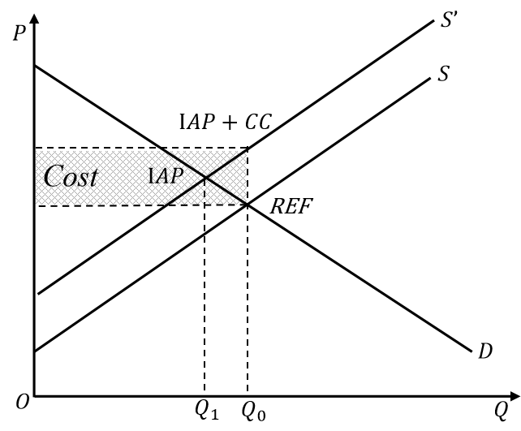
Supplementary Fig. 3. Calculation of Agricultural Subsidy.

Emulator-based global sensitivity analysis
Design of the experiment and sampling choices
We constructed a four-dimensional experimental design over the policy space spanned by land protection, agricultural carbon price, LULUCF carbon price / afforestation intensity, and bioenergy demand. For the global sensitivity analysis we used a Latin hypercube sampling (LHS) design with $N_{sim}=400$ points. The ranges of each input dimension were chosen to cover the policy space implied by the AR6 C2 (1.5 °C overshoot) pathway and our scenario narratives.
The LHS size of 400 runs reflects a compromise between exploration of the four-dimensional space and the computational cost of running the full integrated assessment model. Pilot experiments with smaller designs (e.g., $N=100)$ were used to check that basic non-linearities and pairwise interactions could be captured; increasing to 400 runs substantially stabilised emulator fits and Sobol indices while remaining feasible in terms of model runtime. All regions share the same set of 400 global scenarios; we did not design separate, region-specific samples.
For protected areas, the four biodiversity policy pathways (NBIO, BIOP, BIOPL, BIOPH) correspond to approximate protected-area shares of 17%, 30%, 40% and 50%, respectively. In the emulator and Sobol analysis, we treated this lever as a continuous variable P by mapping each storyline to its associated proportion and linearly rescaling to [0,1]. This allows interpolation between policy levels and avoids treating protection as a purely categorical input.
Emulator construction and validation
Supplementary Fig. 4. Performance of Gaussian-process emulators for hunger, land-sector GHG and biodiversity outcomes.
For each outcome–region pair (BII, land-sector net GHG emissions, and population at risk of hunger; world and 10 macro-regions), we trained a separate Gaussian process (GP) emulator with the four rescaled policy levers as inputs and a single scalar output. The GP uses a constant mean function and a Matérn 5/2 covariance kernel with automatic relevance determination across the four input dimensions, and includes an estimated nugget term to absorb small numerical noise. Hyper-parameters were fitted by maximum likelihood.
Emulator performance was assessed using both in-sample fit and leave-one-out cross-validation. For all indicators and regions, the emulators reproduced the original model outputs with high coefficients of determination and low root-mean-square error, indicating that the emulator can safely replace the full model in the variance-based sensitivity analysis (see Supplementary Fig. 4). Nevertheless, all Sobol indices reported here are conditional on the emulator specification and on the chosen hyper-parameter estimates (we do not propagate uncertainty in the GP parameters).
Sobol index estimation
Using the trained GPs, we computed first-order and total-effect Sobol indices $S_{i}$ and $S_{T_{i}}$ for each outcome–region pair, with $i∈P,A,L,B$. We employed the Jansen Monte-Carlo estimators based on two independent sampling matrices $M$and $N$, each of size $N×4,$, with inputs drawn independently and uniformly from the observed ranges of the four levers in the 400-scenario design. For each factor $i$, a hybrid matrix $M_{ }^{(i)}$ was formed by replacing the $i$-th column of $M$ and $N.$Evaluating the GP emulator at these designs yields three sets of outputs $\{f(M_{n}),f(N_{n}),f(M_{n}^{(i)})\}$, from which we estimate the variance of the output and the Sobol indices. We used N=10,000 Monte-Carlo samples, which was found to provide stable indices; increasing$N$ further changed the estimated ${ S}_{i}$ by less than a few percent.
Supplementary Fig. 5. Convergence of first-order Sobol indices for the undernourished population with Monte-Carlo sample size.
Limitations
Several limitations of this analysis should be noted. First, the 400 design points are generated at the global level and reused for all regions; we do not have region-specific experimental designs, nor do we vary the regional policy levers independently. As a result, the regional Sobol indices quantify the importance of the four global levers for each region, conditional on the joint design, rather than exploring arbitrary region-specific policy combinations.
Second, the emulators are trained only within the convex hull of the 400 simulated scenarios; the Sobol analysis therefore characterises sensitivity within this domain and should not be interpreted as valid outside the sampled policy ranges. Third, for biodiversity we aggregate the underlying model regions to ten macro-regions before fitting regional emulators, which smooths over within-macro-region heterogeneity in BII responses. Finally, our analysis treats scenario design and model structure as fixed and does not account for parametric or structural uncertainty beyond the four levers considered here.
Despite these caveats, the emulator-based Sobol analysis provides a transparent and computationally efficient way to identify the dominant policy drivers of uncertainty in climate, biodiversity and food-security outcomes, both globally and across regions, complementing the main-text results based on direct scenario comparisons.

Supplementary Reference
1. Havlík, P. et al. Global land-use implications of first and second generation biofuel targets. Energy Policy 39, 5690–5702 (2011).
2. Havlík, P. et al. Climate change mitigation through livestock system transitions. Proceedings of the National Academy of Sciences 111, 3709–3714 (2014).
3. Williams, J., Jones, C. A., Kiniry, J. & Spanel, D. EPIC crop growth model. Transactions of the ASAE 32, (1989).
4. FAOSTAT. https://www.fao.org/faostat/en/#home.
5. Bartholomé, E. & Belward, A. S. GLC2000: a new approach to global land cover mapping from Earth observation data. International Journal of Remote Sensing 26, 1959–1977 (2005).
6. Kindermann, G., McCallum, I., Fritz, S. & Obersteiner, M. A global forest growing stock, biomass and carbon map based on FAO statistics. Silva Fennica 42, (2008).
7. Parton, W. J. et al. Observations and modeling of biomass and soil organic matter dynamics for the grassland biome worldwide. Global Biogeochemical Cycles 7, 785–809 (1993).
8. Herrero, M. et al. Biomass use, production, feed efficiencies, and greenhouse gas emissions from global livestock systems. Proceedings of the National Academy of Sciences 110, 20888–20893 (2013).
9. Cramer, W. et al. Comparing global models of terrestrial net primary productivity (NPP): overview and key results. Global Change Biology 5, 1–15 (1999).
10. Zhao, H. et al. China’s future food demand and its implications for trade and environment. Nat Sustain 4, 1042–1051 (2021).
11. Ren, M. et al. Enhanced food system efficiency is the key to China’s 2060 carbon neutrality target. Nat Food 4, 552–564 (2023).
12. Jung, M. et al. Areas of global importance for conserving terrestrial biodiversity, carbon and water. Nat Ecol Evol 5, 1499–1509 (2021).
13. Kindermann, G. et al. Global cost estimates of reducing carbon emissions through avoided deforestation. Proceedings of the National Academy of Sciences 105, 10302–10307 (2008).
14. Gusti, M. An Algorithm for Simulation of Forest Management Decisions in the Global Forest Model. Artificial Intelligence N4, (2010).
15. Lotze-Campen, H. et al. Impacts of increased bioenergy demand on global food markets: an AgMIP economic model intercomparison. Agricultural Economics 45, 103–116 (2014).
16. Lauri, P. et al. Woody biomass energy potential in 2050. Energy Policy 66, 19–31 (2014).
17. Li, W. et al. Mapping the yields of lignocellulosic bioenergy crops from observations at the global scale. Earth System Science Data 12, 789–804 (2020).
18. Lauri, P. et al. Impact of the 2 °C target on global woody biomass use. Forest Policy and Economics 83, 121–130 (2017).
19. Xing, X. et al. Spatially explicit analysis identifies significant potential for bioenergy with carbon capture and storage in China. Nat Commun 12, 3159 (2021).
20. Anderson, K. & Peters, G. The trouble with negative emissions. Science (2016) doi:10.1126/science.aah4567.
21. Kumar, A., Cameron, J. B. & Flynn, P. C. Biomass power cost and optimum plant size in western Canada. Biomass and Bioenergy 24, 445–464 (2003).
22. World Bank Country and Lending Groups – World Bank Data Help Desk. https://datahelpdesk.worldbank.org/knowledgebase/articles/906519-world-bank-country-and-lending-groups.

