Supplementary Figures
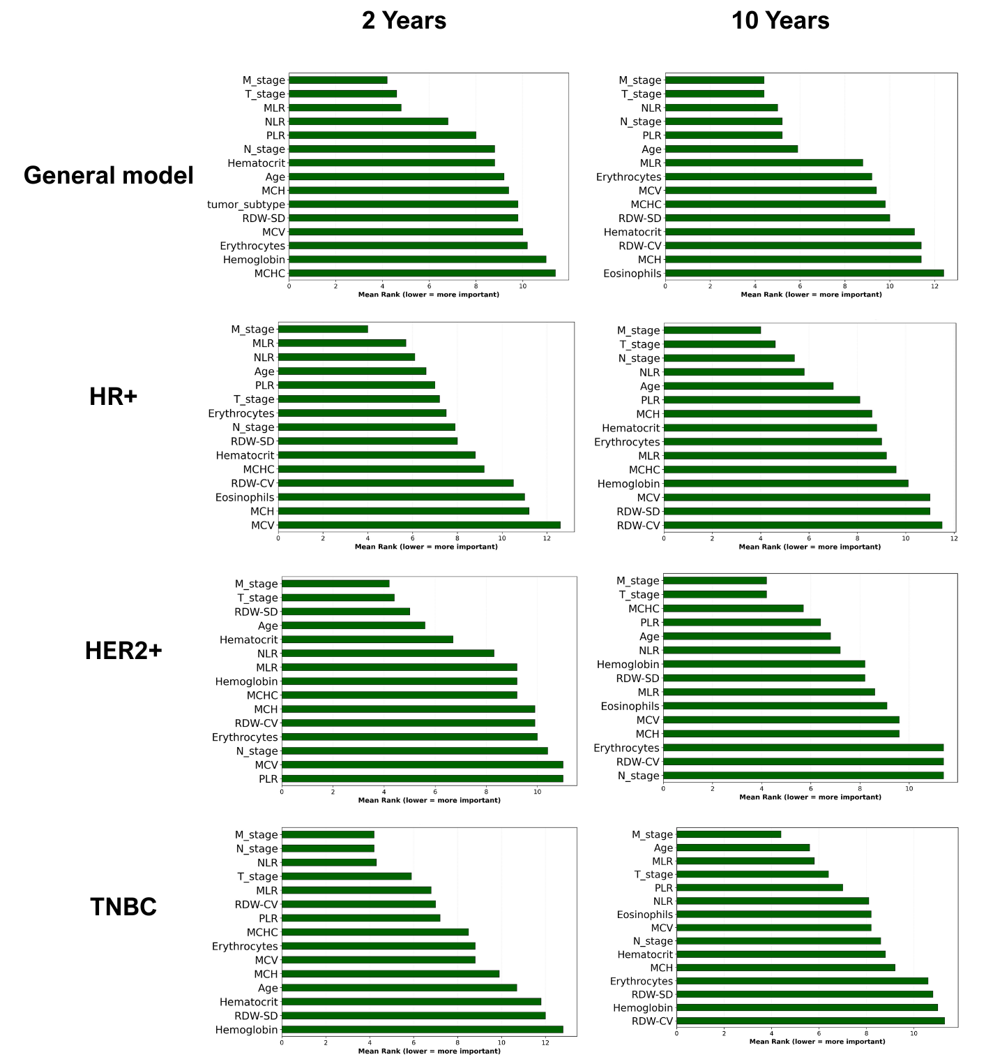
Supplementary Figure S1: Blood-based markers are as important as TNM in Prediction Models Across Molecular Subtypes. Mean feature importance rankings aggregated across five machine learning algorithms for both 2-year and 10-year recurrence or mortality predictions (lower rank = higher importance). Hematologic indices, particularly red cell parameters (MCHC, MCV, RDW-CV, RDW-SD) and complete blood count measures (hemoglobin, erythrocytes, eosinophils), consistently rank among the top predictors alongside clinical staging (M stage, T stage, N stage) across all molecular subtypes in both prediction timeframes. Feature importance patterns differ between 2-year and 10-year models: inflammatory ratios (PLR, NLR, MLR) show higher importance in short-term predictions, while red cell distribution indices (RDW-CV, RDW-SD) and hemoglobin concentration (MCHC) dominate long-term predictions.
Characteristic | N | HR (95% CI)¹ | p-value
Platelets | 4,277 | 1.00 (1.00 to 1.00) | <0.001
Monocyte | 4,277 | 2.41 (1.95 to 2.97) | <0.001
Lymphocyte | 4,277 | 0.87 (0.81 to 0.94) | <0.001
Neutrophil | 4,277 | 1.12 (1.10 to 1.15) | <0.001
Leucocyte | 4,277 | 1.08 (1.06 to 1.10) | <0.001
Eosinophils | 4,277 | 1.03 (0.79 to 1.36) | 0.81
Erythrocyte | 4,277 | 0.66 (0.58 to 0.74) | <0.001
Hematocrit | 4,277 | 0.94 (0.93 to 0.95) | <0.001
Hemoglobin | 4,277 | 0.84 (0.81 to 0.87) | <0.001
RDW.CV | 4,277 | 1.16 (1.13 to 1.19) | <0.001
RDW.SD | 4,277 | 1.06 (1.05 to 1.07) | <0.001
CHCM | 4,277 | 0.87 (0.83 to 0.91) | <0.001
HCM | 4,277 | 0.95 (0.93 to 0.97) | <0.001
VCM | 4,277 | 0.99 (0.98 to 1.00) | 0.045
NLR | 4,277 | 1.16 (1.13 to 1.18) | <0.001
PLR | 4,277 | 1.00 (1.00 to 1.00) | <0.001
MLR | 4,277 | 3.78 (3.15 to 4.55) | <0.001
Clinical Stage T | 4,277
0 |  | —
1 |  | 11,704 (0.00 to Inf) | 0.98
2 |  | 21,009 (0.00 to Inf) | 0.98
3 |  | 42,020 (0.00 to Inf) | 0.98
4 |  | 90,612 (0.00 to Inf) | 0.98
Clinical Stage M | 4,277
0 |  | —
1 |  | 7.64 (6.80 to 8.58) | <0.001
Molecular subtype | 4,277
HR+ |  | —
HER2+ |  | 1.04 (0.91 to 1.19) | 0.57
TNBC |  | 1.80 (1.59 to 2.05) | <0.001
¹HR = Hazard Ratio, CI = Confidence Interval

Supplementary Figure S2: Hematologic Parameters Show Strong Univariate Associations with Breast Cancer Overall Survival. Univariate Cox proportional hazards regression analysis of hematologic biomarkers, inflammatory ratios, clinical staging, and molecular subtypes (N=4,277). Hazard ratios (HR) > 1 indicate increased mortality risk, while HR < 1 indicate protective effects. Elevated monocyte counts (HR=2.41), MLR (HR=3.78), and RDW.CV (HR=1.16) show the strongest adverse associations, while higher erythrocyte counts (HR=0.66), hemoglobin (HR=0.84), and hematocrit (HR=0.94) demonstrate protective effects. All hematologic parameters except eosinophils reached statistical significance (p<0.05). The triple-negative subtype (TNBC) shows significantly elevated risk (HR=1.80) compared to other molecular subtypes.
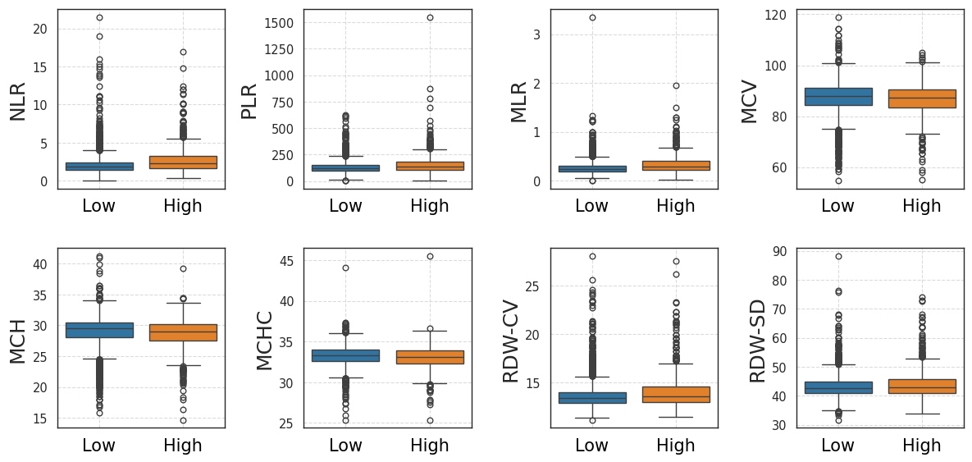
Supplementary Figure S3: Boxplot of values for breast cancer patients (all subtypes of the general model) by the risk of recurrence or death in 2 years. “High” risk group (orange bars) presented recurrence or death in less than 2 years, and “Low” risk group (blue bars) did not. NLR: neutrophil to lymphocyte ratio. PLR: platelet to lymphocyte ratio. MLR: monocyte to lymphocyte ratio. MCV: Mean Corpuscular Volume, reference value: 80 - 95 fL. MCH: Mean Corpuscular Hemoglobin, reference value: 27 - 34 pg. MCHC: Mean Corpuscular Hemoglobin Concentration, reference value: 30 - 35 g/dL. RDW-CV: Red Cell Distribution Width-Coefficient of Variation, reference value: 11.6 - 14.4%. RDW-SD: Red Cell Distribution Width-Standard Deviation, reference value: 35.1 - 43.9 fL.

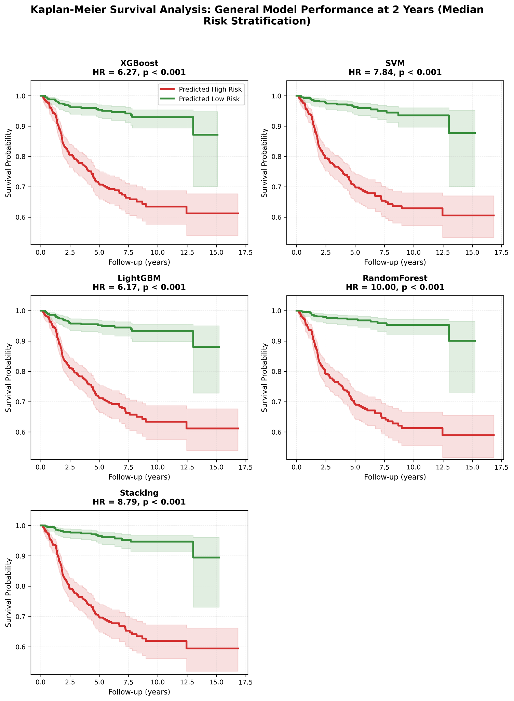

Supplementary Figure S4: Kaplan-Meier Analysis for 2-Year Risk Discrimination in General Cohort. Survival curves stratified by median probability threshold comparing high-risk (red) versus low-risk (green) patient groups. All five algorithms demonstrated significant separation with hazard ratios: XGBoost (HR = 6.27), SVM (HR = 7.84), LightGBM (HR = 6.17), RandomForest (HR = 10.00), and Stacking ensemble (HR = 8.79), all p < 0.001. Shaded regions indicate 95% confidence intervals. RandomForest achieved the strongest discrimination.​
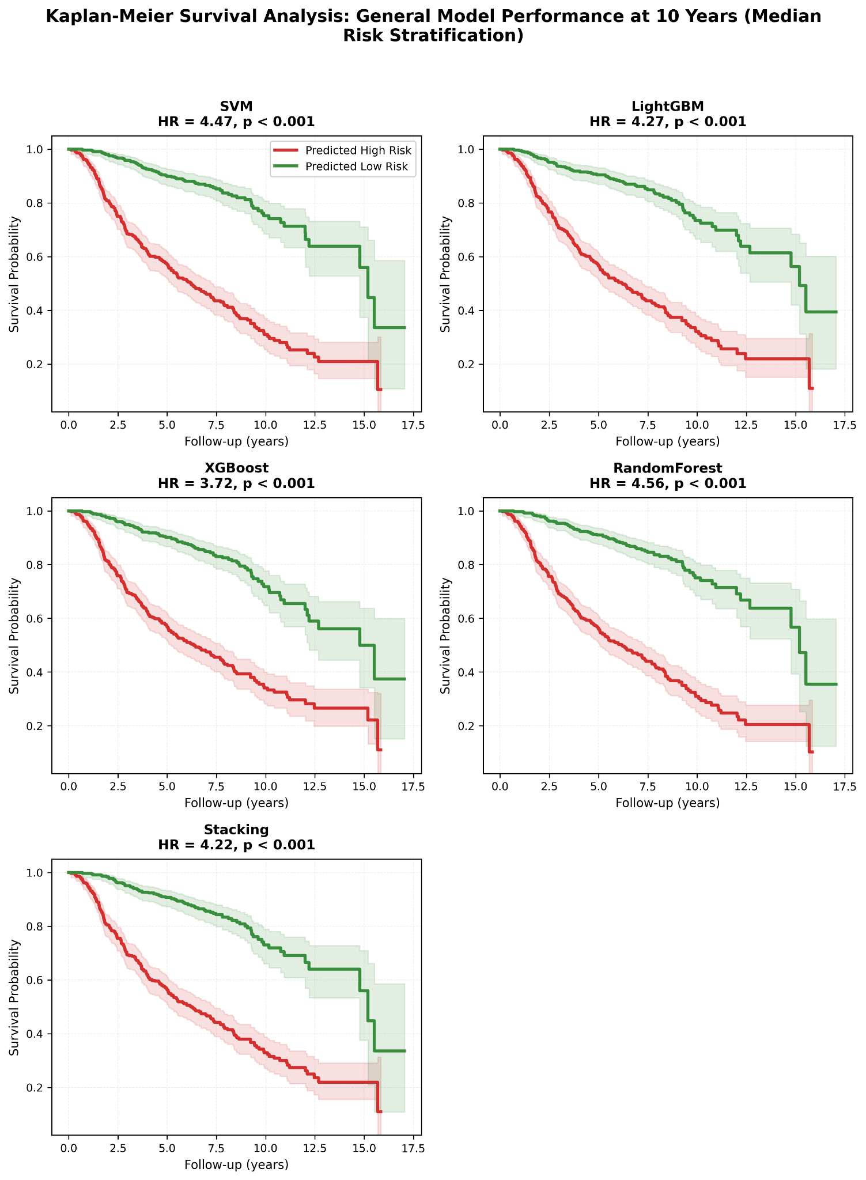
Supplementary Figure S5: Kaplan-Meier Analysis for 10-Year Risk Discrimination in General Cohort. Survival curves stratified by median probability threshold comparing high-risk (red) versus low-risk (green) patient groups. All five algorithms demonstrated significant separation with hazard ratios: SVM (HR = 4.47), LightGBM (HR = 4.27), XGBoost (HR = 3.72), RandomForest (HR = 4.56), and Stacking ensemble (HR = 4.22), all p < 0.001. Shaded regions indicate 95% confidence intervals. RandomForest achieved the strongest discrimination.

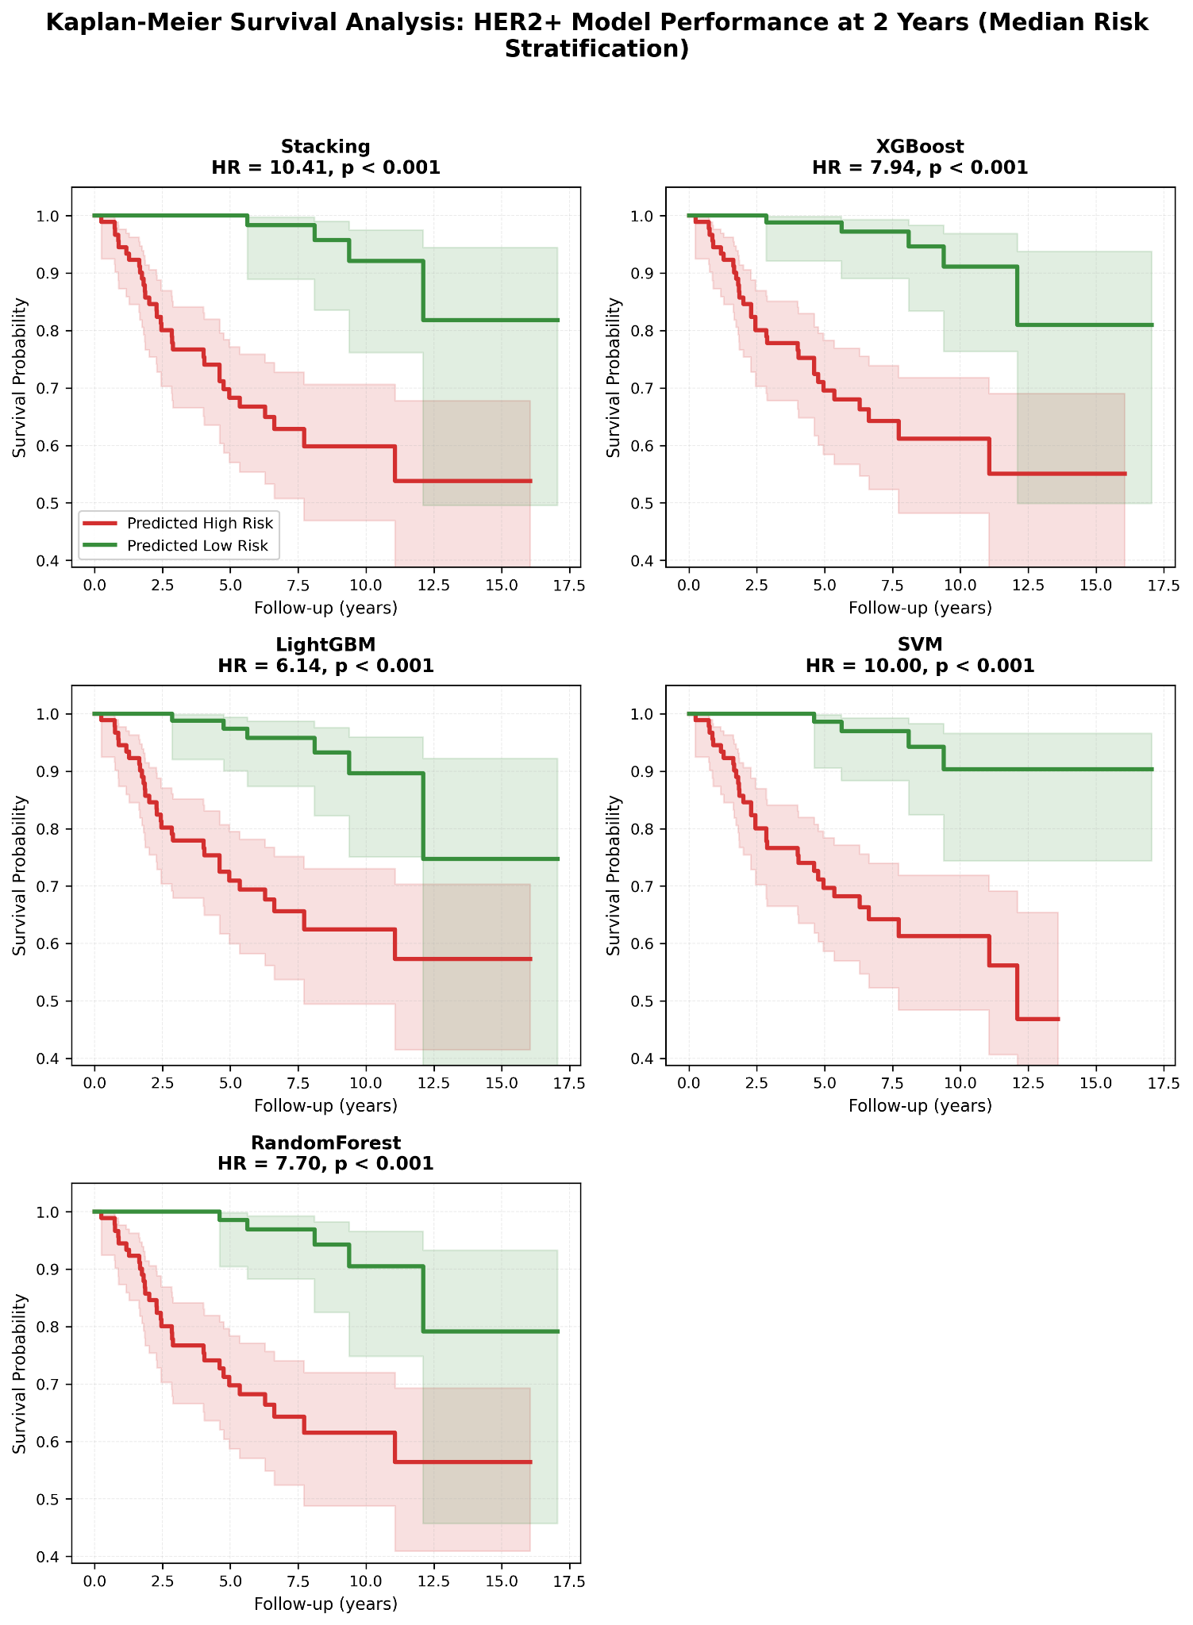
Supplementary Figure S6: Kaplan-Meier Analysis for 2-Year Risk Discrimination in HER2+ Cohort. Survival curves stratified by median probability threshold comparing high-risk (red) versus low-risk (green) patient groups. All five algorithms demonstrated significant separation with hazard ratios: Stacking (HR = 10.41), SVM (HR = 10.00), XGBoost (HR = 7.94), RandomForest (HR = 7.70), and LightGBM (HR = 6.14), all p < 0.001. Shaded regions indicate 95% confidence intervals. Stacking achieved the strongest discrimination.

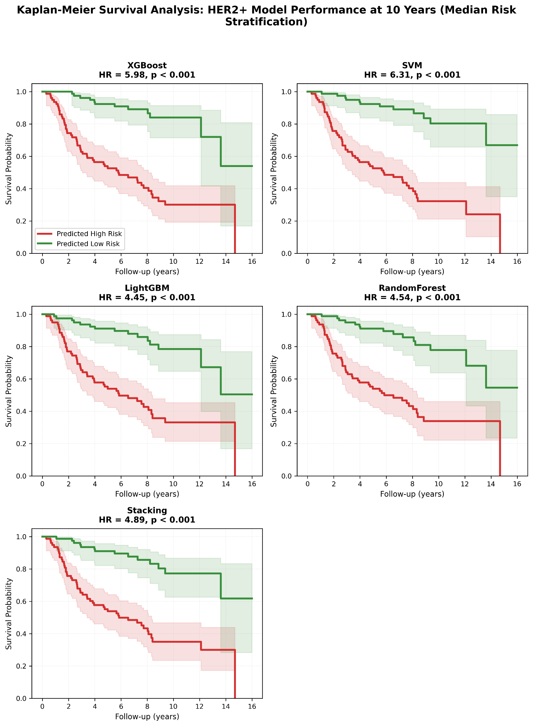
Supplementary Figure S7: Kaplan-Meier Analysis for 10-Year Risk Discrimination in HER2+ Cohort. Survival curves stratified by median probability threshold comparing high-risk (red) versus low-risk (green) patient groups. All five algorithms demonstrated significant separation with hazard ratios: SVM (HR = 6.31), XGBoost (HR = 5.98), Stacking (HR = 4.89), RandomForest (HR = 4.54), and LightGBM (HR = 4.45), all p < 0.001. Shaded regions indicate 95% confidence intervals. SVM achieved the strongest discrimination.
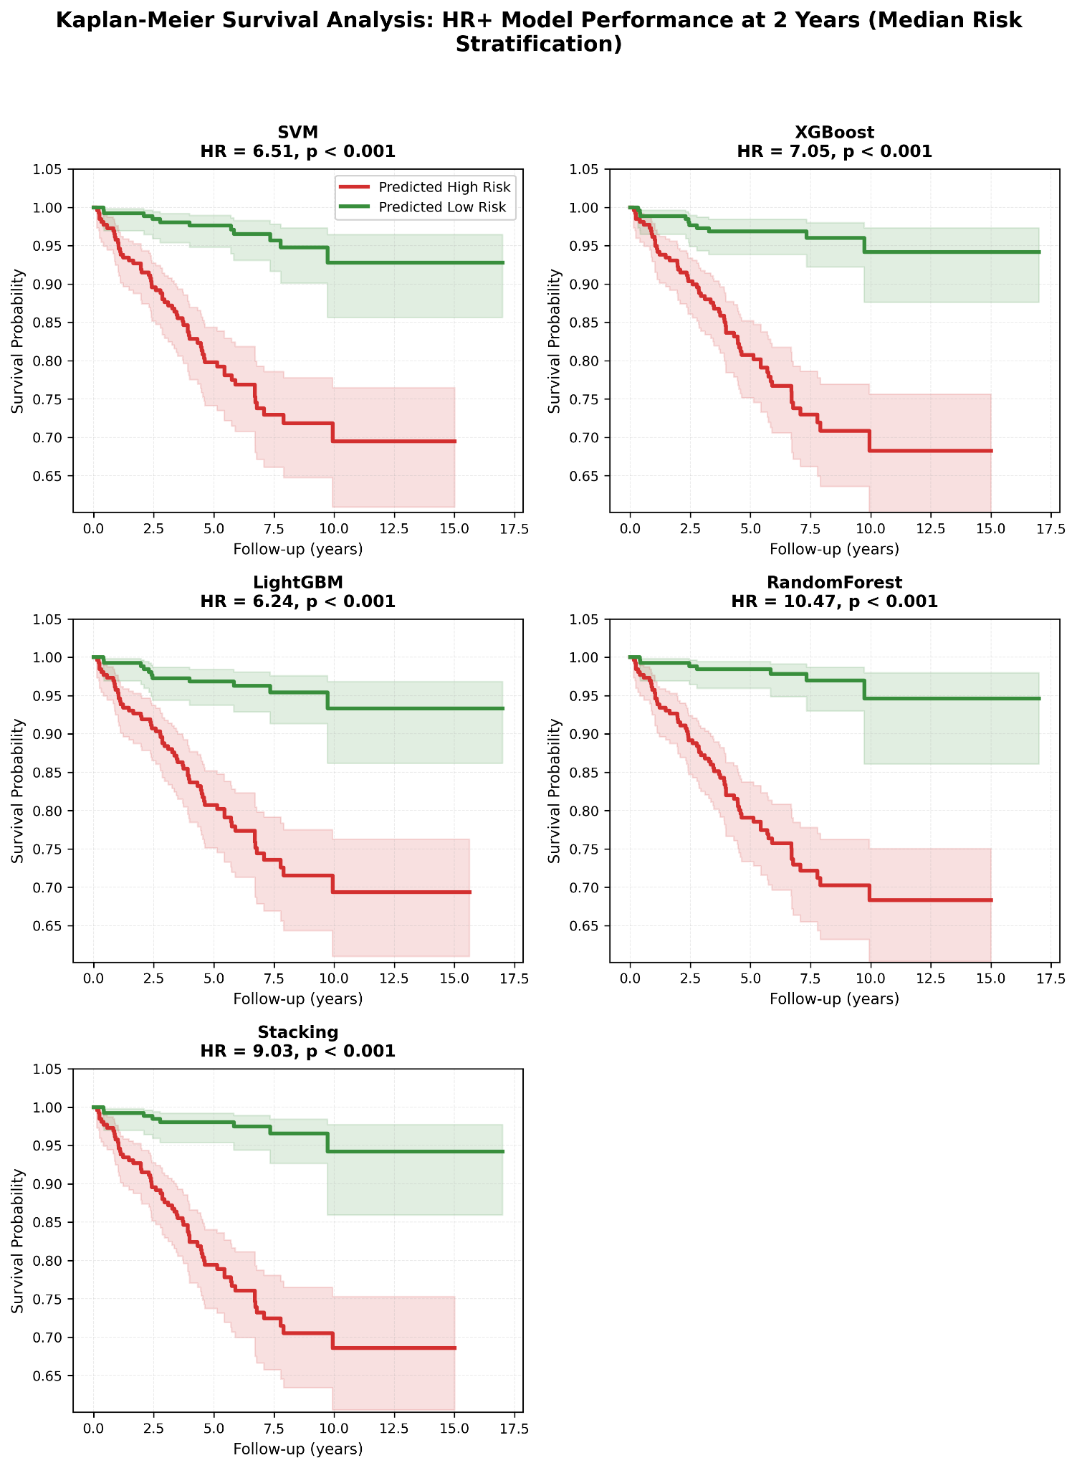
Supplementary Figure S8: Kaplan-Meier Analysis for 2-Year Risk Discrimination in HR+ Cohort. Survival curves stratified by median probability threshold comparing high-risk (red) versus low-risk (green) patient groups. All five algorithms demonstrated significant separation with hazard ratios: RandomForest (HR = 10.47), Stacking (HR = 9.03), XGBoost (HR = 7.05), LightGBM (HR = 6.24), and SVM (HR = 6.51), all p < 0.001. Shaded regions indicate 95% confidence intervals. RandomForest achieved the strongest discrimination.​
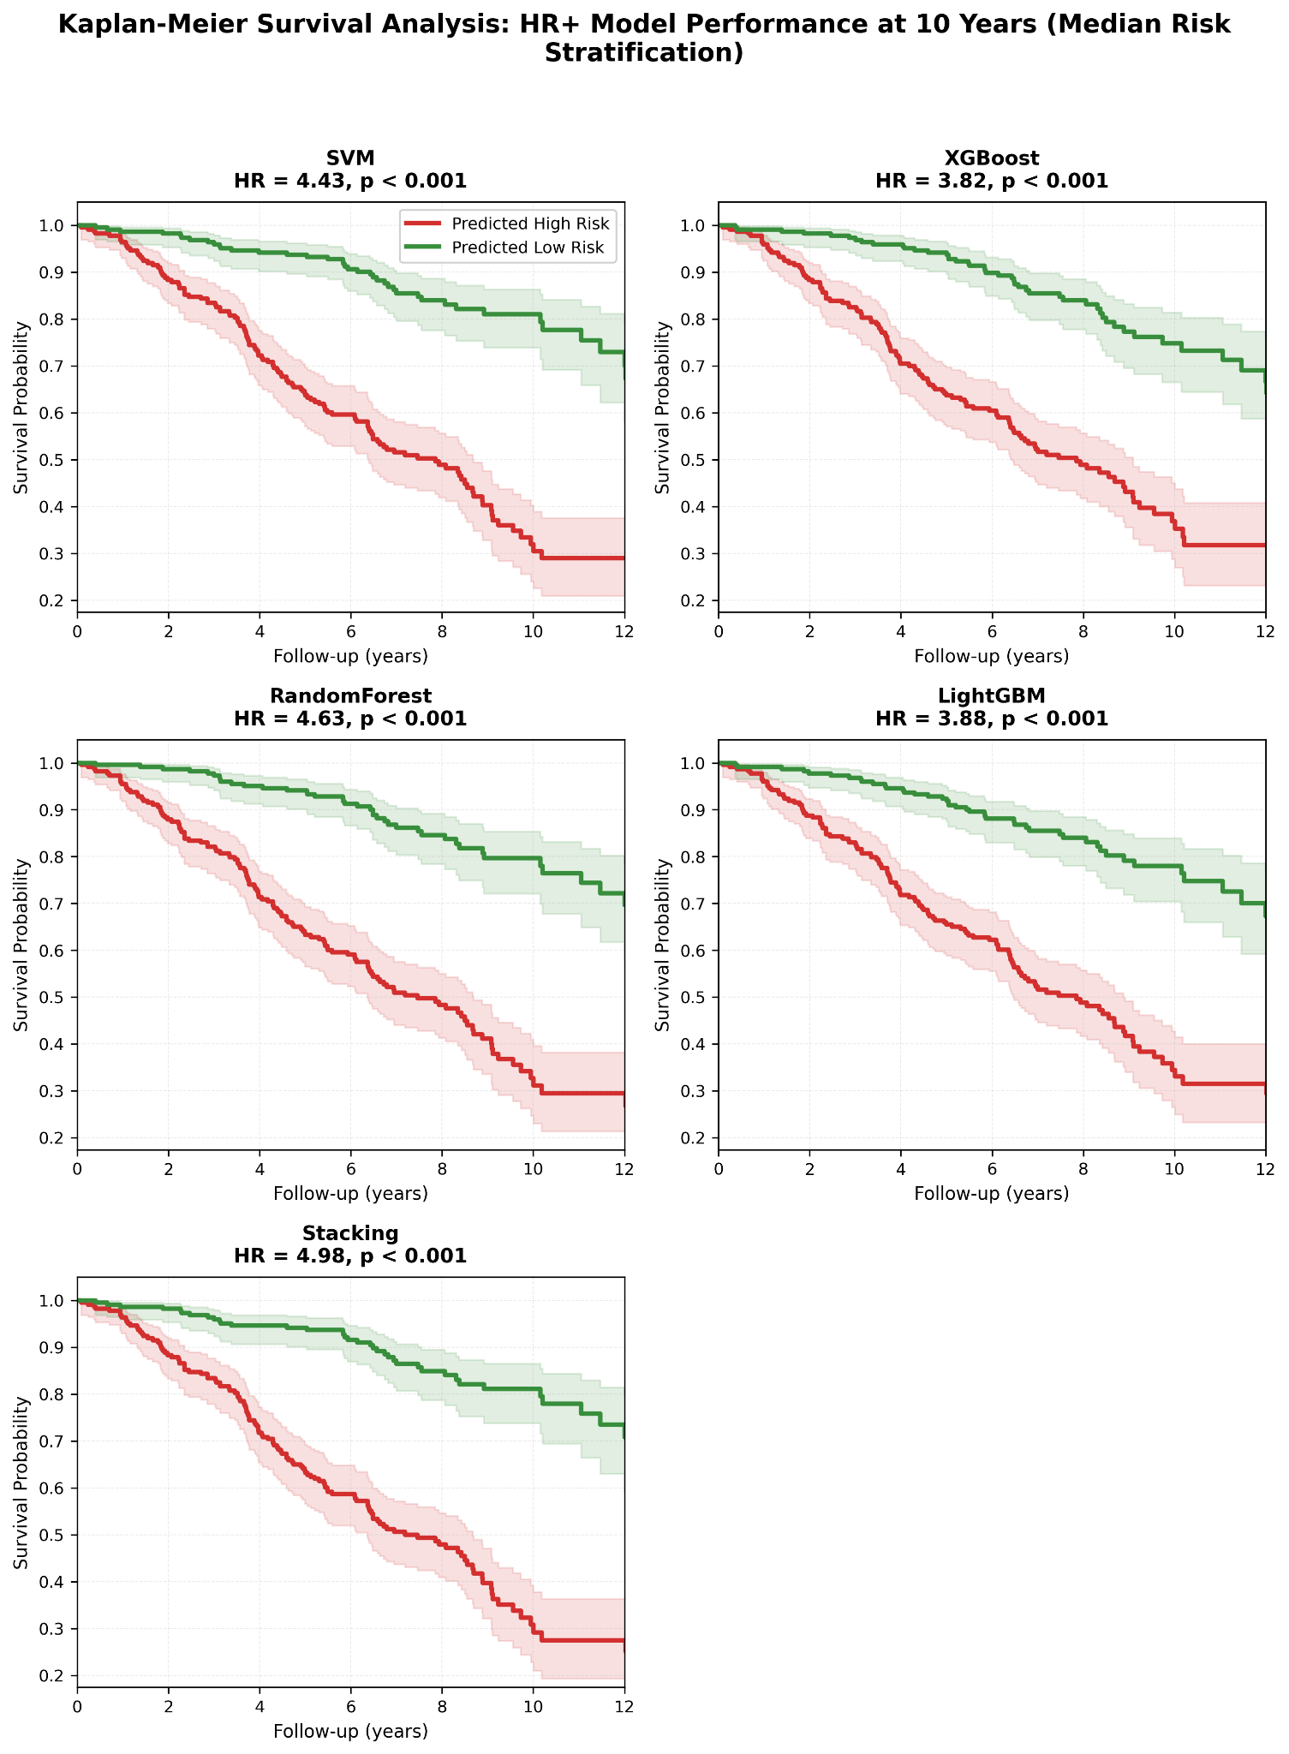
Supplementary Figure S9: Kaplan-Meier Analysis for 10-Year Risk Discrimination in HR+ Cohort. Survival curves stratified by median probability threshold comparing high-risk (red) versus low-risk (green) patient groups. All five algorithms demonstrated significant separation with hazard ratios: SVM (HR = 4.43), Stacking (HR = 4.98), RandomForest (HR = 4.63), XGBoost (HR = 3.82), and LightGBM (HR = 3.88), all p < 0.001. Shaded regions indicate 95% confidence intervals. Stacking achieved the strongest discrimination.
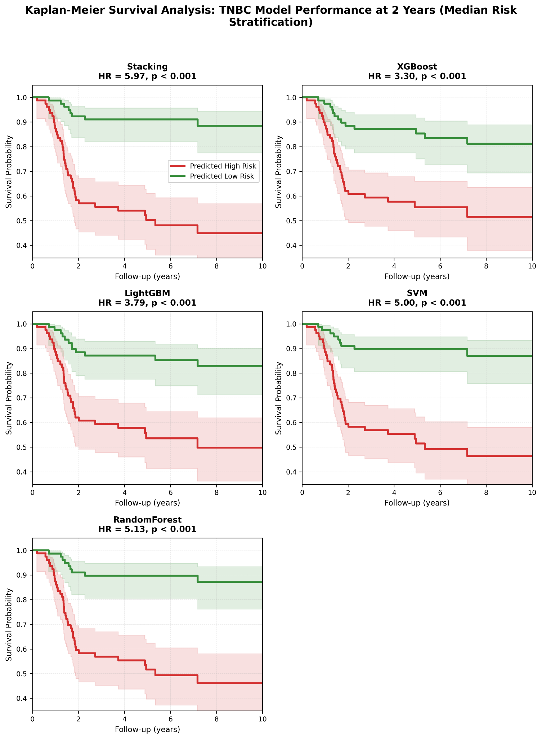
Supplementary Figure S10: Kaplan-Meier Analysis for 2-Year Risk Discrimination in TNBC Cohort. Survival curves stratified by median probability threshold comparing high-risk (red) versus low-risk (green) patient groups. All five algorithms demonstrated significant separation with hazard ratios: Stacking (HR = 5.97), SVM (HR = 5.00), RandomForest (HR = 5.13), LightGBM (HR = 3.79), and XGBoost (HR = 3.30), all p < 0.001. Shaded regions indicate 95% confidence intervals. Stacking achieved the strongest discrimination.​
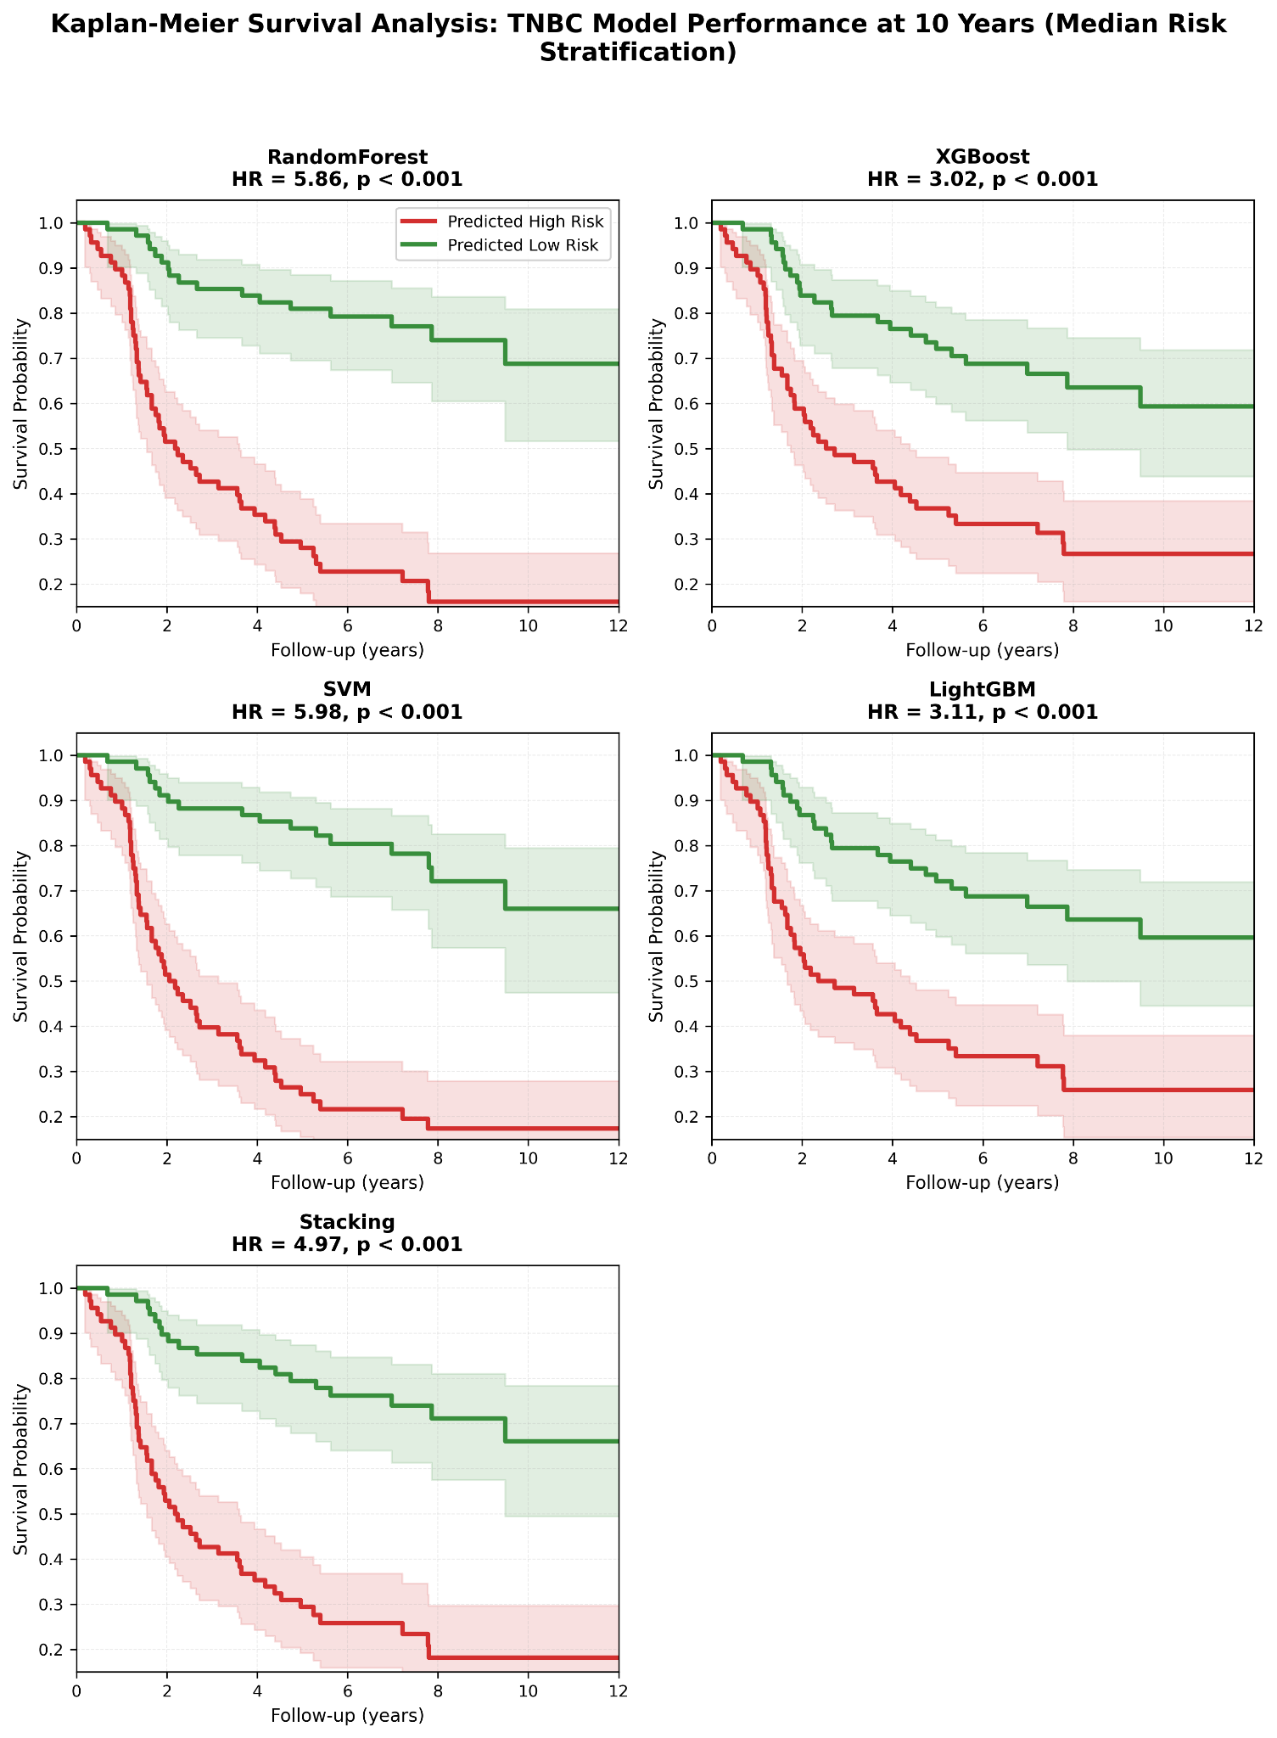
Supplementary Figure S11: Kaplan-Meier Analysis for 10-Year Risk Discrimination in TNBC Cohort. Survival curves stratified by median probability threshold comparing high-risk (red) versus low-risk (green) patient groups. All five algorithms demonstrated significant separation with hazard ratios: RandomForest (HR = 5.86), SVM (HR = 5.98), Stacking (HR = 4.97), LightGBM (HR = 3.11), and XGBoost (HR = 3.02), all p < 0.001. Shaded regions indicate 95% confidence intervals. SVM achieved the strongest discrimination.

