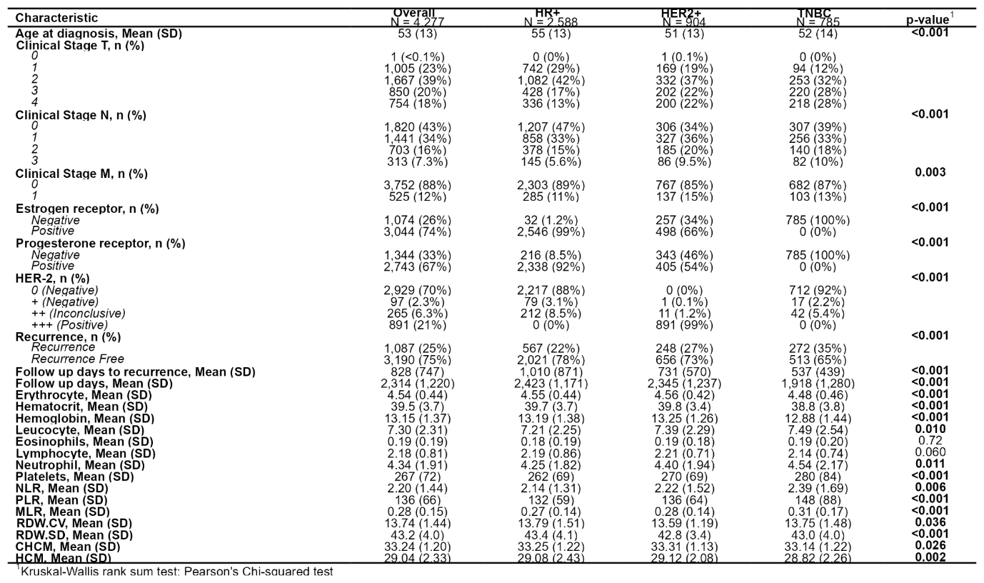
Table 1. Clinical and Hematologic Features Included in the Predictive Models. The table displays the set of baseline variables incorporated into model development, encompassing patient demographics, tumor stage, and receptor status, and hematologic indices derived from pre-treatment complete blood counts. In addition to standard erythrocyte, leukocyte, and platelet parameters, we explicitly calculated inflammatory ratios such as neutrophil-to-lymphocyte ratio (NLR), platelet-to-lymphocyte ratio (PLR), and monocyte-to-lymphocyte ratio (MLR), along with red cell distribution indices. These features integrate established clinical predictors with readily available blood biomarkers, forming the 16 candidate variables subjected to feature selection for model training.

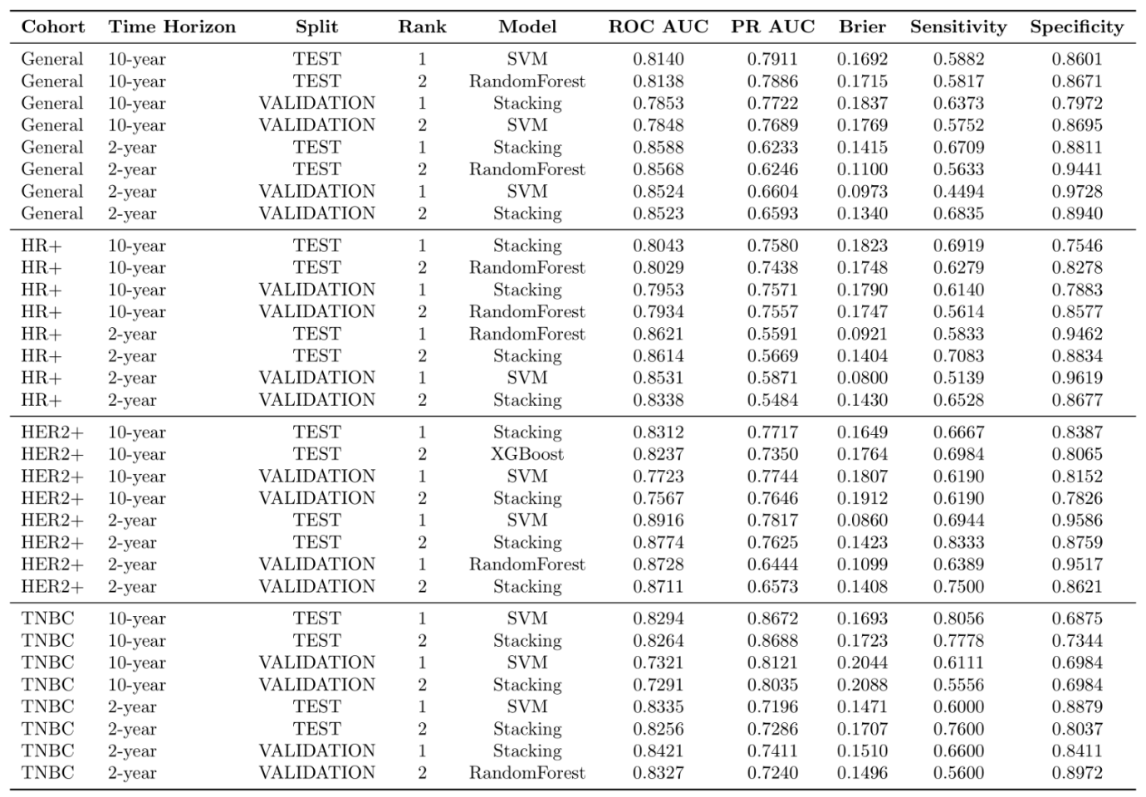
Table 2. Model performance on the original balanced data. Results show 2-year and 10-year survival prediction performance across four breast cancer molecular subtypes (General, HR+, HER2+, and TNBC). From five machine learning models (SVM, Random Forest, XGBoost, LightGBM, and Stacking ensemble), we report the top 2 models ranked by ROC-AUC for each cohort, time horizon, and evaluation split (Test and Validation). Performance metrics include ROC-AUC (primary), PR-AUC, Brier score (lower is better), Sensitivity, and Specificity. Decision thresholds were optimized using Youden's J statistic on the validation set and applied to the test set to avoid data leakage.
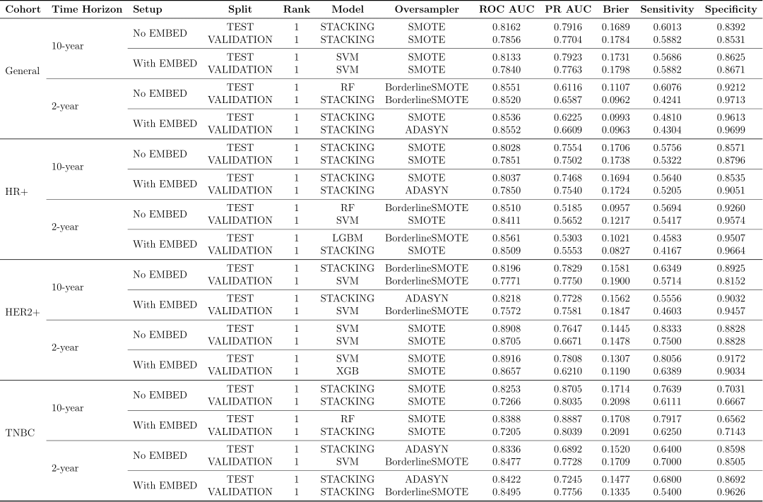
Table 3. Comparative performance of oversampling strategies with and without embedding augmentation. Results compare two feature engineering pipelines: (1) With EMBED: combines oversampling (SMOTE, Borderline-SMOTE, or ADASYN) with unsupervised embeddings (PCA, UMAP) and GMM-derived cluster indicators; and (2) No EMBED: applies oversampling only without additional feature augmentation. Five machine learning models (SVM, Random Forest, XGBoost, LightGBM, and Stacking ensemble) were evaluated across 2-year and 10-year survival prediction horizons, stratified by molecular subtype (General, HR+, HER2+, TNBC) and evaluation split (Test, Validation). For each cohort, time horizon, setup, and split, we report the top 3 models ranked by ROC-AUC (primary metric), along with PR-AUC, Brier score (lower is better), Sensitivity, and Specificity. Oversampling was applied only within training folds; decision thresholds were optimized on the validation set using Youden's J statistic and fixed for test set evaluation to prevent data leakage.

