Geomech. Geophys. Geo-ener Geores.

Supporting Information for

Absorption and scattering signature of fluid-injected, hydrocarbon, and low-to-medium enthalpy geothermal reservoirs

F. Napolitano¹, V. Serlenga², T. A. Stabile², L. De Siena³, P. Capuano¹, O. Amoroso¹
1 Laboratorio di Geofisica e Sismologia, Dipartimento di Fisica “E.R. Caianiello”, Università degli Studi di Salerno, Fisciano, Italy.
2 Consiglio Nazionale delle Ricerche, Istituto di Metodologie per l'Analisi Ambientale, Tito, Italy.
3 Dipartimento di Fisica e Astronomia “Augusto Righi”, Alma Mater Studiorum Università di Bologna, Bologna, Italy.

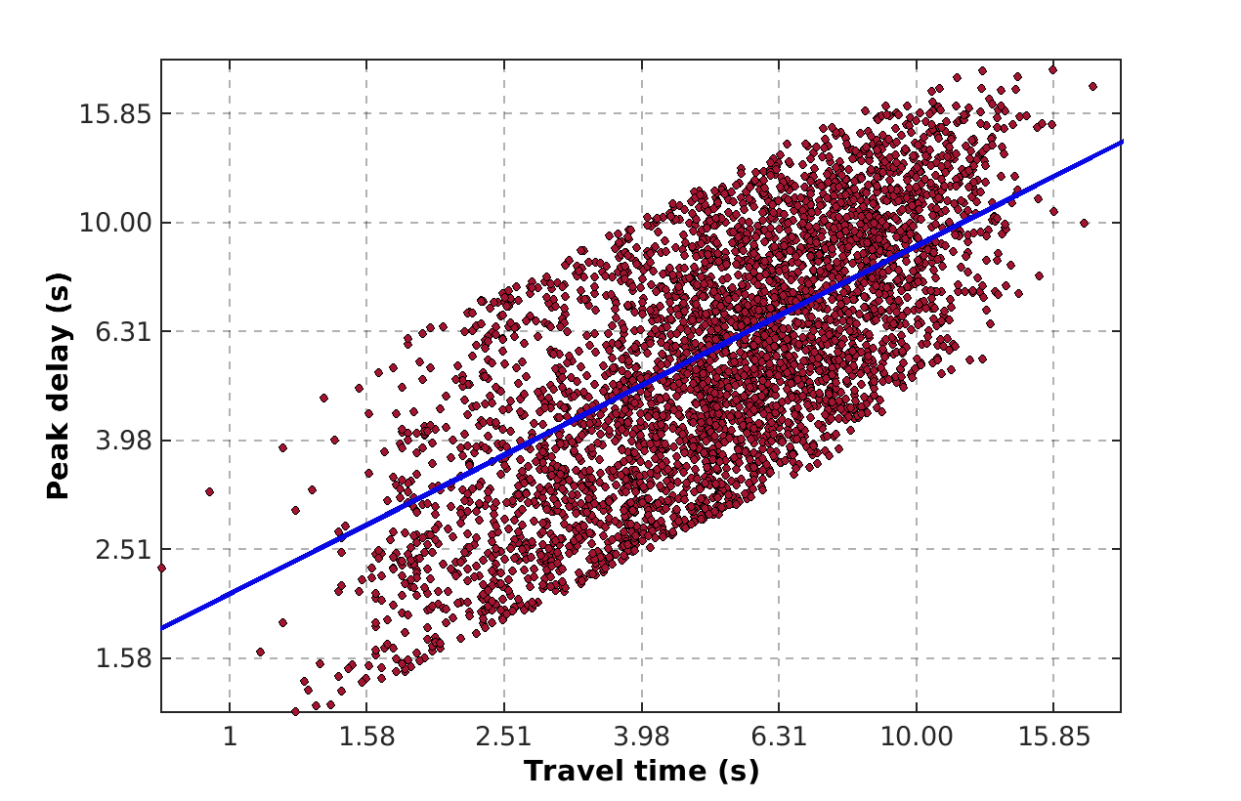
Figure S1. Log-log plot of peak delay computed on each source-receiver ray as a function of the P-wave travel time at a central frequency of 1.5 Hz. Peak delay values (red circles) within two standard deviations from the linear fit (blue line) are retained.

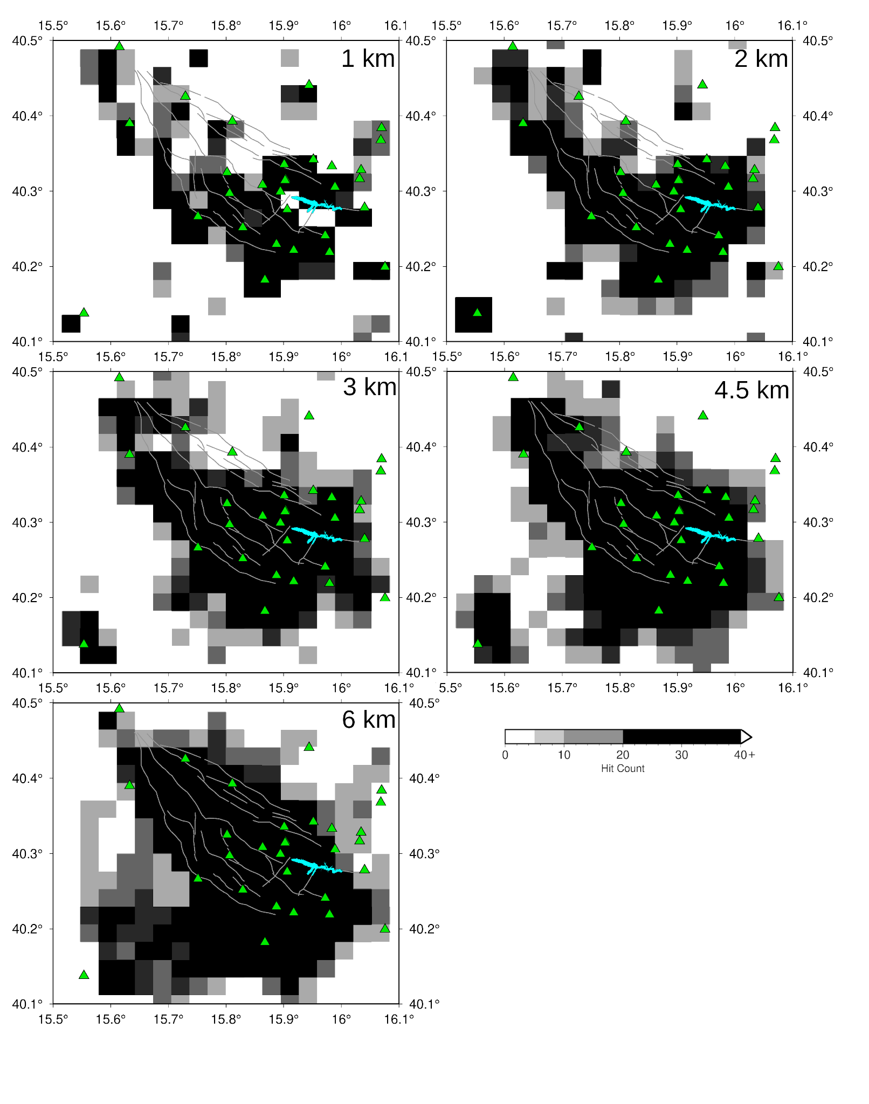
Figure S2. Hit count at different depths (upper right corner of each slice) showing the well resolved areas for peak delay maps. Blocks crossed by at least 20 rays are shown in black color, while we show blocks crossed by a smaller number of rays with lighter shades of gray (lighter for decreasing number of rays), leaving areas not crossed by any ray blank.

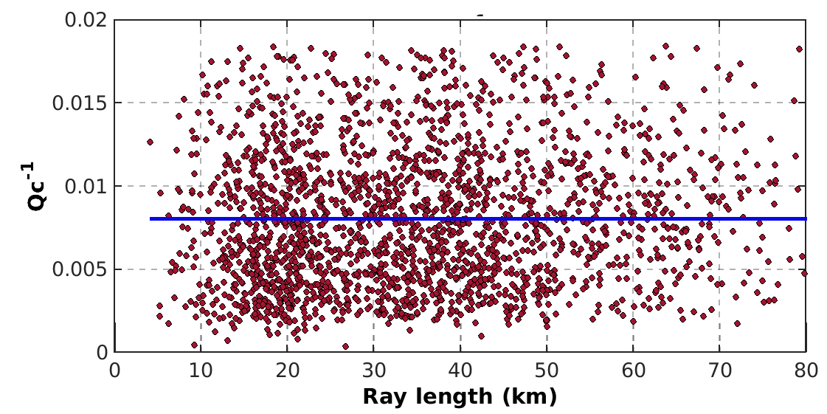
Figure S3: Q_{c}⁻¹ measurements obtained for each waveform (red circles) as a function of the ray length within a central frequency of 1.5 Hz.

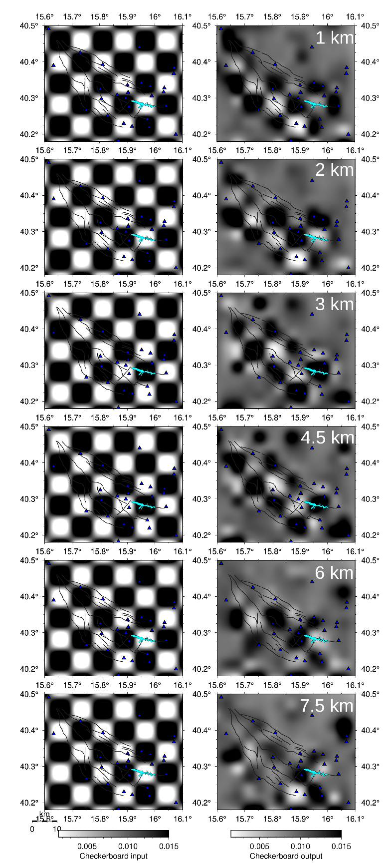

Figure S4: Checkerboard tests (input on the left side and output on the right side) for Q_{c}⁻¹ anomaly at 1,2,3,4.5,6,7.5 km depth, that are the ones where the main absorption anomalies are detected.
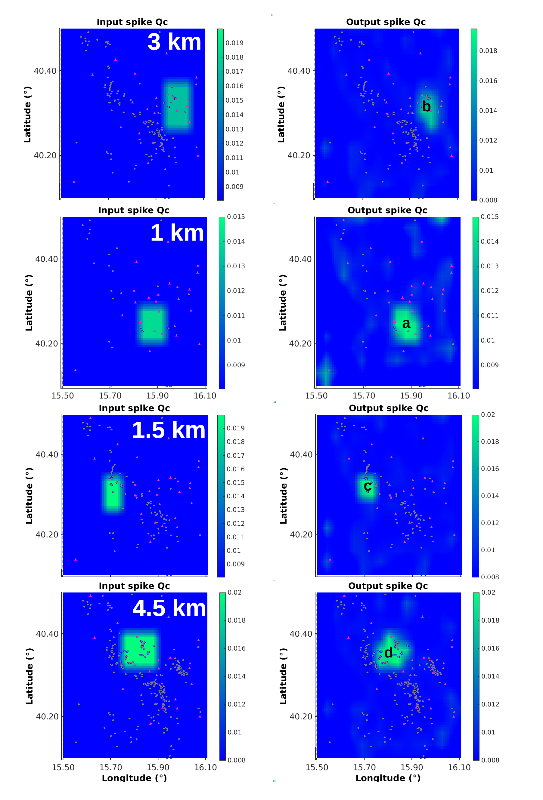
Figure S5: Map view of the input (left column) and output (right column) spike tests performed for the four high absorption anomalies at the depth they appear. For each spike we show the depth (left panels, top right corner) and the name of the anomaly as in the main text (labels from a to d).

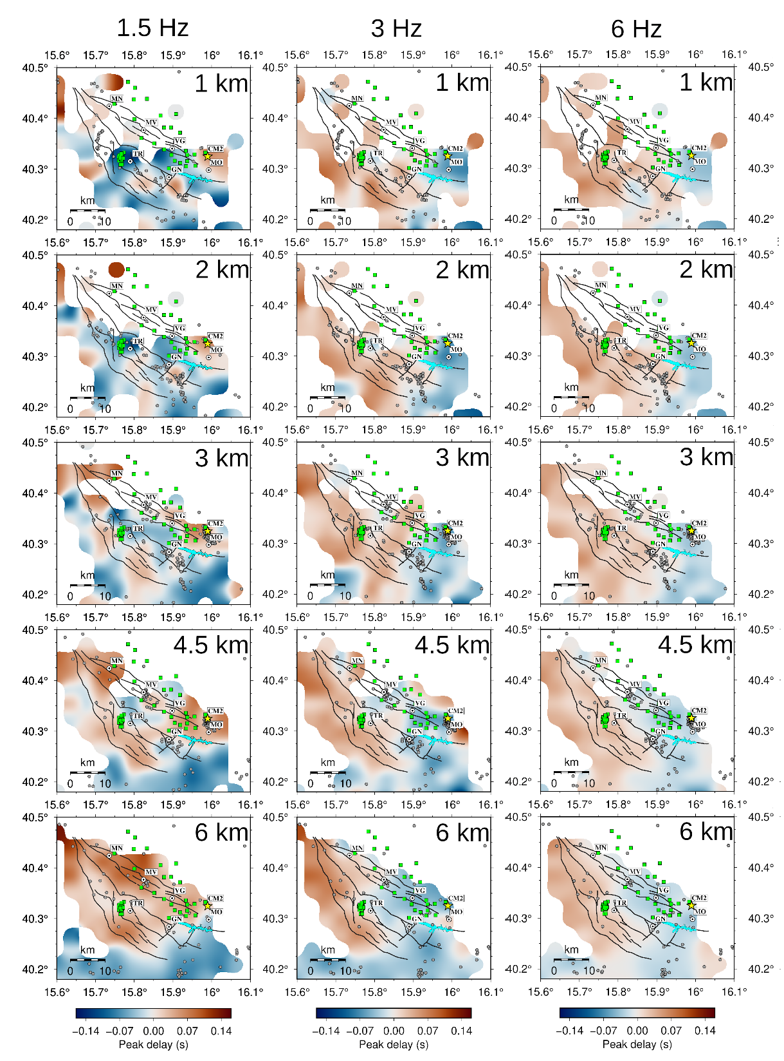

Figure S6. Horizontal slices of peak delay variations (scattering proxy) at 5 different depths (labelled in the upper right corner) at central frequencies of 1.5 Hz (left panels), 3 Hz (central panels) and 6 Hz (right panels). Peak delay variations are only shown in all those blocks crossed by at least 20 rays. Grey circles are the locations of earthquakes within 1 km from the slice depth. Dark grey thin lines are the fault traces available for the area. Green squares are the production wells, yellow star is CM2 location. Major municipalities are represented with black and white circles. For any further detail, please refer to Fig. 1.

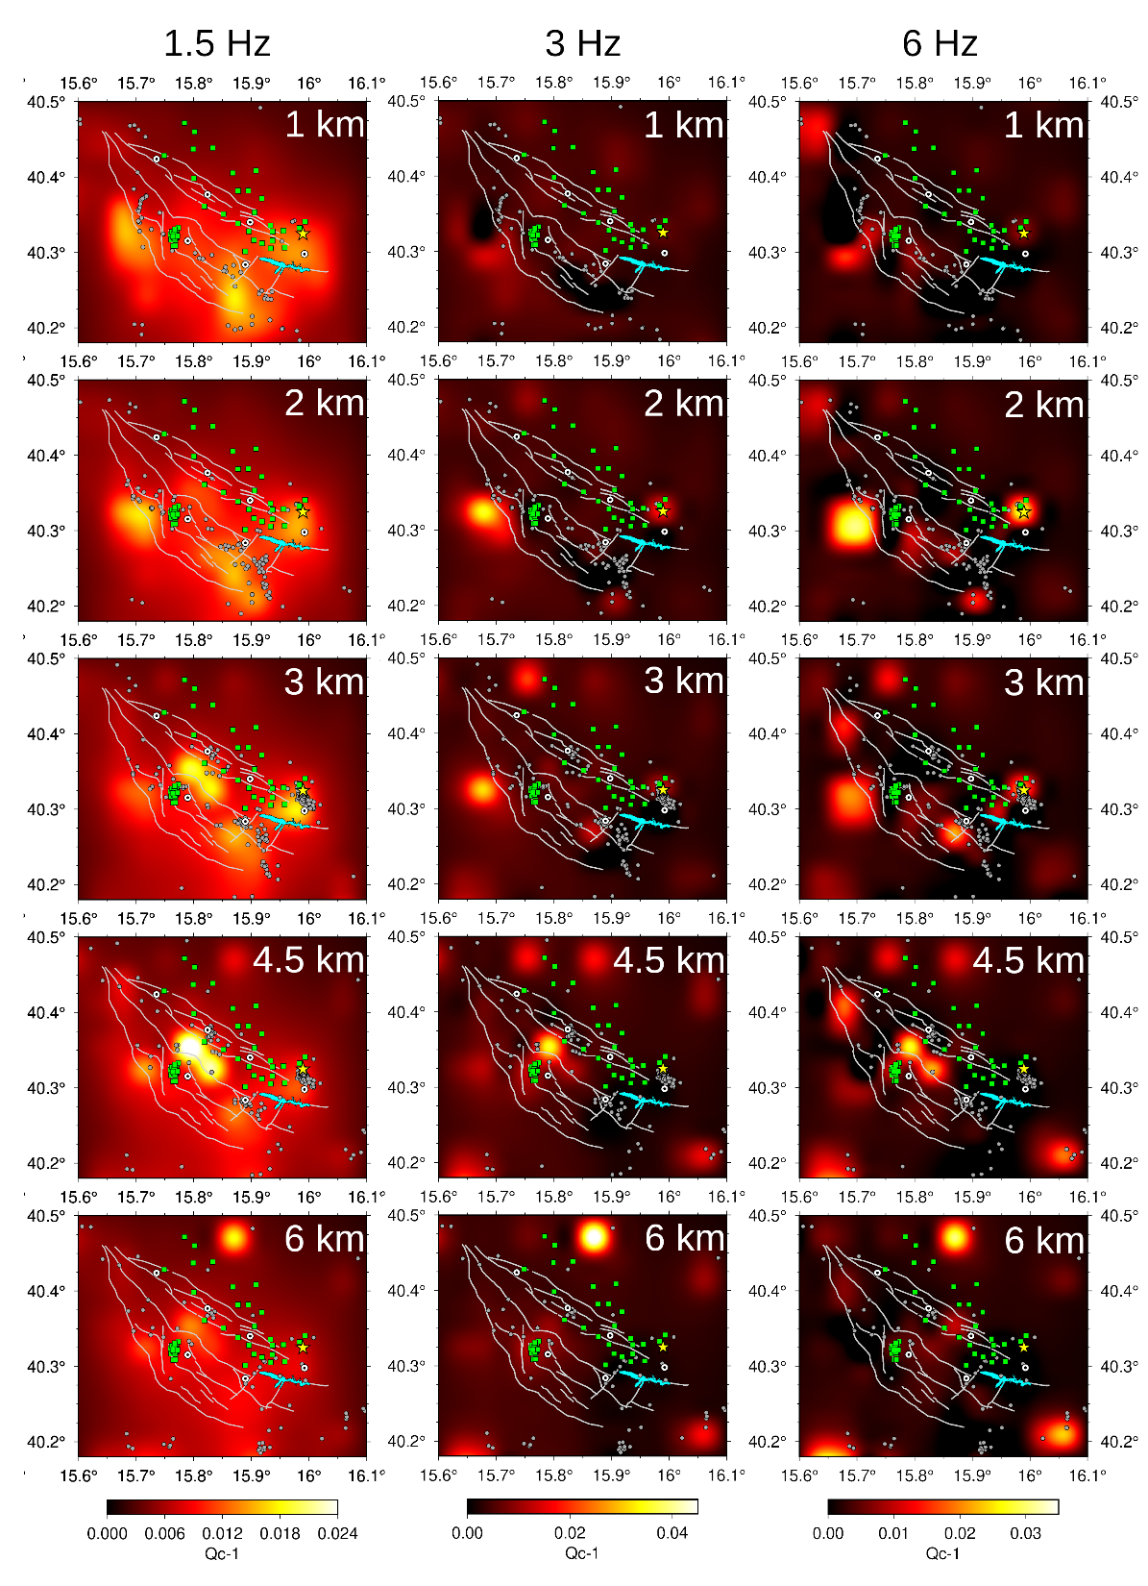
Figure S7. Horizontal slices of Q_{c}⁻¹ variations (absorption proxy) at 5 different depths (labelled in the upper right corner) at central frequencies of 1.5 Hz (left panels), 3 Hz (central panels) and 6 Hz (right panels). Grey circles are the locations of earthquakes within 1 km from the slice depth. Grey thin lines are the fault traces available for the area. Green squares are the production wells, yellow star is CM2 location. Major municipalities are represented with black and white circles. For any further detail, please refer to Fig. 1.

