Supplementary Information

Sample name | Core depth (cm) | Material | mg C | ¹⁴C age (yr BP) | Error (yr BP) | Cal. yr BP (2σ)
LuS 15020 | 84.5 | bulk organic | 1.2 | 1835* | 40 | 1694-1873
LuS 14877 | 86.5 | bulk organic | 0.6 | 2135* | 40 | 1998-2183
LuS 14880 | 174.7 | bulk organic | 0.7 | 2015* | 40 | 1879-2064
LuS 15021 | 178.2 | peat | 1.7 | 1465 | 35 | 1301-1407
LuS 14879 | 245.7 | peat | 1.3 | 1540 | 35 | 1356-1525
LuS 14878 | 260.7 | bulk organic | 1.3 | 1850* | 35 | 1710-1872
LuS 15022 | 299.2 | aquatic plants | 1.1 | 3090 | 40 | 3208-3386
LuS 14881 | 302.7 | bulk organic | 1.3 | 7830* | 40 | 8539-8730
LuS 15023 | 349.2 | bulk organic | 1.4 | 4260* | 40 | 4804-4887
LuS 14882 | 448.5 | peat | 1.4 | 4030 | 40 | 4418-4589

Supplementary Table 1. Overview of all radiocarbon ages that have been extracted and dated from master core AST-P2-18. Calibrated ages and errors are based on the Intcal14 curve as discussed under “Chronology” in the main text. Outliers are highlighted with an asterisk (*).

Deposit | Core depth (cm) | Correlation | Volcanic source | Age (cal. yr BP) | Reference(s)
AST1 | 9.5 | V-1717 | Bárðarbunga | 233 ± 10 | ⁵⁰
AST2 | 69 | 1-113 | Kverkfjöll | 1325 ± 100 | ⁵²
AST3 | 264 | G-Svart | Grímsvötn | 1698 ± 10 | ⁵⁷
AST4 | 292 | Tentative | Askja/Krafla? | 2900-3500/2850±250 | ⁶¹ ⁶²

Supplementary Table 2. Summary of tephra deposits investigated in this study with respect to their name, core depth, volcanic source and the reported ages of correlative isochrons.

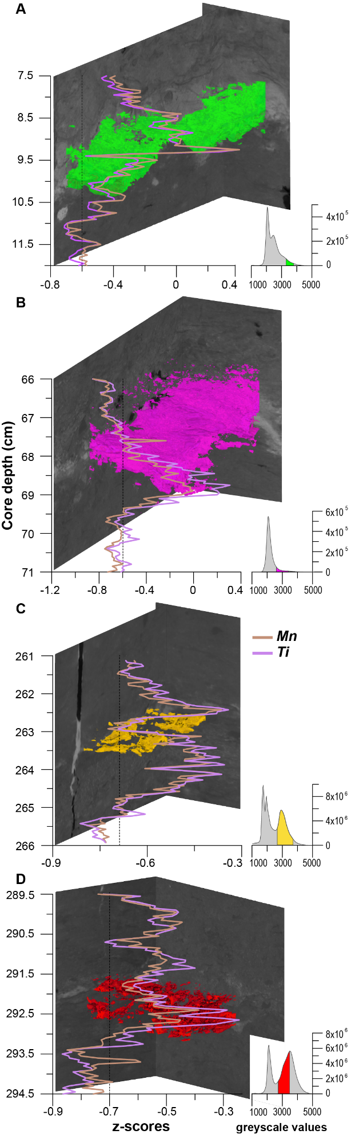
Supplementary Figure 1. CT ortho slices (2-D) and volume renderings (3-D) of analyzed visible tephra horizons (see Fig. 4) in colors that match Figs. 1, 6 and 7. Histograms show the greyscale distributions for each displayed core section in grey, while the range of volcanic ash is highlighted in color. On top of the CT imagery, we plot profiles of standardized XRF Titanium (Ti) and Manganese (Mn) counts; diagnostic elements for basaltic ash ( “methods”).

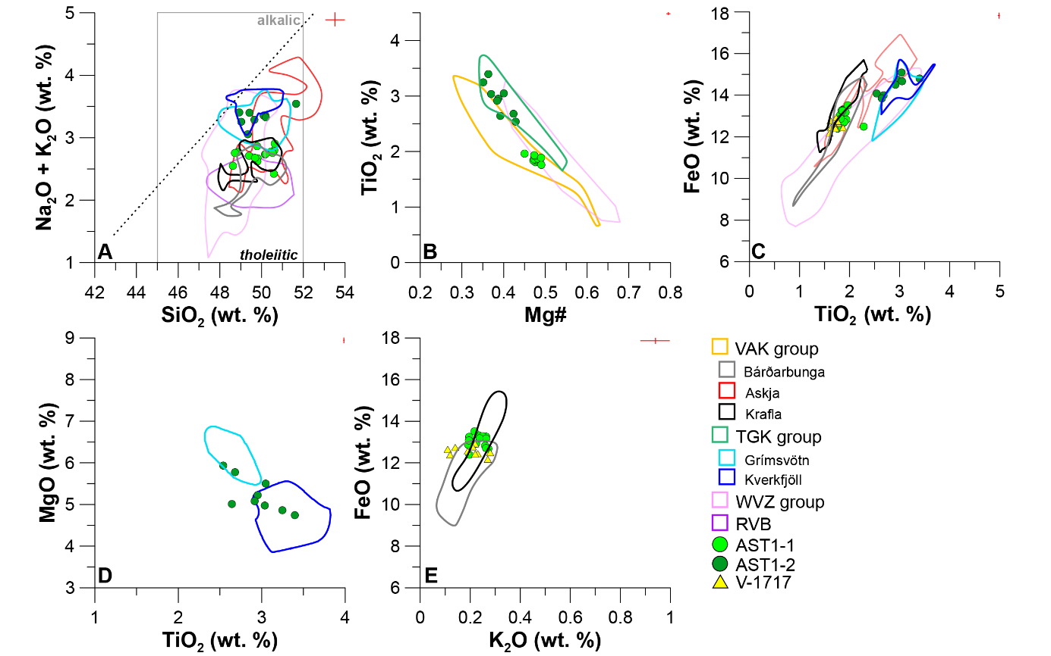
Supplementary Figure 2. Key discriminatory element oxide bi-plots for the shard populations of horizon AST1 (see Fig. 4 and “chronology” in the main text for additional details). Reference Compositional Fields (RCFs) of active Icelandic volcanoes are delineated after⁸² and ³⁶ in colors matching those of Fig. 1. In-set red crosses mark the analytical uncertainty of measurements, based on the pooled and weighted 2σ of secondary standard analyses (Supplementary data).

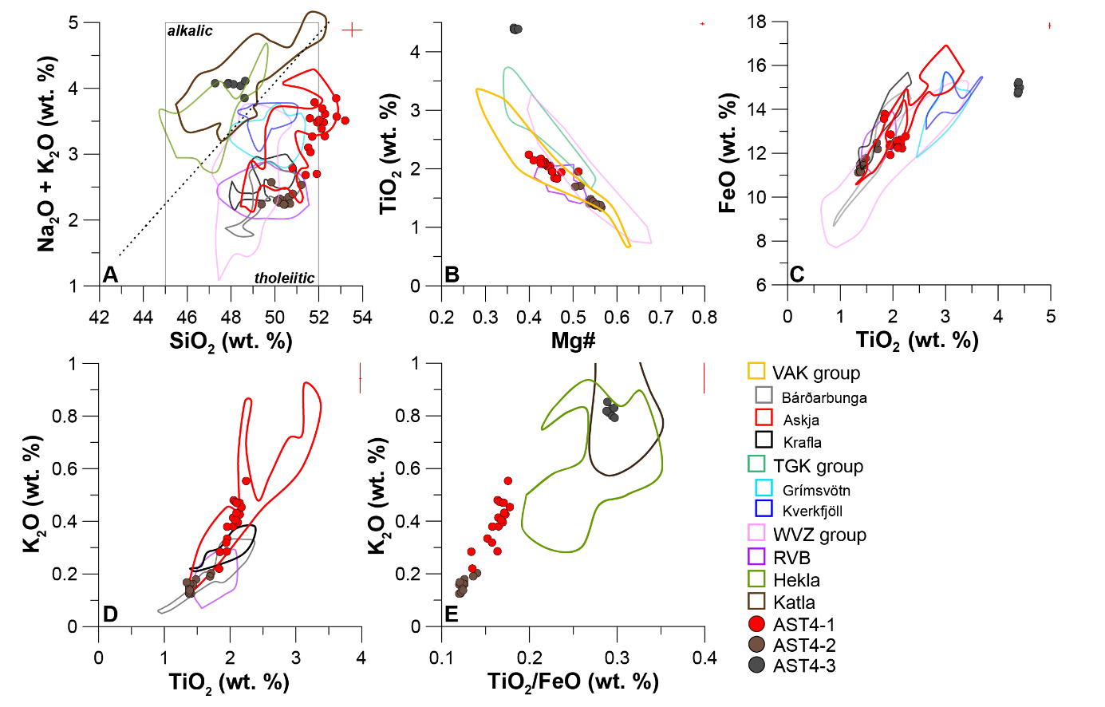
Supplementary Figure 3. Key discriminatory element oxide bi-plots for the shard populations of horizon AST4 (see Fig. 4 and “chronology” in the main text for additional details). Reference Compositional Fields (RCFs) of active Icelandic volcanoes are delineated after⁸² and³⁶ in colors matching those of Fig. 1. In-set red crosses mark the analytical uncertainty of measurements, based on the pooled and weighted 2σ of secondary standard analyses (Supplementary data).

