Synergistic heating effect via CNT/Fe₃O₄ nanocomposite aerogels enabling uniform and rapid induction welding with high bond strength in CFRTPs
Nayeong Kim^{a,b,1}, Inseok Baek^{a,1}, Byeongho Parkª, Dayoung Kim^{a,b}, Chaewon Jeongª, Jungwan Leeª, Jung-soo Kimª, Geunsu Jooª, Seokpum Kim^{c}, Vipin Kumar^{c}, Youngseok Oh^{a,*}, Jinsu Kim^{a,*}
ªComposites & Convergence Materials Research Division, Korea Institute of Materials Science (KIMS), Changwon-daero 797, Seongsan-gu, Changwon-si, Gyeongsangnam-do, 51508, Republic of Korea
^{b}School of Chemical Engineering, Pusan National University, 2 Busandaehak-ro 63beon-gil, Geumjeong-gu, Busan 46241, South Korea
^{c}Manufacturing Science Division, Oak Ridge National Laboratory, P.O. Box 2008, Oak Ridge, Tennessee 37831, USA.
¹There authors contributed equally to this work.
*Corresponding authors: Youngseok Oh (youngsoh@kims.re.kr), Jinsu Kim (jinsu@kims.re.kr)
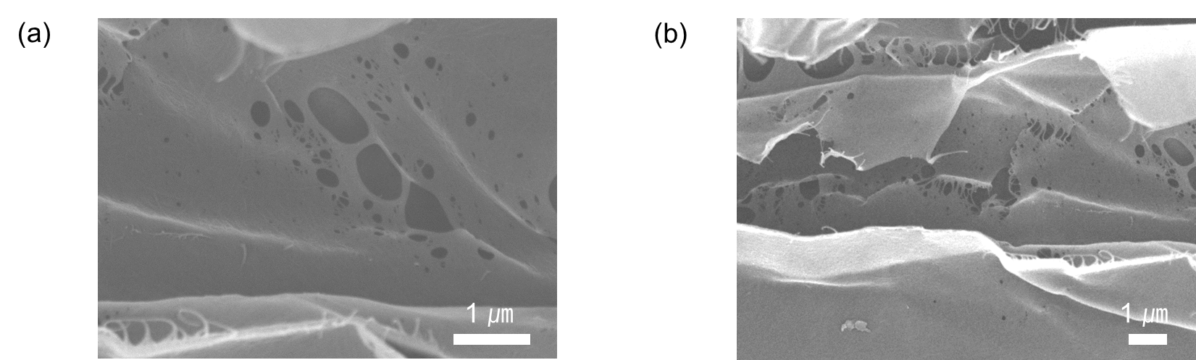
Figure S1. Additional SEM images of the freeze-dried aerogel monolith.
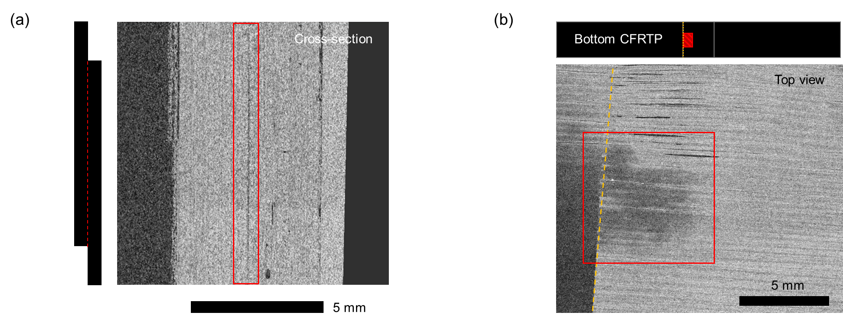
Figure S2. Micro-CT analysis for evaluating weld-line integrity in the CFRP-only joint: (a) cross-section; (b) top view.

