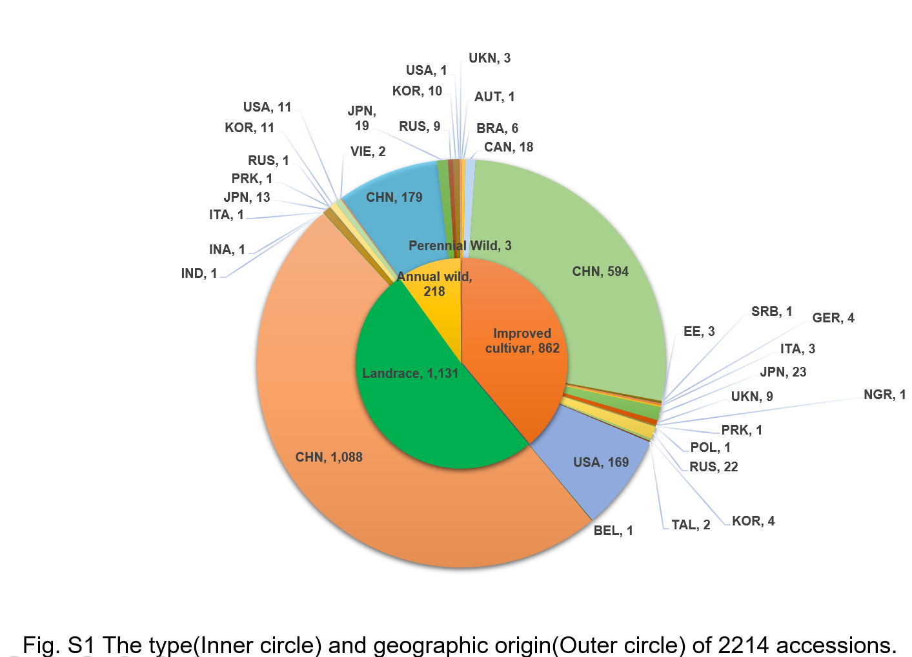
Fig. S1 The types (inner circle) and geographic origins (outer circle) of the 2,214 soybean accessions used in this study
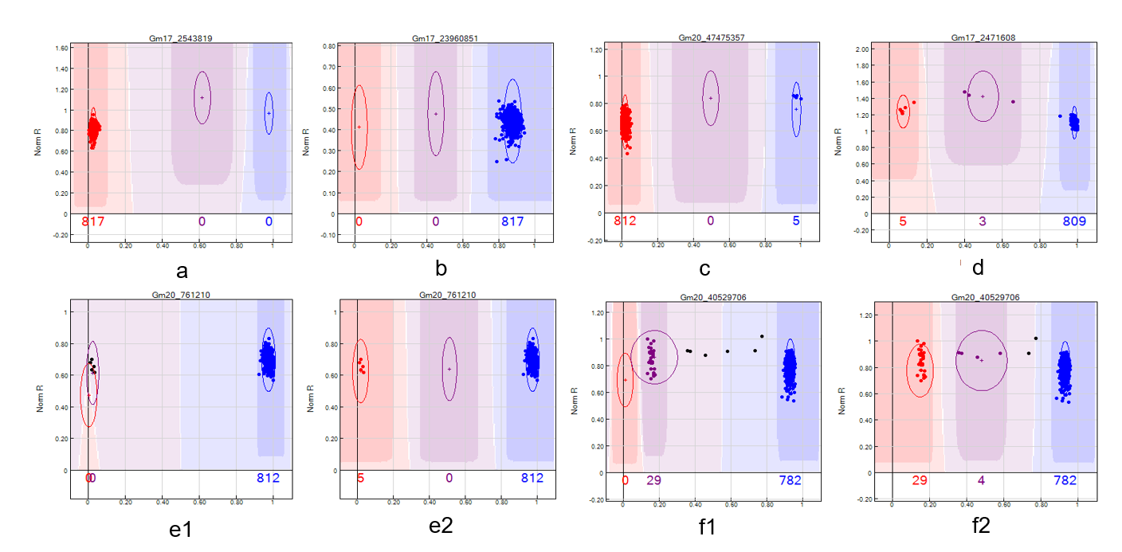
Fig. S2 Typical cluster graphs of SNP markers in ZDX1
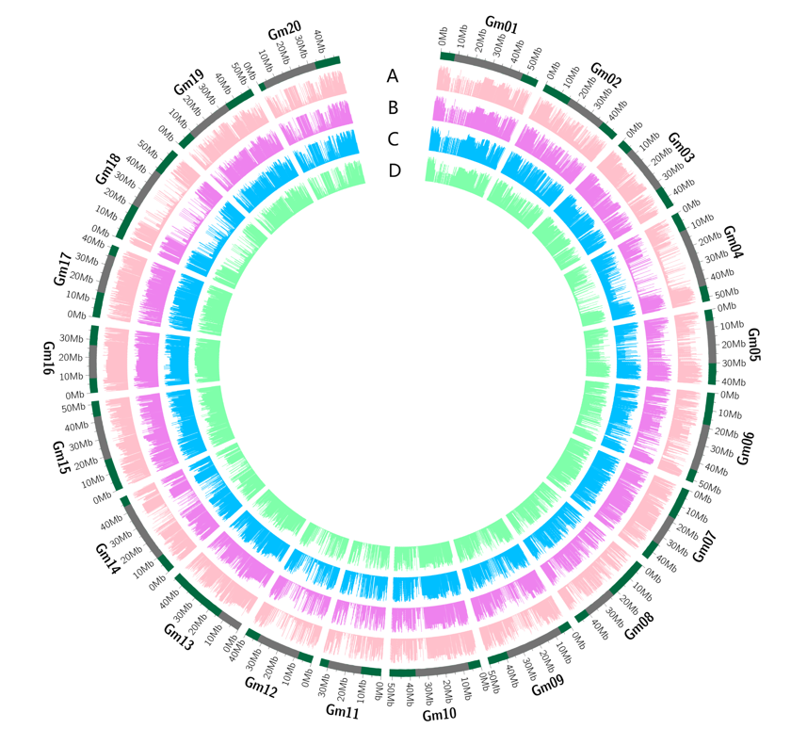
Fig. S3 Soybean genome map
Fig. S4 Distribution of functional sites in the 817 soybean accessions
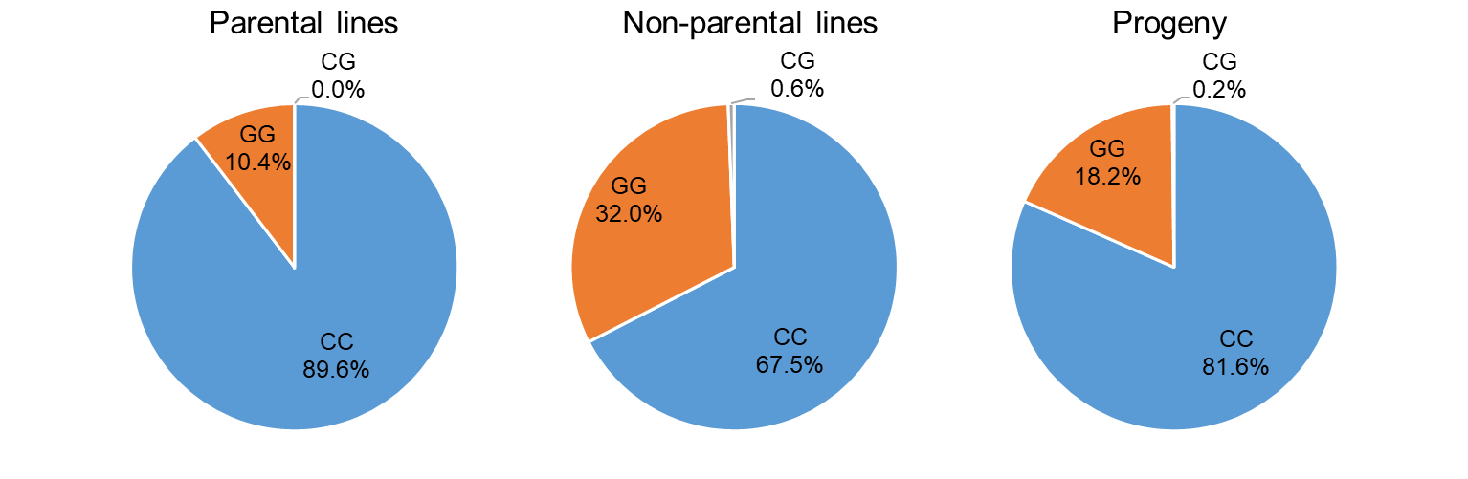
Fig. S5 Distribution of leaf-shape functional loci in the parental lines, non-parental lines, and progeny
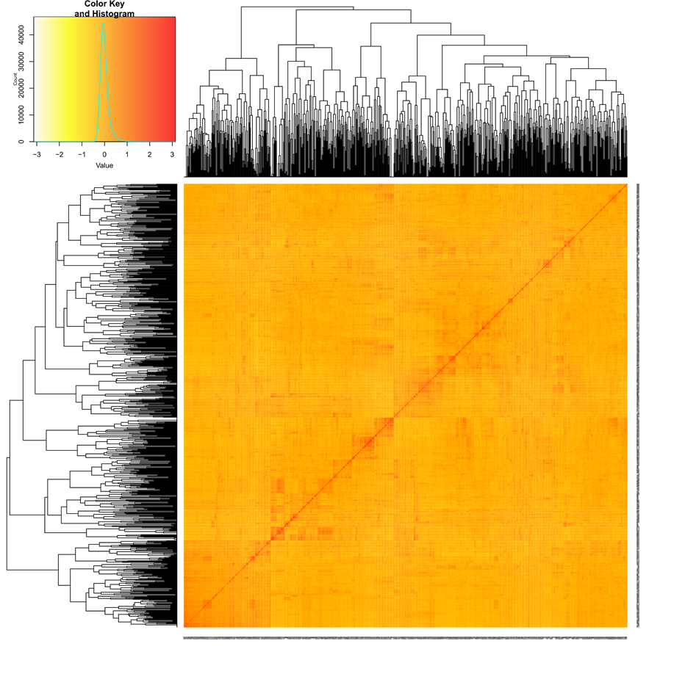
Fig. S6 Kinship plot for the 817 accessions. The heatmap of the values in the kinship matrix was created using GAPIT
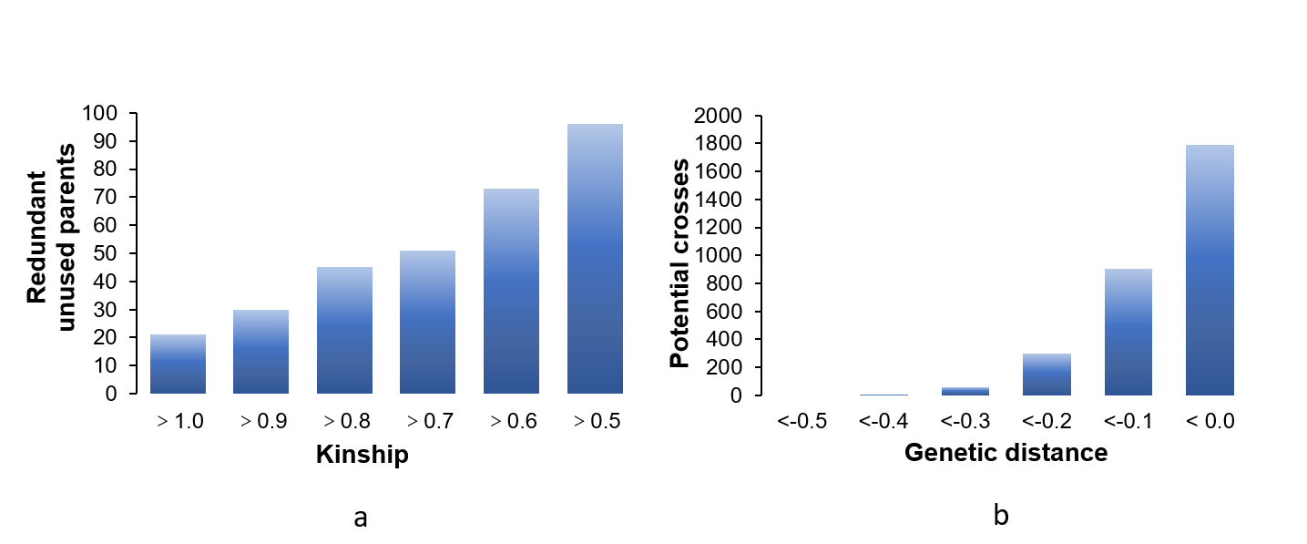
Fig. S7 Screening redundant non-parental lines and making potential hybrid combinations based on kinship

