Supplementary information

Polyelectrolyte Complexes for Zero Liquid Discharge of Saturated Brine Wastewater

Jie Zhu^{1, 2}, Xinran Zhao^{1, 2}, Haiyang Huo^{3, 4}, Dong Wu^{1,2}, Zhaoyan Sun^{3, 4, *}, Xiayun Huang^{1, 2, *} & Zhihong Nie^{1, 2, *}
¹ State Key Laboratory of Molecular Engineering of Polymers, Fudan University, Shanghai, China
² Department of Macromolecular Science, Fudan University, Shanghai, China
³ State Key Laboratory of Polymer Science and Technology, Changchun Institute of Applied Chemistry, Chinese Academy of Sciences, Changchun, China
⁴ School of Applied Chemistry and Engineering, University of Science and Technology of China, Hefei, China
Correspondence to Z.S. (zysun@ciac.ac.cn), X.H. (huangxiayun@fudan.edu.cn) or Z.N. (znie@fudan.edu.cn).

This PDF file includes:
Supplementary Notes 1-8
Supplementary Figures 1-22
Supplementary Tables 1-2
References

Supplementary Notes
Note S1. Chemical reagents
Bacterial cellulose (BC) membranes were purchased from Guilin Qihong Technology Co., Ltd. and used after purification. β-cyclodextrin (β-CD, 97%), 4-vinylpyridine (VP, 99%), sodium 4-styrenesulfonate (SS, 98%), 2-chloro-2-methylpropanoyl chloride (98%), 2-bromo-2-methylpropionyl bromide (98%), methyl iodide (MeI, 99%), triethylamine (99%), copper(I) bromide (CuBr, 98%), cuprous chloride (CuCl, 98%), 2,2'-bipyridine (bpy, 99%), tris(2-(dimethylamino)ethyl)amine (Me6TREN, 99%), pentamethyldiethylenetriamine (PMDETA, 99%), N-methyl-2-pyrrolidone (NMP, anhydrous, 99.5%), N,N-dimethylformamide (DMF, anhydrous, 99.5%), methanol (99.5%), ethanol (anhydrous, 99.5%), chloroform (99.5%), isopropanol (99.5%), diethyl ether (anhydrous, 99.0%), and n-butanol (99.0%) were purchased from Adamas. Inhibitor monomers were purified using alkaline aluminum oxide column chromatography. CuBr was purified by stirring in glacial acetic acid for 24 h at room temperature, followed by filtration, sequential washing with ethanol and diethyl ether, and drying under vacuum overnight at room temperature. CuCl was purified by suspending it in concentrated hydrochloric acid and stirring for 1 h at room temperature, after which it was filtered, washed extensively with deionized water until neutral, rinsed with ethanol and diethyl ether, and dried under vacuum overnight. All other chemicals were used as received without further purification.

Note S2. Synthesis of star-polyelectrolytes
Synthesis of Initiators Br-β-CD and Cl-β-CD
β-CD (1 mmol) was charged into a 50 mL dry Schlenk flask and dried in a vacuum oven at 60°C for 48 h. After three evacuate-argon refill cycles, 16 mL of dry NMP was added, and the mixture was stirred until complete dissolution. Triethylamine (37.8 mmol) was then added under an ice-water bath. A solution of 2-bromo-isobutyryl bromide (31.5 mmol) in 5 mL of chloroform was added dropwise over 30 min, and the reaction was maintained in the ice-water bath for 2 h before warming to room temperature and stirring for an additional 24 h. After completion, 25 mL of chloroform was added. The mixture was extracted three times with saturated NaCl solution, and the organic phase was collected and dried over anhydrous sodium sulfate, filtered, and concentrated. The resulting crude product was precipitated in n-hexane three times to obtain bromo-β-cyclodextrin (Br-β-CD) as a white powder. For synthesis of chloro-β-cyclodextrin (Cl-β-CD), 2-bromo-isobutyryl bromide was replaced with 2-bromo-isobutyryl chloride. The reaction time was extended to 60 h and the reaction temperature increased to 60°C, following the same collection and purification procedure.
Synthesis of sPSS
Star-poly(sodium 4-styrenesulfonate) (sPSS) was synthesized via ATRP using Br-β-CD as the initiator, CuBr/bpy as catalysts, and a methanol/water (1:1 v/v) mixture as the solvents. In a 50 mL Schlenk flask, Br-β-CD (0.1 mmol), bpy (4.2 mmol), SS (105 mmol), and 20 mL of solvent were added and stirred until complete dissolution. The flask was subjected to three freeze-thaw cycles. During the final cycle, CuBr (2.1 mmol) was added. After the mixture returned to room temperature, argon was introduced, and the polymerization was conducted at 25°C for 4 h, reaching ~40% monomer conversion. The reaction was exposed to air to quench the polymerization, diluted, and passed through a neutral alumina column to remove copper species. The filtrate was collected, concentrated, and precipitated into ice cold ether. After centrifugation and vacuum drying, sPSS was obtained as a white powder.
Synthesis of sQPVP
Star-poly(4-vinylpyridine) (sPVP) was synthesized via ATRP using Cl-β-CD as the initiator, CuCl/Me₆TREN as the catalyst, and isopropanol as the solvent. In a 50 mL Schlenk flask, Cl-β-CD (0.1 mmol), Me₆TREN (2.1 mmol), VP (105 mmol), and 8 mL of isopropanol were added and stirred until dissolved. Three freeze-thaw cycles were performed, and CuCl (2.1 mmol) was added during the final cycle. After returning to room temperature, argon was introduced and the polymerization was conducted at a 45°C oil bath for 4 h, achieving ~40% monomer conversion. The reaction was quenched by exposure to air, diluted, and purified through a neutral alumina column to remove copper catalysts. The filtrate was collected, concentrated, and precipitated into ice cold ether. After centrifugation and vacuum drying, sPVP was obtained as a dark-red powder. For quaternization, the sPVP was dissolved in ethanol, and MeI (20-fold molar acess relative to pyridine units in sPVP) was added. The reaction proceeded for 48 h under stirring. The solution was dialyzed against methanol/water mixtures (1:5 v/v) for 3 days with solvent replacement every 12 h. Freeze-drying yield quaternized star-poly(4-vinylpyridine) (sQPVP).

Note S3. Numerical model for salt crystallization in the solar-powered ZLD process
In a solar-powered evaporation system, the concentration of salt in a tank of brine increases as water evaporates, potentially leading to precipitation once the solution reaches saturation. The entire ZLD process is governed by mass conservation of both salt and water. When the salt concentration reaches the saturation concentration $c_{sat}$ , precipitation begins. The time at which the solution reaches saturation is denoted as $t_{sat}$. The calculation follows principles outlined in “Unit Operations of Chemical Engineering” and “Transport Phenomena”.^{1,2}
Before saturation ($0≤t≤t_{sat}$)
The total salt mass in the system remains constant:
$\frac{dn_{s}}{dt}=0⇒n_{s}=n_{s0}=c_{0}V_{0}$ (Equation S1)
where $n_{s}$ is the number of moles of NaCl, $n_{s0}$ is the initial number of moles of NaCl, $c_{0}$ is the initial NaCl concentration, and $V_{0}$ is the initial solution volume.
The rate of change of water mass in the system is equal to the evaporation rate:
$\frac{dM_{water}}{dt}=-JA$ (Equation S2)
where $J$ is the evaporation rate, $A$ is the effective evaporation area, $M_{water}$ is the water mass in the solution.
The solution volume changes over time as water evaporates:
$\frac{dV}{dt}=\frac{1}{ρ(c)}\frac{dM_{water}}{dt}=-\frac{JA}{ρ(c)}$ (Equation S3)
where $ρ(c)$ is the solution density, which can be approximated as a constant $ρ$. Therefore, the solution volume as a function of time is:
$V(t)=V_{0}-\frac{JA}{ρ(c)}t$ (Equation S4)
The NaCl concentration increases as water evaporates:
$c(t)=\frac{n_{s}}{V(t)}=\frac{c_{0}V_{0}}{V_{0}-\frac{JA}{ρ(c)}t}$ (Equation S5)
After Saturation ($t≥t_{sat}$)
The time to reach saturation is:
$t_{sat}=\frac{V_{0}(1-\frac{c_{0}}{c_{sat}})ρ}{JA}$ (Equation S6)
At saturation, the solution volume is:
$V(t_{sat})=\frac{c_{0}V_{0}}{c_{sat}}$ (Equation S7)
Once saturation is reached, the solution maintains a constant salt concentration $c_{sat}$ ,and any further salt precipitates. The solution volume continuous to decrease linearly with ongoing evaporation:
$V(t)=\frac{c_{0}V_{0}}{c_{sat}}-\frac{JA}{ρ}(t-t_{sat})$ (Equation S8)
The amount of salt precipitated after saturation is:
$n_{ppt}(t)=n_{s0}-n_{s}(t)=c_{0}V_{0}-c_{sat}V(t)$ (Equation S9)
The corresponding mass of precipitated salt is:
$m_{ppt}(t)=n_{ppt}(t)M_{NaCl}$ (Equation S10)
This model provides a quantitative description of salt crystallization kinetics under solar-powered evaporation in the ZLD process.

Note S4. Models and simulation methods
To investigate the dynamic stability of star-shaped polyelectrolyte complex (sPEC) structures under varying salt concentrations and their corresponding ion-partition behavior, we conducted coarse-grained molecular dynamics (CG-MD) simulations. In this approach, groups of atoms are represented as single coarse-grained beads, enabling access to larger temporal and spatial scales relevant to the experimental systems.
In our CG model, the single-charge star-polyelectrolyte represents the experimental sQPVP and sPSS systems. The star core is modeled as a smooth, rigid sphere of diameter D=5σ (~1.5 nm). Twenty-one polymer arms are uniformly grafted onto the core. Each arm is a standard bead-spring chain comprising 25 beads of diameter σ (0.3 nm), with one bead per chain carrying a fixed charge to mimic the charged side groups: a single positive charge (+1e) for sQPVP and a single negative charge (-1e) for sPSS. Electroneutrality is maintained by adding an equivalent number of counterions. Positively charged counterions (proton analogues) have a diameter of 0.5σ, while negatively charged counterions (I⁻ analogues) have a diameter of σ. Monovalent salt ions (diameter σ, charge ±1e) were added to achieve experimental salt concentrations of 1.83 M, 3.26 M, and 4.88 M.
Van der Waals interactions between beads are described by a shifted and truncated Lennard-Jones (LJ) potential:
$U_{LJ}\left(r\right)=\left\{\begin{aligned}\text{4}ε_{LJ}\left[{\left(\frac{σ}{r-}\right)}^{\text{12}}-{\left(\frac{σ}{r-}\right)}^{\text{6}}\right]+C, r≤{(r}_{\text{c}}+) \\ 0, r>{(r}_{\text{c}}+)\end{aligned}\right.$ (Equation S11)
where Δ = (D − σ)/2 for the interaction between cores and beads, and the cutoff radius is R_{c} = r_{c} + Δ, with r_{c} = 2^{1/6}σ for repulsive interactions. An attractive component is included for interactions between polymer-grafted beads, with ԑ_{LJ} = 1.0 and r_{c} = 2.5σ. The constant C ensures U_{LJ} = 0 at r_{c}.
The bonded interactions between connected beads were described using a finitely extensible nonlinear elastic (FENE) potential:
$U_{FENE}\left(r\right)=-0.5k{R_{0}}^{2}ln⁡(1-{r^{2}}/{{R_{0}}^{2}})$ (Equation S12)
where the spring constant k = 30 ϵ₀/σ² and the maximum extension R₀ = 1.5σ.
The electrostatic interactions between charged species are governed by the Coulomb potential:
$U_{coul}\left(r\right)=\frac{q_{i}q_{j}}{4{}_{0}{}_{r}r}$ (Equation S13)
where q_{i} and q_{j} are the point charges, ε₀ is the vacuum permittivity, and ε_{r} is the relative dielectric constant. To match the experimental solution conditions, ε_{r} was set to 70, 63, 52, and 40 for salt concentrations of 0 M, 1.83 M, 3.26 M, and 4.88 M, respectively. Electrostatic forces were calculated using the particle-particle particle-mesh (PPPM) algorithm.
All CG-MD simulations were performed in three dimensions under periodic boundary conditions using the GALAMOST (GPU-accelerated large-scale molecular simulation toolkit). The simulations were conducted in the canonical (NVT) ensemble within a cubic box of side length L=150σ (~45 nm). The equations of motion were integrated with a time step of Δt=0.005τ (~5 fs), where τ =σ(m/ԑ_{LJ})^{0.5} is the intrinsic MD time unit. Temperature was maintained at 298 K using a Langevin thermostat.
Each system was first equilibrated for 2×10⁶ steps (10 ns), followed by a production run of 8×10⁶ steps (~40 ns) for data collection, ensuring structural stability. For statistical robustness, several tens of independent simulations with different initial configurations were performed for each system. The reported results are averaged over 10² statistically independent samples.

Note S5. QCM analysis
QCM was employed to monitor the adsorption of salt ions in the polyelectrolyte complex by measuring the change in the resonance frequency at multiple overtones (${Δf}_{i}$), typically $i$ = 3.^{3,4} The mass of adsorbed material per unit area ($m_{QCM}$) was calculated using the Sauerbrey equation:
$m_{QCM}=-C\frac{{Δf}_{i}}{i}$ (Equation S14)
where $C$ = 18.06 ± 0.15 ng cm⁻² Hz⁻¹ is the mass sensitivity constant for sensor with a resonance frequency of 4.95 ± 0.02 MHz.

Note S6. Chemical potential theory for calculating ion-partition coefficient
The chemical potential describes the distribution of ions between sPEC and the surrounding solution, governed by the intrinsic structure of sPEC and its non-covalent interaction. These interactions generate the Donnan potential ($φ_{D}$) that dictates how ions distribute inside the sPEC relative to the bulk solution.⁵⁻⁹
At thermodynamic equilibrium, the electrochemical potential of an ion $i$ with charge $z_{i}$ inside ($μ_{i}^{in}$) and outside ($μ_{i}^{out}$) the sPEC is equal:
$μ_{i}^{in}=μ_{i}^{out}$ (Equation S15)
The electrochemical potential is expressed as:
$μ_{i}=μ_{i}^{0}+k_{B}Tlnc_{i}+z_{i}eφ$ (Equation S16)
From this, the ion concentration inside the sPEC is:
$c_{i}^{in}=c_{i}^{out}exp(-z_{i}φ_{D})$ (Equation S17)
The concentration of ions inside the sPEC depends exponentially on $φ_{D}$, with counterions (opposite charge to the sPEC fixed charges) inside, and co-ions (same charges as the sPEC) depleted.
The Donnan potential $φ_{D}$ arises from the balance between the electrostatic forces due to the fixed charges ($c_{f}$) in the sPEC and the tendency of the system to maintain electroneutrality. For a system with fixed charges, the electrostatic balance inside the sPEC gives:
$zc_{+}^{in}-zc_{-}^{in}-c_{f}=0$ (Equation S18)
For a symmetric salt (e.g., NaCl), the internal ion concentrations are:
$c_{+}^{in}=c_{s}exp(+zφ_{D}), c_{-}^{in}=c_{s}exp(-zφ_{D})$ (Equation S19)
where $c_{s}$ is the concentration of salt in the bulk solution. The ion-partition coefficient K, defined as the ratio of ion concentration inside to outside the sPEC, can be expressed as:
$K=\frac{C_{in}}{C_{out}}=exp(φ_{D})×exp(-βΔμ_{ex}), β={(k_{B}T)}^{-1}$ (Equation S20)
where $Δμ_{ex}$ is the excess chemical potential, representing additional energy required for an ion to enter the sPEC beyond the electrochemical potential. Contributions include solvation effects and dielectric mismatch between the sPEC ($ε_{in}$) and the solution ($ε_{out}$), commonly approximated by the Born term, which accounts for the energy change due to the ion's interaction with the medium:
$Δμ_{i}^{Born}=\frac{z_{i}^{2}e^{2}}{8πε_{0}r_{i}}(\frac{1}{ε_{in}}-\frac{1}{ε_{out}})$ (Equation S21)
where $r_{i}$ is the ionic radius and $ε_{0}$ is the vacuum permittivity. In compact sPEC structure, the Born term typically contributes an additional 0.5–5 $k_{B}T$ to the chemical potential. Compared with linear polyelectrolyte complexes or single-charged star-polyelectrolytes, sPEC exhibit superior salt resistance due to multi-site pairing, topological constraints, and large, salt-insensitive excess chemical potential penalties that hinder ion entry while maintaining high water transport.

Note S7. The techno-economic analysis
The techno-economic analysis (TEA) evaluates both capital expenditure (CAPEX) and operational expenditure (OPEX) for a plant designed to treat 1000 m³ day⁻¹ of high-salinity wastewater (design capacity $C=1000 m^{3} {day}^{-1}$), excluding transportation costs. In the context of ZLD treatment, Reverse Osmosis + thermal Evaporation + Crystallization (ROEC) and Solar-Driven Interfacial Evaporation with in-solution salt crystallization (the iWAVE system) represent two fundamentally different technological paradigms. Although both achieve ZLD, their energy pathways, recovery efficiencies, material configurations, capital structures, and separation mechanisms differ substantially, resulting in distinct techno-economic outcomes. All calculation was guided by ”Plant Design and Economics for Chemical Engineers”, ”Perry's Chemical Engineers Handbook”.^{10,11} The calculated parameters can be referenced from the cited literature.¹²⁻¹⁵
For the ROEC system, water production depends solely on plant availability:
$Q_{y}^{ROEC}=C×365×A$ (Equation S22)
where $A$ is the operational availability (0.85–0.95).
For the iWAVE system, water production is primarily sunlight-driven. Evaporation can be supplemented by electric heating to maintain operation during low-irradiance periods or to increase throughput. Under these conditions, salt continuous to crystallize in the bulk solution rather than on the evaporator surface, ensuring that the evaporator structure remains intact.
$Q_{y}^{iWAVE}=C×365×A×(\frac{H}{24})×η_{weather}$ (Equation S23)
where $H$ is effective solar irradiation duration per day (typically 6–8 h), and $η_{weather}$ is the weather capacity factor (0.80–0.95).Both $H$ and $η_{weather}$ can be enhanced by introducing electric heating. In addition, the daily solar energy can be harvested through photovoltaic and storage systems for backup use.
The CAPEX estimation follows scale-dependent CAPEX and annualized CAPEX. For both ROEC and iWAVE systems, CAPEX follows a power-law scaling:
$CAPEX(C)={CAPEX}_{ref}×C_{ref}×{(\frac{C}{C_{ref}})}^{α}$ (Equation S24)
where $C_{ref}$ is the reference capacity, ${CAPEX}_{ref}$ is the cost factor (USD per m³ day⁻¹ capacity), and $α$ is the scale exponent (0.6-0.8). Typical ${CAPEX}_{ref}$ for ROEC is 900-1200 USD per m³ day⁻¹, and for iWAVE is 150-350 USD per m³ day⁻¹.
Annualized capital cost is calculated using the capital recovery factor (CRF), based on a 3% discount rate (denoted as $r$ in the equation below) and a project lifetime $n$:
$CRF(r, n)=\frac{r{(1+r)}^{n}}{{(1+r)}^{n}-1}$ (Equation S25)
$Annualized CAPEX=CRF(r, n)×CAPEX$ (Equation S26)
The specific energy consumption (SEC) follows a scale-dependent SEC formula and the annual energy cost.
$SEC(C)={SEC}_{min}+({SEC}_{ref}-{SEC}_{min})×{(\frac{C}{C_{ref}})}^{-β}$ (Equation S27)
For ROEC, the values of $SEC$ at reference scale ${SEC}_{ref}$, minimum achievable $SEC$ at infinite scale ${SEC}_{min}$, and $SEC$ scale exponent $β$ are 6 kWh m⁻³, 2.8 kWh m⁻³, and 0.1, respectively. For iWAVE, the corresponding values are 0.1 kWh m⁻³, 0.06 kWh m⁻³, and 0.05, respectively.
When calculating the annual energy cost, the electricity price $P_{e}$ is incorporated into the total energy consumption of the system.
$Energy {OPEX}_{y}=Q_{y}×SEC(C)×P_{e}$ (Equation S28)
Thermal evaporators in ROEC use additional heat energy:
$Thermal {OPEX}_{y}=Q_{y}×h_{latent}×η^{-1}×P_{fuel}$ (Equation S29)
where $h_{latent}=2257 kJ {kg}^{-1}$ is the latent heat for evaporation, and $η$ is the heating efficiency.
Chemical consumption is calculated by the following equation:
$Chem {OPEX}_{y}=Q_{y}×∑(r_{i}, p_{i})$ (Equation S30)
where $r_{i}$ is the chemical dose, and $p_{i}$ is the chemical price. For ROEC, the typical NaOCl dose is 20 g m⁻³, and additional NaOCl/HCl cleaning is required. For iWAVE, the corresponding value is only 1 g m⁻³.
The fixed operation and maintenance (O&M) cost includes labor, maintenance, spare parts, membrane or module replacement, and system monitoring.
$Fixed O\&M(C)={O\&M}_{ref}×{(\frac{C}{C_{ref}})}^{γ}, γ=0.7-0.9$ (Equation S31)
ROEC incurs much higher maintenance costs due to pumps, heat exchangers, crystallizers, and scaling-mitigation requirements, whereas SDIE has far fewer moving parts and therefore much lower fixed O&M costs.
The ROEC process typically recovers less than 75% of the salt and water from high-salinity wastewater, whereas iWAVE achieves recovery rates of up to 95%. This gap implies that ROEC incurs additional costs to treat the unrecovered waste stream.
$W_{y}=Q_{y}×(\frac{1}{R}-1)$ (Equation S32)
${Waster Cost}_{y}=W_{y}×p_{waste}$ (Equation S33)
where $W_{y}$ is the annual waste yield, $R$ is the recovery rate, and $p_{waste}$ is the cost to treat the unrecovered waste.
The revenue of ROEC comes from the recovered salt and water, whereas iWAVE not only produces higher-value high-purity salt and water but also enables additional revenue or savings through energy recovery via heat-exchange and other system-integration strategies.
The break-even price (BEP) satisfies:
${Net Revenue}_{y}(BEP)=Annualized CAPEX+{OPEX}_{y}$ (Equation S34)
For SDIE, the break-even price is lower because it benefits from free solar thermal input, minimal waste-disposal costs, and higher revenue uplift.
SDIE outperforms ROEC in the techno-economic analysis because it eliminates thermal energy demand by using free solar heat, achieves high water and salt recovery with almost no brine-handling cost, and requires low CAPEX due to its modular structure and photothermal coating. Its products—ultrapure water and salt crystallized under mild conditions—also command higher market value. In contrast, ROEC is constrained by a thermal block that dominates energy OPEX, a large and maintenance-intensive crystallizer CAPEX, and substantial brine-discharge costs resulting from its limited recovery efficiency. Moreover, ROEC produces only standard-grade water, offering no additional revenue uplift.

Note S8. The life-cycle assessment
A life-cycle assessment (LCA) was conducted to evaluate the environmental impacts of ROEC and iWAVE, with emphasis on green production and global warming potential. The functional unit was defined as 1 m³ of purified product water. The assessment was guided by ”Plant Design and Economics for Chemical Engineers”, ”Perry's Chemical Engineers Handbook”.^{10,11} The calculated parameters can be referenced from the cited literature.¹²⁻¹⁵
System boundary:
Raw material extraction → component fabrication → plant construction → operation (energy, chemicals, and materials) → maintenance and replacement → brine management. End-of-life processes are excluded due to the lack of industrial-scale data for iWAVE materials.
The per-m³ life-cycle impact ($I$) is computed as:
$I=\frac{I_{energy}+I_{chemical}+I_{material}+I_{replacement}+I_{waste}}{Q_{y}}$ (Equation S35)
Taking energy impact as an example, the cumulative energy demand (CED) and global warming potential (GWP) can be calculated using the following equations, respectively:
${CED}_{energy}=Q_{y}×SEC×{EC}_{energy}$ (Equation S36)
${GWP}_{energy}=Q_{y}×SEC×{EF}_{energy}$ (Equation S37)
where $EC$ is the CED factor (MJ kWh⁻¹), and $EF$ is the GWP emission factor (kg CO₂e kWh⁻¹). For the energy impact, ROEC requires additional thermal input, as the thermal block consumes purchased steam, gas, or electricity.
Chemical-related LCA impact:
${CED}_{chemical}=Q_{y}×∑({Chem}_{i}×{EC}_{chem, i})$ (Equation S38)
${GWP}_{chemical}=Q_{y}×∑({Chem}_{i}×{EF}_{chem, i})$ (Equation S39)
ROEC requires multiple types of chemicals, whereas iWAVE requires only minimal biocide dosing, resulting in a substantially lower chemical-related LCA footprint.
Material Manufacturing Impact:
${CED}_{material}=∑({Material}_{i}×{EC}_{material, i})$ (Equation S40)
${GWP}_{material}=∑({Material}_{i}×{EF}_{material, i})$ (Equation S41)
Compared with ROEC, iWAVE uses lightweight polymeric materials and micron-thick photothermal coatings, resulting in much lower embodied energy than steel-based evaporators and crystallizers.
Component replacement cycles contribute to LCA:
${CED}_{replacement}=\frac{M_{component}×{EC}_{component}}{τ}$ (Equation S42)
${GWP}_{replacement}=\frac{M_{component}×{EF}_{component}}{τ}$ (Equation S43)
where $τ$ represents the replacement interval (years). For ROEC, membranes and anti-scaling components typically require replacement every 3–5 years. For iWAVE, the operation modules may be replaced every 2–3 years but incur much lower manufacturing emissions.
Brine or waste handling impact:
${CED}_{waste}=W_{y}×{EC}_{waste}$ (Equation S44)
${GWP}_{waste}=W_{y}×{EF}_{waste}$ (Equation S45)
ROEC’s low recovery rate leads to a high environmental burden, whereas iWAVE produces nearly zero brine, resulting in a negligible burden.

Supplementary Figures

Figure S1. Chemical reaction pathways for synthesizing star-polyelectrolytes.¹⁶

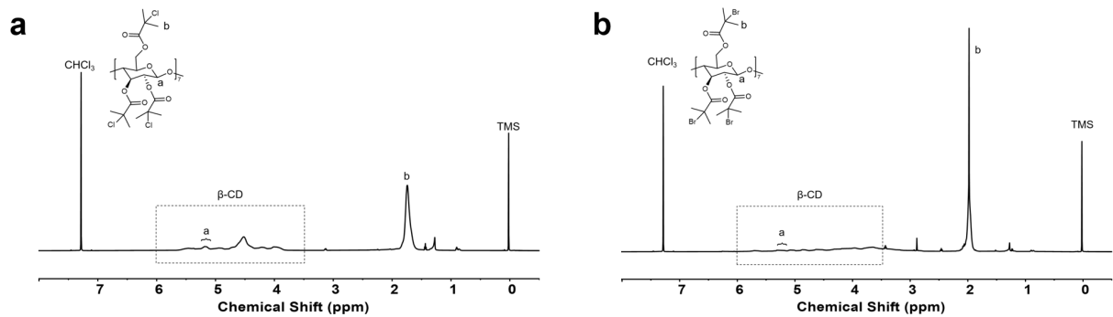
Figure S2. ¹H NMR spectra of a, Cl-β-CD, and b, Br-β-CD. The conversion efficiency of both products was calculated to be 100%.¹⁶

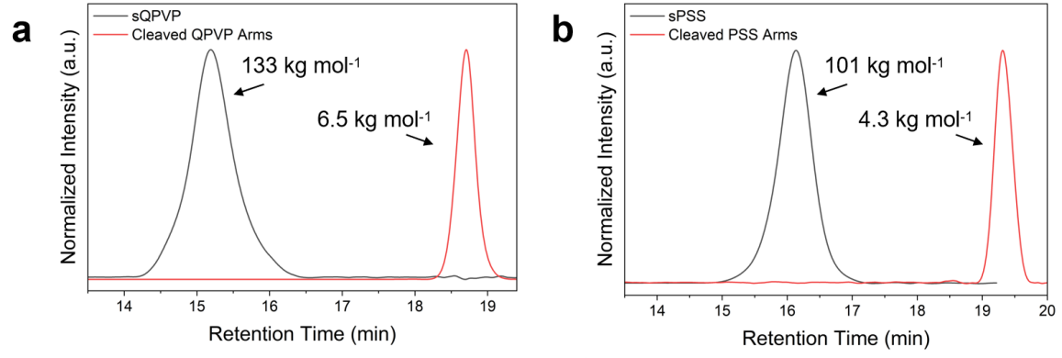
Figure S3. GPC curves of the star-polyelectrolytes and the corresponding cleaved arms, demonstrating an initiation efficiency of around 100%. a, sQPVP system, and b, sPSS system. The arms of star-polyelectrolytes were cleaved by acid solvolysis as described in references.^{17,18} Star sample (50 mg) was dissolved in THF (1 mL) and n-butanol (16 mL), then treated with concentrated sulfuric acid (0.2 mL) and heated at 100°C for 7 days. After removing the solvent under vacuum, the residue was dissolved in CHCl₃ (4 mL), extracted with water (1.5 mL), and the organic layer isolated. The solvent was removed under vacuum, and the resulting polymer was dried for 3 days and characterized by GPC.

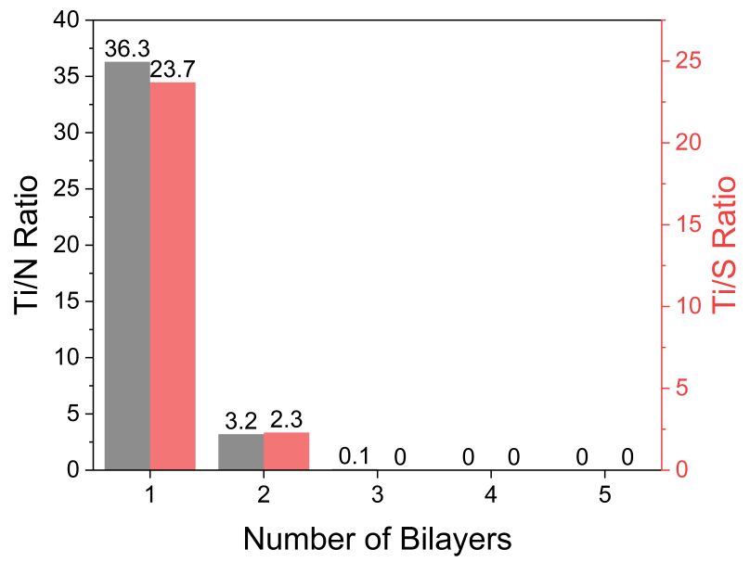
Figure S4. Ti/N and Ti/S ratio of sPEC on the supporting layer as a function of the number of multilayers, with titanium (Ti) doped into the supporting layer. A Ti/N or Ti/S ratio of 0 at three bilayers indicates that the sPEC surface coverage has reached 100%.

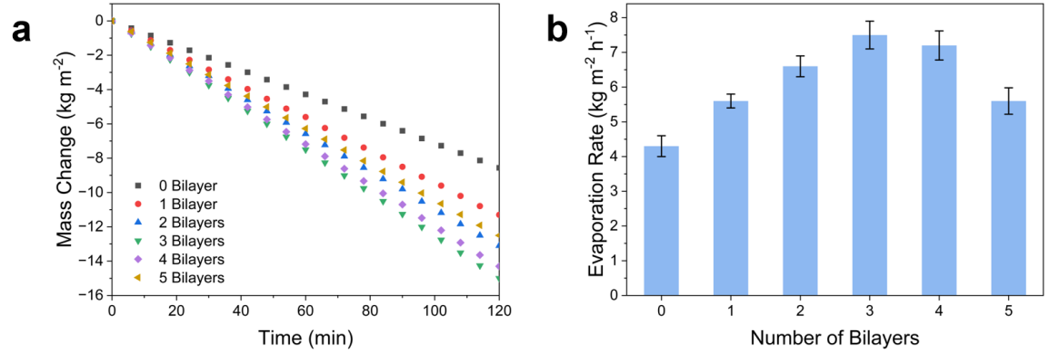
Figure S5. Solar evaporation rates of iWAVE as a function of the number of bilayers. The evaporation solution was a 4.88 M NaCl solution, with an irradiance of 1 sun. Each sample was tested at least three times, and the evaporation duration was 2 hours after preheating. a, Mass change curves, and b, average evaporation rate with the corresponding standard deviation.

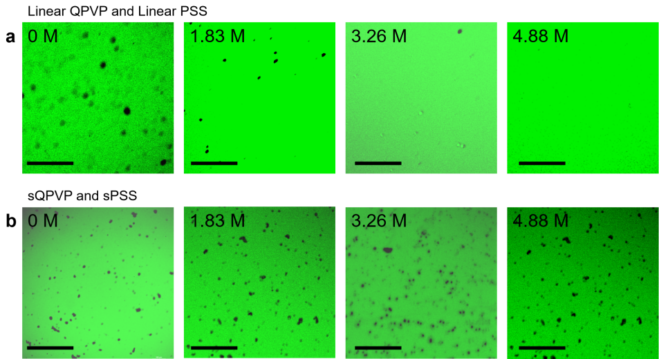
Figure S6. Confocal laser scanning microscope (CLSM) images of polyelectrolyte complexes formed by a, linear or b, star-shaped polyelectrolytes at varying salt concentrations (Scale bar: 100 μm). Hydrophilic dye fluorescein was used as a probe to detect the presence of polyelectrolyte complexes. When polyelectrolyte complexes are formed, hydrophobic microdomains are generated within them, hindering the diffusion of fluorescein and resulting in a black appearance. In regions without polyelectrolyte complexes in the solution, the fluorescein signal is visible, displayed using green pseudocolor, with an excitation wavelength of 488 nm.

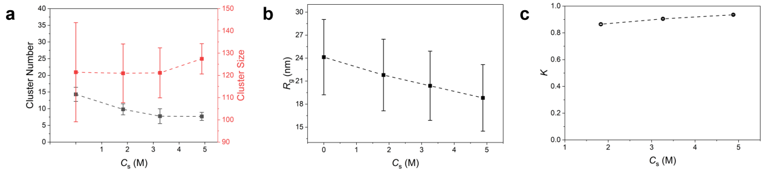
Figure S7. CG-MD simulations of linear polyelectrolytes and PE. a, CG-MD simulations show that linear polyelectrolytes cannot form compact complex structures at different salt concentrations. b, CG-MD simulations of the root-mean-square radius of gyration, c, and ion-partition coefficient of sQPVP at different salt concentrations.

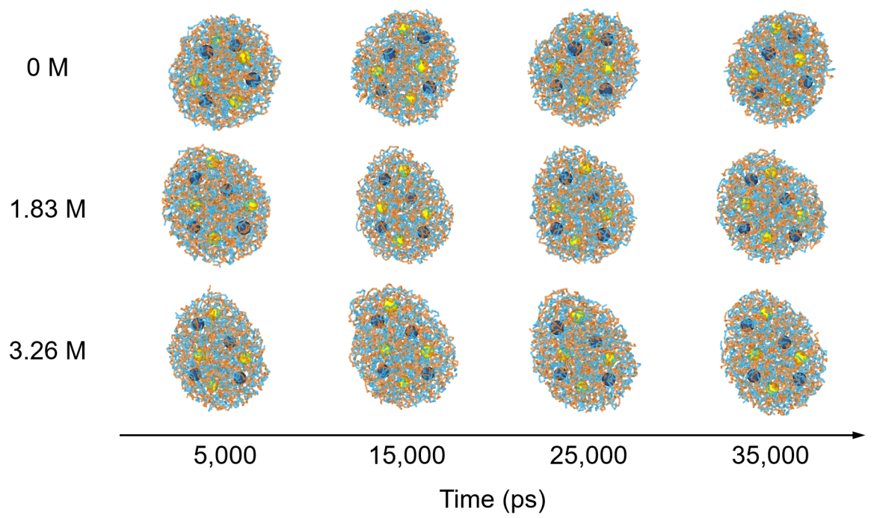
Figure S8. The CG-MD evolution of sPEC in 0 M, 1.83 M, and 3.26 M NaCl solution.

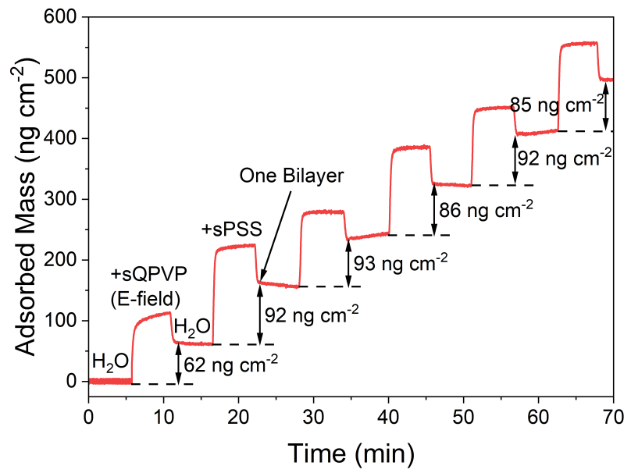
Figure S9. The QCM curve indicates the sPEC formation kinetics on the QCM SiO₂ chip. The electric field assistance and flow adsorption are included to align with the process of constructing the sPEC functional layer on the supporting layer during the experiment.

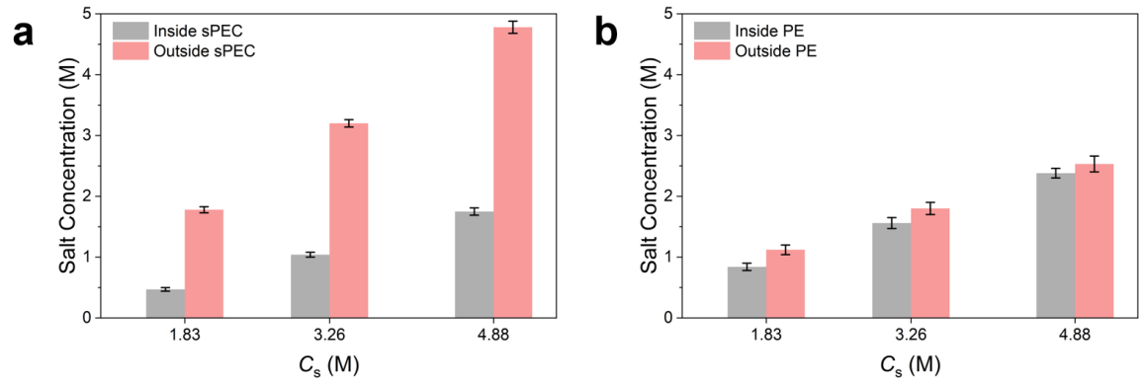
Figure S10. The inner and outer salt concentrations with the presence of PE or sPEC. The ion-partition coefficient was calculated by dividing the inner salt concentration by the outer salt concentration.

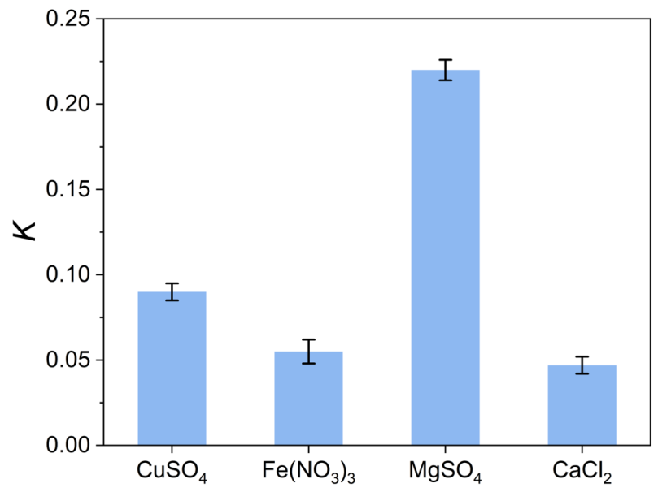
Figure S11. The ion-partition coefficient of sPEC for different types and concentrations of salt ions.

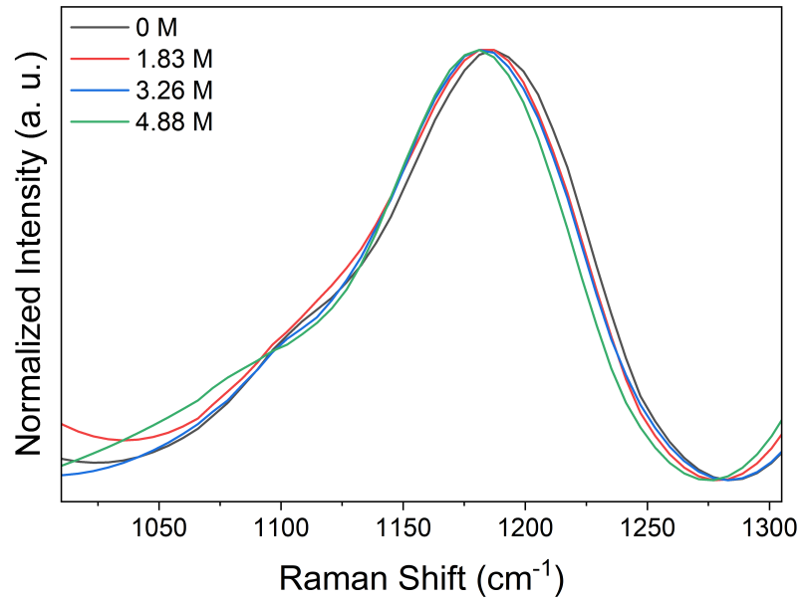
Figure S12. The Raman spectra of sPEC in various salt concentration solutions. The peak at 1100 cm⁻¹ indicates the hydrophobic microdomains formed in the polyelectrolyte complexes, while the peak at 1200 cm⁻¹ corresponds to the vibration of free polyelectrolyte groups with electrostatic interactions.¹⁹

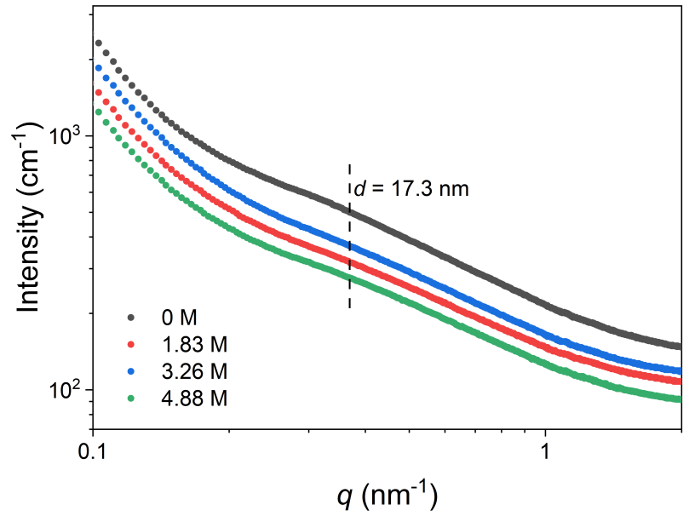
Figure S13. The small-angle X-ray scattering curves of sPEC in various salt concentration solutions maintained the same structural parameters. The magnitude of the scattering vector (q) is given by q = 4π/λ sin(θ/2), where λ is the wavelength of the X-ray and θ is the scattering angle.^{20,21}

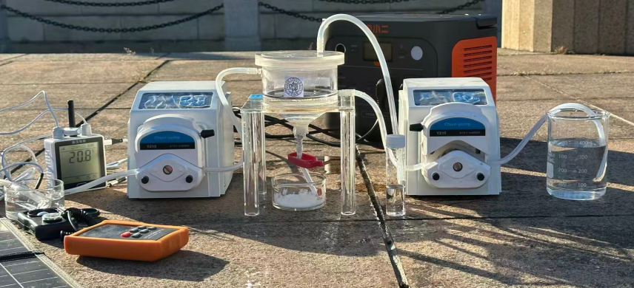
Figure S14. The photograph of the lab-made iWAVE-based ZLD system.

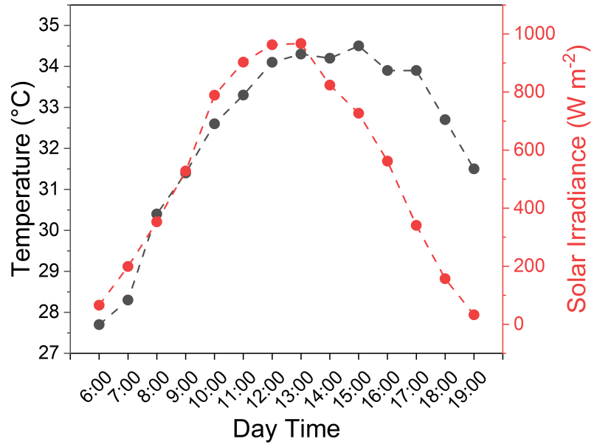
Figure S15. The variation in temperature and solar irradiance on July 3rd, 2025.

.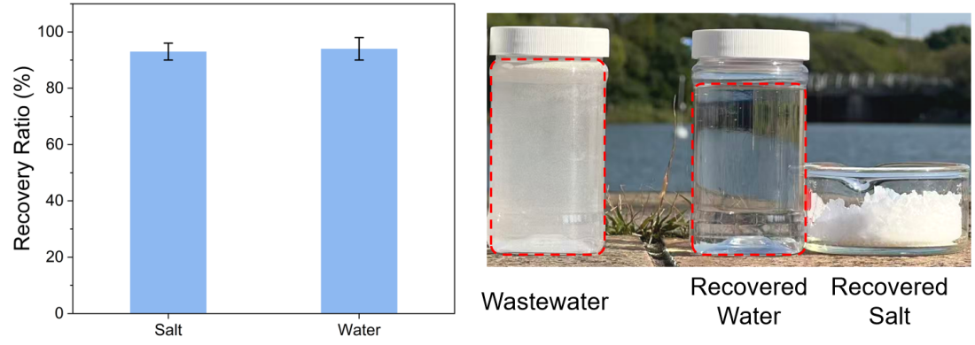
Figure S16. The salt and water recovery ratios of the iWAVE-based ZLD system.

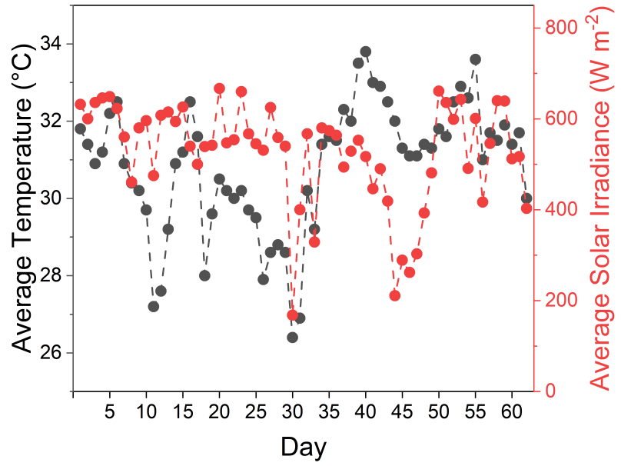
Figure S17. The average temperature and average irradiance from June to August 2025.

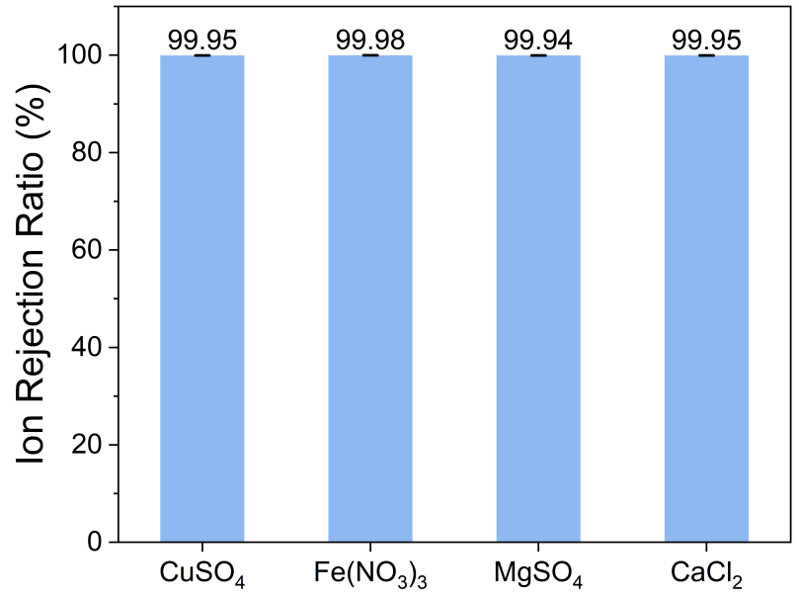
Figure S18. The ion rejection ratio of the iWAVE-based ZLD system when treating 1 M solutions of different types of salts.

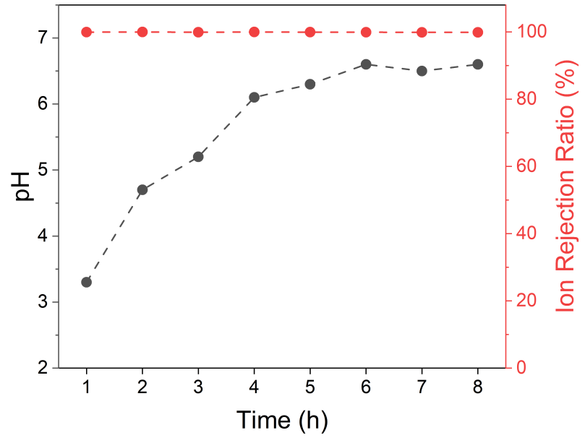
Figure S19. The pH values, and salt rejection ratio of the iWAVE-based system when treating mixed salt solution (simultaneously containing 0.3 M CaCl₂, 0.3 M MgSO₄, 0.3 M CuSO₄, and 0.3 M Fe(NO₃)₃).

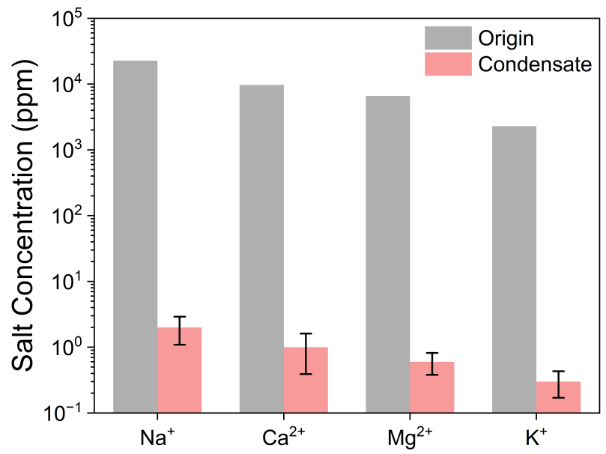
Figure S20. The salt concentration of the original and condensed real seawater treated by the iWAVE-based system.

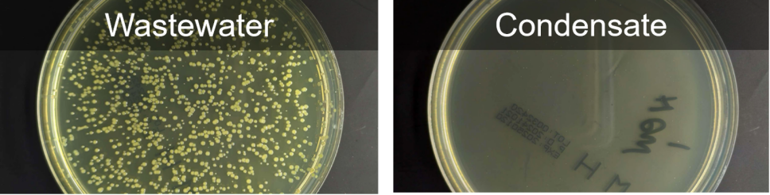
Figure S21. The disinfection activity results of the original and condensed real seawater treated by the iWAVE-based system. Under aseptic conditions, real seawater and iWAVE condensate were analyzed independently. Each sample was diluted 100-fold in sterile phosphate-buffered saline. An aliquot of 0.1 mL of the diluted suspension was spread-plated onto Luria–Bertani (LB) agar plates, followed by incubation inverted at 37 °C for 24 h prior to colony enumeration.^{22,23}

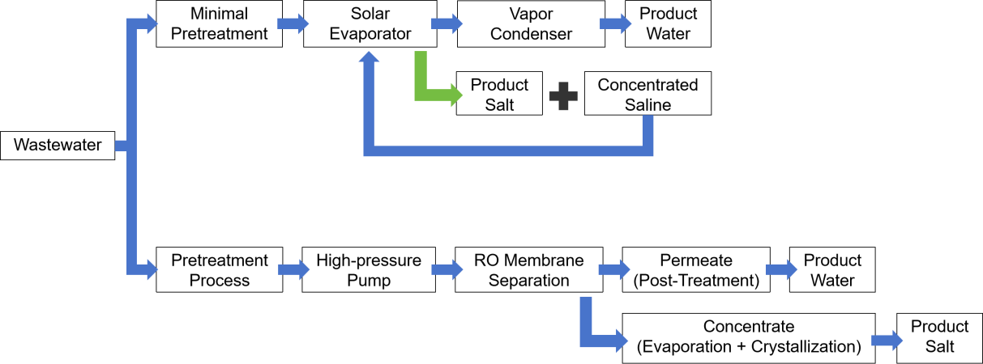
Figure S22. The flowchart of the ROEC and iWAVE-based ZLD system.

Supplementary Tables
Table S1. Molecular weights and polydispersity index (PDI) of star-polyelectrolytes, and their evaporation rate when integrated into iWAVE with 3 bilayers.
Sample# | M_{n,sQPVP}  (kg mol⁻¹) | PDI_{sQPVP} | M_{n,sPSS}  (kg mol⁻¹) | PDI_{sPSS} | Evaporation Rate  (kg m⁻² h⁻¹)
1 | 107 | 1.25 | 74 | 1.17 | 6.3±0.5
2 | 133 | 1.18 | 101 | 1.23 | 7.8±0.4
3 | 397 | 1.27 | 318 | 1.22 | 7.2±0.6

Table S2. Composition of simulated industrial wastewater.²⁴
Water quality of desulfurization wastewater
Total organic carbon(TOC) | 40-60 mg L⁻¹
pH | 9.2
Ca²⁺ | 2500-3500 mg L⁻¹
Mg²⁺ | 4500-5500 mg L⁻¹
Na⁺ | 7000-8000 mg L⁻¹
SO₄²⁻ | 10000-15000 mg L⁻¹
Cl⁻ | 8000-10000 mg L⁻¹
Water quality of Reverse osmosis concentrated water wastewater
TOC | 50-60 mg L⁻¹
pH | 7.8
SO₄²⁻ | 8000-10000 mg L⁻¹
Na⁺ | 10000-12000 mg L⁻¹
Cl⁻ | 10600-15000 mg L⁻¹
Water quality of the wastewater from a textile printing and dyeing plant
TOC | 150-200 mg L⁻¹
pH | 8.3
SO₄²⁻ | 40000-50000 mg L⁻¹
Na⁺ | 20000-24000 mg L⁻¹
Cl⁻ | 10000-15000 mg L⁻¹

References
1. Mccabe, W. L., Smith, J. C. & Harriott, P. Unit Operations of Chemical Engineering. (McGraw Hill, 2004)
2. Bird, R. B., Stewart, W. E. & Lightfoot, E. N. Transport Phenomena. (Wiley, 2006).
3. Zhao, X. et al. Stably Grafting Polymer brushes on both active and inert surfaces using tadpole-like single-chain particles with an interactive “head”. ACS Macro Lett. 13, 882-888 (2024).
4. Liu, Q. et al. Covalent organic framework membranes with vertically aligned nanorods for efficient separation of rare metal ions. Nat. Commun. 15, 9221 (2024).
5. Bannon, S. M. & Geise, G. M. Influence of Donnan and dielectric exclusion on ion sorption in sulfonated polysulfones. J. Membr. Sci. 694, 122396 (2024).
6. Friedowitz, S. et al. Looping-in complexation and ion partitioning in nonstoichiometric polyelectrolyte mixtures. Sci. Adv. 7, eabg8654 (2021).
7. Delaney, K. T. & Fredrickson, G. H. Theory of polyelectrolyte complexation—Complex coacervates are self-coacervates. J. Chem. Phys. 146, 224902 (2017).
8. Staňo, R., van Lente, J. J., Lindhoud, S. & Košovan, P. Sequestration of small Ions and weak acids and bases by a polyelectrolyte complex studied by simulation and experiment. Macromolecules 57, 1383-1398 (2024).
9. Shen, K. & Wang, Z.-G. Electrostatic correlations and the polyelectrolyte self energy. J. Chem. Phys. 146, 084901 (2017).
10. Peters, M. S., Timmerhaus, K. D. & West, R. E. Plant design and economics for chemical engineers. (McGraw Hill, 2006)
11. Green, D. W. & Southard, M. Z. Perry's Chemical Engineers' Handbook 9th Ed. (McGraw Hill, 2018)
12. Chen, Q. et al. A zero liquid discharge system integrating multi-effect distillation and evaporative crystallization for desalination brine treatment. Desalination 502, 114928 (2021).
13. O’Connell, M. G., Rajendran, N., Elimelech, M., Gilron, J. & Dunn, J. B. Analysis of energy, water, land and cost implications of zero and minimal liquid discharge desalination technologies. Nat. Water 2, 1116-1127 (2024).
14. Panagopoulos, A. Assessing the energy footprint of desalination technologies and minimal/zero liquid discharge (MLD/ZLD) systems for sustainable water protection via renewable energy integration. Energies 18, 962 (2025).
15. Panagopoulos, A. Techno-economic assessment of zero liquid discharge (ZLD) systems for sustainable treatment, minimization and valorization of seawater brine. J. Environ. Manage. 306, 114488 (2022).
16. Kim, M. et al. Hierarchical chiral supramolecular assemblies with strong and invertible chiroptical properties. Science 389, eadu0296 (2025).
17. Sumerlin, B. S., Neugebauer, D. & Matyjaszewski, K. Initiation efficiency in the synthesis of molecular brushes by grafting from via atom transfer radical polymerization. Macromolecules 38, 702-708 (2005).
18. Börner, H. G., Beers, K., Matyjaszewski, K., Sheiko, S. S. & Möller, M. Synthesis of molecular brushes with block copolymer side chains using atom transfer radical polymerization. Macromolecules 34, 4375-4383 (2001).
19. Ye, Z., Sun, S. & Wu, P. Distinct cation–anion interactions in the UCST and LCST behavior of polyelectrolyte complex aqueous solutions. ACS Macro Lett. 9, 974-979 (2020).
20. Stevens, K. C. & Tirrell, M. V. Structure and properties of bottlebrush polyelectrolyte complexes. J. Polym. Sci. 62, 3808-3817 (2024).
21. Jeffries, C. M. et al. Small-angle X-ray and neutron scattering. Nat. Rev. Methods Primers 1, 70 (2021).
22. Wang, J. et al. Silver single atoms and nanoparticles on floatable monolithic photocatalysts for synergistic solar water disinfection. Nat. Commun. 16, 981 (2025).
23. Peng, L. et al. Hydrodynamic tearing of bacteria on nanotips for sustainable water disinfection. Nat. Commun. 14, 5734 (2023).
24. Zhang, G. et al. Redox-neutral electrochemical decontamination of hypersaline wastewater with high technology readiness level. Nat. Nanotechnol. 19, 1130-1140 (2024).

