Evaluating the Ocular Safety Profile of Glucagon-Like Peptide-1 Receptor Agonists
Supplementary Material

Table of Contents
Diagnoses Covariates sTable 1 | Page 1
Medications Covariates sTable 2 | Page 4
Demographics Covariates sTable 3 | Page 5
Procedures Covariates sTable 4 | Page 6
Labs & Value Range Covariates sTable 5 | Page 10
Additional Procedure Codes sTable 6  (DR Exclusion Criteria) | Page 12
Proportional Hazard Values sTable 7 | Page 13
Secondary Analyses Covariates sTable 8 | Page 14
Kaplan-Meier Curves sFigures 1-9 | Page 21 - 29
nAMD Kernel-Density Plots sFigure 10 | Page 30
Authors:
Zaid Khan¹, MS, Fatima Chaudhry¹, MS, Neal Dhar², BA, Rohit Adyanthaya^{1,3}, MD
Affiliations:
1. Macon and Joan Brock Virginia Health Sciences, Eastern Virginia Medical School at Old Dominion University, Norfolk, VA
2. Carter Immunology Center, University of Virginia School of Medicine, Charlottesville, VA
3. Virginia Eye Consultants, Norfolk, VA

sTable 1. Diagnoses used as Covariates (Primary Analyses)
DR = Diabetic Retinopathy, nAMD = neovascular age-related macular degeneration
Std Diff. = Standard Mean Difference
Diagnoses | nAMD Patient #  Top Value, Cohort A  Bottom Value, Cohort B | nAMD Std diff. | Glaucoma Patient #  Top Value, Cohort C  Bottom Value, Cohort D | Glaucoma Std diff. | DR Patient #  Top Value, Cohort E  Bottom Value, Cohort F | DR  Std diff.
ICD-10-CM I10  Essential (primary) hypertension | 770  784 | 0.0381 | 151,357  151,251 | 0.0011 | 8,006  8,006 | -
ICD-10-CM E78  Disorders of lipoprotein metabolism and other lipidemias | 759  764 | 0.0132 | 139,011  138,875 | 0.0014 | 6,424  6,423 | 0.0003
ICD-10-CM E66  Overweight and obesity | 463  455 | 0.0168 | 72,910  71,982 | 0.0093 | 6,205  6,199 | 0.0018
ICD-10-CM I25  Chronic ischemic heart disease | 335  360 | 0.0546 | 49,035  49,040 | < 0.0001 | 3,610  3,611 | 0.0003
ICD-10-CM G47.33  Obstructive sleep apnea (adult) (pediatric) | 297  303 | 0.0136 | 36,661  36,553 | 0.0014 | 2,433  2,433 | < 0.0001
ICD-10-CM N18  Chronic kidney disease (CKD) | 285  285 | < 0.0001 | 30,291  29,394 | 0.0122 | 2,387  2,354 | 0.009
ICD-10-CM I50  Heart failure | 214  222 | 0.02 | 26,938  26,850 | 0.0013 | 1,660  1,652 | 0.0025
ICD-10-CM I48  Atrial fibrillation and flutter | 192  196 | 0.0104 | 25,547  25,330 | 0.0032 | 1,542  1,531 | 0.0035
ICD-10-CM I12  Hypertensive chronic kidney disease | 188  184 | 0.0106 | 24,175  24,161 | 0.0002 | 1,503  1,492 | 0.0035
ICD-10-CM N17  Acute kidney failure | 163  183 | 0.0545 | 20,547  20,463 | 0.0013 | 1,411  1,378 | 0.0109
ICD-10-CM I11  Hypertensive heart disease | 138  147 | 0.0265 | 18,660  18,705 | 0.0008 | 1,142  1,153 | 0.0039
ICD-10-CM F17  Nicotine dependence | 107  110 | 0.0099 | 13,666  13,636 | 0.0006 | 901  905 | 0.0016
ICD-10-CM I63  Cerebral infarction | 75  75 | < 0.0001 | 11,962  11,845 | 0.0024 | 860  848 | 0.0049
ICD-10-CM I13  Hypertensive heart and chronic kidney disease | 73  72 | 0.004 | 11,068  11,047 | 0.0004 | 734  725 | 0.0039
ICD-10-CM I21  Acute myocardial infarction | 72  74 | 0.0079 | 8,128  7,988 | 0.0035 | 723  711 | 0.0052
ICD-10-CM Z79.5  Long term (current) use of steroids | 68  78 | 0.0395 | 7,471  7,355 | 0.003 | 597  587 | 0.0048
ICD-10-CM I15  Secondary hypertension | 59  61 | 0.0087 | 7,089  6,921 | 0.0045 | 479  478 | 0.0005
ICD-10-CM G45  Transient cerebral ischemic attacks and related syndromes | 54  52 | 0.0092 | 5,469  5,410 | 0.0018 | 436  448 | 0.0066
ICD-10-CM M06  Other rheumatoid arthritis | 37  36 | 0.0055 | 5,057  4,929 | 0.004 | 433  428 | 0.0028
ICD-10-CM Z72.0  Tobacco use | 31  29 | 0.012 | 4,232  4,255 | 0.0008 | 397  396 | 0.0006
ICD-10-CM L40  Psoriasis | 27  30 | 0.0185 | 3,966  3,967 | < 0.0001 | 303  303 | < 0.0001
ICD-10-CM I24  Other acute ischemic heart diseases | 26  30 | 0.0249 | 3,614  3,537 | 0.0028 | 223  213 | 0.0077
ICD-10-CM I16  Hypertensive crisis | 25  22 | 0.0203 | 2,820  2,772 | 0.002 | 221  214 | 0.0054
ICD-10-CM M35.0  Sjögren syndrome | 22  20 | 0.0143 | 1,776  1,771 | 0.0003 | 204  192 | 0.0097
ICD-10-CM N19  Unspecified kidney failure | 16  14 | 0.0169 | 1,316  1,289 | 0.0016 | 131  121 | 0.01
ICD-10-CM H44.2  Degenerative myopia | 13  12 | 0.0092 | 1,053  1,043 | 0.0007 | 83  78 | 0.0063
ICD-10-CM M32  Systemic lupus erythematosus (SLE) | 13  13 | < 0.0001 | 990  1,005 | 0.001 | 74  72 | 0.0026
ICD-10-CM K51  Ulcerative colitis | 10  10 | < 0.0001 | 884  871 | 0.001 | 65  78 | 0.0173
ICD-10-CM I22  Subsequent ST elevation (STEMI) and non-ST elevation (NSTEMI) myocardial infarction | 10  10 | < 0.0001 | 796  821 | 0.0019 | 53  50 | 0.0047
ICD-10-CM I23  Certain current complications following ST elevation (STEMI) and non-ST elevation (NSTEMI) myocardial infarction (within the 28 day period) | 10  10 | < 0.0001 | 362  349 | 0.0015 | 43  45 | 0.0034
ICD-10-CM Z92.24  Personal history of steroid therapy | 10  10 | < 0.0001 | 176  170 | 0.001 | 35  38 | 0.0056
ICD-10-CM M05  Rheumatoid arthritis with rheumatoid factor | 10  10 | < 0.0001 | 175  174 | 0.0002 | 35  32 | 0.0058
ICD-10-CM K50  Crohn's disease [regional enteritis] | 10  10 | < 0.0001 | 152  150 | 0.0004 | 20  20 | < 0.0001
ICD-10-CM M45  Ankylosing spondylitis | 10  10 | < 0.0001 | 146  145 | 0.0002 | 19  18 | 0.0026
ICD-10-CM I1A  Other hypertension | 10  10 | < 0.0001 | 115  134 | 0.0037 | 12  15 | 0.0091

sTable 2. Medications used as Covariates (Primary Analyses)
DR = Diabetic Retinopathy, nAMD = neovascular age-related macular degeneration
Std Diff. = Standard Mean Difference
Medications | nAMD Patient #  Top Value, Cohort A  Bottom Value, Cohort B | nAMD Std diff. | Glaucoma Patient #  Top Value, Cohort C  Bottom Value, Cohort D | Glaucoma Std diff. | DR Patient #  Top Value, Cohort E  Bottom Value, Cohort F | DR  Std diff.
RxNorm 6809  Metformin | 628  633 | 0.0111 | 136,678  136,396 | 0.0028 | 5,768  5,748 | 0.0056
RxNorm 83367  Atorvastatin | 539  526 | 0.0275 | 103,923  103,506 | 0.004 | 5,686  5,716 | 0.0083
VAHS 501  Insulin | 490  494 | 0.0084 | 92,476  92,429 | 0.0005 | 4,803  4,807 | 0.001
VACV 800  Ace inhibitors | 449  467 | 0.0379 | 84,571  84,513 | 0.0006 | 4,396  4,410 | 0.0035
VACV 805  Angiotensin ii inhibitor | 380  374 | 0.0129 | 63,360  63,341 | 0.0002 | 2,958  2,984 | 0.0067
RxNorm 36567  Simvastatin | 202  204 | 0.0051 | 30,803  30,698 | 0.0014 | 1,594  1,595 | 0.0003
RxNorm 301542  Rosuvastatin | 201  193 | 0.0208 | 28,214  27,819 | 0.0055 | 1,456  1,470 | 0.0045
RxNorm 6472  Lovastatin | 37  37 | < 0.0001 | 4,314  4,300 | 0.0005 | 287  297 | 0.0067
RxNorm 861634  Pitavastatin | 10  11 | 0.0101 | 1,064  1,018 | 0.0031 | 25  25 | < 0.0001
RxNorm 41127  Fluvastatin | 10  10 | < 0.0001 | 246  268 | 0.003 | 12  14 | 0.0062

sTable 3. Demographics used as Covariates (Primary Analyses)
DR = Diabetic Retinopathy, nAMD = neovascular age-related macular degeneration
Std Diff. = Standard Mean Difference
Demographics | nAMD Patients  Top Value, Cohort A  Bottom Value, Cohort B | nAMD Std diff. | Glaucoma Patients  Top Value, Cohort C  Bottom Value, Cohort D | Glaucoma Std diff. | DR Patients  Top Value, Cohort E  Bottom Value, Cohort F | DR  Std diff.
AI Age at Index | 951  951 | 0.0066 | 210,027  210,027 | 0.0038 | 8,006  8,006 | 0.002
2186-5  Not Hispanic or Latino | 700  701 | 0.0024 | 137,300  137,155 | 0.0015 | 5,089  5,068 | 0.0054
2106-3 White | 650  641 | 0.0203 | 129,280  129,702 | 0.0041 | 4,358  4,354 | 0.001
F  Female | 511  495 | 0.0337 | 103,664  103,251 | 0.0039 | 3,960  3,949 | 0.0027
M  Male | 390  400 | 0.0213 | 101,565  101,969 | 0.0038 | 3,844  3,845 | 0.0003
UN  Unknown Ethnicity | 232  248 | 0.0387 | 53,232  53,339 | 0.0012 | 1,867  1,886 | 0.0056
UNK  Unknown Race | 126  135 | 0.0275 | 36,093  36,264 | 0.0022 | 1,807  1,808 | 0.0003
2054-5  Black or African American | 69  62 | 0.0291 | 22,097  22,013 | 0.0013 | 1,110  1,130 | 0.0072
2135-2  Hispanic or Latino | 64  58 | 0.0258 | 19,495  19,533 | 0.0006 | 813  833 | 0.0082
UN  Unknown Gender | 50  56 | 0.0275 | 10,725  10,748 | 0.0005 | 468  456 | 0.0064
2131-1  Other Race | 39  36 | 0.0162 | 9,022  8,438 | 0.0139 | 378  357 | 0.0125
2028-9  Asian | 21  20 | 0.0072 | 4,798  4,807 | 0.0003 | 202  212 | 0.0079
1002-5  American Indian or Alaska Native | 10  0 | 0.1458 | 1,410  1,429 | 0.0011 | 79  77 | 0.0025
2076-8  Native Hawaiian or Other Pacific Islander | 0  10 | 0.1458 | 1,400  1,433 | 0.0019 | 43  43 | < 0.0001
sTable 4. Procedures used as Covariates sTable 4 (Primary Analyses)
DR = Diabetic Retinopathy, nAMD = neovascular age-related macular degeneration
Std Diff. = Standard Mean Difference
Procedures | nAMD Patient #  Top Value, Cohort A  Bottom Value, Cohort B | nAMD Std diff. | Glaucoma Patient #  Top Value Cohort, C  Bottom Value, Cohort D | Glaucoma Std diff. | DR Patient #  Top Value Cohort, E  Bottom Value Cohort, F | DR  Std diff.
CPT 99214  Office or other outpatient visit for the evaluation and management of an established patient, which requires a medically appropriate history and/or examination and moderate level of medical decision making. When using total time on the date of the encounter for code selection, 30 minutes must be met or exceeded. | 540  544 | 0.0085 | 81,151  81,184 | 0.0003 | 4,434  4,433 | 0.0003
CPT 99213  Office or other outpatient visit for the evaluation and management of an established patient, which requires a medically appropriate history and/or examination and low level of medical decision making. When using total time on the date of the encounter for code selection, 20 minutes must be met or exceeded. | 523  521 | 0.0042 | 72,336  71,986 | 0.0035 | 4,221  4,215 | 0.0015
CPT 92014  Ophthalmological services: medical examination and evaluation, with initiation or continuation of diagnostic and treatment program; comprehensive, established patient, 1 or more visits | 424  411 | 0.0275 | 42,536  42,254 | 0.0033 | 2,667  2,656 | 0.0029
CPT 99285  Emergency department visit for the evaluation and management of a patient, which requires a medically appropriate history and/or examination and high level of medical decision making | 270  257 | 0.0305 | 39,620  39,344 | 0.0034 | 2,356  2,367 | 0.003
CPT 99284  Emergency department visit for the evaluation and management of a patient, which requires a medically appropriate history and/or examination and moderate level of medical decision making | 257  257 | < 0.0001 | 27,426  27,184 | 0.0034 | 2,332  2,323 | 0.0025
CPT 92004  Ophthalmological services: medical examination and evaluation with initiation of diagnostic and treatment program; comprehensive, new patient, 1 or more visits | 253  266 | 0.0307 | 25,923  25,813 | 0.0016 | 2,007  2,011 | 0.0012
CPT 99223  Initial hospital inpatient or observation care, per day, for the evaluation and management of a patient, which requires a medically appropriate history and/or examination and high level of medical decision making. When using total time on the date of the encounter for code selection, 75 minutes must be met or exceeded. | 182  194 | 0.0317 | 19,040  18,798 | 0.004 | 1,804  1,803 | 0.0003
CPT 99283  Emergency department visit for the evaluation and management of a patient, which requires a medically appropriate history and/or examination and low level of medical decision making | 173  166 | 0.0192 | 9,700  9,568 | 0.003 | 1,522  1,493 | 0.0093
CPT 99222  Initial hospital inpatient or observation care, per day, for the evaluation and management of a patient, which requires a medically appropriate history and/or examination and moderate level of medical decision making. When using total time on the date of the encounter for code selection, 55 minutes must be met or exceeded. | 143  147 | 0.0117 | 9,102  9,049 | 0.0012 | 1,249  1,245 | 0.0014
CPT 99221  Initial hospital inpatient or observation care, per day, for the evaluation and management of a patient, which requires a medically appropriate history and/or examination and straightforward or low level medical decision making. When using total time on the date of the encounter for code selection, 40 minutes must be met or exceeded. | 72  73 | 0.004 | 8,900  8,887 | 0.0003 | 639  649 | 0.0046
CPT 99282  Emergency department visit for the evaluation and management of a patient, which requires a medically appropriate history and/or examination and straightforward medical decision making | 61  57 | 0.0174 | 8,549  8,490 | 0.0014 | 570  592 | 0.0106
CPT 99281  Emergency department visit for the evaluation and management of a patient that may not require the presence of a physician or other qualified health care professional | 17  16 | 0.0081 | 2,847  2,826 | 0.0009 | 220  216 | 0.0031

sTable 5. Labs & Lab Value Ranges used as Covariates (Primary Analyses)
DR = Diabetic Retinopathy, nAMD = neovascular age-related macular degeneration
Std Diff. = Standard Mean Difference
Labs | nAMD Patient #  Top Value, Cohort A  Bottom Value, Cohort B | nAMD Std diff. | Glaucoma Patient #  Top Value, Cohort C  Bottom Value, Cohort D | Glaucoma Std diff. | DR Patient #  Top Value, Cohort E  Bottom Value, Cohort F | DR  Std diff.
TNX Curated 8001  Glomerular filtration rate/1.73 sq M.predicted [Volume Rate/Area] in Serum, Plasma or Blood by Creatinine-based formula (MDRD) | 740  745 | 0.0298 | 150,609  153,239 | 0.0055 | 6,238  6,194 | 0.0314
At least 60 mL/min/{1.73_m2} | 145  155 | 0.0289 | 24,887  24,755 | 0.0019 | 1,250  1,242 | 0.0028
30-59 mL/min/{1.73_m2} | 472  480 | 0.0168 | 63,410  63,287 | 0.0013 | 3,463  3,456 | 0.0018
At most 30 mL/min/{1.73_m2} | 643  641 | 0.0045 | 130,731  130,788 | 0.0006 | 5,544  5,514 | 0.0081
TNX Curated9037  Hemoglobin A1c/Hemoglobin.total in Blood | 663  669 | 0.0015 | 124,309  122,177 | 0.0584 | 5,723  5,687 | 0.0034
0-7 % | 531  541 | 0.0212 | 72,551  72,747 | 0.002 | 3,258  3,222 | 0.0092
7-9 % | 457  467 | 0.021 | 75,150  74,783 | 0.0036 | 4,444  4,450 | 0.0015
9-11 % | 203  217 | 0.0355 | 39,893  39,566 | 0.004 | 3,290  3,306 | 0.0041
At least 11 % | 114  116 | 0.0065 | 25,053  24,731 | 0.0047 | 2,178  2,198 | 0.0056
TNX Curated 9001  Cholesterol in HDL [Mass/volume] in Serum or Plasma | 620  634 | 0.0023 | 104,478  104,133 | 0.0204 | 5,303  5,352 | 0.0151
At most 40 mg/dL | 400  418 | 0.0382 | 57,620  57,454 | 0.0018 | 3,153  3,153 | < 0.0001
40-60 mg/dL | 459  460 | 0.0021 | 66,909  66,902 | < 0.0001 | 3,854  3,871 | 0.0042
At least 60 mg/dL | 327  341 | 0.0308 | 20,574  20,685 | 0.0018 | 1,399  1,408 | 0.003
TNX Curated 9000  Cholesterol [Mass/volume] in Serum or Plasma | 237  242 | 0.0121 | 104,359  104,169 | 0.0137 | 5,288  5,312 | 0.0102
At most 200 mg/dL | 619  635 | 0.0135 | 71,210  71,252 | 0.0004 | 3,097  3,124 | 0.0069
200-240 mg/dL | 358  368 | 0.0216 | 43,991  43,957 | 0.0004 | 3,528  3,559 | 0.0078
At least 240 mg/dL | 486  475 | 0.0231 | 45,529  45,427 | 0.0012 | 2,799  2,780 | 0.005
TNX Curated 9002  Cholesterol in LDL [Mass/volume] in Serum or Plasma | 210  206 | 0.0102 | 7,442  7,418 | 0.0006 | 2,018  2,017 | 0.0003
0-70 mg/dL | 617  632 | 0.0114 | 102,872  102,792 | 0.015 | 5,256  5,316 | 0.0194
70-100 mg/dL | 581  601 | 0.0434 | 45,284  45,120 | 0.0019 | 4,194  4,204 | 0.0025
100-130 mg/dL | 268  278 | 0.0232 | 56,695  56,708 | 0.0001 | 2,725  2,769 | 0.0116
At least 130 mg/dL | 128  131 | 0.0092 | 46,043  46,014 | 0.0003 | 2,546  2,544 | 0.0005
TNX Curated 9004  Triglyceride [Mass/volume] in Serum, Plasma or Blood | 615  631 | 0.0385 | 34,108  34,134 | 0.0003 | 437  446 | 0.0049
At most 150 mg/dL | 513  521 | 0.0169 | 102,098  103,371 | 0.019 | 5,206  5,251 | 0.0007
150-200 mg/dL | 365  361 | 0.0087 | 88,661  88,623 | 0.0004 | 4,790  4,802 | 0.0031
200-500 mg/dL | 314  315 | 0.0022 | 36,658  36,578 | 0.001 | 2,188  2,181 | 0.002
At least 500 mg/dL | 40  52 | 0.0588 | 19,143  19,122 | 0.0003 | 1,189  1,183 | 0.0021

sTable 6. Additional Ocular Procedure Codes
Used to enhance Diabetic Retinopathy exclusion criteria
CPT = Current Procedural Terminology, SNOMED = Systematized Nomenclature of Medicine
HCPCS = Healthcare Common Procedure Coding System
CPT: 67036 | - Vitrectomy, mechanical, pars plana approach
CPT: 67039 | - Vitrectomy, mechanical, pars plana approach; with focal endolaser photocoagulation
CPT: 67040 | - Vitrectomy, mechanical, pars plana approach; with endolaser panretinal photocoagulation
CPT: 67041 | - Vitrectomy, mechanical, pars plana approach; with removal of preretinal cellular membrane (eg, macular pucker)
CPT: 67042 | - Vitrectomy, mechanical, pars plana approach; with removal of internal limiting membrane of retina (eg, for repair of macular hole, diabetic macular edema), includes, if performed, intraocular tamponade (ie, air, gas or silicone oil)
CPT: 67043 | - Vitrectomy, mechanical, pars plana approach; with removal of subretinal membrane (eg, choroidal neovascularization), includes, if performed, intraocular tamponade (ie, air, gas or silicone oil) and laser photocoagulation
CPT: 67228 | - Treatment of extensive or progressive retinopathy (eg, diabetic retinopathy), photocoagulation
CPT: 1014238 | - Vitrectomy, mechanical, pars plana approach
SNOMED: 172555009 | - Anterior Vitrectomy
SNOMED: 72019009 | - Mechanical vitrectomy by posterior approach
SNOMED: 75732000 | - Vitrectomy
SNOMED: 87021001 | - Mechanical vitrectomy by pars plana approach
HCPCS: C9770 | - Vitrectomy, mechanical, pars plana approach, with subretinal injection of pharmacologic/biologic agent (deprecated 2024)

sTable 7. Proportional Hazards Assumption Values
nAMD = neovascular age-related macular degeneration
DR = Diabetic Retinopathy
Pathology | Outcome Measurement | Proportionality Hazard  (P = n)
nAMD | Diagnosis | 0.1098
nAMD | Procedure | 0.2007
Glaucoma (Primary) | Diagnosis | 0.3850
Glaucoma (Primary) | Procedure | 0.6645
DR | Diagnosis | 0.4771
DR | Procedure | 0.9728
Glaucoma (1-year)  Secondary Analysis | Diagnosis | 0.6049
Glaucoma (1-year)  Secondary Analysis | Procedure | 0.8875
Glaucoma (2-year)  Secondary Analysis | Diagnosis | 0.4725
Glaucoma (2-year)  Secondary Analysis | Procedure | 0.2879

sTable 8. Glaucoma Secondary Analysis Covariates
Std Diff. = Standard Mean Difference
Diagnoses | Glaucoma (1- Year) Patients  Top Value, Cohort C  Bottom Value, Cohort D | Std diff. | Glaucoma (2- Year) Patients  Top Value, Cohort C  Bottom Value, Cohort D | Std diff.
ICD-10-CMI10 Essential (primary) hypertension | 148,497  148,344 | 0.0017 | 151,357  151,251 | 0.0011
ICD-10-CME78 Disorders of lipoprotein metabolism and other lipidemias | 136,464  136,320 | 0.0015 | 139,011  138,875 | 0.0014
ICD-10-CME66 Overweight and obesity | 71,816  70,954 | 0.0088 | 72,910  71,982 | 0.0093
ICD-10-CMI25 Chronic ischemic heart disease | 48,206  48,370 | 0.0019 | 49,035  49,040 | < 0.0001
ICD-10-CMN18 Chronic kidney disease (CKD) | 36,018  35,980 | 0.0005 | 36,661  36,553 | 0.0014
ICD-10-CMG47.33 Obstructive sleep apnea (adult) (pediatric) | 29,908  28,957 | 0.0132 | 30,291  29,394 | 0.0122
ICD-10-CMF17 Nicotine dependence | 26,594  26,575 | 0.0003 | 26,938  26,850 | 0.0013
ICD-10-CMI50 Heart failure | 25,057  24,883 | 0.0026 | 25,547  25,330 | 0.0032
ICD-10-CMN17 Acute kidney failure | 23,825  23,629 | 0.003 | 24,175  24,161 | 0.0002
ICD-10-CMI48 Atrial fibrillation and flutter | 20,294  20,172 | 0.002 | 20,547  20,463 | 0.0013
ICD-10-CMI12 Hypertensive chronic kidney disease | 18,438  18,378 | 0.001 | 18,660  18,705 | 0.0008
ICD-10-CMI11 Hypertensive heart disease | 13,423  13,408 | 0.0003 | 13,666  13,636 | 0.0006
ICD-10-CMI21 Acute myocardial infarction | 11,646  11,663 | 0.0004 | 11,962  11,845 | 0.0024
ICD-10-CMI63 Cerebral infarction | 10,863  10,739 | 0.0027 | 11,068  11,047 | 0.0004
ICD-10-CMZ72.0 Tobacco use | 8,026  7,890 | 0.0034 | 8,128  7,988 | 0.0035
ICD-10-CMI13 Hypertensive heart and chronic kidney disease | 7,317  7,284 | 0.0009 | 7,471  7,355 | 0.003
ICD-10-CMZ79.5 Long term (current) use of steroids | 6,849  6,763 | 0.0023 | 7,089  6,921 | 0.0045
ICD-10-CMG45 Transient cerebral ischemic attacks and related syndromes | 5,324  5,288 | 0.0011 | 5,469  5,410 | 0.0018
ICD-10-CMI15 Secondary hypertension | 5,002  4,897 | 0.0033 | 5,057  4,929 | 0.004
ICD-10-CMM06 Other rheumatoid arthritis | 4,098  4,113 | 0.0005 | 4,232  4,255 | 0.0008
ICD-10-CMI16 Hypertensive crisis | 3,884  3,870 | 0.0005 | 3,966  3,967 | < 0.0001
ICD-10-CML40 Psoriasis | 3,527  3,475 | 0.002 | 3,614  3,537 | 0.0028
ICD-10-CMI24 Other acute ischemic heart diseases | 2,776  2,725 | 0.0022 | 2,820  2,772 | 0.002
ICD-10-CMN19 Unspecified kidney failure | 1,717  1,695 | 0.0012 | 1,776  1,771 | 0.0003
ICD-10-CMK51 Ulcerative colitis | 1,270  1,264 | 0.0004 | 1,316  1,289 | 0.0016
ICD-10-CMM32 Systemic lupus erythematosus (SLE) | 1,050  1,022 | 0.0019 | 1,053  1,043 | 0.0007
ICD-10-CMK50 Crohn's disease [regional enteritis] | 963  980 | 0.0012 | 990  1,005 | 0.001
ICD-10-CMM05 Rheumatoid arthritis with rheumatoid factor | 892  856 | 0.0027 | 884  871 | 0.001
ICD-10-CMM35.0 Sjögren syndrome | 819  800 | 0.0015 | 796  821 | 0.0019
ICD-10-CMM45 Ankylosing spondylitis | 343  340 | 0.0004 | 362  349 | 0.0015
ICD-10-CMZ92.24 Personal history of steroid therapy | 164  160 | 0.0007 | 176  170 | 0.001
ICD-10-CMI1A Other hypertension | 161  141 | 0.0036 | 175  174 | 0.0002
ICD-10-CMI23 Certain current complications following ST elevation (STEMI) and non-ST elevation (NSTEMI) myocardial infarction (within the 28 day period) | 159  163 | 0.0007 | 152  150 | 0.0004
ICD-10-CMH44.2 Degenerative myopia | 140  138 | 0.0004 | 146  145 | 0.0002
ICD-10-CMI22 Subsequent ST elevation (STEMI) and non-ST elevation (NSTEMI) myocardial infarction | 123  132 | 0.0018 | 115  134 | 0.0037
Medications | Glaucoma (1- Year) Patients  Top Value, Cohort C Bottom Value, Cohort D | Std diff. | Glaucoma (2- Year) Patients  Top Value, Cohort C  Bottom Value, Cohort D | Std diff.
RxNorm6809 Metformin | 133,594  133,312 | 0.0029 | 136,678  136,396 | 0.0028
VAHS501 Insulin | 102,147  101,606 | 0.0053 | 103,923  103,506 | 0.004
RxNorm83367 Atorvastatin | 90,711  90,653 | 0.0006 | 92,476  92,429 | 0.0005
VACV800 Ace inhibitors | 82,892  82,795 | 0.001 | 84,571  84,513 | 0.0006
VACV805 Angiotensin ii inhibitor | 61,819  61,901 | 0.0009 | 63,360  63,341 | 0.0002
RxNorm301542 Rosuvastatin | 29,985  30,000 | 0.0002 | 30,803  30,698 | 0.0014
RxNorm36567 Simvastatin | 27,520  27,356 | 0.0023 | 28,214  27,819 | 0.0055
RxNorm6472 Lovastatin | 4,231  4,216 | 0.0005 | 4,314  4,300 | 0.0005
RxNorm861634 Pitavastatin | 1,040  988 | 0.0036 | 1,064  1,018 | 0.0031
RxNorm41127 Fluvastatin | 265  265 | < 0.0001 | 246  268 | 0.003
Labs | Glaucoma (1- Year) Patients  Top Value, Cohort C  Bottom Value, Cohort D | Std diff. | Glaucoma (2- Year) Patients  Top Value, Cohort C  Bottom Value, Cohort D | Std diff.
TNX Curated8001 Glomerular filtration rate/1.73 sq M.predicted [Volume Rate/Area] in Serum, Plasma or Blood by Creatinine-based formula (MDRD) | 149,561  151,996 | 0.0032 | 150,609  153,239 | 0.0055
0-30 mL/min/{1.73_m2} | 24,520  24,325 | 0.0029 | 24,887  24,755 | 0.0019
30-60 mL/min/{1.73_m2} | 62,899  62,964 | 0.0007 | 63,410  63,287 | 0.0013
At least 60 mL/min/{1.73_m2} | 129,685  129,767 | 0.0008 | 130,731  130,788 | 0.0006
TNX Curated9037 Hemoglobin A1c/Hemoglobin.total in Blood | 124,020  121,899 | 0.0601 | 124,309  122,177 | 0.0584
0-7 % | 72,220  72,505 | 0.0029 | 72,551  72,747 | 0.002
7-9 % | 75,026  74,712 | 0.0032 | 75,150  74,783 | 0.0036
9-11 % | 39,901  39,565 | 0.0041 | 39,893  39,566 | 0.004
At least 11 % | 25,020  24,711 | 0.0046 | 25,053|  24,731 | 0.0047
TNX Curated9001 Cholesterol in HDL [Mass/volume] in Serum or Plasma | 103,785  103,572 | 0.0215 | 104,478  104,133 | 0.0204
At most 40 mg/dL | 57,370  57,253 | 0.0013 | 57,620  57,454 | 0.0018
40-60 mg/dL | 66,334  66,467 | 0.0014 | 66,909  66,902 | < 0.0001
At least 60 mg/dL | 20,426  20,484 | 0.0009 | 20,574  20,685 | 0.0018
TNX Curated9004 Triglyceride [Mass/volume] in Serum, Plasma or Blood | 103,673  103,639 | 0.0115 | 104,359  104,169 | 0.0137
At most 150 mg/dL | 70,593  70,884 | 0.003 | 71,210  71,252 | 0.0004
150-200 mg/dL | 43,822  43,729 | 0.0011 | 43,991  43,957 | 0.0004
200-500 mg/dL | 45,464  45,241 | 0.0026 | 45,529  45,427 | 0.0012
At least 500 mg/dL | 7,444  7,363 | 0.0021 | 7,442  7,418 | 0.0006
TNX Curated9002 Cholesterol in LDL [Mass/volume] in Serum or Plasma | 102,209  102,213 | 0.0164 | 102,872  |102,792 | 0.015
0-70 mg/dL | 44,959  44,931 | 0.0003 | 45,284  45,120 | 0.0019
70-100 mg/dL | 56,381  56,297 | 0.0009 | 56,695  56,708 | 0.0001
100-130 mg/dL | 45,786  45,853 | 0.0008 | 46,043  46,014 | 0.0003
At least 130 mg/dL | 33,968  33,955 | 0.0002 | 34,108  34,134 | 0.0003
TNX Curated9000 Cholesterol [Mass/volume] in Serum or Plasma | 101,414  102,860 | 0.0191 | 102,098  103,371 | 0.019
At most 200 mg/dL | 88,054  88,138 | 0.0008 | 88,661  88,623 | 0.0004
200-240 mg/dL | 36,479  36,400 | 0.001 | 36,658  36,578 | 0.001
At least 240 mg/dL | 19,107  19,050 | 0.001 | 19,143  19,122 | 0.0003
Demographics | Glaucoma (1- Year) Patients  Top Value, Cohort C  Bottom Value, Cohort D | Std diff. | Glaucoma (2- Year) Patients  Top Value, Cohort C  Bottom Value, Cohort D | Std diff.
AI Age at Index | 205,779  205,779 | 0.0043 | 210,027  210,027 | 0.0038
2186-5 Not Hispanic or Latino | 134,749  134,585 | 0.0017 | 137,300  137,155 | 0.0015
2106-3 White | 126,977  127,286 | 0.0031 | 129,280  129,702 | 0.0041
F Female | 101,380  100,901 | 0.0047 | 103,664  103,251 | 0.0039
M Male | 99,621  100,097 | 0.0046 | 101,565  101,969 | 0.0038
UN Unknown Ethnicity | 52,634  52,703 | 0.0008 | 53,232  53,339 | 0.0012
2054-5 Black or African American | 35,255  35,440 | 0.0024 | 36,093  36,264 | 0.0022
UNK Unknown Race | 21,375  21,245 | 0.0021 | 22,097  22,013 | 0.0013
2135-2 Hispanic or Latino | 18,396  18,491 | 0.0016 | 19,495  19,533 | 0.0006
2131-1 Other Race | 10,525  10,658 | 0.0029 | 10,725  10,748 | 0.0005
2028-9 Asian | 8,838  8,328 | 0.0124 | 9,022  8,438 | 0.0139
UN Unknown Gender | 4,778  4,781 | < 0.0001 | 4,798  4,807 | 0.0003
2076-8 Native Hawaiian or Other Pacific Islander | 1,425  1,416 | 0.0005 | 1,410  1,429 | 0.0011
1002-5 American Indian or Alaska Native | 1,384  1,406 | 0.0013 | 1,400  1,433 | 0.0019
Procedures | Glaucoma (1- Year) Patients  Top Value, Cohort C Bottom Value, Cohort D | Std diff. | Glaucoma (2- Year) Patients  Top Value, Cohort C  Bottom Value, Cohort D | Std diff.
CPT99214 Office or other outpatient visit for the evaluation and management of an established patient, which requires a medically appropriate history and/or examination and moderate level of medical decision making. When using total time on the date of the encounter for code selection, 30 minutes must be met or exceeded. | 79,779  79,721 | 0.0006 | 81,151  81,184 | 0.0003
CPT99213 Office or other outpatient visit for the evaluation and management of an established patient, which requires a medically appropriate history and/or examination and low level of medical decision making. When using total time on the date of the encounter for code selection, 20 minutes must be met or exceeded. | 70,871  70,450 | 0.0043 | 72,336  71,986 | 0.0035
CPT99285 Emergency department visit for the evaluation and management of a patient, which requires a medically appropriate history and/or examination and high level of medical decision making | 41,599  41,243 | 0.0043 | 42,536  42,254 | 0.0033
CPT99284 Emergency department visit for the evaluation and management of a patient, which requires a medically appropriate history and/or examination and moderate level of medical decision making | 38,466  38,134 | 0.0041 | 39,620  39,344 | 0.0034
CPT99283 Emergency department visit for the evaluation and management of a patient, which requires a medically appropriate history and/or examination and low level of medical decision making | 26,681  26,302 | 0.0055 | 27,426  27,184 | 0.0034
CPT99223 Initial hospital inpatient or observation care, per day, for the evaluation and management of a patient, which requires a medically appropriate history and/or examination and high level of medical decision making. When using total time on the date of the encounter for code selection, 75 minutes must be met or exceeded. | 25,115  25,079 | 0.0005 | 25,923  25,813 | 0.0016
CPT99222 Initial hospital inpatient or observation care, per day, for the evaluation and management of a patient, which requires a medically appropriate history and/or examination and moderate level of medical decision making. When using total time on the date of the encounter for code selection, 55 minutes must be met or exceeded. | 18,312  18,164 | 0.0025 | 19,040  18,798 | 0.004
CPT99282 Emergency department visit for the evaluation and management of a patient, which requires a medically appropriate history and/or examination and straightforward medical decision making | 9,201  9,102 | 0.0023 | 9,700  9,568 | 0.003
CPT92014 Ophthalmological services: medical examination and evaluation, with initiation or continuation of diagnostic and treatment program; comprehensive, established patient, 1 or more visits | 8,755  8,691 | 0.0015 | 9,102  9,049 | 0.0012
CPT92004 Ophthalmological services: medical examination and evaluation with initiation of diagnostic and treatment program; comprehensive, new patient, 1 or more visits | 8,468  8,340 | 0.0031 | 8,900  8,887 | 0.0003
CPT99221 Initial hospital inpatient or observation care, per day, for the evaluation and management of a patient, which requires a medically appropriate history and/or examination and straightforward or low level medical decision making. When using total time on the date of the encounter for code selection, 40 minutes must be met or exceeded. | 8,241  8,195 | 0.0011 | 8,549  8,490 | 0.0014
CPT99281 Emergency department visit for the evaluation and management of a patient that may not require the presence of a physician or other qualified health care professional | 2,694  2,696 | < 0.0001 | 2,847  2,826 | 0.0009

sFigure 1. nAMD Diagnosis Kaplan-Meier curve
The image below was generated by the TriNetX Software, and is unable to be modified. The exact number at risk at each time was not provided by the software and rough estimates were not calculated for the curves displayed here.
nAMD = neovascular age-related macular degeneration
Purple = Glucagon-Like Peptide-1 Receptor Agonists
Teal = Sodium-Glucose Cotransporter-2 inhibitors

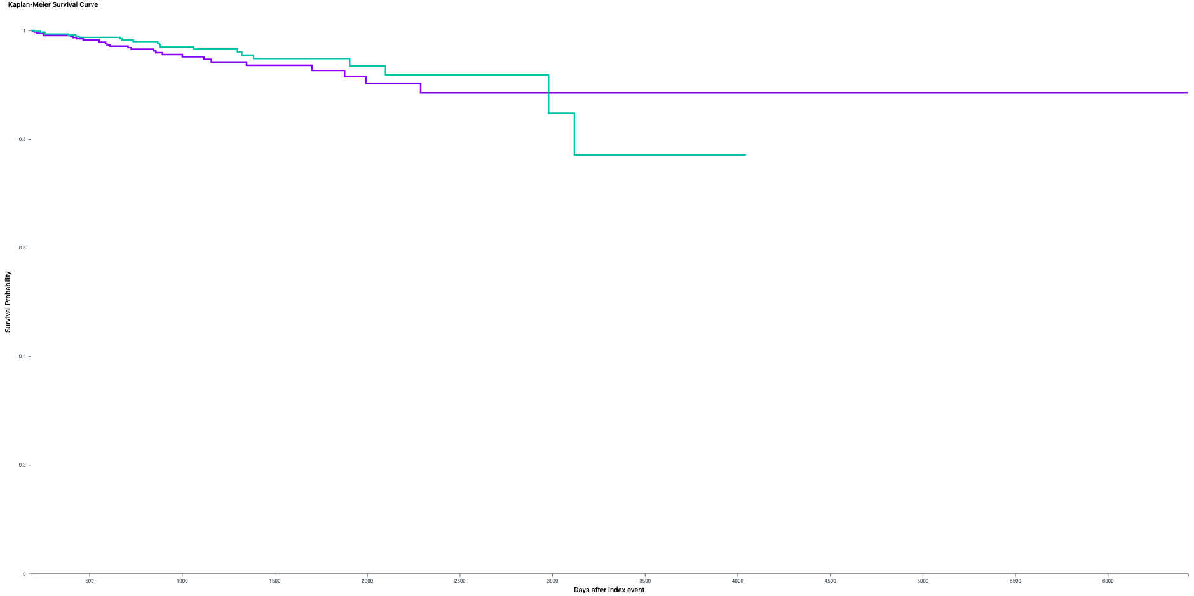

sFigure 2. nAMD Procedure Kaplan-Meier curve
The image below was generated by the TriNetX Software, and is unable to be modified. The exact number at risk at each time was not provided by the software and rough estimates were not calculated for the curves displayed here.
nAMD = neovascular age-related macular degeneration
Purple = Glucagon-Like Peptide-1 Receptor Agonists
Teal = Sodium-Glucose Cotransporter-2 inhibitors

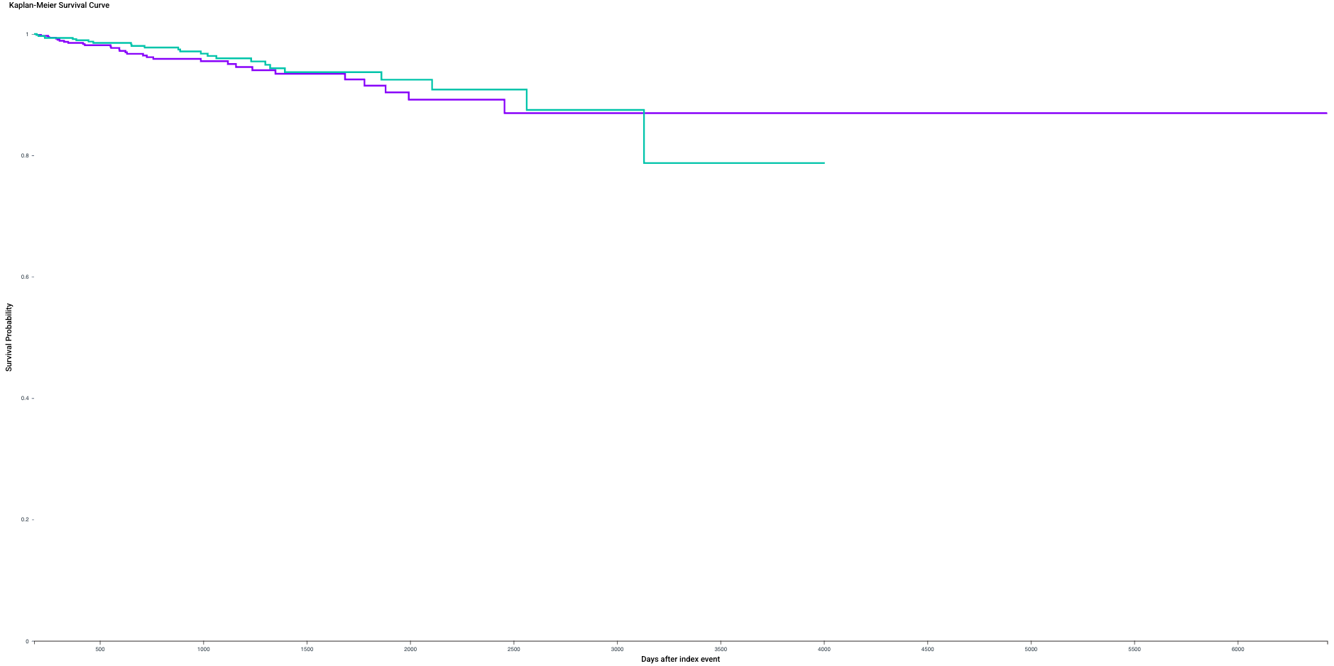

sFigure 3. Glaucoma Diagnosis Kaplan-Meier curve (Primary Analysis)
The image below was generated by the TriNetX Software, and is unable to be modified. The exact number at risk at each time was not provided by the software and rough estimates were not calculated for the curves displayed here.
Purple = Glucagon-Like Peptide-1 Receptor Agonists
Teal = Dipeptidyl Peptidase-4 inhibitors
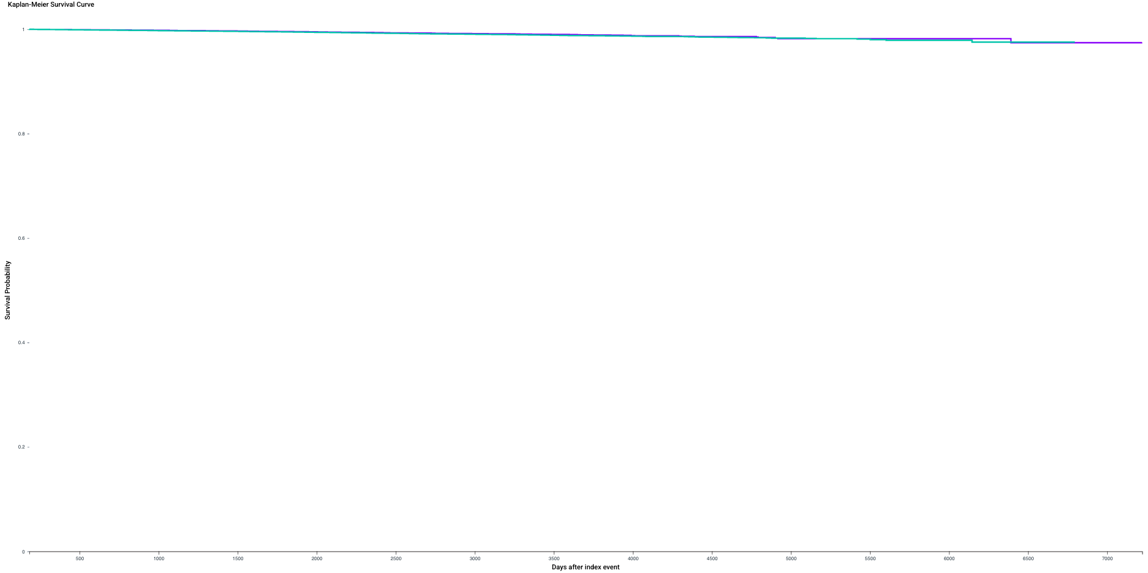

sFigure 4. Glaucoma Procedure Kaplan-Meier curve (Primary Analysis)
The image below was generated by the TriNetX Software, and is unable to be modified. The exact number at risk at each time was not provided by the software and rough estimates were not calculated for the curves displayed here.
Purple = Glucagon-Like Peptide-1 Receptor Agonists
Teal = Dipeptidyl Peptidase-4 inhibitors
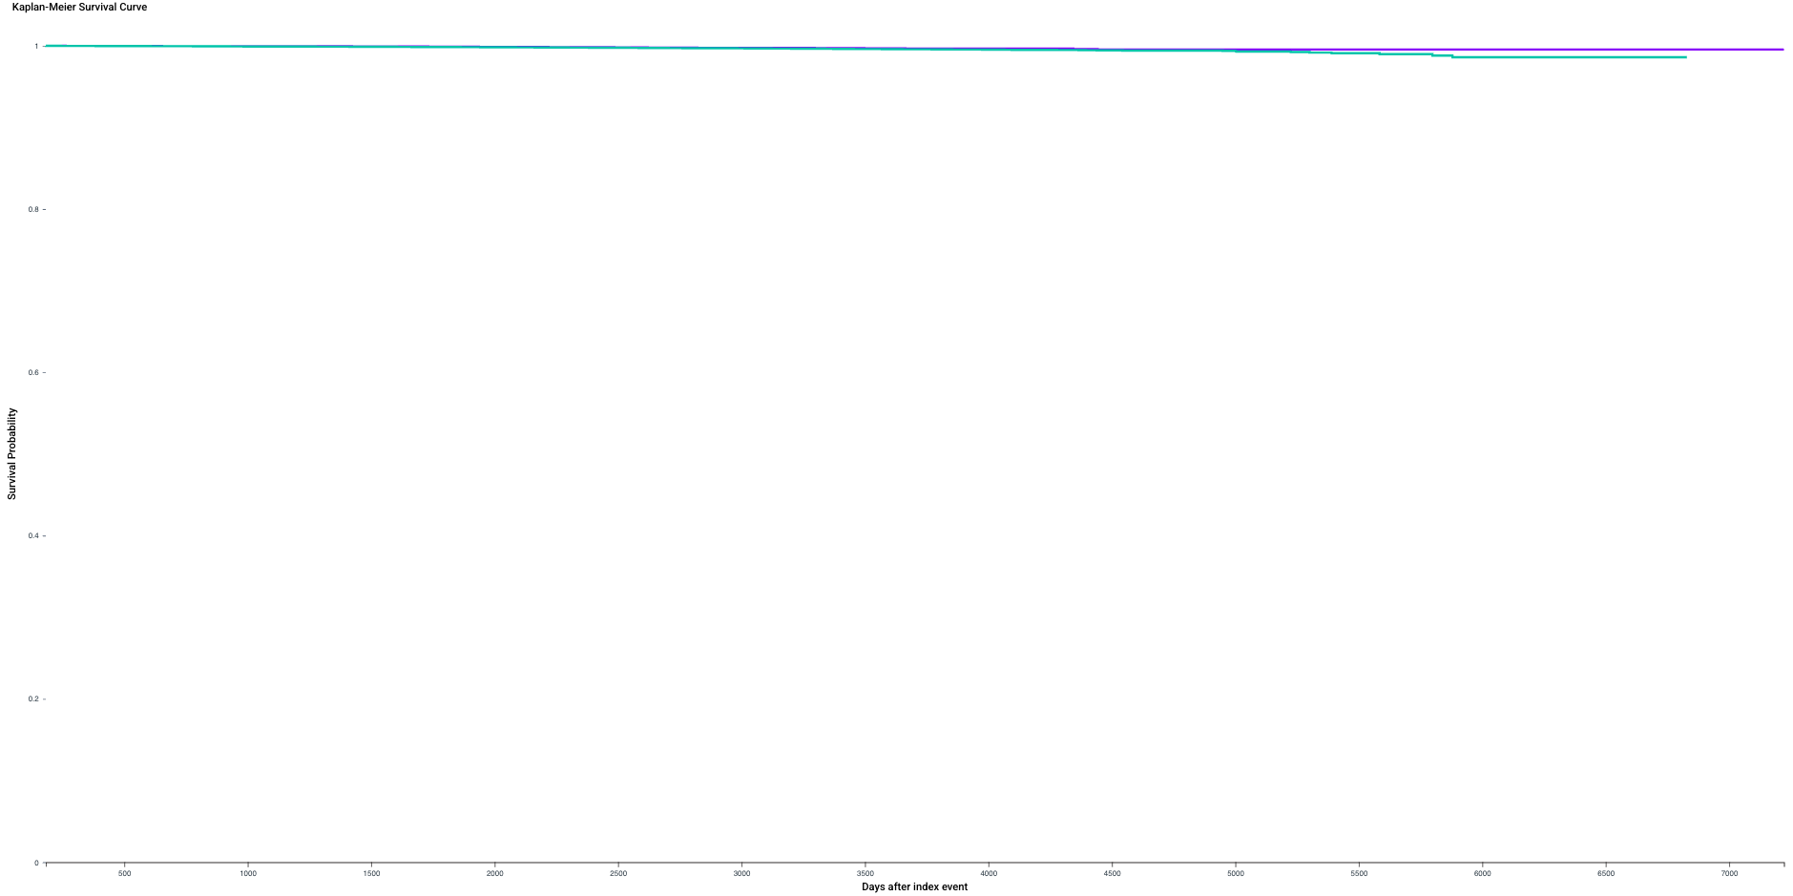

sFigure 5. DR Diagnosis Kaplan-Meier curve
The image below was generated by the TriNetX Software, and is unable to be modified. The exact number at risk at each time was not provided by the software and rough estimates were not calculated for the curves displayed here.
DR = Diabetic Retinopathy
Purple = Glucagon-Like Peptide-1 Receptor Agonists
Teal = Sodium-Glucose Cotransporter-2 inhibitors
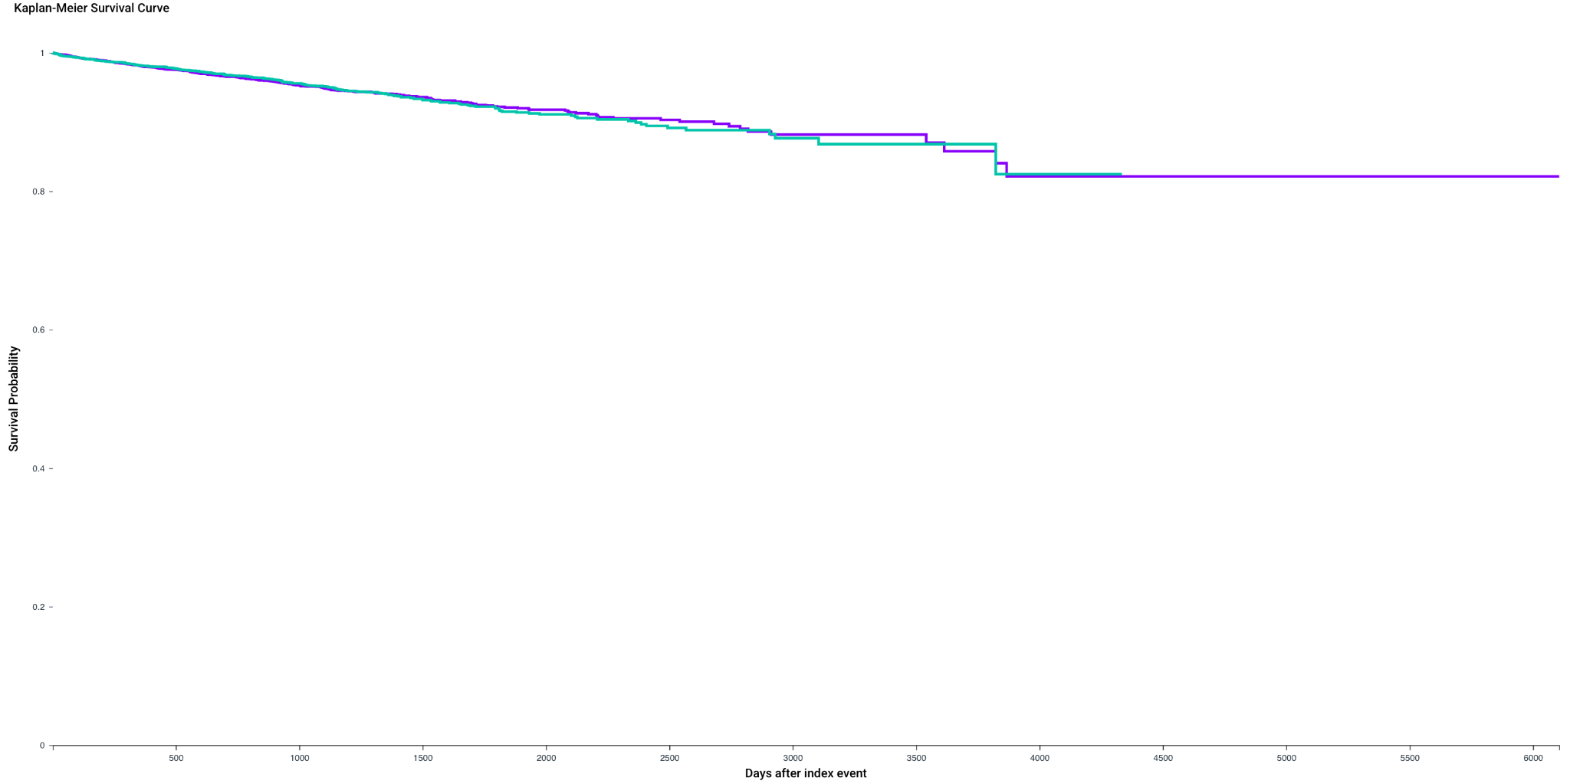

sFigure 6. DR Procedure Kaplan-Meier curves
The image below was generated by the TriNetX Software, and is unable to be modified. The exact number at risk at each time was not provided by the software and rough estimates were not calculated for the curves displayed here.
DR = Diabetic Retinopathy
Purple = Glucagon-Like Peptide-1 Receptor Agonists
Teal = Sodium-Glucose Cotransporter-2 inhibitors

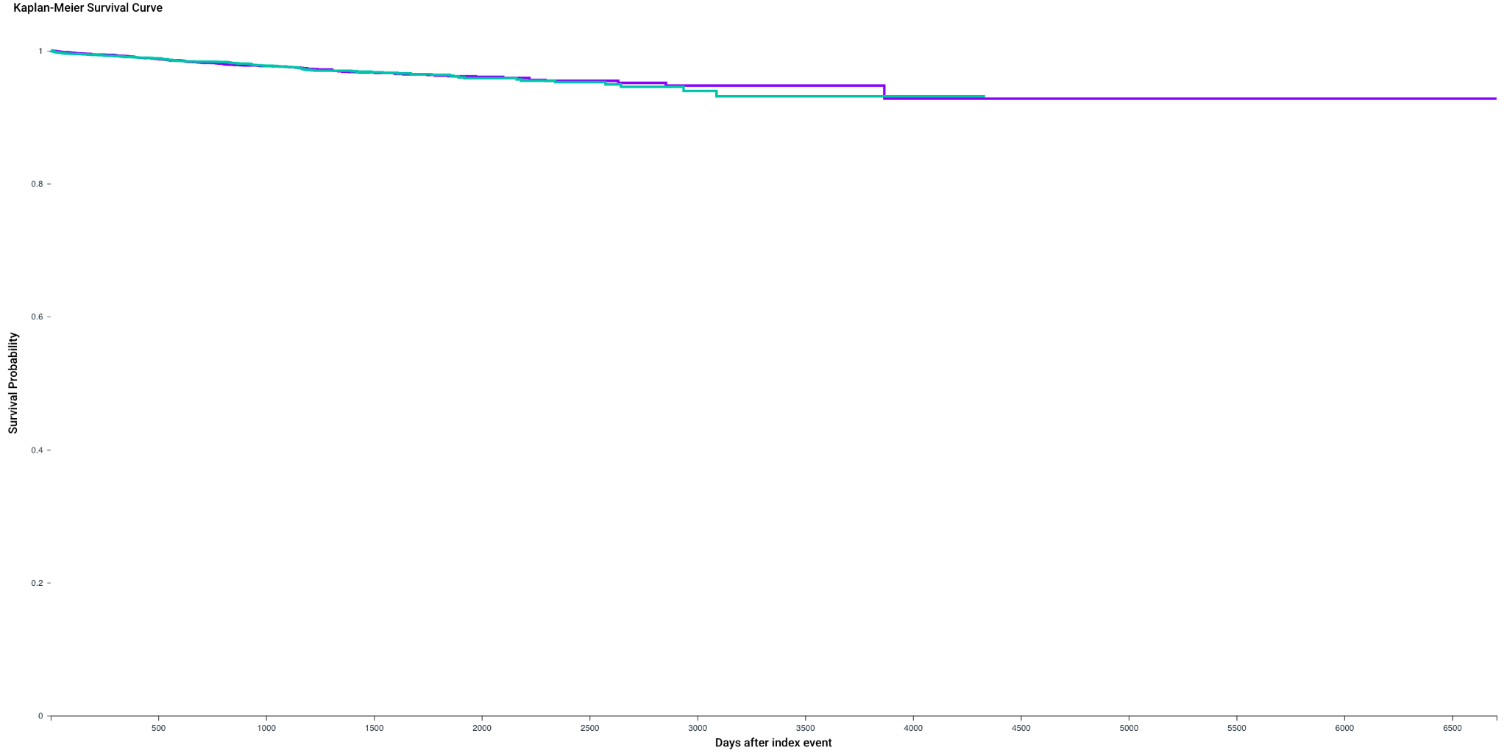

sFigure 7. Glaucoma (1-Year) Diagnosis Kaplan-Meier curve
(Secondary Analysis)
The image below was generated by the TriNetX Software, and is unable to be modified. The exact number at risk at each time was not provided by the software and rough estimates were not calculated for the curves displayed here.
Purple = Glucagon-Like Peptide-1 Receptor Agonists
Teal = Dipeptidyl Peptidase-4 inhibitors

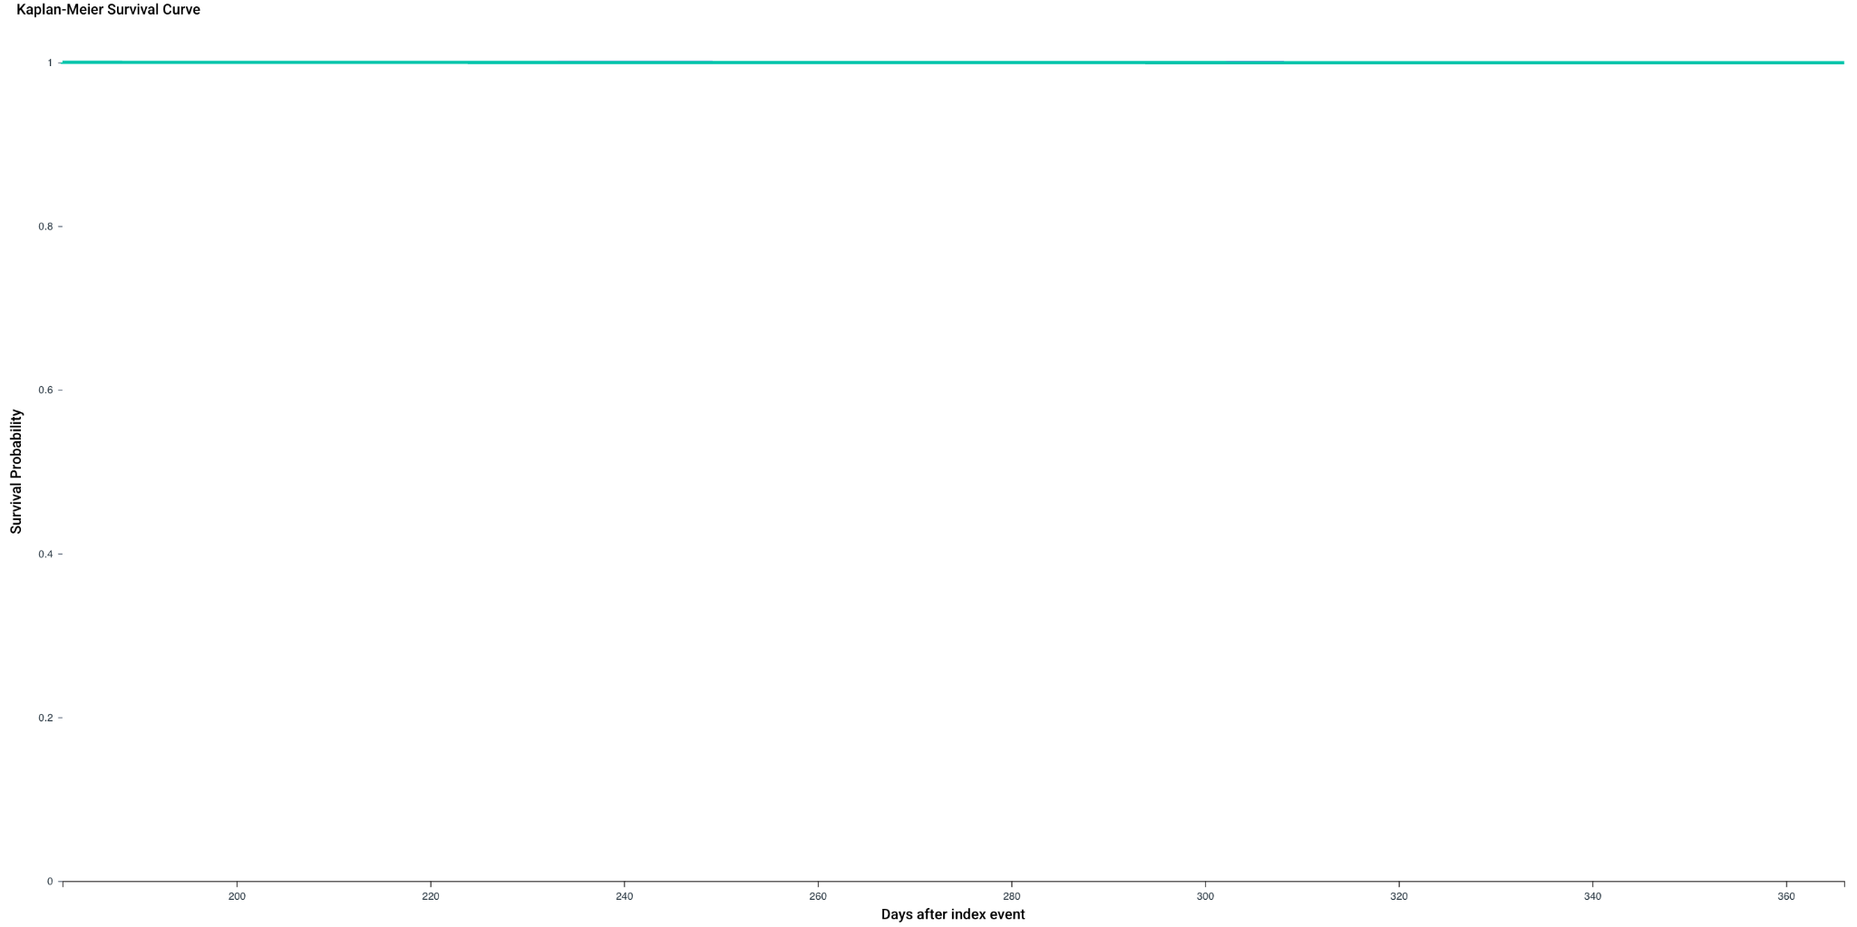

sFigure 8. Glaucoma (1-Year) Procedure Kaplan-Meier curve
(Secondary Analysis)
The image below was generated by the TriNetX Software, and is unable to be modified. The exact number at risk at each time was not provided by the software and rough estimates were not calculated for the curves displayed here.
Purple = Glucagon-Like Peptide-1 Receptor Agonists
Teal = Dipeptidyl Peptidase-4 inhibitors
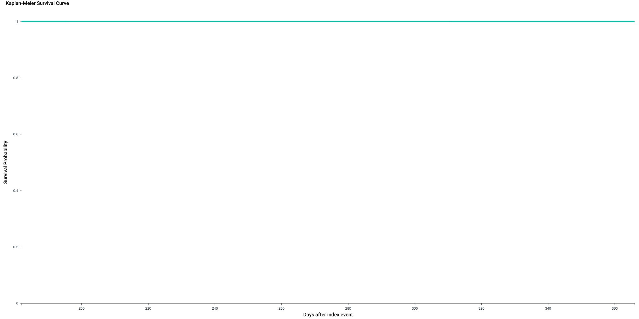

sFigure 9. Glaucoma (2-Year) Procedure Kaplan-Meier curve
(Secondary Analysis)
The image below was generated by the TriNetX Software, and is unable to be modified. The exact number at risk at each time was not provided by the software and rough estimates were not calculated for the curves displayed here.
Please note the Glaucoma (2-Year) Diagnosis Kaplan-Meier curve is represented in the main manuscript.
Purple = Glucagon-Like Peptide-1 Receptor Agonists
Teal = Dipeptidyl Peptidase-4 inhibitors
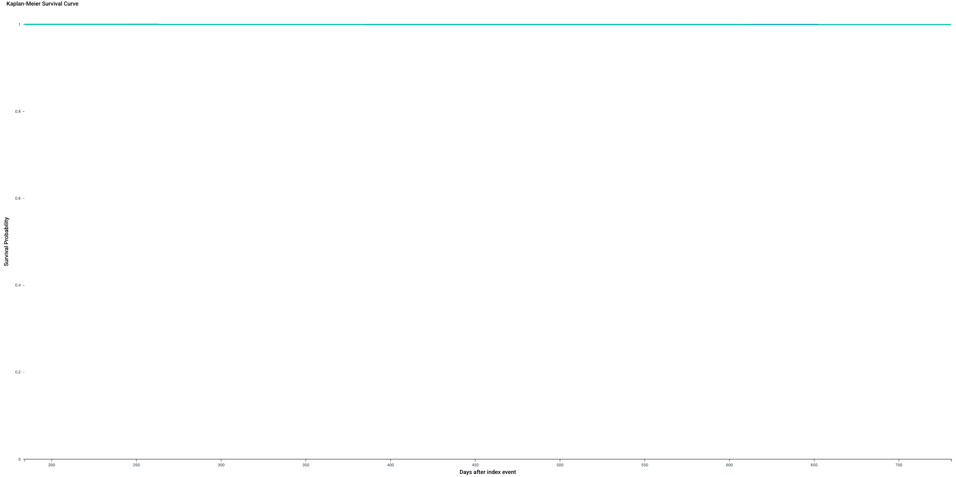

sFigure 10. nAMD Kernel-density plots
Propensity-score overlap before and after matching. Kernel-density estimates of propensity-score distributions by treatment group before matching (left) and after matching (right), demonstrating broad common support and near-coinciding post-match densities.
Purple = Glucagon-Like Peptide-1 Receptor Agonists
Teal = Sodium-Glucose Cotransporter-2 inhibitors
