Supplementary Figure1. The GO terms and KEGG pathways significantly enriched for protective prognostic genes and risk genes.
Supplementary Figure2. The forest plot constructed based on the 16-gene score values and the clinical features in the TCGA (A) and METABRIC (B) cohorts. OR, Odd ratio, CI, confidence interval.

Supplementary Figure3. Kaplan-Meier curves of DFS (A) and PFS (B) for BRCA patients with different 16-gene scores in the TCGA cohort.
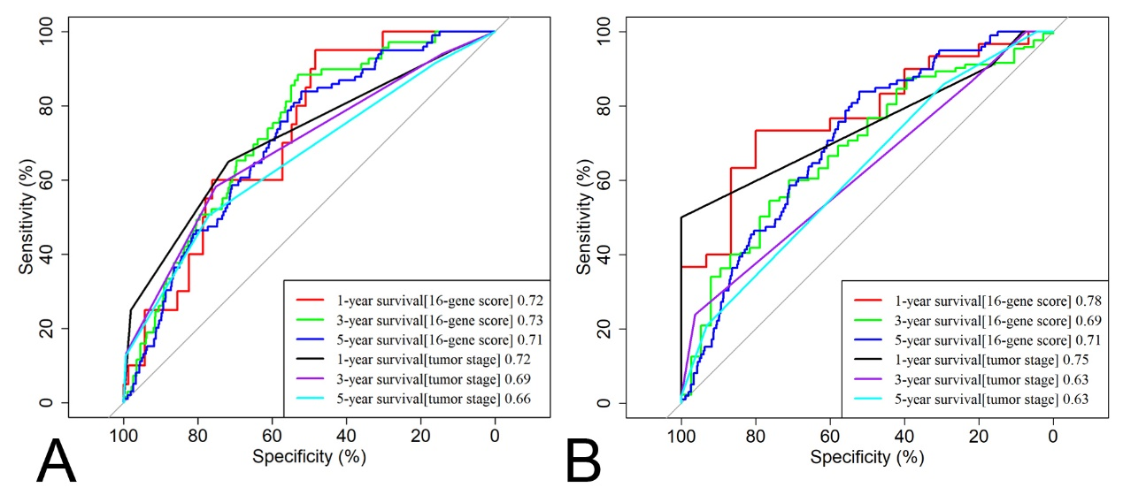
Supplementary Figure4. The ROC curves for the 16-gene score and cancer stage in the TCGA and METABRIC datasets.
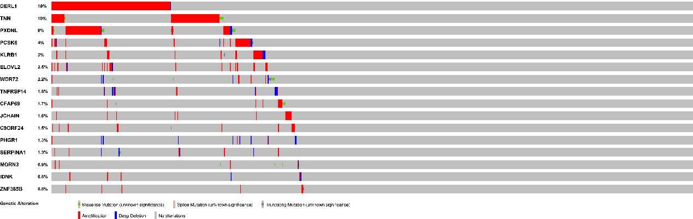
Supplementary Figure5. The mutational profiles for the 16 prognosis-related genes in the TCGA dataset.
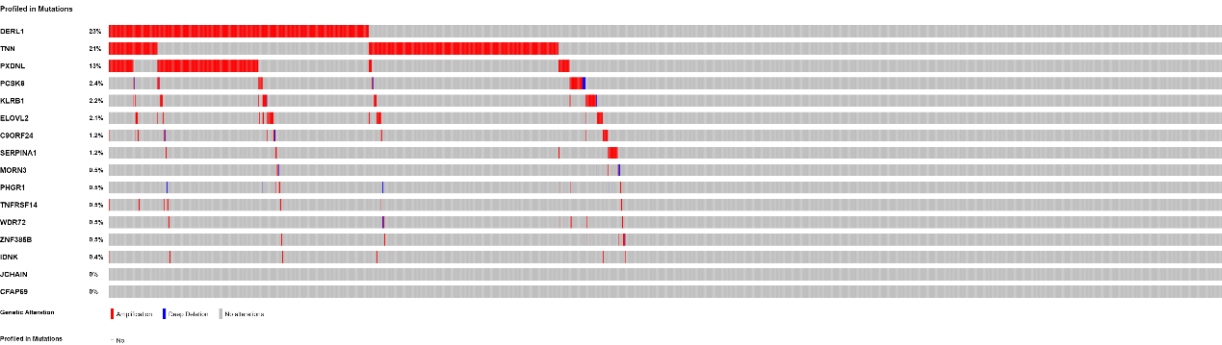
Supplementary Figure6. The mutational profiles for the 16 prognosis-related genes in the METABRIC dataset.

