SUPPLEMENTARY INFORMATION FILE FOR:

Structural and Functional Analysis of GGPPS Inhibition as a Therapeutic Mechanism for Acute Myeloid Leukemia (AML)
Fraser G. Ferens,^{‡1} Daniel D. Waller, ^{‡2} Rebecca Boutin,³ Hiu-Fung Lee,³ Marc Saba El Leil,⁴ Mathieu Tremblay, ⁴ Tian Lai Guan,³ Kathryn Skorey,³ Michael Sebag,^{5,6} Arun P. Wiita,² M. Joanne Lemieux,*¹ Youla S. Tsantrizos*^{3,7}
¹Department of Biochemistry, Faculty of Medicine & Dentistry, University of Alberta
Edmonton AB, T6G 2H7 Canada
²Department of Laboratory Medicine and Department of Bioengineering and Therapeutic Sciences, University of California, San Francisco, San Francisco, CA, 94158, USA
³Department of Chemistry, McGill University, Montreal, QC, H3A 0B8, Canada
⁴Institut de recherche en immunologie et en cancérologie, Université de Montréal, Montréal QC, H3T 1J4, Canada
⁵Department of Medicine, McGill University, Montreal, QC, Canada, H3A 1A1
⁶ Division of Hematology, McGill University Health Center, Montreal, QC, H4A 3J1, Canada
⁷Departement of Biochemistry, McGill University, Montreal, QC, H3G 1Y6, Canada,

*Corresponding authors’ Emails: mlemieux@ualberta.ca and youla.tsantrizos@mcgill.ca
‡Authors contributed equally

This Supplementary Information File includes:
Supplementary Tables: S1 and S2, and Supplementary Figures S1, S2, S3, S4 and S5
Supplementary Tables

Table S1. Crystallography Data collection and refinement statistics
Crystal Structure of Human GGPPS in Complex with Inhibitor CML-07-119
PDB: 9ZB8
Data collection
Space group | P 1 2₁ 1
Cell dimensions
a, b, c (Å) | 84.41, 116.17, 214.41
α, β, γ (°) | 90.00 99.27 90.00
Resolution (Å) | 105.80-2.64 (3.26-2.64)^{a,b}
R_{merge} | 16.7(48.3)
I / σI | 4.3(1.6)
Spherical Completeness (%) | 45.6(9.1)^{c}
Ellipsoidal Completeness (%) | 92.3(71.1)^{c}
Redundancy | 6.9(6.5)
Refinement
Resolution (Å) | 105.80-2.64
No. reflections / Free reflections | 54505/2757
R_{work} / R_{free} | 20.9/24.7
No. atoms
Protein | 28451
Ligand/ion | 480
Water | 91
B-factors
Protein | 54.93
Ligand/ion | 41.01
Water | 16.28
R.m.s. deviations
Bond lengths (Å) | 0.009
Bond angles (°) | 1.610
ª Diffraction limit was anisotropic, highest limit determined by StarAniso is listed
^{b} Diffraction data were obtained from a single crystal
^{c} Determined by the STARANISO server

Table S2. Cryo-EM data collection, refinement and validation statistics
 | Cryo-EM Structure of Human GGPPS in Complex with Inhibitor CML-07-119  (EMDB: EMD-73979)  (PDB: 9ZB9) | Human GGPPS in the Open Hexamer Conformation  (EMDB: EMD-73982)  (PDB: 9ZBC) | Human GGPPS in the Closed Hexamer Conformation  (EMDB: EMD-73983)  (PDB: 9ZBD) | Human GGPPS with CML-07-119 in the  Shielded Binding Site Conformation  (EMDB: EMD-73980)  (PDB: 9ZBA) | Human GGPPS with CML-07-119 in the Exposed Binding Site Conformation  (EMDB: EMD-73981)  (PDB: 9ZBB)
Data collection and processing
Magnification | 105000x | 105000x | 105000x | 105000x | 105000x
Voltage (kV) | 300 | 300 | 300 | 300 | 300
Electron exposure (e–/Å²) | 50 | 50 | 50 | 50 | 50
Defocus range (μm) | -0.8 – 2.2 | -0.8 – 2.2 | -0.8 – 2.2 | -0.8 – 2.2 | -0.8 – 2.2
Pixel size (Å) | 0.8266 | 0.8266 | 0.8266 | 0.8266 | 0.8266
Symmetry imposed | C2 | C2 | D3 | C1 | C1
Initial particle images (no.) | 11731724 | 5451737 | 5451737 | 11731724 | 11731724
Final particle images (no.) | 1582611ª | 531400^{b} | 139130^{b} | 559506ª | 266564ª
Map resolution (Å)  FSC threshold | 1.95  0.143 | 2.25  0.143 | 2.36  0.143 | 2.15  0.143 | 2.27  0.143
Map resolution range (Å) | 20.0 - 1.5 | 27.5-1.5 | 28.4-1.5 | 19.0 - 1.5 | 23.0 - 1.5
Refinement
Initial model used (PDB code) | None | 9ZB9 | 9ZB9 | 9ZB9 | 9ZB9
Model resolution (Å)  FSC threshold | 1.9  0.5 | 2.3  0.5 | 2.4  0.5 | 2.0  0.5 | 2.2  0.5
Map sharpening B factor (Å²) | 64.9 | 77.2 | 86.2 | 64.8 | 67.7
Model composition  Non-hydrogen atoms  Protein residues  Ligands  Water | 13724  1570  24  672 | 12914  1524  0  492 | 13686  1674  0  0 | 2343  282  4  0 | 1944  234  4  0
B factors (Å²)  Protein  Ligand  Water | 7.83  6.61  10.92 | 12.84  -  9.70 | 26.39  -  - | 15.03  -  - | 13.62  4.72  -
R.m.s. deviations  Bond lengths (Å)  Bond angles (°) | 0.002  0.456 | 0.004  0.605 | 0.004  0.636 | 0.003  0.550 | 0.002  0.520
Validation  MolProbity score  Clashscore  Poor rotamers (%) | 0.80  1.00  0.99 | 1.51  3.45  1.61 | 1.79  5.33  2.78 | 0.98  1.72  1.18 | 1.06  1.55  1.44
Ramachandran plot  Favored (%)  Allowed (%)  Disallowed (%) | 98.97  1.03  0.00 | 96.67  3.33  0.00 | 97.07  2.93  0.00 | 99.28  0.72  0.00 | 97.83  2.17  0.00
ªParticle sets were derived from different subsets of the same original particle stack of the GGPPS/CML-07-119 sample
^{b}Particle sets were derived from different subsets of the same original particle stack of the Unliganded GGPPS sample

Supplementary Figures

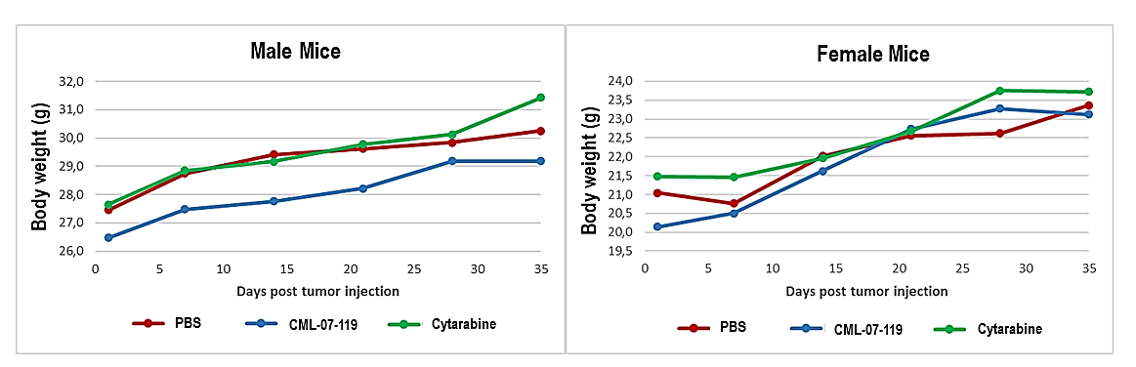
Supplementary Figure S1. Average body weight of mice through the treatment period. The average weight for male and female mice were plotted separately (n= 5 male and 5 female mice per group) from Day 1 (I.V. administration of the AML NOMO-1 Luc cells) to the end of the treatment period on Day 35.

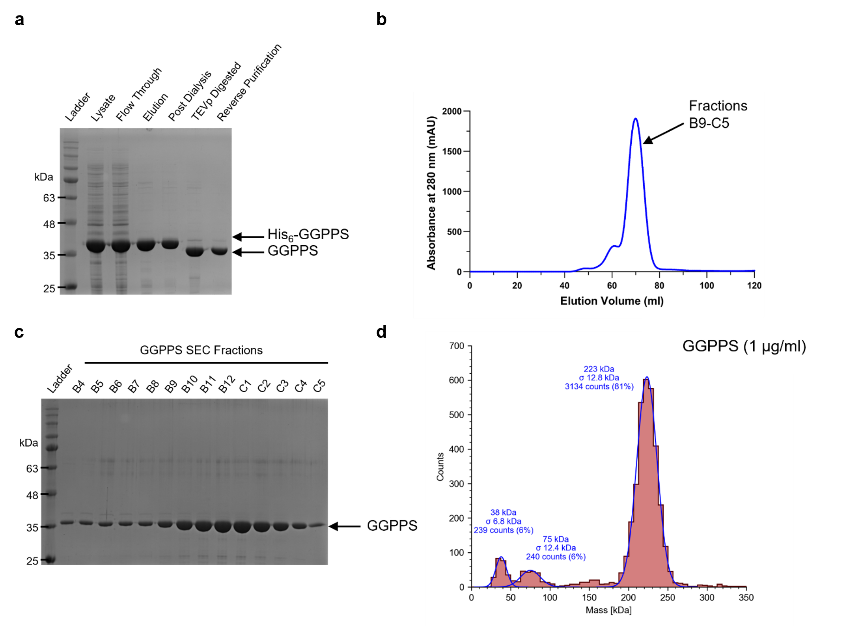
Supplementary Figure S2. Purification and assessment of recombinant human GGPPS homogeneity. (a) SDS-PAGE separation of metal affinity chromatography fractions. (b) Superdex 200 size exclusion chromatography elution profile of GGPPS as measured by UV absorbance at 280 nm, pooled fractions corresponding to the main peak are indicated. (c) SDS-PAGE separation of size exclusion fractions. (d) Mass photometry assessment of purified GGPPS in solution confirms that the protein is predominantly hexameric.
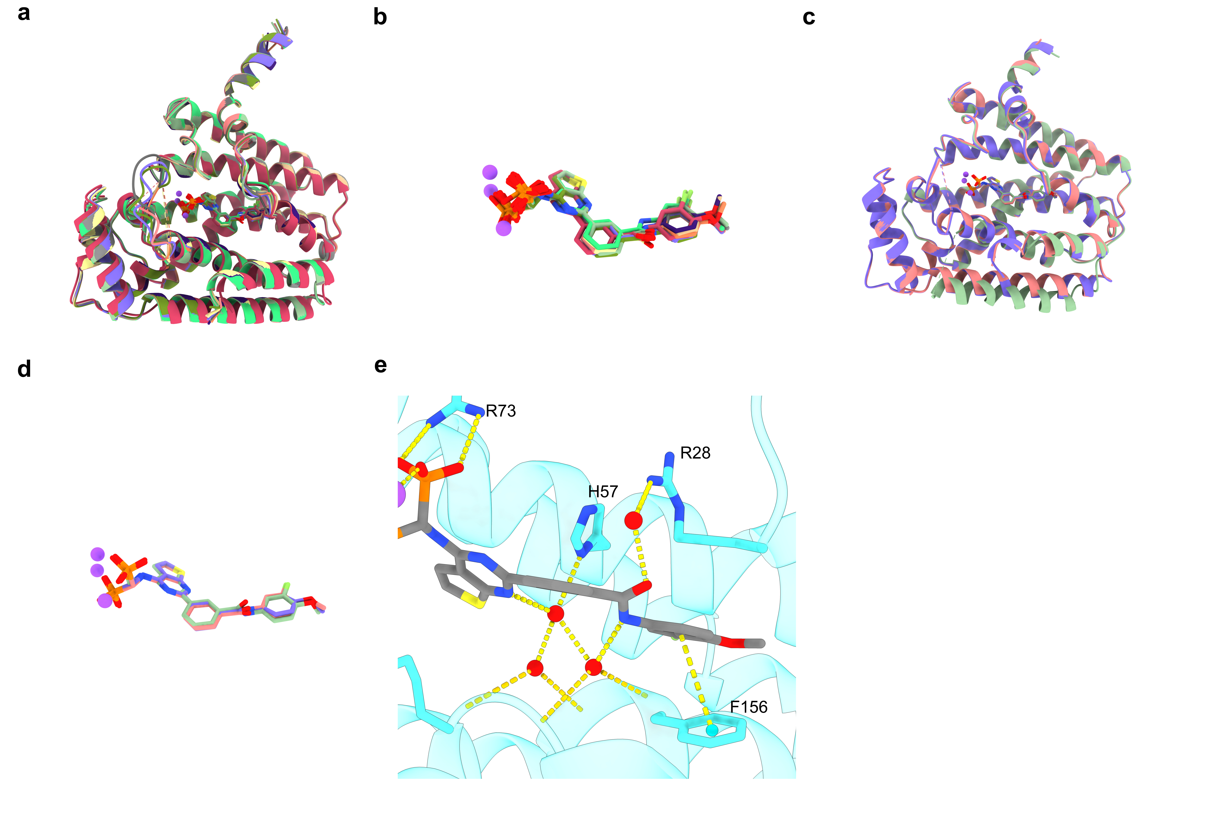
Supplementary Figure S3. GGPPS and CML-07-119 atomic positions are nearly identical among asymmetric chains of the crystal and cryo-EM structures. (a) Aligned GGPPS monomers from the crystal structure asymmetric unit. (b) Overlay of all 12 CML-07-119 molecules from the aligned GGPPS monomers in (a). (c) Aligned unique GGPPS chains (chains A, B and C) from the cryo-EM structure. (d) Overlay of the 3 CML-07-119 molecules from the chains aligned in (c). (e) Observed water bridged interactions between CML-07-119 and Chain B of GGPPS from our cryo-EM structure, interactions between R73 and F156 are shown as visual reference for comparison to Fig. 7j from the main text. In panels (b) and (d) only one copy of the 3 coordinated Mg²⁺ ions is depicted for clarity.

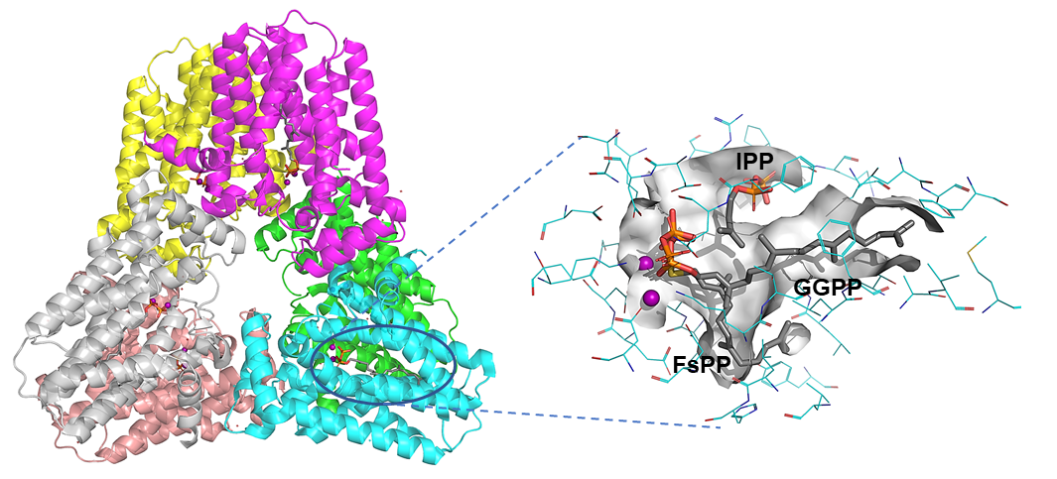
Supplementary Figure S4. Crystal structures of human and yeast GGPPS. (a) Co-crystal structure of wild type human GGPPS with the bound catalytic product GGPP (PDB code: 2Q80); (b) superposition of 2Q80 with co-crystal structure of yeast GGPPS (PDB 2E8T) with FsPP and IPP bound in the allylic and homoallylic pocket, respectively. IPP, FsPP and GGPP are colored by element, grey (C), red (O), yellow (S) and orange (P), the Mg2+ ions are shown as purple spheres.

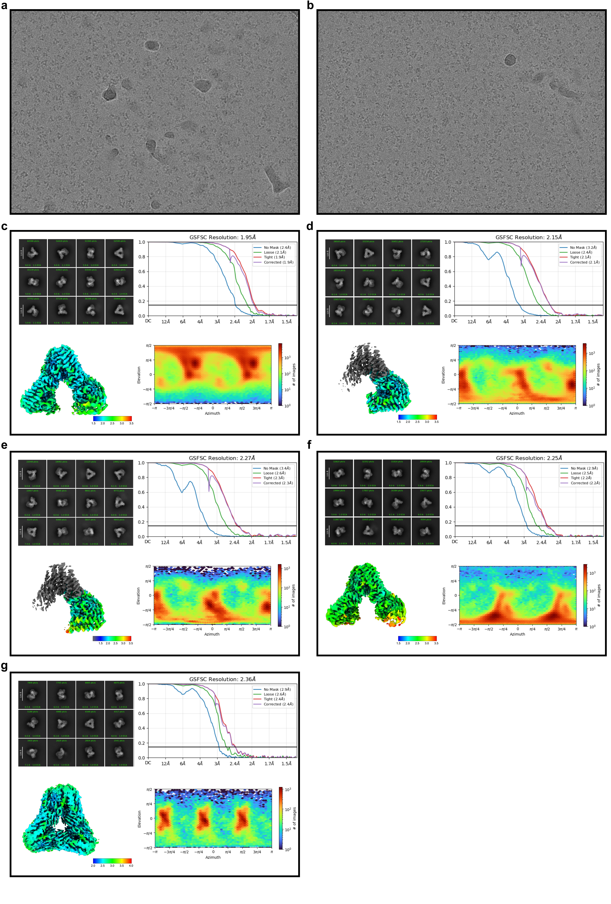
Supplementary Figure S5. Cryo-EM Processing Summary. (a) Representative micrograph from the GGPPS/CML-07-119 complex dataset. (b) Representative micrograph from the unliganded GGPPS dataset. (c) GGPPS/CML-07-119 Complex consensus reconstruction (d) GGPPS/CML-07-119 focused reconstruction in the shielded binding site state. (e) GGPPS/CML-07-119 focused reconstruction in the exposed binding site state. (f) Unliganded GGPPS consensus reconstruction (open hexamer conformation). (g) Unliganded GGPPS reconstruction derived from the particle subset in the closed hexamer conformation. In panels (d) – (g) the processing data includes: example 2D classes derived from the final particle stacks, GSFSC curves, raw map colored by local resolution and particle viewing angle distribution.

