Supplementary Figure S1
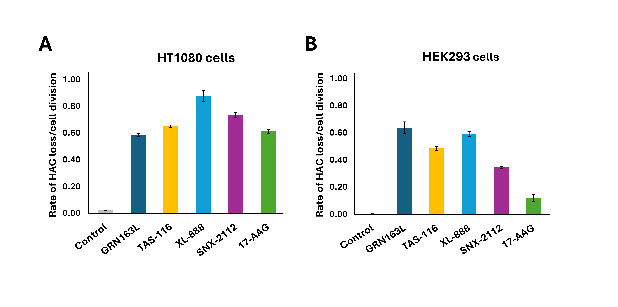 Supplementary Figure S1. HAC loss after 4 days of treatment with HSP90 inhibitors in HT1080 and HEK293 cells.
(A) Rate of HAC loss in HT1080 cells carrying a linear HAC after 4 days of treatment with TAS-116, XL-888, SNX-2112, 17-AAG, or the telomerase inhibitor GRN163L as a positive control.
(B) Rate of HAC loss in HEK293 cells carrying a linear HAC after 4 days of treatment with the same set of compounds. Drug concentrations were adjusted based on the LC₅₀ values determined for each inhibitor in each cell line (see Supplementary Table S1). Results represent independent experiments performed in both cell types. Overall, HSP90 inhibitors induced higher HAC loss in HT1080 cells compared with HEK293, whereas GRN163L produced consistent effects in both. Notably, 17-AAG showed reduced activity in HEK293 cells.

Supplementary Figure S2
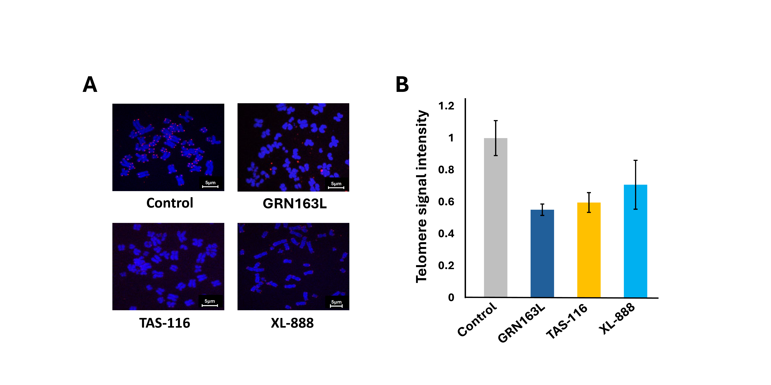 Supplementary Figure S2. FISH analysis of telomere signal intensity in HEK293 cells.
(A) Representative FISH images of HEK293 cells after 20 days of treatment with TAS-116, XL-888, GRN163L (positive control), or untreated control. Telomeres were visualized using a telomeric PNA probe (red), and DNA was counterstained with DAPI (blue).
(B) Quantification of telomere signal intensity from >100 telomere signals per condition, measured using Zeiss Zen software (Supplementary Table S4). GRN163L produced the strongest reduction in telomere signal intensity, followed by TAS-116, while XL-888 showed an intermediate effect compared with untreated cells.

Supplementary Table S1. Concentrations of HSP90 inhibitors used for HAC instability assays in HT1080 and HEK293 cells

HSP90 inhibitors | LC50 in HT1080 Circular HAC (1 day)
TAS-116 | 1mM
XL-888 | 500nM
SNX-2112 | 200nM
17-AAG | 200nM
 | LC50 in HT1080 Circular HAC (4 days)
TAS-116 | 500nM
XL-888 | 40nM
SNX-2112 | 50nM
17-AAG | 40nM
 | LC50 in HT1080 Linear HAC (1 day)
GRN163L | 50μM
TAS-116 | 500nM
XL-888 | 200nM
SNX-2112 | 100nM
17-AAG | 100nM
 | LC50 in HT1080 Linear HAC (4 days)
GRN163L | 20μM
TAS-116 | 500nM
XL-888 | 40nM
SNX-2112 | 50nM
17-AAG | 40nM
 | LC50 in HEK293 Linear HAC (4 days)
GRN163L | 20μM
TAS-116 | 250nM
XL-888 | 20nM
SNX-2112 | 20nM
17-AAG | 200nM

Supplementary Table S2. Effect of HSP90 inhibitors on mis-segregation rates of circular and linear HACs
Table S2A. 1-day treatment in HT1080 (circular HAC instability)
Hsp90 inhibitors | Percentage of phenotype | Rate of HAC loss | P-value
Control | 90.4 | 0.005
TAS-116 | 89.9 | 0.017 | <0.0001
XL-888 | 89.7 | 0.021 | <0.0001
SNX-2112 | 90.6 | 0.002 | <0.0001
17-AAG | 89.9 | 0.017 | <0.0001

Table S2B. 1-day treatment in HT1080 (linear HAC instability)
Hsp90 inhibitors | Percentage of phenotype | Rate of HAC loss | P-value
Control | 88.2 | 0.014
TAS-116 | 81.7 | 0.169 | <0.0001
XL-888 | 81.7 | 0.169 | <0.0001
SNX-2112 | 81.8 | 0.166 | <0.0001
17-AAG | 83.2 | 0.195 | <0.0001

Table S2C. 4-day treatment in HT1080 (circular HAC instability)
Hsp90 inhibitors | Percentage of phenotype | Rate of HAC loss | P-value
Control | 89.2 | 0.0103
TAS-116 | 79.2 | 0.1250 | <0.0001
XL-888 | 85.3 | 0.0609 | <0.0001
SNX-2112 | 80.2 | 0.1051 | <0.0001
17-AAG | 86.8 | 0.0719 | <0.0001

Table S2D. 4-day treatment in HT1080 (linear HAC instability)
Hsp90 inhibitors | Percentage of phenotype | Rate of HAC loss | P-value
Control | 86.5 | 0.0178
TAS-116 | 65.0 | 0.6806 | 0.0001
XL-888 | 60.5 | 0.8385 | 0.0006
SNX-2112 | 68.7 | 0.7041 | 0.0002
17-AAG | 79.2 | 0.5304 | 0.0001

The percentage of phenotype indicates the mean proportion of EGFP-positive cells. The rate of HAC loss is expressed per cell division. p-values were determined by a t-test with Bonferroni correction.
Supplementary Table S3.
Table S3A. Concentrations of HSP90 inhibitors for Southern blot and qPCR in HT1080 and HEK293 cells (20 days)
Hsp90 inhibitors | HT1080
GRN163L | 20μM
TAS-116 | 250nM
XL-888 | 30nM
SNX-2112 | 30nM
17-AAG | 35nM
Hsp90 inhibitors | HEK293
GRN163L | 20μM
TAS-116 | 300nM
XL-888 | 25nM
SNX-2112 | 30nM
17-AAG | 40nM

Table S3B. qPCR fold change in HT1080 cells treated with HSP90 inhibitors
Hsp90 inhibitors | Fold Change | P-value
Control | 1
GRN163L | 0.66 | <0.0001
TAS-116 | 0.55 | <0.0001
XL-888 | 0.89 | 0.0003
SNX-2112 | 0.57 | <0.0001
17-AAG | 0.57 | <0.0001

Table S3C. qPCR fold change in HEK293 cells treated with HSP90 inhibitors
Hsp90 inhibitors | Fold Change | P-value
Control | 1
GRN163L | 0.35 | 0.0002
TAS-116 | 0.5 | 0.0003
XL-888 | 0.87 | <0.0001
SNX-2112 | 0.69 | <0.0001
17-AAG | 0.67 | 0.0002

Supplementary Table S4. FISH analysis of telomere signal intensity
Hsp90 inhibitors | Total # of telomere | Signal intensity | SD | P-value
Control | 95 | 1 | 0.10958
GRN163L | 122 | 0.55154 | 0.035616 | P < 0.0001
TAS-116 | 100 | 0.59661 | 0.061853 | P < 0.0001
XL-888 | 102 | 0.70788 | 0.15312 | P < 0.0001

Supplementary Table S5A. Calculation of γH2AX foci and telomere dysfunction–induced foci (TIFs) per cell
Hsp90 inhibitors | Average # of γH2AX/cell | SD (γH2AX) | T test (γH2AX) | Average # of TIFs/cell | SD  (TIFs) | T test  (TIFs)
Control | 0.4 | 0.5477 |  | 0 | 0
GRN163L | 28 | 2.5495 | <0.0001 | 3.8 | 0.83666 | <0.0001
TAS-116 | 9 | 1.5811 | <0.0001 | 1.8 | 0.83666 | 0.0006
XL-888 | 2.8 | 0.8366 | 0.00034 | 0 | 0 | N/A
SNX-2112 | 1.8 | 0.8366 | 0.00700 | 0 | 0 | N/A
17-AAG | 1.8 | 1.0954 | 0.01693 | 0 | 0 | N/A

Supplementary Table S5B. Calculation of the percentage of micronuclei (MNi) formation

Hsp90 inhibitors | Total # of Nuclei | Total # of MNi | % of MNi | P-value
Control | 112 | 2 | 1.788
GRN163L | 139 | 37 | 26.619 | <0.0001
TAS-116 | 144 | 33 | 22.917 | <0.0001
XL-888 | 107 | 6 | 5.6075 | 0.171
SNX-2112 | 116 | 5 | 4.3134 | 0.448
17-AAG | 53 | 3 | 5.6604 | 0.333

