Table S1: Gene ontology of AtARID genes
Gene name | Biological Process (Acts within and involved in) | Cellular Component (Active and Located in) | Molecular Function
AtARID_01 | DNA templated transcription regulation, glucosinolate metabolic process, pollen germination, pollen tube growth. | Nucleus, pollen tube | Binding of transcription factor, binding of DNA, four-way junction DNA bindng, cis-regulatory region transcription, activity of DNA-binding transcription factor.
AtARID_02 | Transcription regulation by RNA polymerase, glucosinolate metabolic process. | Nucleus, histone deacetylase complex. | Binding of Protein, binding of DNA, binding of transcription cis-regulatory region, binding of adenine-thymine-rich DNA minor groove.
AtARID_03 | Several biological processes | Nucleus | Binding of Protein, binding of DNA, DNA-binding transcription factor activity
AtARID_04 | DNA-templated transcription regulation, Polar nucleus fusion, karyogamy | Nucleus | Binding of Protein, binding of DNA, DNA-binding transcription factor activity
AtARID_05 | DNA-templated transcription regulation, transcription by RNA polymerase II regulation | Nucleus, histone deacetylase complex. | Binding of Protein, binding of DNA, DNA-binding transcription factor activity, binding of transcription cis-regulatory region.
AtARID_06 | Several biological processes | Nucleus | Binding of Protein, binding of DNA, DNA-binding transcription factor activity.
AtARID_07 | Several biological processes | Nucleus | Several molecular functions
AtARID_08 | Positive regulation of gene expression, differentiation of pollen sperm cell | Nucleus, generative cell nucleus, microsporocyte nucleus, histone deacetylase complex. | Several molecular functions
AtARID_09 | DNA-templated transcription regulation, transcription by RNA polymerase II regulation | Nucleus, protein- containing complex | Binding of Protein, binding of DNA, DNA-binding transcription factor activity.
AtARID_10 | Several biological processes | Nucleus, histone deacetylase complex, vacuole | Protein binding

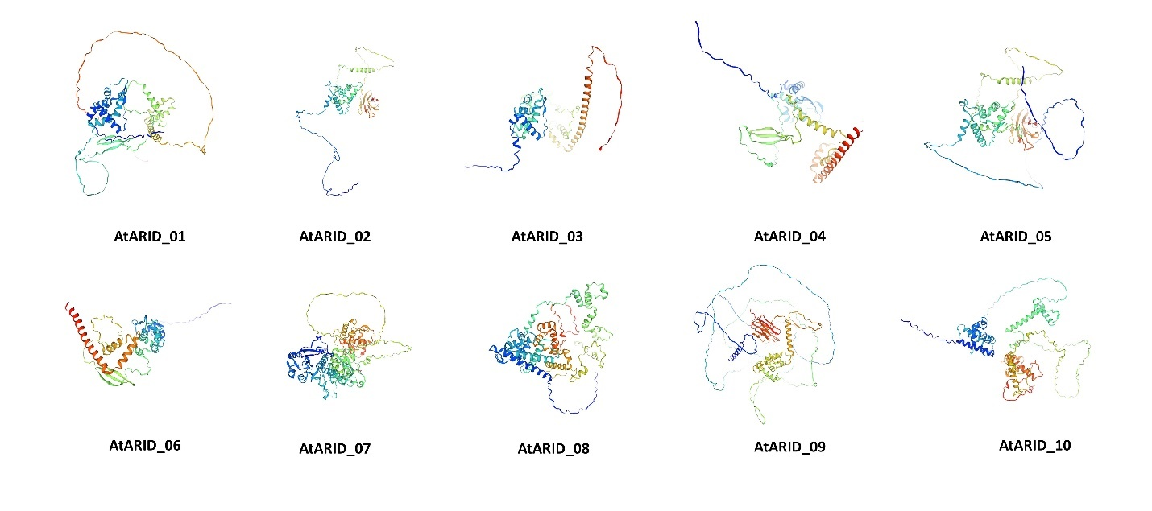
Figure S1. 3D structures of ARID proteins among Arabidopsis thaliana.

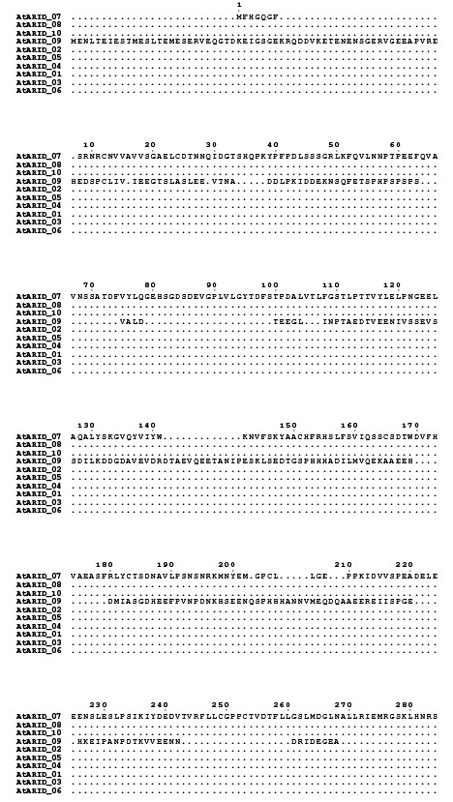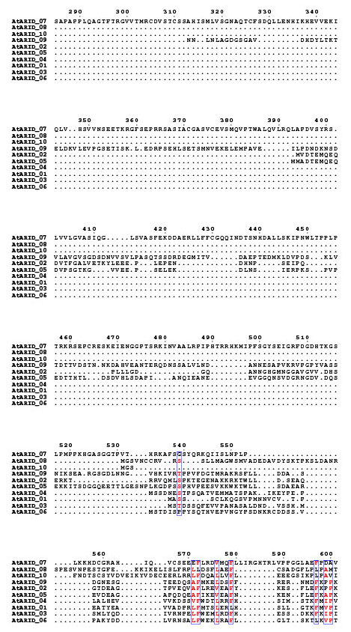
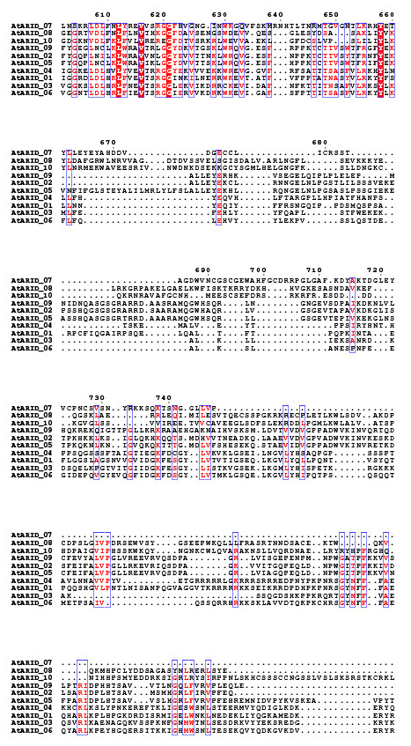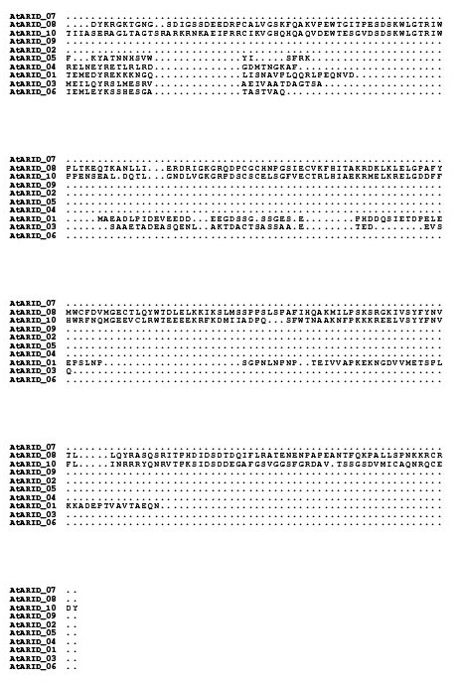
Figure S2. Multiple Sequence Alignment of ARID proteins among Arabidopsis thaliana.

