Archives of Microbiology
Supplementary Material
Psychroserpens luteus sp. nov., isolated from red algae
Xiu-Ya Ping¹, Kai Wang², Jin-Yu Zhang¹, Shu-Xin Wang¹, Zong-Jun Du^{1,3}, Da-Shuai Mu^{1,3}
¹Marine College, Shandong University, Weihai, Shandong, 264209, PRChina
²The PLA Rocket Force Characteristic Medical Center, Xinwai Street 16th, Beijing 100088, China
³State Key Laboratory of Microbial Technology, Shandong University, Qingdao, Shandong, 266237, PR China

Author for correspondence:
Da-Shuai Mu, Email: dashuai.mu@sdu.edu.cn

Supplementary Fig S1. Transmission electron micrograph of cells of strain XSD401^{T}.
Cells were grown on marine agar 2216 at 33 °C for 2 days. Bar, 500 nm.
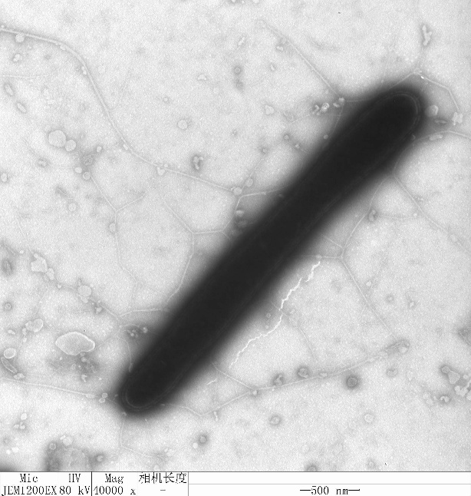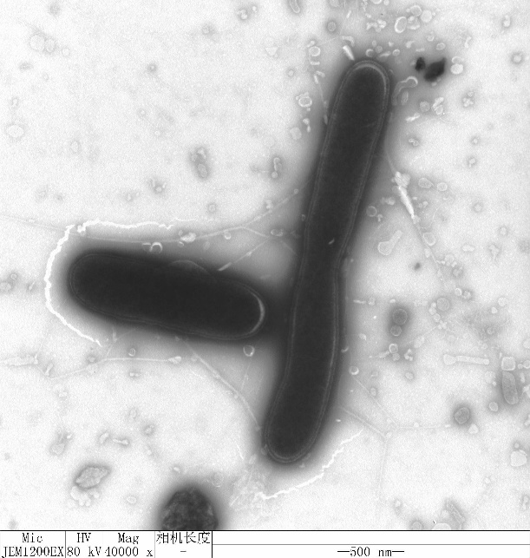
Supplementary Fig S2. Two-dimensional TLC plate images of the total polar lipids of strain XSD401^{T} (A).
The plate is sprayed with 5 % molybdatophosphoric acid to show all lipids.
Abbreviations: PE, phosphatidylethanolamine; AL, unidentified aminolipids; L, unidentified lipid
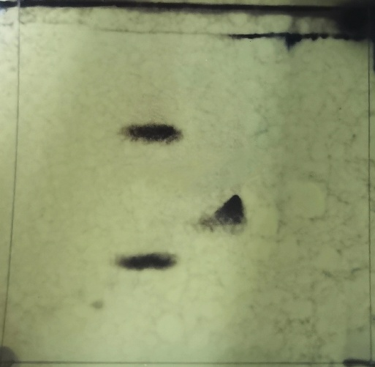
L1
PE
AL2
AL1
AL3
(A)

