Supplementary Material
Statistical Analysis
Analyses were performed using R version 4.3.2. Group differences in cognitive, serum, brain volumes outcomes were assessed using ANCOVA, adjusting for age, sex, education, and time between assessments. Blood flow analyses were corrected for age and sex. Non-normally distributed variables were log-transformed or analyzed using Mann–Whitney U tests. P-values were corrected for multiple comparisons using the Benjamini–Hochberg procedure (p-FDR < 0.05). Functional connectivity analyses used GLMs, with voxel-wise corrections applied via random field theory (p-FDR < 0.05). Effect sizes are reported as eta-squared (h²), reflecting the magnitude of the seed-to-voxel functional connectivity between-group difference. Post hoc ROI-to-ROI functional connectivity was assessed via F-tests for connections.

Cognitive outcomes references and calculations
Tests administered: Mini Mental State Examination,¹ Auditory Verbal Learning Test (immediate/delayed recall),² Trail Making Test A and B,³ Purdue Pegboard Test,⁴ Letter Digit Substitution Test,⁵ Visual Association Test,⁶ Digit Span,⁷ Stroop Color-Word Test,⁸ and Verbal Fluency.⁹

R code cognitive domains:
memolife <- memolife %>%
mutate(memory_domain = (wlt_imm_correct_tot_zscore + wlt_delayed_correct_zscore)/2 ) %>%
mutate(executive_domain = ((2*-1* stroop3_adjusted_zscore)+ 2*fluency_good_zscore + ldst_good_zscore)/5) %>%
mutate(information_processing = ((2*-1* stroop1_adjusted_zscore)+(2*-1* stroop2_adjusted_zscore)+ldst_good_zscore)/5) %>%
mutate(motor_function = pegboard_time_both_hands_zscore)

SPSS code g-factor:
FACTOR
/VARIABLES pegboard_time_both_hands fluency_good wlt_delayed_correct stroop3_adjusted ldst_good_errors
/MISSING LISTWISE
/ANALYSIS pegboard_time_both_hands fluency_good wlt_delayed_correct stroop3_adjusted ldst_good_errors
/PRINT UNIVARIATE INITIAL CORRELATION EXTRACTION
/PLOT EIGEN
/CRITERIA MINEIGEN(1) ITERATE(25)
/EXTRACTION PC
/ROTATION NOROTATE
/SAVE REG(ALL)
/METHOD=CORRELATION.

Resting state functional connectivity
The rs-fMRI image preprocessing was carried out using CONN release 22.a and SPM 12 (RRID:SCR_007037) release 12.7771.¹¹
Functional data and T1-weighted imaging preprocessing
Functional and anatomical data underwent several preprocessing steps: first, scans were coregistered to a reference image using a 6-parameter rigid body transformation and resampled to correct for motion and susceptibility interactions. Second, temporal misalignment between slices was corrected using sinc temporal interpolation. Third, outlier scans were identified with framewise displacement above 2 mm or global blood-oxygenated-level-dependent (BOLD) signal changes above 9 standard deviations using ART. Fourth, data were normalized to MNI space, segmented into grey matter, white matter, and CSF, and resampled to 2 mm isotropic voxels using the SPM unified segmentation and normalization algorithm. Finally, spatial smoothing was applied using a Gaussian kernel of 8 mm full width half maximum (FWHM).
Quality assessment and denoising
Quality assessment was done during the denoising step using automated quality assessment graphs provided by CONN and verified through carpet plots. Functional data were denoised using a pipeline that included regression of potential confounding effects such as white matter timeseries (5 CompCor noise components), CSF timeseries (5 CompCor noise components), motion parameters and their first-order derivatives (12 factors), outlier scans (below 53 factors), session effects and their first-order derivatives (2 factors), and linear trends (2 factors) within each functional run. This was followed by bandpass frequency filtering of the BOLD timeseries between 0.01 Hz and 0.1 Hz. CompCor noise components were estimated by computing the average BOLD signal and the largest principal components orthogonal to the BOLD average, motion parameters, and outlier scans within each subject's eroded segmentation masks. The effective degrees of freedom of the BOLD signal after denoising ranged from 273.6 to 524.2, with an average of 522.2 across all subjects.
First-level analysis
Group-level independent component analyses (group-ICA) were performed to estimate 20 temporally coherent networks from the combined rs-fMRI data of all subjects. The process involved several steps: first, BOLD signals from every timepoint and voxel across subjects and conditions were concatenated along the temporal dimension. Next, a subject-specific singular value decomposition with 64 components for each subject was used for initial dimensionality reduction, followed by a group-level singular value decomposition with 20 components for the concatenated data. Then, a fast-ICA fixed-point algorithm with a hyperbolic tangent (G1) contrast function was applied to identify spatially independent group-level networks from the reduced components. Finally, GICA3 back-projection was used to compute ICA maps for these networks separately for each subject.
Group-level analyses
A General Linear Model (GLM) was used where, for each voxel, a separate GLM was estimated with first-level connectivity measures as dependent variables and groups or subject-level identifiers as independent variables. Voxel-level hypotheses were evaluated using multivariate parametric statistics with random-effects across subjects and sample covariance estimation across multiple measurements. Inferences were made at the cluster level based on Gaussian Random Field theory, with results thresholded using a cluster-forming p < 0.001 voxel-level threshold and a familywise corrected p-FDR < 0.05 cluster-size threshold.
Post-hoc region-of-interest analyses
ROI-to-ROI connectivity (RRC) matrices characterized the functional connectivity between each pair of regions among 36 HPC-ICA networks and Harvard-Oxford atlas ROIs. Functional connectivity strength was represented by Fisher-transformed bivariate correlation coefficients from a weighted-GLM, estimated separately for each pair of ROIs, characterizing the association between their BOLD signal timeseries. To compensate for transient magnetization effects at the beginning of each run, individual scans were weighted by a step function convolved with an SPM canonical hemodynamic response function and rectified.
Group-level analyses were performed using a GLM. For each connection, a separate GLM was estimated with first-level connectivity measures as dependent variables and groups or subject-level identifiers as independent variables. Connection-level hypotheses were evaluated using multivariate parametric statistics with random-effects across subjects and sample covariance estimation across multiple measurements. Inferences were performed at the cluster level, based on parametric statistics within and between pairs of networks (Functional Network Connectivity), with networks identified using a complete-linkage hierarchical clustering procedure based on ROI-to-ROI anatomical proximity and functional similarity metrics. Results were thresholded using a combination of a p < 0.05 connection-level threshold and a familywise corrected p-FDR < 0.05 cluster-level threshold.

ASL processing method additional information:
Multi post-labelling delay (PLD) VEPCASL data was acquired (repetition time = 4050 ms and echo time = 14 ms, voxel size 3.4 x 3.4 x 5 mm, PLDs 250, 500, 750, 1000, 1250, 1500 ms) as previously described.⁵⁸ 3D time of flight images were used to localize the right and left internal carotid arteries and the right and left vertebral arteries and tagged them separately using an eight-cycle paired encoding scheme.
- Structural preprocessing: fsl_anat (https://fsl.fmrib.ox.ac.uk/fsl/fslwiki/fsl_anat) was run on the T1-weighted image (bias-field correction, brain extraction, tissue segmentation) and provided the structural→Montreal Neurological Institute (MNI) non-linear transformation used downstream.
- ASL pipeline and vessel decoding: We processed VEPCASL data with OXASL (Python) v0.2.2 and the vessel-encoded plugin oxasl_ve v0.3.1, which performs vessel decoding prior to kinetic modelling. In detail, ASL images were registered to standard space (using inputs from fsl_anat), compute magnetisation of arterial blood (perfusion-weighted images) and then compute voxel-wise perfusion using the supplied M0 image with Bayesian Inference for Arterial Spin Labelling (BASIL) toolbox.
- Acquisition timings used in modelling: Six PLDs (0.25–1.50 s), fixed bolus duration τ = 1.4 s, and per-slice acquisition time Δt_slice = 45.2 ms (slice-timing accounted for in the fit)
- Model and compartments: Perfusion was estimated with BASIL toolbox with a tissue and an explicit macrovascular (arterial) compartment (two- compartment “mix”), no dispersion model; ATT was inferred. Macrovascular terms were included and inferred. BASIL options included partial volume correction, adaptive spatial smoothing of perfusion images and motion correction of ASL images using MCFLIRT.²
- Calibration: Voxelwise calibration was used with M0, an inversion efficiency of 0.85, T1 blood at 3T = 1.65s.
- ROI analysis: Standard Harvard-Oxford atlases were mapped from MNI to native ASL space using the FSL_ANAT warps; ROI stats required ≥10 voxels. ROIs were masked with “pure” GM/WM masks.
- A sample processing code can be requested to the authors.

References Supplementary Materials

- Folstein MF, Folstein SE, McHugh PR. “Mini-mental state”. A practical method for grading the cognitive state of patients for the clinician. J Psychiatr Res. England; 1975;12:189–198.
- Brand N, Jolles J. Learning and retrieval 69hite69c words presented auditorily and visually. J Gen Psychol. United States; 1985;112:201–210.
- Rey A. L’examen clinique en psychologie. Paris: Presses Universitaires de France. Epub 1964.
- Reitan RM. Validity of the Trail Maiking Test as an Indicator of Organic Brain Damage. Epub 1958.:271–276.
- Tiffin J AEJ. The Purdue pegboard; norms and studies of reliability and validity. . J Appl Psychol.1948;32(3):234–247.
- Van Der Elst W, Van Boxtel M, Van Breukelen G, Jolles J. The Letter Digit Substitution Test: Normative data for 1,858 healthy participants aged 24-81 from the Maastricht Aging Study (MAAS): Influence of age, education, and sex. J Clin Exp Neuropsychol. 2006;28:998–1009.
- Lindeboom J, Schmand B, Tulner L, Walstra G, Jonker C. Visual association test to detect early dementia of the Alzheimer type. J Neurol Neurosurg Psychiatry. England; 2002;73:126–133.
- Wechsler D. Wechsler Adult Intelligence Scale–Third Edition. APA PsycTests. Epub 1997.
- Stroop JR. Studies of interference in serial verbal reactions. J Exp Psychol. 1935;18(6):643–662.
- Lezak M. Neuropsychological Assessment. 3rd ed. New York: Oxford University Press; 1995.
- Whitfield-Gabrieli S, Nieto-Castanon A. Conn: A Functional Connectivity Toolbox for Correlated and Anticorrelated Brain Networks. Brain Connect. 2012;2:125–141.
- Chappell, M. A. et al. BASIL: A toolbox for perfusion quantification using arterial spin labelling. Imaging Neuroscience 1, 1–16 (2023).
Supplementary Table 1. Overall Summary for Alzheimer’s disease, neurodegeneration, and inflammatory and lipid biomarkers.
Biomarker | Median | IQR | Min | Max | n
NfL | 18.52 | 11.08 | 5.73 | 100.85 | 274
Ab40 | 77.02 | 19.99 | 22.29 | 116.04 | 274
Ab42 | 4.69 | 1.80 | 2.24 | 8.78 | 273
Ab42/40 | 0.06 | 0.01 | 0.02 | 0.15 | 273
pTau181 | 24.26 | 13.94 | 8.17 | 101.39 | 270
GFAP | 100.31 | 66.68 | 28.50 | 551.68 | 274

Supplementary Table 2. Percentile Distribution of Biomarkers by Age Group.
Values shown are percentiles from 5th to 95th across 5-year age intervals.
 | 5th | 10th | 25th | 50th (Median) | 75th | 90th | 95th | n
Ab40
[50,55) | 53.11 | 56.20 | 64.57 | 77.25 | 84.45 | 92.48 | 93.39 | 27
[55,60) | 46.31 | 55.70 | 63.48 | 72.33 | 84.36 | 88.44 | 92.39 | 30
[60,65) | 48.74 | 52.57 | 62.37 | 70.61 | 80.04 | 86.06 | 98.14 | 37
[65,70) | 60.06 | 62.80 | 67.76 | 74.23 | 82.23 | 89.04 | 90.32 | 40
[70,75) | 62.91 | 67.46 | 72.87 | 83.49 | 94.08 | 100.67 | 105.17 | 72
[75,80) | 53.52 | 58.78 | 67.57 | 74.97 | 85.32 | 98.01 | 103.90 | 50
[80,85) | 67.16 | 71.57 | 74.50 | 86.79 | 103.84 | 111.48 | 113.55 | 15
[85,90) | 110.09 | 110.09 | 110.09 | 110.09 | 110.09 | 110.09 | 110.09 | 1
[90,95) | 69.25 | 69.82 | 71.54 | 74.41 | 77.28 | 79.00 | 79.57 | 2
Ab42
[50,55) | 3.47 | 3.57 | 4.10 | 4.88 | 5.63 | 6.52 | 6.66 | 27
[55,60) | 3.04 | 3.14 | 3.97 | 4.33 | 5.55 | 6.43 | 6.64 | 30
[60,65) | 2.99 | 3.38 | 3.89 | 4.46 | 5.61 | 6.50 | 7.34 | 37
[65,70) | 3.11 | 3.32 | 3.63 | 4.28 | 4.86 | 6.01 | 6.22 | 40
[70,75) | 3.20 | 3.65 | 4.33 | 5.11 | 6.04 | 7.20 | 7.47 | 72
[75,80) | 2.65 | 3.12 | 3.82 | 4.60 | 5.24 | 6.21 | 6.38 | 49
[80,85) | 3.84 | 3.87 | 4.55 | 5.78 | 6.25 | 6.71 | 7.12 | 15
[85,90) | 4.47 | 4.47 | 4.47 | 4.47 | 4.47 | 4.47 | 4.47 | 1
[90,95) | 4.03 | 4.16 | 4.55 | 5.20 | 5.86 | 6.25 | 6.38 | 2
Ab42/40
[50,55) | 0.05 | 0.05 | 0.06 | 0.06 | 0.07 | 0.08 | 0.08 | 27
[55,60) | 0.04 | 0.06 | 0.06 | 0.07 | 0.07 | 0.07 | 0.08 | 30
[60,65) | 0.05 | 0.06 | 0.06 | 0.07 | 0.07 | 0.08 | 0.08 | 37
[65,70) | 0.05 | 0.05 | 0.05 | 0.06 | 0.06 | 0.07 | 0.08 | 40
[70,75) | 0.05 | 0.05 | 0.06 | 0.06 | 0.07 | 0.07 | 0.08 | 72
[75,80) | 0.04 | 0.05 | 0.05 | 0.06 | 0.07 | 0.07 | 0.08 | 49
[80,85) | 0.05 | 0.05 | 0.05 | 0.06 | 0.07 | 0.08 | 0.08 | 15
[85,90) | 0.04 | 0.04 | 0.04 | 0.04 | 0.04 | 0.04 | 0.04 | 1
[90,95) | 0.06 | 0.06 | 0.06 | 0.07 | 0.08 | 0.08 | 0.08 | 2
GFAP
[50,55) | 33.93 | 42.54 | 53.74 | 72.87 | 83.17 | 104.58 | 136.68 | 27
[55,60) | 52.93 | 57.01 | 61.68 | 75.98 | 95.33 | 104.05 | 116.74 | 30
[60,65) | 44.57 | 54.28 | 69.27 | 91.75 | 122.36 | 132.24 | 160.26 | 37
[65,70) | 57.34 | 60.62 | 74.28 | 105.80 | 126.70 | 187.15 | 194.39 | 40
[70,75) | 59.26 | 73.03 | 89.80 | 103.74 | 152.28 | 193.61 | 220.89 | 72
[75,80) | 80.21 | 92.92 | 126.87 | 152.90 | 183.52 | 248.28 | 267.33 | 50
[80,85) | 90.26 | 95.19 | 103.80 | 136.57 | 178.74 | 216.02 | 243.77 | 15
[85,90) | 264.24 | 264.24 | 264.24 | 264.24 | 264.24 | 264.24 | 264.24 | 1
[90,95) | 133.02 | 140.52 | 163.03 | 200.55 | 238.06 | 260.57 | 268.07 | 2
NfL
[50,55) | 7.79 | 8.34 | 9.98 | 12.14 | 13.53 | 16.13 | 17.89 | 27
[55,60) | 8.02 | 9.12 | 11.32 | 12.90 | 16.70 | 22.14 | 25.22 | 30
[60,65) | 8.45 | 10.45 | 12.09 | 15.00 | 22.11 | 24.64 | 26.99 | 37
[65,70) | 8.79 | 11.51 | 13.62 | 16.63 | 19.78 | 22.47 | 24.63 | 40
[70,75) | 12.23 | 14.34 | 16.89 | 20.91 | 26.05 | 34.82 | 37.32 | 72
[75,80) | 13.49 | 15.01 | 21.09 | 26.22 | 29.77 | 36.71 | 40.10 | 50
[80,85) | 16.99 | 17.83 | 21.54 | 24.57 | 36.25 | 44.28 | 50.80 | 15
[85,90) | 100.85 | 100.85 | 100.85 | 100.85 | 100.85 | 100.85 | 100.85 | 1
[90,95) | 31.57 | 32.22 | 34.19 | 37.46 | 40.73 | 42.69 | 43.34 | 2
pTau181
[50,55) | 10.20 | 11.22 | 15.47 | 20.30 | 25.57 | 35.31 | 39.53 | 27
[55,60) | 10.43 | 12.79 | 15.13 | 19.29 | 23.18 | 27.28 | 39.34 | 30
[60,65) | 17.79 | 19.05 | 21.83 | 23.84 | 31.30 | 34.36 | 43.58 | 33
[65,70) | 16.24 | 16.37 | 17.40 | 22.30 | 29.03 | 34.08 | 38.07 | 40
[70,75) | 11.49 | 13.50 | 18.43 | 23.98 | 34.48 | 42.06 | 53.27 | 72
[75,80) | 16.02 | 19.41 | 25.49 | 31.93 | 40.34 | 46.20 | 50.71 | 50
[80,85) | 24.26 | 24.68 | 25.97 | 31.58 | 37.96 | 63.45 | 71.61 | 15
[85,90) | 63.61 | 63.61 | 63.61 | 63.61 | 63.61 | 63.61 | 63.61 | 1
[90,95) | 20.64 | 21.30 | 23.29 | 26.61 | 29.93 | 31.92 | 32.58 | 2

Supplementary Table 3. VEPCASL region of interest analysis: regions of interest selection steps.
Participants with available VEPCASL data were N = 194.
For regions where < 5 participants were missing we checked the individual images. Four participants were excluded: MEMO_156, MEMO_45, MEMO_65, MEMO_144. Reasons for exclusion were suboptimal planning of the sequence leading to part of the brain being cut-off and missing slices; poor quality; artefacts; probable problems in the vessel tagging step during acquisition.

Harvard-Oxford atlas regions | N of missing cases | % of missing cases
All | 0 | 0.00
Tenperc_plusGM | 0 | 0.00
Tenperc_plusWM | 0 | 0.00
Eightyperc_plusGM | 0 | 0.00
Ninetyperc_plusWM | 0 | 0.00
Cortical_Eightyperc_plusGM | 0 | 0.00
Cerebral_Ninetyperc_plusWM | 0 | 0.00
GM_PV | 0 | 0.00
WM_PV | 0 | 0.00
CSF_PV | 0 | 0.00
Frontal_Pole | 0 | 0.00
Insular_Cortex | 1 | 0.51
Superior_Frontal_Gyrus | 1 | 0.51
Middle_Frontal_Gyrus | 1 | 0.51
Inferior_Frontal_Gyrus_Pars_Tringularis | 47 | 23.74
Inferior_Frontal_Gyrus_Pars_Opercularis | 1 | 0.51
Precentral_Gyrus | 1 | 0.51
Temporal_Pole | 0 | 0.00
Superior_Temporal_Gyrus_Anterior_Division | 185 | 93.43
Superior_Temporal_Gyrus_Posterior_Division | 1 | 0.51
Middle_Temporal_Gyrus_Anterior_Division | 53 | 26.77
Middle_Temporal_Gyrus_Posterior_Division | 1 | 0.51
Middle_Temporal_Gyrus_Temporooccipital_Part | 1 | 0.51
Inferior_Temporal_Gyrus_Anterior_Division | 133 | 67.17
Inferior_Temporal_Gyrus_Posterior_Division | 60 | 30.30
Inferior_Temporal_Gyrus_Temporooccipital_Part | 1 | 0.51
Postcentral_Gyrus | 1 | 0.51
Superior_Parietal_Lobule | 5 | 2.53
Supramarginal_Gyrus_Anterior_Division | 1 | 0.51
Supramarginal_Gyrus_Posterior_Division | 1 | 0.51
Angular_Gyrus | 1 | 0.51
Lateral_Occipital_Cortex_Superior_Division | 0 | 0.00
Lateral_Occipital_Cortex_Inferior_Division | 0 | 0.00
Intracalcarine_Cortex | 1 | 0.51
Frontal_Medial_Cortex | 22 | 11.11
Juxtapositional_Lobule_Cortex_formerly_Supplementary_Motor_Cortex | 1 | 0.51
Subcallosal_Cortex | 5 | 2.53
Paracingulate_Gyrus | 1 | 0.51
Cingulate_Gyrus_Anterior_Division | 1 | 0.51
Cingulate_Gyrus_Posterior_Division | 0 | 0.00
Precuneous_Cortex | 0 | 0.00
Cuneal_Cortex | 1 | 0.51
Frontal_Orbital_Cortex | 1 | 0.51
Parahippocampal_Gyrus_Anterior_Division | 4 | 2.02
Parahippocampal_Gyrus_Posterior_Division | 1 | 0.51
Lingual_Gyrus | 1 | 0.51
Temporal_Fusiform_Cortex_Anterior_Division | 97 | 48.99
Temporal_Fusiform_Cortex_Posterior_Division | 0 | 0.00
Temporal_Occipital_Fusiform_Cortex | 2 | 1.01
Occipital_Fusiform_Gyrus | 2 | 1.01
Frontal_Operculum_Cortex | 79 | 39.90
Central_Opercular_Cortex | 1 | 0.51
Parietal_Operculum_Cortex | 4 | 2.02
Planum_Polare | 66 | 33.33
Heschls_Gyrus_includes_H1_and_H2 | 179 | 90.40
Planum_Temporale | 183 | 92.42
Supracalcarine_Cortex | 198 | 100.00
Occipital_Pole | 1 | 0.51
Left_Cerebral_White_Matter | 0 | 0.00
Left_Cerebral_Cortex | 0 | 0.00
Left_Lateral_Ventricle | 0 | 0.00
Left_Thalamus | 0 | 0.00
Left_Caudate | 0 | 0.00
Left_Putamen | 1 | 0.51
Left_Pallidum | 1 | 0.51
Brain_Stem | 0 | 0.00
Left_Hippocampus | 1 | 0.51
Left_Amygdala | 2 | 1.01
Left_Accumbens | 186 | 93.94
Right_Cerebral_White_Matter | 0 | 0.00
Right_Cerebral_Cortex | 0 | 0.00
Right_Lateral_Ventricle | 0 | 0.00
Right_Thalamus | 1 | 0.51
Right_Caudate | 0 | 0.00
Right_Putamen | 1 | 0.51
Right_Pallidum | 1 | 0.51
Right_Hippocampus | 0 | 0.00
Right_Amygdala | 1 | 0.51
Right_Accumbens | 189 | 95.45

Supplementary Table 4. 17 regions selected based on Rondina et al., 2018.
Harvard-Oxford atlas regions | N of missing cases | % of missing cases
All | 0 | 0.00
Inferior_Frontal_Gyrus_Pars_Opercularis | 0 | 0.00
Middle_Temporal_Gyrus_Temporooccipital_Part | 0 | 0.00
Postcentral_Gyrus | 0 | 0.00
Superior_Parietal_Lobule | 4 | 2.06
Angular_Gyrus | 0 | 0.00
Cingulate_Gyrus_Posterior_Division | 0 | 0.00
Precuneous_Cortex | 0 | 0.00
Cuneal_Cortex | 0 | 0.00
Temporal_Fusiform_Cortex_Posterior_Division | 0 | 0.00
Temporal_Occipital_Fusiform_Cortex | 0 | 0.00
Occipital_Fusiform_Gyrus | 0 | 0.00
Left_Thalamus | 0 | 0.00
Left_Hippocampus | 0 | 0.00
Left_Amygdala | 0 | 0.00
Right_Thalamus | 1 | 0.52
Right_Hippocampus | 0 | 0.00
Right_Amygdala | 0 | 0.00
Rondina, J. M. et al. Selecting the most relevant brain regions to discriminate Alzheimer’s disease patients from healthy controls using multiple kernel learning: A comparison across functional and structural imaging modalities and atlases. Neuroimage Clin 17, 628–641 (2018).
Supplementary Figures

Supplementary Fig.1. Memolife study overview. Created with BioRender.com
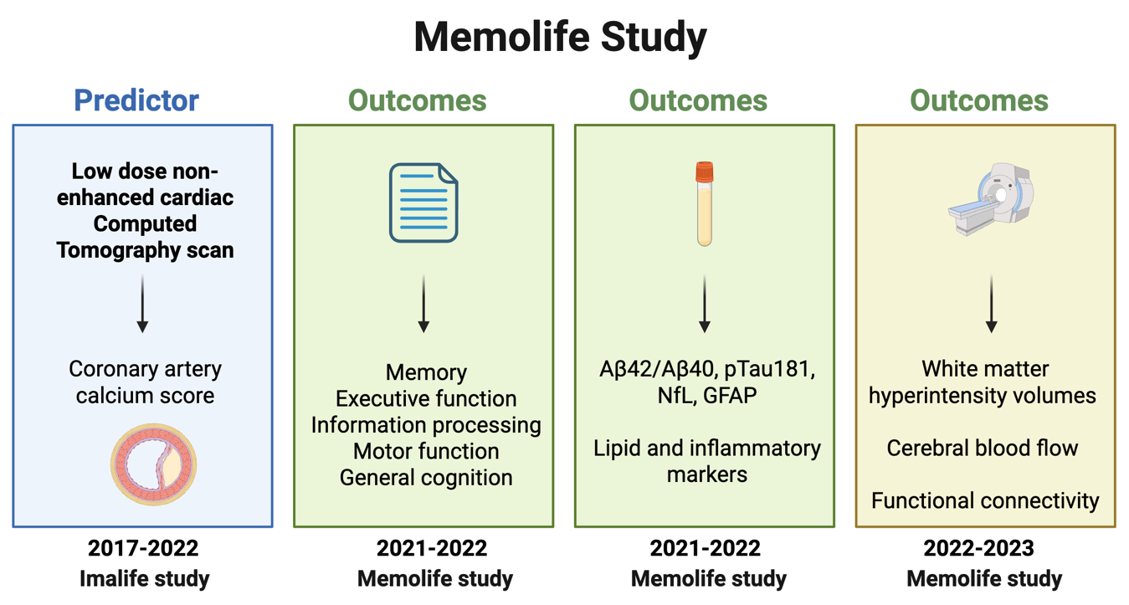
Supplementary Fig.2. Participants’ inclusion flow diagram.
Supplementary Fig.3a. Spatial components as brain networks and regions.
Supplementary Fig.3b. Spatial components as brain networks and regions.
Supplementary Fig.3c. Spatial components as brain networks and regions.
Supplementary Fig.3d. Spatial components as brain networks and regions.
Supplementary Fig.4. Spatial correlation of independent components to template. ICA: Independent component analysis. Voxel to voxel one-sample t-tests ICA spatial overlap map (i.e., large-scale cerebral networks or brain regions) suprathreshold areas (Dice similarity coefficients) with threshold set at Z= 3.7. The larger the box, the stronger the correlation. The best match suggests the network most likely characterized.
Supplementary Fig.5. Seed-to-Voxel Functional connectivity effects for high CAC > absent CAC controlling for age.
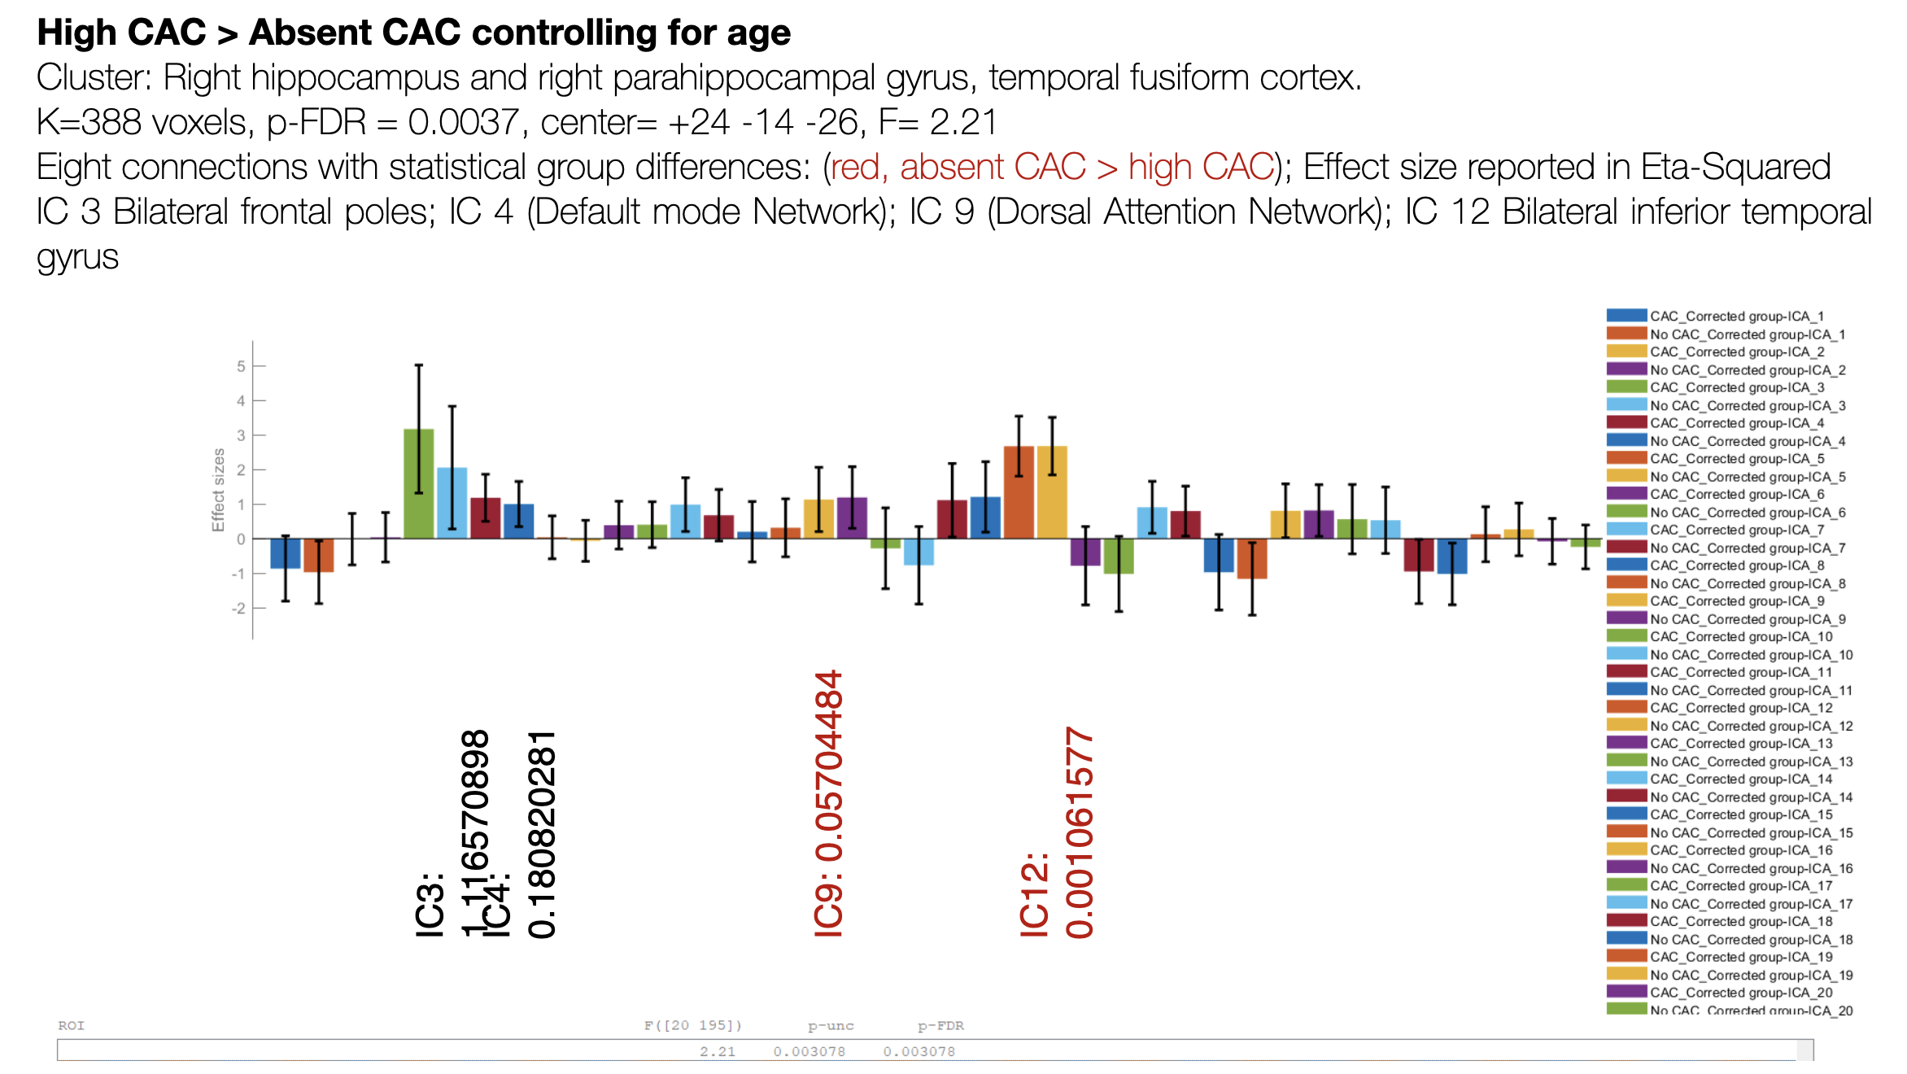
Supplementary Fig.6. Seed-to-Voxel Functional connectivity effects for high CAC > absent CAC controlling for age and sex.
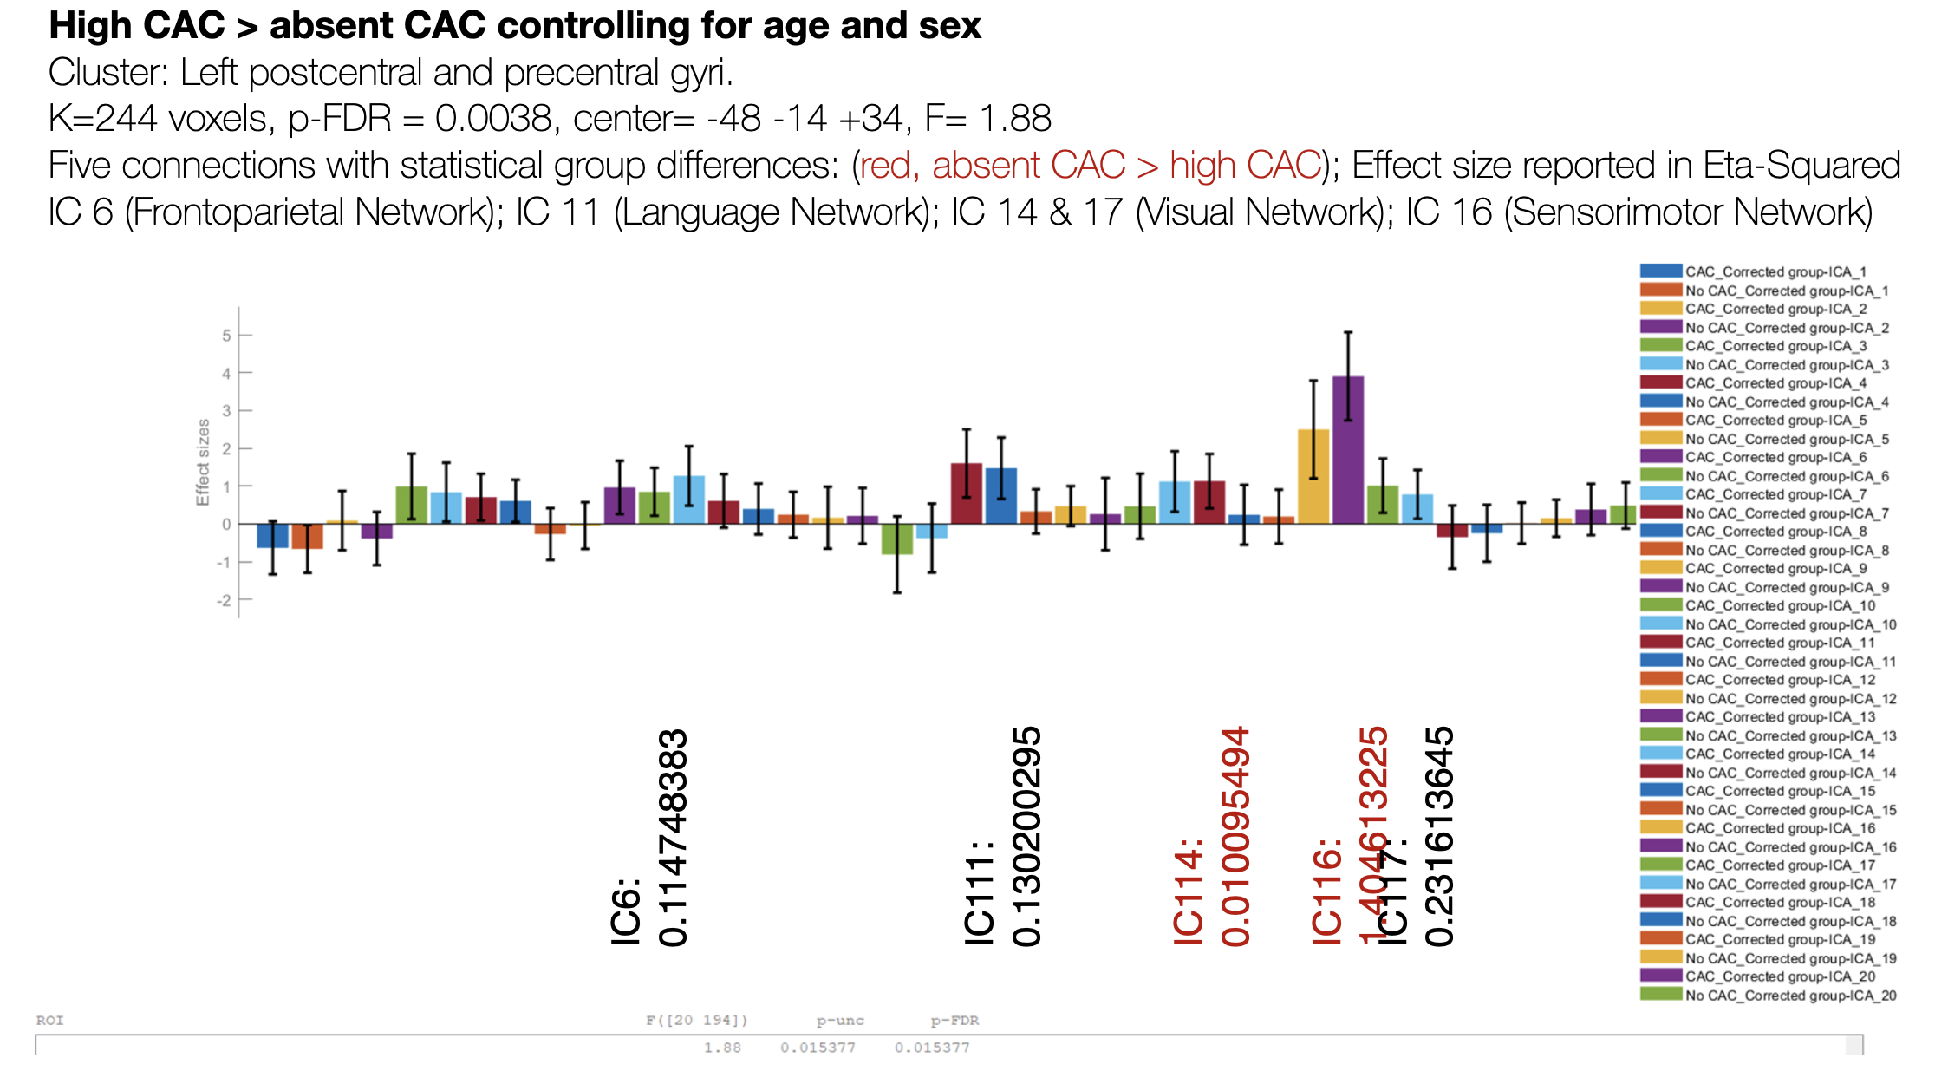
Supplementary Fig.7. Seed-to-Voxel Functional connectivity effects for high CAC > absent CAC controlling for age, sex, and white matter hyperintensity volumes.
