Supplementary Material

Supplementary Figures and Tables

Supplementary Figures
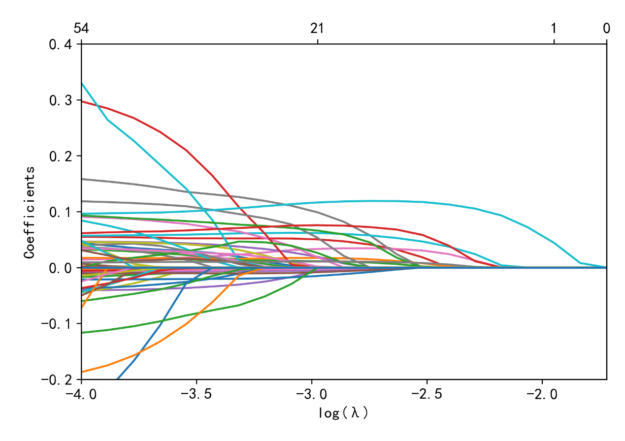
A
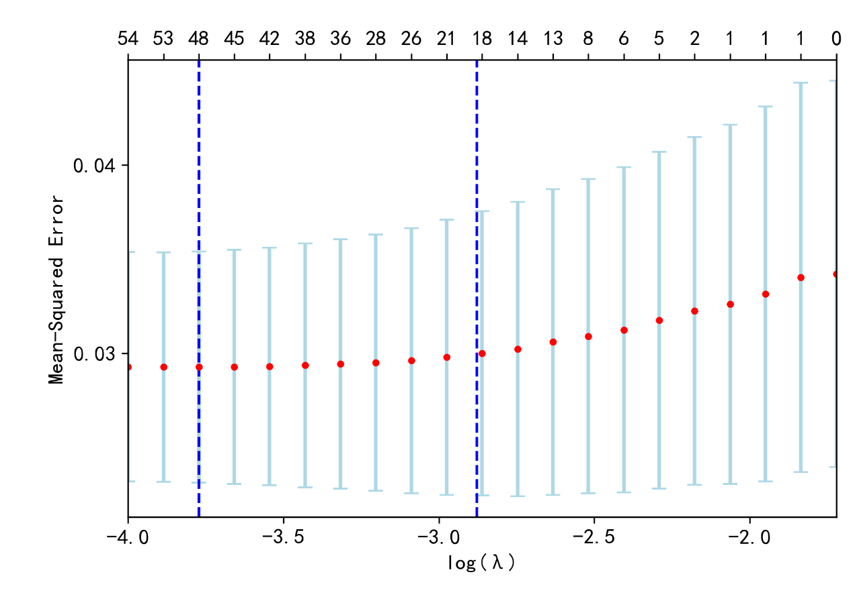
B
Supplementary Figure S1. Feature selection by LASSO analysis. (A) Plots for LASSO analysis coefficients; (B) Cross validation plot for the penalty term.

Figure S2 (A) Mean(|SHAP value|) for LR (average impact on model output magnitude)
Figure S2 (B) Mean(|SHAP value|) for RF (average impact on model output magnitude)
Figure S2 (C) Mean(|SHAP value|) for XBG (average impact on model output magnitude)
Supplementary Figure S2 (A-C). Shap figures of LR, RF, XGBoost. The importance of each predictor by mean SHAP value in the LR, RF and XGBoost models is shown in Figure S2A-C. For GNB, calculating SHAP values requires a lot of sampling and expectation calculation of the model output to measure the contribution of each feature to the prediction result. However, in GNB, due to the linear and independent nature of the model, SHAP values cannot effectively capture the interactions between features, so the generated explanations may not be meaningful.

Supplementary Tables

Table S1 The extracted variables and missing rate
variables | missing rate |  | variables | missing rate
Antithrombin III Activity | 96.85% |  | Fibrinogen Concentration | 7.00%
Basophil Count | 78.53% |  | Prothrombin Activity | 7.00%
Eosinophil Count | 78.53% |  | Thrombin Time | 7.00%
Eosinophil Percentage | 78.53% |  | Creatinine | 6.07%
Basophil Percentage | 78.53% |  | Albumin | 5.12%
Red Cell Distribution Width CV (RDW-CV) | 78.53% |  | Globulin | 5.03%
Red Cell Distribution Width SD (RDW-SD) | 78.53% |  | Myoglobin | 4.84%
White Blood Cells (High Power Field) | 76.08% |  | Whole Blood Troponin T Quantitative Test | 4.69%
Red Blood Cells (High Power Field) | 76.08% |  | Creatine Kinase Isoenzymes | 3.16%
Brain Natriuretic Peptide (BNP) | 74.01% |  | Fasting blood glucose | 2.83%
Very Low Density Lipoprotein Cholesterol (VLDL-C) | 39.79% |  | Sodium | 2.69%
Low Density Lipoprotein Cholesterol (LDL-C) | 39.79% |  | Calcium | 2.58%
High Density Lipoprotein Cholesterol (HDL-C) | 39.79% |  | Main Patient ID | 0
Homocysteine | 39.57% |  | Visit Number | 0
Cholinesterase | 36.26% |  | Name | 0
Apolipoprotein A1 | 35.98% |  | Gender | 0.04%
N-terminal pro b-type natriuretic peptide (NT-proBNP) | 31.46% |  | Age | 0
Albumin to Globulin Ratio | 30.28% |  | Case Type | 0
Urinary Transferrin | 28.98% |  | Date of Visit | 0
Beta-2 Microglobulin | 28.98% |  | CAD admission diagnosis types | 0
Mean Corpuscular Volume (MCV) | 26.52% |  | Severe clinical events during hospitalisation | 0
Apolipoprotein B | 24.67% |  | Traditional Chinese Medicine Diagnosis | 0.18%
Prealbumin | 24.65% |  | Traditional Chinese Medicine Syndrome | 3.53%
Free Fatty Acids | 24.65% |  | Tongue Color | 10.85%
Alpha-L-fucosidase | 24.65% |  | Coating Body | 0
Leucine Aminopeptidase | 24.65% |  | Tongue Coating Color | 14.52%
Alkaline Phosphatase | 24.65% |  | Large fat tongues | 0
Lactate Dehydrogenase | 23.82% |  | Pulse signals | 11.87%
Total Bile Acids | 23.75% |  | Mental State | 10.59%
Gamma-glutamyl transferase (GGT) | 23.74% |  | Duration of Chest Pain | 27.97%
Phosphate | 23.51% |  | Drinking history | 12.66%
Triglycerides | 22.64% |  | Smoking history | 12.61%
Total Cholesterol | 22.64% |  | Pulse Rate | 14.54%
Plateletcrit | 17.50% |  | Systolic Blood Pressure | 15.65%
Large Platelet Ratio | 17.50% |  | Diastolic Blood Pressure | 15.65%
Platelet Distribution Width | 17.50% |  | Mobility Inhibition | 100.00%
Hematocrit | 17.50% |  | Parasite Eggs | 99.99%
Mean Platelet Volume (MPV) | 17.50% |  | Motility | 99.95%
Lymphocyte Percentage | 17.50% |  | Hardness | 81.19%
Monocyte Percentage | 17.50% |  | Fat Droplets | 58.58%
Hemoglobin | 17.50% |  | Undigested Food | 58.32%
Monocyte Count | 17.50% |  | Fibrin Degradation Products | 57.88%
Mean Corpuscular Volume (MCV) | 17.50% |  | Occult Blood | 41.06%
Lymphocyte Count | 17.50% |  | Color (repeated) | 40.61%
Mean Corpuscular Hemoglobin (MCH) | 17.50% |  | Mucus | 40.61%
Neutrophil Count | 17.50% |  | Number of Mucous Threads | 26.52%
White Blood Cell Count | 17.50% |  | Urinary Immunoglobulin IgG | 83.12%
Platelet Count | 17.50% |  | Turbidity | 80.40%
Mean Corpuscular Hemoglobin Concentration (MCHC) | 17.50% |  | Yellowness | 80.39%
Neutrophil Percentage | 17.50% |  | Hemolysis | 80.39%
Red Blood Cell Count | 17.48% |  | Bacteria (High Power Field) | 76.08%
Uric Acid | 16.85% |  | Epithelial Cells (High Power Field) | 76.03%
Total Protein | 16.83% |  | Casts (Low Power Field) | 75.65%
High-sensitivity C-reactive Protein | 15.13% |  | Red Blood Cells (High Power Field) (repeated) | 40.61%
Glycated Hemoglobin (HbA1c) | 13.97% |  | White Blood Cells (High Power Field) (repeated) | 40.61%
Magnesium | 13.87% |  | Urinary N-acetyl-beta-D-glucosaminidase Quantitation | 28.98%
D-dimer | 9.87% |  | Urinary Microalbumin Quantification | 28.98%
Bilirubin | 8.74% |  | Cast Count | 26.52%
Urinary Protein | 8.74% |  | Conductivity | 26.52%
Specific Gravity | 8.74% |  | Epithelial Cell Count | 26.52%
Ketone Bodies | 8.74% |  | Bacterial Count | 26.52%
Urinary Occult Blood | 8.74% |  | Absolute Complete Red Blood Cell Count | 26.52%
Glucose (urine) | 8.74% |  | White Blood Cell Count (repeated) | 26.52%
Indirect Bilirubin | 7.28% |  | Small Round Epithelial Cells | 26.52%
Direct Bilirubin | 7.28% |  | Percentage of Complete Red Blood Cells | 26.52%
Total Bilirubin | 7.28% |  | Red Blood Cell Count (repeated) | 26.52%
Alanine Aminotransferase (ALT) | 7.28% |  | Red Blood Cell Information | 26.52%
Blood Urea Nitrogen | 7.28% |  | Pathological Casts | 26.52%
Urea | 7.26% |  | Yeasts | 26.50%
Aspartate Aminotransferase (AST) | 7.25% |  | Crystal Examination | 26.49%
Total Carbon Dioxide | 7.20% |  | Color (repeated) | 8.74%
Potassium | 7.03% |  | Nitrites | 8.74%
Prothrombin Time | 7.00% |  | White Blood Cells | 8.74%
Chloride | 7.00% |  | Transparency | 8.74%
Activated Partial Thromboplastin Time | 7.00% |  | PH | 8.74%
International Normalized Ratio (INR) | 7.00% |  | Urobilinogen | 8.74%
CAD admission diagnosis types | 0 |  | Hypokalemia | 0
Dyspnea | 0 |  | Hypoproteinemia | 0
Poor sleep | 0 |  | Chronic renal insufficiency | 0
Nausea | 0 |  | Pneumonia | 0
Vomiting | 0 |  | Electrolyte imbalance | 0
Abdominal distension | 0 |  | Hyponatremia | 0
Coughing or expectoration | 0 |  | Cardiac insufficiency | 0
Orthopnea | 0 |  | Acute exacerbation of chronic cardiac insufficiency | 0
Of the chief complaints, chest pain, chest tightness, precordial pain duration ,years | 0 |  | Hypertension classification | 0
Cardiac function grading (NYHA) | 0

Table S2 Confusion matrix defined in this study
 | Predicted positive | Predicted negative
Actual positive | TP | FN
Actual negative | FP | TN

After building the risk prediction models, the performance of the classification models was measured in terms of accuracy, specificity, precision, recall, F1 score and Area Under the Curve (AUC) – Receiver Operating Characteristics (ROC) curve. Among these six measures, AUC is one of the most essential evaluation metrics for comparing the performance of any classification model. Table S6 shows the confusion matrix defined in this study.

(1) Accuracy = $\frac{TP+TN}{TP+TN+FP+FN}$
Accuracy shows the overall performance of the model, which is the ratio of the number of correct predictions to the total number of predictions made.

(2) Sensitivity = $\frac{TP}{TP+FN}$
Sensitivity, also be called Recall or True Postive Rate (TPR), shows the capability of a model to find the targeted cases within the dataset, which is the number of correctly predicted high-risk cases divided by the total of cases that are correctly predicted as high risk and cases that are incorrectly predicted as low risk.

(3) Specificity = $\frac{TN}{TN+FP}$
Specificity, also be called True Negative Rate (TNR), is the ratio of correctly predicted cases as low risk to the total of low-risk cases.

(4) Youden's J statistic = $\frac{TP}{TP+FN}$ $−$ $\frac{TN}{TN+FP}$ = Sensitivity$+$Specificity$−$1
Youden's J statistic evaluates both sensitivity and specificity to reflect the overall performance of a diagnostic test. The closer the value approaches 1, the greater the combined discriminative power of the predictive model. Conversely, values nearer to zero indicate weaker performance.

(5) PPV = $\frac{TP}{TP+FP}$
Positive Predictive Value (PPV), also be called precision, is the ratio of correctly predicted high risk to the total of high-risk cases.

(6) NPV = $\frac{TN}{TN+FN}$
Negative Predictive Value (NPV), Proportion of true negatives among those with negative test results.

(7) F1 score = 2$×\frac{PPV×Sensitivity}{PPV+Sensitivity}$
F1 score is the harmonic average between both metrics of precision and recall, the larger the value of F1 the better the performance of the classifier.

(8)MCC = $\frac{TP×TN−FP×FN}{\sqrt{\left(TP+FP\right)\left(TP+FN\right)\left(TN+FP\right)\left(TN+FN\right)}}$
MCC is the only binary classification rate that generates a high score only if the binary predictor was able to cor- rectly predict the majority of positive data instances and the majority of negative data instances . It ranges in the interval [-1,+1],with extreme values 1 and +1 reached in case of perfect misclassification and perfect classification,respectively,while MCC =0 is the expected value for the coin tossing classifier.

(9) ROC is the probability curve, and AUC indicates the separability degree. It shows how well a model can differentiate between classes. The ROC curve is plotted against the FPR by TPR, where TPR is on the y-axis and FPR on the x-axis. A model that has higher AUC is better at predicting patients with high risk and low risk.

Table S3 Baseline Table of Biochemical Tests, related to Table 1.
Variables | Events group (n=268) | No events group (n=6703) | P-value
Myoglobin | 86.91(41.81, 249.03) | 32.48(23.87, 46.19) | 0.001
Whole Blood Troponin T Quantitative Test | 0.14(0.03, 0.72) | 0.01(0.01, 0.02) | 0.001
Creatine Kinase Isoenzymes | 4.05(2.00, 14.97) | 1.83(1.24, 2.76) | 0.001
Alpha-L-fucosidase | 21.89(18.48, 26.34) | 22.54(19.20, 26.40) | 0.108
Prealbumin | 192.84(143.16, 228.75) | 241.57(208.50, 277.31) | 0.001
Total Protein | 64.77(60.29, 69.43) | 69.60(65.68, 73.30) | 0.001
Total Bilirubin | 10.67(7.30, 15.92) | 10.20(7.50, 13.50) | 0.103
Creatinine | 93.00(71.00, 144.50) | 75.00(63.00, 88.00) | 0.001
Urea | 14.34(9.20, 21.12) | 9.54(5.60, 15.40) | 0.001
Uric Acid | 375.50(304.00, 448.40) | 326.00(272.00, 386.00) | 0.001
Total Cholesterol | 3.71(3.19, 4.48) | 3.85(3.25, 4.61) | 0.125
Triglycerides | 1.19(0.94, 1.50) | 1.23(0.90, 1.66) | 0.097
High Density Lipoprotein Cholesterol (HDL-C) | 0.96(0.82, 1.11) | 1.06(0.91, 1.26) | 0.001
Low Density Lipoprotein Cholesterol (LDL-C) | 2.15(1.71, 2.91) | 2.18(1.69, 2.86) | 0.825
Sodium | 276.00(138.37, 2548.09) | 139.20(75.44, 172.45) | 0.001
Potassium | 4.14(3.83, 4.49) | 4.06(3.81, 4.30) | 0.003
Chloride | 101.72(98.32, 105.42) | 103.80(101.40, 106.05) | 0.001
Calcium | 0.74(0.08, 2.17) | 0.02(0.01, 2.21) | 0.001
Magnesium | 0.90(0.84, 0.95) | 0.88(0.83, 0.93) | 0.002
Phosphate | 35.64(1.40, 60.11) | 31.81(1.16, 66.00) | 0.087
Total Carbon Dioxide | 23.91(21.18, 25.88) | 25.90(24.10, 27.90) | 0.001
High-sensitivity C-reactive Protein | 10.32(2.00, 40.17) | 1.29(0.63, 3.23) | 0.001
Serum or plasma
Yellowness-1 | 212(79.10%) | 5569(83.08%) | 0.001
Yellowness-2 | 23(8.58%) | 933(13.92%) | 0.001
Yellowness-0 | 19(7.09%) | 133(1.98%) | 0.001
Yellowness-3 | 10(3.73%) | 57(0.85%) | 0.001
Yellowness-4 | 2(0.75%) | 6(0.09%) | 0.001
Yellowness-6 | 1(0.37%) | 2(0.03%) | 0.001
Yellowness-5 | 1(0.37%) | 3(0.04%) | 0.001
Turbidity | 12.10(10.00, 16.30) | 13.00(11.00, 18.60) | 0.001
Urinary Microalbumin Quantification | 35.89(13.48, 174.75) | 12.91(7.03, 27.07) | 0.001
Beta-2 Microglobulin | 0.79(0.16, 3.04) | 0.13(0.04, 0.42) | 0.001
White Blood Cell Count | 7.71(6.23, 10.32) | 6.30(5.38, 7.28) | 0.001
Neutrophil Count | 5.61(4.07, 8.33) | 4.12(3.32, 4.86) | 0.001
Lymphocyte Count | 1.27(0.88, 1.65) | 1.58(1.28, 1.93) | 0.001
Monocyte Count | 0.44(0.33, 0.62) | 0.36(0.30, 0.45) | 0.001
Neutrophil Percentage | 75.55(65.55, 83.73) | 65.64(59.70, 70.70) | 0.001
Lymphocyte Percentage | 16.55(9.73, 25.29) | 25.60(20.90, 31.00) | 0.001
Monocyte Percentage | 5.90(4.70, 7.33) | 5.90(5.00, 6.90) | 0.979
Red Blood Cell Count | 3.60(2.61, 4.29) | 4.02(0.78, 4.57) | 0.018
Hemoglobin | 120.00(32.00, 329.00) | 138.00(32.60, 330.00) | 0.022
Hematocrit | 0.36(0.29, 0.40) | 0.40(0.37, 0.43) | 0.001
Mean Corpuscular Volume (MCV) | 89.90(86.65, 94.00) | 89.40(87.42, 92.40) | 0.314
Mean Corpuscular Hemoglobin (MCH) | 30.44(29.40, 31.82) | 30.50(29.74, 31.60) | 0.303
Mean Corpuscular Hemoglobin Concentration (MCHC) | 337.90(331.00, 347.00) | 341.00(335.00, 347.00) | 0.001
Platelet Count | 194.50(153.00, 260.25) | 204.60(175.00, 245.00) | 0.012
Mean Platelet Volume (MPV) | 10.60(9.90, 11.40) | 10.30(9.80, 10.90) | 0.001
Large Platelet Ratio | 29.35(23.30, 35.80) | 27.20(22.90, 32.10) | 0.001
Thrombin Time | 18.00(16.90, 19.10) | 17.50(16.50, 18.60) | 0.001
Prothrombin Time | 9.62(1.05, 12.22) | 5.26(0.98, 11.20) | 0.001
D-dimer | 0.86(0.47, 1.91) | 0.50(0.33, 0.73) | 0.001
Fibrinogen Concentration | 3.32(2.62, 4.29) | 2.89(2.49, 3.36) | 0.001
Color (urine) | 2.00(1.00, 3.00) | 2.00(1.00, 3.00) | 0.973
Urinary Protein-0 | 162(60.45%) | 6091(90.87%) | 0.001
Urinary Protein-1 | 67(25.00%) | 410(6.12%) | 0.001
Urinary Protein-2 | 26(9.70%) | 143(2.13%) | 0.001
Urinary Protein-3 | 12(4.48%) | 56(0.84%) | 0.001
Urinary Protein-4 | 1(0.37%) | 3(0.04%) | 0.001
Urinary Occult Blood-0 | 158(58.96%) | 5555(82.87%) | 0.001
Urinary Occult Blood-1 | 64(23.88%) | 938(13.99%) | 0.001
Urinary Occult Blood-3 | 28(10.45%) | 78(1.16%) | 0.001
Urinary Occult Blood-2 | 18(6.72%) | 132(1.97%) | 0.001
White Blood Cell Count (urine) | 13.90(3.48, 55.94) | 7.10(2.40, 29.61) | 0.001
Fasting blood glucose | 7.50(5.93, 11.44) | 6.32(5.48, 8.18) | 0.001
Glycated Hemoglobin (HbA1c) | 6.31(5.88, 7.60) | 6.20(5.80, 7.00) | 0.002

Table S4 The CAD admission diagnosis type
Category | Disease diagnoses included in EMRs
Chronic Coronary Heart Disease | Coronary Atherosclerotic Heart Disease
Chronic Coronary Heart Disease | Coronary Artery Atherosclerosis
Acute Coronary Heart Disease | Acute Non-ST Segment Elevation Myocardial Infarction (NSTEMI)
Acute Coronary Heart Disease | Acute ST Segment Elevation Myocardial Infarction (STEMI)
Acute Coronary Heart Disease | Acute Inferior Wall Myocardial Infarction
Acute Coronary Heart Disease | Acute Myocardial Infarction
Acute Coronary Heart Disease | Acute Extensive Anterior Wall Myocardial Infarction
Angina: | Unstable Angina
Angina: | Stable Angina
Angina: | Coronary spasm angina
Angina: | Microvascular Angina
Angina: | Effort Angina (Exercise-induced Angina)
Angina: | Variant Angina (Prinzmetal’s Angina)

Table S5 Collinearity Diagnostic by variance inflation factor measure.
Variables | VIF |  | Variables | VIF
Hypokalemia | 1.1807 |  | Dyspnea | 1.2173
Hypoproteinemia | 1.1762 |  | Orthopnea | 1.0785
Pneumonia | 1.3025 |  | Drinking history | 1.2667
Electrolyte imbalance | 1.1098 |  | β2-microglobulin | 1.5660
Hypertension classification | 2.9118 |  | Neutrophil percentage | 7.1347
Red tongue | 2.8090 |  | Proteinuria | 1.4659
Greasy tongue coating | 2.0654 |  | Urinary occult blood | 1.3719
Wiry pulse | 2.3050 |  | Coughing or expectorating phlegm | 1.3256
Mental state | 1.3238 |  | Acute coronary artery disease | 1.2286

Abbreviations: VIF, variance inflation factor.

Table S6 Parameters and Characteristics of the included machine learning algorithms.
Model | parameters | Type | Algorithm Classification | Advantages | Disadvantages
LR | Not applicable | Supervised ML | Interpretive algorithm | 1. High learning efficiency  2. Simple algorithm, fast convergence  3. Good interpretability | 1. Limited prediction performance  2. Unable to handle nonlinear issue  3. Unable to handle unbalance data
RF | 22 trees, minimum sample split node number 9, minimum leaf node number 5, maximum depth 3. | Supervised ML | Ensemble learning (Bagging) | 1. Could predict classification and regression outcomes  2. Less overfitting, good robustness  3. Could handle high-dimensional data | 1. Long calculating time  2. Requiring large RAM
XGB | Tree nodes 5, learning rate 0.01, L1 regularisation 0.1, L2 regularisation 0.1, maximum depth 10, number of iterations 100. | Supervised ML | Boosting | 1. Achieves state-of-the-art results in many machine learning competitions.  2. Captures complex non-linear patterns in the data.  3. Incorporates regularization techniques (L1 and L2) to enhance generalization.  4. Supports parallel and distributed computing, leading to fast training speeds.  5. Automatically deals with missing data without the need for imputation.  6. Provides feature importance scores for model interpretability. | 1. Has many hyperparameters that require careful tuning, which can be time-consuming.  2. May consume significant memory and processing power and time-intensive
GNB | Not applicable | Supervised ML | Probabilistic Generative Models | 1. Simple algorithm with low computational cost, suitable for quick model building  2. Performs well even with limited data  3. Flexible with different types of features.  4. The independence assumption allows it to ignore irrelevant features. | 1. Assumes all features are independent, which is rarely true in practice.  2. Assumes continuous features are normally distributed, which may not hold.  3. May have lower accuracy compared to more complex models.  4. Unable to model correlations between features.
DNN | Learning rate 0.01, activation function Sigmoid, number of iterations 1000. | Supervised ML | Artificial Neural Networks | 1. apable of learning complex non-linear relationships for various tasks  2. Learns feature representations directly from data without manual feature engineering.  3.Customizable architectures suitable for images, speech, text, and more  4. Excels with big data, uncovering deep insights | 1. Training is time-consuming and requires high-performance hardware like GPUs.  2. If not properly regularized or with insufficient data, may overfit the training set.  3. Requires careful tuning of many hyperparameters such as learning rate, number of layers, and neurons.
Abbreviations: LR, logistic regression; RF, random forest; GNB, Gaussian naive Bayes; XGB, extreme gradient boosting; DNN, deep neural network; RAM: random access memory; GPUs, graphics processing units; ML: machine learning

