Identification of common electrochemical oxidation pathways and mass spectrometry fragmentation patterns of the fluoroquinolones difloxacin, norfloxacin, ofloxacin and pefloxacin

Supplemental information

Melanie Voigt, Tobias Weißberg, Jana Boehm, Alexandra Schoentag and Martin Jaeger*

*corresponding author:
Niederrhein University of Applied Sciences, Department of Chemistry and ILOC
Frankenring 20, D-47798 Krefeld, Germany
E-mail: martin.jaeger@hs-niederrhein.de, phone: +49-2151-822-4188

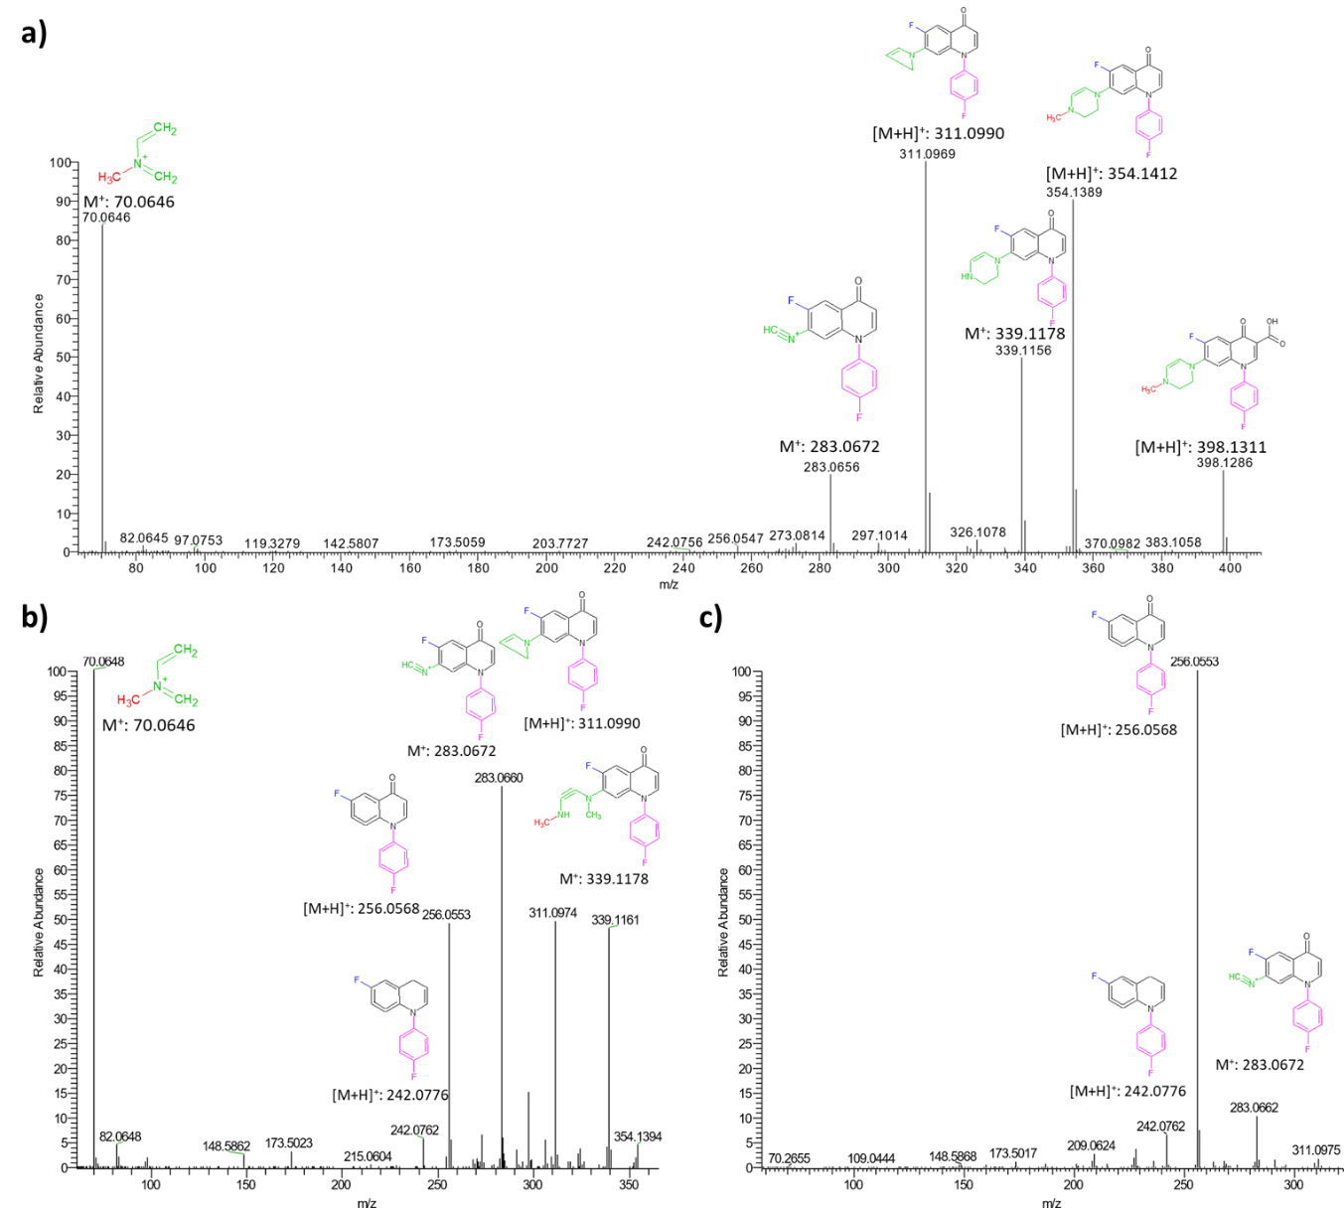
Fig. S1 a) MS/MS of D398 and MS³-spectra of the fragment b) 354 and c) 311
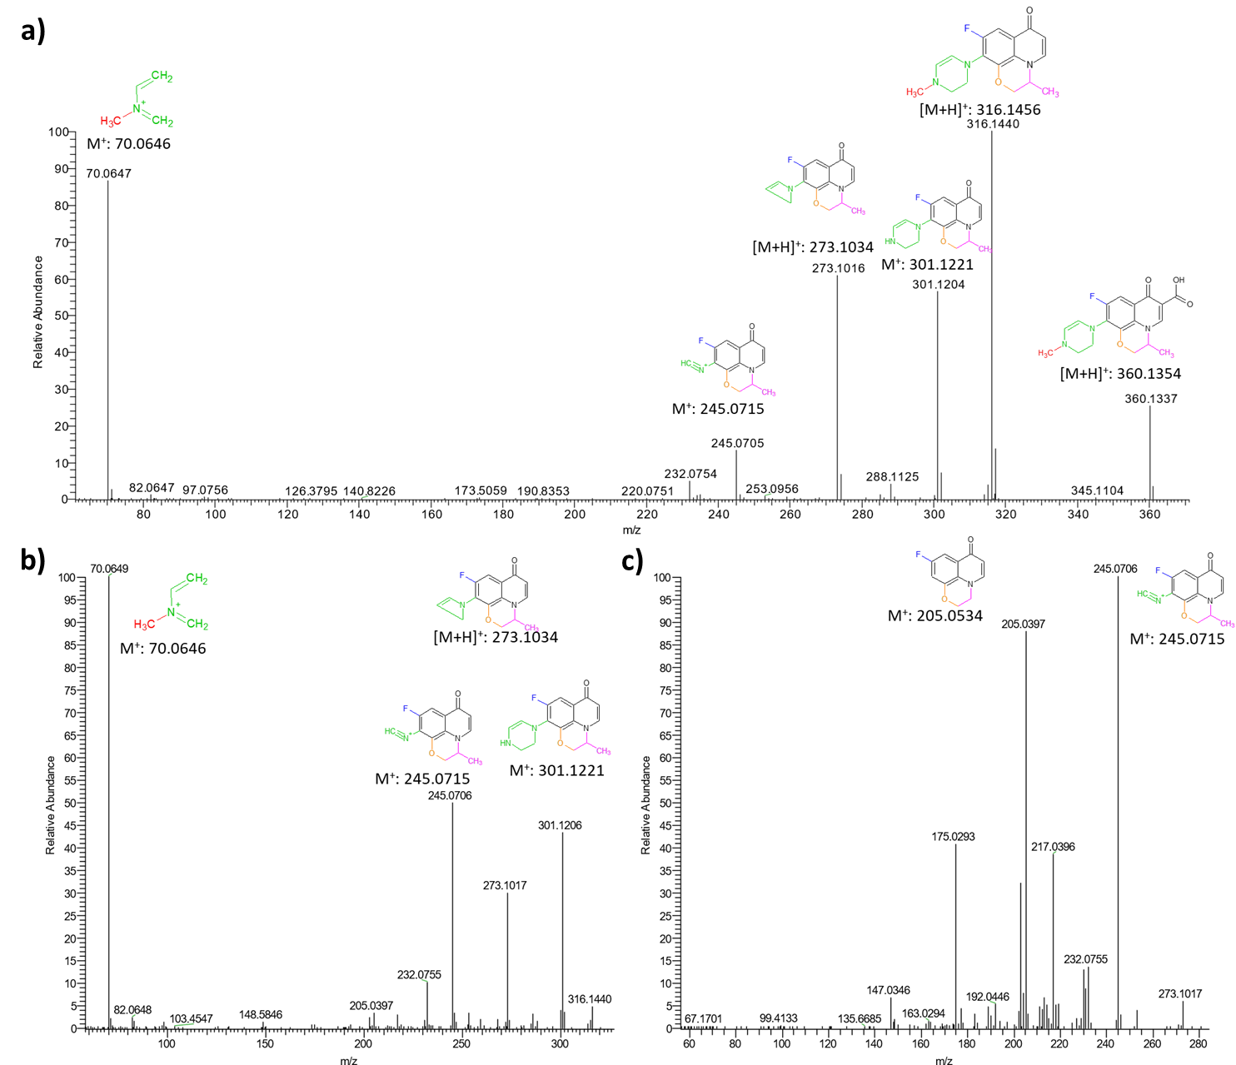
Fig. S2 a) MS/MS of O360 and MS³-spectra of the fragment b) 316 and c) 273

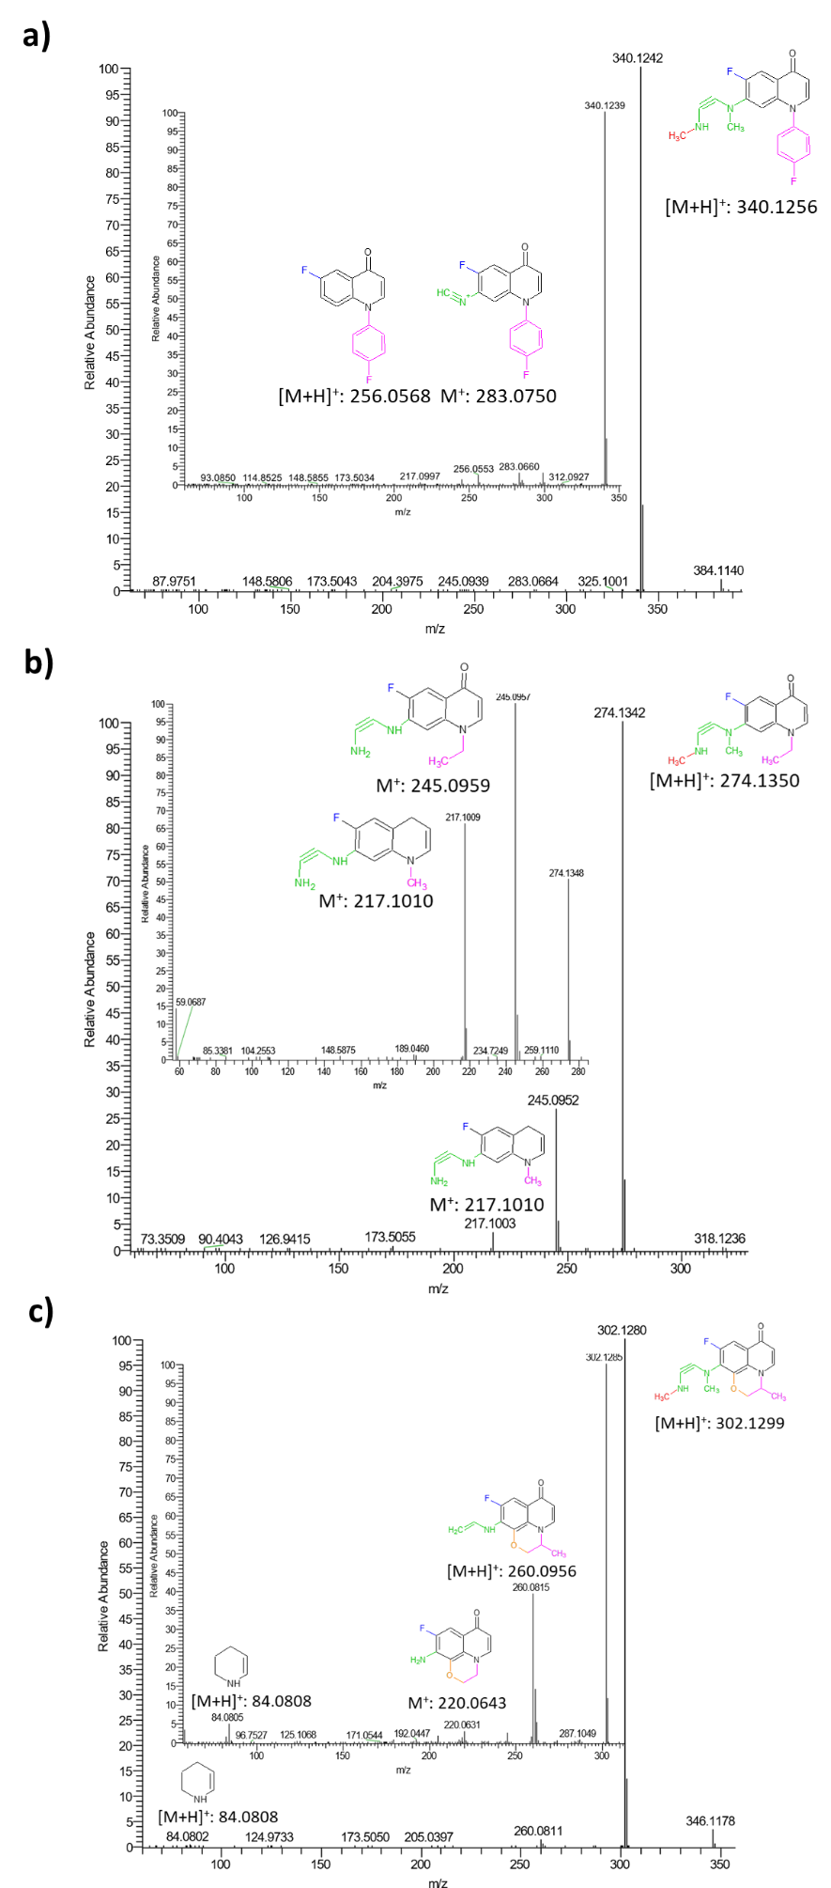
Fig. S3 MS/MS spectrum of a) D384, b) P318 and c) O346; inserted is the MS³-spectrum of the highest signal/fragment
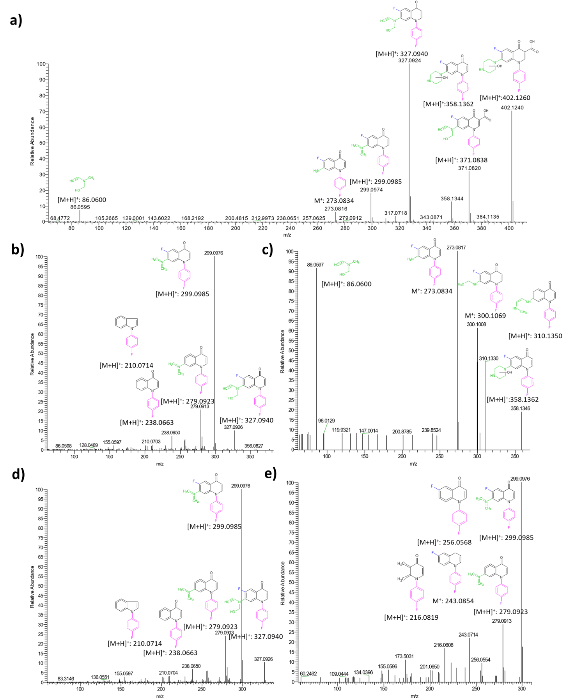
Fig. S4 a) MS/MS of D402 and MS³-spectra of the fragment b) 371, c) 358, d) 327 and e) 299

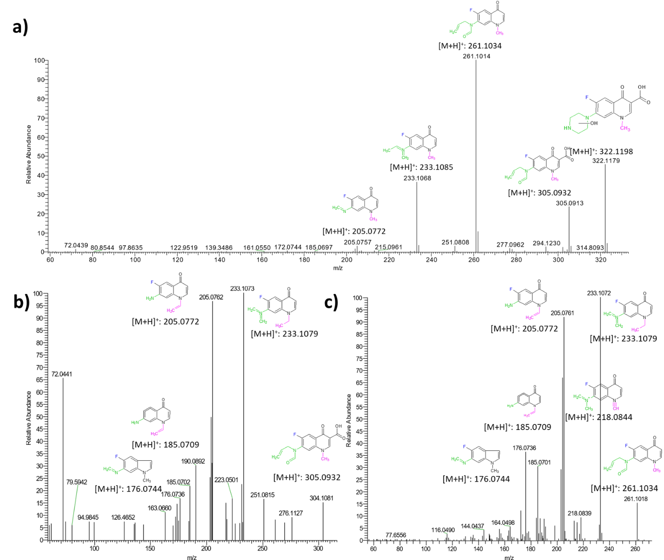
Fig. S5 a) MS/MS of N322 and MS³-spectra of the fragment b) 261 and c) 233

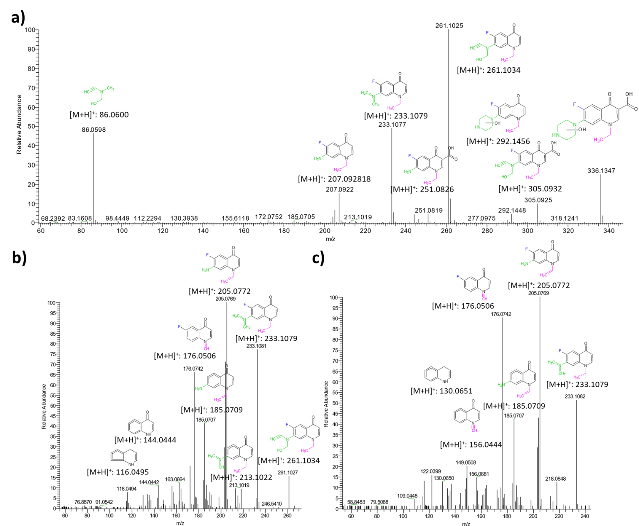
Fig. S6 a) MS/MS of P336 and MS³-spectra of the fragment b) 261 and c) 233

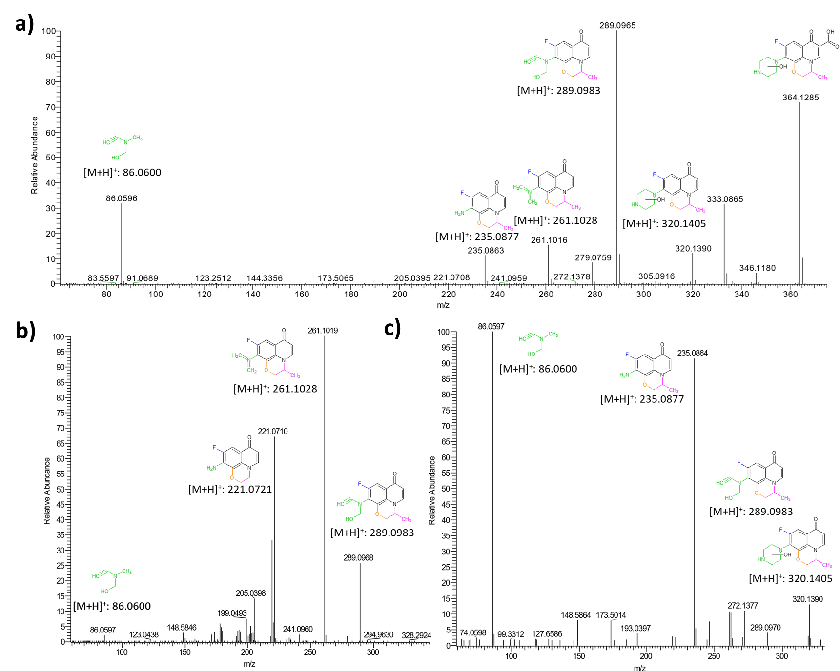
Fig. S7 a) MS/MS of O364 and MS³-spectra of the fragment b) 333 and c) 320
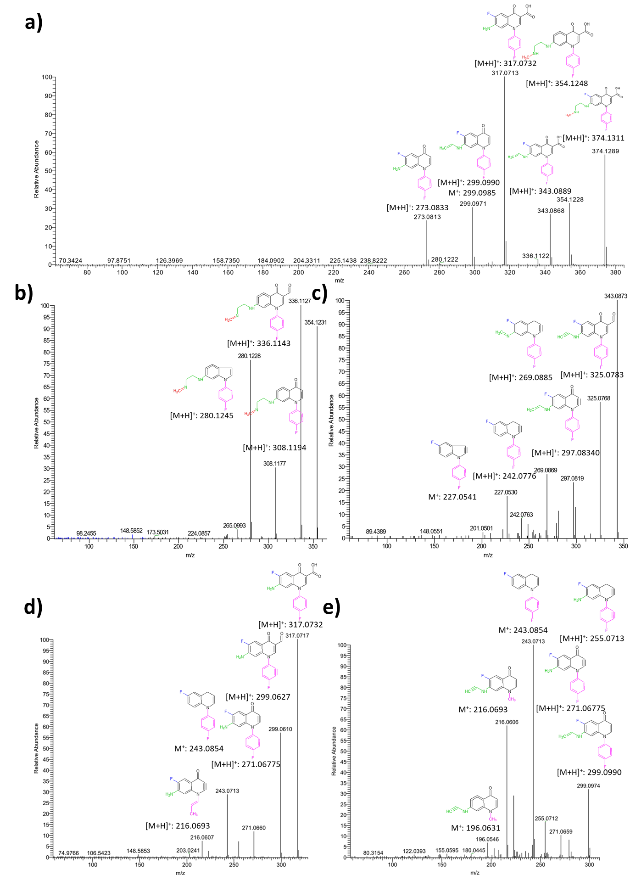
Fig. S8 a) MS/MS of D374 and MS³-spectra of the fragment b) 354, c) 343, d) 317 and e) 299
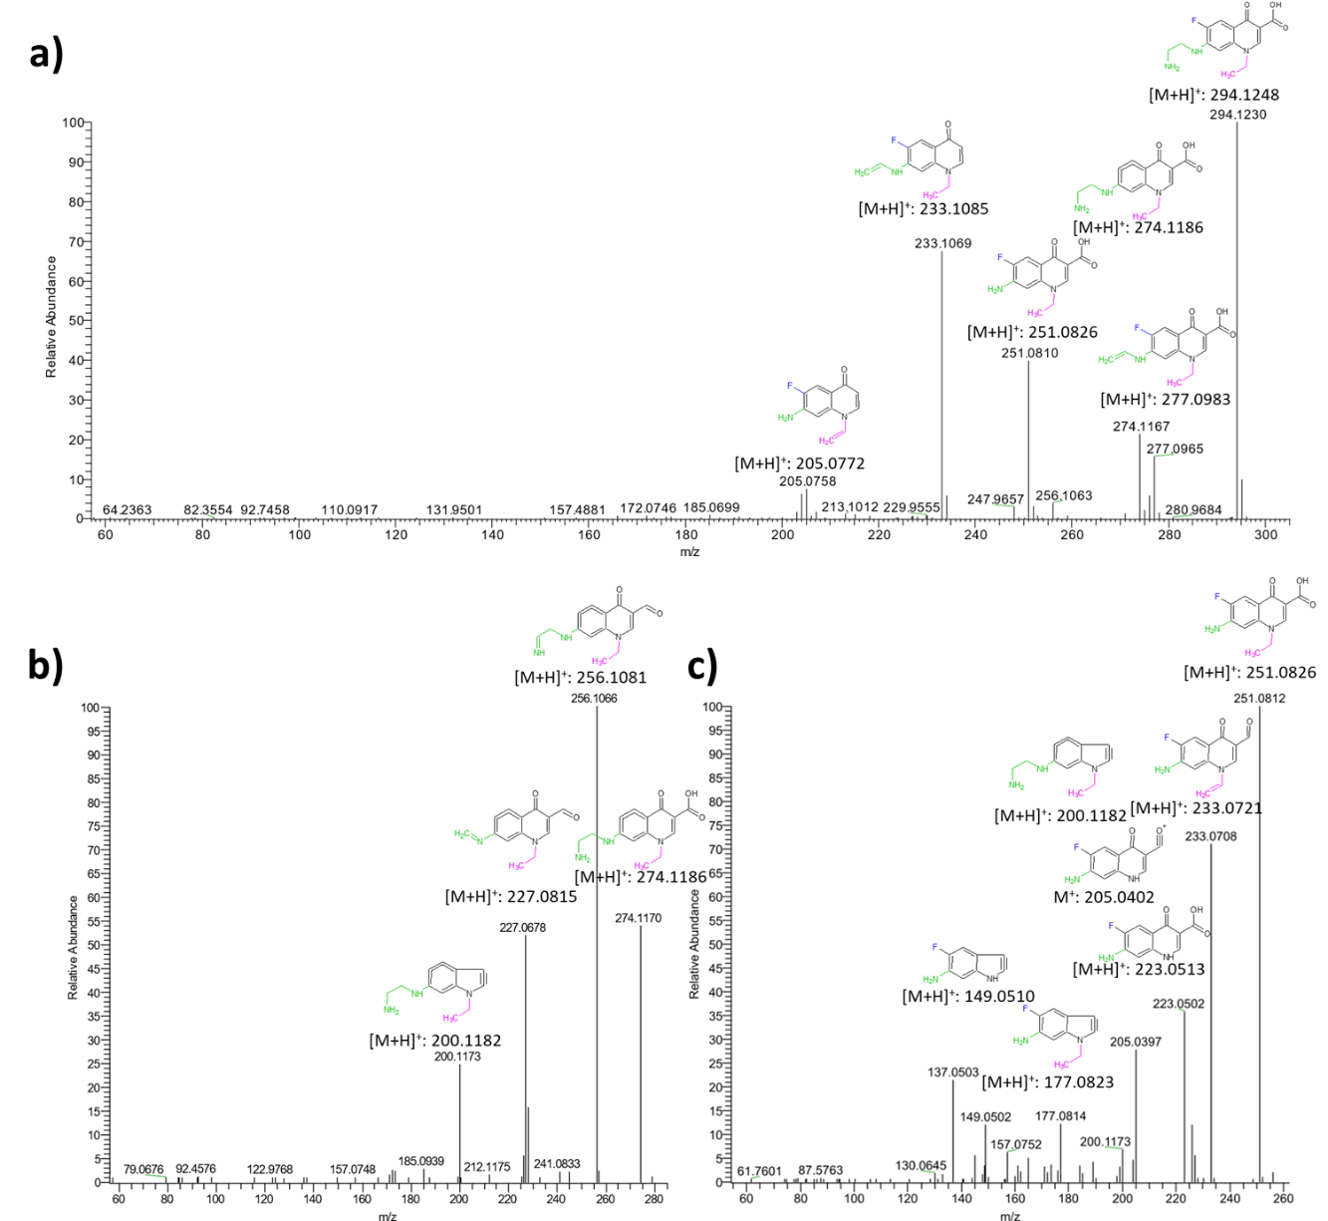
Fig. S9 a) MS/MS of N294 and MS³-spectra of the fragment b) 274 and c) 251
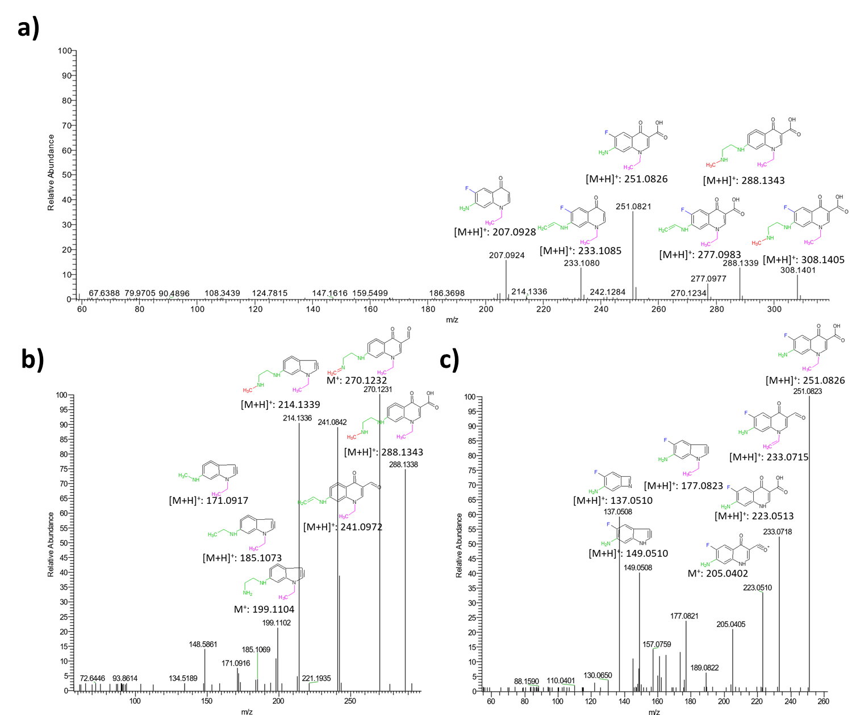
Fig. S10 a) MS/MS of P308 and MS³-spectra of the fragment b) 288 and c) 251
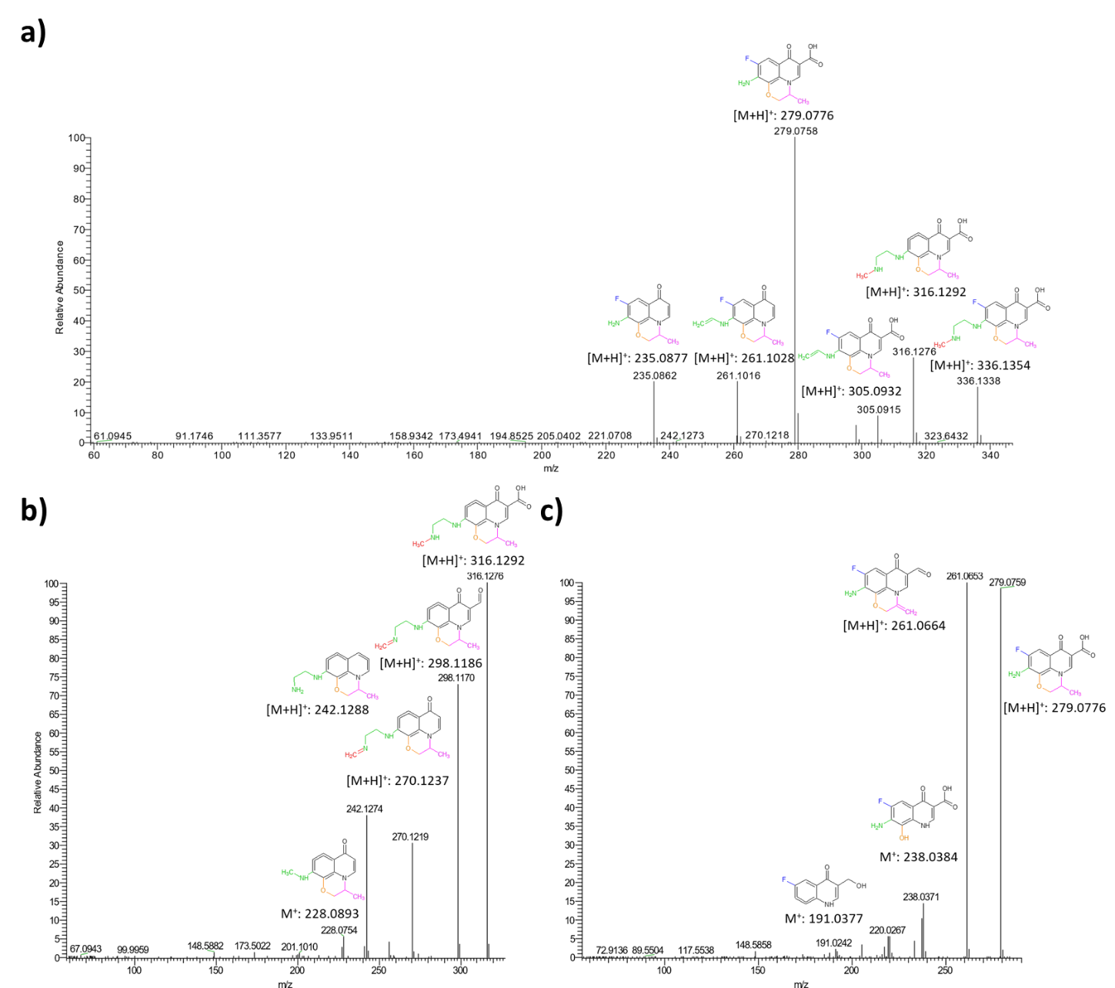
Fig. S11 a) MS/MS of O336 and MS³-spectra of the fragment b) 316 and c) 279

