Supplemental Material
Harnessing Alpine Lake Bacteria for the Development of Synthetic Communities with Broad-Spectrum Antiviral Activity
L. Daniela Morales¹, Jessica Aubouy¹, Shannon David¹, Paul Seguin¹, Olivier Schumpp², Anna Carratalà¹*

¹Laboratory of Environmental Virology, École Polytechnique Fédérale de Lausanne, Switzerland. ²Virology, Bacteriology and Phytoplasmology Laboratory, Agroscope Changins, Switzerland.
*Corresponding author. anna.carratala@epfl.ch

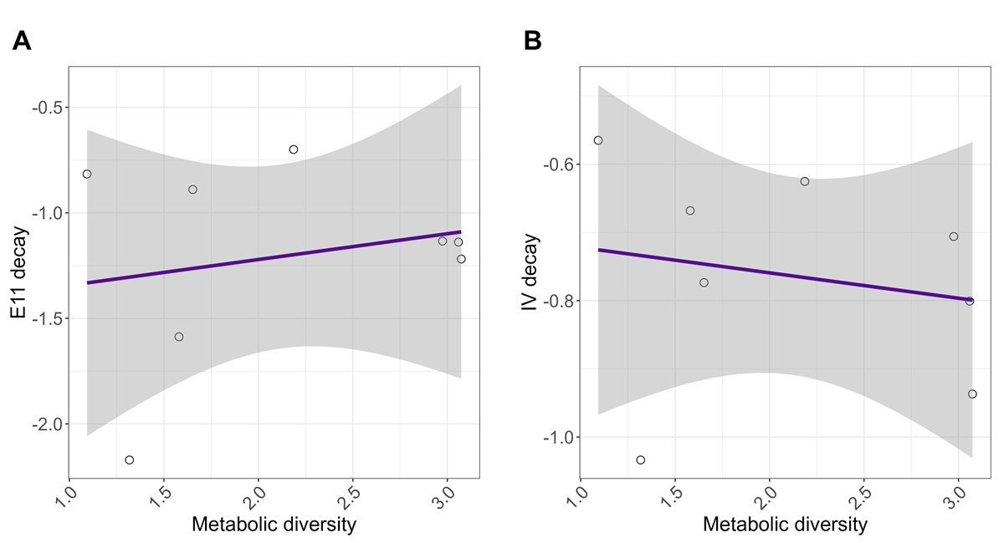
Figures
Figure S1. Correlation between viral decay and metabolic diversity of Alpine lakes. R studio was used to correlate viral decay values of Echovirus 11 (E11) and Influenza A virus (IAV) to Shannon diversity indexes calculated per lake using the data obtained from Biolog EcoPlates. Purple line represents the linear regression line and shaded area represents the confidence interval of the linear regression line.

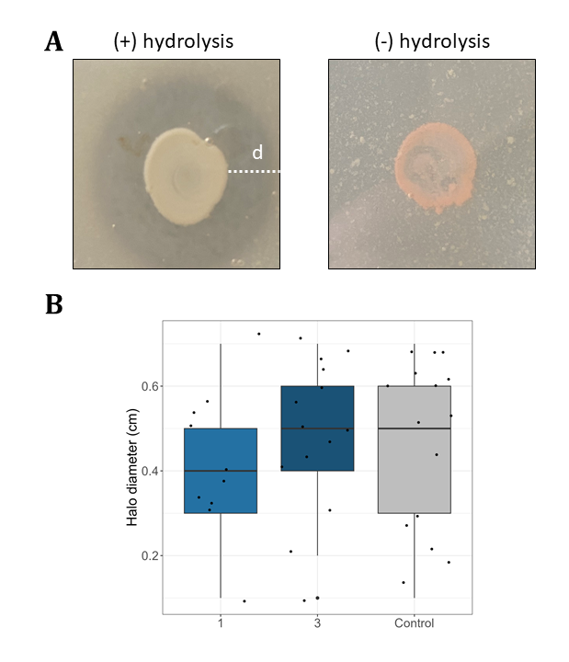
Figure S2. Casein hydrolysis by bacteria isolates present in synthetic communities. (A) Every isolate in the pool was grown in Skim milk agar plates as a proxy of protease production. Positive or negative hydrolysis was detected by the appearance of a halo around the colonies. (B) Casein hydrolysis of all members was compared among communities.

Tables
Table S1. Date of sampling and altitude of alpine lakes sampled in this study.
Lake | Date | Altitude (m)
Stellisee | 02.09.21 | 2538
Grinjisee | 02.09.21 | 2334
Grünsee | 02.09.21 | 2303
Mossjesee | 02.09.21 | 2139
Leisee | 02.09.21 | 2232
Tracouet | 12.09.21 | 2171
Grundsee | 17.09.21 | 1842
Guggisee | 17.09.21 | 2007
Faflersee | 17.09.21 | 1796
Schwarzsee | 17.09.21 | 1861
Spilsee | 02.10.21 | 2401
Mittelsee | 02.10.21 | 2551
Wirbulsee | 02.10.21 | 2658
Lengsee | 02.10.21 | 2707
Lac des Vaux | 08.10.21 | 2545
Small Lac des Vaux | 08.10.21 | 2544
Oeschinensee | 09.10.21 | 1580
Vordersee | 15.10.21 | 2360
Petit Aletsch 1 | 15.10.21 | 2350
Petit Aletsch 2 | 15.10.21 | 2350
Petit Aletsch 3 | 15.10.21 | 2335
Marjelensee | 15.10.21 | 2302
Lac de Salanfe | 19.10.21 | 1925
Lac Bleu | 25.10.21 | 2090

Table S2. Primers used in this study.
Target | Primer name | Sequence (5’- 3’)
Picoeukaryotes | Euk345f | AAGGAAGGCAGCAGGCG
Picoeukaryotes | Euk499r | CACCAGACTTGCCCTCYAAT
Bacteria | 27F | AGAGTTTGATCMTGGCTCAG
Bacteria | 786R | CTACCAGGGTATCTAATC
Phages | g23_Fwd | ACWGGWCTKATYTTCGCAATG
Phages | g23_Rev | AYTTYTCAACWGACCADCKACC
Influenza A Matrix gene | M30F2/08 | ATGAGYCTTYTAACCGAGGTCGAAACG
Influenza A Matrix gene | M264R3/08 | TGGACAAANCGTCTACGCTGCAG
Echovirus 11 | E11_VP1_F | TACCACTCGAGATCAGA
Echovirus 11 | E11_VP1_R | TCTCATCTGCACCATGCG

Table S3. Metabolic diversity indexes.
Lake | Shannon
Faflersee | 2.440455
Grindjisee | 2.724327
Grundsee | 2.816062
Grunsee | 2.671716
Guggisee | 2.974653
Lac Bleu | 3.073953
Lac De Vaux | 1.696464
Leisee | 0.986421
Lengsee | 2.08933
Marjelensee | 1.579767
Mittelsee | 2.186436
Mossjesee | 1.317553
Petit Aletsch 1 | 3.066021
Petit Aletsch 2 | 2.562114
Petit Aletsch 3 | 2.895099
Salanfe | 1.093009
Schwarzsee | 3.058899
Small Lac de Vaux | 1.652769
Spilsee | 1.606728
Stellisee | 0.692476
Tracouet | 2.542304
Vordersee | 2.210877
Wirbulsee | 2.33329

