Supplementary Figure S1. Pure culture of Sclerotium rolfsii showing beginning of sclerotia formation(left), multiplication of the fungi in Sand-maize meal(middle),
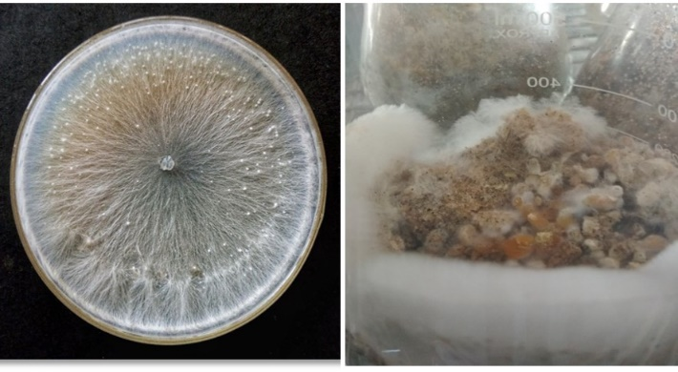
Supplementary Figure S2. Susceptible genotype showing severe disease symptoms and mycelial growth (left) and single plant picture with disease symptom (inset); tolerant genotype showing fewer disease symptoms (right).
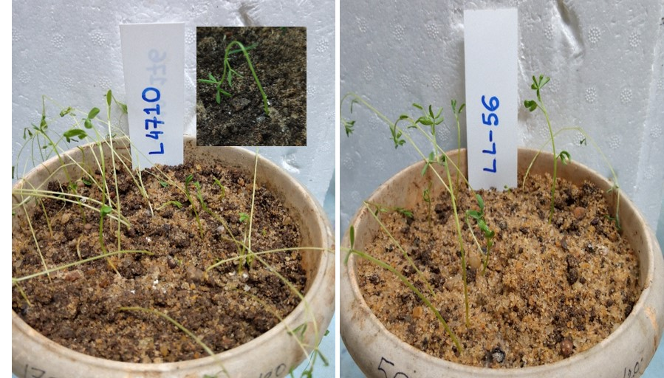

Supplementary Figure S3. Multialignment of Sclerotium rolfsii (Athelia rolfsii) assembled sequence obtained after sequencing (MN833953) and Sclerotium rolfsii (MN610007) retrieved from NCBI database
