Supplementary information for: Enhancing Randomized Controlled Trials Through Smartwatch-Guided Participant Matching
Edan Shahmoon, MS¹, Matan Yechezkel, PhD², Shachar Snir, MS¹, Marco V. Perez, MD , PhD³, Margaret L. Brandeau, PhD⁴, Dan Yamin, PhD^{1,4*}

¹Industrial Engineering Department, Tel Aviv University, Tel Aviv, Israel
²School of Public Health, University of California, Berkeley, CA 94720, USA
³Department of Medicine, Stanford University School of Medicine, Stanford, CA, USA
⁴Department of Management Science and Engineering, Stanford University, Stanford, CA 94305, USA
*Corresponding author: Dan Yamin, Department of Management Science and Engineering, Stanford University, Stanford, CA, 94305, USA , Email: dan.yamin@gmail.com

Contents
Appendix A – Study protocol 2
Data collection platform and data access: 8
1. Architecture 8
2. The PerMed dashboard 8
3. Type of data collected and data access 8
Appendix B - The Smartwatch Informed Matching Procedure 10
Appendix C Post-hoc Validation of Vaccination Timing 12
Appendix D Power Analysis 14
References 17

Appendix A – Study protocol
Study design
In this study, we will analyze data as part of the PerMed study.¹ Participants in the PerMed study are recruited for a period of two years, during which they are equipped with Garmin Vivosmart 4 smartwatches and are asked to wear them as much as they can. In addition, participants will install two applications on their mobile phones: an application that passively collects data from the smartwatch and a dedicated mobile application that allows participants to fill out a daily questionnaire.
Participants
The inclusion criteria for the PerMed study include those aged > 18 years. Individuals who are not eligible to sign a consent form of their own free will are excluded. In this study, we will analyze the data of participants aged 18 years and above who reported being positive for influenza, COVID-19, or group A streptococcus (GAS) infection after joining the PerMed study. To recruit participants and ensure they complete all the study’s requirements, we will hire a professional survey company. Potential participants will be recruited through advertisements on social media, online banners, and word-of-mouth. The survey company is responsible for guaranteeing that the participants meet the study’s requirements, in particular, that the questionnaires are filled out daily, ensuring the smartwatches are charged constantly and worn properly, and assisting participants in resolving technical problems.
Study procedures
Before participation in the study, all participants will be advised orally and in writing about the nature of the experiments and will give written informed consent. At this time, participants will be asked to complete an enrollment questionnaire that includes demographic information and health status. In addition, participants will be asked to install two applications on their mobile phones: an application that passively collects data from the smartwatch, and the PerMed application, which allows participants to fill in the daily questionnaires. Participants will be given instructions regarding the self-reported symptoms questionnaires and how to operate the smartwatch, which they will wear as much as they can.
Enrollment questionnaire
All participants will fill out a one-time enrollment questionnaire that includes demographic questions and questions about the participant’s health condition in general. Specifically, the questionnaire will include the following: age, gender, height, weight, and underlying medical conditions. Other questions such as name, address, phone, and email will be recorded and used by the survey company to contact the participants. The answers will be filled in directly by the survey company to the study’s secured dashboard.
Monitoring device
Participants will be equipped with Garmin Vivosmart 4 smart fitness trackers. Among other features, the smartwatch provides all-day heart rate and heart rate variability measures, daily step count, distance, active time, and active calories.²
The optical wrist heart rate (HR) monitor of the smartwatch is designed to continuously monitor a user’s heart rate. The frequency at which heart rate is measured varies and may depend on the level of activity of the user: when the user starts an activity, the optical HR monitor’s measurement frequency increases.
Since heart rate variability (HRV) is not easily accessible through Garmin’s application programming interface (API), we use Garmin’s stress level instead, which is calculated based on HRV. Specifically, the device uses heart rate data to determine the interval between each heartbeat. The variable length of time between each heartbeat is regulated by the body's autonomic nervous system. Less variability between beats correlates with higher stress levels, whereas an increase in variability indicates less stress.³ A similar relationship between HRV and stress was also seen in ^{4,5}. A stress value of -1 means there was not enough data to detect stress, and -2 means there was too much motion (e.g. the user was walking or running).
Steps are monitored by the Garmin smartwatch as follows: arm movement while walking is captured by the internal 3-axis accelerometer in the watch which records each complete swing of the arm as two steps.⁶
Examining the data collected in our study, we identified an HR sample roughly every 15 seconds and an HRV sample every 180 seconds. Steps were collected on a daily basis.
While the Garmin smartwatch provides state-of-the-art wrist monitoring, it is not a medical-grade device, and some readings may be inaccurate under certain circumstances, depending on factors such as the fit of the device and the type and intensity of the activity undertaken by a participant.^{7–9}
We chose the Garmin Vivosmart 4 for its API access, enabling the collection of essential data measurements such as continuous heart rate, heart rate variability-based stress, daily step count, traveled distance, and daily active calories. Its battery life of up to 7 days – superior to many competitors—reduces the frequency of charging, thereby increasing the device’s wear time. Additionally, the device’s affordability was a crucial consideration, given our objective of managing costs while scaling the study.
Daily questionnaires
All participants will complete the daily self-reported questionnaire in a dedicated application (the PerMed mobile application). The daily questionnaire includes the following questions:
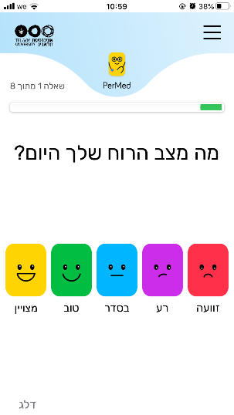 | How is your mood today?  • Awful (-2) • Bad (-1) • OK (0) • Good (1) • Excellent (2)
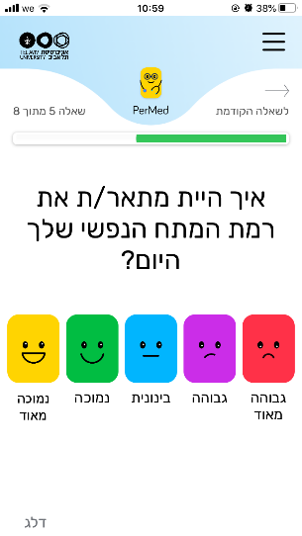 | How would you describe the level of your stress during the last day?  • Very Low (-2) • Low (-1) • Medium (0) • High (1) • Very high (2)
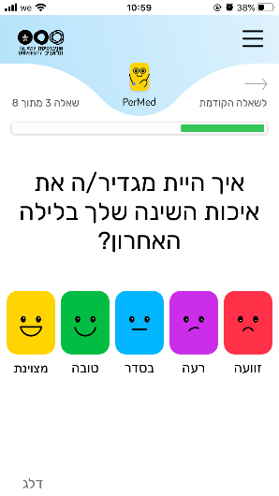 | How would you define your last night sleep quality?  • Awful (-2) • Bad (-1) • OK (0) • Good (1) • Excellent (2)
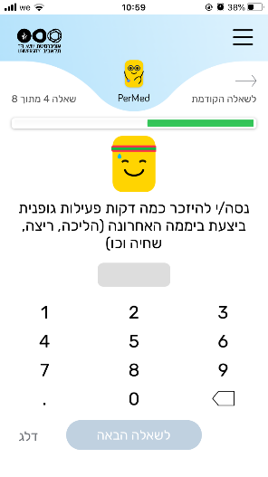 | Try to remember how many minutes of sports activity you performed on the last day?
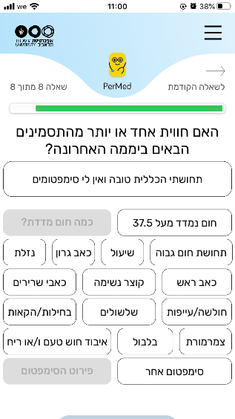 | Have you experienced one or more of the following symptoms in the last 24 hours?  • My general feeling is good, and I have no symptoms • Heat measured above 37.5 • Cough • Sore throat • Runny nose • Headache • Shortness of breath • Muscle aches • Weakness / fatigue • Diarrhea • Nausea / vomiting • Chills • Confusion • Loss of sense of taste / smell • Another symptom.
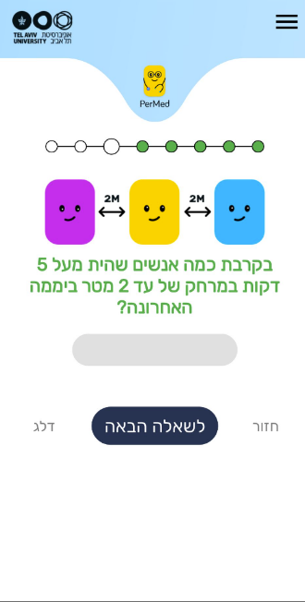 | How many people were you with for more than 5 minutes at up to 2 meters in the last day?
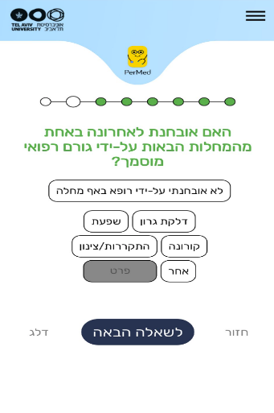 | Have you been diagnosed by a qualified doctor with one or more of the following diseases?  • No diagnosis • throat infection • Influenza • COVID-19 • cold • other
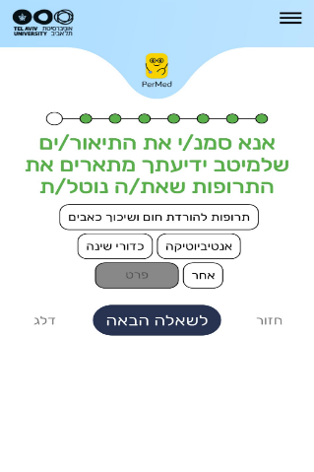 | Please mark the descriptions that, to the best of your knowledge, describe the medicine you are taking.  • Antipyretic and pain reliever pills • antibiotic • sleeping pills • other
Data storage
Data collected from the mobile phone application and the smartwatches will be stored on a secure server within Tel Aviv University facilities. The server runs a CentOS operating system and is located in the Software Engineering Building at Tel Aviv University. This server is protected behind the university's firewall and is not connected to external networks. In addition, a secure connection through an SSL protocol and a trusted certificate will be obtained for the transfer of information from the mobile phone application into the secured server.
Access will be restricted to investigators in the study. The information from the mobile application will be stored in a structured manner on the secured server without any explicitly identifying information (name, ID number, email). Each participant will be assigned a coded participant number that will be used to identify the subject in the database. The code with the identified information will be stored in an encrypted form on a separate secured server that only the research manager will have access to. Access to all servers is restricted with a username and password.
All (non-digital) questionnaires and signed informed consent documents will be stored in a secured cabinet at Tel Aviv University, to which only the research manager and the principal investigators will have access. No data collected as part of the study will be added to individuals’ medical charts.
Case definition for disease diagnosis
Positive diagnoses are either recorded in the individual’s medical record following clinical care or self-reported in the application for those using home rapid test kits. Participants were instructed to report the test time and result in the app. Participants could have multiple positive reports if the interval between reports was greater than 3 months. We defined a COVID-19 case as one where an individual tested positive either through a PCR test administered by Maccabi or via an at-home antigen test.
Potential risks and risk management
No specific risks arising from the smartwatches are expected, as the device is already commercialized with no known adverse reactions. The main risk in this study is the leakage of private data which we intend to manage as we describe in the following section.
Privacy/Confidentiality
Results from this study will be handled at an aggregated level. Individual data records will remain confidential and will not be published or shared with any third party. Signed and dated informed consent forms, as well as data recording sheets (e.g., case report forms) will be stored in locked cabinets during the study and following its completion. A file containing the personal details of the participants will be coded to help preserve confidentiality and will be separated from all other data collected throughout the study. This file will be kept by the principal investigator. Data will be stored on computers in password-protected files.
The data obtained from the smartwatch used in this study will be linked to a coded participant number. The smartwatch does not include a GPS. The data collected by the PerMed application will arrive directly at PerMed back-end servers and will be stored securely.
Study participants’ adherence
We employed a professional survey company to recruit participants and ensure they adhere to the study requirements. Participant recruitment was performed via advertisements on social media and word-of-mouth. Each participant signed an informed consent form after receiving a comprehensive explanation of the study. Then, participants completed a one-time enrollment questionnaire, were equipped with Garmin Vivosmart 4 smartwatches, and installed two applications on their mobile phones: (1) the PerMed application, which collects daily self-reported questionnaires, and (2) an application that passively records smartwatch data. Participants were asked to wear their smartwatches as much as possible. The survey company ensured that participants' questionnaires were filled at least twice a week, that their smartwatches were charged and properly worn, and that any technical problems with the mobile applications or smartwatches were resolved.
We implemented several preventive measures to minimize participant attrition and discomfort as a means to improve the quality, continuity, and reliability of the collected data. First, each day, participants who did not fill out their daily questionnaire by 7 pm received a reminder notification through the PerMed application. Second, we developed a dedicated dashboard that allowed the survey company to identify participants who repeatedly neglected to complete the daily questionnaire or did not wear their smartwatch for extended periods of time; these participants were contacted by the survey company (either by text message or phone call) and encouraged to better adhere to the study protocol. Third, to strengthen participants' engagement, a weekly personalized summary report was generated for each participant, which was available inside the PerMed application. Similarly, a monthly newsletter with recent findings from the study and useful tips regarding the smartwatch's capabilities was sent to the participants. At the end of the study, participants will receive all personal insights that were obtained and can keep the smartwatch as a gift.

Data collection platform and data access:
- Architecture
The data collection platform contains several interacting components (Figure S7):
- The PerMed application – This application is installed on each participant’s phone to collect sensor data and the self-reported daily questionnaires. It also handles the smartwatch pairing. The current version of the application supports both Android and iOS devices.
- The smartwatch – Sends the data to the Garmin Connect app on the smartphone, which then sends this data to Garmin’s server.
- The smartwatch application – This application (currently Garmin) receives information from the smartwatch via Bluetooth and transmits it to the company's server. In addition, it provides a convenient interface for displaying the participant's smartwatch information.
- The app server – The web server handles the database connectivity using REST API pages. It enables the server to authenticate users as they launch the application and write records to the database. A MySQL server stores the sensors' raw data and the answers to the daily questionnaires. At last, there is a batch process running on the server that sends app notifications (a daily reminder to fill out the questionnaire).
- The dashboard server – Hosts the dashboard pages, which assist in monitoring the quality of the information and controlling the experiment. The dashboard has access to participant information and signals indicating whether questionnaires were completed and the smartwatch was worn without seeing its content directly. A batch process is responsible for aggregating raw data for dashboard statistics.
- The smartwatch server – A MySQL server stores the smartwatch data. A batch process collects the data from the Garmin server.
- The PerMed dashboard
Participants were recruited by a qualified external recruitment team headed by Tel Aviv University personnel. The team received limited information essential to control the experiment. We developed a dedicated dashboard for monitoring the quality of the information and controlling the experiment. This dashboard aims to identify data collection issues such as participants who did not fill out the daily questionnaires or participants who did not charge their smartwatch battery. The dashboard also helps us identify problems that were not related to participants’ cooperation, such as bugs in the mobile app. This identification allows us to respond faster and provide timely solutions.
- Type of data collected and data access
Data collected by the platform arrives from four primary sources:
- Enrollment questionnaire – Data were collected from a one-time enrollment questionnaire that includes basic personal characteristics such as socio-demographic information (e.g., age, gender, height, weight), general habits, health status, and a short Big Five personality questionnaire.
- Daily questionnaire – Consists of questions on (1) wellbeing, (2) general health condition, (3) symptoms observed, (4) test results to diagnose infectious diseases, and (5) vaccination or medication consumption (if relevant to the study question).
- Smartphone sensor data – Consists of location, Wi-Fi, Bluetooth, screen, and activity.
- Smartwatch data – Consists of heart rate data, accelerometer, and gyroscope information, and measures based on these data, including active minutes, steps, distance, active calories, and sleep level classification (light, deep, REM, and awake periods).

Appendix B - The Smartwatch Informed Matching Procedure

This procedure produces matched intervention and control groups structurally analogous to randomized clinical trials, but explicitly guided by physiological similarity informed by smartwatch data. The SIM procedure represents a generalizable framework. It can incorporate additional smartwatch-derived covariates that are predictive of an individual's risk of infection or of developing complications following infection.

The Smartwatch-Informed Matching (SIM) procedure is designed to create groups of participants that are comparable in terms of physiological characteristics, similar to how groups are created in traditional randomized clinical trials. First, the study population is divided into smaller groups based on demographic characteristics—specifically, age and sex. This initial step ensures that participants being compared have basic similarities in demographics, making subsequent comparisons more valid.

Next, for each participant, we use smartwatch data collected during a baseline period to understand their physiological patterns. Specifically, we look at heart rate and heart rate variability (HRV), as these metrics can indicate an individual's physiological state or stress level. By observing how each person's heart rate and HRV vary during this baseline period, we create a unique "physiological profile" for each individual.

We then measure how similar these physiological profiles are between different individuals within the same age and sex group. To do this, we use a method called Earth Mover's Distance (EMD), which intuitively shows how much one individual's physiological pattern would need to shift or change to match another’s. A smaller distance means two people have very similar physiological patterns, while a larger distance means they differ significantly.
Because we have two separate measures—heart rate similarity and HRV similarity—we combine these into one overall measure to reflect total physiological similarity between each pair of individuals. Using this combined measure, we identify pairs of individuals who are most similar to each other in their physiological profiles.

Finally, we match these similar individuals together, assigning one to the intervention group and the other to the control group. This matching is done systematically, pairing the most similar people first and continuing until no more suitable matches can be found. The result is a pair of groups—intervention and control—that closely resemble each other physiologically. This careful matching helps ensure that differences observed later between the two groups can be confidently attributed to the intervention rather than underlying physiological differences.

For a complete transparency the procedure is detailed below:
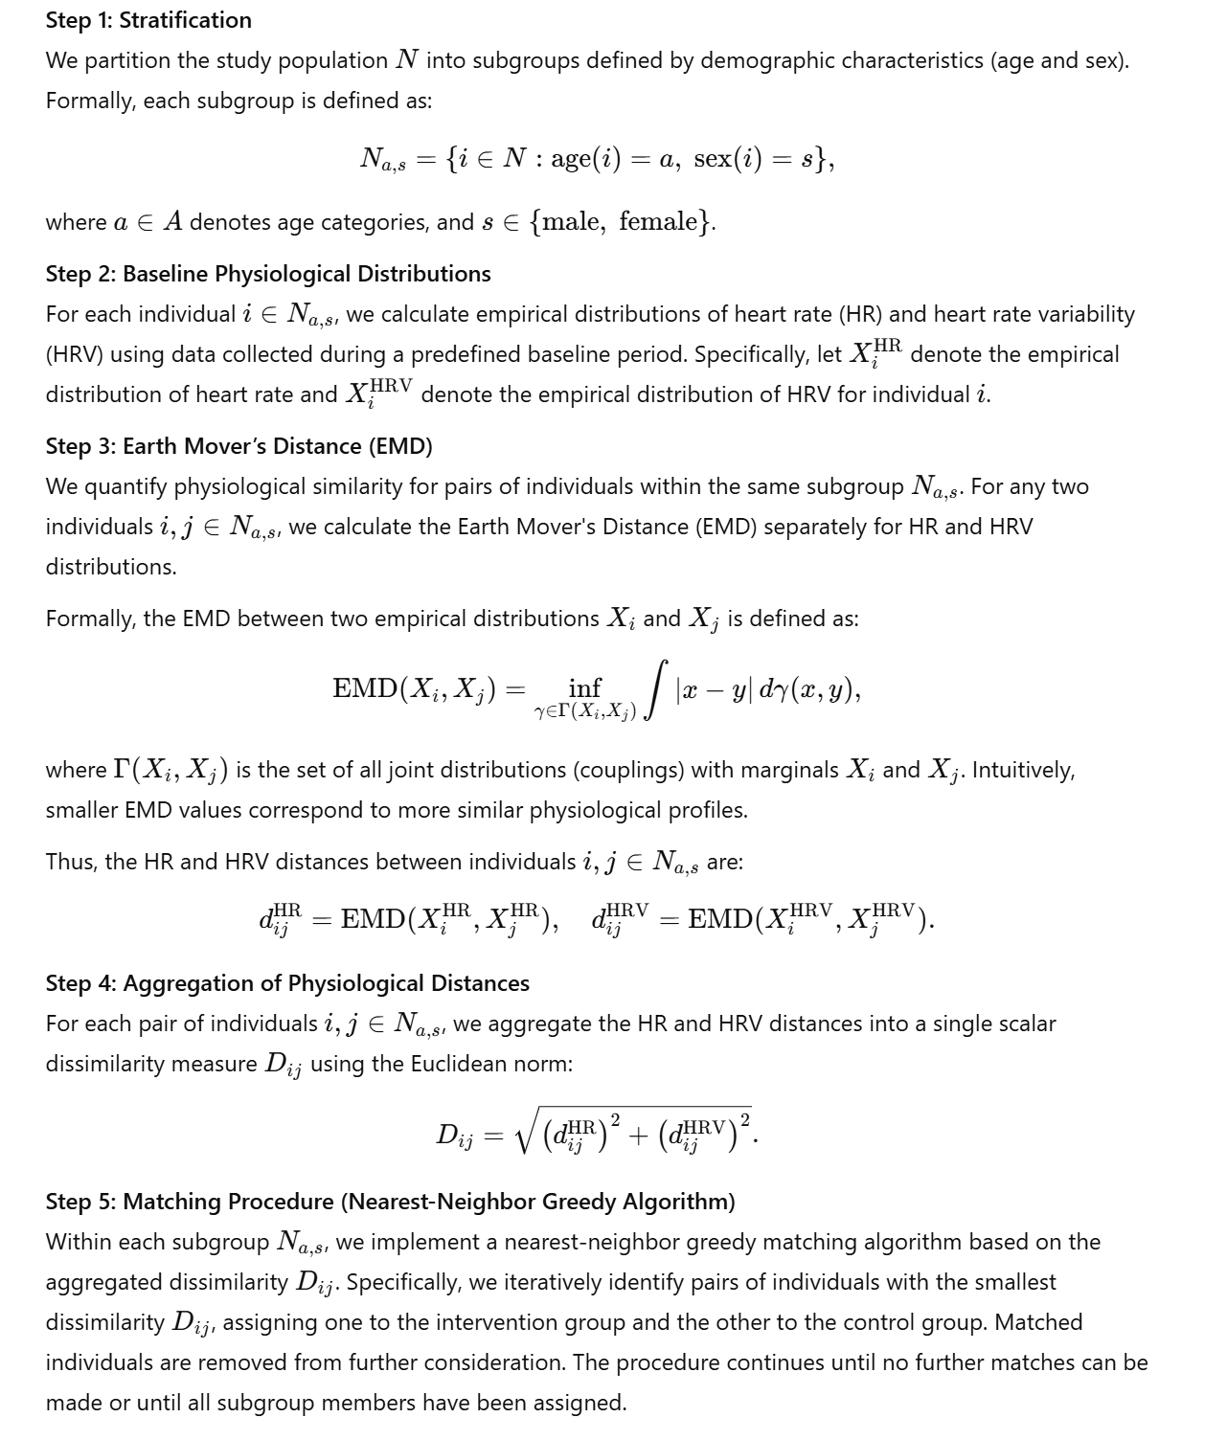

Appendix C Post-hoc Validation of Vaccination Timing
To ensure that differences in vaccination timing between matched individuals did not influence our matching results or bias our results, we performed a post-hoc analysis examining the time elapsed between vaccinations within each matched pair. Specifically, for each iteration of the matching procedure, we constructed cumulative distribution functions (CDFs) illustrating these time differences. Across all iterations, these CDF plots consistently demonstrated that approximately 80% of matched pairs received vaccinations within 20 days of each other. This finding provides strong evidence that vaccination timing was well-balanced between matched pairs, validating that the observed differences in outcomes between groups can be confidently attributed to physiological matching rather than differences in vaccination timing.
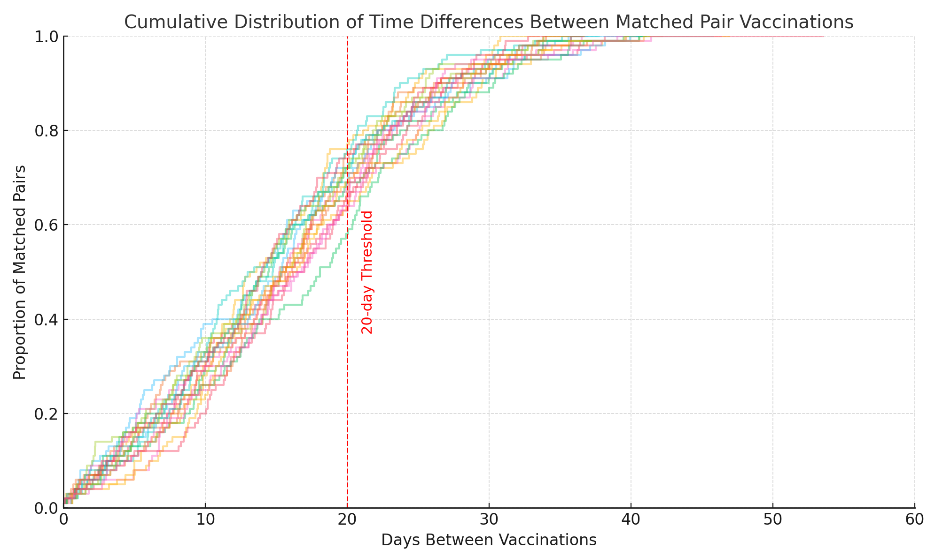
Figure S1: Cumulative distribution of the vaccination time differences within matched pairs.
Each curve represents one iteration of the matching procedure, illustrating the proportion of matched pairs (y-axis) vaccinated within a given number of days from each other (x-axis). Across all iterations, the cumulative distributions consistently indicate that approximately 80% of matched pairs received their vaccinations within 20 days of one another. This confirms minimal differences in vaccination timing between matched pairs and validates that our matching procedure effectively controlled for vaccination timing, ensuring that observed differences in outcomes reflect physiological similarities rather than variability in vaccination schedules.

Appendix D Power Analysis
We conducted a series of detailed power-analysis simulations to quantitatively evaluate how employing the Smartwatch-Informed Matching (SIM) procedure affects the required sample size in hypothetical vaccine trials. The primary goal of these simulations was to assess the extent to which SIM could reduce the necessary sample size compared to traditional matching strategies based solely on demographic characteristics (age and sex), while still maintaining a predefined statistical power.
To ensure comprehensive coverage of realistic trial scenarios, we systematically simulated 100,000 hypothetical clinical trials. Each simulation scenario aimed to estimate the effectiveness of a hypothetical vaccine under varying epidemiological and statistical conditions. Specifically, we varied the following trial parameters:
- Statistical power targets: Two commonly used thresholds for statistical power were tested—0.80 (80% power) and 0.95 (95% power)—to reflect typical and more conservative power standards frequently employed in clinical trial designs.
- Vaccine efficacy (VE): We simulated multiple levels of vaccine effectiveness (40%, 50%, 60%, and 90%), spanning scenarios from modest to high vaccine efficacy. This allowed us to evaluate how the matching method's impact varied with different expected vaccine performances.
- Probability of symptomatic infection (π): Three distinct infection-risk scenarios were assessed, specifically π = 0.003 (low-risk), π = 0.030 (moderate-risk), and π = 0.100 (high-risk). Here, π represents the joint probability of an individual becoming infected and subsequently developing symptomatic illness within the trial duration.
All simulations assumed a standard fixed significance level (α) of 0.05, consistent with the common practice in clinical trial analysis.
The simulations proceeded according to the following detailed methodology:
1. Generation of matched intervention and control outcomes:
For each simulated clinical trial, we first created matched pairs of hypothetical participants. Each pair consisted of one individual assigned to the intervention group (representing a vaccine recipient) and one assigned to the control group. This matching process utilized one of two possible matching methods: (a) the novel Smartwatch-Informed Matching (SIM) approach or (b) the conventional method based solely on demographic variables (age and sex).
Next, for each matched pair, we simulated the occurrence (or non-occurrence) of symptomatic infection. The baseline probability of symptomatic infection (π) was initially applied to control group participants. For matched intervention participants, this baseline probability was reduced proportionally based on the specified vaccine efficacy (VE). For instance, with a vaccine efficacy of 60%, the probability of symptomatic infection in the intervention group was 60% lower than in the matched control participant.
Importantly, to realistically capture the degree of physiological and symptomatic similarity between matched participants, we incorporated dependencies in their simulated outcomes. Specifically, correlations between outcomes of paired individuals were derived from empirical data previously analyzed in the PerMed dataset. We used Spearman’s correlation (ρ) for self-reported symptom severity outcomes and Pearson’s correlation (r) for outcomes based on smartwatch-derived physiological measures. By employing empirically observed correlations, the simulation accurately reflected how closely matched pairs behave similarly in real-world conditions, allowing for an authentic comparison of the SIM versus standard matching methods.
2. Power analysis and required sample size estimation:
Following the simulation of matched participant outcomes, we conducted a statistical power analysis for each hypothetical trial scenario. Our primary outcome measure was detecting a statistically significant vaccine effect at the predetermined significance level (α = 0.05).
For each combination of matching method (SIM vs. standard demographic matching), statistical power target (0.80 or 0.95), vaccine efficacy (40%, 50%, 60%, 90%), and probability of symptomatic infection (π = 0.003, 0.030, 0.100), we estimated the minimum sample size necessary to reliably detect the vaccine's effect. This estimation was performed separately for each outcome type: self-reported symptom-based outcomes and smartwatch-derived physiological outcomes.
Specifically, the required sample size was calculated as the smallest number of matched pairs needed to achieve the specified statistical power (0.80 or 0.95) to detect the true vaccine effect at the significance level of α = 0.05. This provided a rigorous, comparative metric showing precisely how much SIM matching could reduce the number of participants required in each scenario relative to conventional demographic matching.
3. Systematic replication of simulations:
To ensure robust and stable estimates, we systematically repeated this simulation and power-analysis process across a large number (100,000) of simulated trials for each parameter combination. This extensive replication provided stable and reliable estimates of required sample sizes and allowed us to precisely quantify the benefit of employing smartwatch-informed physiological matching (SIM) relative to conventional demographic-only matching.
Through this comprehensive simulation framework, our analysis explicitly quantifies the degree to which incorporating physiological similarity into matching strategies via smartwatch data can improve trial efficiency, reduce necessary sample sizes, and thereby enhance the feasibility and efficiency of future vaccine efficacy trials.
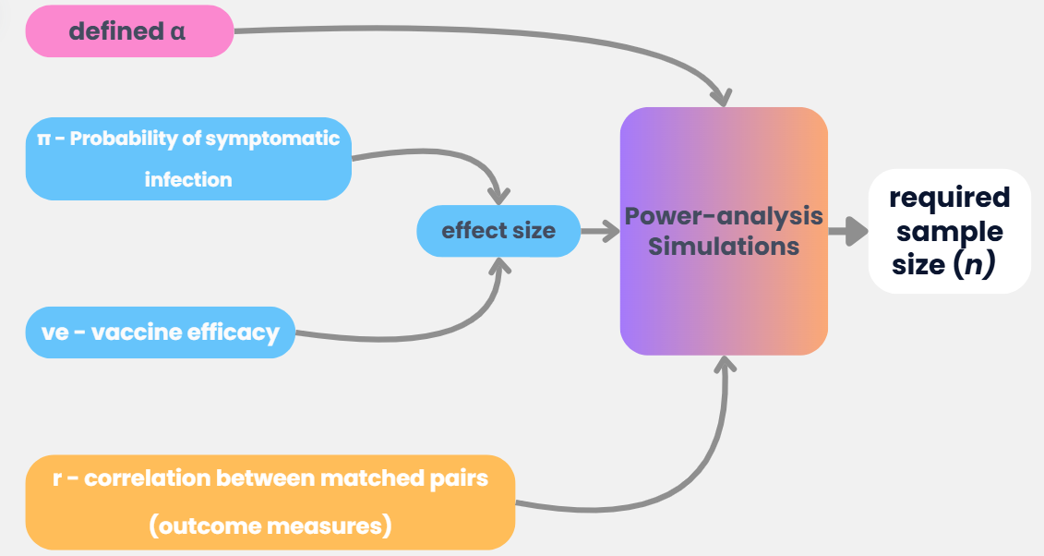

Figure S2: Overview of the power-analysis simulation framework. The required sample size for hypothetical vaccine trials was estimated through comprehensive power-analysis simulations. Input parameters included: the predefined significance level, the probability of symptomatic infection, and vaccine efficacy, which together determine the effect size. Additionally, correlations reflecting outcome similarities within matched pairs (derived from empirical smartwatch and symptom data) were incorporated. These parameters jointly informed the simulation framework, which iteratively estimated the minimal required sample size necessary to detect vaccine efficacy at specified statistical power thresholds.

References
1. Oved S, Mofaz M, Lan A, et al. Differential effects of COVID-19 lockdowns on well-being: interaction between age, gender and chronotype. J R Soc Interface 2021; 18: 20210078.
2. VÍVOSMART ® 4 Owner’s Manual. 2018. www.garmin.com (accessed Aug 23, 2021).
3. What Is the Stress Level Feature on My Garmin Watch? | Garmin Support. https://support.garmin.com/en-US/?faq=WT9BmhjacO4ZpxbCc0EKn9 (accessed Aug 24, 2021).
4. Kim H-G, Cheon E-J, Bai D-S, Lee YH, Koo B-H. Stress and heart rate variability: a meta-analysis and review of the literature. Psychiatry Investig 2018; 15: 235.
5. Pereira T, Almeida PR, Cunha JPS, Aguiar A. Heart rate variability metrics for fine-grained stress level assessment. Comput Methods Programs Biomed 2017; 148: 71-80.
6. My Garmin Watch is Not Accurately Counting Steps | Garmin Customer Support. https://support.garmin.com/en-US/?faq=z1TfJCqajl8ZEZey72gg98 (accessed Feb 19, 2024).
7. Reddy RK, Pooni R, Saharieva D, et al. Accuracy of wrist-worn activity monitors during common daily physical activities and types of structured exercise: evaluation study. JMIR Mhealth Uhealth 2018; 6: e10338.
8. Bent B, Goldstein BA, Kibbe WA, Dunn JP. Investigating sources of inaccuracy in wearable optical heart rate sensors. npj Digital Med 2020 3:1 2020; 3: 1-9.
9. Accuracy | Garmin. https://www.garmin.com/en-US/legal/atdisclaimer/ (accessed Aug 22, 2021).

