Supporting information
Far field metal-enhanced luminescence nanothermometry
By P. Wang,^{a⊥} D. Carrica, ^{b⊥} J. Bueno,^{a⊥} A. Hernández-Medel,^{b} D.H Ortgies,^{,c,d,e,f} M. Rodríguez Osorio, ^{g} D. Granados,^{g} Célia T. Sousa,^{b,f} C. Munuera,ª D. Jaque, ^{,c,d,e,f} A. Blanco, ª S. Carretero-Palacios, ª E. Martín Rodríguez,^{b,d,e,f} B. H. Juárez ª *

⊥: equal contribution
ª P. Wang, J. Bueno, C. Munuera, A. Blanco, S. Carretero, B. H. Juárez*
Instituto de Ciencia de Materiales de Madrid, ICMM, Consejo Superior de Investigaciones Científicas, CSIC. Sor Juana Inés de la Cruz, 3, 28049 Madrid, Spain
E-mail: bh.juarez@csic.es
^{b} D. Carrica, A. Hernández-Medel, Célia T. Sousa, E. Martín Rodriguez
Nanomaterials for BioImaging Group (nanoBIG), Departamento de Física Aplicada, Facultad de Ciencias, Universidad Autónoma de Madrid, C/ Francisco Tomás y Valiente 7, 28049, Madrid, Spain Madrid
D. H. Ortgies, D. Jaque
nanoBIG, Departamento de Física de Materiales, Facultad de Ciencias, Universidad Autónoma de Madrid, C/ Francisco Tomás y Valiente 7, 28049, Madrid, Spain
^{d} D. H. Ortgies, E. Martín Rodriguez, D. Jaque
nanoBIG, Instituto Ramón y Cajal de Investigación Sanitaria (IRYCIS), Ctra. Colmenar Viejo, km. 9,100, 28034 Madrid, Spain.
^{e} Institute for Advanced Research in Chemical Sciences (IAdChem), Universidad Autónoma de Madrid, 28049 Madrid, Spain
^{f} Instituto de Ciencia de Materiales Nicolás Cabrera, Universidad Autónoma de Madrid, 28049 Madrid, Spain
^{g} M. Rodríguez Osorio, D. Granados
IMDEA Nanoscience Foundation, C/ Faraday 9, Universidad Autónoma de Madrid, 28049 Madrid, Spain. Unidad de Nanomateriales Avanzados, IMDEA-Nanociencia, Unidad Asociada al CSIC por el ICMM. C/ Faraday 9, 28049 Madrid, Spain.
Methods
Chemicals：
Silver (I) diethyldithiocarbamate (AgDDTC, 99%), 1-dodecanethiol (DDT, >98%), oleylamine(OAm, ≥98%), sulfur powder(S, synthesis grade), selenium powder(Se, 99.99%), trioctylphosphine (TOP, 97%), toluene (Tol, ≥ 99.5%),acetone(technical grade), chloroform (CHCl₃, >99.8%), tetrachloroethylene (TCE, >99%), ethanol (EtOH, 96%), oleic acid (OAc, 90 %), nitric acid (HNO₃, 68%), intralipid (emulsion, 20%), agar (powder, synthesis grade). All chemicals were purchased from Merck KGaA and used without further purification.
Synthesis Procedure of Ag₂S NPs by Heat up (HU)
In a three-neck rounded flask, 0.1 mmol of AgDDTC was added along with 10 g of DDT. The mixture was heated to 200 °C and left to react for an hour. After the hour, the reaction was quenched, reducing the temperature by the addition of 4 mL of toluene. The NPs solution was washed by adding a 6-fold excess of ethanol and centrifuging at 9000 rpm for 10 minutes. Finally, the NPs were redispersed in 2 mL of toluene.
Synthesis Procedure of Ag₂(S,Se) Core/Shell Nanocrystals by Hot injection (CS)
In a typical synthesis, silver diethyldithiocarbamate (AgDDTC, 0.2 mmol), dodecanethiol (DDT, 50 mmol), and toluene (10 g) were added into a three-neck rounded bottom flask. The mixture was heated to 100°C under continuous stirring until complete dissolution of the silver precursor was achieved. Subsequently, a S@OAm solution (0.1 mL), prepared by dissolving sulfur powder (0.012 g) in oleylamine (OAm, 0.84 g) at 80°C, was rapidly injected into the reaction mixture. The solution was maintained at 100°C for 5 min to facilitate initial nucleation and growth. Thereafter, a Se@TOP solution (1.0 M, 0.1 mL) was rapidly introduced into the system. The reaction proceeded at 100°C for an additional period to promote further growth, after which the mixture was allowed to cool naturally to room temperature. The reaction mixture was transferred to a 50 mL centrifuge tube, and the product was precipitated via controlled addition of ethanol. The precipitate was collected by centrifugation at 9000 rpm for 10 min. The purified nanocrystals were ultimately redispersed in chloroform (CHCl₃, 10 mL) for subsequent characterization.
Synthesis Procedure of Ag₂(S,Se) Core/Shell Nanocrystals treated with a Zn precursor (CSS)
The shell growth procedure commenced with preparation of a supersaturated zinc stock solution. Zinc acetate dihydrate (Zn(Ac)₂·2H₂O, 0.219 g), oleic acid (OAc, 4.4 g), and 1-octadecene (ODE, 4.5 g) were combined in a three-neck flask. This mixture was heated to 130°C under vacuum to ensure precursor activation and solvent purification, yielding a transparent stock solution. For shell deposition, the Ag₂(S,Se) solution (2.5 mL) was transferred into a three-neck round-bottom flask and heated to 60°C. The pre-heated, transparent Zn stock solution was then introduced into the flask. The reaction temperature was maintained for 4 min to enable controlled epitaxial shell growth. Upon cooling to room temperature, the core/shell/shell nanostructures were purified using the identical precipitation and centrifugation protocol described for the Ag₂(S,Se) synthesis.
Preparation of the wells
Wells were fabricated by a combination of photolithography and Reactive Ion Etching (RIE). In a first step, a UV sensitive photoresist (AZ ECI 3027) was spun on a silicon substrate and baked out at 100C during 1 minute. Well’s shape was defined by exposing this resist with a laser writer (DWL66fs, Heidelberg Instruments GmbH). After a proper post-exposure bake (120C, 1 minute), the exposed resist was removed in a bath of AZ 826 MIF developer during 1 minute, and later rinsed in DI water.
A reactive ion etching process with SF₆ and O₂ allowed transferring the defined shapes to the silicon substrate but, prior to that, the substrate underwent two additional steps. The first one was a plasma descum, applied during a short time (100W, 30s). This ensured that no resist residues remained on the developed areas. The second one was carried out just before the RIE and consisted in submerging the sample in a bath of buffered oxide etch (BOE 7:1) during 1 minute. This step was intended to remove the native SiO_{x}, which could provoke the apparition of spikes on the well’s bottom during the RIE process.
The silicon etch was done by using an Inductively Coupled Plasma RIE (ICP-RIE, Plasmalab System 100, Oxford Instruments). RF and ICP power were 15W and 275W, respectively. The flow of reactive gases was set to 19sccm and 3sccm for SF₆ and O₂, respectively. Pressure was 12mTorr and the temperature was set to -95C to allow for high aspect ratio etching.
Finally, the deposition of metals was performed at UHV inside the chamber of an e-beam evaporator (Evovac, Angstrom Engineering).
Filling the wells via Drop-Casting
Following the synthesis of different types of nanoparticles, the silver content in all three NPs solutions was verified to be identical (18.5 mg/mL) by ICP-OES analysis. Subsequently, nanoparticle solution (2 μL) was withdrawn using a micropipette with a volume range of 1–10 μL. The micropipette was held perpendicular to the well, and the tip was gently lowered until the droplet made contact with the metallic substrate at the bottom of the well. Upon confirming contact, the entire liquid volume was dispensed. The samples were then dried either under a gentle nitrogen atmosphere or by allowing them to stand overnight at ambient conditions to obtain dry drop-cast films.
Preparation of Scattering Agar Phantoms to Simulate Body Tissue
To simulate biological tissue, a highly scattering tissue phantom was fabricated using agar supplemented with intralipids. Agar powder (200 mg, w/v) was added to a three-neck round-bottom flask (50 mL capacity) containing deionized water (10 mL) under continuous stirring. The mixture was subsequently heated to 110°C. Upon reaching the target temperature, intralipids (1% v/v) were introduced into the solution. After stirring for 20 min, the homogeneous mixture was dispensed into designated molds and allowed to cool to room temperature, yielding stable phantoms suitable for measurements at ambient conditions.
Inductively Coupled Plasma Optical Emission Spectroscopy (ICP-OES)
The elemental composition of silver in the different samples was determined using a Plasma Emission Spectrometer (ICP PERKIN ELMER mod. OPTIMA 2100 DV). For sample digestion, the nanocrystal (NC) solution (10 µL) was treated with concentrated nitric acid (HNO₃, 68% w/w, 990 µL) and allowed to digest overnight. Subsequently, deionized water (9 mL) was added to dilute the digested sample. Following the determination of silver concentrations in the Ag₂S cores (HU), core/shell (CS), and core/shell/shell (CSS) NC solutions, all three solutions were adjusted to a uniform concentration. These concentration-matched solutions were then employed to drop-casting on different substrates.
Hyperspectral imaging
To acquire the data presented in Figure 2 and Figure 7 of the main text, hyperspectral PL-imaging was employed. The imaging system (IR-VIVO 20219, Photon etc. Canada) comprised a filter wheel for multispectral filtering, a HyperCube™ module for hyperspectral filtering, and an InGaAs camera (ZephIR™ 1.7, Photon etc, Canada) for detection in the spectral range of 900–1600 nm. The sample wells were prepared by drop-casting nanoparticle solutions onto metallic substrates. The substrate was positioned in contact with a thermoelectric Peltier plate (SEGA INVEX 2018-0110, UAM, Spain) at an appropriate working distance of approximately 16 cm from NIR camera to obtain the NIR images.
Thermal Camera
Thermal maps were acquired with a PI 640i thermal camera, from Optris GmbH (Germany), and the images were focused with a Ge lens with a focal length of 18.7 mm. To vary the temperature the substrates were placed on a heating element connected to a temperature controller.
Steady-state optical characterization
Optical characterization was conducted in solution phase. Steady-state near-infrared (NIR) and ultraviolet-visible (UV-Vis) absorption spectra were acquired using a Cary 500 spectrophotometer (Varian). Photoluminescence (PL) spectra were obtained with a NIR spectrofluorometer (Fluorolog TCSPC, Horiba) equipped with an InGaAs detector (Symphony II, Horiba).
For optical excitation, a LIMO 808 nm laser (Aerodiode, France) was employed as the external illumination source, with power densities ranging from 0.4 to 50 mW/cm². The emitted luminescence was collected and spectrally analyzed by the HyperCube™ module (spectral resolution: δλ = 6 nm) before detection by the InGaAs camera. The integration time was varied between 5 and 100 ms depending on the experimental requirements. Luminescence images and spectra were recorded and processed using the PHySpec™ software package (Photon etc, Canada).
Dynamic optical characterization
Luminescence decay curves were obtained using time-correlated single photon counting (TCSPC) on a Timeharp 260 module (PicoQuant) and a photo multiplier tube (PMT) detector (H10330C, HAMAMATSU). The samples were excited by a pulsed laser (EPL-640, Edinburgh Instruments) at a wavelength of 634 nm, featuring a pulse width of 100 ps and a repetition rate of 2 MHz. To generate the decay curve, the samples were illuminated with the pulsed laser, and the photoluminescence was detected by the PMT detector, with a 900 nm long pass filter positioned in front of it. The Timeharp module recorded the resulting photon arrival times.
High-Resolution Transmission Electron Microscopy
High-resolution transmission electron microscopy (HRTEM) images were acquired using a JEOL-JEM Grand ARM 300cF microscope (Madrid, Spain) operated at 60 kV. The microscope was equipped with a spherical aberration (Cs) corrector (ETA-JEOL) and a CMOS camera (4096 × 4096 pixels, Gatan OneView). Energy-dispersive X-ray spectroscopy (EDS) for localized chemical analysis was performed on a JEOL-JSM ARM200F microscope featuring a cold field emission gun and probe spherical aberration correction, operated at 80 kV.
KPFM Measurements
A commercial Atomic Force Microscopy (AFM) system, from CSI Instrument, operating in ambient conditions was employed to perform morphological and surface potential (KPFM) characterization of the samples. Measurements have been acquired in dynamic mode, using the amplitude as the feedback channel for topography acquisition. Surface potential maps have been measured using single pass KFM mode (HD-KFM) with Au-coated tip from Nanosensors (PPP-FMAu). Vac voltage for KPFM measurements was applied to the tip, Vac=1V. Image analysis was performed with the Gwyddion free software.
KPFM records the contact potential difference (V_{CPD}) between the tip and sample, which is defined as V_{CPD} = (ϕ_{tio} – ϕ_{sample})/e, where ϕ_{tip} and ϕ_{sample} are the work functions of the tip and sample, respectively, and e is the elementary charge (1.6 × 10⁻¹⁹ C). The surface potential (SP) values reported in KPFM images correspond to the local CPD measured at each point on the sample. Since these SP is always referenced to the tip, all measurements were performed using the same probe whenever possible, to enable direct comparison between samples and to minimize tip-related variations. This was achieved for all cases except for the HU NPs on Au sample, for which a second tip was required; This was achieved for all cases except for the HU NPs on Au sample, for which a second tip was required. In this case, both the empty and filled Au wells were measured using this second tip to allow direct comparison between them,
KPFM measurements were carried out sequentially, alternating between different samples and repeatedly measuring the same system to confirm that the recorded SP values were consistent over time, demonstrating that the measured differences are intrinsic to the samples.
Simulations
Optical simulations were performed using the Transfer Matrix Method (TMM) implemented in the STACK solver of the commercial software Ansys Lumerical [Lumerical Inc. https://www.lumerical.com/.]. The goal was to calculate the emission properties of Ag₂S NP layers deposited within the wells on different substrates (Ag, Au, and Si). The simulated structure consisted of a planar multilayer stack with the configuration air / Ag₂S (17 µm) / metal (100 nm) / Si (semi-infinite).
The refractive indices were taken from literature values for bulk Ag₂S [Nasrallah, T. B., Dlala, H., Amlouk, M., Belgacem, S. & Bernède, J. C. Some physical investigations on Ag₂S thin films prepared by sequential thermal evaporation. Synth. Met. 151, 225–230 (2005)], from Johnson and Christy for metals [Johnson, P. B. & Christy, R. W. Optical Constants of the Noble Metals. Phys. Rev. B 6, 4370–4379 (1972).], and from Palik for crystalline silicon [Palik, E. D. Handbook of Optical Constants of Solids. (Academic press, Orlando San Diego New York, 1985).]. To reproduce the morphologies observed experimentally by FESEM, the NP layer was modeled as an effective homogeneous medium, with its refractive index determined using either the Bruggeman effective-medium approximation or a simple volumetric mixing model to account for porosity. Packing fractions were chosen according to the observed morphologies: approximately 74 % for CS, 70 % for HU, and 40–60 % for CSS samples, which displayed a more random, porous arrangement.
Simulations were carried out in two steps.
- Excitation field. The system was illuminated by a plane wave at λ = 808 nm under normal incidence, and the spatial distribution of optical absorption within the NP layer was computed to determine the optically active region from which emission originates.
- Emission modeling. Emission from Ag₂S NPs was modeled as radiation from isotropic electric dipoles uniformly distributed along the z-axis (depth direction) within the Ag₂S layer, which was assumed to be optically transparent at the emission wavelengths.
For each dipole position, three orthogonal polarizations were simulated to obtain the total emitted power and the Purcell factor ($F$) of an isotropic source. The dipoles were placed at discrete depths $z_{i}$ throughout the Ag₂S layer, limited to the optically active region (2–3 µm from the surface), with a step size of 10 nm. This yielded a full spatial dependence of the emission response for each NP type and substrate configuration.
The calculated Purcell factor, defined as the ratio between the total power emitted by the dipole and that radiated in an infinite homogeneous medium, oscillates around and remains very close to unity, indicating negligible plasmonic enhancement or cavity coupling.
The far-field radiated power $P_{out}$ was obtained by integrating the power emitted into the upper half-space over all emission angles. The outcoupling efficiency was calculated as $η= P_{out}/F$, averaged over the three orthogonal dipole orientations.
The internal PLQY was kept constant during simulations, as the emitter–metal separation (>100 nm) is too large for any significant modification of the local density of optical states (LDOS) or Purcell enhancement. Simulations of PL enhancement across different substrates were performed independently for each case (Ag, Au, Si), using the experimental PLQY values of 2.5 % (HU), 1 % (CS), and 9 % (CSS). The emission spectra were weighted according to the experimentally measured PL profiles of the colloidal NP solutions and modulated by the computed excitation field distribution, ensuring realistic spectral and spatial weighting.
To emulate the experimental films, which lack perfectly plane-parallel interfaces, the simulated spectra were smoothed to suppress interference fringes, effectively mimicking random-phase averaging and removing coherent interference effects. The smoothing was implemented via spectral averaging over ±Δλ ≈ 30 nm. Other possible contributions, such as reabsorption or photon recycling, were neglected due to the large Stokes shift of Ag₂S emission.
Finally, the model yields the following quantities:
- Spatial absorption maps (excitation field profiles) identifying the optically active region,
- Purcell factors and outcoupling efficiencies for isotropic emitters at different depths, and
- Far-field PL enhancement factors comparing the detected emission on metallic and silicon substrates.

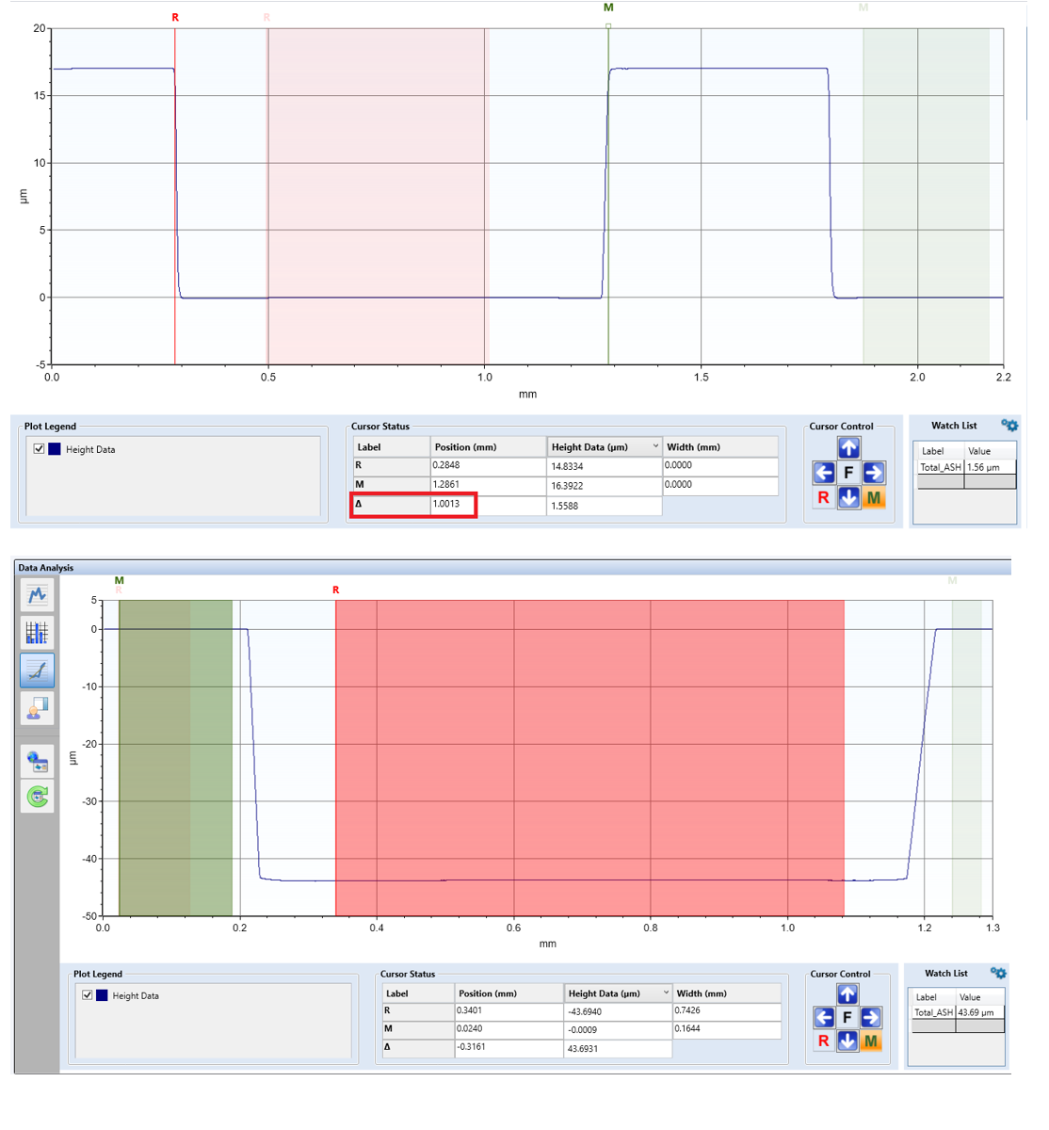
Figure S1. Profilometry of the wells of 17 microns depth in 2 mm diameter (top image) and 40 microns depth in 1 mm diameter (bottom image).
.
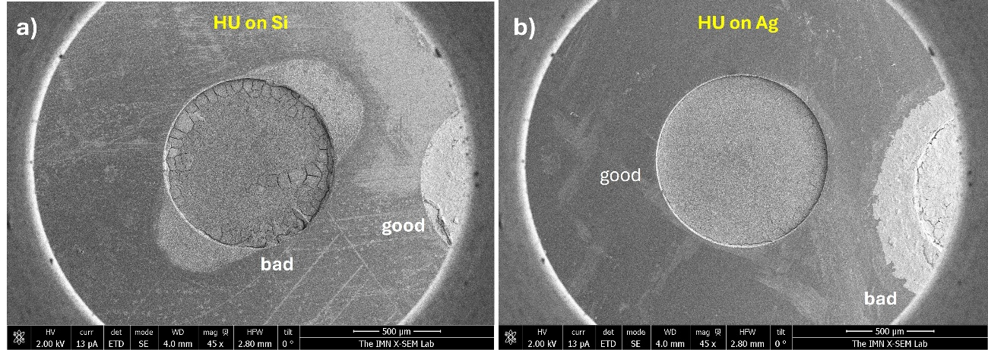 Figure S2. a), b) FESEM images at low magnification showing the non-perfect deposits observed in some of the wells. Bad and good deposits are observed under the SEM microscope

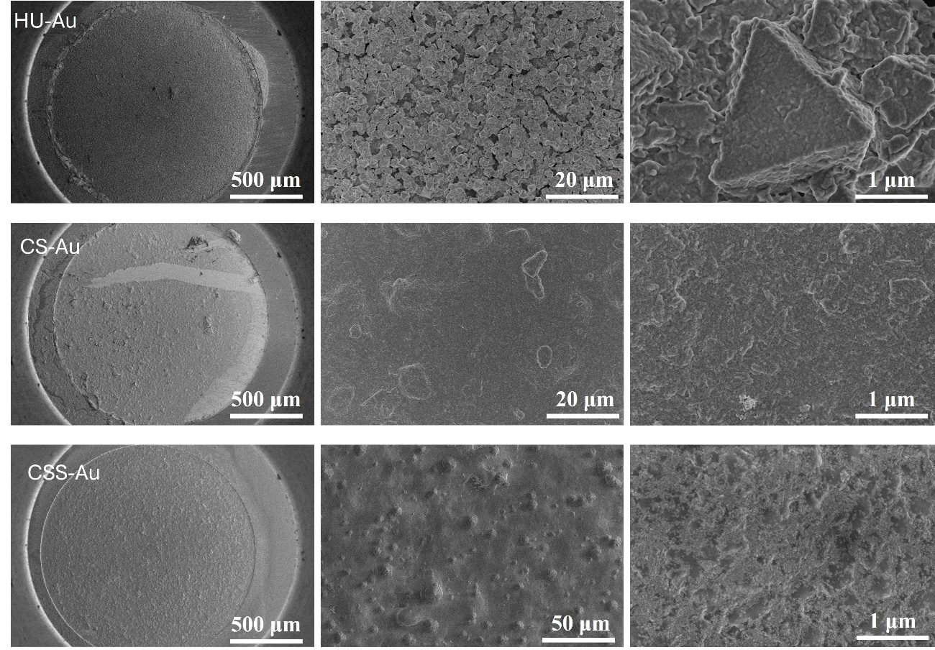
Figure S3. FESEM images at different magnifications of HU, CS and CSS samples on Au substrates.

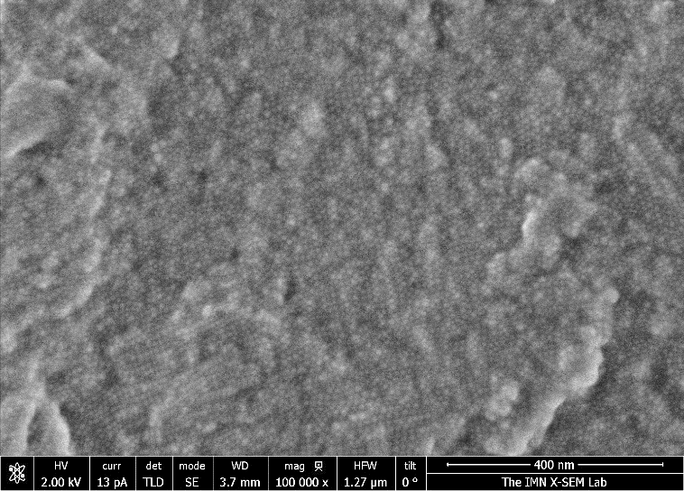
Figure S4. Detail at high magnification of the close packed deposits for CS samples
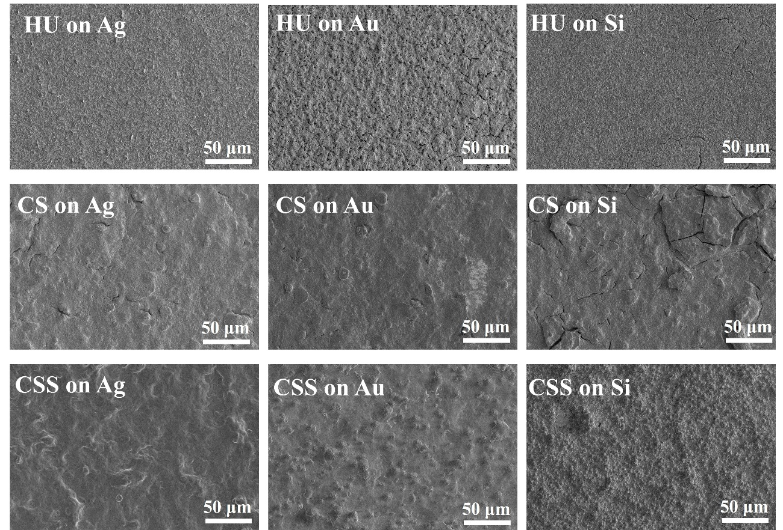
Figure S5. FESEM images of HU, CS and CSS NPs on different substrates, Ag, Au and Si, evidencing a similar organization, regardless the substrate

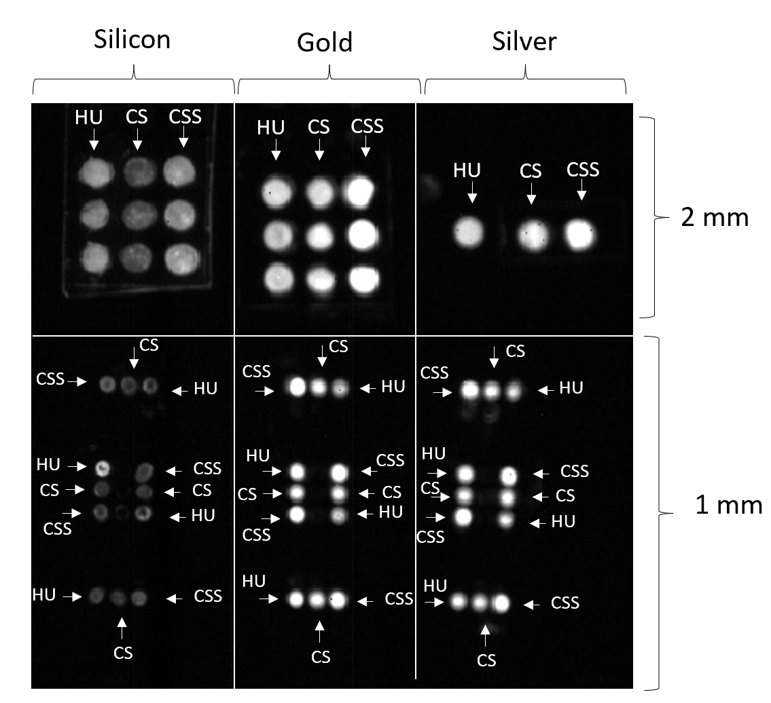
Figure S6. NIR PL images obtained for different wells (2 or 1 mm in diameter) with HU, CS, or CSS NPs.

Time-resolved photoluminescence measurements
Time-resolved photoluminescence measurements were performed on nine samples representing all combinations of three substrates (Si, Au, Ag) and three surface treatments (HU, CS, CSS).
Systematic analysis revealed that the bi-exponential model provides the optimal description of decay kinetics. Rigorous comparison among four mathematical models demonstrated that while the mono-exponential model proved systematically inadequate (R² = 0.988-0.995), the bi-exponential model achieved excellent fits (R² = 0.995-0.999) across all samples. The tri-exponential model, despite incorporating three additional parameters, yielded only marginal improvements (ΔR² < 0.002) that fail to justify the increased complexity according to the parsimony principle. The log-normal distribution model, although providing reasonable fits (R² = 0.994-0.998), exhibited greater inter-sample variability and systematic overestimation of lifetimes.
Thus, we focused on the bi-exponential fits (R² = 0.995-0.999) described by I(t) = A₁exp(-t/τ₁) + A₂exp(-t/τ₂) + y₀ that reveals two distinct recombination timescales: a fast component that varies from HU to CSS NPs (τ₁ = 86.2 - 171.6 ns) and a slow component (τ₂ = 286.4 -987.1 ns) that vary from HU to CSS NPs.
The intensity-weighted average lifetime was calculated according to
$$Av.lifetime= \frac{A_{1 }{τ₁}^{2} + A_{1 }{τ₂}^{2}}{A_{1 }τ₁+A_{2 }τ₂}$$
representing the mean photon emission time weighted by the integrated intensity contribution of each decay:
Sample | $$A_{1 }$$ | $$A_{2 }$$ | τ₁ | τ₂ | Average lifetime (ns)
HU on Si | 0.45905 | 0.5079 | 98.28602 | 312.60902 | 265.18
HU on Au | 0.4067 | 0.56888 | 86.92252 | 286.42262 | 250.86
HU on Ag | 0.40362 | 0.56429 | 86.25002 | 292.99400 | 257.03
CS on Si | 0.41648 | 0.52917 | 64.66579 | 312.11121 | 277.42
CS on Au | 0.39671 | 0.53533 | 85.14723 | 398.06335 | 355.25
CS on Ag | 0.41042 | 0.53219 | 80.37446 | 381.34390 | 339.26
CSS on Si | 0.29902 | 0.61002 | 146.99032 | 881.32653 | 825.83
CSS on Au | 0.29097 | 0.63942 | 171.63187 | 961.39612 | 902.06
CSS on Ag | 0.26805 | 0.65271 | 153.41588 | 987.07249 | 937.05
Table S1. Averaged lifetimes of the different NPs on the different substrates fitted to a bi-exponential function.
The decay curves were analyzed using an automated computational pipeline to ensure statistical rigor and reproducibility. An initial averaged baseline (calculated from pre-pulse data points) was subtracted from all curves to remove detector dark counts. Raw data were temporally aligned to the maximum intensity point (t = 0 at I_{max}), with all prior data discarded to eliminate excitation pulse contributions. An automated noise truncation algorithm was implemented based on signal-to-noise ratio (SNR) criteria: the final 25% of each decay curve was analyzed to estimate background noise using the median and Median Absolute Deviation (MAD). Data points were retained only where I(t) exceeded a conservative 5σ threshold (noise_level + 5 × 1.4826 × MAD), resulting in removal of 15-40% of tail data where photon counts approached detector dark noise (I/I_max < 0.01). This approach eliminates subjective decisions regarding valid data range while preserving exponential decay information.
Statistical weighting followed proper Poisson statistics where σ = √N for photon counting. Critically, weights were calculated on raw, unnormalized intensity data as σᵢ = √(I_raw,i) / I_max before normalization to I_norm = I_raw / I_max, ensuring correct uncertainty propagation. All data processing was performed using Python 3.9+ with NumPy, SciPy, and Pandas libraries.

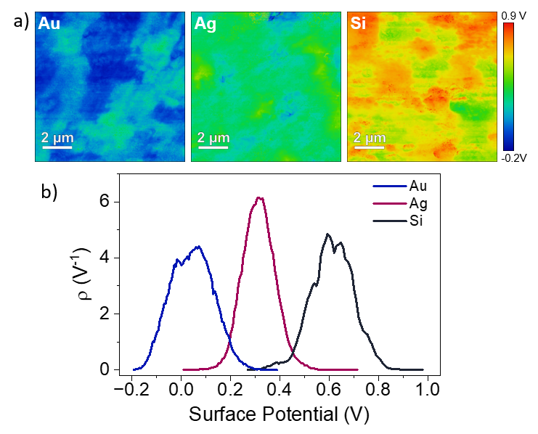
Figure S7, KPFM images on empty wells. The figure shows the surface potential (SP) maps (a) and their corresponding distributions (b) for the empty wells. A clear difference in SP is observed among the three substrates, which can be attributed to their different work functions (WFs). In our KPFM configuration, lower (higher) SP values correspond to higher (lower) WF values. Accordingly, Au and Si follow the expected trend, with a measured SP difference of ΔSP_{Au - Si} = 0.47 ± 0.04 V, in good agreement with the expected WF difference (ϕ_{Au} ≈ 5.1 eV; ϕ_{Si} ≈4.6 - 4.8 eV). The Ag wells exhibit an SP that is 0.22 ± 0.03 V higher than Au and 0.24 ± 0.04 V lower than silicon, corresponding to an apparent work function of ϕ_{Ag} ≈4.8 eV. This value is noticeably higher than the typical WF for Ag surfaces, and the discrepancy can be reasonably ascribed to surface oxidation.

Volumetric mixing model
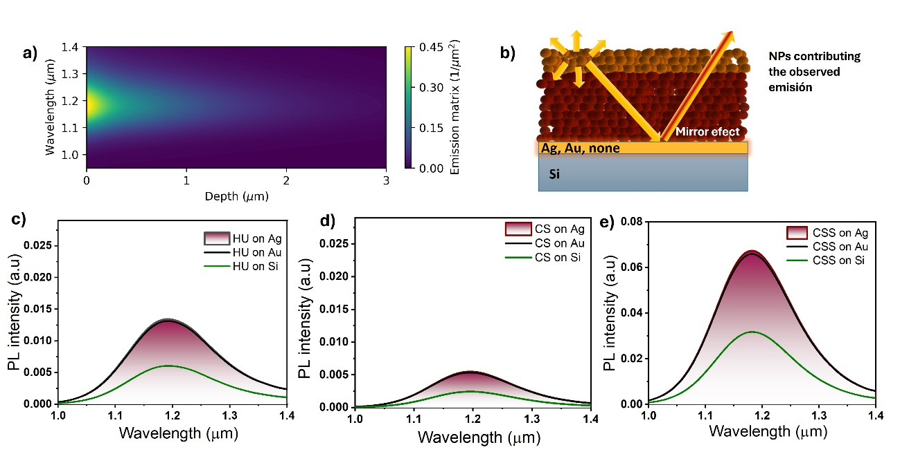
Figure S8. a) Contour map of the excitation-emission process for a plane wave incident on wells containing a 17 µm-thick Ag₂S layer (CSS-type NPs) deposited on a semi-infinite Si substrate, modeled using a volumetric effective-medium approximation for the NP refractive index. Simulations were performed at λ = 808 nm under normal incidence; the color scale represents the normalized electric-field intensity escaping the system. b) Schematic representation of the NP layers on the substrate, illustrating that only the upper few micrometers are optically excited and contribute to the detected PL. c–d) Simulated PL enhancement factors for HU, CS, and CSS NPs, calculated assuming PLQY values of 2.5 %, 1 %, and 9 %, respectively. The filling fractions were chosen according to the morphologies observed in FESEM images: 75 % for HU, 70 % for CS, and 40 % for CSS samples.
Simulations for more densely packed CSS layers (up to 60% filling fraction)
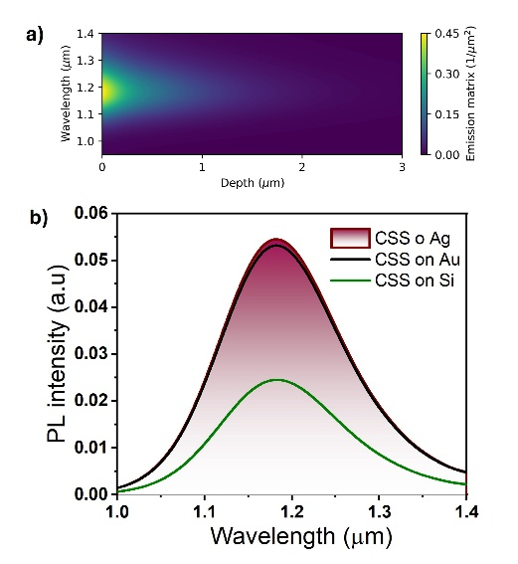
Figure S9. a) Contour map of the excitation-emission process for a plane wave incident on wells containing a 17 µm-thick Ag₂S layer (CSS-type NPs) deposited on a semi-infinite Si substrate, modeled using the Bruggeman effective-medium approximation for the NP refractive index with a filling fraction of 60 %. Simulations were performed at λ = 808 nm under normal incidence; the color scale represents the normalized electric-field intensity escaping the system. b) Simulated PL enhancement factor for CSS NPs, calculated assuming a PLQY of 9 %.

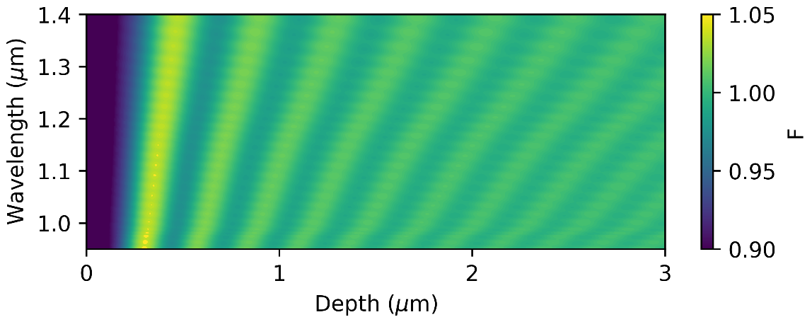
Figure S10. Contour map of the calculated Purcell factor in a 17 µm-thick Ag₂S layer (CSS-type NPs) deposited on a semi-infinite Si substrate, modeled using the Bruggeman effective-medium approximation for the NP refractive index with a filling fraction of 40 %. Results are shown for the excitation region (2-3 top µm), revealing a negligible Purcell factor enhancement oscillating around unity.
Acquisition and calculation of the Thermal Sensitivity
In the HyperSpectral imaging setup, the 3 set of samples were placed on top of a heating element to control the temperature (thermoelectric Peltier plate, SEGA INVEX 2018-0110, UAM, Spain). The samples were illuminated by an 808 nm laser at 15.8 mW/cm² and the data acquired from 900 to 1600 nm in steps of 5 nm. Figure S10a) shows the optical image of the 3 set of samples, wells on Si, wells on Ag and wells on Au. Figure S10b) shows the result of a HI image, where the different labels correspond to HU, CS or CSS samples, as explained in the main text. The hyperspectral images obtained with the PhYSPEC program (.H5 files) were opened by FIJI (Image J extension) and the stacked into one single image. This was performed for temperatures from RT to above 50 degrees. The comparative PL intensity for all wells was acquired by fixing a selected region of interest, ROI, in FIJI, placing a circular selected area of 52 units centered in the middle of every luminescent dot.
Processing of data
On each substrate there are 4 wells containing HU NPs, 4 wells containing CS and 4 wells containing CSS NPs. In FIJI, on each well, a rounded and centered area of interest (ROI) of 52 units was selected and the averaged intensity and standard deviation acquired. These data are plotted in Figure 6a-c, in the main text.
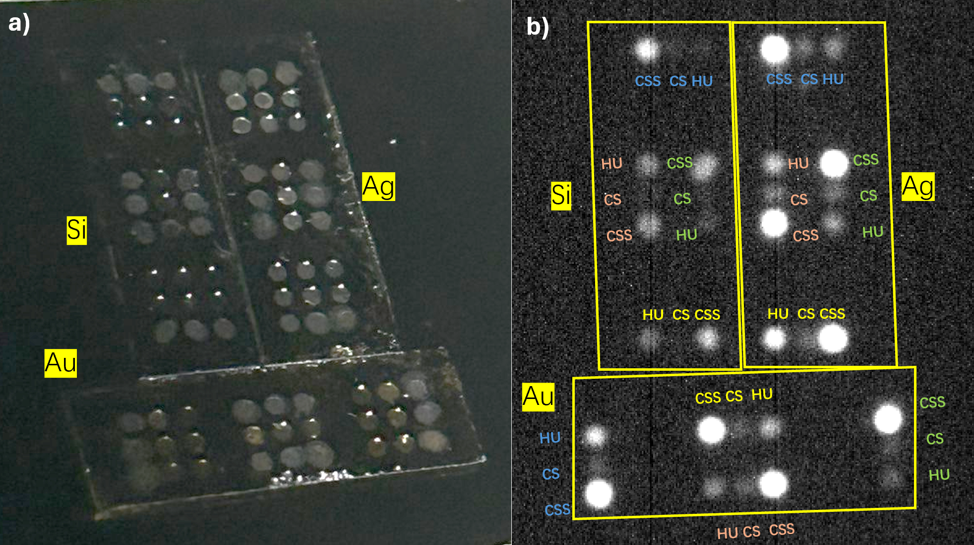
Figure S11. a) Optical image of the 3 set of samples containing wells with HU, CS and CSS NPs. b) A PL image of the wells.
Thermal camera measurements
Temperature values of the X-axes in Figure 6 were acquired in a thermal camera. It is known that metals are low-emissivity materials that reflect ambient IR radiation, instead of emitting their own signal. This causes underestimation of surface temperature, and that is the reason why metals show colder in the thermal image shown in Figure 11. For this reason, the acquired temperatures in figure 6 are the maximum temperature obtained in the marked area on Silicon, exclusively.
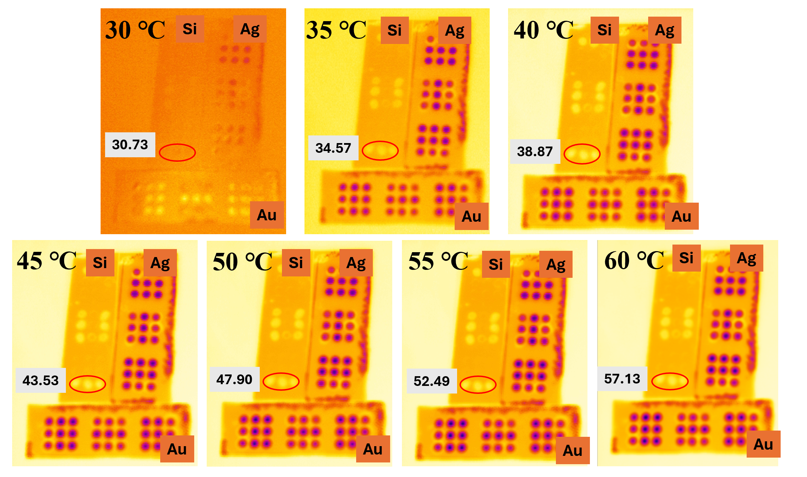
Figure S12. Thermal images of the substrates placed on a heating mantel with the temperature target indicated on the left upper corners of each image. The marked temperature values of the surrounded areas are the ones used in Figure 6, main text.
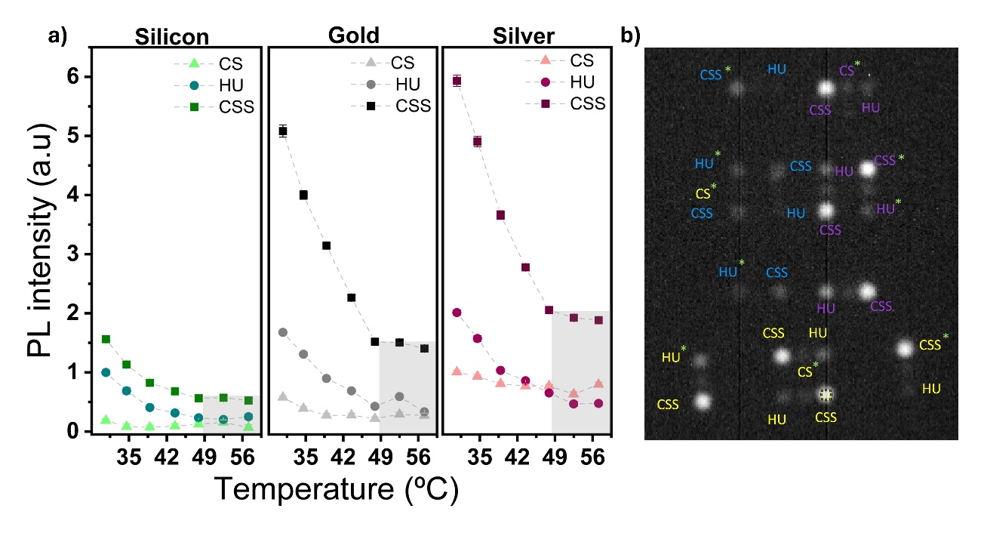
Figure S13. a) PL intensity versus temperature for CS (triangles), HU (dots), and CSS NPs (squares) on silicon (left), gold (middle), and silver substrates (right) panels. The intensity was collected not as an average PL value from 4 wells, as in Figure 6c, main text, but from the indicated wells marked with a green asterisk in Figure S13b). The light-grey areas above 50 °C indicates a low SNR PL signal, and therefore, this region

