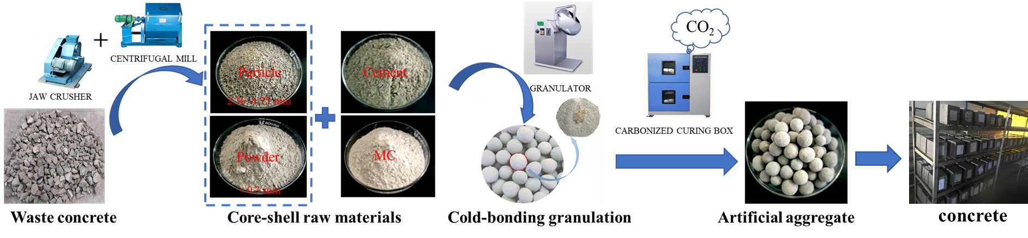
Preparation process of the artificial aggregate and its application

