Table of Contents
- ¹H-NMR, ¹³C-NMR and HRMS-ESI spectrum of probe 1 (Fig. S1–S3)………S2
- The absorbance detection limit of probe 1 in THF (Fig. S4)…………………..S4
- The UV-vis titration of probe 1 in THF-H₂O (Fig. S5) ………………………..S4
- The fluorescence detection limit of probe 1 in THF (Fig. S6)………………....S5
- Comparison of spectra of probe 1 and 2 before and after interaction with fluoride ion (Fig. S7)……………………………………………………………….……S6
- ¹H-NMR titration spectra of probe 1 for fluoride ion (Fig. S8)…………………S6
- Comparison of probe 1 with some reported fluoride probes (Table. S1)…….…S7

- ¹H-NMR, ¹³C-NMR and HRMS-ESI spectrum of probe 1
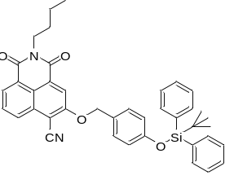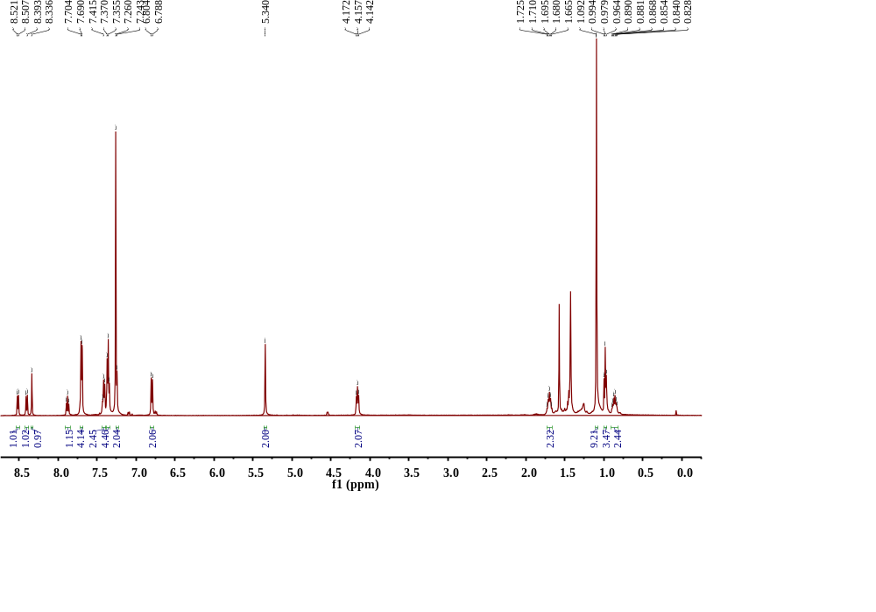
Figure S1.¹H NMR (CDCl₃, 500 MHz) spectra of probe 1.

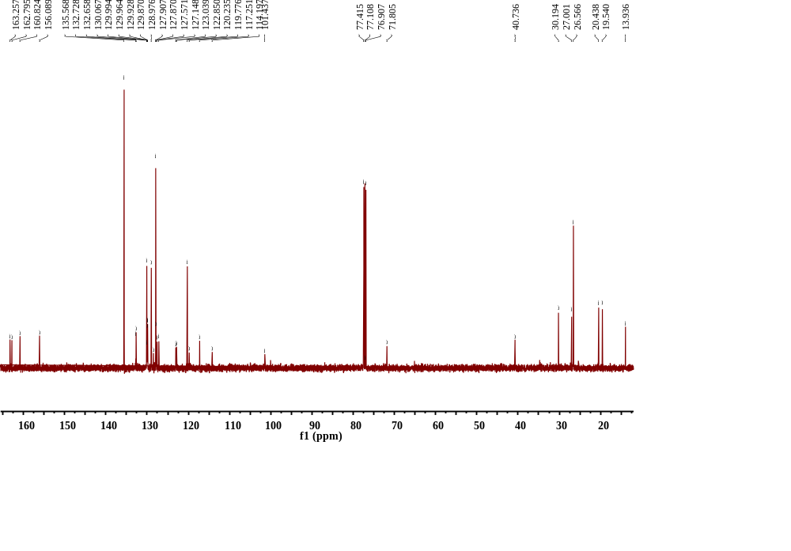
Figure S2. ¹³C NMR (CDCl₃, 125 MHz) spectra of probe 1.
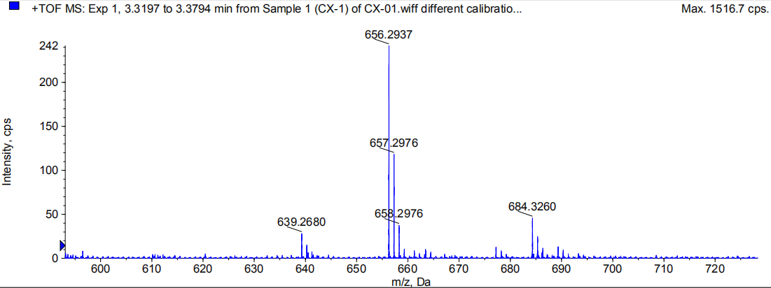
Figure S3. HRMS-ESI mass spectra of probe 1.

- The absorbance detection limit of probe 1 in THF
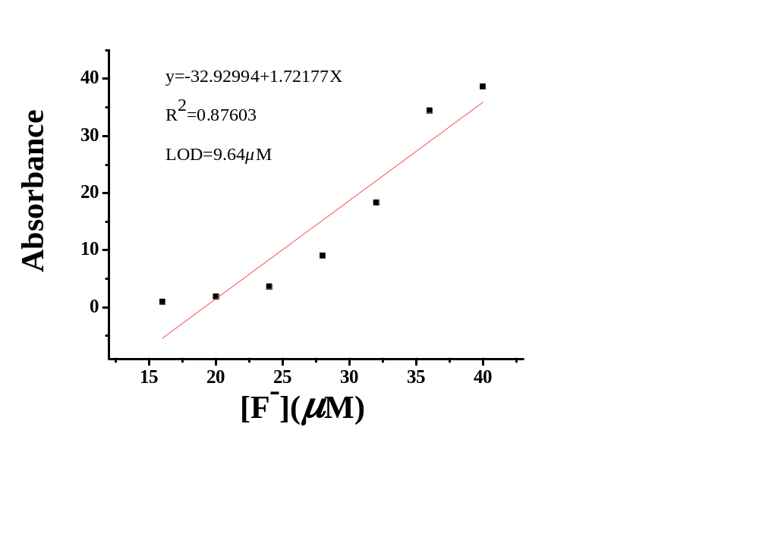
Figure S4.Absorbance detection limit calculation of probe 1 in THF
Equation | Y=A+BX
Parameter | Value | Error
A | -32.92994
B | 1.72177
R | SD | N
0.87603 |  | 7

- The UV-vis titration of probe 1 in THF-H₂O
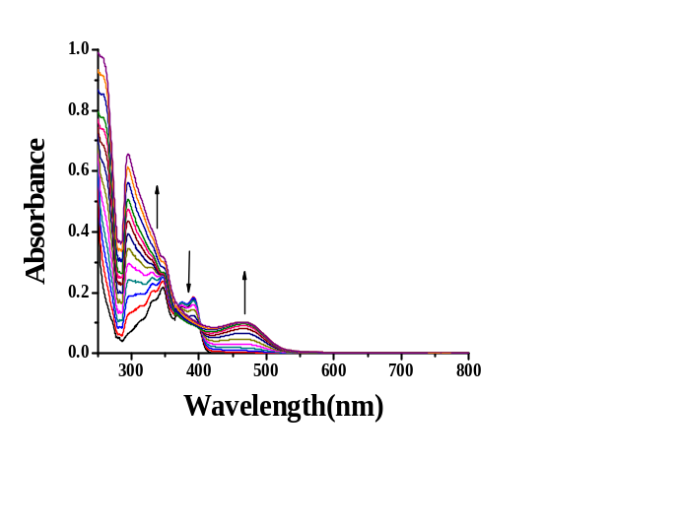
Figure S5. UV-visible titration of probe 1 (20 μM) upon titration with TBAF (5 mM) (0 to 1000.0 equiv) in THF/H₂O (v/v: 9:1).

- The fluorescence detection limit of dosimeter 1 in CH₃CN
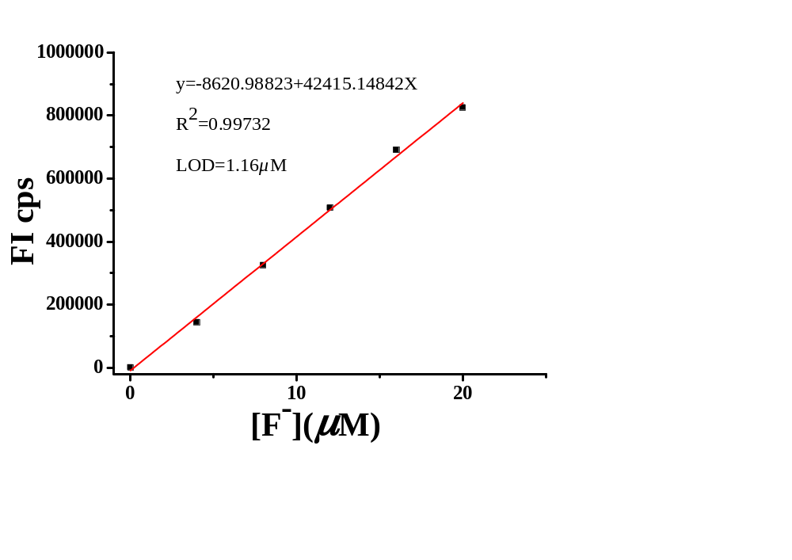
Figure S6.Fluorescence detection limit calculation of probe 1 in THF.
Equation | Y=A+BX
Parameter | Value | Error
A | 8620.98823
B | 42415.14842
R | SD | N
0.99732 |  | 6
- Comparison of spectra of probe 1 and 2 before and after interaction with fluoride ion
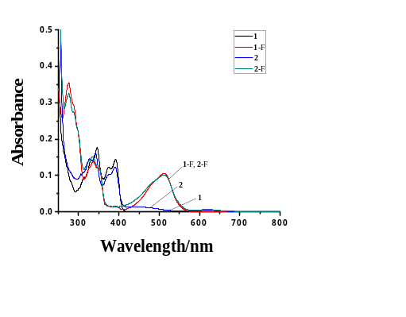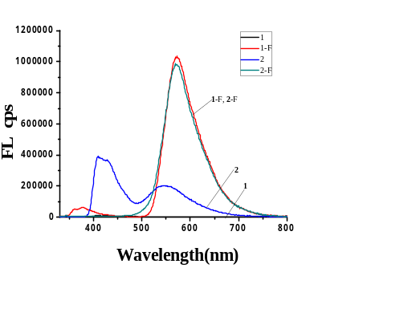
Figure S7. (a) UV absorption spectrum of probe 1 and reference 2 before and after interaction with fluoride ion. (b) Fluorescence emission spectrum of probe 1 and reference 2 before and after interaction with fluoride ion.

- ¹H-NMR titration spectra of probe 1 for fluoride ion

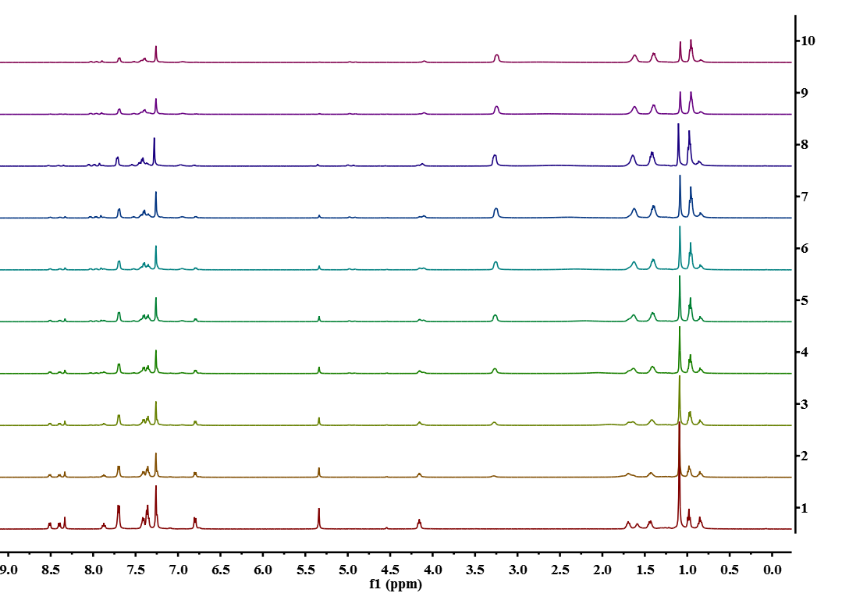
Figure S8. ¹H-NMR titration spectra of probe 1 (20 mM) upon addition of various equivalents fluoride ions in CDCl₃, from the bottom to top: probe 1 and 0-1.8 equiv fluoride ions.

- Comparison of probe 1 with some reported fluoride probes.
Table S1. Comparison of probe 1 with some reported fluoride probes.
Probe | Solvent | λ_{ex}/λ_{em}  (nm) | Detection limit(μM) | fluorescence | Application | Ref.
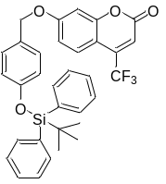  dosimeter 1 | acetonitrile | 410/500  nm for fluorinion | 0.13μM  for fluorinion | On | test papers | 22
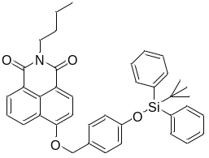  NP-OTBDPS | V_{DMSO}:V_{H2O} = 9:1 | 300/560  nm for fluorinion | 0.07μM  for fluorinion | On | test-strips | 23
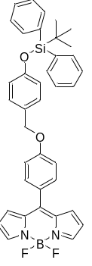  probe R | DMF | 450/513  nm for fluorinion | 163 nM  for fluorinion | Off | test papers | 24
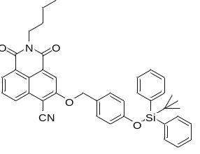probe 1 | THF | 410/570nm for fluorinion | 1.16μM  for fluorinion | On | test papers | This work

