Appendix 1

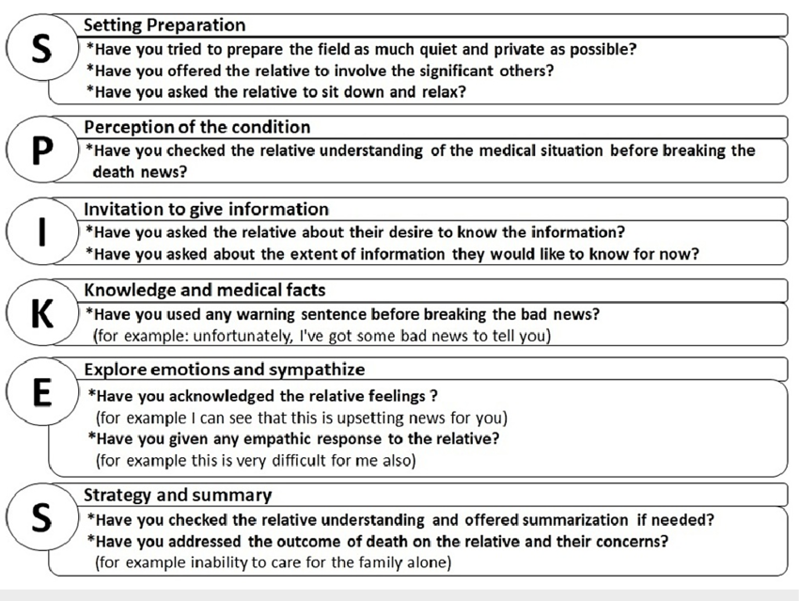

Appendix 2. Preliminary survey form for healthcare staff.

Objectives :
- Identify difficulties encountered during diagnosis disclosing the diagnosis.
- Gather suggestions for improvement.
- Sociodemographic data.
- Age
- Sex
- Nationality
- Professional profile : Oncologist Gynecologist Midwife

Radiotherapist Other, please specify

- Establishment :
- Seniority :
- Frequency of disclosure : ……………………number/months

- Perception of the disclosure procedure.
- Training:

◦ Have you received specific training to conduct disclosures? Yes No

◦ If yes, did this training provide you with the necessary tools? Yes No

◦ If no, would you like to receive such training? Yes No

- Resources:
◦ Do you have the necessary resources (documentation, psychological support, etc.) to conduct a disclosure? Yes No

◦ If yes, please specify:
◦ Institutional support:
◦ Do you feel supported by your management in conducting disclosures?
Yes No

◦ If yes, please specify:
- Difficulties encountered.
What are the main difficulties you encounter during disclosures? (Check the corresponding options and specify if needed)
Lack of appropriate framework/structure

Inappropriate or difficult language to use

Inappropriate attitudes (from the patient, family member or caregiver)

Lack of time to properly conduct the disclosure

Difficulties managing patients' emotions

Other, please specify:

- Professional practices.
Preparing for the disclosure
- How do you prepare for a disclosure?
- What elements do you consider essential for conducting a disclosure effectively? (Multiple answers possible)
Complete collection of medical information

Knowledge of the patient's personal context

Personal emotional preparation (taking a step back, managing stress)

Choosing a suitable place and time

Anticipating possible questions and reactions

Availability of complementary resources (psychologist, documentation)

Other, please specify

- How the disclosure is made?
- What are the main points you cover when making the disclosure? (Multiple answers possible)
Clear and adapted information about the diagnosis

Explanations about the proposed treatments

Answers to questions and concerns
Information about medical follow-up and available support

Expressing empathy and support

Managing emotional reactions

Other, please specify

- How do you manage patients' emotional reactions? (Multiple answers possible)
Respect moments of silence and allow the patient to express her emotions.

Use active and caring listening.

Offer immediate or future psychological support.

Reassure the patient by answering questions with empathy.

Call on a multidisciplinary team (psychologist, social worker).

Adapt to each patient’s rhythm pace and emotional needs

Appendix 3. Medical staff satisfaction questionnaire

Objectives :
• Assess healthcare professionals' satisfaction with the disclosure protocol.
• Identify strengths and weaknesses of the protocol
• Gather suggestions for improvement.
            - Sociodemographic data.
Sex :
Age :
Profession :
Years of practice :
Nationality :
Place of practice :
Frequency of disclosure : ...number/months

            - Perception of the disclosure protocol.

On a scale of 1 to 10, to what extent has the disclosure protocol enabled you to feel comfortable when conducting disclosures?
1 : Not at all comfortable
2 : Very little comfortable
3 : Sligthly comfortable
4 : Rather uncomfortable
5 : Neither comfortable nor uncomfortable
6 : Rather comfortable
7 : Comfortable
8 : Very comfortable
9 : Extremely comfortable
10 : Perfectly comfortable

- Can you explain what contributed to your level of comfort (or discomfort) when using the protocol ?
- I feel very uncomfortable with the protocol because I do not understand how it works
- I encountered several technical difficulties that made using the protocol stressful
- I experienced some moments of discomfort but managed to adapt after some time.
- Overall, I feel quite comfortable.
5. I feel very comfortable with the protocol because it provides valuable support and facilitates communication with patients.
Others, please specify :
- Collaboration with other professionals :
Was collaboration with other healthcare professionals (psychologists, social workers, etc.) facilitated ?
- Collaboration was very complicated; there were often misunderstandings and lack of communication.
- I have difficulties collaborating with certain professionals, which made teamwork frustrating.
- Collaboration was sometimes smooth, but there were times when obstacles appeared.
- Overall, collaboration proceeded well, although some adjustments could be beneficial.
- Collaboration was very smooth and pleasant, with good communication and mutual support.
Others, please specify :
If it wasn't facilitated, what could be done to improve it?
1. I don't believe there is anything to be done to improve collaboration.
- Minor improvements such as occasional meetings could help enhance mutual understanding.
- Implementing clear collaboration protocols and information-sharing tools would be beneficial.
- Creating interpersonal training and common workspaces would significantly strenghten collaboration and team spirit
Others, please specify :
- Difficulties encountered:
Did you encounter difficulties specifically related to the protocol when disclosing the diagnosis?
1. I did not encounter any difficulties related to the protocol during the disclosure.
2. I experienced some minor difficulties, but they did not significantly impact the disclosure.
3. I encountered comprehension problems that made the disclosure more complicated.
4. Some aspects of the protocol occasionally confused me, which complicated communication with the patient.
5. Difficulties related to the protocol significantly affected the disclosure, making the situation even more stressful.
Others, please specify :
- Overall satisfaction :
Overall, are you satisfied with the disclosure protocol ?
1 : Not at all satisfied
2 : Very little satisfied
3 : Sligthly satisfied
4 : Rather unsatisfied
5 : Neither satisfied nor unsatisfied
6 : Rather satisfied
7 : Satisfied
8 : Very satisfied
9 : Extremely satisfied
10 : Perfectly satisfied
Can you explain what most contributed to your level of satisfaction (or dissatisfaction) with the protocol?
1. I feel very uncomfortable with the device because I don't understand how it works.
2. I encountered several technical difficulties that made using the protocol stressful.
3. I had a few moments of discomfort, but I managed to adapt after a while.
4. Overall, I feel fairly comfortable.
5. I feel very comfortable with the protocol because it provides valuable support and facilitates communication.
Others, please specify :
Has this protocol helped you better support patients? Yes No

3. Impact of the protocol on professional practice.
- Evolution of your practice:
Since implementing the protocol, have you observed an evolution in your approach to disclosure?
1. I haven't observed any change in my approach to disclosure.
2. I've noticed some minor adjustments, but they're not significant.
3. I've begun to feel slightly more comfortable, but there's still progress to be made.
4. My approach to disclosures has improved; I feel more prepared and confident.
5. I have observed a complete transformation in my approach to disclosures; I feel much more serene and capable of managing the situation.
Others, please specify :
- Impact on patient-physician relationship:

Do you estimate that the protocol has improved your initial contact with the patient? Yes No

- Impact on your personal well-being:
Does the disclosure protocol influence your personal well-being?
- I do not perceive a significant impact on my personal well-being.
- The protocol provides some support, but I don't always find it useful.
- It helps me better understand the situation, which reduces my anxiety.
- I feel more supported and confident due to the clarity of shared information.
- The protocol has a very positive impact on my well-being, enabling me to better manage my emotions and feel understood by the patient.
4. Improvement proposals.
What improvements would you suggest to make the disclosure protocol more effective?
1. I believe the protocol functions well as it is.
2. A few minor adjustments could be beneficial, such as additional explanations.
3. More in-depth training for users could improve the protocol’s effectiveness.
4. Integrating customization options to better address individual patient needs
5. Creating a real-time feedback system so patients can express concerns immediately after the disclosure.
What other tools or supports would you like to see implemented? (Multiple answers possible)
1. I believe the current protocol is sufficient.
2. Additional information brochures could be useful.
3. Explanatory videos about the diagnostic process would be beneficial.
4. Implementing support groups to share experiences and advice
5. Developing a mobile application offering resources, advice, and a space for questions after the disclosure.
Others, please specify :
In your opinion, what are the main strengths and limitations of the disclosure protocol?
- Strengths:
1. The protocol has some positive aspects, but they are limited.
2. It offers some clarity in communicating information.
3. The protocol provides a useful support framework for patients.
4. It facilitates access to important information and helps reduce anxiety.
5. The protocol is an essential tool that significantly improves patients’ experience during the disclosure.
Other, please specify:
- Limitations:
1. The limitations are not significant and do not greatly affect the disclosure experience.
2. The procedure may seem somewhat impersonal at times.
3. It does not always take into account individual patients’ emotions.
4. The procedure is complex or difficult to use.
5. The procedure’s limitations may undermine the empathy necessary during the disclosure, which can affect the overall experience.
6. There is no transcultural adaptation for translation into the vernacular language.
Other, please specify:

Annexe 4. Patient satisfaction questionnaire

Objectives :
• Measure patients’ satisfaction with the manner in which the diagnosis was disclosed to them.
• Assess the clarity of information transmitted.
- Sociodemographic data.

Âge :
Type of cancer :
Education level :
Profession :
Institution that referred you :
Nationality :

2. Diagnostic disclosure.
- Location: Where did the disclosure take place?

Hospital Private clinic Other, please specify

- People present : Who was present during the disclosure?
Physician Nurse Psychologist

Family members/companion, please specify

- If a family member was present, was it at your request or the physician's ?
At my request At the physician's request

- Clarity of information
Did you understand all the information that whose given to you? Yes No

Were the medical terms used by the physician clear? Yes No

- Quality of communication:
Did the physician take time to answer your questions? Yes No

Did you feel listened to and understood? Yes No

On a scale of 1 to 5, how would you rate the physician's responses?
1. Not clear at all
2. Not clear enough
3. Fairly clear
4. Sufficiently clear
5. Perfectly clear
- Emotional support:
In your opinion, was the physician attentive to your emotions/reactions? Yes No

On a scale of 1 to 5, to what extent did you feel supported by the physician?
1. Not at all supported
2. Slightly supported
3. Moderately supported
4. Very supported
5. Extremely supported
- Practical information:
Did you received all the necessary practical information (follow-up, treatments, etc.)?

Treatment Patient pathway Social follow-up Prognosis Stage of the disease Psychological follow-up Other, please specify I don't remember No information

- 3. Impact of the disclosure.
How did you feel immediately after the announcement? (Multiple answers possible)
Shock Fear Sadness Anger Anxious Guilty Ashamed Refusal to accept (Denial) Alone Uncertain/lost

Relieved Determined Hopeful Resilient

Other, please specify

How do you feel today?
Calm Thoughtful Worried Reassured Hopeful Resilient Determined Other, please specify

Quality of life :
Has the diagnosis disclosure affected your daily life?
- Impact on daily life
1. I experience fatigue, disinterest in everything
2. I have sleep disturbances (insomnia, nightmares)
3. I have begun to pay more attention to my health and diet
4. Other, please specify
5. No change
- Impact on professional and financial activities:
1. I had to adjust my schedule for treatments.
2. I stopped/reduced my professional activities.
3. I reviewed my financial priorities.
4. Other, please specify.
5. No change.
- Impact on social and family life
1. I received considerable support from my family and friends.
2. I sought support groups to share my experience.
3. I noticed that some people distanced themselves.
4. Other, please specify.
5. No change.
- Spiritual and existential impact
1. I began to appreciate life’s small things more.
2. I became aware of the importance of living in the present moment.
3. I reassessed my priorities and life goals.
4. Other, please specify.
5. No change

- Impact on Well-being
1. I experienced moments of despair, but I also found ways to remain positive.
2. I began practicing relaxation or meditation techniques.
3. I considered consulting a mental health professional.
4. Other, please specify
5. No change
What types of support do you currently need?
Psychological Social Financial Others, please specify None

- 4. Improvement proposals.
Do you have any suggestions to improve the disclosure of a cancer diagnosis?

Appendix 5. Proposed guidelines for implementing a cancer diagnosis disclosure protocol in Gabon.

Preamble

Professional conduct during the disclosure.
• Physician's availability, choice of words, tone, and posture in relation to the patient.
• Establish a simple and authentic relationship.
• Prepare for the consultation by considering what the patient already knows, the messages to convey, and anticipated difficulties.
• Engage in active listening to the patient to adapt discourse and enable family members to ask questions.
• Respect the patient's wish to remain uninformed of a diagnosis or prognosis
• Adopt a caring tone and clear vocabulary
• Be mindful of body language
• Use diagrams, drawings, or images to facilitate the patient comprehension
• Ensure understanding of information provided and responses to questions
(Source : https://oncopl.fr/wp-content/uploads/2022/03/Fiches-pratiques-DA_VF-avec-liens.pdf)

We propose a two-step protocol, taking into account the healthcare realities of our country as well as the needs expressed by patients (confidentiality, frank communication, listening time, compassion, comfort).
- First consultation with the specialist (before the Multidisciplinary Team Meeting): Diagnosis confirmation.
Lead practitioner : specialist physician (gynecologists).
Participants : nurse or intern, psychologist, companion.
When scheduling the appointment, encourage the patient to be accompanied by a family member or close companion.

1. inquire about the patient’s referral source

- Referred from a hospital facility
- Self-referred
- Referred from an awareness campaign

- Ensure possession of all medical documents

- Medical reports
- Radiological examinations, etc.

- Ask the patient whether they are accompanied and/or wish to be accompanied during the consultation.

- Verify whether the patient has already been informed (formally or informally) of the diagnosis.
- If yes, inquire about the circumstances of the disclosure and note the reactions manifested.
Who made the disclosure?
Where?
Under what conditions?
Who was present?
What feelings did they experience at that moment?
- If no, proceed to point 5 before undertaking the disclosure.

- Assess the patient's level of knowledge (information) about the pathology.
- Personal knowledge
- Knowledge delivred from culture or society
- Knowledge acquired via social media.
Note this information without judgment. Provide clarifications on certain points, if necessary.
- Conduct the disclosure.
- Allow time to assimilate the information. Depending on the circumstances, the specialist may step out briefly and leave the patient with the psychologist, if present. Otherwise, continue with the protocol.
- Reassure the patient by providing, if possible:
- The clearest possible information about the disease (adapt language to the patient’s level);
- Available therapeutic options;
- Consideration of quality of life;
- The principle of the Multidisciplinary Team Meeting
- Provide the patient the opportunity to ask questions
- Ensure comprehension of the information shared
- Invite the patient to repeat in their own words what they retained from the exchange.
- Propose psychological consultation if this support has not already been initiated.
- Second consultation with the specialist (after the multidisciplinary team meeting): Therapeutic disclosure.
Lead practitioner : specialist physician (oncologist or radiotherapists).
Participants : nurse or intern, psychologist, companion.
1. Inquire whether the patient has been seen by a psychologist.
2. Review the information previously shared.
3. Provide the patient with the opportunity to ask questions.
4. Present therapeutic proposals: expected benefits, treatment modalities, adverse effects and prevention methods, standard or non-standard nature of the therapeutic regimen
5. Obtain patient consent (informed consent) and mention the right to a second opinion if possible.
6. Raise awareness about therapeutic interactions (alternative or traditional treatments) and their side effects.
7. Address quality of life.
8. Propose a personalized care program.
9. Ensure patient comprehension.
10. Offer support sessions with other practitioners.

