Supplementary
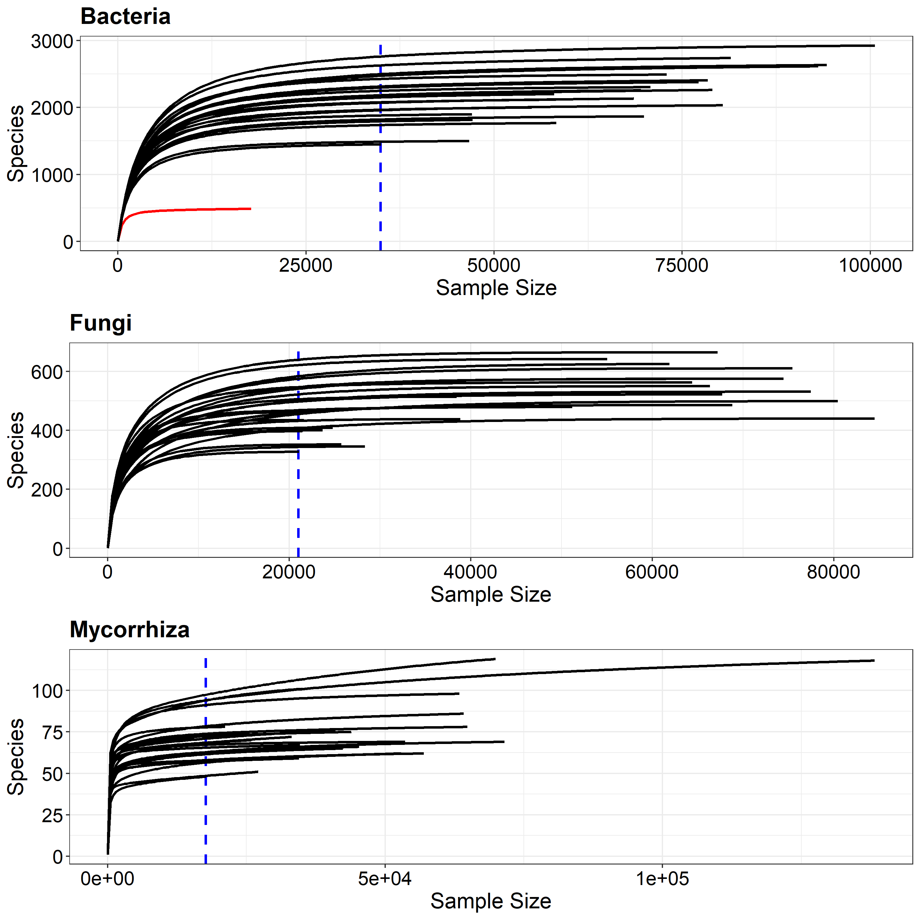
Supplementary Figure S1. Rarefaction curves showing the number of unique phylotypes as a function of normalized library size for all samples. Red curves represent samples with small library sizes and thus, excluded from downstream analysis.

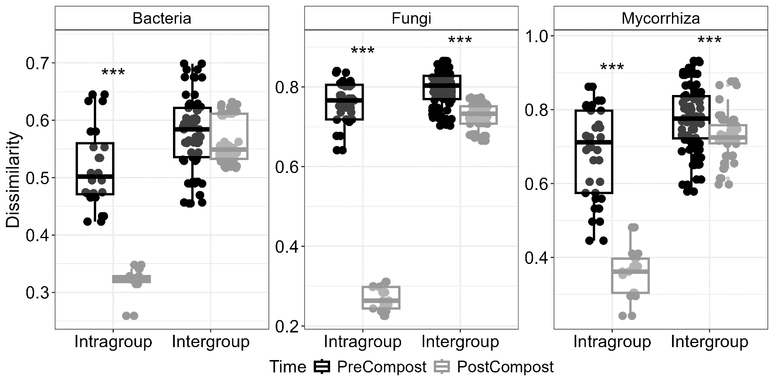
Supplementary Figure S2. Boxplots representing the Bray-Curtis community dissimilarity within each livestock group (Intragroup) and across livestock groups (Intergroups). Asterisks denote significant differences (Wilcoxon test, *p < 0.05, **p < 0.01, ***p < 0.001).

Supplementary Table S1. Anova results (F and p-value) showing the main significant factors (i.e., livestock management, compost addition, or interaction).
Anova results |  | Bacteria |  | Fungi |  | Mycorrhiza
 |  | F | T | F | T | F | T
 |  | p | T | p | T | p | T
Livestock | Exclusion | 0.051  ns | a | 4.373  * | b | 10.128  ** | b
Livestock | Equine | 0.051  ns | a | 4.373  * | a | 10.128  ** | a
Livestock | Ovine | 0.051  ns | a | 4.373  * | ab | 10.128  ** | b
Compost |  | 1.288 ns |  | 27.298 *** |  | 0.354 ns
Livestock : compost |  | 0.221 ns |  | 1.221 ns |  | 0.394 ns

