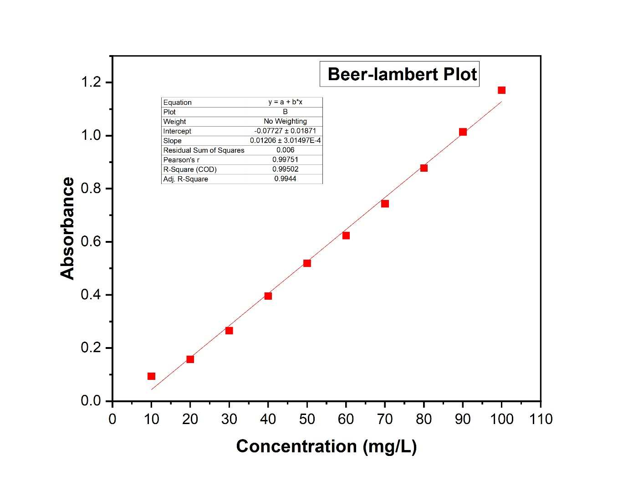
Plot Concentration vs Absorbance

