Individualized Dosing Regimens of Teicoplanin for Patients with Hypoalbuminemia Based on Population Pharmacokinetics and Pharmacokinetic/Pharmacodynamic Parameters
International Journal of Clinical Pharmacy

Jianpeng He^{1,2} · Chen Ye¹ · Ying Wang¹ · Zhanhua Hu¹ · Zeyuan He¹ · Yuqing Chen¹ · Junyan Wu¹ · Guocheng Li¹ · Min Huang² · Xiaoxia Yu¹

¹ Department of Pharmacy, Sun Yat-sen Memorial Hospital, Guangzhou, China
² School of Pharmaceutical Sciences, Sun Yat-sen University, Guangzhou, China

Corresponding Authors:
Xiaoxia Yu, Department of Pharmacy, Sun Yat-Sen Memorial Hospital, Sun Yat-Sen University, Guangzhou, China
Email: yuxx@mail.sysu.edu.cn

Supplementary material
Table S1. The parameter estimates of the base model
Compartment Model | Parameter | Estimate | RSE (%) | 95% CI
One-Compartment  (OFV =2245.098) | Typical value
One-Compartment  (OFV =2245.098) | CL (L/h) | 0.579 | 8.85 | (0.478,0.680)
One-Compartment  (OFV =2245.098) | V (L) | 91.6 | 7.67 | (77.8,105)
One-Compartment  (OFV =2245.098) | Interindividual variability
One-Compartment  (OFV =2245.098) | On CL (%) | 39.9 | 12.1 | (19.2,43.7)
One-Compartment  (OFV =2245.098) | On V (%) | 31.5 | 19.7 | (30.4,49.4)
One-Compartment  (OFV =2245.098) | Residual variability
One-Compartment  (OFV =2245.098) | Proportional error (%) | 22.7 | 8.93 | (18.7,26.7)
Two-Compartment  (OFV =2233.136) | Typical value
Two-Compartment  (OFV =2233.136) | CL (L/h) | 0.213 | 11.4 | (0.165,0.260)
Two-Compartment  (OFV =2233.136) | V (L) | 74.3 | 7.58 | (63.2,85.4)
Two-Compartment  (OFV =2233.136) | CL₂ (L/h) | 0.630 | 19.4 | (0.390,0.871)
Two-Compartment  (OFV =2233.136) | V₂ (L) | 246 | 29.8 | (101,389)
Two-Compartment  (OFV =2233.136) | Interindividual variability
Two-Compartment  (OFV =2233.136) | On CL (%) | 83.3 | 4.36 | (76.1,90.4)
Two-Compartment  (OFV =2233.136) | On V (%) | 32.6 | 19.7 | (20.0,45.3)
Two-Compartment  (OFV =2233.136) | On CL₂ (%) | 68.7 | 20.2 | (41.5,96.0)
Two-Compartment  (OFV =2233.136) | On V₂ (%) | 92.2 | 59.8 | (-16.4,201)
Two-Compartment  (OFV =2233.136) | Residual variability
Two-Compartment  (OFV =2233.136) | Proportional error (%) | 0.234 | 8.18 | (0.196,0.271)
CI, confidence interval; CL, clearance; OFV, objective function value; RSE, relative standard error; Scr, serum creatinine; V, apparent volume of distribution

Table S2. Stepwise Covariate Screening Results
Covariate | OFV  before step | OFV after step | ΔOFV | P values
Forward Inclusion
CL-eGFR | 2245.098 | 2166.940 | -78.158 | <0.05
V-urea | 2245.098 | 2213.222 | -31.876 | <0.05
V-Alb | 2245.098 | 2230.705 | -14.393 | <0.05
CL-Scr | 2245.098 | 2169.671 | -75.427 | <0.05
V-Scr | 2245.098 | 2219.616 | -25.482 | <0.05
CL-Alb | 2245.098 | 2244.206 | -0.892 | >0.05
CL-AST | 2245.098 | 2242.352 | -2.746 | >0.05
V-eGFR | 2245.098 | 2220.561 | -24.537 | <0.05
V-urea+CL-eGFR | 2166.940 | 2148.549 | -18.391 | <0.05
V-Alb+CL-eGFR | 2166.940 | 2150.479 | -16.461 | <0.05
CL-eGFR+CL-Scr | 2166.940 | 2158.503 | -8.437 | <0.05
CL-eGFR+V-Scr | 2166.940 | 2155.068 | -11.872 | <0.05
CL-eGFR+CL-Alb | 2166.940 | 2165.293 | -1.647 | >0.05
CL-eGFR+CL-AST | 2166.940 | 2164.236 | -2.704 | >0.05
CL-eGFR+V-eGFR | 2166.940 | 2157.186 | -9.754 | <0.05
V-urea+V-Alb+CL-eGFR | 2148.549 | 2135.137 | -13.412 | <0.05
V-urea+CL-eGFR+CL-Scr | 2148.549 | 2141.442 | -7.107 | <0.05
V-urea+CL-eGFR+V-Scr | 2148.549 | 2147.724 | -0.825 | >0.05
V-urea+CL-eGFR+CL-Alb | 2148.549 | 2147.183 | -1.366 | >0.05
V-urea+CL-eGFR+CL-AST | 2148.549 | 2147.146 | -1.403 | >0.05
V-urea+CL-eGFR+V-eGFR | 2148.549 | 2148.019 | -0.53 | >0.05
V-urea+V-Alb+CL-eGFR+CL-Scr | 2135.137 | 2127.511 | -7.626 | <0.05
V-urea+V-Alb+CL-eGFR+V-Scr | 2135.137 | 2133.496 | -1.641 | >0.05
V-urea+V-Alb+CL-eGFR+CL-Alb | 2135.137 | 2131.893 | -3.244 | >0.05
V-urea+V-Alb+CL-eGFR+CL-AST | 2135.137 | 2134.167 | -0.97 | >0.05
V-urea+V-Alb+CL-eGFR+V-eGFR | 2135.137 | 2134.209 | -0.928 | >0.05
V-urea+V-Alb+CL-eGFR+CL-Scr+V-Scr | 2127.511 | 2126.325 | -1.186 | >0.05
V-urea+V-Alb+CL-eGFR+CL-Scr+CL-Alb | 2127.511 | 2122.631 | -4.88 | <0.05
V-urea+V-Alb+CL-eGFR+CL-Scr+CL-AST | 2127.511 | 2126.788 | -0.723 | >0.05
V-urea+V-Alb+CL-eGFR+CL-Scr+V-eGFR | 2127.511 | 2126.384 | -1.127 | >0.05
Backward Elimination
V-Alb+CL-eGFR+CL-Scr | 2127.511 | 2141.476 | 13.965 | >0.001
V-urea+CL-eGFR+CL-Scr | 2127.511 | 2141.442 | 13.931 | >0.001
V-urea+V-Alb+CL-Scr | 2127.511 | 2136.506 | 8.995 | <0.001
V-urea+V-Alb+CL-eGFR | 2127.511 | 2135.137 | 7.626 | <0.001
V-Alb+CL-eGFR | 2135.137 | 2150.479 | 15.342 | >0.001
V-urea+CL-eGFR | 2135.137 | 2148.549 | 13.412 | >0.001
V-urea+V-Alb | 2135.137 | 2205.040 | 69.903 | >0.001
Final Model
V-urea+V-Alb+CL-eGFR | - | 2135.137 | - | -
Alb, albumin; ALT, alanine aminotransferase; AST, aspartate aminotransferase; CL, clearance; eGFR, estimated glomerular filtration rate (estimated by the 2021 CKD-EPI Equation); OFV, objective function value; Scr, serum creatinine; V, apparent volume of distribution
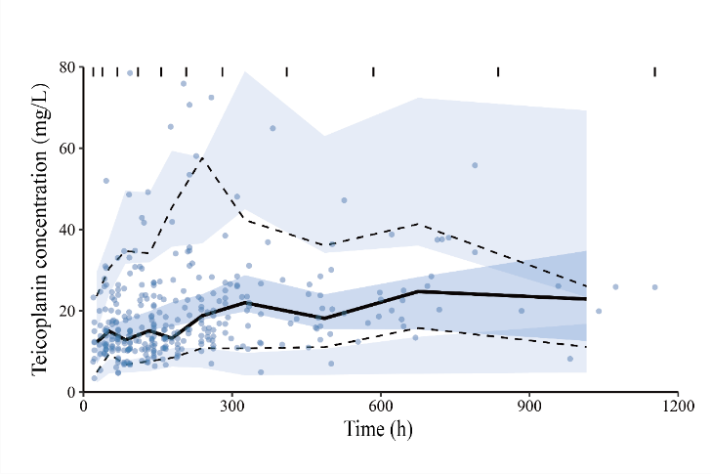
Figure S1. Visual predictive check plot of the final PPK model. The lower, middle and upper lines are the 5th, 50th and 95th percentile of actual observations, respectively. The shaded areas are the 95% CIs for the 5th, 50th and 95th percentile of prediction
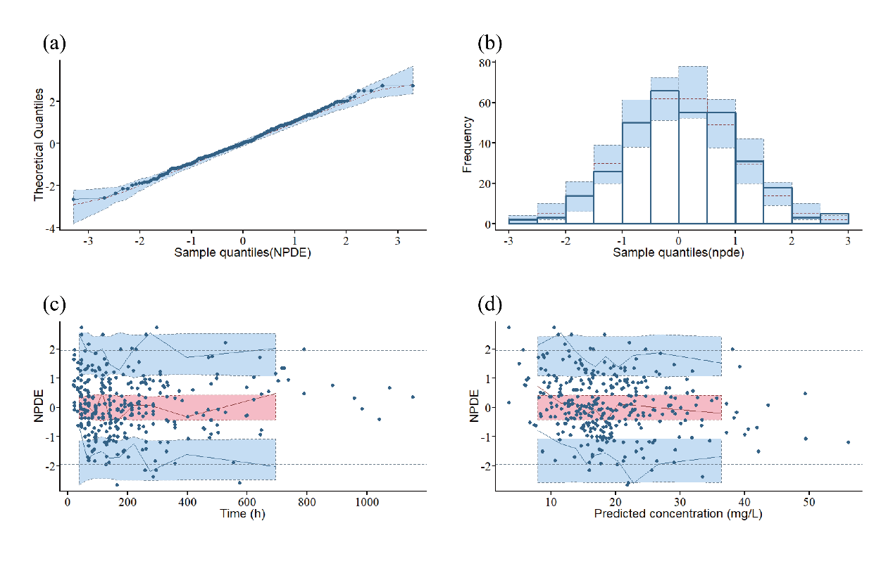
Figure S2. Normalized prediction distribution error plots of the final PPK model. (a) Q-Q plot of NPDE. (b) Histogram of the distribution of NPDE. (c) NPDE vs Time. (d) NPDE vs Predicted concentration.
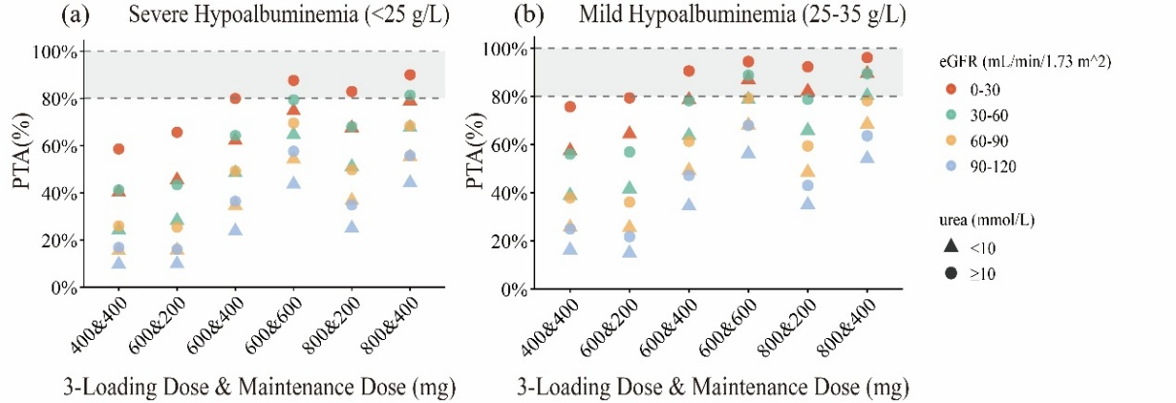
Figure S3. Individualized dosing regimens of teicoplanin targeting C_{min} ≥15 mg/L at 96 hours after initial administration. (a) Simulation results of patients with severe hypoalbuminemia (<25 g/L). (b) Simulation results of patients with mild hypoalbuminemia (25-35 g/L). The color and shape of points represent the levels of eGFR and urea of patients, respectively. The x-axis represents the loading dose (mg) q12h for 3 doses combined with maintenance dose (mg) qd. The y-axis represents the probability of target attainment (PTA) under different dosing regimens and varying levels of patients' biochemical parameters. Dosing regimens achieving a PTA exceeding 80% are recommended

