Supporting Information
Supplementary Figure S1. Kaplan–Meier estimates of PSA progression-free survival and overall survival in matched patients with high-risk mHSPC and GS5 (left) and without GS5 (right).

Supplementary Table S1. Sequential therapy following PSA progression.

Supplementary Table S2. Adverse events occurring in patients with mHSPC.

Supplementary Table S3. Adverse events in each treatment group.

Supplementary Table S4. PSA kinetics in patients with mHSPC.

Supplementary Table S5. Characteristics of matched patients with high-risk mHSPC (triplet vs. doublet).

Supplementary Table S6. Characteristics of matched patients with mHSPC (triplet vs. APA or ENZ).

Supplementary figure S1 Kaplan–Meier estimates of PSA progression-free survival and overall survival in matched patients with high-risk mHSPC and GS5 (left) and without GS5 (right).
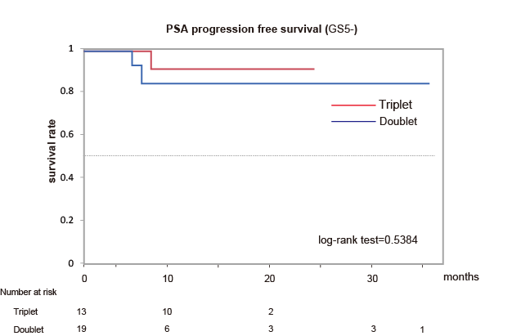
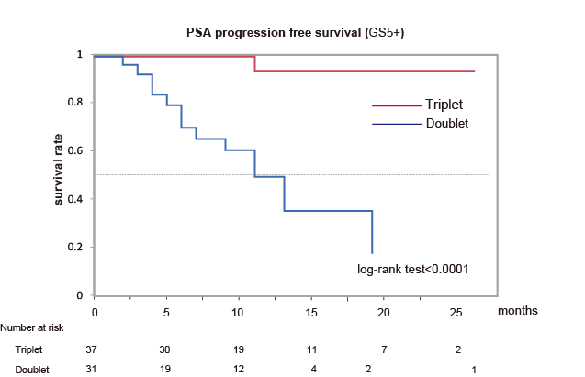

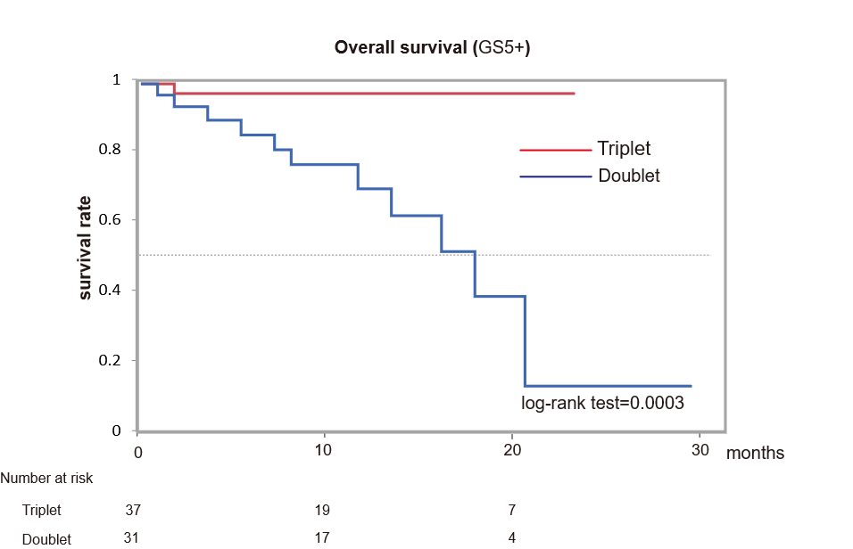
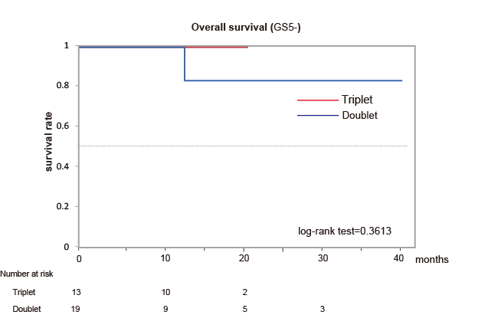

Supplementary Table S1. Sequential therapy following PSA progression

Agent | ABI | APA | ENZ | Triplet
Agent | N =(%) | N =(%) | N =(%) | N =(%)
Abiraterone acetate plus prednisone | 0 (0) | 7 (30.4%) | 5 (22.7) | 0 (0)
Enzaltamide | 34 (45.3%) | 5 (21.7%) | 0 (0) | 2 (66.7)
Docetaxel | 26 (34.5%) | 9 (39.1%) | 10 (45.5) | 0 (0)
Apalutamide | 2 (2.7%) | 0 (0) | 1 (4.5) | 0 (0)
Olaparib | 0 (0) | 0 (0) | 0 (0) | 1 (33.3)
Others | 13 (17.5%) | 2 (8.8%) | 6 (27.3) | 0 (0)

Supplementary Table S2. Adverse events occurring in patients with mHSPC.

Highest AE grade | Patients n=76 (%)  Triplet therapy | Patients n=424 (%)  Doublet therapy
0 | 9 (11.8) | 354 (83.5)
1 | 7 (9.2) | 37 (8.7)
2 | 10 (13.2) | 17 (4.0)
3 | 10 (13.2) | 15 (3.6)
4 | 40 (52.6) | 1 (0.2)
5 | 0 (0) | 0 (0)

Supplementary Table S3. Adverse events in each treatment group
Adverse event  (Triplet therapy) | Grade 1 |  | Grade 2 |  | Grade 3 |  | Grade 4
Adverse event  (Triplet therapy) | No | % | No | % | No | % | No | %
Neutropenia | 6 | 7.9 | 4 | 5.2 | 5 | 6.6 | 40 | 52.6
Fatigue | 24 | 31.6 | 3 | 3.9 | 1 | 1.3
Loss of appetite | 12 | 15.8 | 5 | 6.6 | 1 | 1.3
Skin disorder | 6 | 7.9 | 2 | 2.6 | 1 | 1.3
AST/ALT elevation | 7 | 9.2 | 1 | 1.3 | 2 | 2.6
Electrolyte abnormality | 3 | 3.9 |  |  | 1 | 1.3
Hypertension | 4 | 5.2 | 1 | 1.3
Diarrhea | 5 | 6.6 | 2 | 2.6
Constipation | 10 | 13.1 | 2 | 2.6
Anemia | 20 | 26.3 | 4 | 5.2 | 4 | 5.2 | 2 | 2.6
Thrombocytopenia | 14 | 18.4 | 3 | 3.9
Peripheral neuropathy | 12 | 15.8 | 3 | 3.9 | 1 | 1.3
Alopecia | 21 | 27.6 | 6 | 7.9
Edema | 9 | 11.8 | 11 | 14.5
Nail changes | 15 | 19.7 | 2 | 2.6
Others | 5 | 6.6 |  |  | 3 | 3.9

Supplementary Table S4. PSA kinetics in patients with mHSPC.
 | ABI |  | APA |  | ENZ |  | Triplet
 | No | % | No | % | No | % | No | %
PSA decrease of 90% | 172 | 95.6 | 107 | 94.7 | 120 | 91.6 | 70 | 92.1

Supplementary Table S5. Characteristics of matched patients with high-risk mHSPC (triplet vs. doublet).
Hormone therapy | Triplet (n = 50) | Doublet (n = 50) | p-Value
Median age at diagnosis years (range) | 73.5 (57-87) | 73 (54-87) | 0.6227
Performance status (ECOG) ≧1, n (%) | 10 (20.0) | 9 (18.0) | 0.9499
Median pretreatment PSA level (ng/mL) | 195 (0.76-12978) | 289.3 (5.54-8756) | 0.5425
Median pretreatment LDH (U/L) | 195 (100-706) | 206 (38.1-2405) | 0.2360
Gleason pattern 5, n (%) | 37 (74.0) | 31 (62.0) | 0.1974
Presence of bone metastasis, n (%) | 47 (94.0) | 48 (96.0) | 0.6453
Presence of visceral metastasis, n (%) | 11 (22.0) | 11 (22.0) | 1.000
Presence of lymph node metastasis, n (%) | 33 (66.0) | 38 (76.0) | 0.2696
Median observation period month (range) | 10.5 (3-26) | 10.0 (3-46) | 0.9413

Supplementary Table S6. Characteristics of matched patients with mHSPC (triplet vs. APA or ENZ).

Hormone therapy | Triplet (n = 45) | APA(n=21) or ENZ(n=24) | p-Value
Median age at diagnosis years (range) | 74 (57-85) | 74 (54-86) | 0.9492
Performance status (ECOG) ≧1, n (%) | 11 (24.4) | 8 (17.7) | 0.3969
Median pretreatment PSA level (ng/mL) | 185 (0.76-12978) | 148 (0.307-8756) | 0.8321
Median pretreatment LDH (U/L) | 196 (115-519) | 202 (38.1-441) | 0.8251
Gleason pattern 5, n (%) | 28 (62.2) | 25 (55.5) | 0.5202
High risk of LATITUDE criteria, n (%) | 35 (77.7) | 33 (73.3) | 0.6236
Presence of bone metastasis, n (%) | 39 (86.6) | 36 (80.0) | 0.3948
Presence of visceral metastasis, n (%) | 8 (17.7) | 9 (20.0) | 0.7877
Presence of lymph node metastasis, n (%) | 32 (71.1) | 33 (73.3) | 0.8139
Median observation period month (range) | 11 (3-28) | 11 (3-46) | 0.4921

