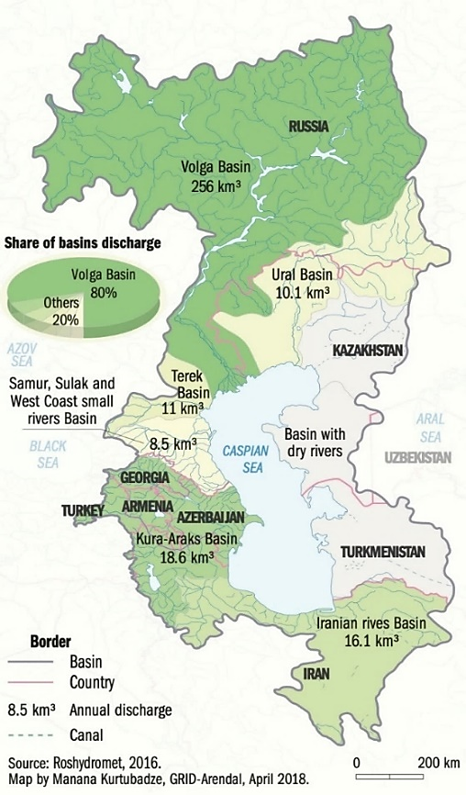
Supplementary Figure S1. Major river basins draining into the Caspian Sea and their annual discharge (km³ yr⁻¹), based on Roshydromet data²³.

Supplementary Figure S2. Flowchart of the Research Workflow
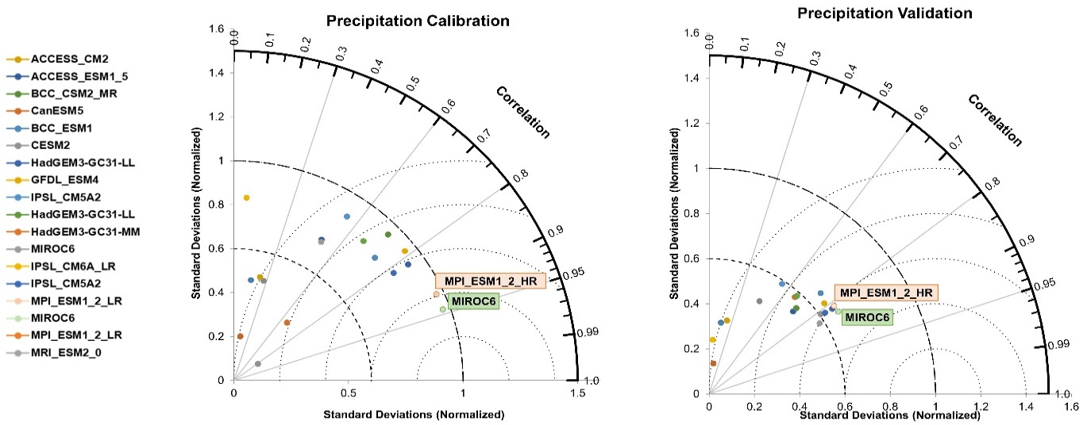
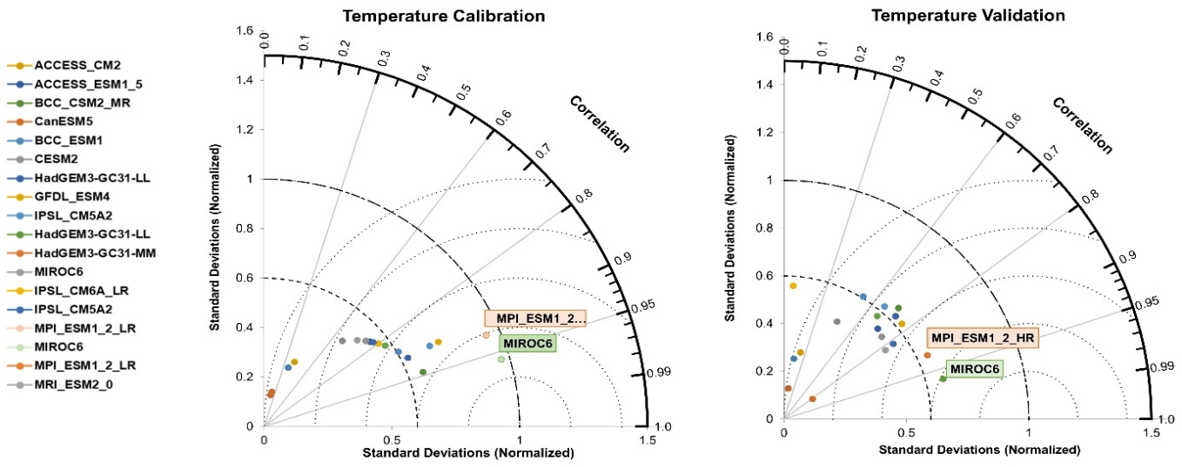
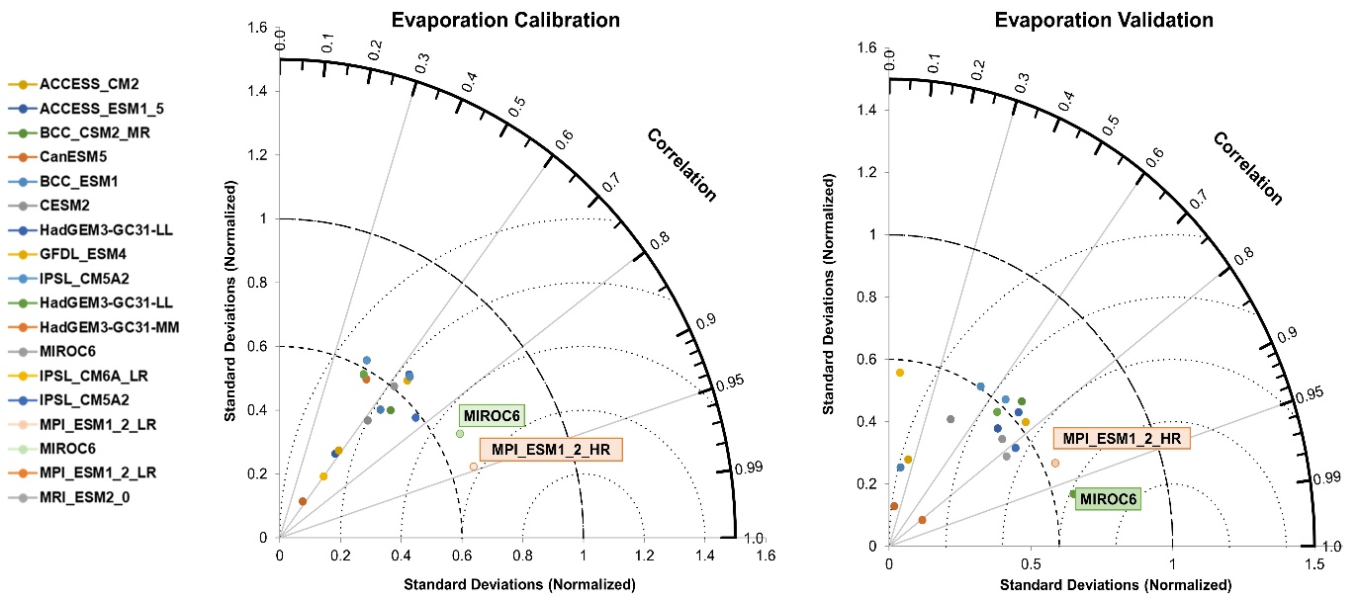
Supplementary Figure S3. Estimated correlation coefficients between climate models and observations for precipitation, evaporation, and temperature
Supplementary Figure S4. Schematic Diagram of Delft3D Model Inputs and Applied Coefficients

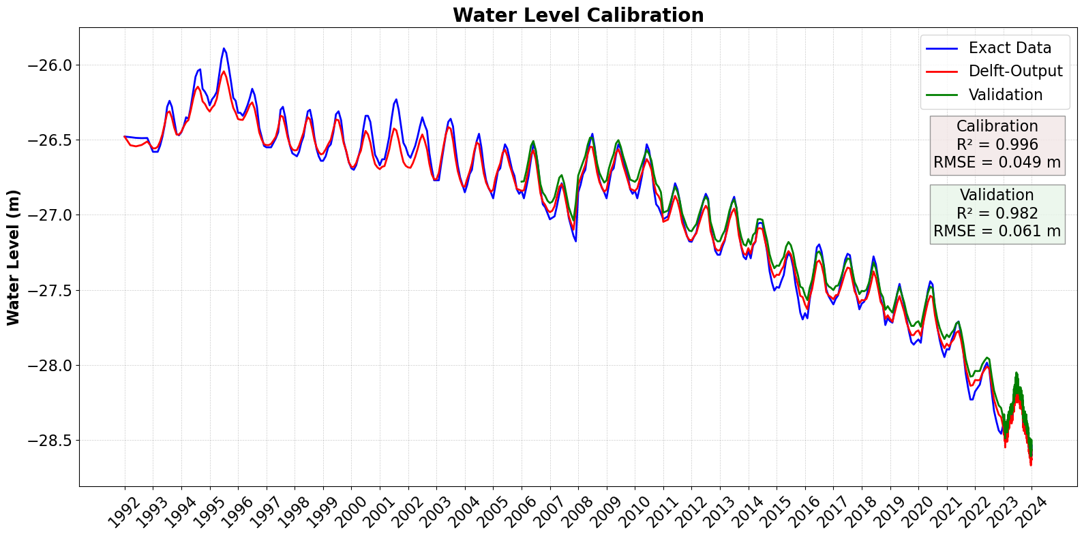
Supplementary Figure S5. Calibration & Validation of Caspian Sea Water Level Variations (Monthly Mean Sea Level Changes vs. Satellite Altimetry Data from 1992 to 2022, provided by https://cds.climate.copernicus.eu/dataset/satellite-lake-water-level)
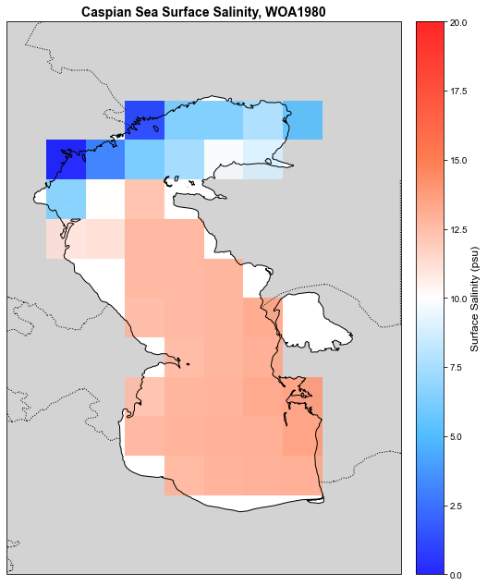 | Caspian Sea Surface Salinity, Delft3D Model  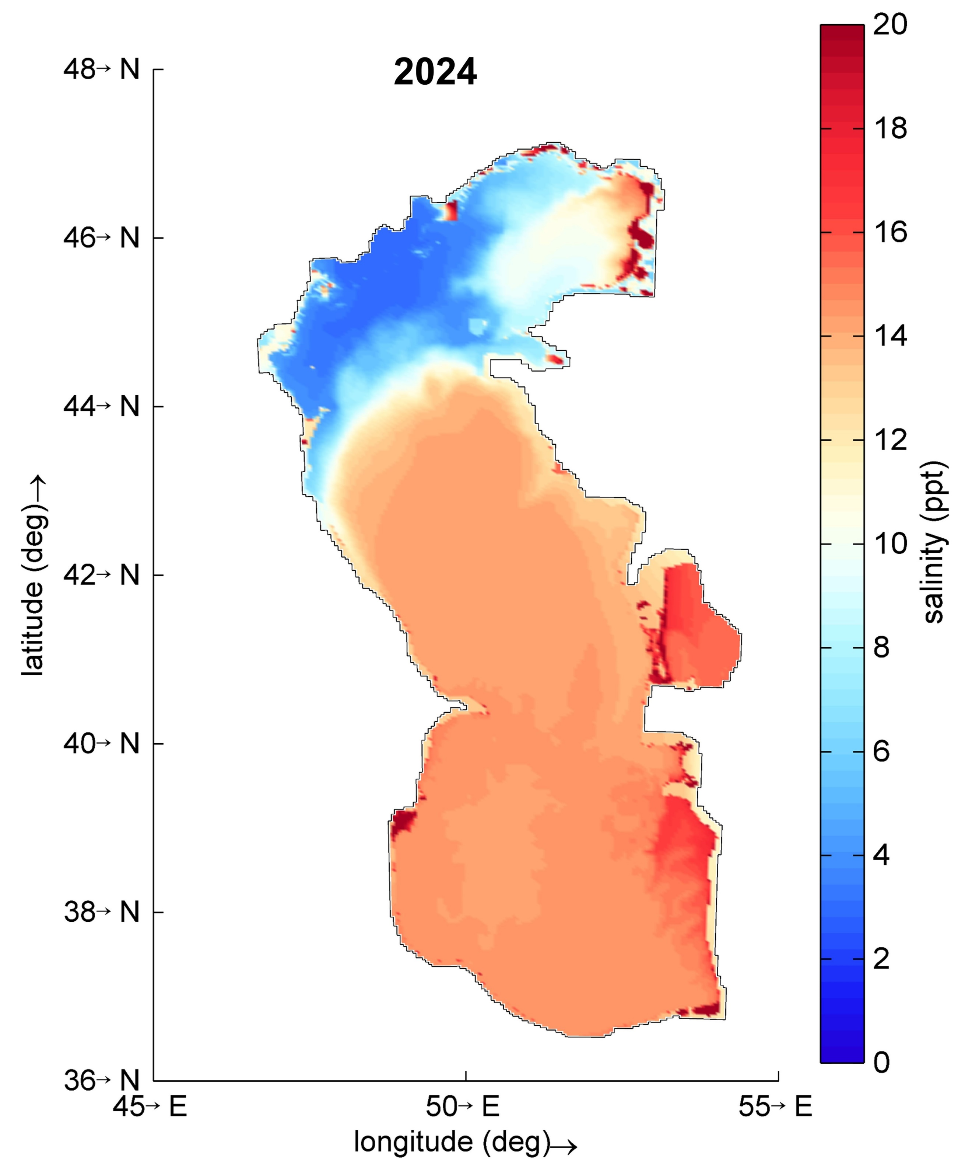
Supplementary Figure S6. Surface salinity calibration. The simulated salinity distribution was compared with WOA1980 and reproduced using Delft3D2024, showing lowest salinity in the north, moderate in the center, and highest in the south.

Supplementary Figure S8. Monthly Mean River Discharge to the Caspian Sea

Supplementary Figure S9. Seasonal Mean River Discharge to the Caspian Sea

Supplementary Tabel S1. List of CMIP6 models used in this study, along with horizontal resolution and country of origin
Models | Institution |  | Resolution
ACCESS-CM2²⁹  ACCESS-ESM1-5²⁹ | Commonwealth Scientific and Industrial Research Organization, Australia | 1.25° ×1.875°
BCC-CSM2-MR³⁰  BCC-ESM1³¹ | Beijing Climate Center, China Meteorological Administration, China | 1.125° ×1.125°
CanESM5³² | Canadian Centre for Climate Modelling and Analysis, Canada | 2.8° ×2.8°
GFDL-CM4³³  GFDL-ESM4³³ | NOAA Geophysical Fluid Dynamics Laboratory, USA | 1° ×1.25°
HadGEM3-GC31-LL³⁴  HadGEM3-GC31-MM³⁴ | Met Office Hadley Centre, UK | 1.25° ×1.875°
IPSL-CM6A-LR³⁵  IPSL-CM5A2³⁵ | Institute Pierre-Simon Laplace (IPSL), France | 1.26° ×2.5°
MIROC6³⁶ | University of Tokyo and the Japan Agency for Marine-Earth Science and Technology (JAMSTEC), Japan | 1.4° ×1.4°
MIROC-ES2L³⁷ | National Institute for Environmental Studies and RIKEN Center for Computational Science, Japan | 2.8° ×2.8°
MPI-ESM-1-2-HR³⁸  MPI-ESM-1-2-LR³⁸ | Max Planck Institute for Meteorology, Germany | 0.9375° ×0.9375°
MPI-ESM-1-2-HR³⁸  MPI-ESM-1-2-LR³⁸ | Max Planck Institute for Meteorology, Germany | 1.875° ×1.875°
MRI-ESM2-0³⁹ | Meteorological Research Institute, Japan | 1.125° ×1.125°
NorESM2-LM⁴⁰  NorESM2-MM⁴⁰ | Norwegian Climate Prediction Model (NorCPM), Norway | 1.875° ×2.5°  0.9375° ×1.25°

Supplementary Table S2. Description of Observational Data: Monthly Water Volume (km³)
Hazar | Chaloos | Polrud | sefidrud | Sulak | Terek | Kura | Ural | Volga | Rivers
36°17'N 52°22'E | 36°31'N 51°20'E | 36°60'N  50°18'E | 37°17'N 49°56'E | - | - | - | 47°41'N  51°35'E | 46°45'N  47°48'E | Coordinate
Kore Sang | Pole Zoghal | Toolkit | Pole Astane | - | - | - | Makhambet village | V. Lebyazhe | Post
1960 | 1960 | 1960 | 1960 | 1980 | 1980 | 1950 | 1938 | 1938 | Launch date

