DNA damage and repair and cancer risk: a systematic review and meta-analysis of 55 case-control studies
Supplemental Figure 1. Funnel plot of DNA repair capacity and cancer risk in the meta-analysis
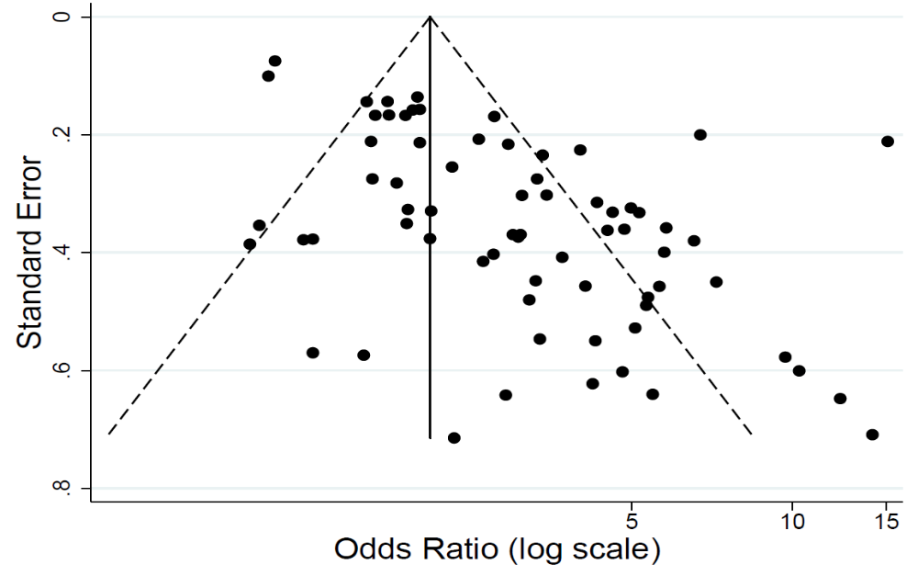
Supplemental Figure 2. Flow chart of study selection
PubMed search on key words: “cancer” AND “DNA repair phenotype” OR “DNA repair capacity” OR “comet assay” OR “Host-cell reactivation” OR “γ-H2AX assay” OR “Mutagen sensitivity assay”
(n=2045)

Publication excluded studies (n=1932) :1) examined cancer prognosis as an outcome, 2) did not have cellular base assay for DNA damage and repair, and 3) did not compare differences in DNA damage and repair between cancer cases and unaffected controls using either case-control or cohort study design.

Eligibility studies for meta-analysis (n=55)
Full-text articles assessed for eligibility (n=113)
Publication excluded studies (n=58) did not estimate effect size of DNA damage and repair between cancer cases and unaffected controls.
Supplemental Table 1. Characteristics of the studies reporting on the association between DNA repair capacity and cancer risk

Author | Year | Country | Population | Assay | DNA Damage Reagent | Adjustment Factors
Wei³² | 1993 | USA | 88 cases diagnosed with BCC, and 135 cancer free controls. All subjects were Caucasians 20-60 yr of age | Host-cell reactivation-CAT | UVC (254nm at 350 and 700 J/m2) | age, and sex
Hall³³ | 1994 | Australia | 86 cases diagnosed with either BCC or SCC, and 87 controls. All subjects were 44-68 yr of age | Host-cell reactivation-CAT | UVC (254nm at 350 J/m2) | age, sex, and lymphocyte viability
Landi³⁴ | 2002 | Italian | 132 cases diagnosed with melanoma and 145 age-, sex-matched controls | Host-cell reactivation-CAT | UVC (254nm at 350 J/m2) | age, sex, lymphocyte viability and sample storage time
Wei³⁵ | 2003 | USA | 312 cases diagnosed with melanoma and 324 controls frequency-mated by age, and sex. All were Caucasians. | Host-cell reactivation-CAT | UVC (254 nm at 800 J/m2) | age, and sex
Wang³⁶ | 2005 | USA | Cases diagnosed with either BCC (N=143) or SCC (N=88), and 327 controls. | Mutagen Sensitivity Assay | UVB (302nm at 150 J/m2) | age, and sex
Wang³⁷ | 2007 | USA | Cases diagnosed with either BCC (N=146) or SCC (N=109), and 333 controls. | Host-cell reactivation-CAT | UVC (254nm at 800 J/m2) | age, sex, and sample storage time
Wang³⁸ | 2016 | USA | 133 cases diagnosed with melanoma and 176 controls | Mutagen Sensitivity Assay | Nitroquinoline-1-oxide (10 µmol) | age, and sex
Spitz³⁹ | 1995 | USA | 90 cases diagnosed with lung cancer and 119 controls. All were African-American. | Mutagen Sensitivity Assay | Bleomycin (0.03 unit/ml) | age-, sex-, years smoked, education and household size
Storm⁴⁰ | 1995 | USA | 67 cases diagnosed with lung cancer and 107 controls. All were Mexican-Americans. | Mutagen Sensitivity Assay | Bleomycin (0.03 unit/ml) | age, sex, and pack-years of smoking
Wu⁴¹ | 1995 | USA | 180 lung cancer cases (113 Africans and 67 Mexicans), and 270 controls | Mutagen Sensitivity Assay | Colcemid (0.04 µg/ml) | age, sex, race, pack-year and overall wood dust exposure
Wei⁴² | 1996 | USA | 51 lung cancer cases, and 56 controls | Host-cell reactivation-CAT | Benzo(a)pyrene diol epoxide (75 µM) | age, sex, race, and smoking status.
Wei⁴³ | 2000 | USA | 316 lung cancer cases, and 316 controls matched on age, sex and smoking status | Host-cell reactivation-CAT | Benzo(a)pyrene diol epoxide (60 µM) | age, sex, cell storage time, pack-yr smoking, and family history of cancer
Rajaee-Behbahani⁴⁴ | 2001 | Germany | 160 lung cancer cases, and 180 controls | Comet assay | Bleomycin (20 µg/ml) | age, and sex
Spitz⁴⁵ | 2001 | USA | 341 white lung cancer cases, and 360 age, sex, race and smoking matched controls | Host-cell reactivation-CAT | Benzo(a)pyrene diol epoxide (75 µM)
Shen⁴⁶ | 2003 | USA | 467 lung cancer cases, and 488 controls | Host-cell reactivation-CAT | Benzo(a)pyrene diol epoxide (60 µM) | age, sex, race and pack-yr smoking
Spitz⁴⁷ | 2003 | USA | 764 lung cancer cases, and 677 controls | Host-cell reactivation-CAT | Benzo(a)pyrene diol epoxide (60 µM) | age, sex and smoking status
Paz-Elizur⁴⁸ | 2003 | Irsel | 68 lung cancer cases, and 68 controls | Radiolabeled synthetic: OGG1 activity |  | smoking
Wang⁴⁹ | 2007 | USA | 48 lung cancer cases, and 45 controls | Host-cell reactivation-luciferase | Nicotine-derived nitrosamine 4-(methylnitrosamino)-1-(3-pyridyl)-I-butanone | age, sex and smoking status
Wu⁵⁰ | 2007 | USA | 977 lung cancer cases, and 977 controls | Mutagen Sensitivity Assay | Benzo(a)pyrene diol epoxide (2 µM) | age, sex and smoking status
El-Zein⁵¹ | 2010 | USA | 30 lung cancer cases, and 90 controls | Comet assay | H2O2 | age, sex, and family history of cancer
Sigurdson*⁸ | 2011 | USA | 117 lung cancer cases, and 117 controls | Host-cell reactivation-luciferase, comet assay, mutagen sensitive assay | Benzo(a)pyrene diol epoxide (60 µM) | age
Sevilya⁵⁰ | 2013 | Irsel | 96 lung cancer cases, and 96 controls | Radiolabeled synthetic: OGG1, MPG, APE1
Wang⁵³ | 2013 | USA | Discovery phase: 914 lung cancer cases, and 860 controls; Replication: 679 lung cancer cases, and 695 controls | Host-cell reactivation-CAT | Benzo(a)pyrene diol epoxide | age, sex, race and pack-yr smoking
He⁵² | 2014 | USA | 306 lung cancer cases, and 306 controls | γ-H2AX | Ionizing radiation (2.5 Gy) | age, sex, race, smoking status, FHX, dust exposure and emphysema
Leitner-Dagan⁵⁵ | 2014 | Irsel | 96 lung cancer cases, and 96 controls | Radiolabeled synthetic: OGG1, MPG |  | smoking
Sevilya⁵⁶ | 2015 | Irsel | 96 lung cancer cases, and 96 controls | Radiolabeled synthetic: APE |  | age, sex and smoking status
Paz-Elizur⁵⁷ | 2020 | Irsel | 150 lung cancer cases, and 143 controls | Radiolabeled synthetic: OGG1, MPG, APE1 |  | age, sex and smoking status
Zhao⁵⁸ | 2017 | USA | 320 colorectal cancer cases, and 320 controls | γ-H2AX assay | Ionizing radiation (2.5 Gy) | age, sex and smoking status
Schabath⁵⁹ | 2003 | USA | 114 bladder cancer cases, and 145 controls | Comet assay. | Gamma-radiation | age, sex, race and smoking status
Fernández⁶⁰ | 2013 | USA | 174 bladder cancer cases, and 174 controls | γ-H2AX assay | Ionizing radiation (2.5 Gy) | age, sex, smoking status
Shao⁶¹ | 2005 | USA | 102 esophageal cancer cases, and 112 age, sex and race matched controls | Comet assay. | Benzo(a)pyrene diol epoxide and gamma-radiation | age, sex, race and smoking status
Xu⁶² | 2013 | USA | 211 esophageal cancer cases, and 211 controls | γ-H2AX assay | Ionizing radiation (2.5 Gy) | age, sex and smoking status
Cheng⁶³ | 1998 | USA | 55 head and neck cancer cases, and 61 controls | Host-cell reactivation-CAT | Benzo(a)pyrene diol epoxide | age, sex, race, smoking status, and alcohol use
Wang⁶⁴ | 1998 | USA | 60 head and neck cancer cases, and 112 controls | Mutagen Sensitivity Assay | Benzo(a)pyrene diol epoxide (4µM) | age, sex race, smoking status and alcohol drinking
Xiong⁶⁵ | 2007 | USA | 123 head and neck cancer cases, and 136 controls | Comet assay. | Benzo(a)pyrene diol epoxide (4µM) | age, sex, smoking status and alcohol drinking
Wang⁶⁶ | 2008 | USA | 895 head and neck cancer cases (767 whites, 69 Hispanics and 59 Africans), and 898 controls (763 whites, 70 Hispanics and 65 Africans) | Mutagen Sensitivity Assay | Benzo(a)pyrene diol epoxide (4µM) | age, sex, smoking and alcohol drinking
Wang⁶⁷ | 2010 | USA | 744 head and neck cancer cases, and 753 age, sex and race matched controls | Host-cell reactivation-CAT | Benzo(a)pyrene diol epoxide (60µM) | age, sex, race, and smoking
Liu⁶⁸ | 2016 | USA | 100 head and neck cancer cases, and 124 controls. All subjects were Caucasians. | ETOP-induced DSBs assay | ETOP | age, sex, smoking and alcohol drinking
Han⁶⁹ | 2018 | USA | 349 head and neck cancer cases, and 295 controls. | Nucleotide Excision Repair Proteins array |  | age, sex, smoking and alcohol drinking
Wu⁷⁰ | 1998 | USA | 28 hepatocellular carcinoma cases, and 110 controls. | Mutagen Sensitivity Assay | Benzo(a)pyrene diol epoxide and Bleomycin
Xiong⁷¹ | 2001 | USA | 100 breast cancer cases, and 105 controls. | Mutagen Sensitivity Assay | Benzo(a)pyrene diol epoxide (4µM) | age, race, smoking and alcohol use
Smith⁷² | 2003 | USA | 70 breast cancer cases, and 70 controls. | Comet assay | Gamma-irradiation (6-Gy) | age
Shi⁷³ | 2004 | USA | 69 breast cancer cases, and 79 controls. | Host-cell reactivation-CAT | Benzo(a)pyrene diol epoxide (60µM) | age, smoking, cell storage time, baseline CAT expression
Kennedy⁷⁴ | 2005 | USA | 154 breast cancer cases, and 154 controls. | Immunofluorescence | Benzo(a)pyrene diol epoxide | age, BMI, and smoking
Natarajan⁷⁵ | 2006 | USA | 61 breast cancer cases, and 84 controls. All subjects were Africans. | Mutagen Sensitivity Assay | Gamma-irradiation (6-Gy)
Bau⁷⁶ | 2007 | Taiwan | 112 breast cancer cases, and 108 controls. All subjects were Asian. | End-joining assay |  | age, family history of cancer, BMI, and reproductive risk
Machella²⁹ | 2008 | USA | 86 breast cancer cases, and 96 controls. | End- joining assay with EcoRI or HincII cut plasmid substrates |  | age, BMI, and smoking
Wang⁷⁷ | 2012 | USA | 515 breast cancer cases, and 402 controls. | Mutagen sensitivity | Gamma-irradiation | age, smoking and alcohol use
Matta⁸⁴ | 2012 | Puerto Rico | 285 breast cancer cases, and 539 controls. | Host-cell reactivation-luciferase | UVC (254nm at 350 and 700 J/m2) | age, BMI, family history of cancer, number of children, marital status and smoking
Shen*⁷⁸ | 2020 | USA | 152 breast cancer cases, and 152 controls; Nested case-control study: 50 breast cancer cases, and 50 controls; | Homologous Recombination Repair assay |  | age, BMI, smoking, alcohol and physical activity
Hu⁷⁹ | 2004 | USA | 140 prostate cancer cases, and 96 controls. | Host-cell reactivation-luciferase | UVC (254nm at 700 J/m2) | age, race, smoking status, and family history
Dong⁸⁰ | 2012 | China | 517 gastric cancer cases, and 525 controls. | Mutagen Sensitivity Assay | Gamma-irradiation (1.5-Gy) | age, sex, H pylori infection, smoking and drinking
Spitz⁸¹ | 1989 | USA | 75 upper aerodigestive tract cancer cases, and 62 controls. | Mutagen Sensitivity Assay | Bleomycin
Wu⁸² | 1998 | USA | 67 upper aerodigestive tract cancer cases, and 81 controls. | Mutagen Sensitivity Assay | Benzo(a)pyrene diol epoxide | age, sex, ethnicity and smoking
Bondy⁸³ | 1996 | USA | 45 Gliomas cancer cases, and 117 controls. | Mutagen Sensitivity Assay | Gamma-irradiation
BCC: basal cell carcinoma; SCC: squamous cell carcinoma; CMM: cutaneous malignant melanoma
*blood were collected before cancer diagnosis

