SUPPLEMENTARY MATERIALS TO ACCOMPANY:

Polygenic prediction of cannabis-related outcomes over time: Evidence from the ALSPAC longitudinal cohort and the EU-GEI case-control study
Contents
SUPPLEMENTARY 3
1. Methods 3
1.1 ALSPAC – cannabis use variables 3
1.2 ALSPAC – multiple imputation 4
1.3 EU-GEI – cannabis use variables 4
2. Results 5
2.1 ALSPAC cohort recruitment flow chart 5
2.2 EU-GEI cohort recruitment flow chart 5
2.3 Participants’ characteristics and patterns of cannabis use in the ALSPAC sample and differences between cases and controls across sociodemographic factors and patterns of cannabis use in the EU-GEI sample 6
2.4 Correlation and multicollinearity measures for the PRSs in the ALSPAC and the EU-GEI samples 7
2.5 Sensitivity analyses: validation of the SZ PRS predictive performance and attrition bias in ALSPAC 8
2.6 Binomial logistic regressions to test the association between each PRS, both main PRSs and sensitivity PRSs, and lifetime cannabis use at 16, 17, and 24 years 13
2.7 Binomial logistic regressions to test the association between each PRS, both main PRSs and sensitivity PRSs, and lifetime cannabis use in the EU-GEI cohort 15
2.8 Regression models testing the association between main and sensitivity PRSs with levels of cannabis use. For the ALSPAC sample, CAST at 17, 20, and 24 years. For the EU-GEI, a composite measure of cannabis use 16
2.9 ALSPAC sample – sensitivity analyses testing the association between main PRSs and sensitivity PRSs and a composite measure of frequency of cannabis use at 17, 20, and 24 years. 18
2.10 EU-GEI cohort – multinomial logistic regressions testing the association between main PRSs and sensitivity PRSs and a composite measure of frequency of cannabis use. 21
2.11 ALSPAC sample – stepwise analyses testing the association between PRSs and age at first use 25
2.12 EU-GEI sample – stepwise analyses testing the association between PRSs and age at first use 27
2.13 ALSPAC sample – variance in cannabis use at 24 years explained by main and sensitivity PRSs and age at cannabis initiation 29
2.14 EU-GEI sample – variance in frequency of cannabis use explained by main and sensitivity PRSs and age at cannabis initiation 34
2.15 ALSPAC sample – interaction models PRSs x age at first use on the risk of developing heavy cannabis use, including all sensitivity analyses 36
2.16 EU-GEI sample – interaction models PRSs x age at first use on the risk of developing heavy cannabis use 40
2.17 ALSPAC cohort – Sensitivity analyses in the multinomial regression between SZ PRS and frequency of cannabis use – controlling for CUD PRS 44
2.18 The European Network of National Schizophrenia Networks Studying Gene-Environment Interactions (EU-GEI) WP2 Group 45

The authors have provided the supplementary material to give readers additional information about their work

SUPPLEMENTARY

1. Methods

1.1 ALSPAC – cannabis use variables
In the ALSPAC sample, our main analyses were conducted using the Cannabis Abuse Screening Test (CAST)¹. It is a reliable measure of problematic cannabis use that has been validated with DSM-based diagnoses². It is a short screening tool (6 items), and it assesses the presence of past year problematic cannabis use which is more clinically relevant than frequency of cannabis use and adds the additional advantage of being repeatedly administrated at many assessment waves. For the present study, we utilised the following time points: 17, 20, and 24 years. And only the 24-year time point for the interaction model. Additionally, it should be borne in mind that CAST scores at 20 years were based on self-assessment questionnaires completed by the study participants, while data collected at ~17 years 6 months (Teen Focus 4), and at 24 years (F24) were collected through face-to-face interviewing.
The CAST questionnaire is comprised of the following questions: “in the last 12 months, (1) have you smoked cannabis before midday? (2) have you smoked cannabis when you were alone? (3) have you had memory problems when you smoked cannabis? (4) Have friends or members of your family told you that you ought to reduce or stop your cannabis use? (5) Have you tried to reduce or stop your cannabis use without succeeding? (6) Have you had problems because of your use of cannabis (argument, fight, accident, bad result at school, etc)?”.
Participants with no lifetime/past year cannabis use were coded as no abuse. Each answer was coded as either 0 or 1, with a total maximum score of 6.

Reported below is the distribution of CAST scores at different time points (in the subsample of participants with available genetic data):

CAST at 15 years: 800 (9.73%) respondents vs 7,424 (90.27%) missing.
CAST score at 15 years breakdown: 0 = 358 (4.35%), 1 =190 (2.31%), 2 = 99 (1.2%), 3 = 50 (0.61%), 4 = 43 (0.52%), 5 = 23 (0.28%), 6 = 37 (0.45%), NA = 7,424 (90,27).

CAST at 16 years: 915 (11.13%) respondents vs 7,309 (88.87%) missing.
CAST score at 16 years breakdown: 0 = 452 (5.5%), 1 = 200 (2.43%), 2 = 76 (0.92%), 3 = 75 (0.91%), 4 = 33 (0.4%), 5 = 43 (0.52%), 6 = 36 (0.44%), NA = 7,309 (88.87%).

CAST at 17 years: 895 (10.88%) respondents vs 7,329 (89.12%) missing.
CAST score at 17 years breakdown: 0 = 765 (9.3%), 1 = 70 (0.85%), 2 = 20 (0.24%), 3 = 19 (0.23%), 4 = 10 (0.12%), 5 = 7 (0.09%), 6 = 4 (0.05%), NA = 7,329 (89.12%).

CAST at 20 years: 1,587 (19.3%) respondents vs 6,637 (80.7%) missing.
CAST score at 20 years breakdown: 0 = 1,434 (17.44%), 1 = 85 (1.03%), 2 = 36 (0.44%), 3 = 14 (0.17%), 4 = 9 (0.11%), 5 = 6 (0.07%), 6 = 3 (0.04%), NA = 6,637 (80.7%).

CAST at 24 years: 836 (10.17%) respondents vs 7,388 (79.83%) missing.
CAST score at 24 years breakdown: 0 = 671 (8.16%), 1 = 85 (1.03%), 2 = 45 (0.55%), 3 = 18 (0.22%), 4 = 13 (0.16%), 5 = 2 (0.02%), 6 = 2 (0.02%), NA = 7,388 (89.83%).

1.2 ALSPAC – multiple imputation
As reported in the main manuscript, in the recruitment flow chart and in the demographic table below, the ALSPAC dataset had missing data on our exposure variables. We therefore addressed missing data in outcomes through multiple imputation, using multiple imputation by chained equation (MICE) in R Studio. Cannabis results were imputed via regression models (20 datasets). To ensure transparency and provide additional robustness, throughout the supplemental materials document we have reported a side-by-side comparison of non-imputed and imputed datasets results. Visual inspection of trace and density plots indicated satisfactory imputation quality for all variables.
For each outcome, we tailored our multiple imputation model to match the specific regression (or interaction) analysis. In two models (i.e., the stepwise age at cannabis initiation regression analyses and in the RERI interaction model), we included key auxiliary variables, as reported below, alongside, as always, the non-imputed models.

1.3 EU-GEI – cannabis use variables
Detailed information on cannabis use was collected in the EU-GEI using the modified Cannabis Experiences Questionnaire, further updated (CEQ_{EU-GEI})³. Based on our team’s previous work, we created the variables on patterns of use, frequency of cannabis use, and age at first cannabis use (used both as a continuous numeric variable and using a dichotomous version, ≤15 years vs >15 years). Regarding the variable frequency of cannabis use, we merged the two highest consumption categories (“(more than) once a week” and “daily”) into a single ‘weekly-to-daily’ use category. The frequency variable, therefore, included 4 different levels of cannabis consumption: 0 = Never used; 1 = Only once or twice; 2 = A few times each month; 3 = Weekly to daily use. We also conducted sensitivity analyses using the original 5-level variable, with 0 = Never used; 1 = Only once or twice; 2 = A few times each month; 3 = (More than) once a week; 4 = Daily.
We also employed a lifetime cannabis use variable (yes/no) so that we could compare our findings to the existing literature on the genetics and cannabis initiation. This is particularly relevant since the most accurate genome-wide association studies (GWAS) have highlighted a clear genetic distinction between cannabis initiation and cannabis use disorder (CUD)⁴. Participants were asked about cannabis use with no reference to its harmful effects and its potential role as a risk factor for psychotic disorders.

2. Results

2.1 ALSPAC cohort recruitment flow chart
As reported in the main text, the present study is based on a subsample of individuals with available genotype measures and information on cannabis consumption at different stages. Below, we report the recruitment flow chart for the study. In ALSPAC, all genotyped individuals were of European ancestry.

Figure S1. Recruitment flow chart for the ALSPAC study

2.2 EU-GEI cohort recruitment flow chart
Figure S2. Recruitment flow chart for the EU-GEI study

2.3 Participants’ characteristics and patterns of cannabis use in the ALSPAC sample and differences between cases and controls across sociodemographic factors and patterns of cannabis use in the EU-GEI sample
Table S1 Participants’ characteristics and patterns of cannabis use in the ALSPAC sample and differences between cases and controls across sociodemographic factors and patterns of cannabis use in the EU-GEI sample
 |  | ALSPAC |  | EU-GEI
 |  | Total sample  (n=15,443) |  | Controls  (N=994)  Cases  (N=752) |  |  | dfª |  |  | Test stat |  | p-valueª
Age |  | NA |  | 36.6 (13.5)  30.6 (10.5) |  |  | 1741.72 |  |  | t = 10.37 |  | <0.001
mean (SD)
Sex |  | 7,688 (49.14) |  | 450 (47)  430 (63) |  |  | 1 |  |  | X² = 43.08 |  | <0.001
N male (% male)
Lifetime cannabis use at 16 years  Yes (% used) |  | 1,347 (26.7) |  | NA
Lifetime cannabis use at 17 years |  | 1,705 (41) |  | NA
Yes (% used)
Lifetime cannabis use (at 24 years, for ALSPAC) |  | 2,414 (60.7) |  | 431 (43.8)  490 (65.9) |  |  | 1 |  |  | X² = 82.91 |  | <0.001
Age at first use |  | 16.9 (2.7) |  | 18.1 (4.5)  17.2 (5.2) | 908.63 |  |  | t = 2.78 |  |  |  | 0.006
M (SD)
Age at first use (>15 vs ≤15y) |  | 783 (30.8) |  | 569 (65.3)  303 (34.7)
≤15y (% of users)
Frequency of use^{e}  N (%)  ALSPAC: Daily or almost daily – at 24 years  EU-GEI daily use of cannabis |  | 138 (0.9) |  | 75 (7.6)  191 (26) |  |  | 5 |  |  | X² = 189.3 |  | <0.001
CAST score at 17 years  M (SD) |  | 0.3 (0.9) |  | N/A
CAST score at 20 years  M (SD) |  | 0.19 (0.68) |  | N/A
CAST score at 24 years  M (SD) |  | 0.35 (0.87) |  | N/A
Df = Degrees of freedom; SD = Standard deviation. Cases for the EU-GEI study were defined as first-episode psychosis patients. ALSPAC sample recorded data on lifetime cannabis use at the age of 16, 17, and 20 years, frequency of cannabis use at 24, CAST score at 17, 20, and 24 years, and Psychosis-like experiences. The EU-GEI study recorded data on lifetime cannabis use and the highest lifetime frequency of cannabis use. Both samples collected data on age at first cannabis use.

2.4 Correlation and multicollinearity measures for the PRSs in the ALSPAC and the EU-GEI samples
Figure S3. Correlation heatmap between the PRSs in the ALSPAC sample
Pairwise correlation coefficient between standardised PRS for CUD, MDD, Pain, short sleep duration, long sleep duration, insomnia, and SCZ. Colour scale represents Pearson’s correlation coefficient (r), ranging from -1.0 (negative correlation, purple) to 1.0 (positive correlation, yellow).

Figure S4. Correlation heatmap between the PRSs in the EU-GEI sample
Pairwise correlation coefficient between standardised PRS for CUD, MDD, Pain, short sleep duration, long sleep duration, and insomnia. Colour scale represents Pearson’s correlation coefficient (r), ranging from -1.0 (negative correlation, purple) to 1.0 (positive correlation, yellow).

2.5 Sensitivity analyses: validation of the SZ PRS predictive performance and attrition bias in ALSPAC
We conducted a series of sensitivity analyses, in order to assess the predictive validity of the schizophrenia (SZ) PRS and examine potential attrition bias in the ALSPAC cohort. We chose the SZ PRS because of its importance in previous studies and because we aimed to compare the ALSPAC sample with the EU-GEI first-episode psychosis-control study.
Firstly, we tested whether the SZ PRS was associated with the outcome variable (CAST score) at ages 17, 20, and 24. The SZ PRS was divided into quintiles, and we examined differences in mean CAST scores across these groups. The analyses showed no significant associations between SZ PRS quintile and CAST score at any time point, suggesting limited predictive power of the SZ PRS for this outcome in the ALSPAC sample. See Figures S5-S7.
Secondly, we assessed the possibility of attrition bias in the PRS data by investigating whether mean SZ PRS scores differed between participants with observed versus missing CAST outcome data, stratified by PRS quintile. For each CAST outcome, we conducted two-sample t-tests comparing the SZ PRS between participants with and without data (complete vs missing). The differences in mean PRS scores were minimal and non-significant across all time points (CAST 17y: p = 0.92, Δ_{mean} = 0.0034; CAST 20y: p = 0.215, Δ_{mean} = -0.00338; CAST 24y: p = 0.27, Δ_{mean} = 0.0387), indicating no meaningful evidence of selective dropout based on SZ PRS. See Figures S8-S10.
These analyses support the comparability of participants with and without CAST scores. Additionally, the lack of associations with SZ PRS is unlikely due to attrition bias or poor data quality in the ALSPAC cohort.
We also assessed the possibility of attrition bias in the PRS data by examining whether mean CUD PRS scores differed between participants with observed versus missing CAST. For CAST at 17 years and CAST at 24, we did not find any meaningful evidence of selective dropout based on genetic susceptibility for cannabis use disorder. Conversely, we found some non-negligible difference in the distribution of CUD PRS in participants with available data on CAST at 20 years vs those with missing information on this measure. This suggests exercising more caution when interpreting data at this time point. See Figures S11-S13.
It is worth noting that, using a similar methodology, Taylor and colleagues found opposite results for the SZ PRS which suggested that this score was associated with lower participation in the ALSPAC study⁵. We used, however, the most up to date (2022) schizophrenia GWAS⁶ instead of the less powered 2014 GWAS⁷.

Figure S5. CAST at 17y by PRS quintile
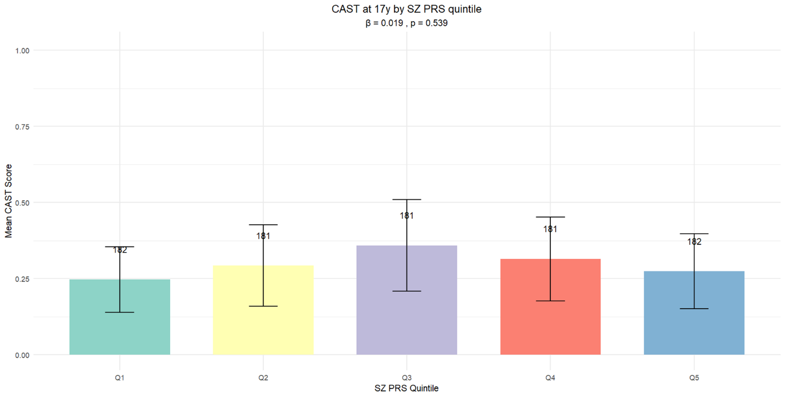
Figure S6. CAST at 20y by PRS quintile
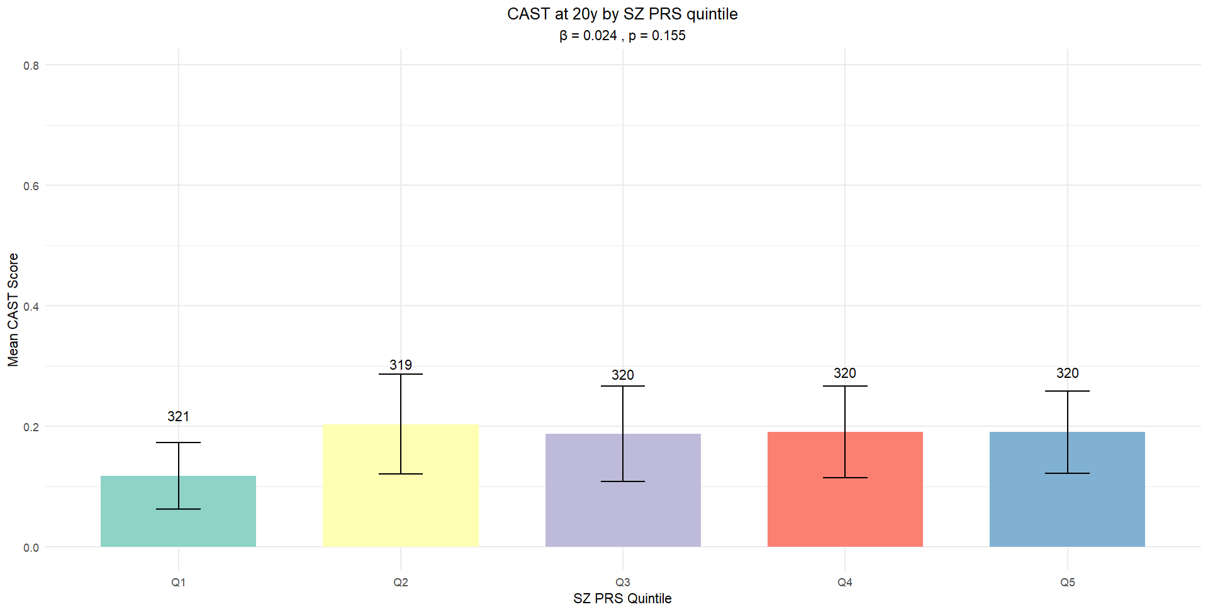
Figure S7. CAST at 24y by PRS quintile

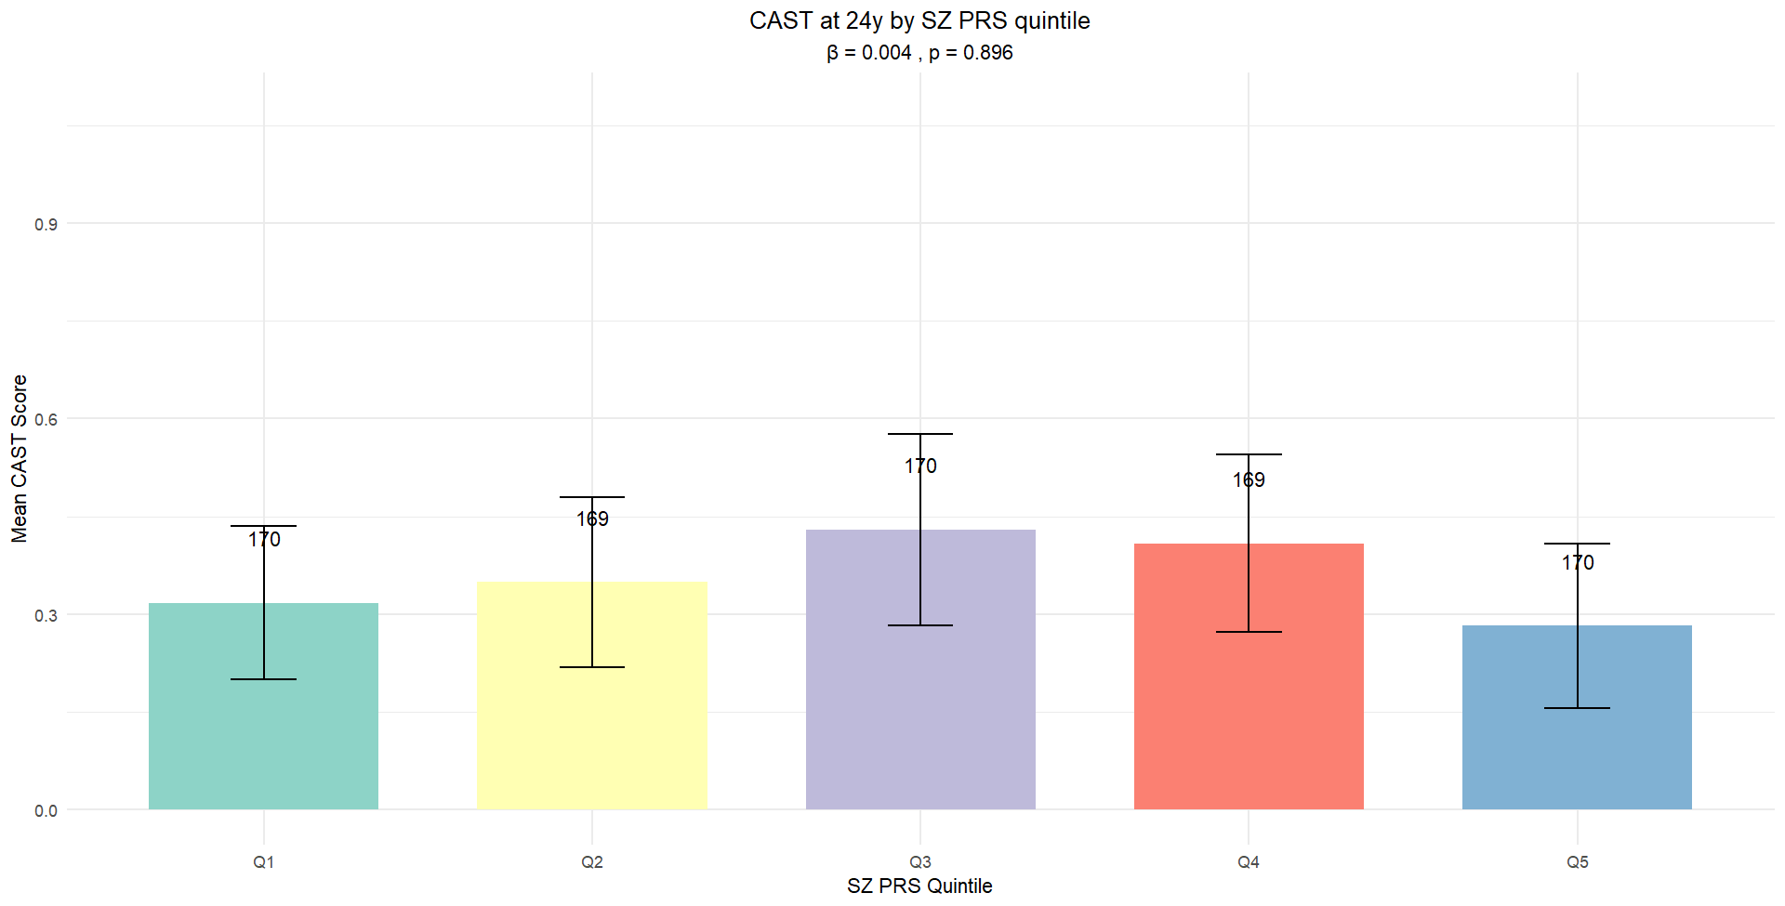
Figure S8. SZ PRS by quintile and missingness: CAST at 17y
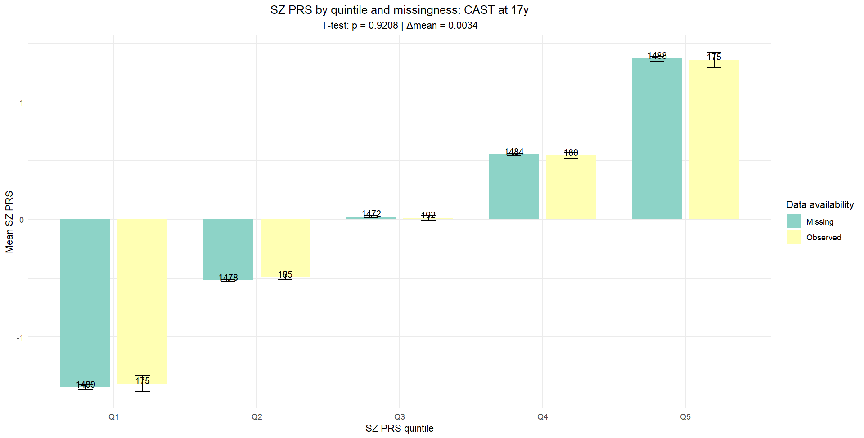

Figure S9. SZ PRS by quintile and missingness: CAST at 20y
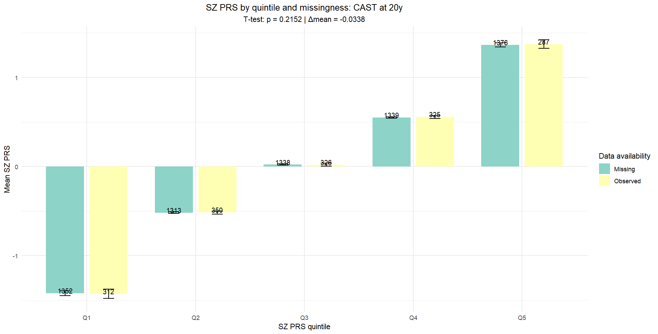

Figure S10. SZ PRS by quintile and missingness: CAST at 24y
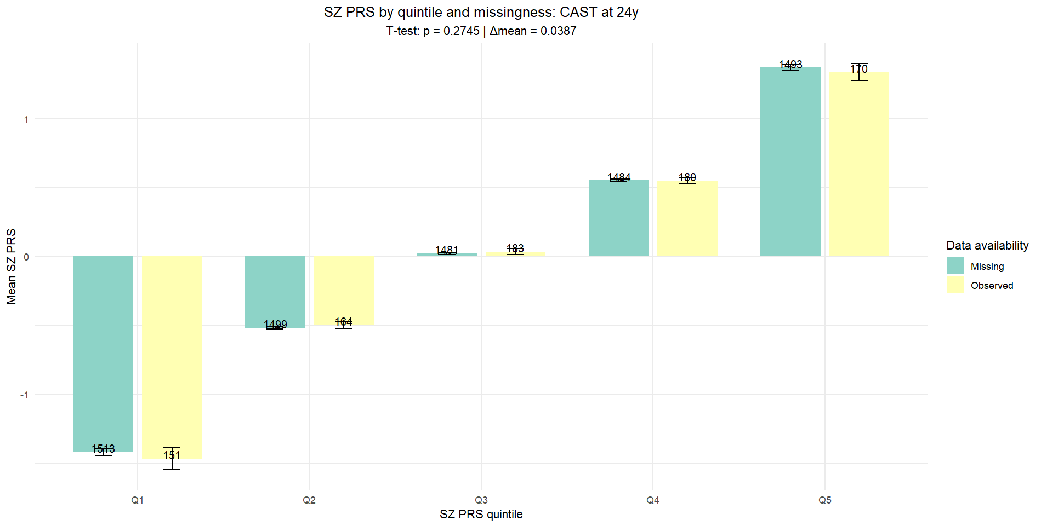

Figure S11. CUD PRS by quintile and missingness: CAST at 17y
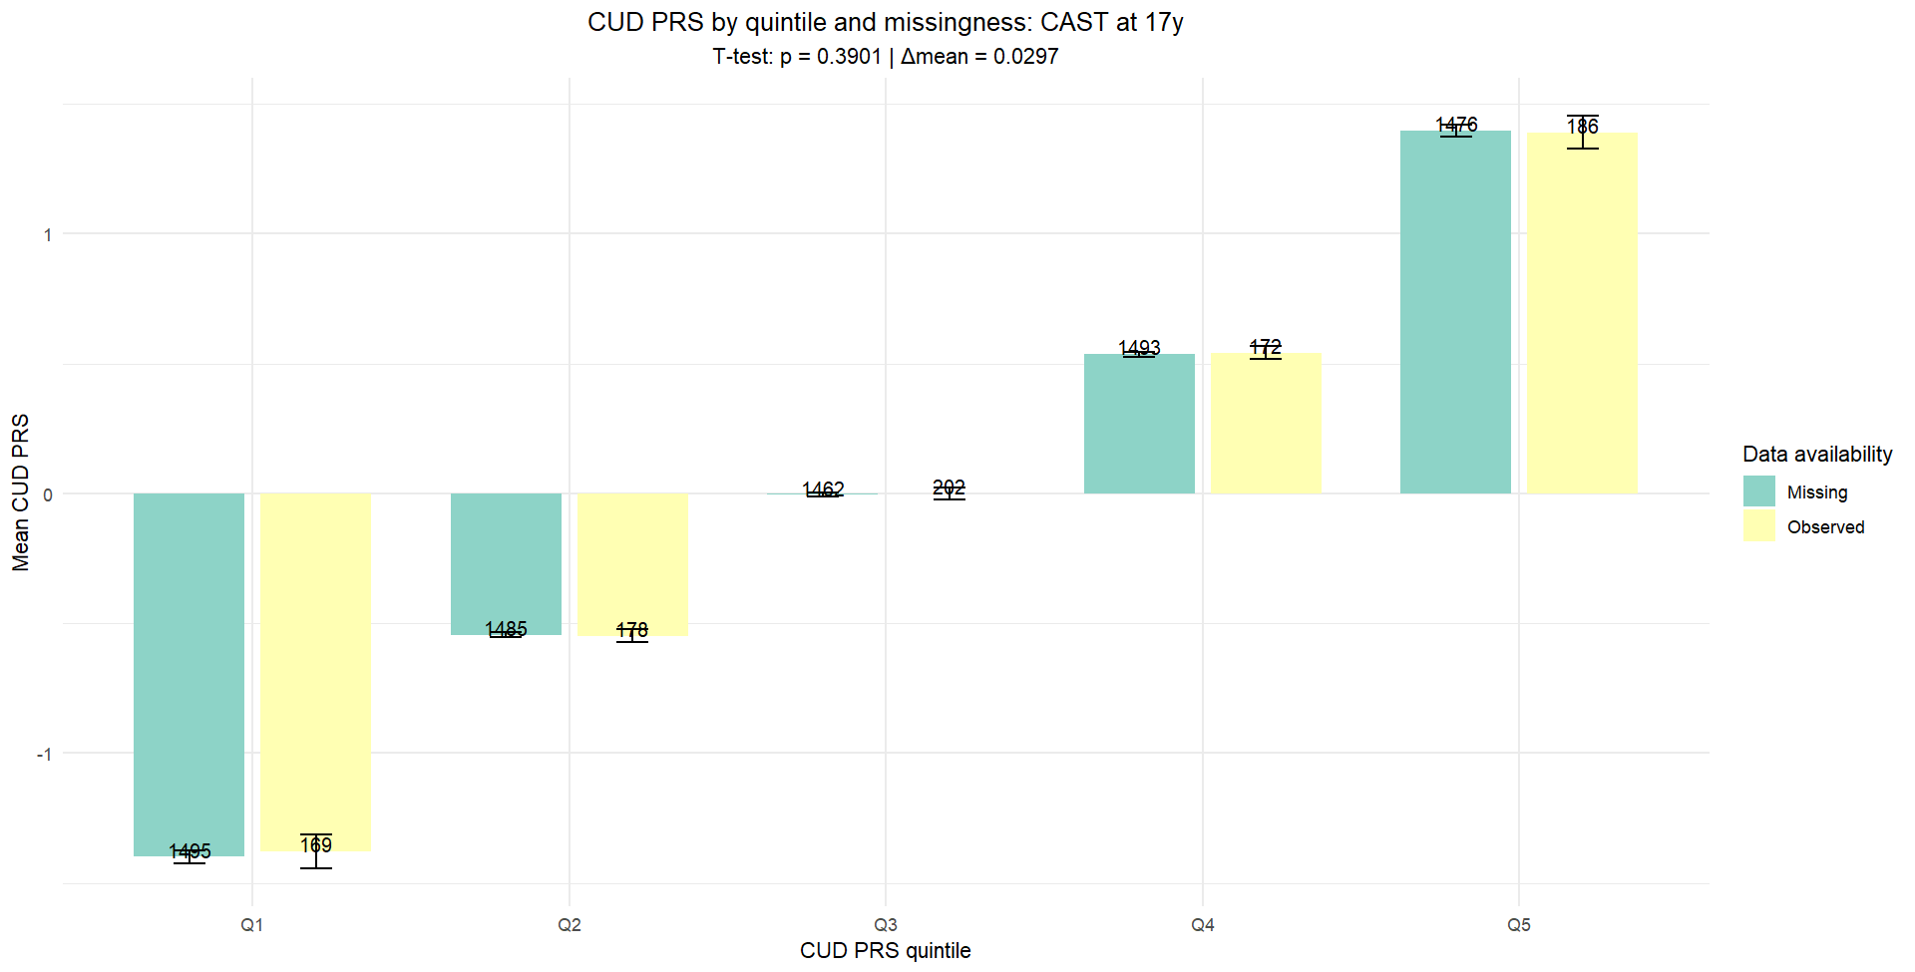
Figure S12. CUD PRS by quintile and missingness: CAST at 20y
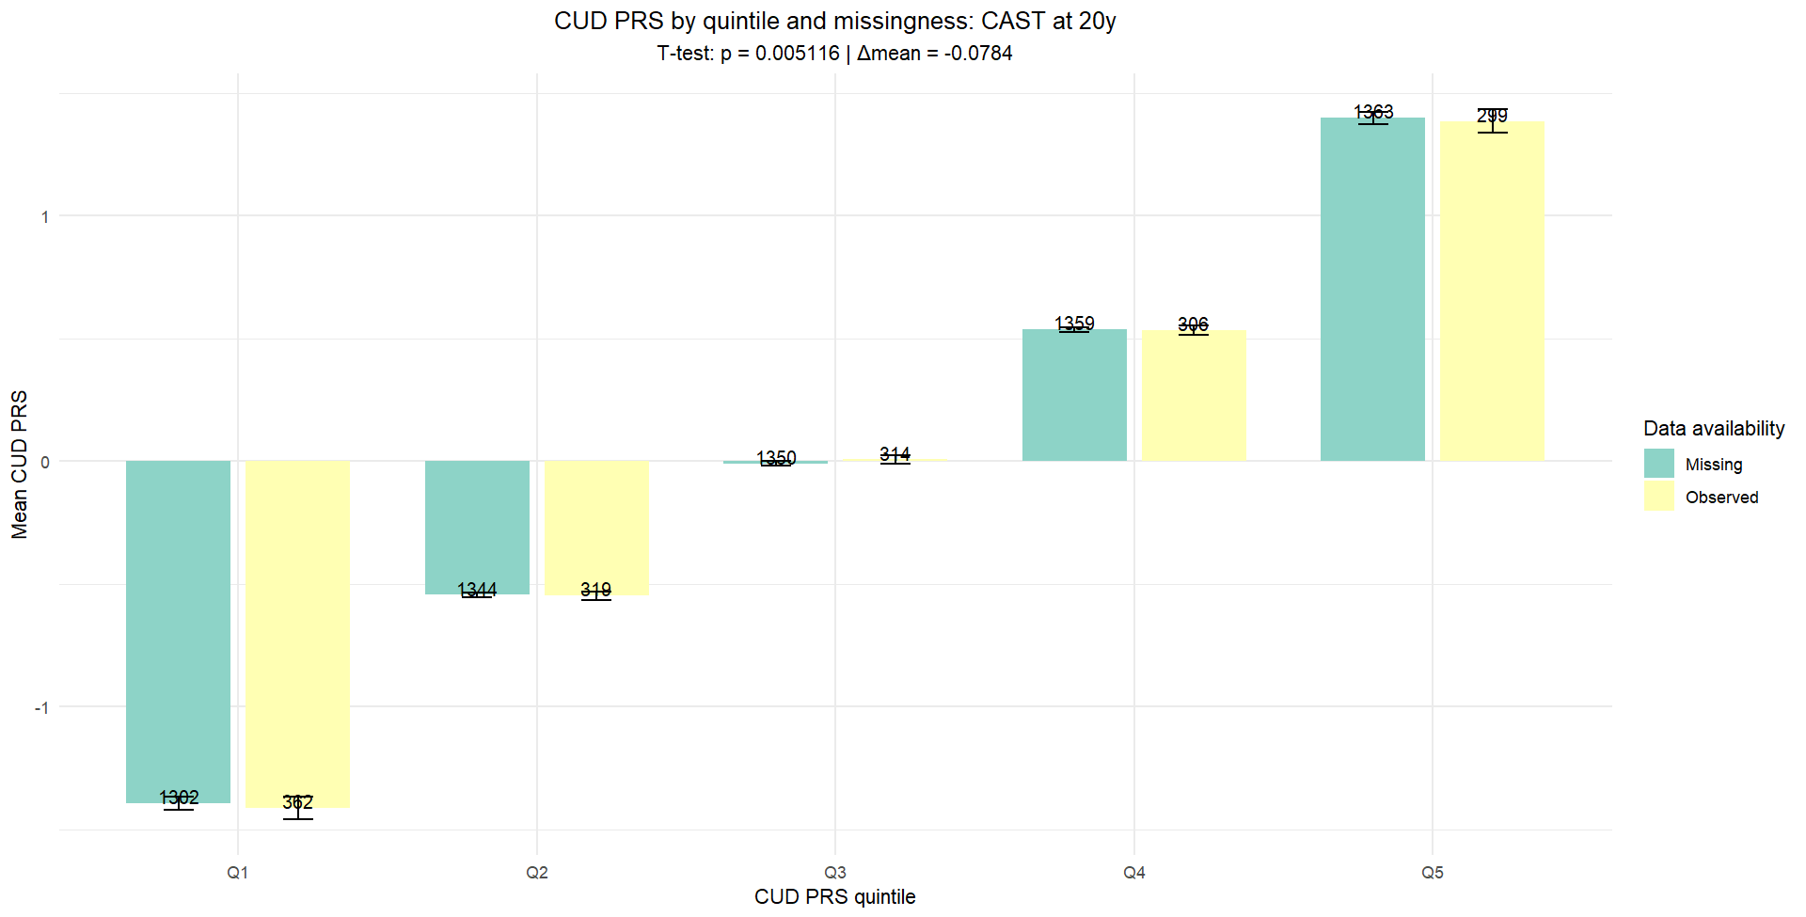

Figure S13. CUD PRS by quintile and missingness: CAST at 24y
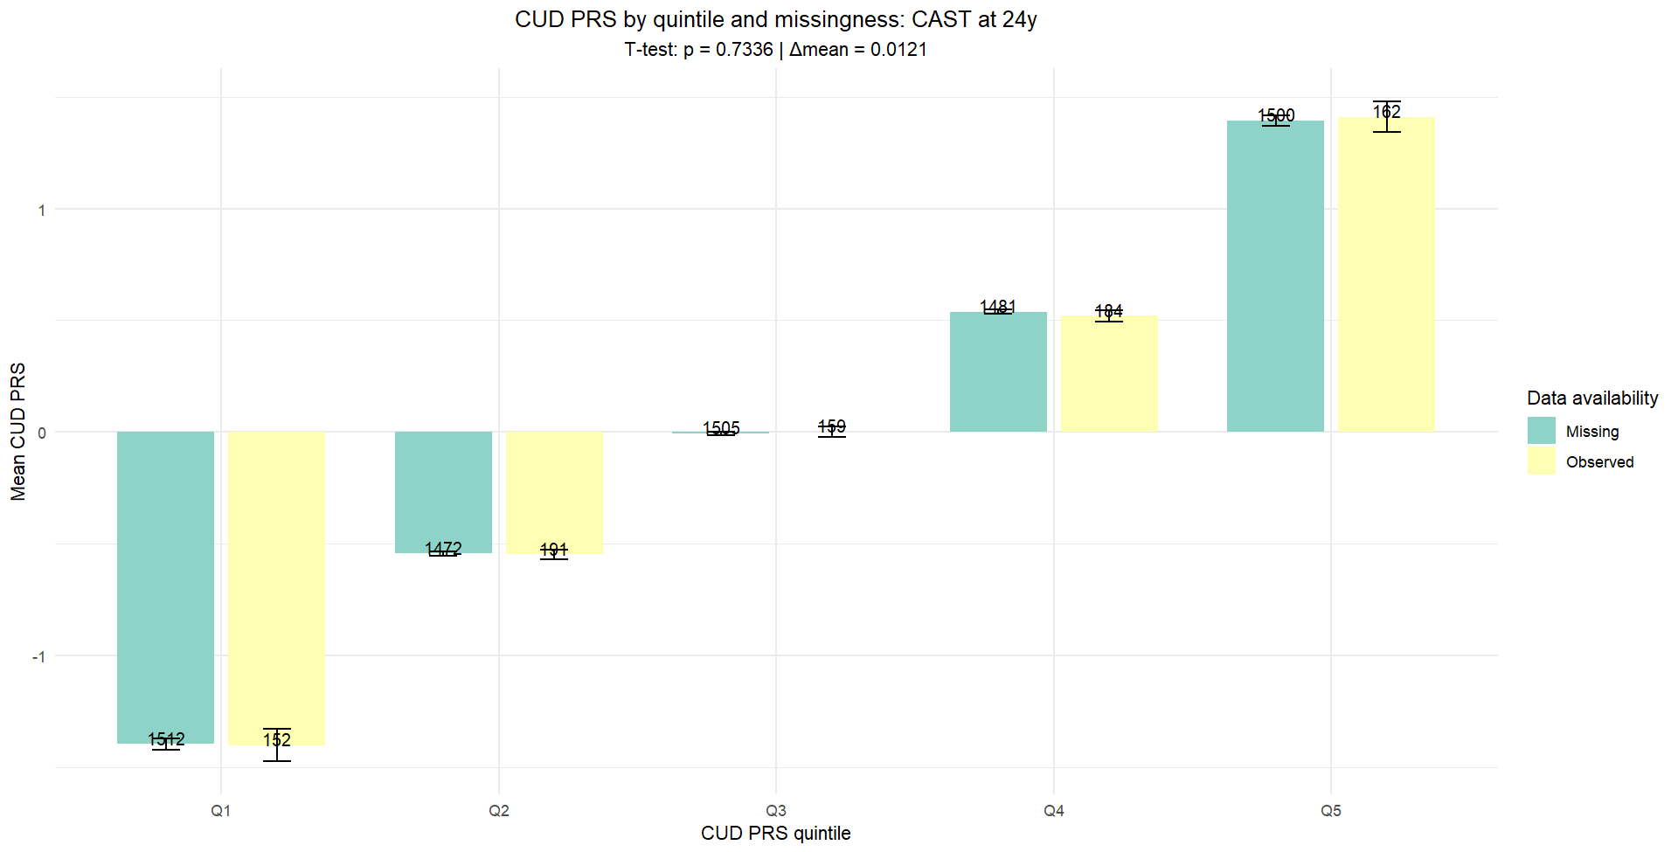

2.6 Binomial logistic regressions to test the association between each PRS, both main PRSs and sensitivity PRSs, and lifetime cannabis use at 16, 17, and 24 years
Sensitivity analyses were conducted using binomial logistic regressions to examine the associations between PRSs – both main and sensitivity PRSs – and lifetime cannabis use at age 16, 17, and 24 years. All models were adjusted for sex and 10 PCs. Odds Ratios (ORs), 95% CIs, and FDR-adjusted p-values are reported in the tables below (Tables S2-S3).
Because lifetime cannabis use at all time points had missing data, we conducted multiple imputation by chained equations (MICE) under a missing at random (MAR) assumption. Imputed results (Table S4) were highly consistent with the non-imputed analyses. ORs were almost identical, and the adjusted p-values showed that the same pattern of significant results emerged. This suggests that the missing outcome data did not substantially bias the findings. Therefore, these data show an association of CUD, MDD, Pain, and SZ PRSs with lifetime cannabis use, which was robust across different strategies. Using multiple imputation confirmed that the unimputed estimates were not significantly affected by selective missingness.

Table S2. Output of the binomial logistic regressions between PRSs (both main and sensitivity PRSs), and lifetime cannabis use at 16, 17, and 24 years
 | Lifetime use 16 years | Lifetime use 17 years | Lifetime use 24 years
 | OR (95% CI); p_{FDR}-value | OR (95% CI); p_{FDR}-value | OR (95% CI); p_{FDR}-value
CUD PRS | 1.24 (1.15-1.33); <0.001 | 1.18 (1.10-1.27); <0.001 | 1.17 (1.08-1.26); <0.001
MD PRS | 1.20 (1.11-1.29); <0.001 | 1.21 (1.13-1.31); <0.001 | 1.22 (1.13-1.32); <0.001
Pain PRS | 1.13 (1.05-1.21); 0.001 | 1.09 (1.02-1.18); 0.03 | 1.09 (1.01-1.18); 0.045
Insomnia PRS | 1.02 (0.95-1.1); 0.57 | 1.03 (0.96-1.11); 0.4 | 1.05 (0.97-1.13); 0.24
Short sleep PRS | 1.09 (1.02-1.17); 0.02 | 1.07 (1-1.15); 0.09 | 1.06 (0.98-1.14); 0.19
Long sleep PRS | 1.06 (0.99-1.14); 0.11 | 1.02 (0.95-1.10); 0.57 | 1.07 (0.99-1.15); 0.14
SCZ PRS | 1.22 (1.12-1.32); <0.001 | 1.16 (1.07-1.26); <0.001 | 1.14 (1.05-1.24); 0.005
Each model is adjusted for sex and genetic ancestry (principal components). The table reports Odds Ratios (OR), 95% confidence intervals (95% CI), and FDR-adjusted p-values (FDR p-values).

Table S3. Output of the binomial logistic regressions between PRSs (both main and sensitivity PRSs), and lifetime cannabis use at 16, 17, and 24 years – IMPUTED DATA
 | Lifetime use 16 years | Lifetime use 17 years | Lifetime use 24 years
 | OR (95% CI); p_{FDR}-value | OR (95% CI); p_{FDR}-value | OR (95% CI); p_{FDR}-value
CUD PRS | 1.25 (1.16-1.34); <0.001 | 1.19 (1.11-1.29); <0.001 | 1.15 (1.07-1.23); <0.001
MD PRS | 1.2 (1.13-1.28); <0.001 | 1.2 (1.11-1.29); <0.001 | 1.19 (1.1-1.28); <0.001
Pain PRS | 1.13 (1.07-1.2); <0.001 | 1.1 (1.03-1.18); 0.007 | 1.08 (1.00-1.18); 0.007
Insomnia PRS | 1.01 (0.95-1.09); 0.7 | 1.01 (0.95-1.07); 0.78 | 1.02 (0.93-1.11); 0.74
Short sleep PRS | 1.08 (1.01-1.15); 0.028 | 1.07 (1.00-1.15); 0.076 | 1.04 (0.96-1.12); 0.4
Long sleep PRS | 1.07 (1.00-1.14); 0.06 | 1.04 (0.97-1.12); 0.28 | 1.03 (0.96-1.12); 0.4
SCZ PRS | 1.22 (1.11-1.34); <0.001 | 1.18 (1.1-1.26); <0.001 | 1.12 (1.00-1.25); 0.13
Each model is adjusted for sex and genetic ancestry (principal components). Odds Ratios (OR), 95% confidence intervals (95% CI), and FDR-adjusted p-values (FDR p-values) are reported in the table. Significant results after the FDR-adjustment are reported after FDR-adjustment. Results of this table are reported in the main manuscript as Table 2 PANEL A.

2.7 Binomial logistic regressions to test the association between each PRS, both main PRSs and sensitivity PRSs, and lifetime cannabis use in the EU-GEI cohort

Table S4. Output of the binomial logistic regressions between PRSs (both main and sensitivity PRSs), and lifetime cannabis use in cases and controls, cases and controls (adjusted for case-control status), cases only, controls only
 | Cases-controls | Cases-controls (cov-adj) | Cases only | Controls only
 | OR (95% CI); p_{FDR}-value | OR (95% CI); p_{FDR}-value | OR (95% CI); p_{FDR}-value | OR (95% CI); p_{FDR}-value
CUD PRS | 1.47 (1.14-1.89); 0.016 | 1.29 (0.99-1.67); 0.13 | 1.4 (0.89-2.2); 0.24 | 1.34 (0.97-1.88); 0.16
MD PRS | 1.33 (1.15-1.54); <0.001 | 1.28 (1.1-1.48); 0.008 | 1.41 (1.1-1.82); 0.03 | 1.22 (1.01-1.47); 0.1
Pain PRS | 1.06 (0.93-1.22); 0.49 | 1.03 (0.89-1.18); 0.72 | 1.17 (0.92-1.48); 0.3 | 0.96 (0.81-1.15); 0.71
Insomnia PRS | 1.15 (0.96-1.37); 0.22 | 1.10 (0.92-1.31); 0.39 | 1.52 (1.11-2.1); 0.04 | 0.94 (0.75-1.18); 0.68
Short sleep PRS | 1.18 (0.96-1.45); 0.3 | 1.13 (0.92-1.4); 0.41 | 1.74 (1.21-2.54); 0.02 | 0.98 (0.74-1.29); 0.86
Long sleep PRS | 1.11 (0.97-1.28); 0.3 | 1.11 (0.97-1.27); 0.3 | 1.1 (0.86-1.4); 0.52 | 1.1 (0.92-1.31); 0.41
Each model is adjusted for sex, age, site, and genetic ancestry (principal components). The table reports odds Ratios (OR), 95% confidence intervals (95% CI), and FDR-adjusted p-values (FDR p-values).

2.8 Regression models testing the association between main and sensitivity PRSs with levels of cannabis use. For the ALSPAC sample, CAST at 17, 20, and 24 years. For the EU-GEI, a composite measure of cannabis use
As shown in Table 2 and reported in the main manuscript, we tested associations between main PRSs (CUD, MDD, pain, and insomnia PRS) and sensitivity PRSs (short sleep duration, long sleep duration, and SZ PRS) with measures of heavy cannabis use. In the ALSPAC, the main outcome was CAST scores at 17, 20, and 24 years, while in the EU-GEI, we used a composite measure of cannabis use. All models were adjusted for sex and genetic ancestry (10 principal components). Missing CAST data were imputed using multiple imputation (20 datasets; chained equation) via the mice package in R Studio (multiple imputation by chained equation), and results were pooled using Rubin’s rules. Imputed and non-imputed results are reported side by side to confirm the methodological strength of the analyses. FDR-adjusted p-values were reported to control for multiple testing.
We calculated and adjusted R² within each imputed dataset to determine how much variance each PRS explained in CAST scores. We reported all pooled values (Table S5, S6).
Across both imputed and non-imputed datasets, higher MDD PRS and pain PRS consistently predicted greater CAST scores at all ages. The CUD PRS also showed strong associations, particularly at age 24. Associations for insomnia PRS were weaker and less consistent. Together, the main PRSs explained between ~1% and almost 4% of the variance in CAST scores, with the largest effects for MDD PRS, pain PRS at all time points, and, for CUD PRS at 24 years (Tables S7, S8). The sensitivity PRSs showed a modest to non-significant association with CAST scores, with a lower percentage of variance explained. Interestingly, the CUD PRS did not predict CAST score at 17 year
Table S5. Output of the linear regressions between PRSs (both main and sensitivity PRSs), and CAST scores at 17, 20, and 24 years – NON-IMPUTED dataset
 | CAST score 17 years | CAST score 20 years | CAST score 24 years
 | β (95% CI); p_{FDR}-value | β (95% CI); p_{FDR}-value | β (95% CI); p_{FDR}-value
CUD PRS | 0.05 (-0.02, 0.1); 0.15 | 0.04 (0.01, 0.08); 0.01 | 0.14 (0.08, 0.2); <0.001
MD PRS | 0.13 (0.07, 0.19); <0.001 | 0.06 (0.02, 0.09); 0.003 | 0.11 (0.05, 0.17); <0.001
Pain PRS | 0.12 (0.06, 0.18); <0.001 | 0.06 (0.03, 0.1); <0.001 | 0.1 (0.05-0.17); <0.001
Insomnia PRS | 0.06 (0.0, 0.12); 0.06 | 0.02 (-0.01, 0.06); 0.19 | 0.04 (-0.02, 0.11); 0.21
Short sleep PRS | 0.08 (0.02, 0.14); 0.04 | 0.03 (-0.002, 0.06); 0.2 | 0.05 (-0.01, 0.11); 0.15
Long sleep PRS | 0.05 (-0.01, 0.11); 0.14 | 0.01 (-0.02, 0.05); 0.4 | 0.07 (0.008, 0.13); 0.08
SCZ PRS | 0.02 (-0.05, 0.08); 0.6 | 0.02 (-0.01, 0.06); 0.3 | 0.01 (-0.06, 0.08); 0.77
Each model is adjusted for sex and genetic ancestry (PC1-PC10). Beta coeff. (β), 95% confidence intervals (95% CI), and FDR-adjusted p-values (FDR p-values) are reported in the table.

Table S6. Output of the linear regressions between PRSs (both main and sensitivity PRSs), and CAST scores at 17, 20, and 24 years – IMPUTED data
 | CAST score 17 years | CAST score 20 years | CAST score 24 years
 | β (95% CI); p_{FDR}-value | β (95% CI); p_{FDR}-value | β (95% CI); p_{FDR}-value
CUD PRS | 0.02 (-0.04, 0.08); 0.5 | 0.04 (0.01, 0.07); 0.03 | 0.11 (0.04, 0.18); 0.005
MD PRS | 0.1 (0.04, 0.15); 0.002 | 0.06 (0.02, 0.1); 0.01 | 0.09 (0.02, 0.16); 0.01
Pain PRS | 0.09 (0.04, 0.14); 0.002 | 0.07 (0.04, 0.1); <0.001 | 0.09 (0.03-0.14); 0.005
Insomnia PRS | 0.04 (-0.02, 0.11); 0.23 | 0.02 (-0.02, 0.06); 0.28 | 0.04 (-0.02, 0.1); 0.2
Short sleep PRS | 0.06 (0.01, 0.12); 0.08 | 0.03 (-0.00, 0.06); 0.17 | 0.04 (-0.03, 0.1); 0.4
Long sleep PRS | 0.04 (-0.02, 0.1); 0.29 | 0.02 (-0.02, 0.06); 0.41 | 0.04 (-0.01, 0.1); 0.3
SCZ PRS | 0.03 (-0.03, 0.08); 0.33 | 0.02 (-0.03, 0.06); 0.41 | 0.01 (-0.05, 0.07); 0.72
Each model is adjusted for sex and genetic ancestry (PC1-PC10). Beta coeff. (β), 95% confidence intervals (95% CI), and FDR-adjusted p-values (FDR p-values) are reported in the table.

Table S7. Output of the variance explained for the linear regressions between main PRSs and CAST scores at 17, 20, and 24 years. Analyses were conducted both in the imputed and in the non-imputed dataset.
PRS | ALSPAC
PRS | CAST at 17 years |  |  | CAST at 20 years |  |  | CAST at 24 years
PRS | R² | Adj-R² | R²-Fish | R² | Adj-R² | R²-Fish | R² | Adj-R² | R²-Fish
IMPUTED DATASET
CUD PRS | 2.6% | 2.5% | 2.6% | 1.7% | 1.6% | 1.7% | 3.9% | 3.7% | 3.8%
Insomnia PRS | 2.8% | 2.7% | 2.8% | 1.5% | 1.3% | 1.5% | 2.4% | 2.2% | 2.3%
MDD PRS | 3.7% | 3.6% | 3.7% | 2.1% | 2% | 2.1% | 3.3% | 3.1% | 3.2%
Pain PRS | 3.6% | 3.5% | 3.6% | 2.4% | 2.3% | 2.4% | 3.1% | 3% | 3.1%
NON-IMPUTED DATASET
PRS | CAST at 17 years |  |  | CAST at 20 years |  |  | CAST at 24 years
 | R² | Adj-R² | R²-Fish | R² | Adj-R² | R²-Fish | R² | Adj-R² | R²-Fish
CUD PRS | 2% | 0.7% | NA | 2.1% | 1.4% | NA | 4.6% | 3.2% | NA
Insomnia PRS | 2.2% | 0.9% | NA | 1.8% | 1.1% | NA | 2.5% | 1.1% | NA
MDD PRS | 3.8% | 2.5% | NA | 2.4% | 1.6% | NA | 3.8% | 2.4% | NA
Pain PRS | 3.6% | 2.2% | NA | 2.6% | 1.9% | NA | 3.8% | 2.4% | NA
Variance explained (R²) was reported as a percentage.

Table S8. Output of the variance explained for the linear regressions between SENSITIVITY PRSs and CAST scores at 17, 20, and 24 years. Analyses were conducted both in the imputed and in the non-imputed dataset.
PRS | ALSPAC
PRS | CAST at 17 years |  |  | CAST at 20 years |  |  | CAST at 24 years
PRS | R² | Adj-R² | R²-Fish | R² | Adj-R² | R²-Fish | R² | Adj-R² | R²-Fish
IMPUTED DATASET
Short sleep | 3% | 2.9% | 3% | 1.6% | 1.5% | 1.6% | 2.4% | 2.2% | 2.3%
Long sleep | 2.7% | 2.5% | 2.7% | 1.5% | 1.4% | 1.5% | 2.4% | 2.2% | 2.3%
SZ PRS | 2.6% | 2.5% | 2.6% | 1.5% | 1.4% | 1.5% | 2.2% | 2% | 2.1%
NON-IMPUTED DATASET
PRS | CAST at 17 years |  |  | CAST at 20 years |  |  | CAST at 24 years
 | R² | Adj-R² | R²-Fish | R² | Adj-R² | R²-Fish | R² | Adj-R² | R²-Fish
Short sleep | 2.5% | 1.1% | NA | 1.9% | 1.2% | NA | 1.8% | 1.1% | NA
Long sleep | 2.1% | 0.8% | NA | 1.8% | 1.1% | NA | 2.9% | 1.5% | NA
SZ PRS | 1.8% | 0.5% | NA | 2.7% | 1% | NA | 2.4% | 0.9% | NA
Variance explained (R²) was reported as a percentage.

2.9 ALSPAC sample – sensitivity analyses testing the association between main PRSs and sensitivity PRSs and a composite measure of frequency of cannabis use at 17, 20, and 24 years.
Given that the ALSPAC and the EU-GEI samples used different measures of cannabis consumption (CAST scores in ALSPAC vs frequency of cannabis use in EU-GEI), we conducted sensitivity analyses in ALSPAC using a composite measure of cannabis-use frequency at 17, 20, and 24 years. For most PRSs (CUD, MDD, and Pain), associations with heavy cannabis use were consistent across non-imputed and imputed datasets. The main exception was the SZ PRS, which revealed a modest but significant association with daily or almost daily use at 17 and 20 years in the imputed dataset only. Attrition bias is unlikely to explain this difference, as outlined in paragraph 2.4 (Fig. S5-S13), since SZ PRS distributions were similar in participants with and without cannabis use data. Moreover, unlike the CUD PRS, the SZ PRS did not show a linear gradient across increasing use categories. Additional adjustment for CUD PRS showed that the SZ PRS no longer associated with daily or almost daily use of cannabis at 17 years and the association with frequency of use at 20 years was markedly reduced (Paragraph 2.17, Table S26).
Regarding this paragraph, statistics are reported in Tables S9-S12. To help readability, we only reported that output for the highest level of cannabis use (namely, “four or more times a week” for frequency of cannabis use at 17 years, and “Daily or almost daily” for frequency at 20 and 24 years).
Table S9. Output of the multinomial regressions between MAIN PRSs and frequency of cannabis use at 17, 20, and 24 years. These analyses were conducted in the non-imputed dataset. We computed McFadden and Nagelkerke R²
Outcome | PRS | Level | p-value | RRR (95% CI) | p_{FDR} | McFadden R² | Nagelkerke
Frequency 17y | CUD PRS | 4+ times per week | 4.32e-07 | 1.81 (1.44-2.27) | 8.63e-07 | 2.5% | 5.1%
Frequency 17y | Insomnia PRS | 4+ times per week | 0.23 | 1.15 (0.91-1.44) | 0.23 | 1.8% | 3.6%
Frequency 17y | MDD PRS | 4+ times per week | 7.89e-08 | 1.85 (1.48-2.32) | 3.16e-07 | 2.6% | 5.3%
Frequency 17y | Pain PRS | 4+ times per week | 1.08e-06 | 1.81 (1.43-2.3) | 1.45e-06 | 2.2% | 4.5%
Frequency 20y | CUD PRS | Daily or almost daily | 0.001 | 1.4 (1.14-1.72) | 0.002 | 1.6% | 4.9%
Frequency 20y | Insomnia PRS | Daily or almost daily | 0.65 | 1.05 (0.85-1.3) | 0.65 | 1.4% | 4.4%
Frequency 20y | MDD PRS | Daily or almost daily | 8.96e-05 | 1.54 (1.24-1.92) | 0.0003 | 1.8% | 5.5%
Frequency 20y | Pain PRS | Daily or almost daily | 0.005 | 1.36 (1.1-1.69) | 0.007 | 1.6% | 5%
Frequency 24y | CUD PRS | Daily or almost daily | 1.45e-05 | 1.59 (1.29-1.96) | 5.78e-05 | 2.7% | 7%
Frequency 24y | Insomnia PRS | Daily or almost daily | 0.53 | 1.07 (0.87-1.32) | 0.53 | 2.3% | 6.1%
Frequency 24y | MDD PRS | Daily or almost daily | 0.0005 | 1.43 (1.17-1.75) | 0.0007 | 2.6% | 6.9%
Frequency 24y | Pain PRS | Daily or almost daily | 0.0002 | 1.5 (1.21-1.87) | 0.0004 | 2.5% | 6.6%
RRR = Relative risk ratio; 95% Confidence Intervals, p_{FDR} = FDR-adjusted p-values. In bold are reported significant results after FDR-adjustment.
Table S10. Output of the multinomial regressions between MAIN PRSs and frequency of cannabis use at 17, 20, and 24 years. Analyses were conducted in the imputed dataset. We calculated McFadden and Nagelkerke R-squared
Outcome | PRS | Level | p-value | RRR (95% CI) | p_{FDR} | McFadden R² | Nagelkerke
Frequency 17y | CUD PRS | 4+ times per week | 1.22e-10 | 1.72 (1.47-2.02) | 4.91e-10 | 2% | 4.2%
Frequency 17y | Insomnia PRS | 4+ times per week | 0.23 | 1.12 (0.93-1.34) | 0.23 | 1.3% | 2.8%
Frequency 17y | MDD PRS | 4+ times per week | 4.29e-09 | 1.82 (1.52-2.17) | 8.59e-09 | 2.2% | 4.6%
Frequency 17y | Pain PRS | 4+ times per week | 3.9e-07 | 1.71 (1.42-2.07) | 8.59e-07 | 1.8% | 3.7%
Frequency 20y | CUD PRS | Daily or almost daily | 2.03e-05 | 1.4 (1.21-1.63) | 4.05e-05 | 1.2% | 3.7%
Frequency 20y | Insomnia PRS | Daily or almost daily | 0.09 | 1.15 (0.98-1.36) | 0.09 | 1% | 3.2%
Frequency 20y | MDD PRS | Daily or almost daily | 5.88e-06 | 1.57 (1.31-1.88) | 2.35e-05 | 1.4% | 4.4%
Frequency 20y | Pain PRS | Daily or almost daily | 5e-04 | 1.41 (1.17-1.7) | 6.9e-04 | 1.2% | 4%
Frequency 24y | CUD PRS | Daily or almost daily | 2-07 | 1.53 (1.32-1.78) | 7.98e-07 | 2% | 5.5%
Frequency 24y | Insomnia PRS | Daily or almost daily | 0.91 | 1.01 (0.88-1.15) | 0.91 | 1.6% | 4.5%
Frequency 24y | MDD PRS | Daily or almost daily | 3.18e-05 | 1.43 (1.22-1.67) | 4.25e-05 | 1.9% | 5.2%
Frequency 24y | Pain PRS | Daily or almost daily | 1.12e-06 | 1.47 (1.27-1.7) | 2.24e-06 | 1.8% | 5%
RRR = Relative risk ratio; 95% Confidence Intervals, p_{FDR} = FDR-adjusted p-values. Significant results after the FDR adjustment are reported in bold.

Table S11. Output of the multinomial regressions between SENSITIVITY PRSs and frequency of cannabis use at 17, 20, and 24 years. These analyses were conducted in the non-imputed dataset. We calculated McFadden and Nagelkerke R-squared
Outcome | PRS | Level | p-value | RRR (95% CI) | p_{FDR} | McFadden R² | Nagelkerke
Frequency 17y | Long Sleep | 4+ times per week | 0.05 | 1.26 (1.0-1.59) | 0.07 | 1.9% | 3.9%
Frequency 17y | SZ PRS | 4+ times per week | 0.1 | 1.24 (0.96-1.59) | 0.1 | 1.9% | 4%
Frequency 17y | Short sleep | 4+ times per week | 0.018 | 1.32 (1.05-1.66) | 0.05 | 1.9% | 3.8%
Frequency 20y | Long Sleep | Daily or almost daily | 0.71 | 1.04 (0.85-1.28) | 0.71 | 1.5% | 4.5%
Frequency 20y | SZ PRS | Daily or almost daily | 0.05 | 1.27 (1.0-1.6) | 0.14 | 1.5% | 4.9%
Frequency 20y | Short Sleep | Daily or almost daily | 0.11 | 1.19 (0.96-1.48) | 0.16 | 1.5% | 4.6%
Frequency 24y | Long Sleep | Daily or almost daily | 0.1 | 1.19 (0.96-1.46) | 0.3 | 2.3% | 6.2%
Frequency 24y | SZ PRS | Daily or almost daily | 0.4 | 1.1 (0.88-1.38) | 0.61 | 2.3% | 6.1%
Frequency 24y | Short Sleep | Daily or almost daily | 0.69 | 1.04 (0.85-1.28) | 0.69 | 2.2% | 6%
RRR = Relative risk ratio; 95% Confidence Intervals, p_{FDR} = FDR-adjusted p-values. In bold are reported significant results after FDR-adjustment.

Table S12. Output of the multinomial regressions between SENSITIVITY PRSs and frequency of cannabis use at 17, 20, and 24 years. These analyses were conducted in the imputed dataset. We calculated McFadden and Nagelkerke R-squared
Outcome | PRS | Level | p-value | RRR (95% CI) | p_{FDR} | McFadden R² | Nagelkerke
Frequency 17y | Long Sleep | 4+ times per week | 0.002 | 1.27 (1.1-1.48) | 0.003 | 1.5% | 3%
Frequency 17y | SZ PRS | 4+ times per week | 0.02 | 1.25 (1.04-1.51) | 0.02 | 1.5% | 3.2%
Frequency 17y | Short sleep | 4+ times per week | 0.0007 | 1.31 (1.12-1.53) | 0.002 | 1.5% | 3%
Frequency 20y | Long Sleep | Daily or almost daily | 0.23 | 1.11 (0.93-1.31) | 0.23 | 1% | 3.2%
Frequency 20y | SZ PRS | Daily or almost daily | 0.0005 | 1.32 (1.13-1.54) | 0.0007 | 1.2% | 3.7%
Frequency 20y | Short Sleep | Daily or almost daily | 0.0003 | 1.29 (1.13-1.49) | 0.0007 | 1.1% | 3.5%
Frequency 24y | Long Sleep | Daily or almost daily | 0.18 | 1.11 (0.95-1.3) | 0.27 | 1.5% | 4.2%
Frequency 24y | SZ PRS | Daily or almost daily | 0.08 | 1.15 (0.98-1.35) | 0.23 | 1.6% | 4.4%
Frequency 24y | Short Sleep | Daily or almost daily | 0.3 | 1.08 (0.93-1.25) | 0.3 | 1.5% | 4.2%
RRR = Relative risk ratio; 95% Confidence Intervals, p_{FDR} = FDR-adjusted p-values. Significant results after the FDR-adjustment are reported in bold.

2.10 EU-GEI cohort – multinomial logistic regressions testing the association between main PRSs and sensitivity PRSs and a composite measure of frequency of cannabis use.
In the EU-GEI cohort (replication dataset), we conducted multinomial logistic regressions to test the association between our main PRSs (CUD, MDD, Pain, and Insomnia) and sensitivity PRSs (short and long sleep duration) and a composite measure of cannabis-use frequency. To reduce attrition bias, these analyses were conducted across four groups: (a) the full sample of cases and controls, (b) in cases and controls adjusting for case-control status, and stratified analyses among (c) cases only, and (d) controls only. Models were adjusted for age, sex, recruitment site, and 10 principal components to control for population stratification.
Cannabis use frequency was assessed using both the original six-level variable (Table S13, S14) and a simplified four-category composite measure reflecting increasing frequency: Non-use, occasional use, (more than) monthly, and weekly-to-daily use (Table S15, S16).
Across both versions of the frequency of cannabis use variable, results showed consistent and significant associations between CUD PRS and higher cannabis use frequency in nearly all models. In the case-control-status-adjusted model, CUD PRS was significantly associated with higher odds of (more than) once a week use (RRR = 2.1; 95% CI: 1.44-3; p_{FDR} < 0.001) and daily use (RRR = 1.69; 95% CI: 1.22-2.33; p_{FDR} = 0.004). See Table S13.
In addition, MDD PRS and Pain PRS were associated with higher levels of cannabis use frequency, particularly among cases. Among cases only, the Pain PRS was associated with daily use (RRR = 1.31; 95% CI: 1.05-1.65; p_{FDR} = 0.033), and the MDD was associated with using cannabis (more than) once a week (RRR = 1.53; 95% CI: 1.17-2.01; p_{FDR}= 0.009). Table S13.
Insomnia and the two sensitivity PRS, long- and short-sleep duration PRSs, showed less consistent effects overall.
Overall, these results replicate the ALSPAC cohort, in which we found an association between most PRSs (CUD, MDD, and Pain), but not Insomnia PRS, with heavy cannabis use. See Paragraphs 2.8 and 2.9 for the analyses in the ALSPAC dataset.

Table S13. Output of the multinomial regressions between MAIN PRSs and frequency of cannabis use in cases and controls, cases and controls (adjusted for case-control status), cases only, controls only.
Outcome | PRS | Level | p-value | RRR (95% CI) | p_{FDR}
Frequency cases-controls | CUD PRS | (More than) 1 week | <0.001 | 2.59 (1.81-3.7) | <0.001
Frequency cases-controls | Insomnia PRS | (More than) 1 week | 0.047 | 1.3 (1-1.68) | 0.23
Frequency cases-controls | MDD PRS | (More than) 1 week | <0.001 | 1.63 (1.33-1.99) | <0.001
Frequency cases-controls | Pain PRS | (More than) 1 week | <0.001 | 1.46 (1.21-1.76) | <0.001
Frequency cases-controls | CUD PRS | Daily | <0.001 | 2.12 (1.55-2.9) | <0.001
Frequency cases-controls | Insomnia PRS | Daily | 0.96 | 0.99 (0.8-1.24) | 0.96
Frequency cases-controls | MDD PRS | Daily | 0.26 | 1.1 (0.93-1.3) | 0.44
Frequency cases-controls | Pain PRS | Daily | 0.09 | 1.15 (0.98-1.35) | 0.24
Frequency cov-adj | CUD PRS | (More than) 1 week | <0.001 | 2.1 (1.44-3) | <0.001
Frequency cov-adj | Insomnia PRS | (More than) 1 week | 0.18 | 1.2 (0.92-1.56) | 0.71
Frequency cov-adj | MDD PRS | (More than) 1 week | <0.001 | 1.49 (1.22-1.83) | 0.001
Frequency cov-adj | Pain PRS | (More than) 1 week | <0.001 | 1.46 (1.21-1.76) | 0.001
Frequency cov-adj | CUD PRS | Daily | 0.002 | 1.69 (1.22-2.33) | 0.004
Frequency cov-adj | Insomnia PRS | Daily | 0.38 | 0.91 (0.72-1.13) | 0.71
Frequency cov-adj | MDD PRS | Daily | 0.92 | 1.1 (0.85-1.2) | 0.92
Frequency cov-adj | Pain PRS | Daily | 0.09 | 1.16 (0.98-1.36) | 0.22
Frequency Cases only | CUD PRS | (More than) 1 week | <0.001 | 2.65 (1.6-4.38) | 0.001
Frequency Cases only | Insomnia PRS | (More than) 1 week | 0.01 | 1.63 (1.13-2.36) | 0.024
Frequency Cases only | MDD PRS | (More than) 1 week | 0.002 | 1.53 (1.17-2.01) | 0.009
Frequency Cases only | Pain PRS | (More than) 1 week | <0.001 | 1.77 (1.37-2.29) | <0.001
Frequency Cases only | CUD PRS | Daily | 0.09 | 1.47 (0.94-2.31) | 0.15
Frequency Cases only | Insomnia PRS | Daily | 0.15 | 1.27 (0.92-1.75) | 0.19
Frequency Cases only | MDD PRS | Daily | 0.45 | 1.09 (0.87-1.38) | 0.56
Frequency Cases only | Pain PRS | Daily | 0.019 | 1.31 (1.05-1.65) | 0.033
Frequency Controls only | CUD PRS | (More than) 1 week | 0.49 | 1.23 (0.68-2.23) | 061
Frequency Controls only | Insomnia PRS | (More than) 1 week | 0.74 | 0.93 (0.62-1.41) | 0.92
Frequency Controls only | MDD PRS | (More than) 1 week | 0.043 | 1.43 (1.01-2.02) | 0.22
Frequency Controls only | Pain PRS | (More than) 1 week | 0.18 | 1.26 (0.9-1.75) | 0.6
Frequency Controls only | CUD PRS | Daily | <0.001 | 2.7 (1.61-4.53) | <0.001
Frequency Controls only | Insomnia PRS | Daily | 0.16 | 0.77 (0.53-1.11) | 0.45
Frequency Controls only | MDD PRS | Daily | 0.57 | 0.92 (0.69-1.23) | 0.89
Frequency Controls only | Pain PRS | Daily | 0.32 | 1.15 (0.87-1.53) | 0.6
RRR = Relative risk ratio; 95% Confidence Intervals; cov-adj = additionally adjusted for case-control status; p_{FDR} = FDR-adjusted p-values. Significant results after the FDR adjustment are reported in bold. To improve readability, we only reported the main outcomes (namely, ‘(More than) once a week’ and ‘Daily’).

Table S14. Output of the multinomial regressions between SENSITIVITY PRSs and frequency of cannabis use in cases and controls, cases and controls (adjusted for case-control status), cases only, controls only.
Outcome | PRS | Level | p-value | RRR (95% CI) | p_{FDR}
Frequency cases-controls | Long sleep PRS | (More than) 1 week | 0.11 | 1.17 (0.97-1.41) | 0.18
Frequency cases-controls | Short Sleep PRS | (More than) 1 week | 0.06 | 1.35 (0.99-1.84) | 0.31
Frequency cases-controls | Long sleep PRS | Daily | 0.03 | 1.2 (1.01-1.41) | 0.08
Frequency cases-controls | Short Sleep PRS | Daily | 0.64 | 1.07 (0.82-1.39) | 0.9
Frequency cov-adj | Long sleep PRS | (More than) 1 week | 0.06 | 1.21 (0.99-1.46) | 0.1
Frequency cov-adj | Short Sleep PRS | (More than) 1 week | 0.18 | 1.2 (0.92-1.56) | 0.71
Frequency cov-adj | Long sleep PRS | Daily | 0.002 | 1.69 (1.22-2.33) | 0.004
Frequency cov-adj | Short Sleep PRS | Daily | 0.38 | 0.91 (0.72-1.13) | 0.71
Frequency Cases only | Long sleep PRS | (More than) 1 week | 0.32 | 1.15 (0.88-1.5) | 0.4
Frequency Cases only | Short Sleep PRS | (More than) 1 week | 0.1 | 1.43 (0.93-2.2) | 0.1
Frequency Cases only | Long sleep PRS | Daily | 0.12 | 1.21 (0.95-1.54) | 0.28
Frequency Cases only | Short Sleep PRS | Daily | 0.06 | 1.45 (0.99-2.12) | 0.1
Frequency Controls only | Long sleep PRS | (More than) 1 week | 0.054 | 1.37 (0.99-1.88) | 0.13
Frequency Controls only | Short Sleep PRS | (More than) 1 week | 0.11 | 1.52 (0.91-2.54) | 0.52
Frequency Controls only | Long sleep PRS | Daily | 0.72 | 1.05 (0.8-1.39) | 0.88
Frequency Controls only | Short Sleep PRS | Daily | 0.58 | 0.88 (0.55-1.39) | 0.58
RRR = Relative risk ratio; 95% Confidence Intervals; cov-adj = additionally adjusted for case-control status; p_{FDR} = FDR-adjusted p-values. Significant results after the FDR adjustment are reported in bold. To improve readability, we only reported the main outcomes (namely, ‘(More than) once a week’ and ‘Daily’).

Table S15. Output of the multinomial regressions between MAIN PRSs and frequency of cannabis use (4-categories variable) in cases and controls, cases and controls (adjusted for case-control status), cases only, controls only.
Outcome | PRS | Level | p-value | RRR (95% CI) | p_{FDR}
Frequency cases-controls | CUD PRS | >1 month | 0.002 | 2.06 (1.31-3.22) | 0.005
Frequency cases-controls | Insomnia PRS | >1 month | 0.33 | 1.17 (0.86-1.59) | 0.5
Frequency cases-controls | MDD PRS | >1 month | 0.42 | 1.1 (0.87-1.4) | 0.5
Frequency cases-controls | Pain PRS | >1 month | 0.67 | 1.05 (0.83-1.34) | 0.67
Frequency cases-controls | CUD PRS | Weekly to Daily | <0.001 | 2.29 (1.75-2.99) | <0.001
Frequency cases-controls | Insomnia PRS | Weekly to Daily | 0.3 | 1.1 (0.92-1.33) | 0.5
Frequency cases-controls | MDD PRS | Weekly to Daily | 0.001 | 1.28 (1.11-1.3) | 0.004
Frequency cases-controls | Pain PRS | Weekly to Daily | 0.001 | 1.27 (1.1-1.45) | 0.004
Frequency cov-adj | CUD PRS | >1 month | 0.001 | 2 (1.27-3.15) | 0.011
Frequency cov-adj | Insomnia PRS | >1 month | 0.42 | 1.14 (0.83-1.55) | 0.66
Frequency cov-adj | MDD PRS | >1 month | 0.44 | 1.1 (0.86-1.4) | 0.66
Frequency cov-adj | Pain PRS | >1 month | 0.66 | 1.06 (0.83-1.34) | 0.72
Frequency cov-adj | CUD PRS | Weekly to Daily | <0.001 | 1.82 (1.38-2.41) | <0.001
Frequency cov-adj | Insomnia PRS | Weekly to Daily | 0.93 | 1.01 (0.83-1.22) | 0.93
Frequency cov-adj | MDD PRS | Weekly to Daily | 0.037 | 1.17 (1.01-1.35) | 0.08
Frequency cov-adj | Pain PRS | Weekly to Daily | 0.001 | 1.27 (1.11-1.46) | 0.007
Frequency Cases only | CUD PRS | >1 month | 0.2 | 1.61 (1.24-2.74) | 0.217
Frequency Cases only | Insomnia PRS | >1 month | <0.001 | 2.67 (1.57-4.53) | 0.002
Frequency Cases only | MDD PRS | >1 month | 0.08 | 1.42 (0.96-2.12) | 0.083
Frequency Cases only | Pain PRS | >1 month | 0.062 | 1.44 (0.98-2.13) | 0.1
Frequency Cases only | CUD PRS | Weekly to Daily | 0.003 | 1.84 (1.24-2.74) | 0.01
Frequency Cases only | Insomnia PRS | Weekly to Daily | 0.028 | 1.38 (1.04-1.85) | 0.08
Frequency Cases only | MDD PRS | Weekly to Daily | 0.04 | 1.24 (1.01-1.53) | 0.08
Frequency Cases only | Pain PRS | Weekly to Daily | <0.001 | 1.49 (1.21-1.82) | 0.002
Frequency Controls only | CUD PRS | >1 month | <0.001 | 2.73 (1.73-4.3) | <0.001
Frequency Controls only | Insomnia PRS | >1 month | 0.13 | 0.76 (0.53-1.09) | 0.4
Frequency Controls only | MDD PRS | >1 month | 0.92 | 1.02 (0.74-1.4) | 0.92
Frequency Controls only | Pain PRS | >1 month | 0.43 | 0.88 (0.65-1.21) | 0.74
Frequency Controls only | CUD PRS | Weekly to Daily | 0.002 | 1.93 (1.27-2.94) | 0.013
Frequency Controls only | Insomnia PRS | Weekly to Daily | 0.21 | 0.83 (0.62-1.11) | 0.48
Frequency Controls only | MDD PRS | Weekly to Daily | 0.49 | 1.09 (0.86-1.37) | 0.74
Frequency Controls only | Pain PRS | Weekly to Daily | 0.13 | 1.19 (0.95-1.49) | 0.4
RRR = Relative risk ratio; 95% Confidence Intervals, p_{FDR} = FDR-adjusted p-values. Significant results after the FDR adjustment are reported in bold. To improve readability, we only reported the main outcomes (namely, ‘(More than) once a week’ and ‘Daily’).

Table S16. Output of the multinomial regressions between SENSITIVITY PRSs and frequency of cannabis use (4-categories variable) in cases and controls, cases and controls (adjusted for case-control status), cases only, controls only.
Outcome | PRS | Level | p-value | RRR (95% CI) | p_{FDR}
Frequency cases-controls | Long sleep PRS | >1 month | 0.004 | 1.42 (1.12-1.8) | 0.024
Frequency cases-controls | Short Sleep PRS | >1 month | 0.79 | 1.05 (0.73-1.52) | 0.996
Frequency cases-controls | Long sleep PRS | Weekly to Daily | 0.016 | 1.19 (1.03-1.37) | 0.047
Frequency cases-controls | Short Sleep PRS | Weekly to Daily | 0.2 | 1.16 (0.93-1.46) | 0.4
Frequency cov-adj | Long sleep PRS | >1 month | 0.003 | 1.43 (1.13-1.82) | 0.02
Frequency cov-adj | Short Sleep PRS | >1 month | 0.82 | 1.05 (0.72-1.52) | 0.92
Frequency cov-adj | Long sleep PRS | Weekly to Daily | 0.009 | 1.21 (1.05-1.21) | 0.028
Frequency cov-adj | Short Sleep PRS | Weekly to Daily | 0.41 | 1.1 (0.87-1.39) | 0.83
Frequency Cases only | Long sleep PRS | >1 month | 0.15 | 1.33 (0.9-1.97) | 0.18
Frequency Cases only | Short Sleep PRS | >1 month | 0.07 | 1.75 (0.95-3.21) | 0.14
Frequency Cases only | Long sleep PRS | Weekly to Daily | 0.1 | 1.2 (0.96-1.48) | 0.16
Frequency Cases only | Short Sleep PRS | Weekly to Daily | 0.049 | 1.41 (1-1.99) | 0.14
Frequency Controls only | Long sleep PRS | >1 month | 0.011 | 1.49 (1.1-2.04) | 0.07
Frequency Controls only | Short Sleep PRS | >1 month | 0.51 | 0.87 (0.57-1.32) | 0.57
Frequency Controls only | Long sleep PRS | Weekly to Daily | 0.14 | 1.18 (0.95-1.47) | 0.29
Frequency Controls only | Short Sleep PRS | Weekly to Daily | 0.57 | 1.11 (0.77-1.6) | 0.57
RRR = Relative risk ratio; 95% Confidence Intervals, p_{FDR} = FDR-adjusted p-values. Significant results after the FDR adjustment are reported in bold. To improve readability, we only reported the main outcomes (namely, ‘(More than) once a week’ and ‘Daily’).

2.11 ALSPAC sample – stepwise analyses testing the association between PRSs and age at first use
To characterise later interaction models between PRSs, age at cannabis initiation, and cannabis use levels at 24 years (CAST), we first examined whether polygenic liability (for both our main and our sensitivity PRSs) was associated with age at first cannabis use. Analyses were conducted in the genotyped subsample, non-imputed and imputed datasets. Age at cannabis initiation was considered both as a binary outcome (≤15 years vs > 15 years) and as a continuous measure. Binomial logistic and linear regression models were run separately for each PRS, adjusting for sex and 10 genetic principal components. Analyses were conducted in the genotyped subsample. Results are reported in Tables S17 and S18. In the imputed model, we included auxiliary variables to further improve our model. The auxiliary variables for imputation of missing values that we added all had theoretical rationale for being included in the model and be associated with our outcome (namely, age at cannabis initiation). These were: (1) Teenager has been offered drugs (time point 13 years and half), (2) Mum ever smoked tobacco, (3) Teenager has smoked cigarettes (13y and 1/2), (4) Teenager has been offered drugs (13y), (5) socioeconomic status, (6) months of education.

Table S17. Output of the logistic regressions between main and sensitivity PRSs and age at cannabis initiation (binary outcome: ≤15 years vs > 15 years). These analyses were conducted in the non-imputed dataset. We calculated the McFadden and Nagelkerke R-squared, which are reported in percentage points
PRS | OR (95% CI) | SE | p-value | p_{FDR} | McFadden | Nagelkerke
NON-IMPUTED
CUD PRS | 1.2 (1.08-1.33) | 0.052 | 0.0005 | 0.001 | 1% | 1.7%
MDD PRS | 1.19 (1.07-1.31) | 0.05 | 0.0008 | 0.001 | 0.93% | 1.6%
Pain PRS | 1.22 (1.11-1.36) | 0.05 | <0.001 | 0.0004 | 1.1% | 2%
Insomnia PRS | 1.1 (0.99-1.22) | 0.053 | 0.07 | 0.07 | 0.6% | 1%
Short Sleep PRS | 1.05 (0.95-1.16) | 0.05 | 0.37 | 0.37 | 0.5% | 0.82%
Long Sleep PRS | 1.14 (1.04-1.26) | 0.051 | 0.008 | 0.012 | 0.74% | 1.3%
SZ PRS | 1.28 (1.14-1.43) | 0.058 | <0.001 | <0.001 | 1.2% | 2.2%
IMPUTED
CUD PRS | 1.2 (1.1-1.29) | 0.05 | 0.001 | 0.005 | 1.5% | 2.5%
MDD PRS | 1.15 (1.05-1.26) | 0.04 | 0.001 | 0.007 | 1.2% | 2.1%
Pain PRS | 1.04 (0.95-1.14) | 0.04 | 0.36 | 0.36 | 0.9% | 1.6%
Insomnia PRS | 0.93 (0.83-1.04) | 0.05 | 0.18 | 0.24 | 1% | 1.6%
Short Sleep PRS | 1.07 (0.98-1.16) | 0.04 | 0.13 | 0.13 | 1% | 1.7%
Long Sleep PRS | 1.07 (0.99-1.16) | 0.04 | 0.07 | 0.1 | 1% | 1.7%
SZ PRS | 1.17 (1.08-1.26) | 0.04 | <0.001 | <0.001 | 1.2% | 2.1%
OR = Odds Ratio; 95% Confidence Intervals, p_{FDR} = FDR-adjusted p-values. In bold are reported significant results after FDR-adjustment.

Table S18. Output of the linear regressions between main and sensitivity PRSs and age at cannabis initiation (continuous outcome). These analyses were conducted in the non-imputed dataset. We calculated the R² and adjusted R², which are reported in percentage points
 | PRS | β (95% CI) | SE | p-value | p_{FDR} | R² | Adj-R²
 | NON-IMPUTED
 | CUD PRS | -0.27 (-0.4, -0.14) | 0.065 | <0.001 | <0.001 | 1.9% | 1.18%
 | MDD PRS | -0.2 (-0.33, -0.07) | 0.065 | 0.002 | 0.004 | 1.5% | 0.8%
 | Pain PRS | -0.12 (-0.25, 0.01) | 0.06 | 0.06 | 0.09 | 1.1% | 0.4%
 | Insomnia PRS | 0.02 (-0.11, 0.16) | 0.07 | 0.72 | 0.72 | 1% | 0.2%
 | Short Sleep PRS | -0.07 (-0.2, 0.05) | 0.06 | 0.26 | 0.26 | 1% | 0.3%
 | Long Sleep PRS | -0.13 (-0.26, -0.) | 0.06 | 0.05 | 0.07 | 1.2% | 0.4%
 | SZ PRS | -0.27 (-0.4, -0.13) | 0.073 | <0.001 | <0.001 | 1.7% | 1%
IMPUTED
CUD PRS |  | -0.26 (-0.4, -0.11) | 0.07 | 0.001 | 0.004 | 2.8% | 2.7%
MDD PRS |  | -0.16 (-0.3, -0.05) | 0.06 | 0.005 | 0.01 | 2.2% | 2.1%
Pain PRS |  | 0.02 (-0.1, 0.14) | 0.06 | 0.79 | 0.79 | 1.9% | 1.7%
Insomnia PRS |  | 0.18 (0.01, 0.34) | 0.08 | 0.03 | 0.05 | 2.4% | 2.2%
Short Sleep PRS |  | -0.09 (-0.2, 0.03) | 0.06 | 0.13 | 0.2 | 2% | 1.8
Long Sleep PRS |  | -0.07 (-0.18, 0.04) | 0.05 | 0.24 | 0.24 | 1.9% | 1.8%
SZ PRS |  | -0.18 (-0.3, -0.08) | 0.07 | <0.001 | 0.002 | 2.2% | 2.1%
β = Beta coefficient; 95% Confidence Intervals, p_{FDR} = FDR-adjusted p-values. In bold are reported significant results after FDR-adjustment.

2.12 EU-GEI sample – stepwise analyses testing the association between PRSs and age at first use
Table S19. Output of the logistic regressions between main and sensitivity PRSs and age at cannabis initiation (binary outcome: ≤15 years vs > 15 years).
PRS | OR (95% CI) | SE | p-value | p_{FDR}
CASES AND CONTROLS
CUD PRS | 1.14 (0.85-1.54) | 0.15 | 0.38 | 0.38
MDD PRS | 0.9 (0.77-1.06) | 0.08 | 0.2 | 0.27
Pain PRS | 1.13(0.97-1.32) | 0.08 | 0.13 | 0.25
Insomnia PRS | 0.79 (0.64-0.97) | 0.11 | 0.02 | 0.09
Short sleep PRS | 0.92 (0.72-1.18) | 0.13 | 0.51 | 0.51
Long sleep PRS | 1.06 (0.91-1.24) | 0.08 | 0.44 | 0.51
CASES AND CONTROLS (CASE-CONTROL STATUS ADJ)
CUD PRS | 1.14 (0.85-1.54) | 0.15 | 0.38 | 0.38
MDD PRS | 0.9 (0.77-1.06) | 0.08 | 0.2 | 0.27
Pain PRS | 1.13 (0.97-1.32) | 0.08 | 0.13 | 0.25
Insomnia PRS | 0.79 (0.64-0.97) | 0.11 | 0.02 | 0.09
Short sleep PRS | 0.92 (0.72-1.18) | 0.13 | 0.51 | 0.51
Long sleep PRS | 1.06 (0.91-1.24) | 0.08 | 0.44 | 0.51

CASES ONLY
CUD PRS | 1.14 (0.75-1.73) | 0.21 | 0.55 | 0.73
MDD PRS | 0.88 (0.71-1.1) | 0.11 | 0.27 | 0.55
Pain PRS | 1.01 (0.82-1.24) | 0.11 | 0.92 | 0.92
Insomnia PRS | 0.68 (0.51-0.92) | 0.15 | 0.01 | 0.046
Short sleep PRS | 0.76 (0.54-1.06) | 0.17 | 0.11 | 0.22
Long sleep PRS | 1.05 (1.04-1.30) | 0.11 | 0.63 | 0.63

CONTROLS ONLY
CUD PRS | 1.04 (0.66-1.65) | 0.23 | 0.85 | 0.87
MDD PRS | 0.95 (0.73-1.24) | 0.13 | 0.69 | 0.87
Pain PRS | 1.21 (0.94-1.57) | 0.13 | 0.13 | 0.54
Insomnia PRS | 0.97 (0.71-1.33) | 0.16 | 0.87 | 0.87
Short sleep PRS | 1.2 (0.81-1.8) | 0.2 | 0.37 | 0.73
Long sleep PRS | 1.03 (0.8-1.32) | 0.13 | 0.84 | 0.84

OR = Odds Ratio; 95% Confidence Intervals, p_{FDR} = FDR-adjusted p-values. Significant results after the FDR adjustment are reported in bold.

Table S20. Output of the linear regressions between main and sensitivity PRSs and age at cannabis initiation (continuous outcome).
PRS | β (95% CI) | SE | p-value | p_{FDR}
CASES AND CONTROLS
CUD PRS | -0.02 (-0.61, 0.56) | 0.3 | 0.94 | 0.94
MDD PRS | 0.42 (0.1, 0.73) | 0.16 | 0.009 | 0.02
Pain PRS | 0.13 (-0.17, 0.44) | 0.15 | 0.38 | 0.51
Insomnia PRS | 0.87 (0.47, 1.27) | 0.2 | <0.001 | <0.001
Short sleep PRS | 0.31 (-0.17, 0.79) | 0.24 | 0.2 | 0.22
Long sleep PRS | -0.19 (-0.5, 0.12) | 0.16 | 0.22 | 0.22
CASES AND CONTROLS (CASE-CONTROL STATUS ADJ)
CUD PRS | -0.02 (-0.61, 0.56) | 0.3 | 0.94 | 0.94
MDD PRS | 0.42 (0.1, 0.73) | 0.16 | 0.009 | 0.02
Pain PRS | 0.13 (-0.17, 0.44) | 0.15 | 0.38 | 0.51
Insomnia PRS | 0.87 (0.47, 1.27) | 0.2 | <0.001 | <0.001
Short sleep PRS | 0.31 (-0.17, 0.79) | 0.24 | 0.2 | 0.22
Long sleep PRS | -0.19 (-0.5, 0.12) | 0.16 | 0.22 | 0.22
CASES ONLY
CUD PRS | -0.07 (-0.91, 0.77) | 0.43 | 0.87 | 0.87
MDD PRS | 0.66 (0.23, 1.08) | 0.22 | 0.002 | 0.005
Pain PRS | 0.31 (-0.09, 0.72) | 0.21 | 0.13 | 0.18
Insomnia PRS | 1.3 (0.73, 1.87) | 0.29 | <0.001 | <0.001
Short sleep PRS | 0.62 (-0.03, 1.28) | 0.34 | 0.06 | 0.13
Long sleep PRS | -0.21 (-0.63, 0.22) | 0.22 | 0.34 | 0.34
CONTROLS ONLY
CUD PRS | -0.21 (-1.02, 0.61) | 0.41 | 0.62 | 0.997
MDD PRS | 9e-4 (-0.47, 0.47) | 0.24 | 0.997 | 0.997
Pain PRS | -0.29 (-0.74, 0.15) | 0.23 | 0.19 | 0.77
Insomnia PRS | 0.08 (-0.48, 0.65) | 0.29 | 0.78 | 0.997
Short sleep PRS | -0.66 (-1.36, 0.04) | 0.36 | 0.07 | 0.13
Long sleep PRS | -0.05 (-0.49, 0.4) | 0.23 | 0.84 | 0.84
β = Beta coefficient; 95% Confidence Intervals, p_{FDR} = FDR-adjusted p-values. Significant results after the FDR adjustment are reported in bold.

2.13 ALSPAC sample – variance in cannabis use at 24 years explained by main and sensitivity PRSs and age at cannabis initiation
We calculated the variance explained and the adjusted R² for CAST score at 24 years predicted by our main PRSs (CUD, MDD, insomnia, and pain) and sensitivity PRSs (long sleep duration, short sleep duration, and SZ) in our genotyped subsample (participants of European heritage) within the ALSPAC sample. Output of the variance explained and adjusted R² for PRSs and CAST score at 24 years are reported in Tables S7, S8.
In the ALSPAC cohort, the step 1 model included sex and 10 principal components. In step 2, we added in separate models each PRS (CUD PRS, MDD PRS, chronic pain PRS, and insomnia PRS). Step 3 consisted of adding age at cannabis initiation. See Figures S5, S7 to see the variance explained by hierarchical model and R²-adjusted variance explained by hierarchical model with main PRSs. Figure S7b displays the contribution of age at cannabis initiation alone.
For the sensitivity PRSs, namely, long sleep duration PRS, short sleep duration PRS, and SZ PRS, these are reported in Figures S6, S8 (respectively, variance explained and R²-adjusted variance explained model).
Lastly, we conducted sensitivity analyses using a composite measure of frequency of cannabis use at 24 years, instead of CAST score, estimating McFadden R² (Figures S9, S10). McFadden R² showed the same pattern across steps.
Overall, our findings show that CUD PRS, MDD PRS, pain PRS, and SZ PRS explain a small but significant proportion of the variance in CAST score/cannabis use at 24 years. However, age at cannabis initiation contributes much more strongly to the variance explained, highlighting the importance of environmental risk factors alongside polygenic liability. Importantly, while SZ PRS has previously been suggested as a risk factor for heavy cannabis use, its contribution was smaller than other polygenic liabilities for depression and pain, traits not classically studied as potentially contributing the cannabis-psychosis association.

Figure S5. Variance explained by hierarchical models predicting CAST scores at 24 years in the ALSPAC cohort. Models from 1 to 3 include the following variables: 1) sex and 10 principal components, 2) adding MAIN PRSs (CUD PRS, MDD PRS, Insomnia PRS, and Pain PRS), and 3) adding age at cannabis initiation.
Figure S6. Variance explained by hierarchical models predicting CAST scores at 24 years in the ALSPAC cohort. Models from 1 to 3 include the following variables: 1) sex and 10 principal components, 2) adding SENSITIVITY PRSs (Long sleep duration PRS, Short sleep duration PRS, and SZ PRS), and 3) adding age at cannabis initiation.
Figure S7. Adjusted R² by hierarchical models predicting CAST scores at 24 years in the ALSPAC cohort. Models from 1 to 3 include the following variables: 1) sex and 10 principal components, 2) + MAIN PRSs (CUD PRS, MDD PRS, Insomnia PRS, and Pain PRS), and 3) + age at cannabis initiation.
Figure S7b highlights the contribution of age at cannabis initiation alone

Figure S8. Adjusted R² by hierarchical models predicting CAST scores at 24 years in the ALSPAC cohort. Models from 1 to 3 include the following variables: 1) sex and 10 principal components, 2) + SENSITIVITY PRSs (Long sleep duration PRS, Short sleep duration PRS, and SZ PRS), and 3) + age at cannabis initiation.
Figure S9. McFadden R² by hierarchical models predicting frequency of cannabis use at 24 years in the ALSPAC cohort. Models from 1 to 3 include the following variables: 1) sex and 10 principal components, 2) + MAIN PRSs (CUD PRS, MDD PRS, Insomnia PRS, and Pain PRS), and 3) + age at cannabis initiation.
Figure S10. McFadden R² by hierarchical models predicting frequency of cannabis use at 24 years in the ALSPAC cohort. Models from 1 to 3 include the following variables: 1) sex and 10 principal components, 2) + SENSITIVITY PRSs (Long sleep duration PRS, Short sleep duration PRS, and SZ PRS), and 3) + age at cannabis initiation.

2.14 EU-GEI sample – variance in frequency of cannabis use explained by main and sensitivity PRSs and age at cannabis initiation
Figure S11. McFadden R² by hierarchical models predicting frequency of cannabis use in the EU-GEI cohort. Models from 1 to 4 include the following variables: 1) sex, site and 10 principal components, 2) adding age, 3) adding MAIN PRSs (CUD PRS, MDD PRS, Insomnia PRS, and Pain PRS), and SENSITIVITY PRSs (short and long sleep duration PRSs), and 4) adding age at cannabis initiation. Analyses were conducted in cases and controls.
Figure S11b highlights the contribution of age at cannabis initiation alone
Figure S12. McFadden R² by hierarchical models predicting frequency of cannabis use in the EU-GEI cohort. Models from 1 to 4 include: 1) sex, site and 10 principal components, 2) + age, 3) + MAIN PRSs (CUD, MDD, Insomnia, and Pain PRSs), and SENSITIVITY PRSs (short and long sleep duration PRSs), and 4) + age at cannabis initiation. Analyses were conducted in the controls-only sampleFigure S13. McFadden R² by hierarchical models predicting frequency of cannabis use in the EU-GEI cohort. Models from 1 to 4: 1) sex, site and 10 principal components, 2) + age, 3) + MAIN PRSs (CUD PRS, MDD PRS, Insomnia PRS, and Pain PRS), and SENSITIVITY PRSs (short and long sleep duration PRSs), and 4) + age at cannabis initiation. Analyses were conducted in the cases-only sample

2.15 ALSPAC sample – interaction models PRSs x age at first use on the risk of developing heavy cannabis use, including all sensitivity analyses
Analyses tested whether PRSs for CUD, MDD, and SZ interacted with age at cannabis initiation (≤15 years vs >15 years) in predicting problematic cannabis outcome at age 24 (CAST score at 24 years). Analyses were adjusted for sex and 10 principal components. Analyses were conducted both in the complete dataset and in the imputed dataset.

Negative binomial regression (continuous CAST score as the outcome) – See Table S21; Figures S14-S16). In the non-imputed dataset, higher CUD PRS (IRR = 1.34; 95% CI 1.04-1.74; p_{FDR} = 0.036) and higher MDD PRS (IRR = 1.46; 95% CI 1.12-1.92; p_{FDR} = 0.013) were associated with increased CAST score at 24 years. We found no significant interaction with age at first cannabis use for any PRS. Results were consistent in the imputed dataset: CUD PRS (IRR = 1.5; 95% CI 1.16-1.93; p_{FDR} = 0.004) and MDD PRS (IRR = 1.44; 95% CI 1.19-1.75; p_{FDR} < 0.001) remained significantly associated with CAST score, while interaction terms remained non-significant. SZ PRS was not associated with CAST score in either dataset.
An important consideration should be given to the non-linear prediction that can be seen in the interaction plot. This is expected from the exponential link function used in our model; however, it can be accentuated when there are too many “zero” outcomes in the data. Excess zeros violate the generalised linear model assumption that the counts arise only from the modelled fit and may result in poor model fit and biased estimates. To address this, we compared our primary model with a Zero-inflated negative binomial (ZINB) model, which is a model that can be preferred when many observations are zero. Model fitting and statistics, however, showed that the two models did not differ significantly. ZINB model had a slightly lower AIC (1206.6 vs 1209.1) and higher log-likelihood (-593.3 vs -595.5), suggesting a marginally better fit, but similar BIC (1251.6 vs 1253.8). The Vuong test is not significant suggesting that no model is significantly better than the other and most zeros are still modelled well by the negative binomial model. Taken together, these model fit statistics support the validity of our primary negative binomial model.

Logistic regression (daily or almost daily use at 24 years sensitivity analysis) – See Table S22.
In the non-imputed dataset, none of the PRSs were associated with daily or almost daily use after FDR correction, and no PRS x age at cannabis initiation were found. In the imputed dataset, CUD PRS was significantly associated with increased risk of developing daily or almost daily use (OR = 1.38; 95% CI 1.12-1.71; p_{FDR} = 0.008), but MDD and SZ PRSs were not. The interaction models confirmed no evidence of multiplicative interaction.

Additive interaction models RERI, dichotomous CAST outcome – See Table S23.
On the additive scale, we found some evidence that early cannabis initiation may amplify the genetic effect of CUD and MDD PRSs. In the imputed dataset, CUD PRS showed significant additive interaction with early initiation (RERI = 2.4, 95% CI = 0.82-3.99, p = 0.003, p_{FDR} = 0.009). MDD and SZ PRSs did not show any evidence of additive interaction with age at cannabis initiation. In the non-imputed analyses, the interaction patterns maintained a similar direction of the association, but were less precise, with wider confidence intervals.
Overall, these analyses suggest that the impact of genetic liability on problematic or heavy cannabis use at 24 years does not depend on age at cannabis initiation. These findings indicate that genetic and environmental risk act additively rather than synergistically. We included auxiliary variables to our imputed model, to further improve it. The auxiliary variables for imputation of missing values that we added all had theoretical rationale for being included in the model and be associated with our outcome (namely, age at cannabis initiation). These were: (1) Teenager has been offered drugs (time point 13 years and half), (2) Mum ever smoked tobacco, (3) Teenager has smoked cigarettes (13y and 1/2).

Table S21. Output of the interaction models (negative binomial model). Interaction terms were PRSs for CUD, MDD, and SZ x age at cannabis initiation. The outcome was the CAST score at 24 years. Analyses were conducted both in the main and in the imputed dataset (we imputed age at 1st use and CAST)
Interaction CUD PRS x Age at 1st use, CAST score at 24 years, non-imputed dataset
Term | IRR | 95% CI | p-value | p_{FDR}
CUD PRS | 1.34 | 1.04 – 1.74 | 0.024 | 0.036
Age at 1st use | 2.67 | 1.9 – 3.78 | < 0.001 | < 0.001
PRS x age at 1st use | 1.07 | 0.75 – 1.52 | 0.71 | 0.71
Interaction MDD PRS x Age at 1st use, CAST score at 24 years, non-imputed dataset
MDD PRS | 1.46 | 1.12 – 1.92 | 0.004 | 0.013
Age at 1st use | 2.85 | 2.02 – 4.04 | < 0.001 | < 0.001
PRS x age at 1st use | 0.87 | 0.61 – 1.24 | 0.43 | 0.65
Interaction SZ PRS x Age at 1st use, CAST score at 24 years, non-imputed dataset
SZ PRS | 0.87 | 0.65 – 1.15 | 0.29 | 0.29
Age at 1st use | 2.93 | 2.07 – 4.16 | < 0.001 | < 0.001
PRS x age at 1st use | 1.15 | 0.81 – 1.65 | 0.42 | 0.65
Interaction CUD PRS x Age at 1st use, CAST score at 24 years, IMPUTED dataset
CUD PRS | 1.5 | 1.16 – 1.93 | 0.002 | 0.004
Age at 1st use | 2.57 | 1.94 – 3.4 | < 0.001 | < 0.001
PRS x age at 1st use | 0.95 | 0.82 – 1.11 | 0.55 | 1
Interaction MDD PRS x Age at 1st use, CAST score at 24 years, IMPUTED dataset
MDD PRS | 1.44 | 1.19 – 1.75 | < 0.001 | < 0.001
Age at 1st use | 2.59 | 1.94 – 3.47 | < 0.001 | < 0.001
PRS x age at 1st use | 0.95 | 0.84 – 1.08 | 0.44 | 1
Interaction SZ PRS x Age at 1st use, CAST score at 24 years, IMPUTED dataset
SZ PRS | 0.96 | 0.8 – 1.15 | 0.64 | 0.64
Age at 1st use | 2.71 | 2.02 – 3.63 | < 0.001 | < 0.001
PRS x age at 1st use | 0.99 | 0.84 – 1.19 | 0.99 | 1
IRR = Incidence Rate Ratio (outcome of the negative binomial regression); 95% Confidence Intervals, p_{FDR} = FDR-adjusted p-values. Significant results after the FDR adjustment are reported in bold. All analyses were adjusted for sex and PCs.

Table S22. Output of the interaction models—logistic models for sensitivity analyses. Interaction terms were PRSs for CUD, MDD, and SZ x age at cannabis initiation. The outcome was the probability of “daily or almost daily use” at 24 years. Analyses were conducted both in the main and in the imputed dataset (we imputed age at 1st use and cannabis use frequency)
Interaction CUD PRS x Age at 1st use, probability of daily use at 24 years, non-imputed dataset
Term | OR | 95% CI | p-value | p_{FDR}
Interaction CUD PRS x Age at 1st use, probability of daily use at 24 years, non-imputed dataset
CUD PRS | 1.32 | 0.96 – 1.81 | 0.09 | 0.27
PRS x age at 1st use | 1.01 | 0.67 – 1.53 | 0.97 | 0.97
Interaction MDD PRS x Age at 1st use, probability of daily use at 24 years, non-imputed dataset
MDD PRS | 1.22 | 0.9 – 1.67 | 0.2 | 0.31
PRS x age at 1st use | 0.87 | 0.58 – 1.31 | 0.51 | 0.97
Interaction SZ PRS x Age at 1st use, probability of daily use at 24 years, non-imputed dataset
SZ PRS | 0.9 | 0.65 – 1.26 | 0.55 | 0.55
PRS x age at 1st use | 0.99 | 0.65 – 1.51 | 0.97 | 0.97
Interaction CUD PRS x Age at 1st use, probability of daily use at 24 years, IMPUTED dataset
CUD PRS | 1.38 | 1.12 – 1.71 | 0.003 | 0.008
PRS x age at 1st use | 1.01 | 0.77 – 1.32 | 0.96 | 1
Interaction MDD PRS x Age at 1st use, probability of daily use at 24 years, IMPUTED dataset
MDD PRS | 1.24 | 0.96 – 1.62 | 0.1 | 0.2
PRS x age at 1st use | 0.99 | 0.72 – 1.39 | 0.98 | 1
Interaction SZ PRS x Age at 1st use, probability of daily use at 24 years, IMPUTED dataset
SZ PRS | 0.95 | 0.75 – 1.2 | 0.67 | 0.67
PRS x age at 1st use | 1.02 | 0.77 – 1.37 | 0.87 | 1
OR = Incidence Rate Ratio (outcome of the logistic model); 95% Confidence Intervals, p_{FDR} = FDR-adjusted p-values. Significant results after the FDR adjustment are reported in bold. All analyses were adjusted for sex and PCs.

Table S23. Output of the additive interaction models—RERI. Interaction terms were PRSs for CUD, MDD, and SZ x age at cannabis initiation. The outcome was the CAST score at 24 years (dichotomous). Analyses were conducted both in the main and in the imputed dataset (we imputed age at 1st use and CAST)
Term | Estimate | 95% CI | p-value | p_{FDR}
RERI interaction CUD PRS x Age at 1st use, CAST score at 24 years, non-imputed dataset
RERI | 3.11 | 0.21 – 9.13 | 0.036 | 0.11
Interaction MDD PRS x Age at 1st use, probability of daily use at 24 years, non-imputed dataset
RERI | 0.94 | -2.32 – 4.28 | 0.54 | 0.55
Interaction SZ PRS x Age at 1st use, probability of daily use at 24 years, non-imputed dataset
RERI | -0.49 | -3.22 – 1.23 | 0.55 | 0.55
Interaction CUD PRS x Age at 1st use, probability of daily use at 24 years, IMPUTED dataset
RERI | 2.4 | 0.82 – 3.99 | 0.003 | 0.009
Interaction MDD PRS x Age at 1st use, probability of daily use at 24 years, IMPUTED dataset
RERI | 1.28 | -0.04 – 2.61 | 0.06 | 0.08
Interaction SZ PRS x Age at 1st use, probability of daily use at 24 years, IMPUTED dataset
RERI | -0.28 | -1.14 – 0.58 | 0.53 | 0.53

Figure S14. Interaction CUD PRS x age at cannabis initiation in the imputed dataset (it corresponds to main manuscript Fig 2).
Figure S15. Interaction MDD PRS x age at cannabis initiation in the imputed dataset (main manuscript Fig 3).

Figure S16. Interaction SZ PRS x age at cannabis initiation in the imputed dataset (main manuscript Fig 4).

2.16 EU-GEI sample – interaction models PRSs x age at first use on the risk of developing heavy cannabis use
In ALSPAC, only the CUD and MDD PRSs showed significant associations with age at cannabis initiation and were thus selected for inclusion in interaction models with cannabis use frequency. We replicated this interaction strategy in the EU-GEI to be consistent with our approach. The interaction was tested 1) in our case-control sample, 2) in our case-control sample adjusting for case-control status, 3) in the subsample of cases only, and 4) in the subsample of controls only.
Consistent with the ALSPAC findings, no significant multiplicative interaction between genetic liability (CUD and MDD PRSs) and early cannabis initiation (≤15 years) was found in the EU-GEI sample across any of our four models. Results are reported in Table S24 and in Figures S17-S18. Similarly, no significant additive interaction was detected (Table S25).
While the replication did not reach statistical significance, the consistence in the direction of the effect with the ALSPAC main dataset—particularly for the CUD PRS—provides some support for the robustness of the main findings. It is likely that power issues (due to lower sample size), rather than the absence of real effect, may be the reason of a lack of replication in EU-GEI.

Table S24. Output of the interaction models—logistic models. Interaction terms were PRSs for CUD and MDD x age at cannabis initiation. The outcome was the probability of “weekly-to-daily” use. Analyses were conducted 1) in cases and controls, 2) in cases and controls adjusted for case-control status, 3) in the cases-only subgroup, and 4) in the controls-only subgroup.
Interaction CUD PRS x Age at 1st use, probability of weekly-to-daily use
Term | OR | 95% CI | p-value | p_{FDR}
Interaction CUD PRS x Age at 1st use, probability of weekly-to-daily use—cases and controls
CUD PRS | 1.53 | 1.02 – 2.31 | 0.04 | 0.17
PRS x age at 1st use | 1.48 | 0.8 – 2.81 | 0.22 | 0.34
Interaction MDD PRS x Age at 1st use, probability of weekly-to-daily use—cases and controls
MDD PRS | 1.08 | 0.86 – 1.36 | 0.52 | 0.69
PRS x age at 1st use | 1.30 | 0.88 – 1.95 | 0.19 | 0.34
Interaction CUD PRS x Age at 1st use, probability of weekly-to-daily use—cases&controls (adj)
CUD PRS | 1.53 | 1.02 – 2.31 | 0.04 | 0.17
PRS x age at 1st use | 1.48 | 0.8 – 2.81 | 0.22 | 0.34
Interaction MDD PRS x Age at 1st use, probability of weekly-to-daily use—cases&controls (adj)
MDD PRS | 1.08 | 0.86 – 1.36 | 0.52 | 0.69
PRS x age at 1st use | 1.30 | 0.88 – 1.95 | 0.19 | 0.34
Interaction CUD PRS x Age at 1st use, probability of weekly-to-daily use—cases only
CUD PRS | 1.3 | 0.67 – 2.57 | 0.44 | 0.69
PRS x age at 1st use | 1.77 | 0.68 – 4.83 | 0.25 | 0.34
Interaction MDD PRS x Age at 1st use, probability of weekly-to-daily use—cases only
MDD PRS | 0.996 | 0.7 – 1.41 | 0.98 | 0.98
PRS x age at 1st use | 1.48 | 0.82 – 2.74 | 0.2 | 0.34
Interaction CUD PRS x Age at 1st use, probability of weekly-to-daily use—controls only
CUD PRS | 1.44 | 0.81 – 2.6 | 0.21 | 0.57
PRS x age at 1st use | 0.83 | 0.31 – 2.26 | 0.71 | 0.81
Interaction MDD PRS x Age at 1st use, probability of weekly-to-daily use—controls only
MDD PRS | 1.03 | 0.73 – 1.46 | 0.86 | 0.98
PRS x age at 1st use | 0.96 | 0.5 – 1.88 | 0.91 | 0.91
OR = Incidence Rate Ratio (outcome of the logistic model); 95% Confidence Intervals, p_{FDR} = FDR-adjusted p-values. All analyses were adjusted for sex, site, age, and PCs. Case-control additional adjustment was reported.

Table S25. Output of the additive interaction models—RERI. Interaction terms were PRSs for CUD and MDD x age at cannabis initiation. The outcome was the frequency of cannabis use (dichotomous). Analyses were conducted 1) in cases and controls, 2) in cases and controls adjusted for case-control status, 3) in the cases-only subgroup, and 4) in the controls-only subgroup.
Term | Estimate | 95% CI | p-value | p_{FDR}
RERI interaction CUD PRS x Age at 1st use, prob. of weekly-to-daily use—cases and controls
RERI | 0.18 | -0.35 – 0.65 | 0.51 | 0.85
RERI interaction MDD PRS x Age at 1st use, prob. of weekly-to-daily use—cases and controls
RERI | -0.05 | -0.6 – 0.39 | 0.79 | 0.85
RERI interaction CUD PRS x Age at 1st use, prob. of weekly-to-daily use—cases&controls (adj)
RERI | 0.17 | -0.28 – 0.55 | 0.45 | 0.85
RERI interaction MDD PRS x Age at 1st use, prob. of weekly-to-daily use—cases&controls (adj)
RERI | -0.08 | -0.6 – 0.3 | 0.68 | 0.85
RERI interaction CUD PRS x Age at 1st use, prob. of weekly-to-daily use—cases only
RERI | 0.18 | -0.28 – 0.62 | 0.46 | 0.85
RERI interaction MDD PRS x Age at 1st use, prob. of weekly-to-daily use—cases only
RERI | -0.13 | -0.7 – 0.28 | 0.54 | 0.85
RERI interaction CUD PRS x Age at 1st use, prob. of weekly-to-daily use—controls only
RERI | -0.11 | -1.38 – 0.97 | 0.85 | 0.85
RERI interaction MDD PRS x Age at 1st use, prob. of weekly-to-daily use—controls only
RERI | -0.44 | -1.71 – 0.61 | 0.4 | 0.85

Figure S17. Interaction CUD PRS x age at cannabis initiation in the case-control sample

Figure S18. Interaction MDD PRS x age at cannabis initiation in the case-control sample

2.17 ALSPAC cohort – Sensitivity analyses in the multinomial regression between SZ PRS and frequency of cannabis use – controlling for CUD PRS
Consistent with Austin-Zimmerman et al, 2024⁸, we tested whether this partial association between SZ PRS and cannabis use frequency at 17 and 20 years was influenced by genetic correlation with CUD PRS. We therefore conducted sensitivity analyses controlling for CUD PRS. See Table S26. When we additionally adjusted for CUD-PRS (both in the imputed and non-imputed dataset), SZ PRS no longer predicted daily or almost daily use of cannabis at 17 years and we also noticed a marked reduction at 20 years point.

Table S26. Output of the multinomial regressions between SZ PRS and frequency of cannabis use at 17, 20, and 24 years. These analyses were conducted in both the non-imputed and the imputed datasets. We calculated McFadden and Nagelkerke R-squared
Outcome | PRS | Level | p-value | RRR (95% CI) | p_{FDR}
Freq 17y | SZ PRS | 4+ times per week | 0.1 | 1.24 (0.96-1.59) | 0.1
Freq 17y-adj-CUD PRS | SZ PRS | 4+ times per week | 0.4 | 1.11 (0.86-1.44) | 0.41
Freq 17y-IMPUTED | SZ PRS | 4+ times per week | 0.006 | 1.28 (1.07-1.52) | 0.01
Freq 17y-IMPUTED-adj-CUD PRS | SZ PRS | 4+ times per week | 0.1 | 1.16 (0.97-1.38) | 0.2
Frequency 20y | SZ PRS | Daily or almost daily | 0.05 | 1.27 (1.0-1.6) | 0.05
Freq 20y-adj-CUD PRS | SZ PRS | Daily or almost daily | 0.14 | 1.2 (0.94-1.52) | 0.14
Frequency 20y- IMPUTED | SZ PRS | Daily or almost daily | 0.003 | 1.27 (1.09-1.49) | 0.006
Freq 20y-IMPUTED-adj-CUD PRS | SZ PRS | Daily or almost daily | 0.02 | 1.21 (1.03-1.43) | 0.04
Frequency 24y | SZ PRS | Daily or almost daily | 0.4 | 1.1 (0.88-1.38) | 0.4
Freq 20y-adj-CUD PRS | SZ PRS | Daily or almost daily | 0.95 | 1.0 (0.8-1.27) | 0.95
Frequency 24y- IMPUTED | SZ PRS | Daily or almost daily | 0.14 | 1.13 (0.96-1.34) | 0.29
Freq 20y-IMPUTED-adj-CUD PRS | SZ PRS | Daily or almost daily | 0.55 | 1.05 (0.87-1.25) | 0.95
RRR = Relative risk ratio; 95% Confidence Intervals, p_{FDR} = FDR-adjusted p-values. In bold are reported significant results after FDR-adjustment.

2.18 The European Network of National Schizophrenia Networks Studying Gene-Environment Interactions (EU-GEI) WP2 Group
Ulrich Reininghaus, PhD, Department of Psychiatry and Neuropsychology, School for Mental Health and Neuroscience, South Limburg Mental Health Research and Teaching Network, Maastricht University Medical Centre, Maastricht, the Netherlands, and Department of Health Service and Population Research, Institute of Psychiatry, King’s College London, De Crespigny Park, Denmark Hill, London, England; Kathryn Hubbard, MSc, Department of Health Service and Population Research, Institute of Psychiatry, King’s College London, De Crespigny Park, Denmark Hill, London, England; Stephanie Beards, PhD, Department of Health Service and Population Research, Institute of Psychiatry, King’s College London, De Crespigny Park, Denmark Hill, London, England; Simona A. Stilo, MSc, Department of Health Service and Population Research, and Department of Psychosis Studies, Institute of Psychiatry, King’s College London, De Crespigny Park, Denmark Hill, London, England; Giada Tripoli, MSc, Department of Psychosis Studies, Institute of Psychiatry, King’s College London, De Crespigny Park, Denmark Hill, London, England, and Department of Experimental Biomedicine and Clinical Neuroscience, Section of Psychiatry, University of Palermo, Palermo, Italy; Mara Parellada, MD, PhD, Department of Child and Adolescent Psychiatry, Hospital General Universitario Gregorio Marañón, School of Medicine, Universidad Complutense, Investigación Sanitaria del Hospital Gregorio Marañón (Centro de Investigación Biomédica en Red de Salud Mental), Madrid, Spain; Pedro Cuadrado, MD, Villa de Vallecas Mental Health Department, Villa de Vallecas Mental Health Centre, Hospital Universitario Infanta Leonor/Hospital Virgen de la Torre, Madrid, Spain; José Juan Rodríguez Solano, MD, Puente de Vallecas Mental Health Department, Hospital Universitario Infanta Leonor/Hospital Virgen de la Torre, Centro de Salud Mental Puente de Vallecas, Madrid, Spain; Angel Carracedo, MD, PhD, Fundación Pública Galega de Medicina Xenómica, Hospital Clínico Universitario, Santiago de Compostela, Spain; Enrique García Bernardo, MD, Department of Psychiatry, Hospital General Universitario Gregorio Marañón, School of Medicine, Universidad Complutense, Investigación Sanitaria del Hospital Gregorio Marañón (Centro de Investigación Biomédica en Red de Salud Mental), Madrid, Spain; Laura Roldán, PhD, Department of Child and Adolescent Psychiatry, Hospital General Universitario Gregorio Marañón, School of Medicine, Universidad Complutense, Investigación Sanitaria del Hospital Gregorio Marañón (Centro de Investigación Biomédica en Red de Salud Mental), Madrid, Spain; Gonzalo López, PhD, Department of Child and Adolescent Psychiatry, Hospital General Universitario Gregorio Marañón, School of Medicine, Universidad Complutense, Investigación Sanitaria del Hospital Gregorio Marañón (Centro de Investigación Biomédica en Red de Salud Mental), Madrid, Spain; Bibiana Cabrera, MD, Department of Psychiatry, Hospital Clinic, Institut d’Investigacions Biomèdiques August Pi i Sunyer, Centro de Investigación Biomédica en Red de Salud Mental, Universidad de Barcelona, Barcelona, Spain; Esther Lorente-Rovira, PhD, Department of Psychiatry, School of Medicine, Universidad de Valencia, Centro de Investigación Biomédica en Red de Salud Mental, Valencia, Spain; Paz Garcia-Portilla, MD, PhD, Department of Medicine, Psychiatry Area, School of Medicine, Universidad de Oviedo, Centro de Investigación Biomédica en Red de Salud Mental, Oviedo, Spain; Javier Costas, PhD, Fundación Pública Galega de Medicina Xenómica, Hospital Clínico Universitario, Santiago de Compostela, Spain; Estela Jiménez-López, MSc, Department of Psychiatry, Servicio de Psiquiatría Hospital “Virgen de la Luz,” Cuenca, Spain; Mario Matteis, MD, Department of Child and Adolescent Psychiatry, Hospital General Universitario Gregorio Marañón, School of Medicine, Universidad Complutense, Investigación Sanitaria del Hospital Gregorio Marañón (Centro de Investigación Biomédica en Red de Salud Mental), Madrid, Spain; Marta Rapado, PhD, Department of Child and Adolescent Psychiatry, Hospital General Universitario Gregorio Marañón, School of Medicine, Universidad Complutense, Investigación Sanitaria del Hospital Gregorio Marañón (Centro de Investigación Biomédica en Red de Salud Mental), Madrid, Spain; Emiliano González, PhD, Department of Child and Adolescent Psychiatry, Hospital General Universitario Gregorio Marañón, School of Medicine, Universidad Complutense, Investigación Sanitaria del Hospital Gregorio Marañón (Centro de Investigación Biomédica en Red de Salud Mental), Madrid, Spain; Covadonga Martínez, MD, Department of Child and Adolescent Psychiatry, Hospital General Universitario Gregorio Marañón, School of Medicine, Universidad Complutense, Investigación Sanitaria del Hospital Gregorio Marañón (Centro de Investigación Biomédica en Red de Salud Mental), Madrid, Spain; Emilio Sánchez, MD, Department of Psychiatry, Hospital General Universitario Gregorio Marañón, School of Medicine, Universidad Complutense, Investigación Sanitaria del Hospital Gregorio Marañón (Centro de Investigación Biomédica en Red de Salud Mental), Madrid, Spain; Mª Soledad Olmeda, MD, Department of Psychiatry, Hospital General Universitario Gregorio Marañón, School of Medicine, Universidad Complutense, Investigación Sanitaria del Hospital Gregorio Marañón (Centro de Investigación Biomédica en Red de Salud Mental), Madrid, Spain; Nathalie Franke, MSc, Department of Psychiatry, Early Psychosis Section, Academic Medical Centre, University of Amsterdam, Amsterdam, the Netherlands; Eva Velthorst, PhD, Department of Psychiatry, Early Psychosis Section, Academic Medical Centre, University of Amsterdam, Amsterdam, the Netherlands, and Departments of Psychiatry and Preventive Medicine, Icahn School of Medicine at Mount Sinai, New York, New York; Fabian Termorshuizen, PhD, Department of Psychiatry and Neuropsychology, School for Mental Health and Neuroscience, South Limburg Mental Health Research and Teaching Network, Maastricht University Medical Centre, Maastricht, the Netherlands, and Rivierduinen Centre for Mental Health, Leiden, the Netherlands; Daniella van Dam, PhD, Department of Psychiatry, Early Psychosis Section, Academic Medical Centre, University of Amsterdam, Amsterdam, the Netherlands; Elsje van der Ven, PhD, Department of Psychiatry and Neuropsychology, School for Mental Health and Neuroscience, South Limburg Mental Health Research and Teaching Network, Maastricht University Medical Centre, Maastricht, the Netherlands, and Rivierduinen Centre for Mental Health, Leiden, the Netherlands; Elles Messchaart, MSc, Rivierduinen Centre for Mental Health, Leiden, the Netherlands; Marion Leboyer, MD, PhD, AP-HP, Groupe Hospitalier “Mondor,” Pôle de Psychiatrie, Créteil, France, Institut National de la Santé et de la Recherche Médicale, U955, Créteil, France, Faculté de Médecine, Université Paris-Est, Créteil, France, and Fondation Fondamental, Créteil, France; Franck Schürhoff, MD, PhD, AP-HP, Groupe Hospitalier “Mondor,” Pôle de Psychiatrie, Créteil, France, Institut National de la Santé et de la Recherche Médicale, U955, Créteil, France, Faculté de Médecine, Université Paris-Est, Créteil, France, and Fondation Fondamental, Créteil, France; Stéphane Jamain, PhD, Institut National de la Santé et de la Recherche Médicale, U955, Créteil, France, Faculté de Médecine, Université Paris-Est, Créteil, France, and Fondation Fondamental, Créteil, France; Flora Frijda, MSc, Etablissement Public de Santé Maison Blanche, Paris, France; Grégoire Baudin, MSc, AP-HP, Groupe Hospitalier “Mondor,” Pôle de Psychiatrie, Créteil, France, Institut National de la Santé et de la Recherche Médicale, U955, Créteil, France; Aziz Ferchiou, MD, AP-HP, Groupe Hospitalier “Mondor,” Pôle de Psychiatrie, Créteil, France, Institut National de la Santé et de la Recherche Médicale, U955, Créteil, France; Baptiste Pignon, MD, AP-HP, Groupe Hospitalier “Mondor,” Pôle de Psychiatrie, Créteil, France, Institut National de la Santé et de la Recherche Médicale, U955, Créteil, France, and Fondation Fondamental, Créteil, France; Jean-Romain Richard, MSc, Institut National de la Santé et de la Recherche Médicale, U955, Créteil, France, and Fondation Fondamental, Créteil, France; Thomas Charpeaud, MD, Fondation Fondamental, Créteil, France, CMP B CHU, Clermont Ferrand, France, and Université Clermont Auvergne, Clermont-Ferrand, France; Anne-Marie Tronche, MD, Fondation Fondamental, Créteil, France, CMP B CHU, Clermont Ferrand, France, and Université Clermont Auvergne, Clermont-Ferrand, France; Daniele La Barbera, MD, PhD, Department of Experimental Biomedicine and Clinical Neuroscience, Section of Psychiatry, University of Palermo, Palermo, Italy; Caterina La Cascia, PhD, Department of Experimental Biomedicine and Clinical Neuroscience, Section of Psychiatry, University of Palermo, Palermo, Italy; Giovanna Marrazzo, MD, PhD, Unit of Psychiatry, “P. Giaccone” General Hospital, Palermo, Italy; Lucia Sideli, PhD, Department of Experimental Biomedicine and Clinical Neuroscience, Section of Psychiatry, University of Palermo, Palermo, Italy; Crocettarachele Sartorio, PhD, Unit of Psychiatry, “P. Giaccone” General Hospital, Palermo, Italy; Laura Ferraro, PhD, Department of Experimental Biomedicine and Clinical Neuroscience, Section of Psychiatry, University of Palermo, Palermo, Italy; Fabio Seminerio, MSc, Department of Experimental Biomedicine and Clinical Neuroscience, Section of Psychiatry, University of Palermo, Palermo, Italy; Camila Marcelino Loureiro, MD, Departamento de Neurociências e Ciencias do Comportamento, Faculdade de Medicina de Ribeirão Preto, Universidade de São Paulo, São Paulo, Brasil, and Núcleo de Pesquina em Saúde Mental Populacional, Universidade de São Paulo, São Paulo, Brasil; Rosana Shuhama, PhD, Departamento de Neurociências e Ciencias do Comportamento, Faculdade de Medicina de Ribeirão Preto, Universidade de São Paulo, São Paulo, Brasil, and Núcleo de Pesquina em Saúde Mental Populacional, Universidade de São Paulo, São Paulo, Brasil; Mirella Ruggeri, MD, PhD, Section of Psychiatry, Department of Neuroscience, Biomedicine and Movement, University of Verona, Verona, Italy; Sarah Tosato, MD, PhD, Section of Psychiatry, Department of Neuroscience, Biomedicine and Movement, University of Verona, Verona, Italy; Chiara Bonetto, PhD, Section of Psychiatry, Department of Neuroscience, Biomedicine and Movement, University of Verona, Verona, Italy; Doriana Cristofalo, MA, Section of Psychiatry, Department of Neuroscience, Biomedicine and Movement, University of Verona, Verona, Italy; Sheri Oduola, Department of Health Service and Population Research, King's College London, Institute of Psychiatry, Psychology & Neuroscience, London, UK and South London and Maudsley NHS Foundation Trust, NIHR Maudsley Biomedical Research Centre, London, UK; Elena Bonora, PhD, Department of Medical and Surgical Science, Genetic Unit, Alma Mater Studiorium Università di Bologna, Bologna, Italy; Roberto Muratori, MD, Department of Mental Health and Pathological Addiction, Local Health Authority, Bologna, Italy; Marco Seri, MD, Department of Medical and Surgical Science, Genetic Unit, Alma Mater Studiorium Università di Bologna, Bologna, Italy; Ilaria Tarricone, MD, Department of Medical and Surgical Sciences, Alma Mater Studiorum – Bologna University, Bologna, Italy.

REFERENCES

1 Legleye, S., Karila, L., Beck, F. & Reynaud, M. Validation of the CAST, a general population Cannabis Abuse Screening Test. J Subst Use 12, 233-242 (2007).
2 Lees Thorne, R. et al. Persistent increased severity of cannabis use disorder symptoms in adolescents compared to adults: a one-year longitudinal study. Eur. Arch. Psychiatry Clin. Neurosci., 1-10 (2024).
3 Di Forti, M. et al. The contribution of cannabis use to variation in the incidence of psychotic disorder across Europe (EU-GEI): a multicentre case-control study. Lancet Psychiatry 6, 427-436 (2019).
4 Johnson, E. C. et al. A large-scale genome-wide association study meta-analysis of cannabis use disorder. Lancet Psychiatry 7, 1032-1045 (2020).
5 Taylor, A. E. et al. Exploring the association of genetic factors with participation in the Avon Longitudinal Study of Parents and Children. Int J Epidemiol 47, 1207-1216 (2018).
6 Trubetskoy, V. et al. Mapping genomic loci implicates genes and synaptic biology in schizophrenia. Nature 604, 502-508 (2022).
7 Schizophrenia Working Group of the Psychiatric Genomics Consortium. Biological insights from 108 schizophrenia-associated genetic loci. Nature 511, 421-427 (2014).
8 Austin-Zimmerman, I. et al. The impact of schizophrenia genetic load and heavy cannabis use on the risk of psychotic disorder in the EU-GEI case-control and UK Biobank studies. Psychol. Med. 54, 4160-4172 (2024).

