Detailed Clinical Course of the Illustrative Case
The patient was a 58-year-old woman (height 1.54 m, weight 59 kg) who was admitted on August 7, 2024, with a 3-day history of left-sided flank and abdominal discomfort. Non–contrast-enhanced abdominal computed tomography (CT) demonstrated a stone located at the left ureteropelvic junction, accompanied by ipsilateral hydronephrosis (Supplementary Figure S1 and Supplementary Video S1). The stone measured 16.3 × 9.0 × 4.9 mm, with a mean attenuation value of 1382 Hounsfield units. No prior abdominal surgery or known gastrointestinal disease was documented. Preoperative laboratory evaluation and anesthetic assessment did not reveal contraindications to surgical intervention.
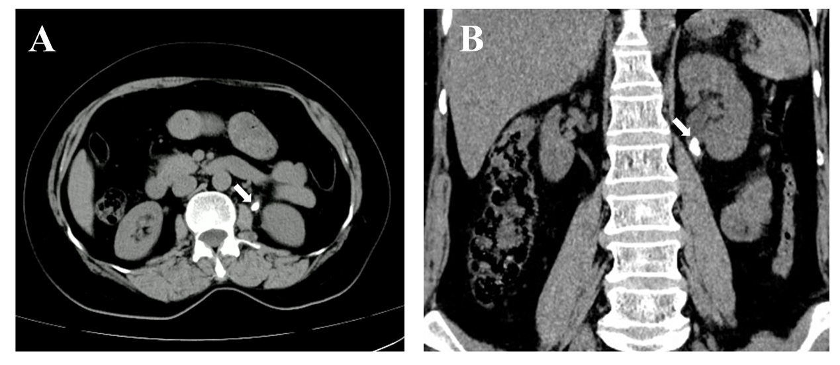
Supplementary Figure S1: Preoperative non–contrast-enhanced abdominal CT showing a left ureteropelvic junction stone (white arrows) on axial (A) and coronal (B) images.
On August 8, 2024, the patient underwent left-sided percutaneous nephrolithotomy (PCNL) under general anesthesia. A 6-Fr ureteral catheter was first placed cystoscopically, after which the patient was repositioned prone. Ultrasound-guided puncture of the renal middle calyx was attempted via a flank percutaneous approach. After urine return was observed, a guidewire was inserted, and tract dilation was performed stepwise to 18-Fr, followed by placement of a nephrostomy access sheath. Holmium:YAG laser lithotripsy was performed under direct endoscopic visualization, with successful stone fragmentation. The total operative time was approximately 95 minutes.
Immediately after returning to the ward, the patient developed severe flank and abdominal pain that was poorly responsive to nonsteroidal anti-inflammatory analgesics. Physical examination revealed abdominal wall guarding and generalized abdominal tenderness, which was most prominent in the left abdomen. Given the atypical severity of symptoms, emergency contrast-enhanced abdominal CT was performed. Imaging demonstrated perirenal fluid accumulation and revealed that the nephrostomy tract traversed the descending colon before entering the renal collecting system via the ventral aspect of the middle calyx, consistent with colonic injury (Supplementary Figure S2A and S2D, and Supplementary Video S2). Bedside abdominal ultrasonography demonstrated left-sided intraperitoneal fluid with a maximal depth of approximately 25 mm. Despite these findings, the patient remained hemodynamically stable and afebrile, with no evidence of diffuse or progressive peritonitis.
Conservative management was initiated, including bowel rest, gastric protection, total parenteral nutrition, and escalation to broad-spectrum antibiotic therapy with ertapenem. The patient’s condition stabilized, and severe abdominal pain gradually resolved. From postoperative day 3 onward, the patient reported no significant abdominal pain. On physical examination, the abdomen was soft, with no obvious abnormalities, and mild deep tenderness was present in the left flank.
On postoperative day 6, follow-up non-contrast abdominal CT was performed (Supplementary Figure S2B and S2E, and Supplementary Video S3). Based on serial imaging findings and measurement of the access tract length, the nephrostomy tube was withdrawn, with the tip estimated to be positioned within the colonic lumen. Enteral nutrition was introduced in addition to parenteral support. During this period, approximately 10 mL/day of dark green fluid was intermittently drained for two days, after which no further drainage was observed.
On postoperative day 15, follow-up non-contrast abdominal CT demonstrated that the nephrostomy tube had completely withdrawn from the colon, with the tube tip located within the paraspinal muscle layer (Supplementary Figure S2C and S2F, and Supplementary Video S4). The patient was transitioned to a semi-liquid diet, which was well tolerated. After 48 hours of observation without recurrence of symptoms, the nephrostomy tube was removed, and the patient was discharged on August 27, 2024.
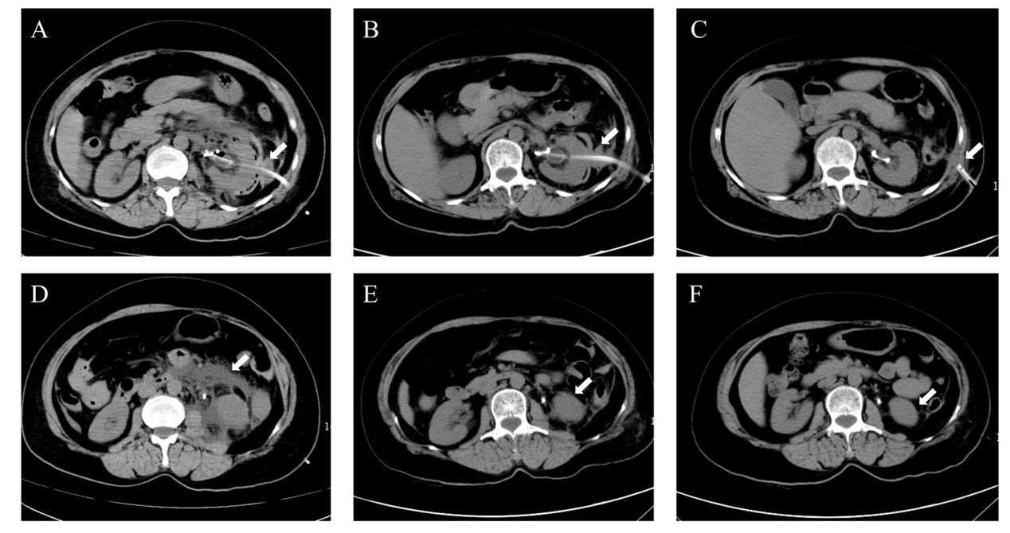
Supplementary Figure S2: Serial postoperative CT findings of colonic injury and interval changes. (A) Non-contrast phase of contrast-enhanced abdominal CT on postoperative day (POD) 0 showing traversal of the nephrostomy tube through the descending colon before entering the renal pelvis via the anterior group of the middle calyx (white arrow). (B) Follow-up non–contrast-enhanced abdominal CT on POD 6 demonstrating persistent colonic traversal of the nephrostomy tube (white arrow). (C) Follow-up non–contrast-enhanced abdominal CT on POD 15 showing complete withdrawal of the nephrostomy tube from the colon, with the tube tip located within the paraspinal muscle layer (white arrow). (D–F) Corresponding images to panels A–C demonstrating progressive improvement and near-complete resolution of perirenal fluid and gas collections over time.
During hospitalization, bowel function gradually normalized. The patient reported one bowel movement on August 12, none on August 13, and regular formed stools (1–2 per day) from August 14 until discharge, without blood or purulent material. Vital signs remained stable throughout the postoperative course, with stable heart rate and no sustained fever (Supplementary Figure S3). Serial blood tests on postoperative days 0, 1, and 6 showed leukocytosis with neutrophil predominance, peaking on postoperative day 1 and gradually declining thereafter. Hematological parameters returned to within normal ranges by postoperative day 10.
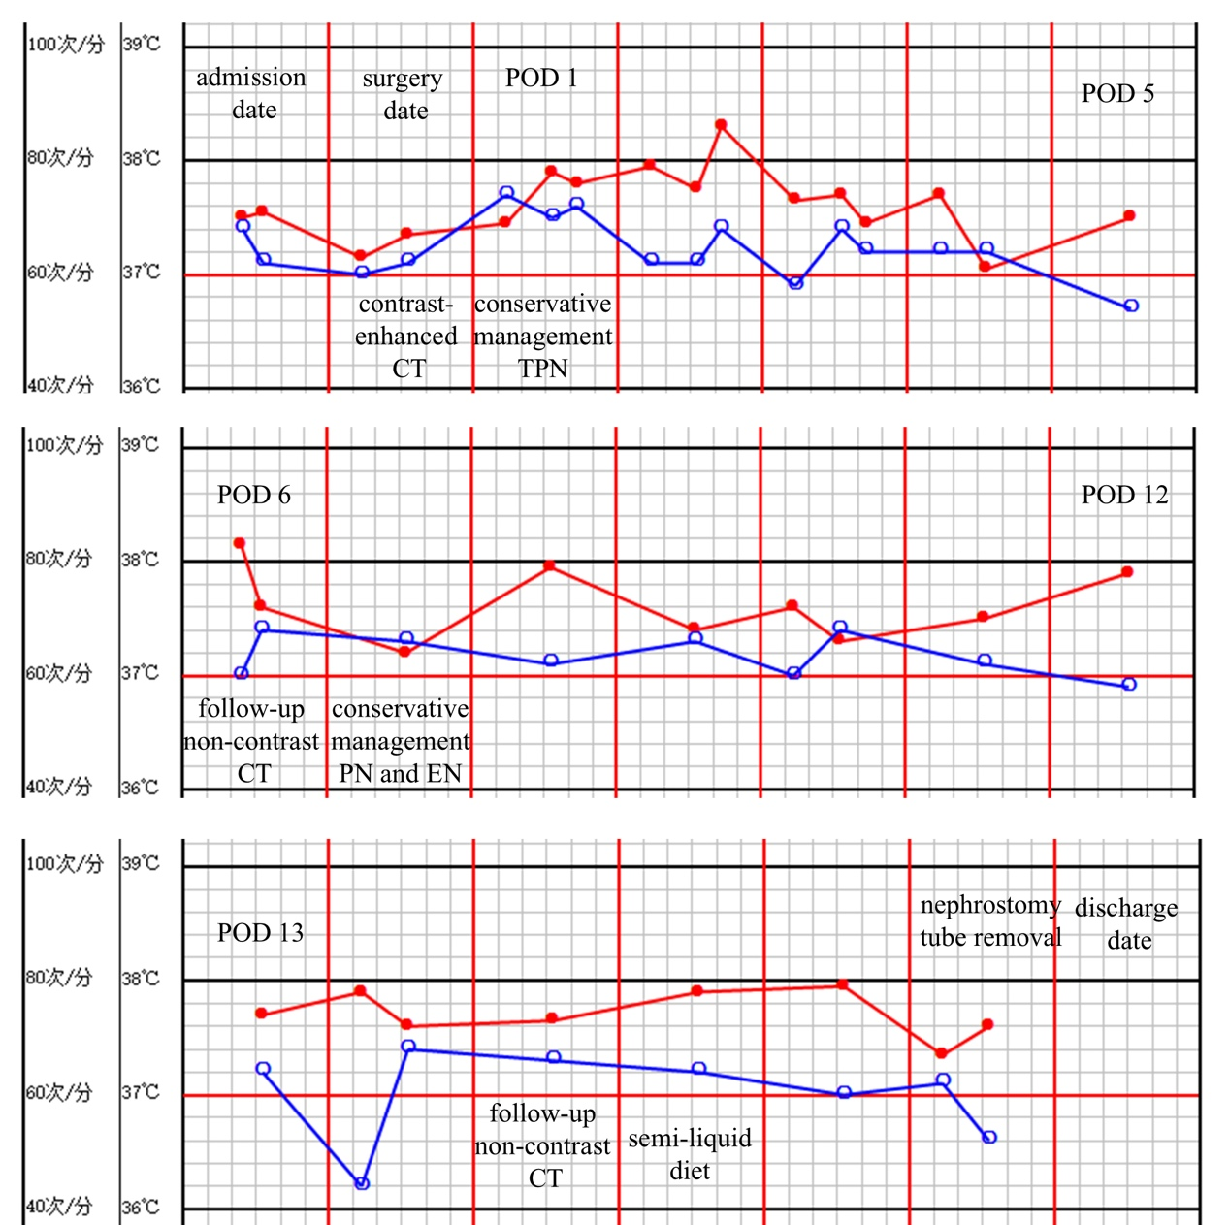
Supplementary Figure S3: Postoperative heart rate (red) and body temperature (blue) over time with key clinical events annotated. POD, postoperative day; CT, computed tomography; TPN, total parenteral nutrition; PN, parenteral nutrition; EN, enteral nutrition.
Two weeks after discharge, the patient returned for outpatient removal of the indwelling ureteral stent, which was performed uneventfully. During subsequent follow-up, the patient was contacted by telephone at 3-month intervals over a period of nearly one year and reported no abdominal symptoms, urinary complaints, or signs of fistula formation, indicating full clinical recovery.

