Supporting Information

Investigating Civilian Nitrocellulose in tuning performance of Nitramine Gun Propellant via a Combined Experimental and Theoretical calculation
Heng Gao†‡∭, Ling Chen†‡∭, Shouyu Wang†‡∭, Peichen Han†‡∭, Fengqiang Nan†‡∭*, Ping Du†‡∭*, and Weidong He†‡∭*
† School of Chemistry and Chemical Engineering, Nanjing University of Science and Technology, Nanjing, Jiangsu, 210094, China;
‡ Key Laboratory of Special Energy Materials, Ministry of Education, Nanjing, Jiangsu, 210094, China；
∭ National special materials resource and green disposal technology innovation center, Nanjing, Jiangsu, 210094, China；
Corresponding Email: dp1314@163.com; nfq@163.com; hewedong@njust.edu.cn.

Total number of pages: 13 (S1-S13)
Total number of figures: 10 (Figure S1- Figure S10)
Total number of equations: 1 (Eq S1)

1. Curves of MS
Fig. S1. The curves of total energy, kinetic energy, potential energy and non-bond energy (a-d), temperature (d), density (e), of CNC/RDX GP with simulation time.

2. SEM images
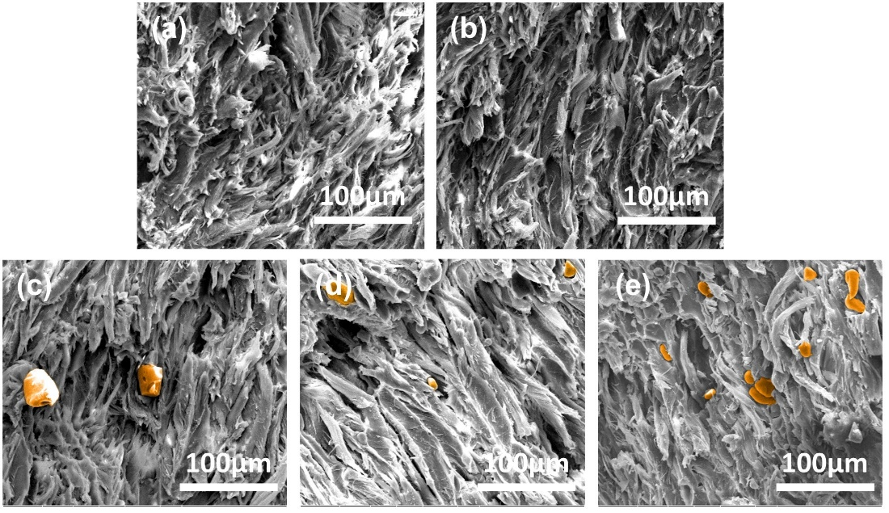
Fig. S2. The SEM images of the transverse section of obtained CNC-based GPs with different content of RDX (a) blank sample, (b) 0%, (c) 5%, (c) 10% and (c) 15%.

3. Thermal analysis

Fig. S3. The DSC curves of the RDX at heating rates of 10 K·min⁻¹.

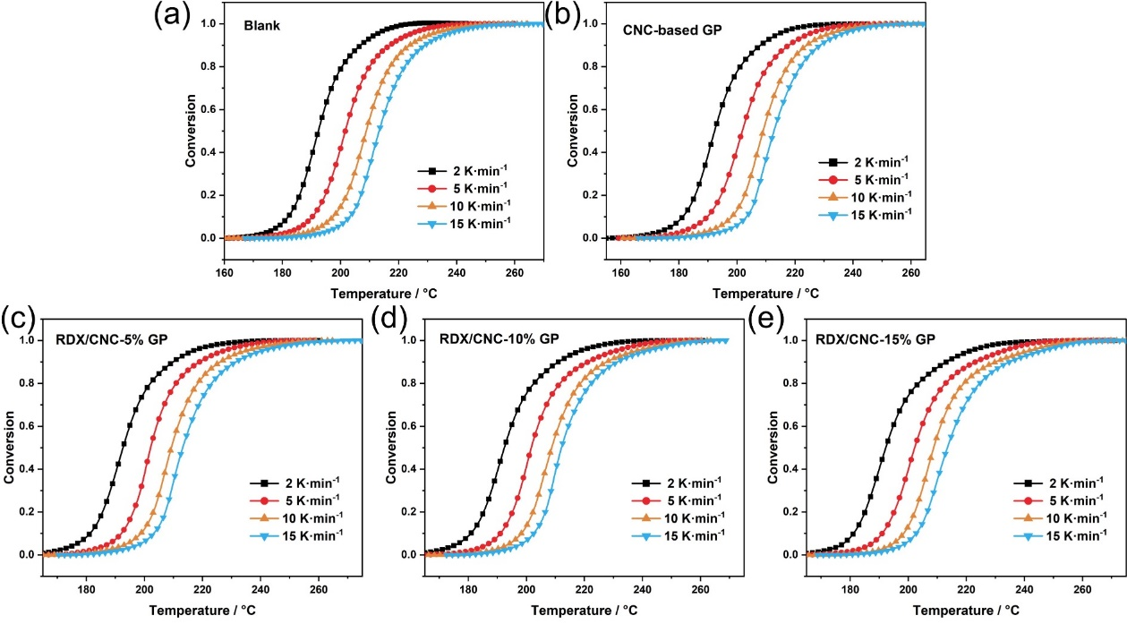
Fig. S4. The conversion variation α of the obtained propellants.

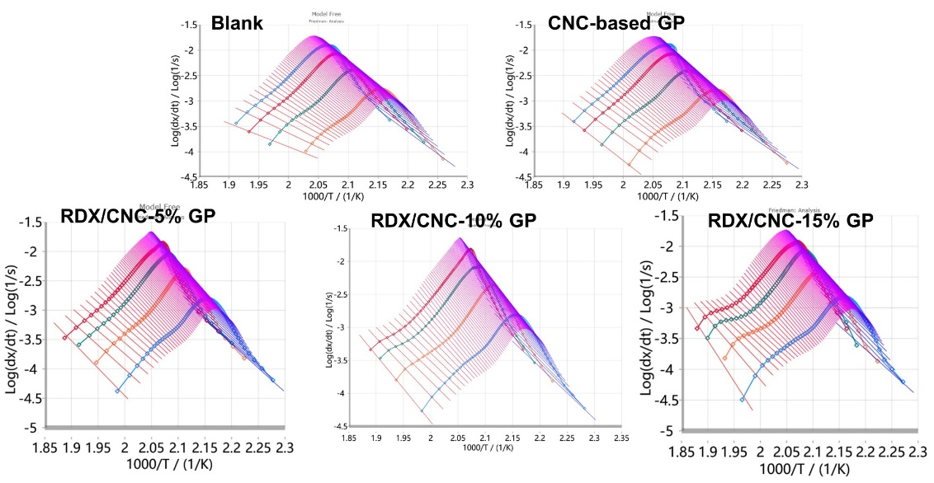
Fig. S5. The Log A of propellants of the calculation process obtained by Friedman method.

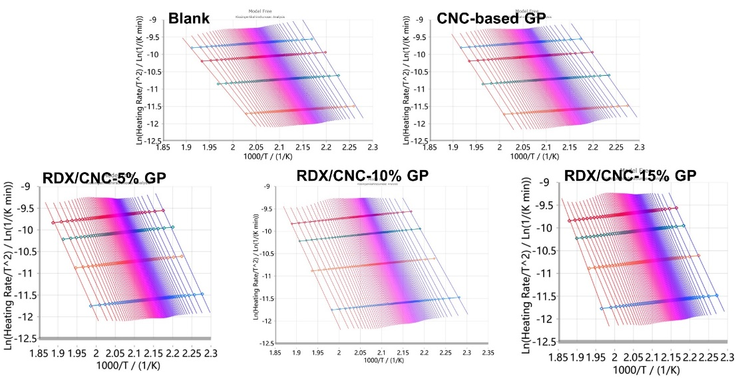
Fig. S6. The Log A of the calculation process obtained by KAS method.

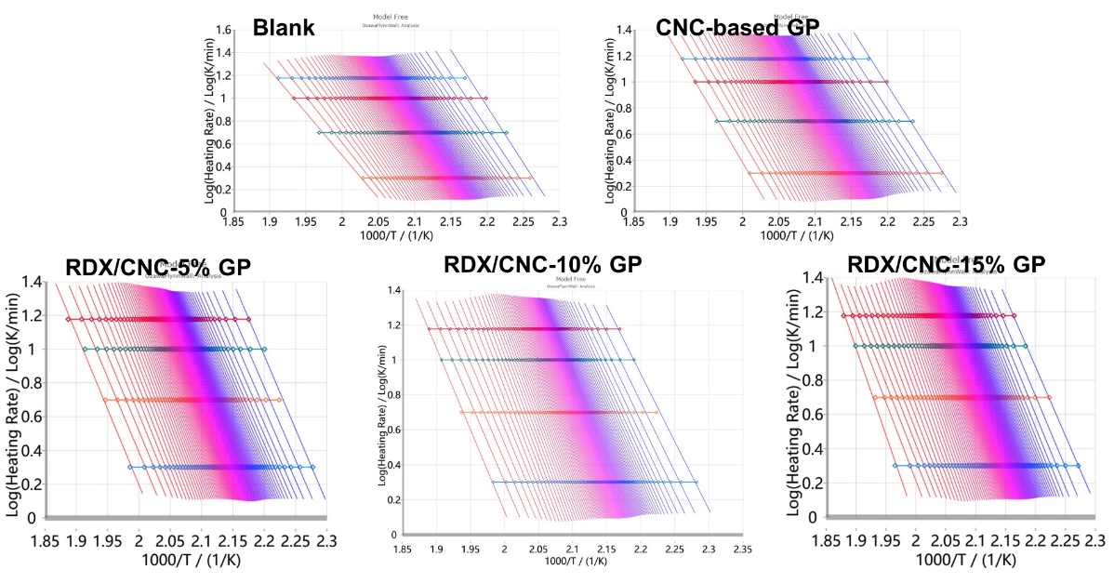
Fig. S7. The Log A of the calculation process obtained by OFW method.

4. Characterization
The mechancial properties of propellants were tested with regard to impact strengths with five times of each sample in each time, and the average values were reported. The impact strengths tests were conducted on a drop weight impact testing machine (American Instron, Dynatup 9250HV). The grains were machined to a length of 60 mm.
Impact strength test
Eq. S1
In Eq. S1, a_{k} is the impact strength test of sample, kJ·m⁻²;
A, impact energy consumed during test fracture, J;
D, outer diameter of tubular propellant sample, mm;
d, Inner diameter of tubular propellant sample, mm.
The closed vessel tests performed using a 111.6 cm³ vessel reflected a constant volume combustion. A 1.0 g NC powder with 10.98 MPa ignition pressure was used as the ignitor. The loading density of each sample was 0.2 g/cm³ at -40 °C, 20 °C and 50 °C. In terms of the gunpowder impetus, which was tested with two loading density of each sample about 0.2 g/cm³ and 0.12 g/cm³ at 20 °C. The burning pressure (p), burning time (t), burning rate (u), dynamic vivacity (L), and relative pressure (B) were used to characterize the stability of the combustion (p-t curves), the change rule in burning rate (u-p curves), and burning progressive state of the burning surface (L-B curves).

5. Burning parameters analysis of gun propellant

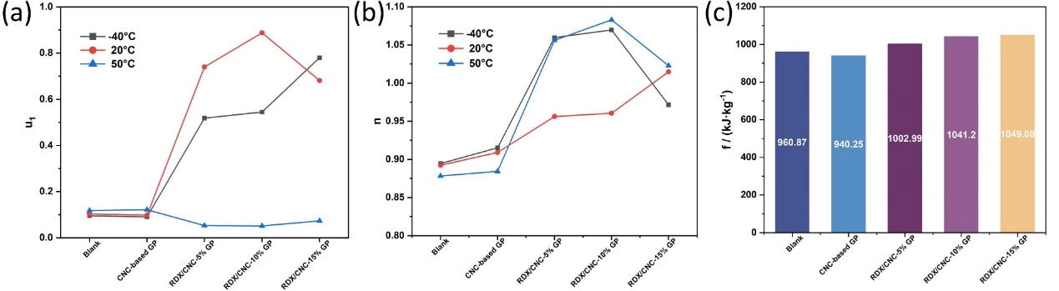
Fig. S8. The burning rate coefficient (u₁), pressure exponent (n) and gunpowder impetus of propellants in the combustion process.

6. Molecular dynamics simulation of propellant

Fig. S9. The H bond number and RDF between CNC_{13.1%} and CNC_{12.0%} of CNC/RDX propellants.

Fig. S10. The ratio of electrostatic interactions and van der Waals interactions between each CNC/RDX propellant samples.

