Encoding in social-evaluative context enhances and biases long-term recognition memory: Behavioral and electrophysiological evidence

SUPPLEMENTARY MATERIALS

Sebastian Schindler^{1,2,3}, Ria Vormbrock² and Johanna Kissler^{1,4*}

¹ Department of Psychology, Bielefeld University
² Institute of Medical Psychology and Systems Neuroscience, University of Muenster
³ Otto Creutzfeldt Center for Cognitive and Behavioral Neuroscience, University of Muenster
⁴ Center for Cognitive Interaction Technology (CITEC), Bielefeld University
* Corresponding author

Correspondence address
Johanna Kissler
Department of Psychology
Bielefeld University
33501 Bielefeld
Germany
e-mail: johanna.kissler@uni-bielefeld.de
Section A: Memory performance one week later
Hits and false alarms
Analyses across the three groups tested for main and interaction effects, including the within factors condition (two levels) and emotion (three levels). Hit rate differed between groups (F_{(2,65)} = 32.99, p < .001, partial η² = .504; see Supplementary Table S1, Supplementary Figure S1) and was significantly higher in the social-feedback group than both in the verbal-learning (p = .002) and the levels-of-processing group (p < .001). The verbal-learning group showed significantly more hits than the levels-of-processing group (p < .001). There was also an interaction between group and emotion (F_{(4,130)} = 4.87, p = .001, partial η² = .130) and a three-way interaction between group, condition, and emotion (F_{(3.61,117.26)} = 20.53, p < .001, partial η² = .387). This three-way interaction was due to condition differences in the levels-of-processing group: The impact of emotional content on the hit rate differed between the levels-of-processing and the concreteness task (see Table 3). Experimental groups did not differ in false alarm rates (F_{(2,65)} = 2.51, p = .089, partial η² = .072), and there was no interaction of emotion and group (F_{(3.53,114.64)} = 2.56, p = .050, partial η² = .073) regarding false alarms.
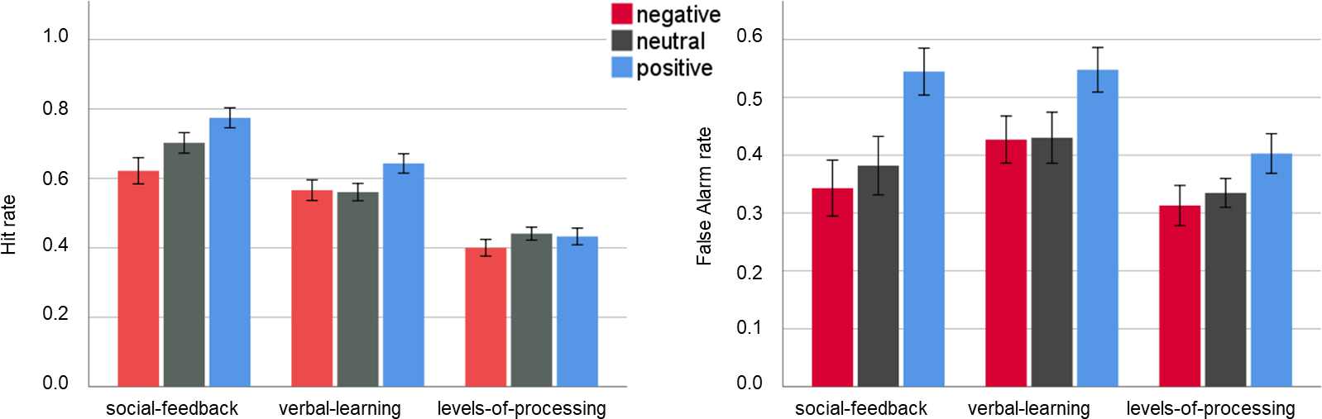Supplementary Figure S1: Behavioral data for the social-feedback, verbal-learning, and levels-of-processing group. The upper row depicts mean hits and false alarms in per cent per emotional category and group. Error bars depict ±1 Standard Error of the Mean.
Supplementary Table S1: Hit and false alarm rates for the three groups
social-feedback group (N = 24)
 |  |  |  | human feedback |  |  | computer feedback
 | condition  F_{(1,23)} | emotion  F_{(2,46)} | interaction  F_{(2,46)} | negative | neutral | positive | negative | neutral | positive
Hit rate | 1.12 | 19.93*** | 2.17 | .66  (0.21) | .73  (0.17) | .78  (0.13) | .58  (0.22) | .68  (0.22) | .77  (0.21)
FAR |  | 25.41*** |  | .34  (0.24) | .38  (0.25) | .54  (0.20) | .34  (0.24) | .38  (0.25) | .54  (0.20)
verbal-learning group (N = 21)
 |  |  |  | block A |  |  | block B
 | condition  F_{(1,20)} | emotion  F_{(2,40)} | interaction  F_{(2,40)} | negative | neutral | positive | negative | neutral | positive
Hit rate | 0.07 | 7.27** | 0.57 | .55  (0.15) | .57  (0.11) | .64  (0.14) | .58  (0.15) | .56  (0.16) | .65  (0.15)
FAR |  | 14.11*** |  | .43  (0.19) | .43  (0.20) | .55  (0.18) | .43  (0.19) | .43  (0.20) | .55  (0.18)
levels-of-processing group (N = 23)
 |  |  |  | self-reference task |  |  | semantic task
 | condition  F_{(1,22)} | emotion  F_{(2,44)} | interaction  F_{(2,44)} | negative | neutral | positive | negative | neutral | positive
Hit rate | 0.04 | 1.93 | 30.06*** | .44  (0.19) | .33  (0.17) | .52  (0.17) | .36  (0.12) | .55  (0.15) | .35  (0.16)
FAR |  | 5.72** |  | .31  (0.17) | .33  (0.12) | .40  (0.17) | .31  (0.17) | .33  (0.12) | .40  (0.17)
Note: * = p < 0.05, ** = p < 0.01, *** = p < 0.001. Standard deviations appear in parentheses. FAR = False alarm rate. P_{r} = discrimination accuracy, B_{r} = recognition bias. Hits in percent
Section B: Correlations of ERPs and memory performance
For late ERP components, mean ERP amplitudes were correlated with subsequent memory performance (Hits and False Alarms (FA)) using JASP (www.jasp.org). We calculated both Bonferroni-corrected inferential and Bayesian Pearson correlation coefficients. For Bayesian analyses, the null hypothesis was specified as a point-null prior (i.e., standardized effect size δ = 0). It defined the alternative hypothesis as a Jeffreys-Zellner-Siow (JZS) prior, i.e., a folded Cauchy distribution centered around δ = 0 with the scaling factor r = 0.707. This scaling factor assumes a roughly normal distribution. To assign verbal labels to the strength of evidence, we followed the taxonomy suggested by Jeffreys (1998), labeling Bayes Factors with a BF₁₀ of 1 as no evidence, BF₁₀ between 1 - 3 as anecdotal evidence, 3 - 10 as moderate evidence, 10 - 30 as strong evidence, 30 - 100 as very strong evidence, and larger BFs as extreme evidence in favor of the alternative hypothesis.
These correlations showed stronger mean ERP amplitudes during the LPP time window with subsequent hit rate or false alarm rate (see Supplementary Table S2). For the social-feedback group, parietal LPP amplitudes were overall negatively related to the false alarm rate, showing moderate evidence of a relationship for positive words. Although the levels-of-processing group showed a similar relationship pattern over parietal sensors, Bayes Factors showed no at least moderate evidence for such a relationship. For the verbal-learning group, the strongest relationships of ERP amplitudes were found over the frontal LPP cluster. Here, strong evidence was found for a relationship between ERP amplitudes during the presentation and the subsequent hit rate for neutral words. A similar pattern was found concerning negative and positive words, but Bayes Factors showed only anecdotal evidence of a relationship. Please note that given the small sample sizes of each group, these relationships should be interpreted cautiously.
Supplementary Table S2: Relationship of ERPs during encoding and subsequent memory
 | Frontal LPP (400 – 800) |  |  |  | parietal LPP (400 – 800)
 |  | negative | neutral | positive |  | negative | neutral | positive
social-feedback group (N = 24)
Hits Pearson r |  | -.156 | -.304 | -.241 |  | .039 | -.113 | -.210
p-Value ª |  | .468 | .149 | .256 |  | .856 | .599 | .324
BF₁₀ |  | 0.325 | 0.679 | 0.465 |  | 0.257 | 0.289 | 0.401
FA Pearson r |  | .028 | -.056 | .101 |  | -.194 | -.317 | -.495
p-Value ª |  | .896 | .794 | .637 |  | .363 | .132 | .014
BF₁₀ |  | 0.255 | 0.261 | 0.381 |  | 0.374 | 0.740 | 4.403*
verbal learning group (N = 21)
Hits Pearson r |  | .402 | .703 | .415 |  | -.332 | -.077 | -.146
p-Value ª |  | .071 | <.001 | .061 |  | .142 | .740 | .528
BF₁₀ |  | 1.251 | 98.105** | 1.399 |  | 0.745 | 0.285 | 0.326
FA Pearson r |  | .286 | .343 | .427 |  | .032 | -.055 | -.046
p-Value ª |  | .209 | .128 | .053 |  | .890 | .812 | .845
BF₁₀ |  | 0.567 | 0.801 | 1.558 |  | 0.273 | 0.278 | 0.275
levels-of-processing group (N = 23)
Hits Pearson r |  | -.009 | -.101 | .267 |  | -.006 | .419 | .356
p-Value ª |  | .969 | .648 | .217 |  | .979 | .033 | .095
BF₁₀ |  | 0.259 | 0.285 | 0.530 |  | 0.259 | 1.678 | 0.962
FA Pearson r |  | -.093 | -.100 | .283 |  | -.301 | -.420 | .139
p-Value ª |  | .671 | .651 | .191 |  | .162 | .046 | .0528
BF₁₀ |  | 0.281 | 0.285 | 0.579 |  | 0.650 | 1.685 | 0.312
 | Frontal slow-wave (800 – 1200) |  |  |  | parietal slow-wave (800 – 1200)
 |  | negative | neutral | positive |  | negative | neutral | positive
social-feedback group (N = 24)
Hits Pearson r |  | .181 | .072 | .119 |  | .266 | .033 | .120
p-Value ª |  | .398 | .737 | .578 |  | .209 | .878 | .578
BF₁₀ |  | 0.355 | 0.267 | 0.293 |  | 0.533 | 0.256 | 0.293
FA Pearson r |  | -.125 | -.329 | -.207 |  | .203 | -.186 | -.226
p-Value ª |  | .561 | .117 | .333 |  | .341 | .385 | .289
BF₁₀ |  | 0.297 | 0.809 | 0.395 |  | 0.389 | 0.362 | .431
verbal learning group (N = 21)
Hits Pearson r |  | .024 | -.221 | .149 |  | -.016 | -.125 | -.060
p-Value ª |  | .917 | .336 | .519 |  | .944 | .590 | .796
BF₁₀ |  | 0.272 | 0.417 | 0.329 |  | 0.271 | 0.310 | 0.279
FA Pearson r |  | .011 | -.019 | .002 |  | -.037 | .262 | .162
p-Value ª |  | .962 | .934 | .992 |  | .873 | .251 | .482
BF₁₀ |  | 0.271 | 0.271 | 0.270 |  | 0.274 | 0.501 | 0.341
levels-of-processing group (N = 23)
Hits Pearson r |  | .135 | -.124 | .032 |  | .104 | .123 | .059
p-Value ª |  | .539 | .572 | .886 |  | .636 | .575 | .790
BF₁₀ |  | 0.309 | 0.301 | 0.261 |  | 0.287 | 0.300 | 0.267
FA Pearson r |  | .010 | .111 | .108 |  | -.272 | -.201 | -.024
p-Value ª |  | .964 | .613 | .625 |  | .209 | .359 | .913
BF₁₀ |  | 0.259 | 0.292 | 0.289 |  | 0.545 | 0.385 | 0.260
Note: LPP and slow wave amplitudes for the respective emotional category were correlated with subsequent hits for this emotional category. Hits and False alarms (FA) are examined. ª Bonferroni-corrected significance threshold for is p < .00417; * = BF₁₀ > 3; ** = BF₁₀ > 10. (where BF₀₁ = 1/ BF₁₀).

Section C:
Following up on the encoding condiditon x emotion x channel group interaction (F_{(4,138)} = 3.48, p = .010, η_{p}² = .092) within the social feedback group, we explored emotion differences between the two encoding conditions (“human” vs “computer” feedback) for the frontal and parietal ROI. Frontal emotion differences concerned “human feedback” (F_{(2,46)} = 4.78, p = .013, η_{p}² = .172), with a relatively larger positivity for negative and positive compared to neutral feedback (ps < .05), positive and negative not differing (p = .923) and no effect for the “computer” encoding condition (F_{(2,46)} = 0.32, p = .731, η_{p}² = .014). Parietally, no emotion difference was found in the “human” condition (F_{(2,46)} = 1.09, p = .344, η_{p}² = .045), but there were differences within the computer condition (F_{(2,46)} = 13.13, p < .001, η_{p}² = .363), where an increased positivity for positive feedback compared to both negative and neutral feedback (ps < .001) was observed, while negative and neutral did not differ (p = .705). No further significant interactions occurred (Fs < 2.10, ps > .084).

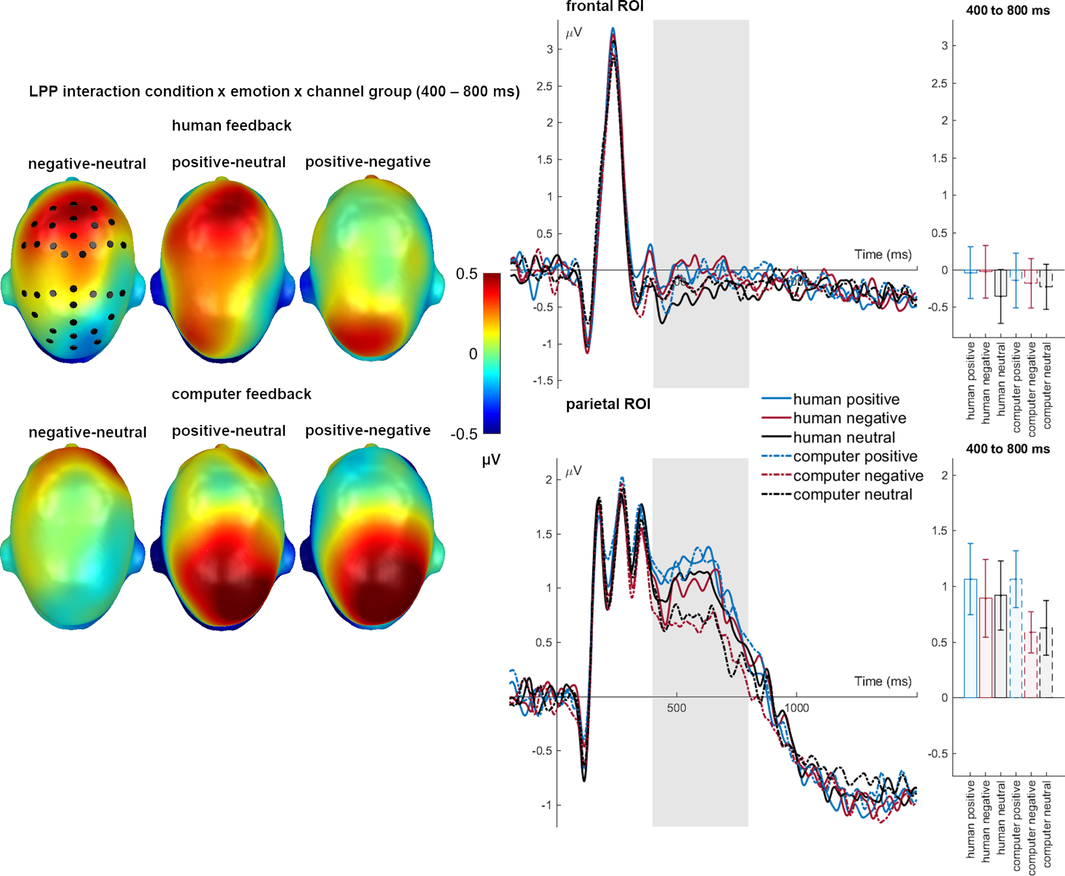 Supplementary Figure S2. LPP interaction between encoding condition, emotion, and channel group for the social-feedback group. A) Scalp topographies depict the mean emotion amplitude differences separately for the encoding conditions (human vs. computer feedback). B) Scalp topographies per emotion for differences between the feedback conditions. ERP waveforms show the time course from averaged highlighted sensors. Difference potentials contain 95% bootstrap confidence intervals. For bar charts, error bars show 95% confidence intervals.

